REAL TIME CHATTING APPLICATION
Project Synopsis Presentation

Date: 15/02/2023

Major Project (IMW651)
Degree : BCA(MAWT)

_{Project Guide:} Mr.Sanjeev Soni Keshav saini
TCA(2055004)


FACULTY OF ENGINEERING & COMPUTING SCIENCES TEERTHANKER MAHAVEERUNIVERSITY, MORADABAD


Team Details

Student Name | Role

Bhuvnesh Saini | Designing , Front-end
 | Development
Keshav Saini | Backend Development

2 T011A/ Template Version 5.0
Table of Contents

Contents:

- Project Brief

- Methodology, Technologies or Tools Used

- ContextDiagram

- Modules in Application

- Data Flow Diagram

- Advantages of the project

3

Project Brief

The main objective of this project is to allow each and every person can get connected to each other, like a normal chat application.

It’s a web based application and it is the real time chatting application.
It manage the details of the Chat user, Chat history.

Functions:

- Login/Signup with multiple methods.

- Users can upload their profile photo.

- Send and receive unlimited length of text message.

- User can send emoji and photos.

- Manage the information of user chat.

- Shows the information and description of Chat History.

4
Methodologies

The user interacts with the application using a GUI or we know that this application is web based so it is supported by all the browsers .

- The GUI operates in two forms, the list form & the chat form.

List Form :

In this form, or we can say that it can be a sidebar of the application where all the users names are listed below and also have a search bar to search any specific user.

Chat Form :

This form is really called only when an element or user chat profile is selected from the List form. In this form, a connection is created between the host and the selected user with the help of socket.

5 T011A/ Template Version 5.0
Technologies/ Tools to be used

- Front End:

  - HTML, CSS ,

  - Reactjs(Framework)

  - Bootstrap/Tailwind CSS

- Back End:

  - Nodejs

  - Socket.io

- Database:

  - Firebase/ Mongo DB

- Tools:

  - VS Code

5 T011A/ Template Version 5.0
Context Diagram (Overall Project)
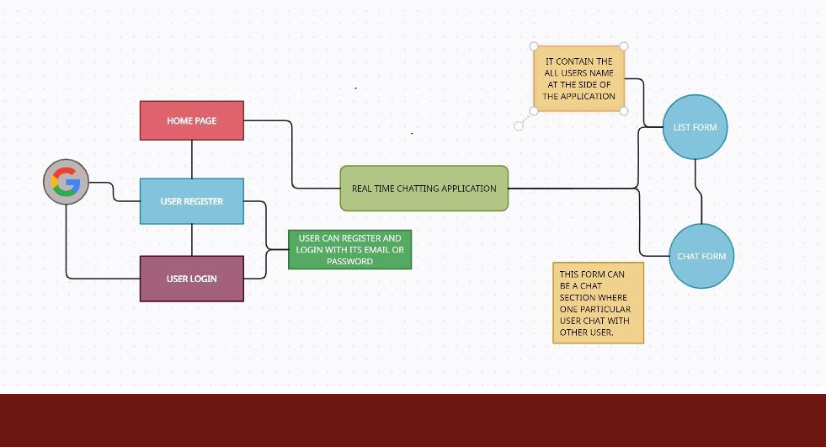

6 T011A/ Template Version 5.0

- Modules in Application

Various modules in project:

- Full UI design module.

- User Registration and login Module.

- Text Message sending module.

- Image and Emoji sending module.

- Chat History module.

7 T011A/ Template Version 5.0

Data Flow Diagram (DFD)
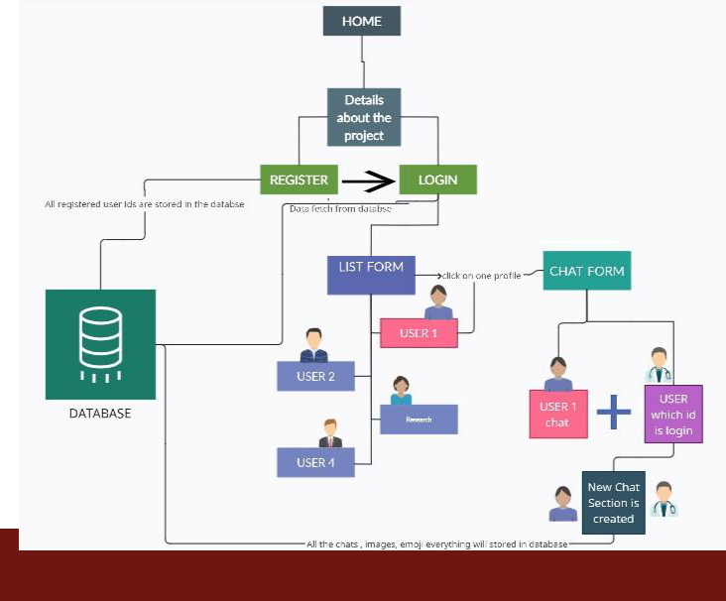

8

\Advantage of The Project

Strong Points of Real Time Chatting Application :

- Speed in usage.

- Easy and friendly UI.

- Privacy Protection.

- No lose of data.

- Firebase database is used in it so it is easy to deploy the application.

9 T011A/ Template Version 5.0

Thanks

