REAL TIME CHATTING APPLICATION

Project Synopsis Report

Major Project (IMW651)

Degree

BACHELOR OF COMPUTER APPLICATION

(Mobile Application and Web Technology)

PROJECT GUIDE:

SUBMITTED BY:

Mr. Sanjeev Soni

Keshav Saini (TCA2055004)

February, 2023


FACULTY OF ENGINEERING & COMPUTING SCIENCES

TEERTHANKER MAHAVEER UNIVERSITY, MORADABAD

TMU-FOE&CS T001A-Project Synopsis

 |  | Table of Contents
1 | Project Title ........................................................................................................................................... |  | 3
2 | Domain .................................................................................................................................................. |  | 3
3 | Problem Statement ............................................................................................................................... |  | 3
4 | Project Description ................................................................................................................................ |  | 3
4.1 |  | Scope of the Work ......................................................................................................................... | 4
4.2 |  | Project Modules ............................................................................................................................ | 4
5 | Implementation Methodology .............................................................................................................. |  | 4
6 | Technologies to be used ....................................................................................................................... |  | 5
6.1 |  | Software Platform ......................................................................................................................... | 5
6.2 |  | Hardware Platform........................................................................................................................ | 5
6.3 |  | Tools .............................................................................................................................................. | 5
7 | Advantages of this Project .................................................................................................................... |  | 5
8 | Future Scope and further enhancement of the Project ........................................................................ |  | 6
9 | Team Details.......................................................................................................................................... |  | 6
10 |  | Conclusion ......................................................................................................................................... | 6
11 |  | References ........................................................................................................................................ | 6

Project Title: REAL TIME CHATTING APPLICATION Page 2 of 6
TMU-FOE&CS T001A-Project Synopsis

1 Project Title

The project title is ‘REAL TIME CHATTING APPLICATION’. The main objective of this project is to allow each and every person can get connected to each other, like a normal chat application. It’s a web based application and it is the real time chatting application. It manage the details of the Chat user, Chat history.

2 Domain

REAL TIME CHATTING APPLICATION (Web Technology)

3 Problem Statement

This project is to create a chat application with a server and users to enable to users to chat with each other easily. The project should be very easy to use even a novice person can use it. Chat application has become a popular way for n-way conversation or discussion among people. Chat applications range from simple, text-based.

Project Title: REAL TIME CHATTING APPLICATION Page 3 of 6
TMU-FOE&CS T001A-Project Synopsis

4 Project Description

As mentioned earlier, this project is used to support the users to chat with the others users easily.
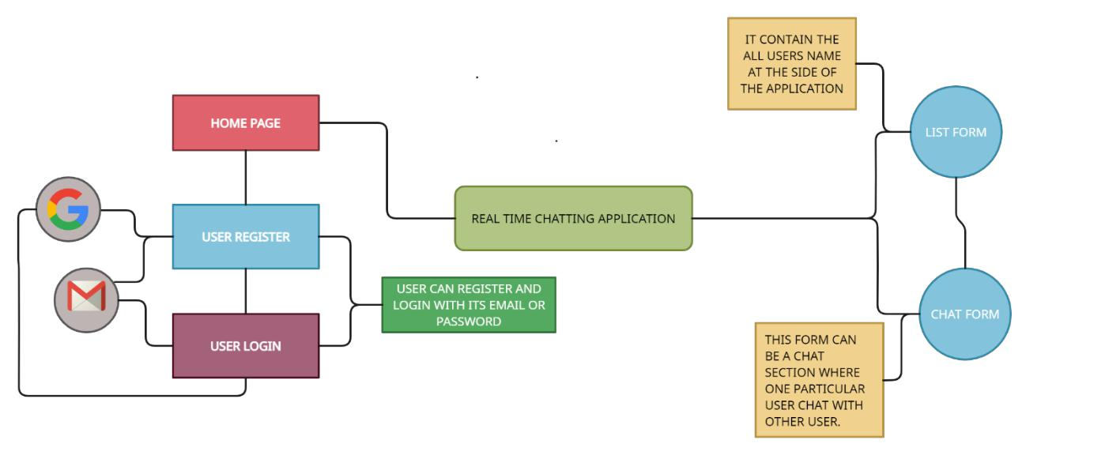

Context Diagram

Project Title: REAL TIME CHATTING APPLICATION Page 4 of 6
TMU-FOE&CS T001A-Project Synopsis

4.1 Scope of the Work

The application is designed as a web based application. It provides a general architecture for chat applications, and anyone or organization can use it as the basis for providing instant messaging capabilities. This application will be made in Reactjs library of JavaScript which is used to make a single page web application so its means the application will respond fastly and the data of the users or users chat will be stored securely in the database and the access of manage the data is only provided to the admin of the application,

4.2 Project Modules

The project will contain the following modules:

- Designing UI -- In this module, the main focus is to develop the UI part of the application by which user interacts.

- User Registration and Login – In this module, all the authorization and authentication process done

- Text message sending – In this module, I will work on the message sending process.

- Images and Emoji sending – As the name suggests, in this module, I have to work on sending images and emoji to the users.

- Chat History module— In this module, I mainly focus on how to store the chat of every user.

Project Title: REAL TIME CHATTING APPLICATION Page 5 of 6
TMU-FOE&CS T001A-Project Synopsis

5 Implementation Methodology

The user interacts with the application using a GUI or we know that this application is desktop based so it is supported by all the browsers. The GUI operates in two forms, the list form & the chat form.

1. List Form:

In this form, or we can say that it can be a sidebar of the application where all the users names are listed below and also have a search bar to search any specific user.

2. Chat Form:

This form is really called only when an element or user chat profile is selected from the List form. In this form, a connection is created between the host and the selected user with the help of socket.
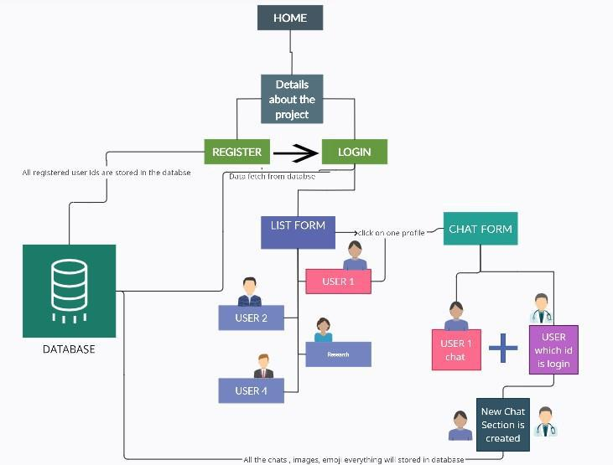

Data Flow Diagram

The above diagram depicts the data flow of the project

Project Title: REAL TIME CHATTING APPLICATION Page 6 of 6
TMU-FOE&CS T001A-Project Synopsis

6 Technologies to be used

The following technologies are utilized for this project. This list may change as need for more features/improvements arises in the future.

6.1 Software Platform

- Front-end

  - HTML, CSS

  - Bootstrap/Tailwind CSS

  - Reactjs (Framework)

- Back-end

  - Nodejs

  - Socket.io

- Database

  - Firebase/ MongoDB

6.2 Hardware Platform

- 4 GB RAM

- 500gb Hard Disk,

- Windows 10,

- Google Chrome v105.0.5195.

6.3 Tools

During the planned development phase, the main tool is VS Code v1.71 by Microsoft used as an editor for quick and precise development of the project.

7 Advantages of this Project

The main advantages of this project are:

- Speed in usage.

- No possibility of lose the data.

- Easy and friendly UI.

- Privacy Protection.

- Firebase database is used in it so it is easy to deploy the application.

Project Title: REAL TIME CHATTING APPLICATION Page 7 of 6
TMU-FOE&CS T001A-Project Synopsis

8 Future Scope and further enhancement of the Project

With the knowledge I have gained by developing this application, I am confident that in the future I can make the application more effectively by adding this services.

- We can implement the backup mechanism for taking backup of chat of every user on the regular basis.
- We can give more advance software of Online Chat application with more facilities.
- Integrate multiple load balancers to distribute the loads of the system.
- We can use other technologies to make the application more faster or decrease the load time.

9 Team Details

Project Name | Course Name | Student ID | Student Name | Role | Signature
& ID
REAL TIME | Major Project | TCA2055002 | Bhuvnesh | Designing ,
CHATTING |  |  | Saini | Front-end ,
APPLICATION |  |  |  | Back-end
 |  |  |  | Development

10 Conclusion

The main objective of the project is to develop a Secure Chat Application. I had taken a wide range of literature review in order to achieve all the tasks. We’ve seen that making “Real Time Chat Application” is quite interesting thing and new thing to make other than making a website about a product or any portfolio. In Today’s world chat application is in much demand & needed around everywhere and its reducing our much problem and time, with the help of the chat application we can just send the same message to many users at a time and we don’t need to call every time to anyone for any type of queries or problem, we can just message them

- References

  - YouTube -- links for the videos for some queries.

  - Google for problem solving.

  - https://creately.com/ -- This website is used for making the data flow diagram and context diagrams.

Project Title: REAL TIME CHATTING APPLICATION Page 8 of 6

