Underwater Image Restoration (G1)

Keshav Moorthy (16BCI0066)
Vellore Insitute Of Technology
Vellore, Tamil Nadu
keshav.moorthy2016@vitstudent.ac.in

Manjari Jain (16BEC0077)
Vellore Institute Of Technology
Vellore, Tamil Nadu
manjari.jain2016@vitstudent.ac.in

Abstract—
We acquaint a powerful method with upgrade the images caught submerged and corrupted because of the medium dissipating and assimilation. Our technique is a solitary image approach that does not require particular equipment or learning about the submerged conditions or scene structure. It expands on the mixing of two images that are straightforwardly gotten from a shading redressed and white-adjusted rendition of the first debased image. The two images to combination, just as their related weight maps, are characterized to advance the exchange of edges and shading difference to the yield image. Our broad subjective and quantitative assessment uncovers that our upgraded images and recordings are portrayed by better exposedness of the dim districts, improved worldwide differentiation, and edges sharpness. Our approval likewise demonstrates that our calculation is sensibly autonomous of the camera settings, and improves the exactness of a few image preparing applications, for example, image division and key point coordinating.
Keywords—Underwater, image fusion, white-balancing

Introduction AND OVERVIEW
SUBMERGED condition offers numerous uncommon attractions, for example, marine creatures and fishes, astonishing scene, and baffling wrecks. Other than submerged photography, submerged imaging has additionally been a vital wellspring of enthusiasm for various parts of innovation and logical research [1], for example, investigation of submerged foundations [2] and links [3], discovery of synthetic items [4], control of submerged vehicles [5], sea life science inquire about [6], and archaic exploration [7].
Not quite the same as basic images, submerged images experience the ill effects of poor deceivability coming about because of the lessening of the engendered light, primarily because of retention and dispersing impacts. The retention considerably decreases the light vitality, while the dissipating causes alter in the light proliferation course. They result in foggy appearance and difference corruption.

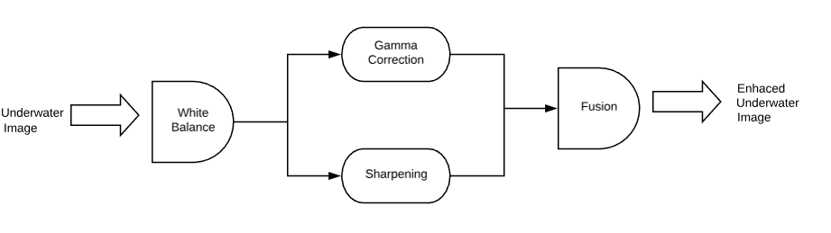
Fig. 1. Figure review: two images are gotten from a white-adjusted form of the single information, and are blended dependent on a combination. The oddity of our methodology lies in the proposed pipeline, yet in addition in the meaning of a white-balancing calculation that is fit to our underwater upgrade issue.

There have been a few endeavors to reestablish and improve the deceivability of such debased images. Since the weakening of submerged scenes results from the mix of multiplicative and added substance forms [8] customary improving strategies for example, gamma revision, histogram adjustment appear to be emphatically constrained for such an undertaking. In the past works that are reviewed in Section II.B, the issue has been handled by custom fitted securing methodologies utilizing numerous images [9], particular equipment [10] or polarization channels [11]. Notwithstanding of their important accomplishments, these methodologies experience the ill effects of a number of issues that diminish their reasonable materialness. Interestingly, this paper acquaints a novel methodology with evacuate the cloudiness in submerged images dependent on a solitary image caught with a traditional camera. As delineated in Fig. 1, our methodology expands on the combination of various information sources, yet determines the two contributions to consolidate by amending the difference furthermore, by honing a white-adjusted form of a solitary local input image. The white adjusting stage goes for expelling the shading cast incited by submerged light dispersing, so as to deliver a characteristic appearance of the sub-ocean images. The fusion usage of the combination procedure results in an antique free mixing.
The flow of our paper is structured as follows. The Section III, we present our novel white-adjusting approach, particularly intended for submerged images. Section IV depicts the primary segments of our combination based upgrading system, including inputs and related weight maps definition. Prior to finishing up, we present subjective and quantitative evaluations of our white-adjusting and combination based submerged dehazing procedures, just as certain outcomes about their significance to address basic PC vision issues, specifically image division and highlight coordinating.

literature review
The current submerged dehazing procedures can be assembled in a few classes. An imperative class relates to the techniques utilizing specific equipment [1], [10], [12]. For example, the dissimilar shaft submerged Lidar imaging (UWLI) framework [10] utilizes an optical/laser-detecting strategy to catch turbid submerged images. Shockingly, these intricate obtaining frameworks are over the top expensive, and control devouring.
The second procedure comprises in polarization-based techniques. These methodologies utilize a few images of a similar scene caught with various degrees of polarization, as acquired by turning a polarizing channel fixed to the camera. For example, Schechner and Averbuch [11] misuse the polarization related to back-dissipated light to evaluate the transmission map. While being compelling in recuperating far off areas, the polarization strategies are not relevant to video procurement, and are hence of constrained help when managing dynamic scenes.
A third rate class of methodologies utilizes different images [9], [13] or an unpleasant estimation of the scene show [14]. Narasimhan and Nayar [9] misused changes in forces of scene focuses under various climate conditions so as to recognize profundity discontinuities in the scene. Profound Photo framework [14] can reestablish images by utilizing the current georeferenced advanced landscape and urban 3D models. Since this extra data (images and profundity estimate) is commonly not accessible, these strategies are unfeasible for normal clients.
A fourth class of techniques abuses the similitude between light spread in haze and submerged. As of late, a few single image dehazing strategies have been acquainted with reestablish images of outside foggy scenes [15] – [20]. These dehazing methods reproduce the inherent splendor of items by upsetting the Koschmieder's deceivability display [21]. In spite of this model was at first figured under exacting suppositions (for example homogeneous air light, one of a kind termination coefficient whatever the light wavelength, and space-uniform dispersing process) [22], a few works have loose those exacting limitations, and have demonstrated that it very well may be utilized in heterogeneous lightning conditions and with heterogeneous eradication coefficient as long as the model parameters are assessed locally [17], [18], [23]. Nonetheless, the underwater imaging is even more challenging, due to the fact that the extinction resulting from scattering depends on the light wavelength i.e. on the color component.
The Underwater Dark Channel Prior (UDCP) has been appeared to appraise better the transmission of submerged scenes than the traditional DCP. Galdran et al. [24] see that, submerged, the red segment proportional increments with the separation to the camera, and acquaint the Red Channel earlier with recuperate hues related with short wavelengths in submerged. Emberton et al. [30] planned a various leveled rank based strategy, utilizing a lot of highlights to discover those image areas that are the most murkiness dark, along these lines refining the back-dispersed light estimation, which reciprocally improves the light transmission demonstrate reversal. Lu et al. [25]. utilize shading lines, as in [26], to assess the encompassing light, and actualize a variation of the DCP to gauge the transmission. As extra beneficial commitments, respective channel is considered to expel featured areas before surrounding light estimation, and another locally versatile channel is considered to refine the transmission. In all respects as of late, [25] has been stretched out to expand the goals of its de-scattered and shading redressed yield. This expansion is displayed in [27] and expands on super resolution from changed self-models [28] to infer two high-goals (HR) images, individually from the yield got in [25] and from a de-noised/de-scattered variant of this yield. A combination based system is then considered to mix those two middle of the road HR images. This combination goes for saving the edges and point by point structures of the loud HR image, while exploiting the diminished commotion and disperse in the second HR image. It anyway does not affect the rendering of shading acquired with [25]. Interestingly, our methodology on a very basic level goes for improving the hues (white balancing segment in Fig. 1), and utilized the combination to strengthen the edges (honing obstruct in Fig. 1) and the shading contrast (Gamma revision in Fig. 1). All things considered, our answer gives an option to [31], while the HR combination presented in [27] ought to be considered as a discretionary supplement to our work, to be connected to the yield of our technique when high goals is wanted. An underlying variant of our combination based methodology had been introduced in our IEEE CVPR gathering paper [29]. Contrasted with this primer work, this diary paper proposes a novel white adjusting technique that is appeared to beat our underlying arrangement in nearness of serious light constriction, while supporting precise transmission estimation in different procurement settings.
To finish up this study, it merits referencing that a class of specific submerged image upgrading methods have been presented [30]– [32], in view of the expansion of the customary improving strategies that are found in business instruments, for example, shading rectification, histogram evening out/extending, and straight mapping. Inside this class, Chambah et al. [33] planned an unsupervised shading amendment technique, Arnold-Bos et al. [31] built up a system to manage explicit submerged commotion, while the procedure of Petit et al. [32] reestablishes the image differentiate by altering a light lessening model in the wake of applying a shading space compression. These methodologies anyway have all the earmarks of being viable just for moderately very much enlightened scenes, and for the most part present solid radiances and shading contortions in nearness of generally poor lightning conditions.

Underwater white balance

As portrayed in Fig. 1, our image upgrade approach embraces a two stage procedure, joining white adjusting and image combination, to improve submerged images without depending on the express reversal of the optical model. In our methodology, white adjusting goes for making up for the shading cast brought about by the particular ingestion of hues with profundity, while image combination is considered to improve the edges and subtleties of the scene, to alleviate the loss of complexity coming about because of back-dissipating. The combination step is point by point in Section IV. We presently center around the white-adjusting stage. White-adjusting goes for improving the image viewpoint, essentially by expelling the undesired shading castings because of different enlightenment or medium lessening properties. In submerged, the impression of shading is exceedingly corresponded with the profundity, and a vital issue is the green-somewhat blue appearance that needs to be redressed. As the light infiltrates the water, the lessening procedure influences specifically the wavelength range, in this manner influencing the power and the presence of a shaded surface. Since the dissipating constricts more the long wavelengths than the short ones, the shading observation is influenced as we go down in more profound water. By and by, the constriction and the loss of shading additionally relies upon the aggregate remove between the spectator and the scene.

We have considered the huge range of existing white adjusting techniques [34], and have recognized various arrangements that are both compelling and fit to our concern. In the accompanying we quickly reexamine those methodologies and clarify how they roused us in the inference of our novel methodology proposed for submerged scenes. The vast majority of those strategies make a particular supposition to evaluate the shade of the light source, and after that accomplish shading steadiness by partitioning each shading channel by its comparing standardized light source force. Among those techniques, the Gray world calculation [35] expect that the normal reflectance in the scene is colorless. Subsequently, the illuminant shading dispersion is essentially evaluated by averaging each channel freely.

The techniques that best evacuate the somewhat blue tone is the Gray World, however we see that this strategy experiences extreme red ancient rarities. Those relics are because of a little mean an incentive for the red channel, prompting an overcompensation of this divert in areas where red is available (on the grounds that Gray world devides each channel by its mean esteem). To bypass this issue, following the finishes of past submerged works [36], [24], we in this way principally expect to adjust for the loss of the red channel. In a second step, the Gray World calculation will be embraced to register the white adjusted image.

To adjust for the loss of red channel, we expand on the four after perceptions/standards:

1. The green channel is generally all around safeguarded submerged, contrasted with the red and blue ones. Light with a long wavelength, for example the red light, is to be sure lost first when going in clear water;

2. The green channel is the one that contains adversary shading data contrasted with the red channel, and it is along these lines particularly imperative to make up for the more grounded lessening prompted on red, contrasted with green. Thusly, we remunerate the red weakening by including a small amount of the green channel to red.

3. The remuneration ought to be relative to the distinction between the mean green and the mean red qualities in light of the fact that, under the Gray world presumption (all channels have a similar mean an incentive before constriction), this distinction mirrors the uniqueness/unbalance among red and green weakening;

4. To dodge immersion of the red channel amid the Gray World advance that pursues the red misfortune remuneration, the upgrade of red ought to principally influence the pixels with little red channel esteems, and ought not change pixels that as of now incorporate a noteworthy red part.

As such, the green channel data ought not be moved in districts where the data of the red channel is as yet huge. In this manner, we need to maintain a strategic distance from the rosy appearance presented by the Gray-World calculation in the over-uncovered districts.

Scientifically, to represent the above perceptions, we propose to express the repaid red channel ,I-rc. at each pixel area (x) as pursues:

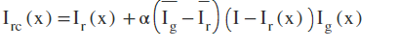
where Ir, Ig corresponds to the red and green shading channels of image I, each divert being in the interim [0, 1], after standardization by the furthest reaches of their dynamic range; while Ir' and Ig' indicate the mean estimation of Ir and Ig. By and by, our tests have uncovered that an estimation of α = 1 is suitable for different light conditions and obtaining settings.

To finish our research about the extreme and shading subordinate lessening of light submerged, it is important the works in [25] and [37]– [39], which uncover and misuse the way that, in turbid waters or in spots with high centralization of microscopic fish, the blue channel might be fundamentally constricted because of retention by natural issue. To address those cases, when blue is firmly weakened and the pay of the red channel has all the earmarks of being deficient, we propose to likewise adjust for the blue channel lessening, for example we process the remunerated blue channel Ibc as:

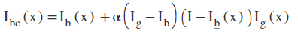

where Ib, Ig speak to the blue and green shading channels of image I, and α is additionally set to one. All outcomes are determined dependent on the sole red remuneration. After the red (and alternatively the blue) channel weakening has been redressed, we resort to the regular Gray-World presumption to appraise and repay the illuminant shading cast.

After the red and the blue channel attenuation have been compensated, we resort to the conventional Gray-World assumption to estimate and compensate the illuminant color cast. Our white-balancing approach reduces the quantization artifacts introduced by domain stretching (the red regions in the different outputs). The reddish appearance of high intensity regions is also well corrected since the red channel is better balanced.

Regardless of white adjusting is essential to recuperate the shading, utilizing this redress step isn't adequate to take care of the dehazing issue since the edges and subtleties of the scene have been influenced by the dispersing. In the following area, we subsequently propose a successful combination based methodology, depending on gamma adjustment and honing to manage the dim idea of the white adjusted image.

Pseudo Code:
1. Obtain image using opencv
2. Perform white balancing on image by converting RGB image to LAB
3. Return the RGB version of the image in the function
4. The white balance function takes in individual channels and performs white balancing on each function
5. Unsharp masking is performed on the initial image using gaussian blur opencv function
6. Gamma correction is performed after unsharp masking
7. The two images are fused together and then displayed in the output
8. After every stage the image is saved using imsave function

Fusion process

Our submerged dehazing system comprises in two principle steps: inputs derivation from the white balanced underwater image and fusion of the inputs and inputs derivation.

Inputs for the Fusion Process

Since the color redress is basic in submerged, we initially apply our white balancing method to the first image. This progression goes for upgrading the image appearance by disposing of undesirable color casts brought about by different lights up. In water further than 35 ft, white adjusting experiences perceptible impacts since the consumed hues are hard to be recuperated. Therefore, to get our first information we play out a gamma revision of the white adjusted image adaptation. Gamma rectification goes for amending the worldwide difference and is applicable since, when all is said in done, white adjusted submerged images will in general show up excessively splendid. This rectification builds the distinction between darker/lighter districts at the expense of lost subtleties in the under-/over-uncovered locales.
To make up for this misfortune, we determine a second info that compares to a honed variant of the white adjusted image. Accordingly, we pursue the unsharp covering standard, as in we mix an obscured or unsharp (here Gaussian sifted) variant of the image with the image to hone. The run of the mill recipe for unsharp concealing characterizes the honed image S as:
S = I + β(I − G ∗ I),
where I is the image to hone (for our situation the white adjusted image), G ∗ I indicates the Gaussian separated form of I, and β is a parameter. By and by, the choice of β isn't insignificant. A little β neglects to hone I, yet a too substantial β results in over-soaked locales, with more splendid features and darker shadows. To bypass this issue, we characterize the honed image S as pursues: To circumvent this problem, we define the sharpened image S as follows:
S = (I + N {I − G ∗ I}) /2,
with N {.} indicating the straight standardization administrator, likewise named histogram extending in the writing. This administrator moves and scales all the shading pixel forces of an image with a novel moving and scaling factor characterized so the arrangement of changed pixel esteems spread the whole accessible unique range.

The sharpening strategy characterized in the above equation, is alluded to as standardized unsharp veiling process in the accompanying. It has the favorable position to not require any parameter tuning, and seems, by all accounts, to be compelling as far as honing. This second information basically helps in decreasing the corruption brought about by dissipating. Since the distinction between white adjusted image and its Gaussian separated rendition is a highpass flag that approximates the inverse of Laplacian, this activity has the awkward to amplify the high frequency clamor, along these lines creating undesired relics in the second information [40].
The fusion strategy described is the addition of white balanced gamma correction and white balanced sharpened version .

Results AND DISCUSSIONS

In this segment, we initially play out a thorough approval of our white-adjusting approach presented in Section IV.

Fig 2: Original Image:
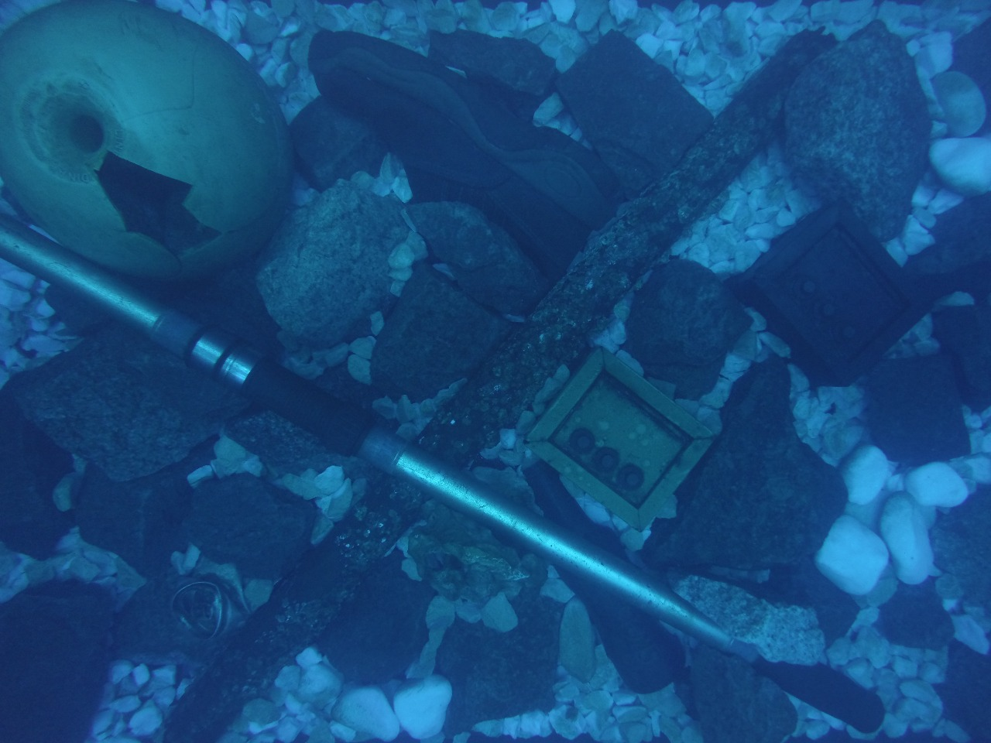

Fig 3: Gamma Correction of White Colour Balance:
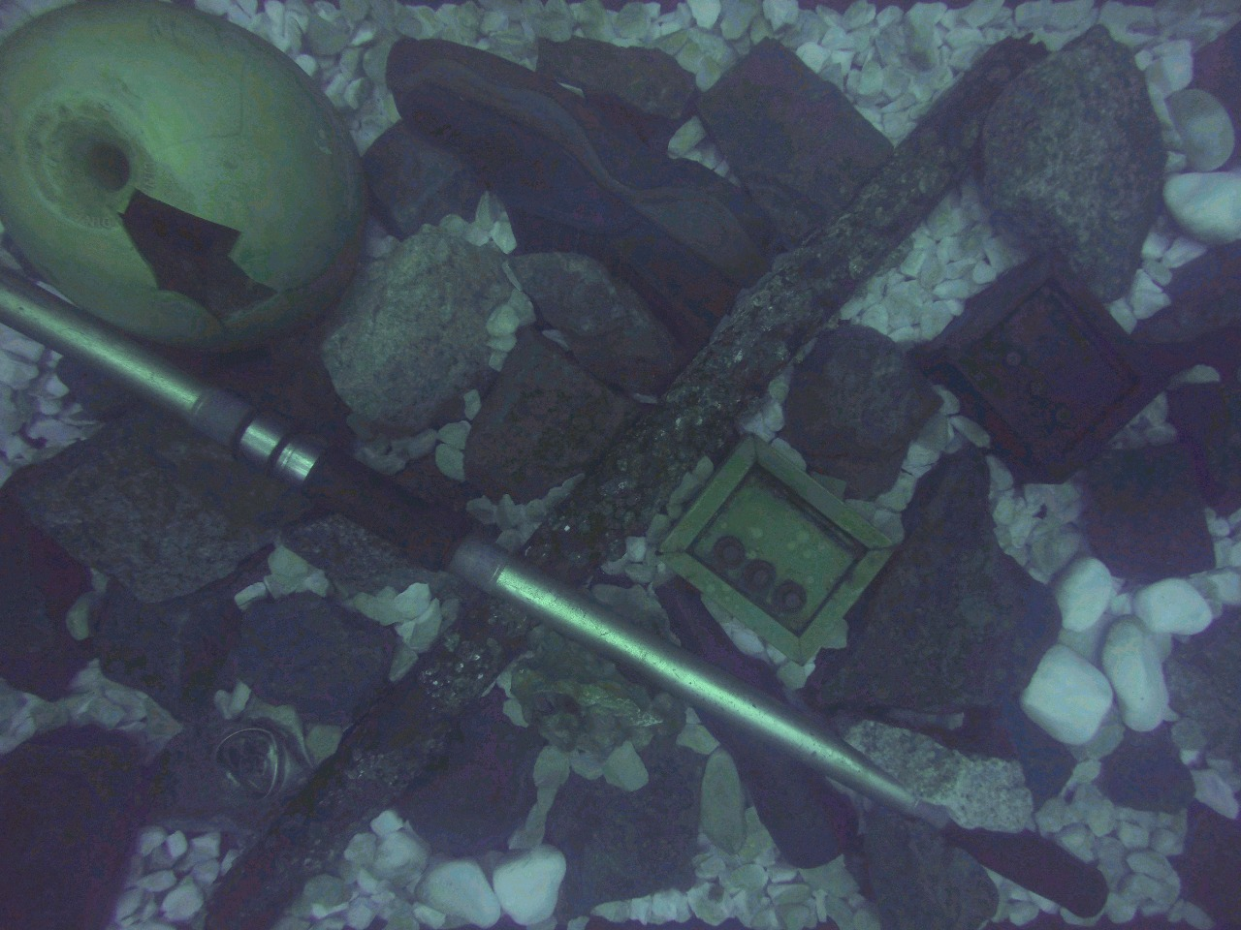

Fig 4: Sharpened Version of White Colour Balance:
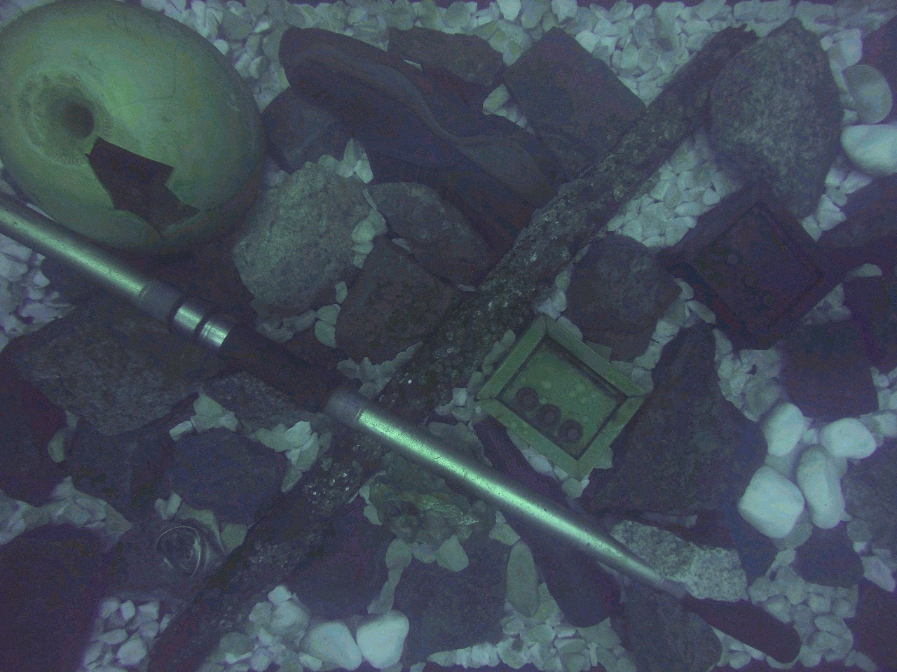

Fig 5: Fusion:
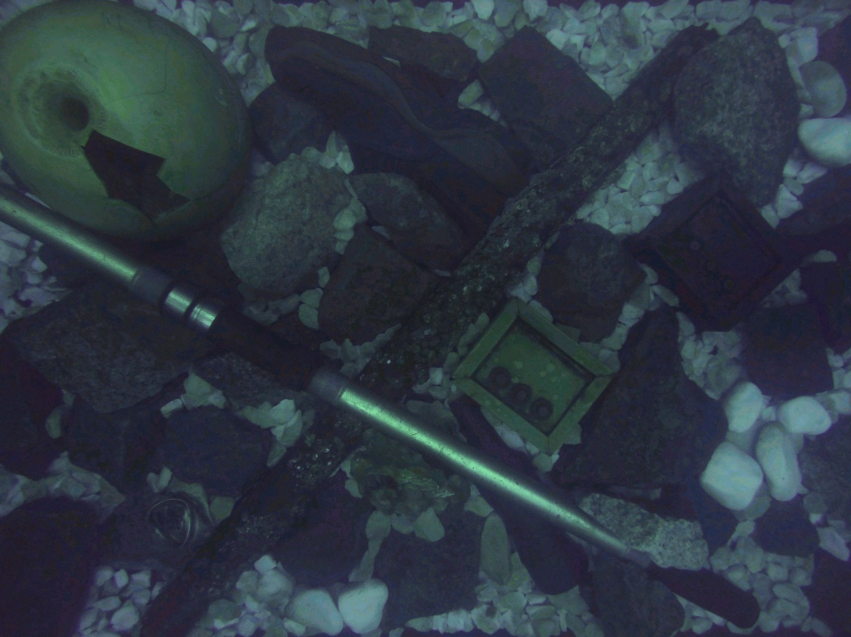

In general, we infer that our methodology by and large outcomes in great perceptual quality, with huge upgrade of the worldwide difference, the shading, and the image structure subtleties. The fundamental constraints are identified with the way that: (i) shading cannot generally be completely reestablished, and (ii) some murkiness is kept up, particularly in the scene locales that are a long way from the camera. Those confinements are anyway restricted, particularly when contrasted with past works. The great execution of our methodology is affirmed by the couple of more precedents exhibited in Fig. 4 and 5. Through this visual appraisal, we likewise see that, regardless of the dim world suspicion may clearly not generally be carefully legitimate, the upgraded images got from our white-adjusted image are always outwardly charming. It is our conviction that the gamma redress associated with the combination (see Fig. 1) helps in moderating the shading cast incited by a wrong dim world speculation. This is for instance outlined in Fig. 3, where input 1-got after gamma adjustment seems more brilliant than second information 2, which compares to a honed variant of the white adjusted image.

Applications
We observed our strategy to be appropriate for PC vision applications, as quickly depicted in the accompanying segment.
Segmentation goes for separating images into disjoint and homogeneous locales as for certain attributes (for example surface, shading). In this work, we utilize the G AC + +segmentation calculation [41], which relates to a fundamental geodesic dynamic shapes technique.
Neighborhood highlight focuses coordinating is a principal undertaking of numerous PC vision applications. We utilize the SIFT [42] administrator to register key points, and think about the key point calculation and coordinating procedures for a couple of submerged images, with the one figured for the comparing pair of images upgraded by our strategy. We utilize the first usage of SIFT connected precisely in the equivalent route in the two cases. The promising accomplishments showed that, by improving the worldwide difference and the neighborhood includes in submerged images, our strategy essentially builds the quantity of coordinated sets of key points.

Conclusion

We have introduced an elective way to deal with upgrade submerged recordings and images. Our technique expands on the combination rule and does not require extra data than the single unique image. We have appeared in our tests that our methodology can upgrade a wide scope of submerged images (for example distinctive cameras, profundities, light conditions) with high precision, having the capacity to recoup essential blurred highlights and edges. In addition, out of the blue, we exhibit the utility and pertinence of the proposed image improvement system for a few testing submerged PC vision applications.

References

- M. D. Kocak, F. R. Dalgleish, M. F. Caimi, and Y. Y. Schechner, 2008 .“A focus on recent developments and trends in underwater imaging,”.Marine Technol. Soc. J. vol. 42, no. 1. pp. 52–67.
- G. L. Foresti. Oct. 2001. “Visual inspection of sea bottom structures by an autonomous underwater vehicle,”. IEEE Trans. Syst.Man, Cybern. B, Cybern.vol. 31. no. 5. pp. 691–705.
- A. Ortiz, M. Simó, and G. Oliver, Jul. 2002. “A vision system for an underwater cable tracker,” Mach. Vis. Appl. vol. 13, pp. 129–140,.S. Bazeille, I. Quidu, L. Jaulin, and J.-P. Malkasse, 2006., “Automatic underwater image pre-processing,” in Proc. Caracterisation du Milieu Marin (CMM), Brest, France.
- A. Olmos and E. Trucco.2002 .,“Detecting man-made objects in unconstrained subsea videos,”. in Proc. BMVC., Sep, pp. 1–10.
- B. A. Levedahl and L. Silverberg. Oct. 2009. “Control of underwater vehicles in full unsteady flow,” IEEE J. Ocean. Eng., vol. 34., no. 4., pp. 656–668.
- C. H. Mazel. Sep. 2006 ,“In situ measurement of reflectance and fluorescence spectra to support hyperspectral remote sensing and marine biology research,” in Proc. IEEE OCEANS., pp. 1–4.
- Y. Kahanov and J. G. Royal. Oct. 2001. “Analysis of hull remains of the Dor D Vessel, Tantura Lagoon, Israel,” Int. J. Nautical Archeol., vol. 30, pp. 257–265,. A. Galdran, D. Pardo, A. Picón,. Jan. 2015, and A. Alvarez-Gila, “Automatic red-channel underwater image restoration,” J. Vis. Commun. Image Represent., vol. 26, pp. 132–145.
- R. Schettini and S. Corchs, Dec. 2010., “Underwater image processing: state of the art of restoration and image enhancement methods.,” EURASIP J. Adv. Signal Process.., vol. 2010, Art. no. 746052.
- S. G. Narasimhan and S. K. Nayar, Jun. 2003 ,“Contrast restoration of weather degraded images,” IEEE Trans. Pattern Anal. Mach. Learn., vol. 25, no. 6., pp. 713–724.
- D.-M. He and G. G. L. Seet, Jan. 2004, “Divergent-beam LiDAR imaging in turbid water,” Opt. Lasers Eng., vol. 41, pp. 217–231,.
- Y. Y. Schechner and Y. Averbuch, Sep. 2007., “Regularized image recovery in scattering media,” IEEE Trans. Pattern Anal. Mach. Intell., vol. 29, no. 9, pp. 1655–1660.
- M. Levoy, B. Chen, V. Vaish, M. Horowitz, I. McDowall, and M. Bolas, Aug. 2004., “Synthetic aperture confocal imaging,” in Proc. ACM SIGGRAPH., pp. 825–834.
- S. K. Nayar and S. G. Narasimhan, Sep. 1999., “Vision in bad weather,” in Proc. IEEE ICCV, pp. 820–827.
- J. Kopf et al., Dec. 2008., “Deep photo: Model-based photograph enhancement and viewing,” ACM Trans. Graph., vol. 27., Art. no. 116.
- R. Fattal., Aug. 2008., “Single image dehazing,” in Proc. ACM SIGGRAPH, Art. no. 72.
- K. He, J. Sun, and X. Tang, Jun. 2009 , “Single image haze removal using dark channel prior,” in Proc. IEEE CVPR, pp. 1956–1963.
- J.-P. Tarel and N. Hautiere, Sep. 2009 , “Fast visibility restoration from a single color or gray level image,” in Proc. IEEE ICCV, , pp. 2201–2208.
- J.-P. Tarel, N. Hautiere, L. Caraffa, A. Cord, H. Halmaoui, and D. Gruyer, Aug. 2012., “Vision enhancement in homogeneous and heterogeneous fog,” IEEE Intell. Transp. Syst. Mag., vol. 4, no. 2., pp. 6–20.
- L. Kratz and K. Nishino, Sep. 2009., “Factorizing scene albedo and depth from a single foggy image.,” in Proc. IEEE ICCV, pp. 1701–1708.
- C. O. Ancuti and C. Ancuti, Aug. 2013 ,“Single image dehazing by multi-scale fusion,” IEEE Trans. Image Process., vol. 22, no. 8, pp. 3271–3282.
- H. Koschmieder, 1924 .,“Theorie der horizontalen sichtweite,” Beitrage Phys. Freien Atmos., vol. 12, pp. 171–181.
- H. Horvath, Mar. 1971 ,“On the applicability of the koschmieder visibility formula,” Atmos. Environ., vol. 5, no. 3, pp. 177–184.
- C. Ancuti, C. O. Ancuti, C. De Vleeschouwer, and A. Bovik, Sep. 2016, “Night-time dehazing by fusion,” in Proc. IEEE ICIP, pp. 2256–2260.
- A. Galdran, D. Pardo, A. Picón, and A. Alvarez-Gila, Jan. 2015, “Automatic red-channel underwater image restoration,” J. Vis. Commun. Image Represent., vol. 26, pp. 132–145.
- H. Lu, Y. Li, L. Zhang, and S. Serikawa, May 2015., “Contrast enhancement for images in turbid water,” J. Opt. Soc. Amer. A, Opt. Image Sci., vol. 32, no. 5, pp. 886–893.
- R. Fattal, “Dehazing using color-lines, Nov. 2014., ” ACM Trans. Graph., vol. 34., Art. no. 13.
- H. Lu, Y. Li, S. Nakashima, H. Kim, and S. Serikawa, 2017., “Underwater image super-resolution by descattering and fusion,” IEEE Access, vol. 5, pp. 670–679.
- J.-B. Huang, A. Singh, and N. Ahuja, Jun. 2015, “Single image super-resolution from transformed self-exemplars,” in Proc. IEEE CVPR, pp. 5197–5206.
- C. Ancuti, C. O. Ancuti, T. Haber, and P. Bekaert, Jun. 2012., “Enhancing underwater images and videos by fusion,” in Proc. IEEE CVPR, pp. 81–88.
- S. Bazeille, I. Quidu, L. Jaulin, and J.-P. Malkasse, 2006., “Automatic underwater image pre-processing,” in Proc. Caracterisation du Milieu Marin (CMM), Brest, France.
- A. Arnold-Bos, J.-P. Malkasset, and G. Kervern. Jun. 2005.“Towards a model-free denoising of underwater optical images,” in Proc. IEEE Eur. Oceans Conf., pp. 527–532.
- F. Petit, A.-S. Capelle-Laizé, and P. Carre.Apr. 2009. “Underwater image enhancement by attenuation inversion with quaternions,” in Proc. IEEE ICASSP. pp. 1177–1180.
- M. Chambah, D. Semani, A. Renouf, P. Courtellemont, and A. Rizzi.Dec. 2003.“Underwater color constancy: Enhancement of automatic live fish recognition,” Proc. SPIE. vol. 5293.pp. 157–169.
- M. Ebner, Color Constancy.2007.1st ed. Hoboken, NJ, USA: Wiley.
- G. Buchsbaum.Jul. 1980. “A spatial processor model for object colour perception,” J. Franklin Inst., vol. 310. no. 1. pp. 1–26.
- P. Drews, Jr., E. Nascimento, F. Moraes, S. Botelho, M. Campos, and R. Grande-Brazil.Dec. 2013.“Transmission estimation in underwater single images,” .in Proc. IEEE ICCV. pp. 825–830.
- H. Lu et al.Jul. 2016.“Underwater image enhancement method using weighted guided trigonometric filtering and artificial light correction,”. J. Vis. Commun. Image Representvol. 38.pp. 504–516.
- F. Bonin, A. Burguera, and G. Oliver.2011.“Imaging systems for advanced underwater vehicles,” J. Maritime Res vol. 8, no.1 . pp. 65–86.
- S. Serikawa and H. Lu.2014. “Underwater image dehazing using joint trilateral filter,” Comput. Elect. Eng., vol. 40.no. 1, pp. 41–50.
- G. C. Rafael and W. E. Richard, Digital Image Processing.2008.Englewood Cliffs, NJ, USA: Prentice-Hall.
- G. Papandreou and P. Maragos . Jan. 2007. “Multigrid geometric active contour models,” IEEE Trans. Image Process., vol. 16, no. 1, pp. 229–240.
- D. G. Lowe.Nov. 2004. “Distinctive image features from scale-invariant keypoints,” Int. J. Comput. Vis., vol. 60, no. 2, pp. 91–110.

