**Frequency based Traffic Control System using IOT**

J COMPONENT PROJECT REPORT

submitted by

**SHALAKA MAHURKAR (16BCE2211)**

**ARORA ISHA HEMANT (16BCE2003)**

**KESHAV MOORTHY (16BCI0066)  
S. DHANYA ABHIRAMI (16BCE0965)**

**B. Tech**

in

**Computer Science and Engineering**



Vellore-632014, Tamil Nadu, India

**School of Computer Science and Engineering**

APRIL, 2018

**I. Abstract**

The emerging technologies and advancement of life due to these technologies is a boon for humans. The basic for humans has become having a car and car accidents and jam being the most faced problems. Due to these advancement, ideas have been implemented and cars made smarter by adding various types of sensors on them. This also gives a chance for some technology to be implemented on how to control these accidents or traffic too. There have been many methods tries to be implemented using wired and wireless networks and classifications based on machine learning, port-based and payload-based algorithms. But Machine Learning offers a better choice. So, in our paper we suggest a way to avoid these traffic jams by using machine learning and Arduino board which would be controlling the traffic lights.

**II. Introduction**

Internet of Things are Internet - connected devices. It is a combination of sensors and actuators, both along with the physical objects connected to the Internet, all operating on both wired and wireless communications.[36] Today the urban construction has a new mainstream – the Smart City. The Smart City can be considered as a technology intensive network and uses advanced technology to link urban factors like population, information and vehicles. The data provided by these Smart City networks are Big Data streams.[39] Internet of Things is to be the among the greatest sources of data, data sciences will make a great contribution to make the applications working on IoT more intelligent.[36]

Machine Intelligence also known as Machine Learning is based on algorithms which are investigated to handle the processing of high-volume data. While the network collecting the data transmits information to the cloud, these algorithms make decisions and predictions based on the data collected consequently eliminating data redundancy and also reducing the amount of information to be processed. The algorithms in context operate in real time. [45]

Machine Learning can be used for profiling by using any of the three methods which include context-based, collaborative and a combination of both the methods. [46]

The emergence of the Internet of things provides a new technology platform for the realization of intelligent transportation. [18] This also helps us reduce the traffic jams and the avoidable accidents that may occur if the system is manually controlled. Timely and accurate traffic classification and application characterization become increasingly important with many of its applications in wired and wireless networks. Compared to traditional classification methods such as port-based and payload-based algorithms, machine learning (ML) approaches offer a better choice in Internet traffic characterization by using payload independent traffic statistics. [31] In this paper we are going to make a setup using the Arduino board where through machine language, we take the input of the path and returns the best time at which the vehicles can move and wait in signals.

**III. Literature Review/ Related Work**

An ample amount of research has been done in related areas of this field.

There are two methods involved in predicting traffic flow, these being Parametric and No-Parametric approaches. Non Parametric approach is the most famous and currently used in research. A multi resolution Finite Impulse Responses Neural network algorithm (FIRNN) is designed by Alarcon-Aquino and Barria (2006) through discrete wavelet transform. This framework analyses the discrete wavelet signals and transforms them into scaling and wavelet coefficients. Real world traffic data was applied to this model and it was found to have a higher accuracy considering only the FIRNN approach.

Suguna Devi [43] proposed a Machine Learning based congestion prediction algorithm that used Logistic Regression. This gives a simple, accurate and early prediction of the traffic congestion for a given static road network.

Manoharan [44] proposed a model that involves deep learning approach for Leeds traffic flow prediction. It was concluded that this model has a higher traffic flow prediction as compared to other models which perform shallow traffic predictions. This method performs multilayer procedures for processing the data and brings out greater results by deeply analysing the traffic pattern.

**IV. Survey Table**

Machine Learning Applications in Traffic Sector

|  |  |  |
| --- | --- | --- |
| **Algorithm** | **Application** | **Description** |
| Linear Classifier | Smart Grid | Linear Classifiers can be used to characterize data received from smart grid sensors based on a linear combination of its characteristics. |
| Quadratic Classifier | Smart Parking | A broader implementation of linear classifier, quadratic classifiers can be used in smart parking by using a quadratic surface to assist in the separation of multiple object classes obtained from soft sensors. |
| Decision Tree | Smart lighting | Decision trees use a tree-like model of possible decisions and their resulting consequences to determine the best course of action, such as turning lights on or off or dimming lights during certain time frames. |
| Neural Network | Smart Sensors | CNN is used in a hybrid approach for combining deep and shallow features in machine learning. |
| Extended Kalman Filter and Evolutionary Machine Learning | Smart City | A robust low cost approach for real time car positioning in a smart city. |

**V. Procedure and Algorithm (Proposed Method)**

* This goal is accomplished through the creation of a genetic algorithm, which enhances an input algorithm through genetic principles to produce the fittest algorithm.
* The program was comprised of two major elements: coding in Java and coding in Simulation of Urban Mobility (SUMO), which is an environment that simulates real traffic.
* The Java code called upon the SUMO simulation via a command prompt which ran the simulation, received the output, altered the algorithm, and looped.

* The data collected is analysed with the traditional scheduling methods.

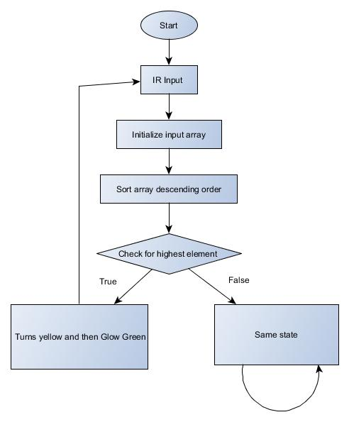

**VI. Implementation and Results**

* We have generated a simulation using SUMO – Simulation of Urban Mobility
* We have used of the OSM Web Wizard, which is part of the SUMO package.
* With the OSM Web Wizard we setup a of scenario VIT Campus by selecting the desired area on OpenStreetMap in a web browser.
* OSM Web Wizard also provides some options to define the traffic demand (e.g. modes of transport). We chose the movement of cars only in this simulations.
* From this selection, the OSM Web Wizard generates a complete SUMO simulation scenario, which will be run and displayed in the graphical user interface.
* We have further implemented the simulation in Arduino Uno using LED signals which represent traffic signals.
* Algorithms run in the background to detect the optimal time of waiting for all cars present in the lane.
* As the number of cars in a lane increases the time of waiting for the other lanes increases.

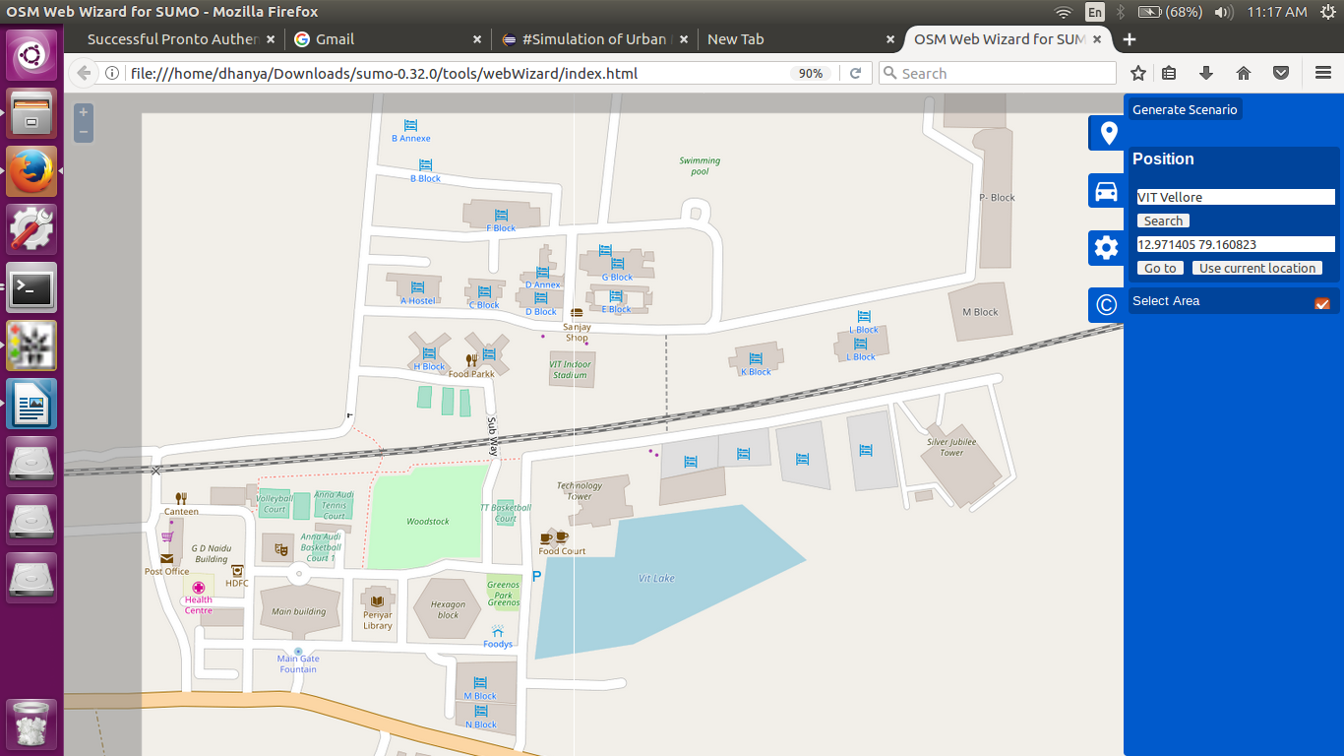

Figure 1: Map

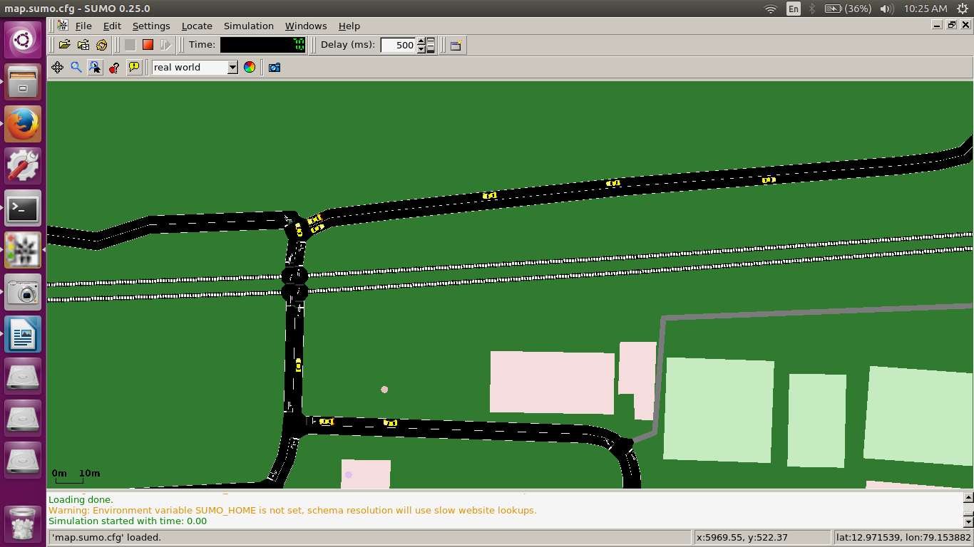

Figure 2: Car Movement

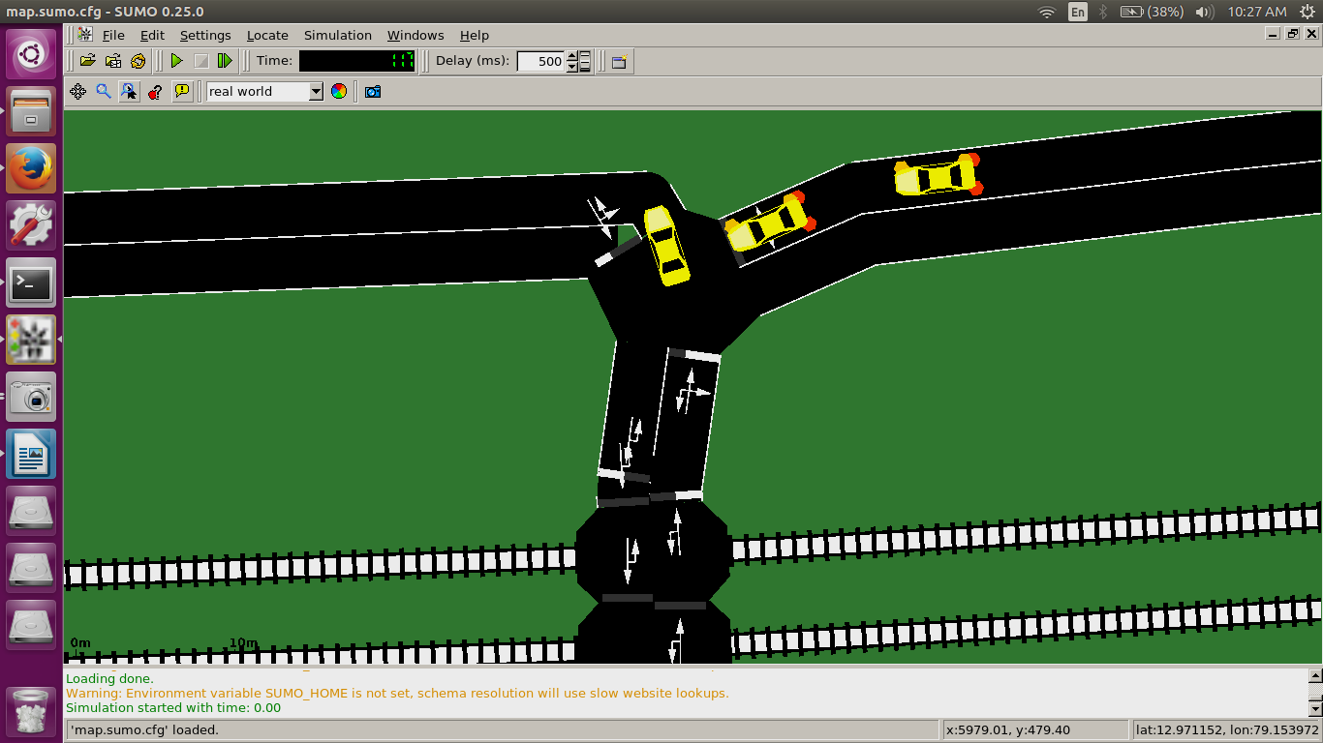

Figure 3: Closeup

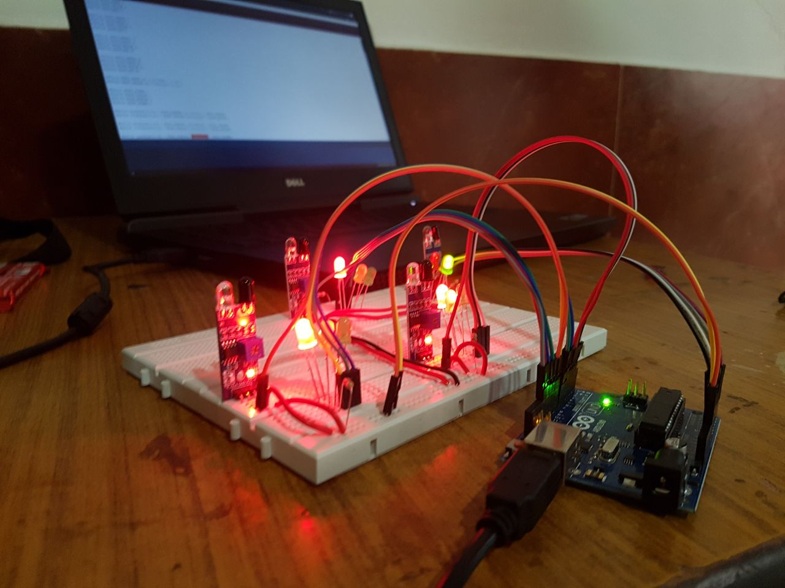

Figure 4: IoT Setup

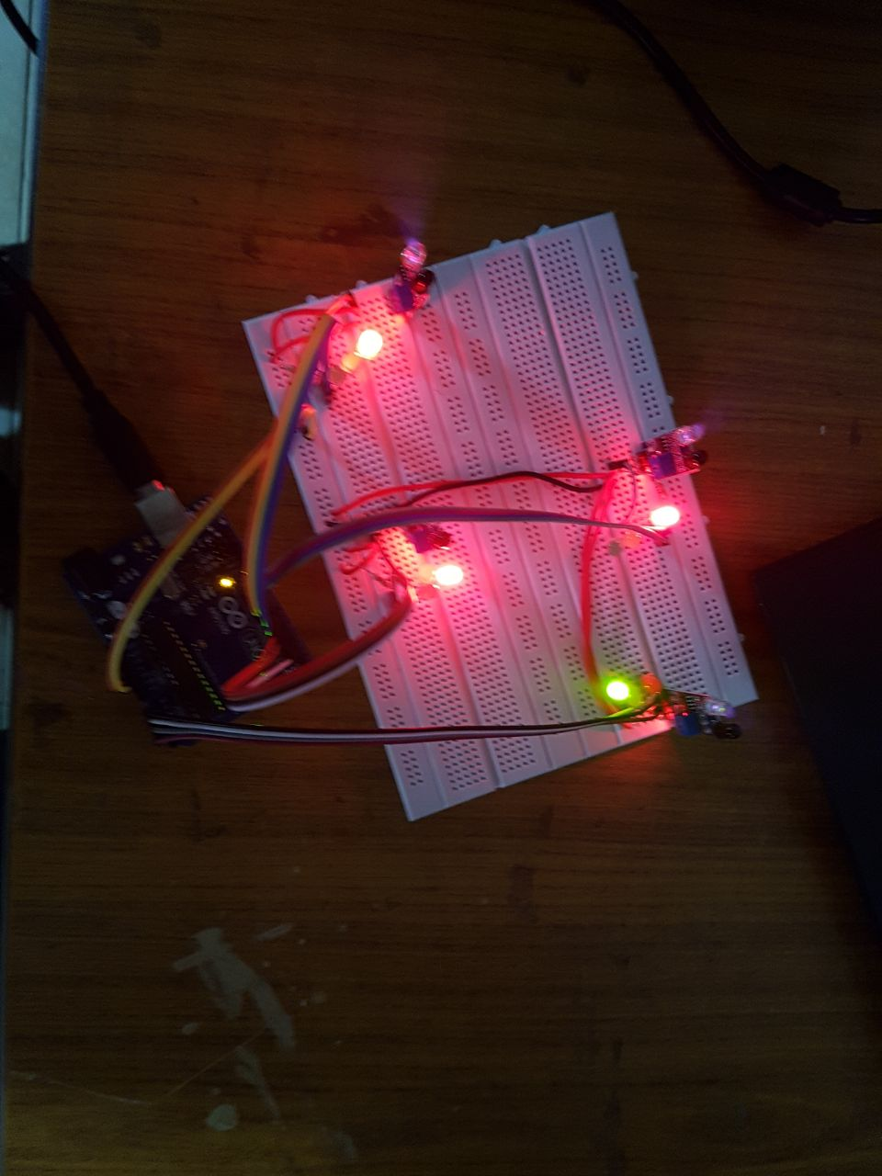

Figure 5: Circuit

* We have simulated a road transport system which replicated real world vehicle movement scenario.
* The car paths are randomly generated but it is ensured that the cars do not collide with each other or with any buildings/pedestrians.
* A genetic algorithm is capable of improving itself in comparison to the ideal timing based traffic controls like traffic lights.
* The simulation is implemented in Arduino Uno using 12 LED signals which represent the traffic signals.
* Generate random array with number of vehicles in every lane
* Random array size = 4 as the sample size in problem is 4
* As time goes by value in array keeps increasing as cars come and decrease as cars go by.
* Hence when signal = green in a given lane,

Number of cars decreases.

* Number of incoming cars constantly increases.
* Weight of cars and time already waited by vehicles in lane is calculated
* With more cars waiting in a lane and with more time already waited, a sub optimal lane is chosen for letting cars go.
* Hence number of cars, time in lane taken in measure.
* Mean of the parameters is taken
* The output is generated.

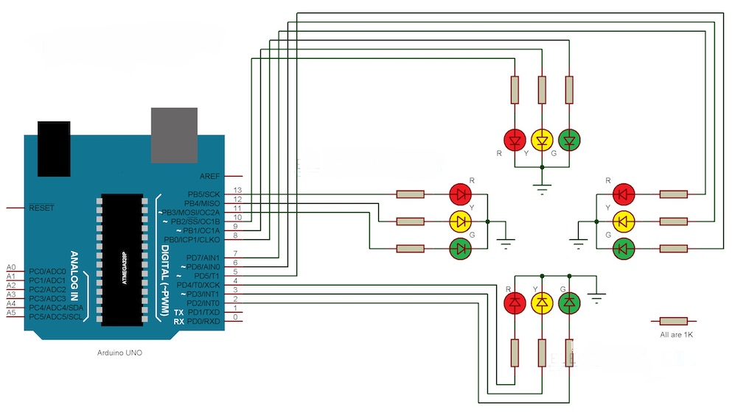

**Output Table**

|  |  |  |  |  |  |  |
| --- | --- | --- | --- | --- | --- | --- |
| **S.No.** | **Cars in Lane1** | **Cars in Lane2** | **Cars in Lane3** | **Cars in Lane4** | **Waiting time for least cars** | **Waiting time for most cars** |
| 1 | **4** | **5** | **6** | **7** | **15(1)** | **0(4)** |
| 2 | **5** | **6** | **7** | **8** | **20(1)** | **5(4)** |
| **3** | **8** | **7** | **6** | **5** | **15(4)** | **5(1)** |
| **4** | **7** | **6** | **5** | **4** | **20(4)** | **5(1)** |

**Output table explanation:**

* In the first case as the number of cars is more in 4 and least in 1, lane 1 waits for other three lanes hence 15 seconds.
* In the second case since lane 1 is last executed, lane 4 waits 5 seconds before getting signal,
* In the third case the most cars switches to lane 1 and least to lane 4.
* Hence lane 2 gets signal initially as lane 1 already had green and has to wait 5 seconds for the switch

**VII. Conclusion**

A simulation of a system for flow of traffic was executed along with a thorough implementation using IOT. The whole system relies on the weight of traffic along every signal and hence determines the time of wait for every junction.

**VIII. References**

[1] T. Nakatsuji, S. Seki, S. Shibuyam, and T. Kaku, “Artificial Intelligence Approach for Optimizing Traffic Signal Timings on Urban Road Network,” *Veh. Navig. Inf. Syst. Conf. Proc.*, vol. 00, pp. 1–4, 1994.

[2] I. Comm and C. Science, “The Optimization of Traffic Signal Light using Artificial Intelligence,” pp. 1279–1282, 2001.

[3] M.-F. Balcan, A. Blum, J. D. Hartline, and Y. Mansour, “Mechanism design via machine learning,” *46th Annu. IEEE Symp. Found. Comput. Sci.*, pp. 605–614, 2005.

[4] C. Yuan, G. Medioni, J. Kang, and I. Cohen, “Detecting motion regions in the presence of a strong parallax from a moving camera by multiview geometric constraints,” *IEEE Trans. Pattern Anal. Mach. Intell.*, vol. 29, no. 9, pp. 1627–1641, 2007.

[5] J. Wang and Q. Tao, “Machine learning: the state of the art,” *Intell. Syst. IEEE*, no. November/December, pp. 49–55, 2008.

[6] E. Sahin and B. Mutlu, “Traffic planning application made by using artificial intelligence (TPAUAI),” *Signal Process. …*, pp. 322–325, 2012.

[7] M. Buzdalov, A. Buzdalova, and A. Shalyto, “A first step towards the runtime analysis of evolutionary algorithm adjusted with reinforcement learning,” *Proc. - 2013 12th Int. Conf. Mach. Learn. Appl. ICMLA 2013*, vol. 1, pp. 203–208, 2013.

[8] G.-X. Liu\ and F. Liu2, “lOT-BASED TPL WHOLE SUPPLY CHAIN LOGISTICS INFORMATION SYST EM MODEL,” *Proc. 2013 Int. Conf. Mach. Learn. Cybern. Tianjin*, pp. 14–17, 2013.

[9] H. Zou, H. Jiang, X. Lu, and L. Xie, “An online sequential extreme learning machine approach to WiFi based indoor positioning,” *2014 IEEE World Forum Internet Things*, pp. 111–116, 2014.

[10] A. K. Ramakrishnan, D. Preuveneers, and Y. Berbers, “Enabling self-learning in dynamic and open Iot environments,” *Procedia Comput. Sci.*, vol. 32, pp. 207–214, 2014.

[11] J. Melià-Seguí and R. Pous, “Human-object interaction reasoning using RFID-enabled smart shelf,” *2014 Int. Conf. Internet Things, IOT 2014*, pp. 37–42, 2014.

[12] M. M. Cummings, “Man versus machine or man + machine?,” *IEEE Intell. Syst.*, vol. 29, no. 5, pp. 62–69, 2014.

[13] R. Saatchi and A. Dogman, “Multimedia traffic quality of service management using statistical and artificial intelligence techniques,” *IET Circuits, Devices Syst.*, vol. 8, no. 5, pp. 367–377, 2014.

[14] V. Hahanov, “Smart traffic light in terms of the Cognitive road traffic management system ( CTMS ) based on the Internet of Things Volodymyr Miz PhD student at Kharkov National University of Radio,” *Proc. IEEE East-West Des. Test Symp. (EWDTS 2014)*, pp. 1–5, 2014.

[15] J. Arauz, “The moving IoT,” *Proc. - 2014 Int. Conf. Futur. Internet Things Cloud, FiCloud 2014*, pp. 264–271, 2014.

[16] F. Ganz, D. Puschmann, P. Barnaghi, and F. Carrez, “A Practical Evaluation of Information Processing and Abstraction Techniques for the Internet of Things,” *IEEE Internet Things J.*, vol. 2, no. 4, pp. 340–354, 2015.

[17] S. Ageev, Y. Kopchak, I. Kotenko, and I. Saenko, “Abnormal traffic detection in networks of the Internet of things based on fuzzy logical inference,” *Proc. Int. Conf. Soft Comput. Meas. SCM 2015*, pp. 5–8, 2015.

[18] G. Fu and Z. Yang, “The Intelligent Traffic Control based on the Internet of Things,” no. Bmei, pp. 614–618, 2015.

[19] R. Sharma, N. Kumar, N. B. Gowda, and T. Srinivas, “Waiting time analysis for delay sensitive traffic in internet of things,” *Proc. - 2015 IEEE Reg. 10 Symp. TENSYMP 2015*, pp. 58–61, 2015.

[20] M. Taneja, “A framework for traffic management in IoT networks,” *Proc. 2016 2nd Int. Conf. Contemp. Comput. Informatics, IC3I 2016*, pp. 316–323, 2016.

[21] X. Luo, J. Liu, D. Zhang, and X. Chang, “A large-scale web QoS prediction scheme for the Industrial Internet of Things based on a kernel machine learning algorithm,” *Comput. Networks*, vol. 101, pp. 81–89, 2016.

[22] L. Valerio, “Accuracy vs . traffic trade-off of Learning IoT Data Patterns at the Edge with Hypothesis Transfer Learning,” 2016.

[23] a. Rakotonirainy, O. Orfila, and D. Gruyer, “Reducing driver’s behavioural uncertainties using an interdisciplinary approach: Convergence of Quantified Self, Automated Vehicles, Internet Of Things and Artificial Intelligence.,” *IFAC-PapersOnLine*, vol. 49, no. 32, pp. 78–82, 2016.

[24] J. Siryani, B. Tanju, and T. J. Eveleigh, “A Machine Learning Decision-Support System Improves the Internet of Things’ Smart Meter Operations,” *IEEE Internet Things J.*, vol. 4, no. 4, pp. 1056–1066, 2017.

[25] D. Chemodanov, F. Esposito, A. Sukhov, P. Calyam, H. Trinh, and Z. Oraibi, “AGRA: AI-augmented geographic routing approach for IoT-based incident-supporting applications,” *Futur. Gener. Comput. Syst.*, 2017.

[26] M. Z. Talukder, S. S. Towqir, A. R. Remon, and H. U. Zaman, “An IoT Based Automated Traffic Control System With Real-Time Update Capability,” pp. 1–6, 2017.

[27] A. Celesti, A. Galletta, L. Carnevale, M. Fazio, A. Lay-Ekuakille, and M. Villari, “An IoT Cloud System for Traffic Monitoring and Vehicular Accidents Prevention Based on Mobile Sensor Data Processing,” *IEEE Sens. J.*, vol. 1748, no. c, 2017.

[28] A. A. Diro and N. Chilamkurti, “Distributed attack detection scheme using deep learning approach for Internet of Things,” *Futur. Gener. Comput. Syst.*, 2017.

[29] H. Rahman and R. Rahmani, “Enabling distributed intelligence assisted Future Internet of Things Controller (FITC),” *Appl. Comput. Informatics*, vol. 14, no. 1, pp. 73–87, 2017.

[30] F. Al-Turjman, “Information-centric framework for the Internet of Things (IoT): Traffic modelling &amp; optimization,” *Futur. Gener. Comput. Syst.*, vol. 80, pp. 63–75, 2017.

[31] Z. Fan and R. Liu, “Investigation of machine learning based network traffic classification,” *2017 Int. Symp. Wirel. Commun. Syst.*, pp. 1–6, 2017.

[32] T. Banerjee and a Sheth, “IoT Quality Control for Data and Application Needs,” *IEEE Intell. Syst.*, vol. 32, no. 2, pp. 68–73, 2017.

[33] S. Gangadhar and J. P. G. Sterbenz, “Machine Learning Aided Traffic Tolerance to Improve Resilience for Software Defined Networks,” pp. 9–11, 2017.

[34] N. Wang, T. Jiang, S. Lv, and L. Xiao, “Physical-Layer Authentication Based on Extreme Learning Machine,” *IEEE Commun. Lett.*, vol. 21, no. 7, pp. 1557–1560, 2017.

[35] P. M. Kumar and U. Devi Gandhi, “A novel three-tier Internet of Things architecture with machine learning algorithm for early detection of heart diseases,” *Comput. Electr. Eng.*, vol. 0, pp. 1–14, 2017.

[36] M. S. Mahdavinejad, M. Rezvan, M. Barekatain, P. Adibi, P. Barnaghi, and A. P. Sheth, “Machine learning for Internet of Things data analysis: A survey,” *Digit. Commun. Networks*, 2017. For survey ,,, introduction part

[37] P. Lin, D. C. Lyu, F. Chen, S. S. Wang, and Y. Tsao, “Multi-style learning with denoising autoencoders for acoustic modeling in the internet of things (IoT),” *Comput. Speech Lang.*, vol. 46, pp. 481–495, 2017.

[38] N. Nesa, T. Ghosh, and I. Banerjee, “Non-parametric sequence-based learning approach for outlier detection in IoT,” *Futur. Gener. Comput. Syst.*, no. June 2009, pp. 1–10, 2017.

[39] J. Yang, Y. Han, Y. Wang, B. Jiang, Z. Lv, and H. Song, “Optimization of real-time traffic network assignment based on IoT data using DBN and clustering model in smart city,” *Futur. Gener. Comput. Syst.*, 2017.

[40] S. Tedeschi, J. Mehnen, N. Tapoglou, and R. Roy, “Secure IoT Devices for the Maintenance of Machine Tools,” *Procedia CIRP*, vol. 59, no. TESConf 2016, pp. 150–155, 2017.

[41] J. Holler, V. Tsiatsis, and C. Mulligan, “Toward a Machine Intelligence Layer for Diverse Industrial IoT Use Cases,” *IEEE Intell. Syst.*, vol. 32, no. 4, pp. 64–71, 2017.

[42] D. Serrano, T. Baldassarre, and E. Stroulia, “based on Open Data and Open-Source Software,” no. d, pp. 661–665.

[43] Suguna Devi, T Neetha “Machine Learning based traffic congestion prediction in a IoT based smart-city,” *International Research Journal of Engineering and Technology,* 2017 pp: 2395-56

[44] Sivabalaji Manoharan “Short Term Traffic Flow Prediction Using Deep Learning Approach”, *MSc Research Project in Data Analytics,* 2016

[45] H. Habibzadeh, A. Boggio-dandry, Z. Qin, T. Soyata, B. Kantarci, and H. T. Mouftah, “Soft Sensing in Smart Cities : Handling 3Vs Using Recommender Systems , Machine Intelligence , and Data Analytics,” no. February, pp. 78–86, 2018.

[46] J. Chin, V. Callaghan, and I. Lam, “Understanding and personalising smart city services using machine learning, the Internet-of-Things and Big Data,” in IEEE International Symposium on Industrial Electronics, 2017.