IBM Cognos Dashboard Creation – End-to-End Steps
1. Access Cognos Portal
- Open your browser
- Enter your Cognos URL (example: https://<server>/ibmcognos/bi)
- Log in using your credentials
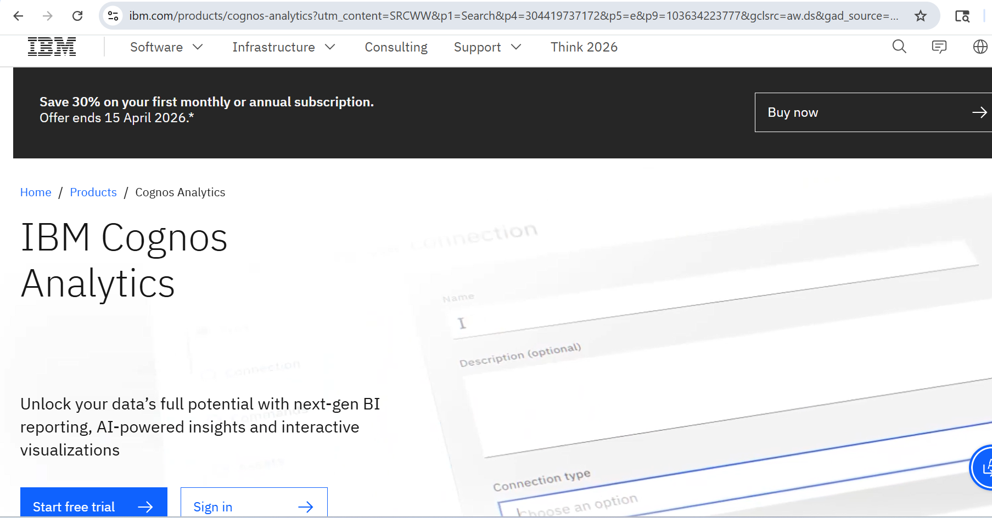

2. Enter the credentials. The system first prompts for the user ID, and after clicking Continue, it then prompts for the password.

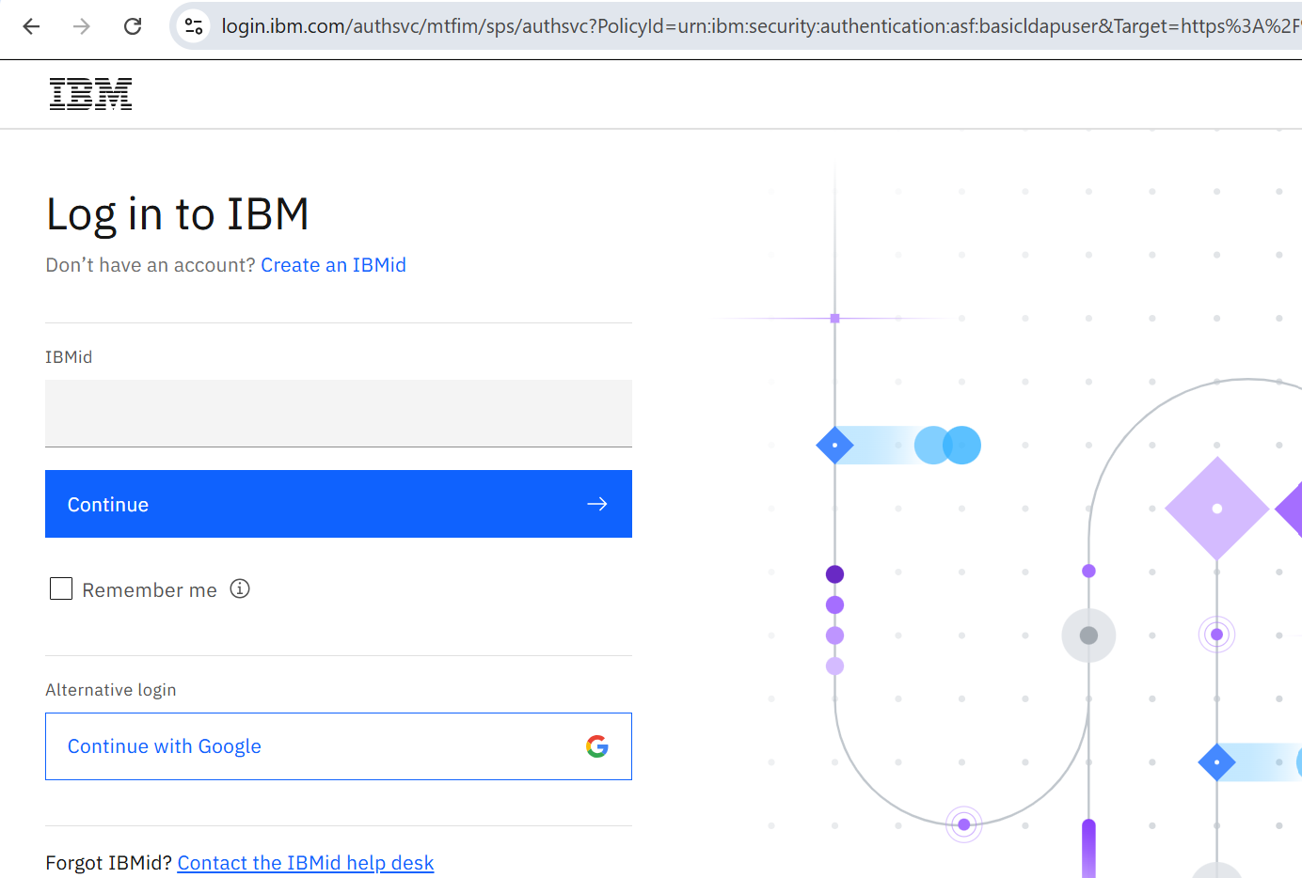

- Click Launch
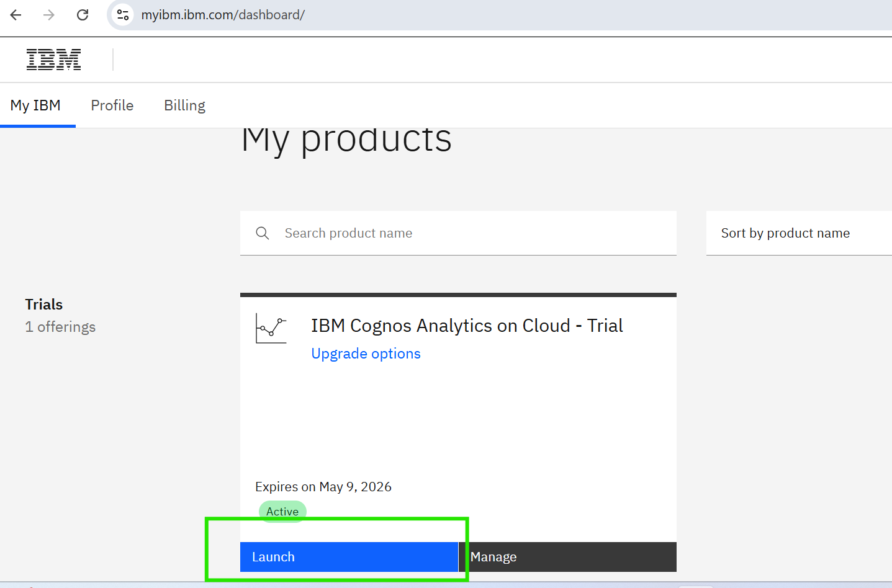

4. Navigate to Content
- Click on ☰ (Menu icon) – in top left corner
- Select > Data Server
  - Team Content (shared dashboards) OR
  - My Content (personal workspace)
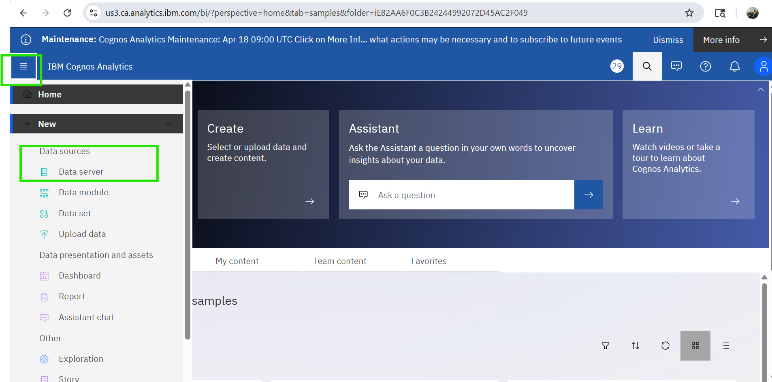

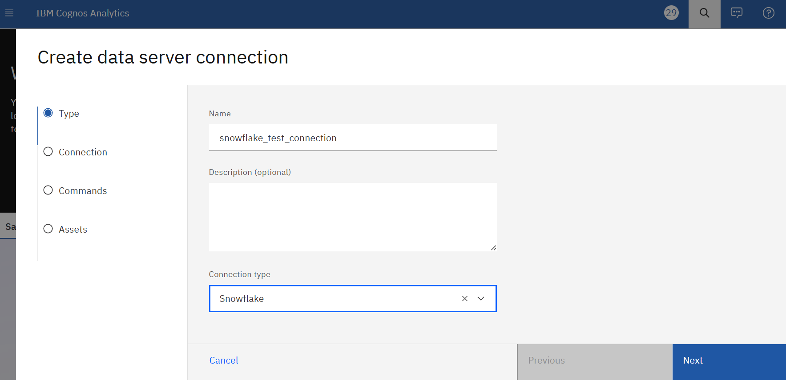

Snowflake JDBC Credentials : snowflake jdbc : jdbc:snowflake://ooc47367.us-east-1.snowflakecomputing.com
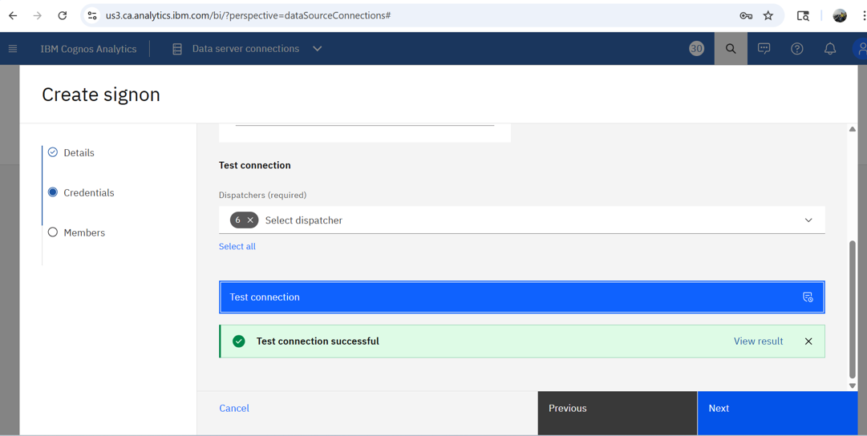

5. Provide valid Snowflake user credentials (username and password) to authenticate and establish the data server connection in IBM Cognos Analytics and click Done.
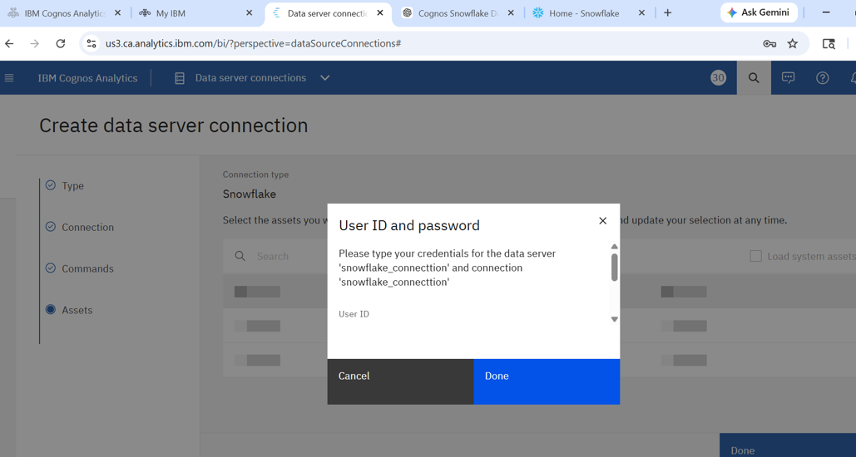

6. Navigate to the Data Module interface to view imported tables/views, validate structure, preview data, and configure relationships for reporting and dashboard creation

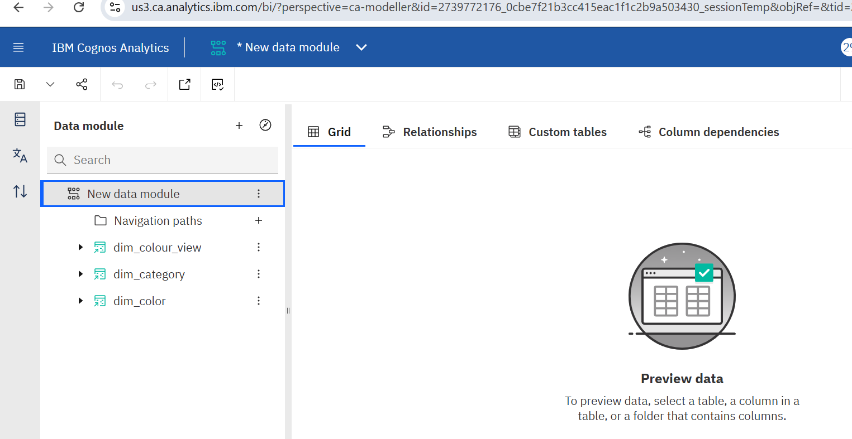

7. Click on the triple dot option in the Data Module and select ‘Calculation’ to create a new calculated column or expression based on existing data
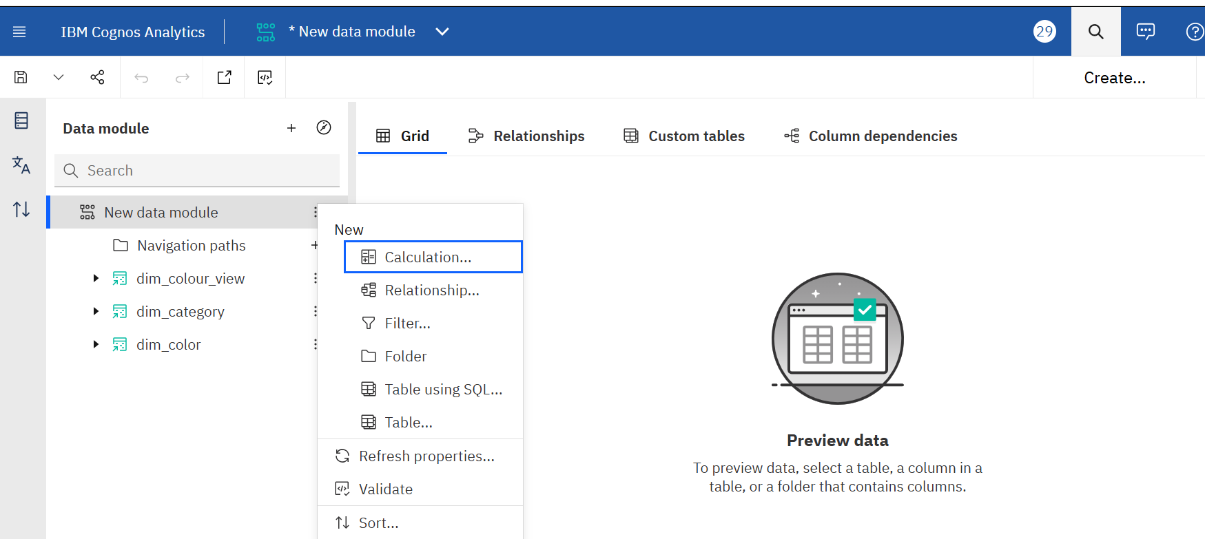

8. Open the Dashboard in edit mode to visualize and analyze data using charts such as bar and pie visualizations created from the data module

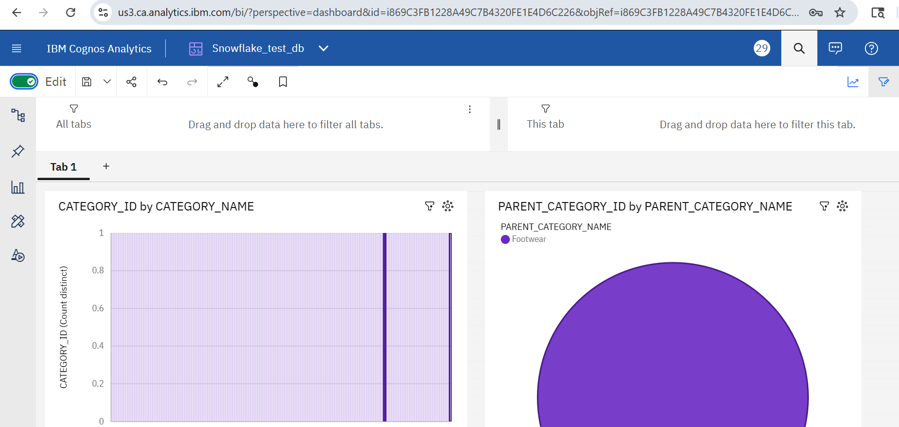

9. Click on the Share icon and navigate to the Export tab, then select the desired format (PDF) and click Export to download the dashboard
