# Alumni Registration Portal

This project is a web-based Alumni Registration Portal developed to facilitate the management and registration of alumni. It provides functionalities for user login, searching alumni, and managing contact, education, and experience details.

Project Link: https://github.com/keshavagarwal670/Testing-project

## Features

• Login System: Allows users to log in securely.

• Search Alumni: Search functionality to find alumni using various filters.

• Forms: Dynamic forms for entering and managing:

* - Contact Information
* - Educational Background
* - Professional Experience

## Technology Stack

• Frontend: React.js

• Backend: Spring Boot

• Database: MySQL

## Testing

• Unit Testing: Unit test cases were designed and implemented for each component.

• Mutation Testing: Integrated Stryker to perform mutation testing and assess the robustness of the code.

- Mutation Score: See the screenshot below for the mutation testing score using Stryker.

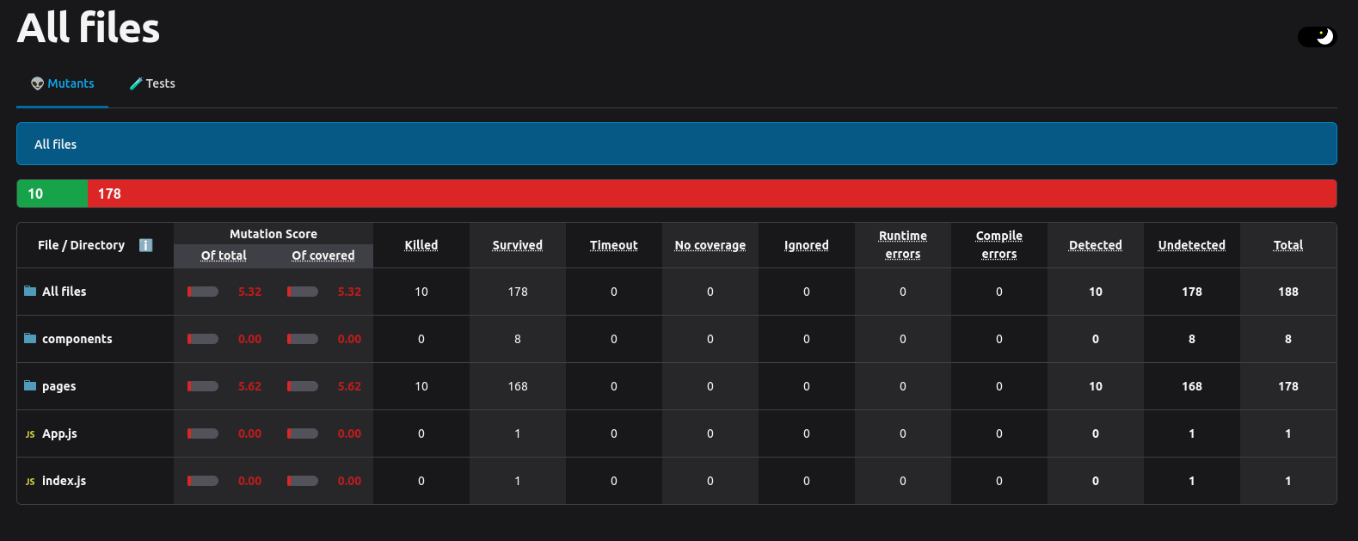

## Roles and Contributions

1. Keshav Agarwal (Roll Number: MT2023114)

- Developed the backend and frontend for:

* - Login Page
* - Search Page

2. Pratyasa Ray (Roll Number: MT2023014)

- Developed the backend and frontend for:

* - Forms for Contact, Education, and Experience.

## How to Run the Project

1. Clone the repository:

* ```bash
* git clone https://github.com/your-repo-link.git
* cd alumni-registration-portal
* ```

2. Backend Setup:

* - Ensure you have Java and Maven installed.
* - Navigate to the backend folder:
* ```bash
* cd backend
* mvn clean install
* mvn spring-boot:run
* ```

3. Frontend Setup:

* - Ensure you have Node.js and npm installed.
* - Navigate to the frontend folder:
* ```bash
* cd frontend
* npm install
* npm start
* ```

4. Database Setup:

* - Create a MySQL database named `alumni_portal`.
* - Import the provided SQL schema from `db/schema.sql`.

5. Access the portal:

* - Frontend: http://localhost:3000
* - Backend API: http://localhost:8080

## License

This project is licensed under the MIT License. See the LICENSE file for details.

## Acknowledgments

• IIIT Bangalore: For academic support and resources.

• Stryker: For the mutation testing framework.