**Max-Pooling**

**Uses of max-pooling**

* Reducing the computational load
* Reducing the overfitting
* Reducing the noise

**Learnable parameter-**

**i/p*o/p+biases of a layer**

**for ANN-**

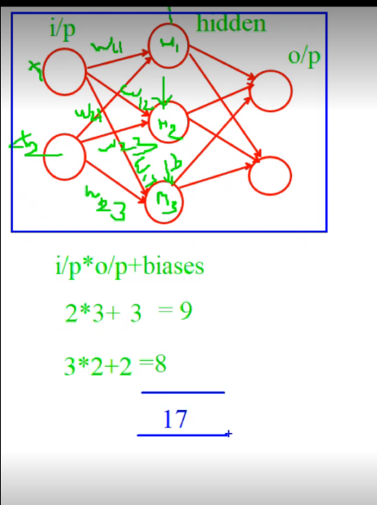

**For CNN-**

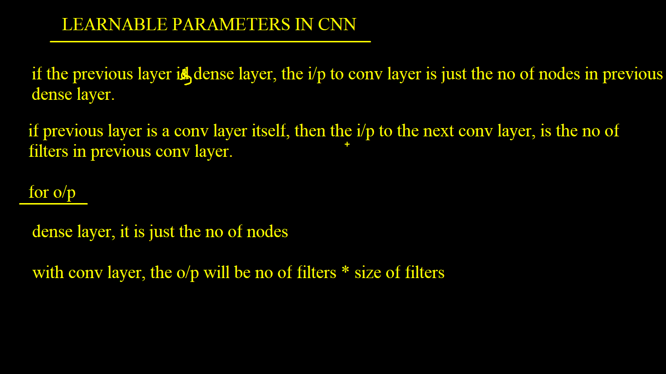

**Calculation for LP-**

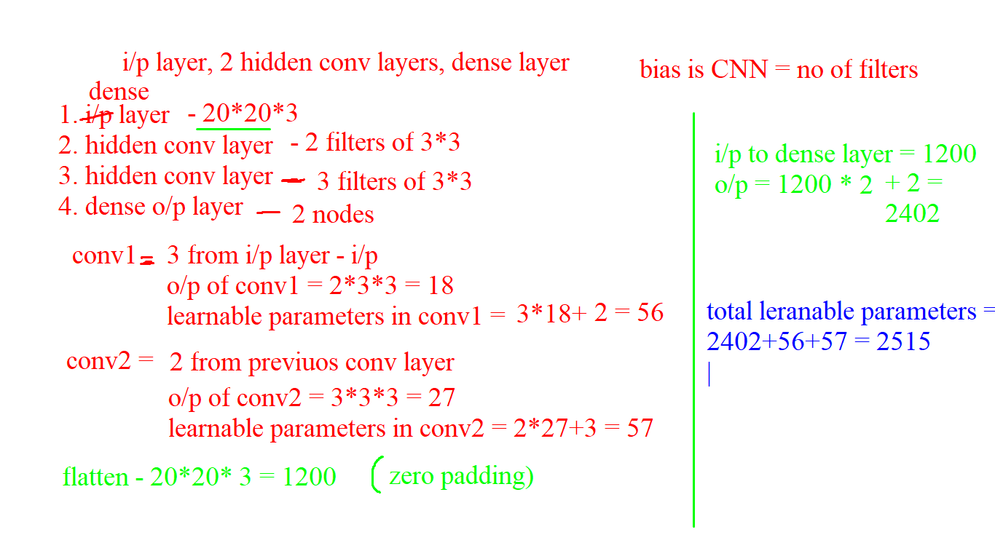

**Optimizers**

**Wn= Wo- (learning rate * Gradient)**

Here**,**

**Wn** is New Weight

**Wo** is old weight

**Gradient** use backpropagation

**Types of Dataset-**

Training data

Validation data

Testing data

Defining validation data-

1)

Vaild_set=[(sample,label),(sample,label)……(sample,label)]

Validation_data=valid_Set

2)

Validation_Split=0.1 #takes 10% of training data

**Reducing Overfitting**

#adding more data to the training set

#data augmentation (like zooming image, cropping, flipping etc ) by adding more images by augmenting the training data.

#By reducing complexity of the model (by reducing layers and node etc)

#dropout (its randomly ignore some subset of nodes)

**Reducing Underfitting**

#increase the complexity of the model

#add more features to the input samples

#reduce dropout

Convolutional neural network explain video