
Team:
- Bhavya Mittal (102303643)
- Keshav Bansal (102303647)
- Keshee Jain (102303650)

Automated Attendance System

Problem Statement:
Manual attendance systems are prone to errors, inefficiency, and fraudulent practices such as proxy attendance. Traditional methods, including paper-based registers and manual inputs in digital systems, consume time and effort. There is a need for an automated attendance system that ensures accuracy, efficiency, and security in attendance management, minimizing human intervention and potential errors.

Background:
Attendance tracking is a crucial aspect of various institutions, including schools, universities, and corporate organizations. Traditional attendance methods, such as roll calls and manual registers, are inefficient and susceptible to manipulation. With advancements in Artificial Intelligence (AI) and machine learning, automated attendance systems have gained attention. Face recognition, biometric authentication, and RFID-based tracking have emerged as reliable solutions. AI-driven attendance systems leverage computer vision and deep learning techniques to identify and verify individuals efficiently, providing a seamless, non-intrusive, and accurate method for tracking attendance.

Methodology:
The development of an AI-based automated attendance system involves the following steps:
- Data Collection
  - Capture facial images of individuals.
  - Pre-process images to enhance quality (resizing, normalization, and augmentation).
  - Store images with unique identifiers for recognition purposes.
- Model Selection and Training
  - Use deep learning techniques such as Convolutional Neural Networks (CNNs) for facial recognition.
  - Train the model using datasets containing diverse facial images to improve accuracy.
  - Implement a face detection model (e.g., OpenCV, MTCNN, or Dlib) to detect faces in real-time.
- System Development
  - Integrate the trained AI model with a real-time camera feed.
  - Implement facial recognition algorithms to match captured faces with the stored database.
  - Develop a web-based or mobile application for attendance management and real-time monitoring.
- Database Management
  - Store and manage attendance records in a secure database.
  - Use cloud-based storage for scalability and remote access.
- Implementation and Testing
  - Deploy the system in a controlled environment for validation.
  - Test accuracy, efficiency, and performance under various conditions (lighting, angles, occlusions).
  - Optimize the model and system for real-time operation.
- Integration with Existing Systems
  - Connect with Learning Management Systems (LMS) or HR management tools for automated record-keeping.
  - Implement notifications and reports for stakeholders.
- Security and Ethical Considerations
  - Ensure data privacy and compliance with regulations such as GDPR.
  - Implement encryption and authentication mechanisms to prevent unauthorized access.
  - Address ethical concerns regarding biometric data collection and usage.
By implementing an AI-driven automated attendance system, organizations can streamline attendance tracking, reduce administrative workload, and enhance accuracy and security in attendance management.

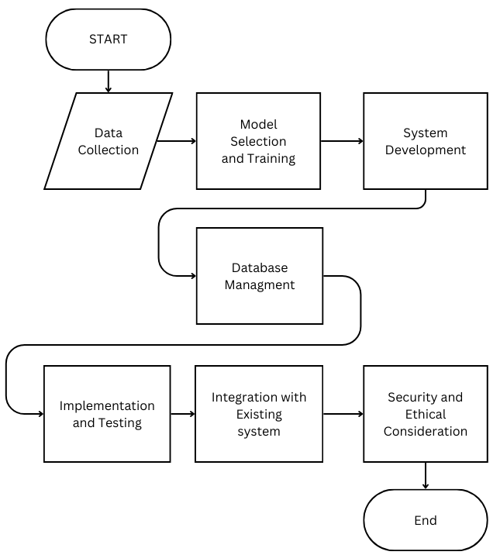

---------------------------------- ❖ ❖END ❖ ❖---------------------------------

