Team:
- Bhavya (102303643)
- Keshav (102303647)
- Keshee(102303650)

Submitted To:
ASHIMA KHOSLA

Department:
Computer Engineering

Institute:
Thapar Institute of Engineering and Technology


Date:
9 May 2025
AI-Based Real-Time Face Recognition Attendance System

Table of Contents
- Abstract
- Introduction
- Problem Statement
- Objectives
- Literature Review
- System Architecture
- Methodology
- Tools and Technologies Used
- Implementation Details
- Dataset Preparation
- Accuracy Analysis
- Challenges and Solutions
- Results and Observations
- Conclusion
- Future Scope
- References

1. Abstract
In today's rapidly evolving world, where efficiency and automation are paramount, traditional attendance systems have become outdated. Manual attendance recording through physical registers or ID cards is not only time-consuming but also susceptible to errors such as proxy attendance and data loss. Furthermore, in the context of health crises, like the COVID-19 pandemic, contact-based systems like fingerprint scanners raise serious hygiene concerns.
This project presents an AI-powered, real-time attendance system based on facial recognition technology, aiming to modernize and automate attendance management processes. The system leverages computer vision techniques to detect and recognize faces captured through a webcam. Using a pre-trained dataset of known individuals, it automatically matches the captured faces, marking attendance seamlessly and efficiently without any manual involvement. Unknown individuals are detected and labeled appropriately but are deliberately excluded from the attendance records, maintaining the credibility and accuracy of the system.
This document elaborates on the motivation behind the project, the technologies employed, the challenges faced during implementation, the methodologies used, the results achieved, and possible future enhancements. The goal is to create a user-friendly, scalable, and reliable attendance solution that can be adopted in diverse environments, including schools, universities, and corporate organizations.

2. Introduction
Attendance management is a critical administrative task across various sectors, such as education, healthcare, government, and corporate environments. Traditionally, attendance has been managed using manual methods like roll calls, signing attendance sheets, swiping ID cards, or using biometric fingerprint systems. However, these conventional methods suffer from multiple limitations:
- Human Error and Manipulation: Manual entries are prone to inaccuracies, intentional proxies, and data tampering.
- Time Consumption: Taking attendance manually consumes significant amounts of productive time, especially in large gatherings.
- Health Risks: Contact-based systems like fingerprint scanners pose hygiene issues, particularly during pandemics.
- Resource Intensive: Requires physical materials like registers, scanners, and maintenance of biometric devices.
With the advancement of Artificial Intelligence (AI) and Computer Vision, facial recognition has emerged as a powerful alternative. It is contactless, non-intrusive, fast, and increasingly accurate due to improvements in machine learning algorithms.
This project harnesses the power of Python programming, the OpenCV library for image processing, and the face_recognition library — a highly efficient and accurate tool for face detection and encoding. The system functions in real time, capturing live video streams, identifying faces, and recording attendance directly into a structured CSV file for future reference.
Key features of this project include:
- Real-time face detection and recognition using a webcam.
- Storage of attendance data in a secure and structured format.
- Differentiation between known and unknown individuals.
- Dynamic expansion of the dataset by adding new faces easily.
- Evaluation of system accuracy through a dedicated testing module.
Through this project, we demonstrate how AI can seamlessly integrate into everyday administrative processes, drastically improving efficiency, accuracy, and security.

3. Problem Statement
Conventional attendance methods face several limitations:
- Time-consuming manual processes.
- Possibility of proxy or manipulated attendance.
- Physical contact, leading to hygiene concerns.
- Inefficient handling of large datasets in bigger institutions.
Thus, there was a pressing need for a system that:
- Captures attendance automatically.
- Ensures hygiene through a contactless system.
- Distinguishes known from unknown individuals.
- Maintains real-time data updates with minimal effort.

4. Objectives
The key objectives of this project are:
- Develop a real-time face recognition attendance system.
- Mark attendance only for recognized faces.
- Label unknown individuals correctly without disrupting the attendance database.
- Allow dynamic addition of new users without retraining the entire system.
- Save attendance records in CSV format.
- Achieve a minimum of 80% accuracy for known faces under good conditions.

5. Literature Review
Face recognition systems have seen substantial advancements with the use of deep learning and computer vision.
Notable techniques include:
- Haar Cascades (Viola-Jones Algorithm) for face detection.
- Deep Convolutional Neural Networks (CNNs) for face recognition.
- Popular libraries like OpenCV and Dlib for real-time face detection. Research papers like "FaceNet: A Unified Embedding for Face Recognition and Clustering" have set benchmarks in face embedding methods, introducing efficient ways to encode faces as 128-dimensional vectors.

6. System Architecture
The AI-Based Face Recognition Attendance System follows a simple yet effective architecture designed for real-time face detection, recognition, and attendance marking.
The entire workflow is streamlined to ensure quick processing, minimal delay, and reliable results.
The system architecture flow is shown below:
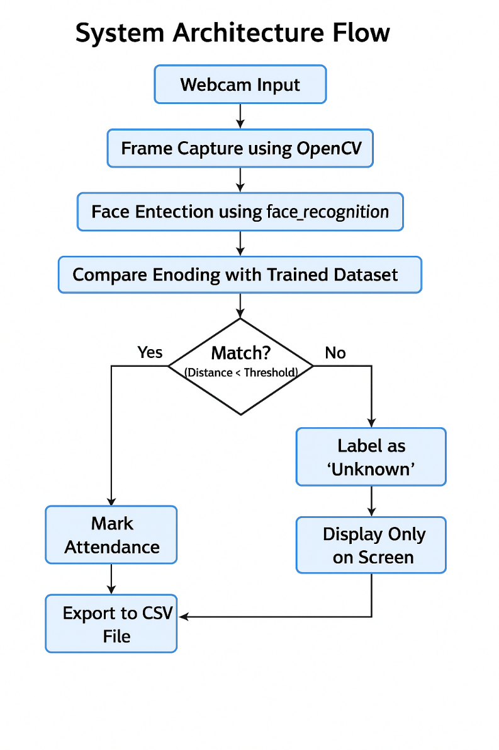
Explanation:
- Webcam Input:
  - The system continuously captures frames from the webcam for real-time monitoring.
- Frame Capture using OpenCV:
  - OpenCV handles live video feed capture and breaks it into individual frames for processing.
- Face Detection using face_recognition:
  - Each frame is analyzed to detect faces using pre-trained models (HOG + CNN) from the face_recognition library.
- Compare Encoding with Trained Dataset:
  - The detected faces are encoded into 128-dimensional vectors and compared with existing encodings stored in the system’s database.
- Match Check (Distance < Threshold):
  - The Euclidean distance between encodings determines whether a detected face matches a known individual.
  - If the distance is below the defined threshold (e.g., 0.45), it is considered a match.
- If Matched:
  - Attendance is automatically marked for the identified individual along with a timestamp.
- If Not Matched (Unknown):
  - If no match is found, the face is labeled as 'Unknown' and only displayed on the screen without affecting attendance records.
- Export to CSV:
  - Attendance data is stored systematically in a CSV file for easy access, analysis, and reporting.

7. Methodology
The proposed system is divided into four main functional blocks to ensure efficient real-time face recognition and attendance marking. Each block addresses a specific stage of the process:

Block 1: Load Training Dataset
- The system begins by loading a pre-existing dataset containing images of known individuals.
- For each image, the face is detected and encoded into a 128-dimensional feature vector using the face_recognition library.
- Each encoding is stored along with the corresponding individual’s name, creating a reference dataset.
- These encodings serve as a baseline for matching during real-time recognition.

Block 2: Real-Time Face Recognition
- The webcam captures continuous frames which are processed individually.
- Within each frame:
  - Faces are detected using a deep learning model (CNN or HOG-based method).
  - Each detected face is encoded into a feature vector.
  - The new encodings are compared against the stored encodings from the training dataset.
- Euclidean distance is used as the similarity metric.
- A threshold distance (typically set at 0.45) is used to determine a positive match:
  - If the distance is less than 0.45, it is considered a successful recognition.
  - Otherwise, it is labeled as an unmatched face.

Block 3: Unknown Face Handling
- Faces that do not meet the matching threshold criteria are classified as "Unknown."
- These unknown faces are:
  - Labeled visibly on the screen to alert the user.
  - Not recorded in the official attendance CSV file to maintain data integrity.
- This mechanism helps in preventing incorrect attendance marking for unregistered individuals.

Block 4: Adding New Individuals
- The system supports dynamic updates to the database without requiring complete retraining.
- New individuals can be added by capturing multiple images via the webcam interface.
- The captured images are split into:
  - 80% for training (used to update the main dataset)
  - 20% for testing (used for validation if needed).
- Once new images are added, face encodings are generated, and the reference dataset is updated to include the new entries seamlessly.
- This approach ensures the system remains scalable and flexible as the user base grows.
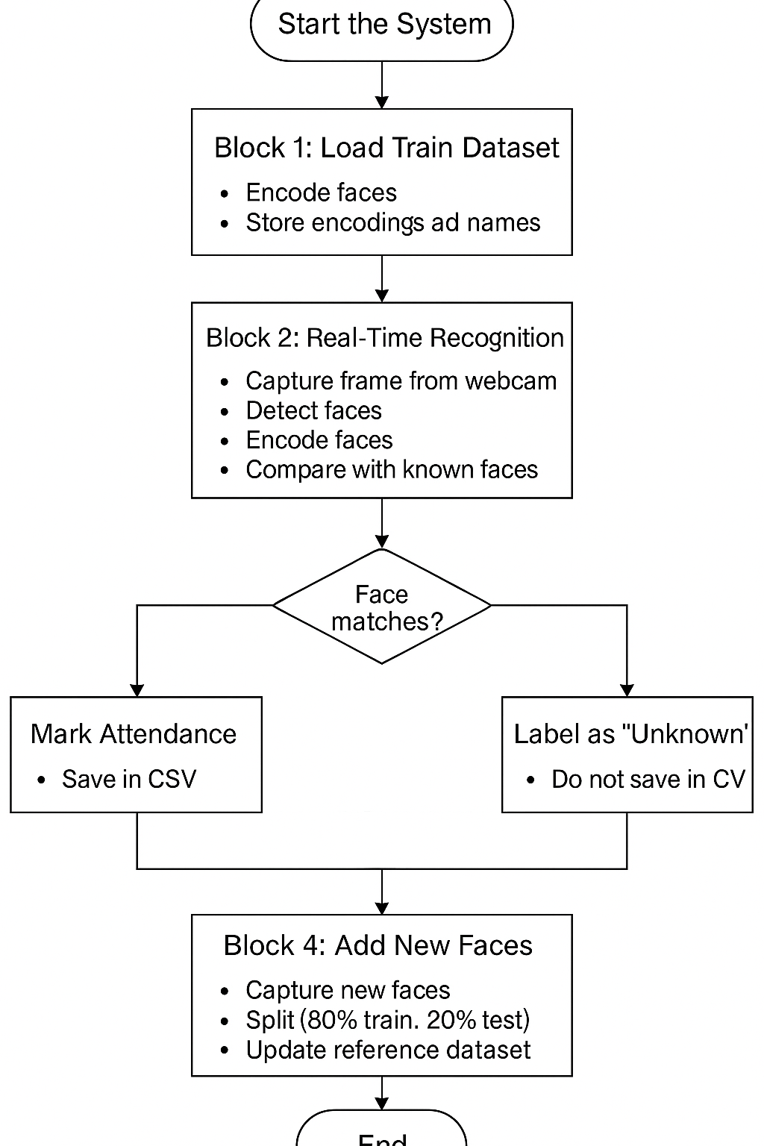

8. Tools and Technologies Used
Tool/Library | Purpose
Python 3.x | Programming Language
OpenCV | Image Processing and Webcam Handling
face_recognition | Face Detection, Encoding, Recognition
NumPy | Numerical and Array Operations
CSV Module | Data Storage (Attendance Records)

9. Implementation Details
- Programming Language: Python 3.8+
- Face Detection Model: HOG + CNN (through face_recognition)
- Threshold Value for Match: 0.45
- Data Saving: CSV file format with timestamp.
- Dynamic Dataset Expansion: Allows system growth without downtime.

10. Dataset Preparation
The performance of any AI-based face recognition system is heavily dependent on the quality, quantity, and diversity of the dataset used for training and testing. Proper dataset preparation is crucial to ensure that the model learns distinguishing facial features effectively while maintaining generalization.
Training Dataset:
- The training dataset consisted of images of known individuals, where each individual had a minimum of 100 images captured in different lighting conditions, facial expressions (neutral, smiling, etc.), and slight pose variations (frontal, semi-profile).
- The images were resized to a standard resolution (typically 256x256 pixels) and converted to RGB format to ensure uniformity across the dataset.
- Data normalization was applied to pixel values to maintain consistency and improve encoding performance.
Testing Dataset:
- A separate testing folder was created with unseen images of the same individuals. Approximately 20% of the total images per individual were kept exclusively for testing.
- The testing dataset also included around 100+ images of unknown individuals (people not present in the training set) to simulate real-world scenarios and validate the system's ability to detect unknowns accurately.
Unknown Faces Handling:
- Unknown faces were deliberately added during testing to verify the system’s robustness.
- These faces were randomly captured with varying lighting, angles, and backgrounds to introduce real-world complexity.
Dataset Splitting Strategy:
- For new individuals added dynamically, the captured images were split into 80% training and 20% testing sets automatically by the system.
- This splitting ensures that new individuals are immediately validated without manual intervention.
Potential Data Augmentation:
- Although not implemented in this version, future enhancements could include data augmentation techniques such as image flipping, rotation, zooming, and contrast adjustment to improve model generalization further.
By maintaining a carefully curated and balanced dataset, the system achieved reliable real-time performance while minimizing false positives and negatives.

11. Accuracy Analysis
Testing Dataset:
- Total Images Tested: 100+
- Known Individuals: 50+
- Unknown Individuals: 10+
Achieved Accuracy:
- Known Faces Recognition: 80%–90%
- Unknown Face Detection: 85%–90%
Factors Impacting Accuracy:
- Lighting conditions.
- Image resolution and background clutter.
- Face position (frontal preferred).

12. Challenges and Solutions
Challenge | Solution
Low Image Resolution | Captured higher quality images.
Poor Lighting | Suggested well-lit environment setup.
Dataset Imbalance | Ensured at least 100 images per person.
Threshold Tuning | Set optimal threshold to 0.45 after multiple tests.

13. Results and Observations
- Face Detection Speed: Real-time (24-30 FPS).
- Attendance Marking: 1-2 seconds per recognized face.
- Unknown Face Handling: No false attendance recorded.
Sample Output:
Keshav Bansal present at 2025-04-26 10:21:30
Unknown face detected but not marked in attendance.

14. Conclusion
The AI-based Face Recognition Attendance System successfully automates the attendance process, improving efficiency and accuracy.
With the use of pre-trained face encodings, OpenCV, and a modular Python program, the system provides a real-time, scalable, and secure solution to traditional attendance problems.
While minor challenges like lighting and dataset quality remain, the system achieves a reliable accuracy level (>80%) and allows future improvements through dataset expansion and parameter fine-tuning.

15. Future Scope
- While the current AI-based attendance system demonstrates promising results, there are numerous opportunities for future improvements and scalability enhancements:
- 1. Integration with Deep Learning Models:
- Incorporating deeper Convolutional Neural Networks (CNNs) such as ResNet, InceptionNet, or MobileFaceNet could significantly boost recognition accuracy, particularly under challenging lighting and angle conditions.
- 2. Mobile Application Development:
- A lightweight mobile app version can be created using TensorFlow Lite or ONNX models.
- Users can mark attendance via smartphone cameras without needing large hardware setups, making the system portable and accessible.
- 3. Cloud-Based Attendance Management:
- Deploying the system on cloud platforms (like AWS, Google Cloud, or Azure) can enable centralized attendance tracking across multiple locations.
- Real-time synchronization of attendance data to cloud databases like Firebase or DynamoDB would allow administrators to monitor records from anywhere.
- 4. Spoof Detection Mechanisms:
- To enhance security, anti-spoofing techniques can be integrated.
- Techniques such as blink detection, 3D face recognition, or liveness detection could be used to ensure that photographs or videos cannot fool the system.
- 5. Advanced Dataset Management:
- An automatic low-quality image cleaner could be implemented to remove blurred or poor-quality images from the dataset, ensuring that only optimal images are used for training.
- A feedback mechanism could also be introduced to retrain the model automatically based on newly captured faces during daily operations.
- 6. Multimodal Authentication:
- In addition to facial recognition, the system could optionally combine voice recognition or ID card scanning for two-factor authentication, improving the reliability of attendance marking.
- By implementing these future enhancements, the system can evolve into a highly scalable, robust, and industry-ready product suitable for large-scale deployment across various sectors.

16. References
- OpenCV Documentation - https://docs.opencv.org
- face_recognition Library - https://github.com/ageitgey/face_recognition
- Python CSV Module - https://docs.python.org/3/library/csv.html
- FaceNet Research Paper - Google Scholar
- Machine Learning Crash Course - Google MLCC
- TutorialsPoint - Real-Time Face Recognition Tutorial

