Task 1
Room 1
What is Networking?
- What I did?
Objective: To learn networking
Started the YouTube video on what is networking?
Learnt about networking.
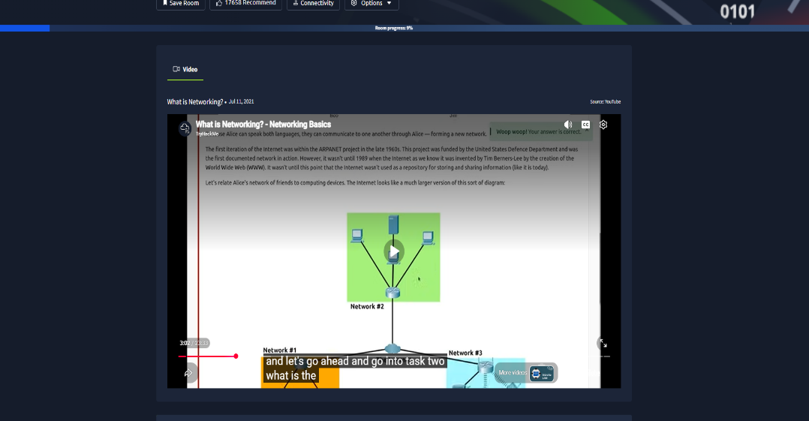
Started and understood what is internet
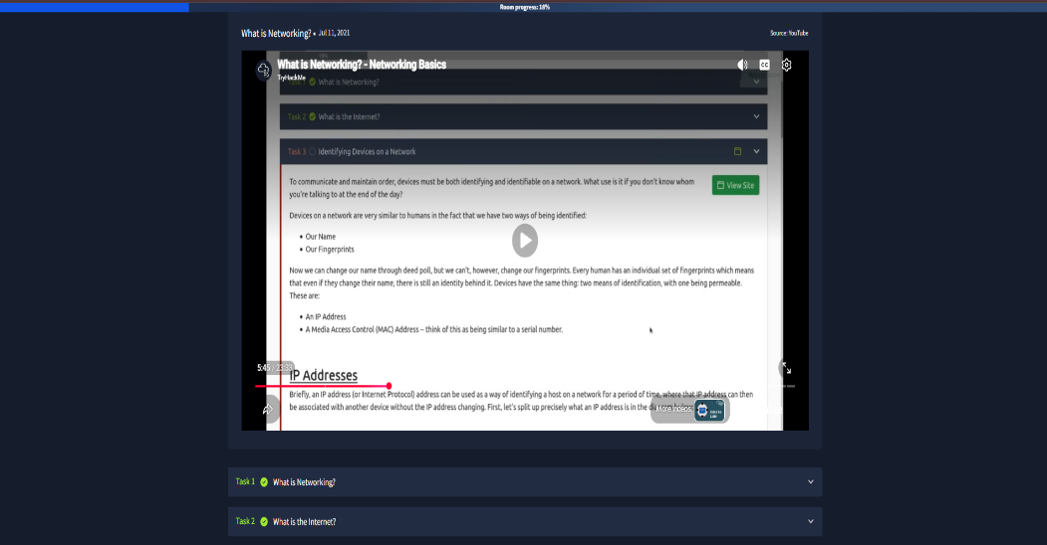
Started and understood how to identify devices on a network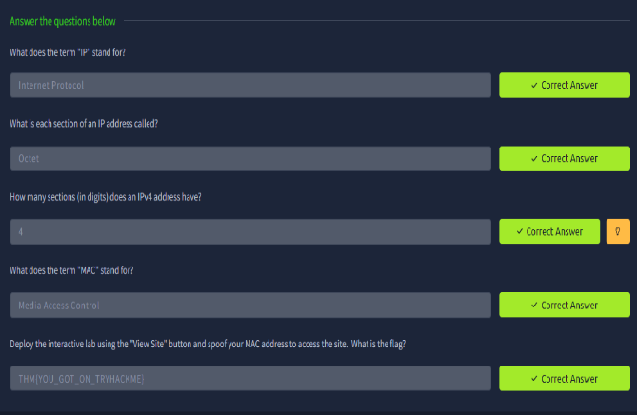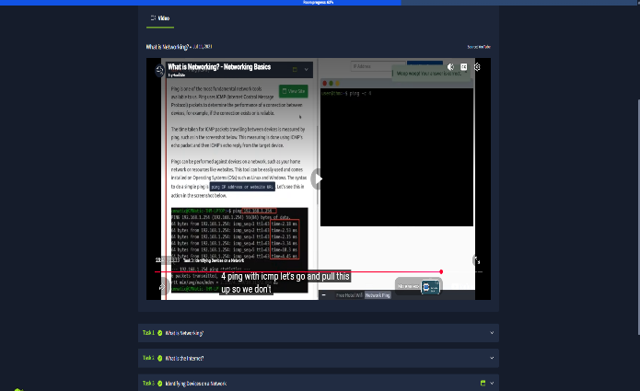
Did a task of spoofing MAC address.
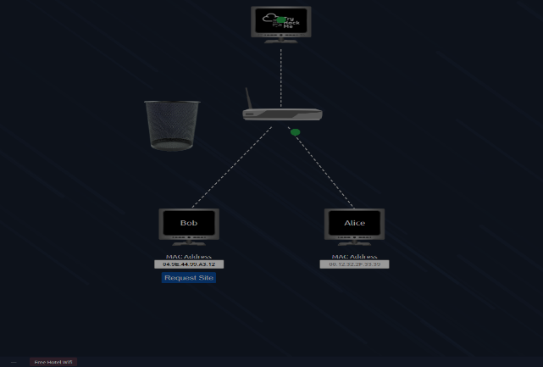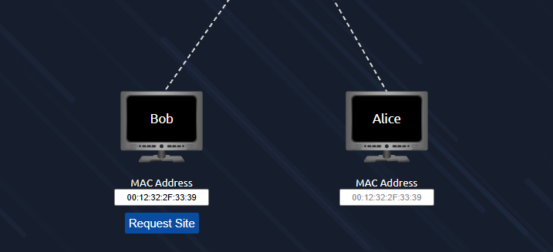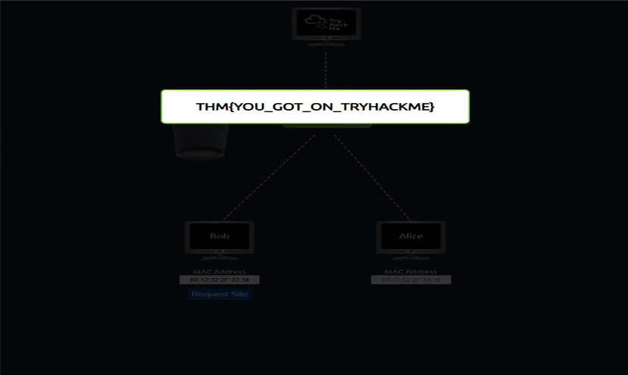
Started and understood PING.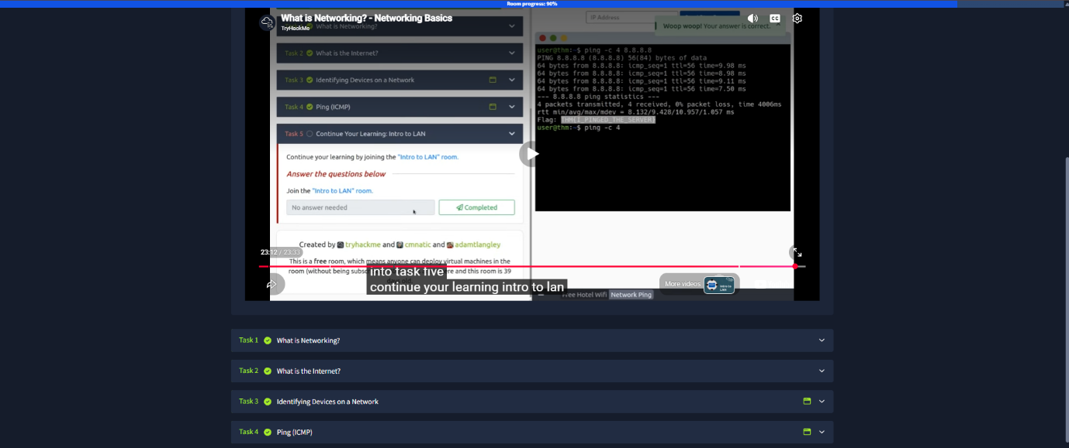
Did a task to check ping
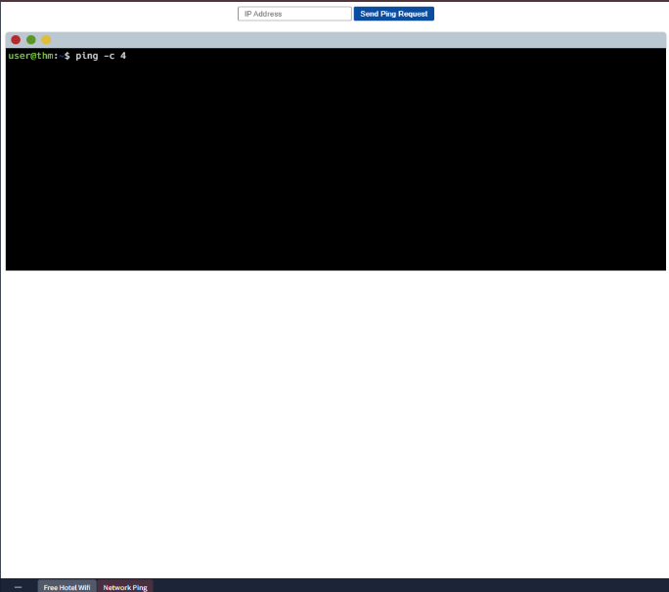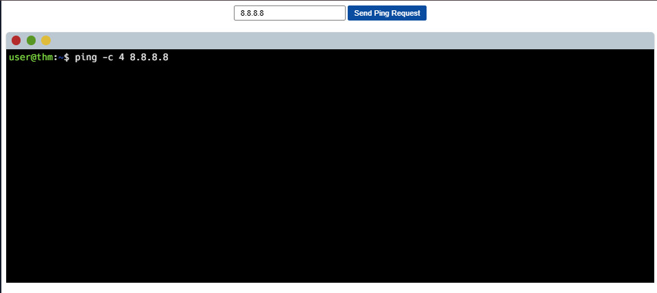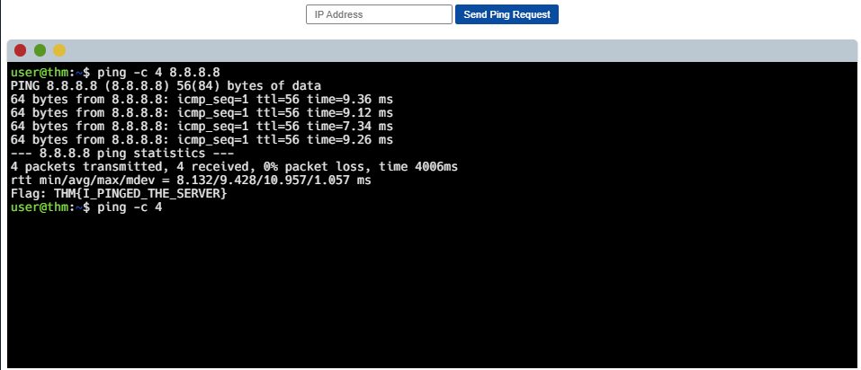

Completed the Room.
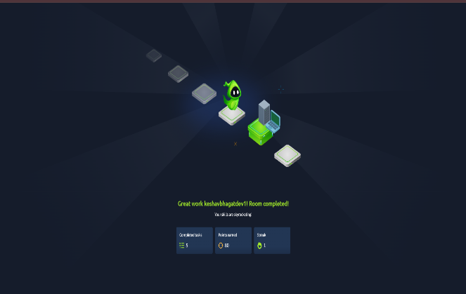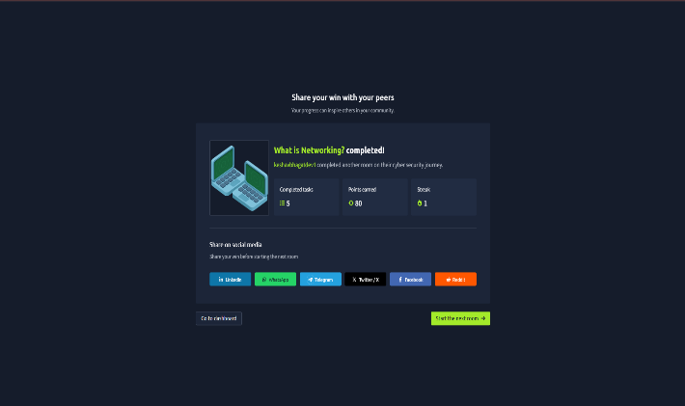
- What I learned?
Networking:
- Networking is way of connecting things.
- Let’s take a real-life example suppose I have five friends now that connection will be called network of friends.
- In terms of computing Networking is the way people are connected on multiple devices. It can be anywhere from two devices to millions or billions. These devices include many things like laptop to mobile, mobile to mobile, laptop to laptop. CCTVs, etc.

Internet:
- Internet is a way of connecting multiple networks.
- For example, I know three friends and we’re Group 1. Now I know two friends who are not in our Group 1. So, I can become the point of connection between the two friends and Group 1.
- It can also be taken as people from different states coming to a college and forming new networks.
- In 1980 The Internet as we know today was invented by Tim Berners Lee by creation of the World Wide Web (WWW).
- From then Internet Started Being used as a storage or a rep in technical terms for storing and sharing Information.
- Network can be of two types - Private network and public network.

Identifying a device:
- To communicate and maintain order devices on the Internet have unique addresses. This can compare to real life, different people having Aadhar card in India.
- We need these addresses to identify people with whom we connect on the internet.
- Two means of Device identification
- IP address
- MAC address (Media Access Protocol)
- IP address can be used as a way of identifying a device. An Ip address is unique for a device and one IP address Can be allotted to only one device at a time.
- IP address Has four parts. Each Is called an octet. An octet can have values from zero to 255. The technique to calculate IP address is called Ip addressing and subnetting.
- IP addresses follow set of protocols. These are nothing but rules and regulations like you follow in a college. They are the backbone of networking
- Private address Is hidden behind A public address. A public address Is provided by your ISP Internet service provider. The following table shows some IP addresses. They are both private and public
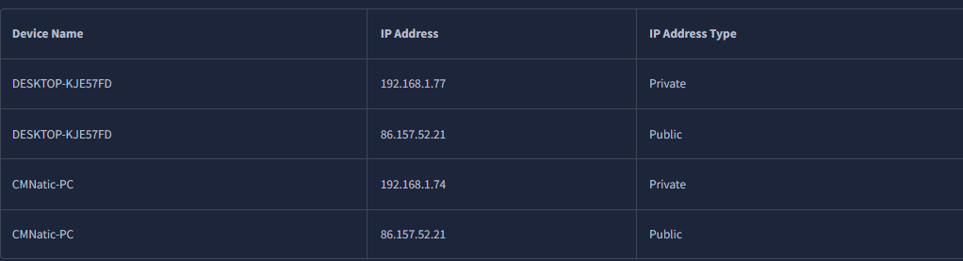
To support over 50 billion devices connected by 2021, IPv6 was created to replace IPv4, resolving its limitations and expanding address capacity to $2^{128}$ (over 340 trillion).

Media Access Protocol:
- A Media Access Control (MAC) address is a unique 12-character hexadecimal code assigned to network hardware (like a Wi-Fi card) during manufacturing. Devices use MAC addresses to identify themselves on a local network, but this address can be fake or "spoofed" to impersonate another device—essentially acting as digital identity theft.

Ping:
- Ping measures network latency—the time it takes for ICMP data packets to travel between devices. For gamers, "high ping" means noticeable lag.
- ICMP Stands for Internet Control Message Protocol
- You can cheque your ping on any device by the command Given in the device Screenshot
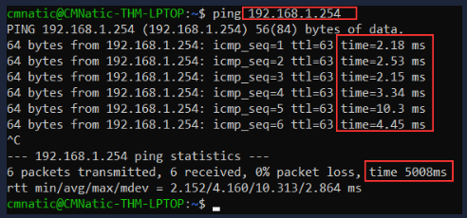

Room 2:
- What I did?
Objective: Understand core networking principles, including the OSI and TCP/IP models, their practical application, and basic networking tools.
Started and learnt about OSI model and answered some questions
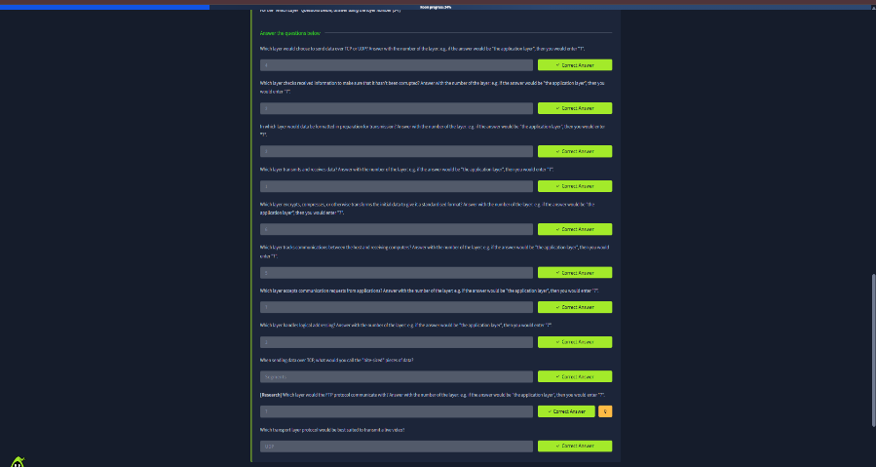
Started and learnt about Encapsulation and answered some questions
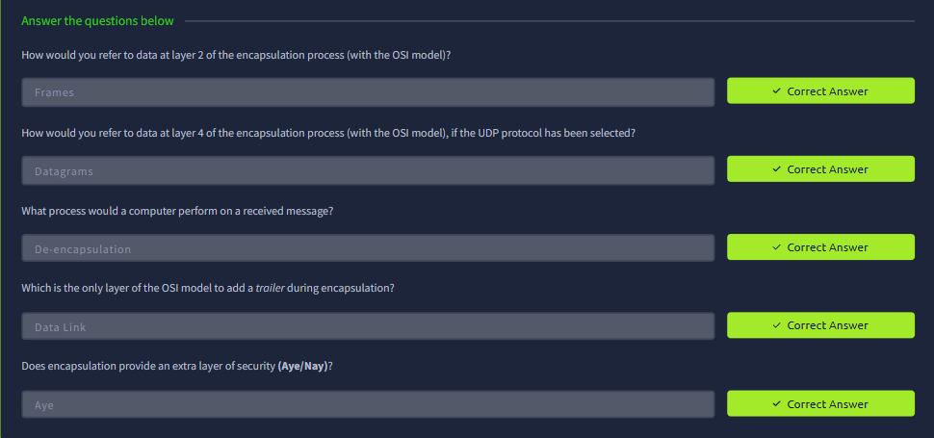
Started and learnt about TCP/IP model and answered some questions
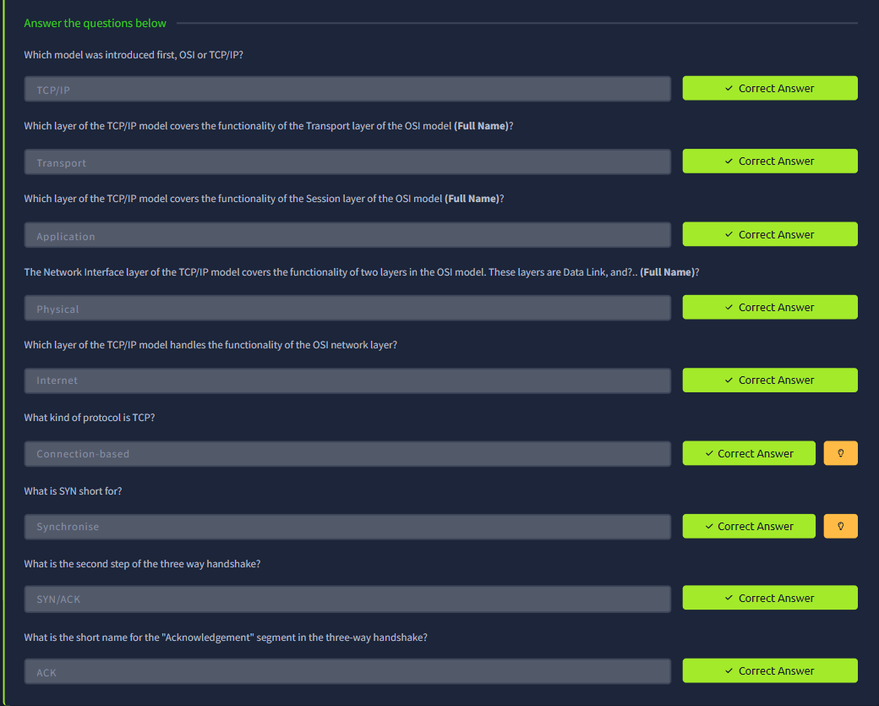
Started and learnt about Ping and answered some questions and did a task
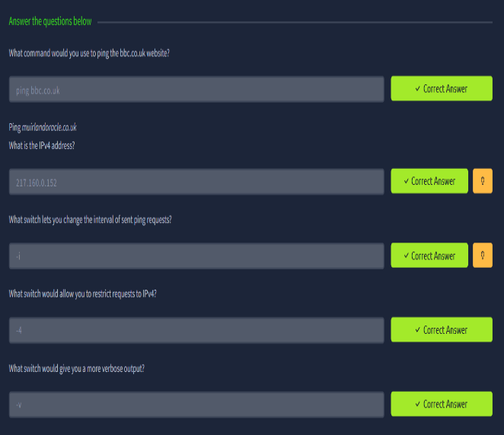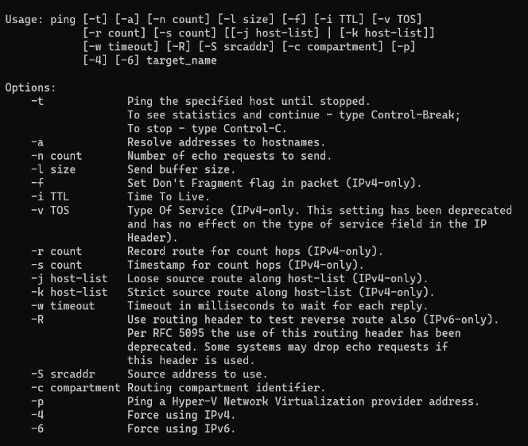

Started and learnt about Traceroute and answered some questions and did a task
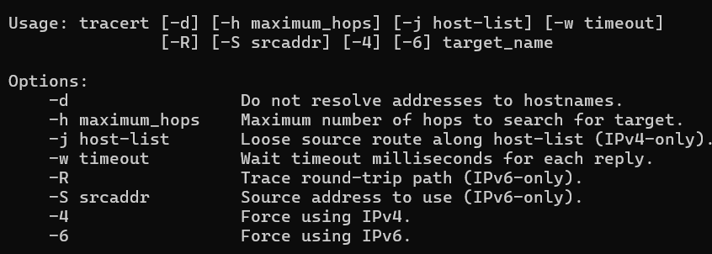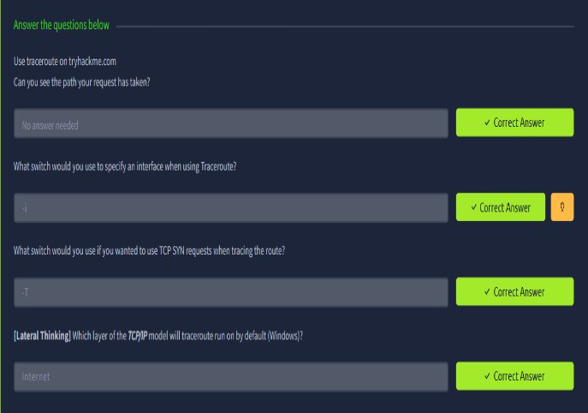
Started and learnt about WHOIS and answered some questions and did a task
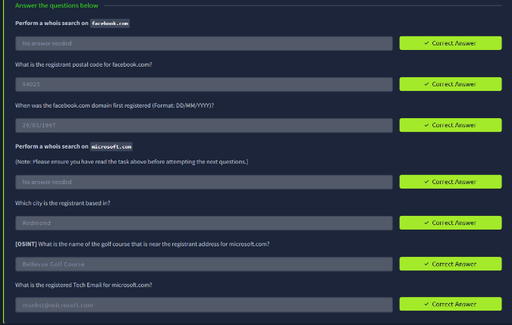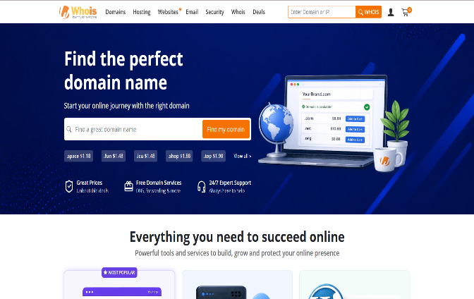
Started and learnt about Dig and answered some questions and did a task
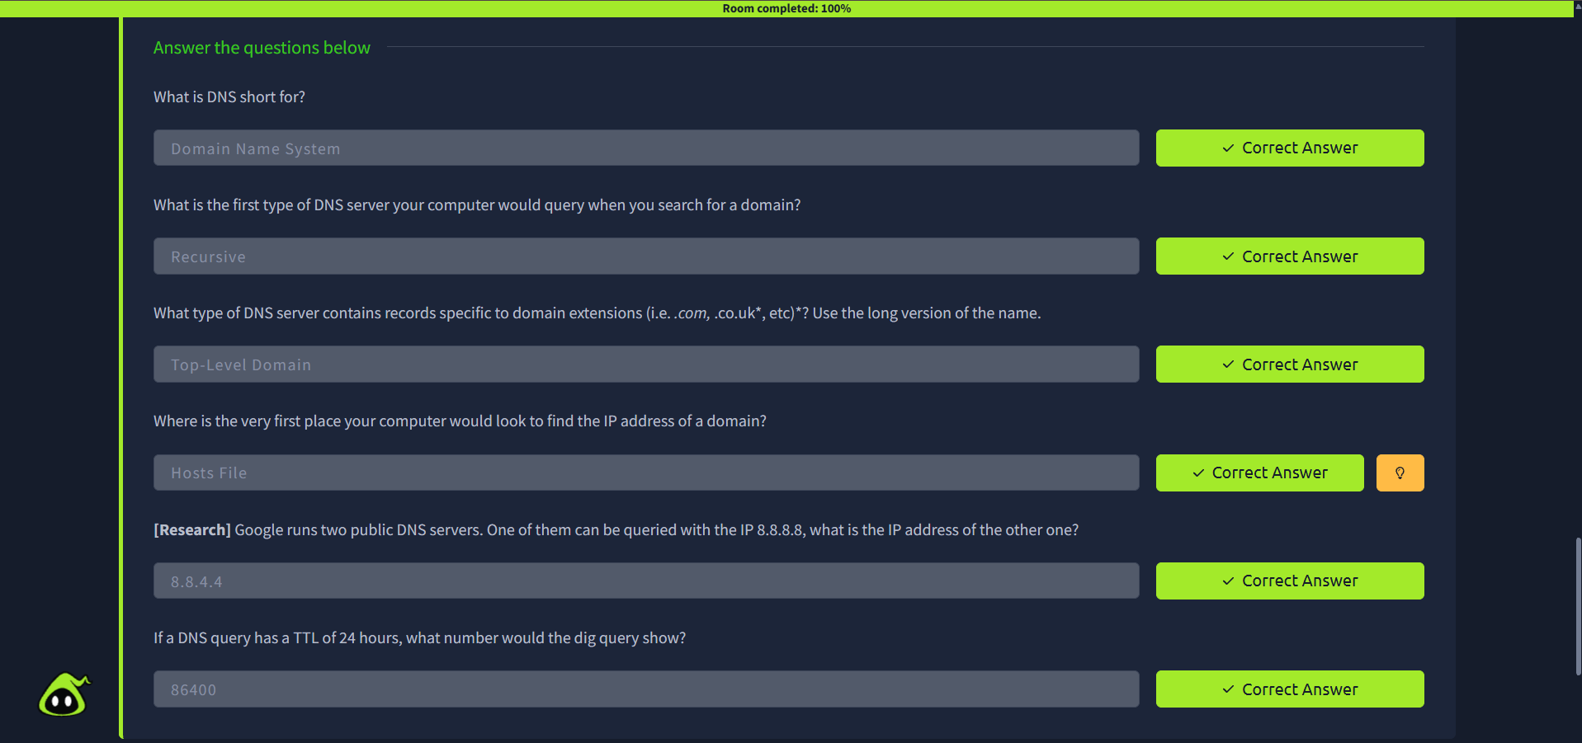

Completed the Room.
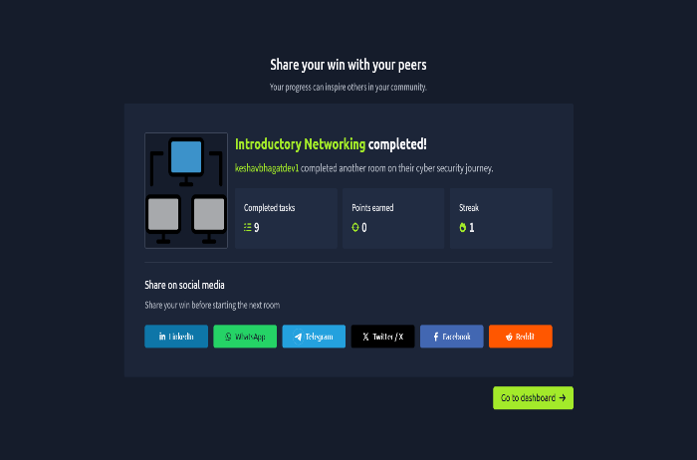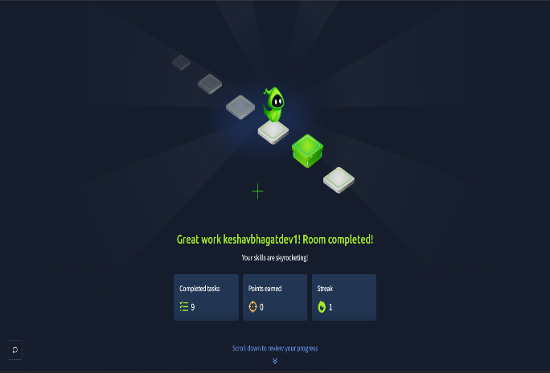

- What I learned?
The OSI (Open System Interconnection) model is a standard 7-layer framework used to understand how data moves through a network. It is easier to learn than the real-world TCP/IP model.
The 7 Layers (Top to Bottom):
- Application
- Presentation
- Session
- Transport
- Network
- Data Link
- Physical
(Mnemonic: Anxious Pain Shakespeare Treated Nervous Drunks Patiently)
Why it matters: It breaks networking down into simple steps so you can easily understand and troubleshoot where network issues happen.
Application Layer: The top layer where network programs (like web browsers) run. It handles data in a format the specific app understands.
Presentation Layer: Translates that app-specific data into a standardized format. It also handles encryption and compression before passing the data down.
Session Layer:
Creates, manages, and maintains a unique connection between your computer and a remote device. It keeps communications synced, allows multiple active connections at once, and returns an error if a connection fails.
Transport Layer:
Handles data delivery and chooses how packets are sent:
- TCP: Focuses on accuracy. It checks for lost data, ensures steady speeds, and resends missing packets. Used for web browsing and file downloads.
- UDP: Focuses on speed over accuracy. It sends data continuously without checking for missing packets, which can cause lag or pixelated video. Used for live streaming, video calls, and online gaming.
Transport Layer (Data Slicing):
After picking a protocol, it splits data into smaller pieces: Segments for TCP or Datagrams for UDP.

Network Layer:
Finds the destination across the network using logical addressing (IP addresses). IP addresses organize networks so data reaches the correct location.
Data Link Layer:
Focuses on physical addressing (MAC addresses). It adds the destination's unique MAC address (hardcoded on its network card) to the packet, formats the data for physical transmission, and checks for errors or corruption.
Physical Layer:
Handles the physical hardware. It converts digital binary data ($1$s and $0$s) into electrical or optical signals to send across wires or Wi-Fi, and converts incoming signals back into binary.

Encapsulation is the process of adding specific information (headers and trailers) to data as it moves down the OSI layers from sender to receiver.
- Network Layer: Adds a header with source and destination IP addresses.
- Data Link Layer: Adds a trailer to detect data corruption and tampering.
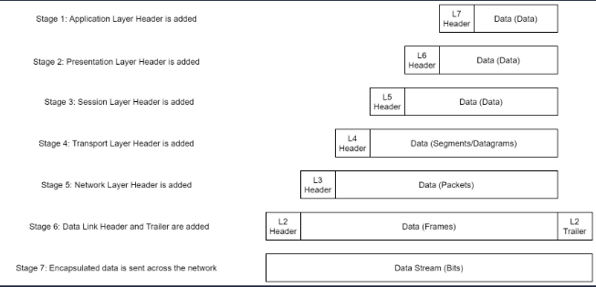

Data Names at Each Stage (PDUs)
- Layers 7, 6, 5 (Application, Presentation, Session): Data
- Layer 4 (Transport): Segments (TCP) or Datagrams (UDP)
- Layer 3 (Network): Packets
- Layer 2 (Data Link): Frames
- Layer 1 (Physical): Bits
De-encapsulation & Purpose
When the receiving computer gets the data, it performs de-encapsulation—reversing the process by stripping off headers as data moves back up to the Application layer.
TCP/IP Model:
The TCP/IP model is older than OSI and serves as the practical foundation for real-world networking. It traditionally consists of 4 main layers (some newer versions split the bottom layer into Data Link and Physical to make 5 layers):
- Application (Covers OSI layers 7, 6, 5)
- Transport (Covers OSI layer 4)
- Internet (Covers OSI layer 3)
- Network Interface (Covers OSI layers 2, 1)
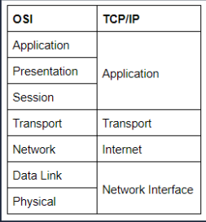
TCP Three-Way Handshake
TCP is a connection-based protocol, meaning a stable connection must be established before sending data. This is done via a 3-step process:
- SYN: Your computer sends a packet with a SYN (synchronize) bit requesting to start a connection.
- SYN-ACK: The server responds with a packet containing both a SYN bit and an ACK (acknowledgment) bit.
- ACK: Your computer sends a final ACK bit to confirm the connection is set up.
Once complete, data is transmitted reliably. Any lost or corrupted data is automatically resent, creating a virtually lossless connection.

Ping Command:
The ping command checks if a remote device or website is reachable using the ICMP protocol (which operates at the OSI Network Layer / TCP/IP Internet Layer).
- Basic Syntax: ping <target> (e.g., ping google.com)
- Key Features:
  - Reveals IP Addresses: Converts domain names (URLs) into the server's actual IP address.
  - Universal Support: Built into virtually all operating systems and network-enabled devices out of the box.
Traceroute Overview:
Traceroute maps the exact path your data takes across intermediate servers ("hops") to reach a target destination.
- Basic Syntax: traceroute <destination> (Linux) or tracert <destination> (Windows)
- Protocols Used:
  - Windows (tracert): Uses ICMP by default.
  - Linux/Unix (traceroute): Uses UDP by default.
Domain Names & WHOIS Command:
- Domain Names: Human-readable web addresses (e.g., tryhackme.com) that translate into numerical IP addresses so you don't have to memorize numbers. They are leased from Domain Registrars.
- WHOIS: A tool used to look up registration details and ownership information for a domain name.
  - Syntax: whois <domain>
  - Privacy Note: Personal contact details are often redacted (especially in Europe due to privacy laws), but WHOIS searches can still reveal registrar and technical info.
The dig Tool:
dig is a Linux command-line tool used to manually query DNS servers and troubleshoot network issues.
- Basic Syntax: dig <domain> or dig <domain> @<dns-server-ip>
- Key Output Sections:
  - ANSWER SECTION: Displays the queried domain and its corresponding IP address.
  - TTL (Time To Live): Measured in seconds (second column of the answer section), telling your device how long to store the result in cache before requesting a fresh copy.

