Task 2
CIA Triad

CIA Triad stands for Confidentiality, Integrity and Availability.
Confidentiality:
Confidentiality means only authorized people can see the data. Confidentiality is violated when someone who is not permitted to see the data sees the data.
Real World Scenario:
Unauthorized Exposure of National Examination & Student Data (CBSE Incident)
In a major cybersecurity incident involving the Central Board of Secondary Education (CBSE) On-Screen Marking (OSM) evaluation ecosystem, a hacker accessed their database:
- The Failure: Storage systems and evaluation portals suffered from unlocked cloud storage folders and insecure administrative backdoor passwords left in the code.
- How Confidentiality was Violated: An ethical hacker discovered that improperly configured storage buckets allowed unauthorized downloading of sensitive examination records—including scanned answer sheets, question papers, student marks, and evaluators' private personal details such as names and contact details—without proper authentication. The data could also be modified.
- How to Fix / Prevent It: Restrict permissions on cloud storage buckets so they are private by default. Remove hardcoded admin credentials from the source code, use secure environment variables, and require Multi-Factor Authentication (MFA) for administrative portal access
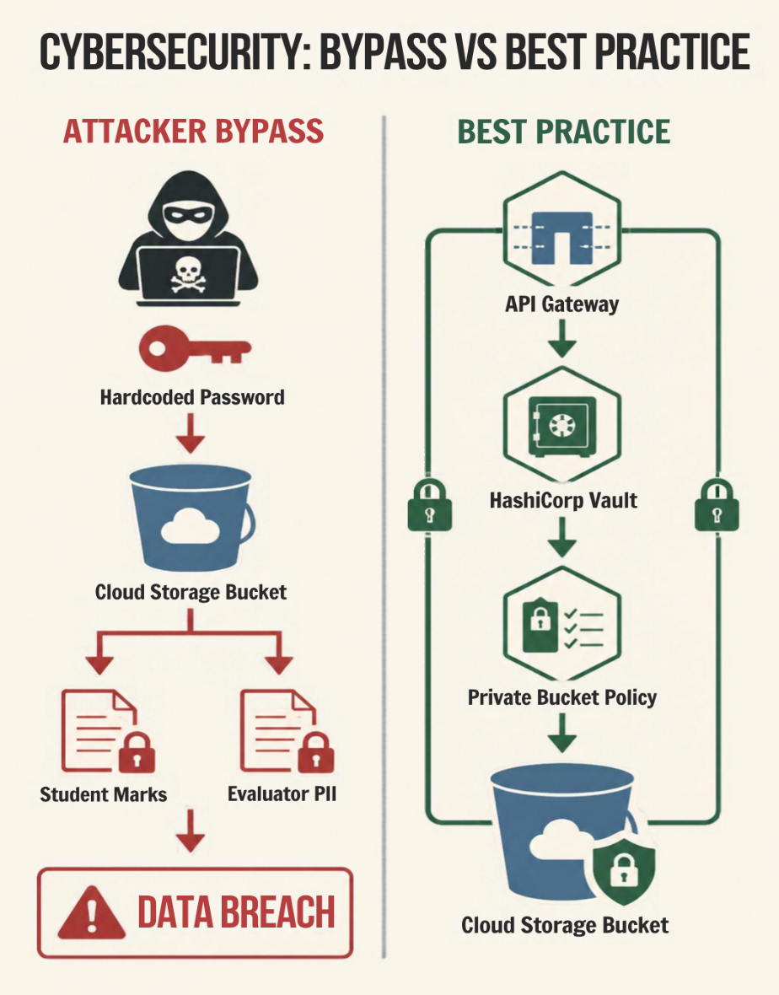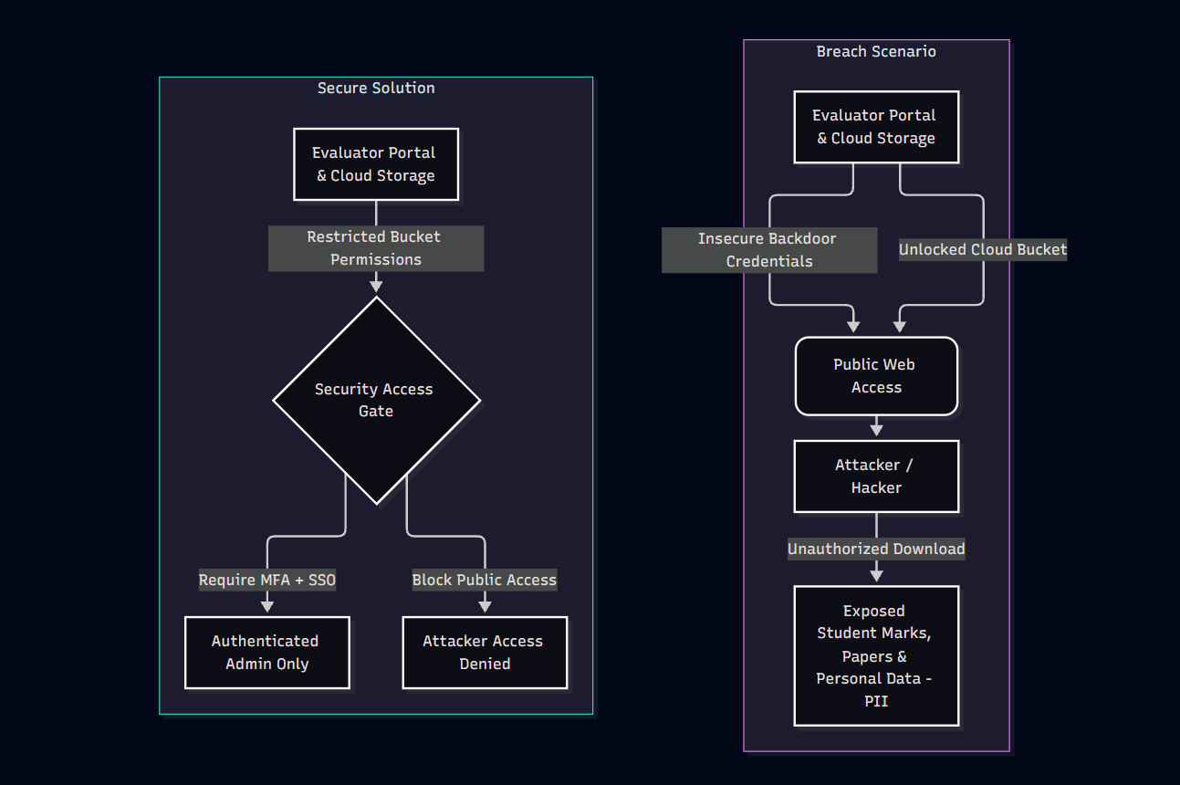

Integrity:
Integrity makes sure that data hasn't been tampered with, accidentally or on purpose during the entire transit.
Real World Scenario:
Client-Side Memory Tampering via Cheat Engine
A competitive online multiplayer game runs locally on a player's PC while syncing game state updates with a centralized server.
- The Failure: The game engine stores core gameplay variables (such as player health, movement speed, currency, or ammo counts) in local RAM (Computer’s temporary memory) and relies entirely on client-side calculations without server-side validation or code integrity checks.
- How Integrity was Violated: A user attaches a utility like Cheat Engine Table to the running game process. By scanning for specific memory addresses, the player freezes their health variable or increases or decreases their ammo or currency count. Because on the user side integrity was compromised, the player gains an unfair advantage, invalidating the intended execution state of the game.
- How to Fix / Prevent It: Shift critical calculations to server-side authority. The server must validate every health change or item transaction before updating the game state, and the game should run client-side anti-cheat tools to detect active memory manipulation.
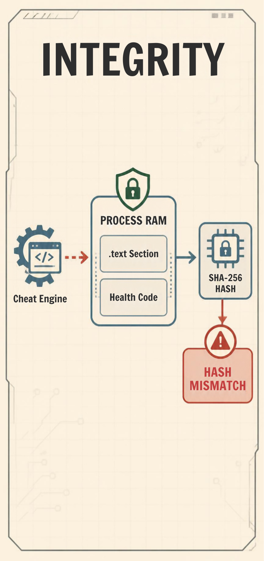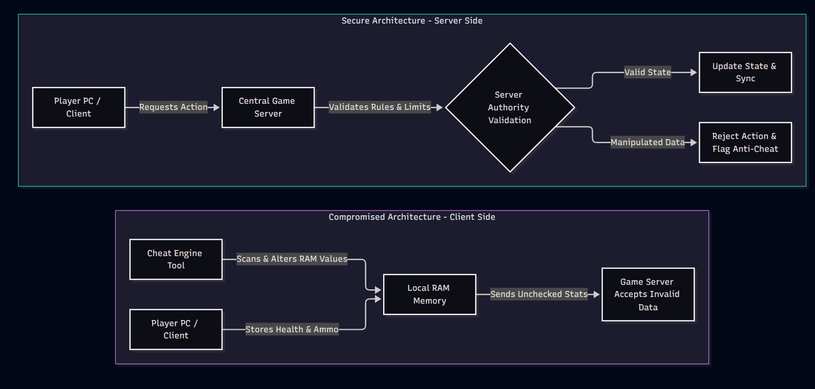
Availability:
Availability makes sure that the system/data is accessible to the authorised users when needed.
Real World Scenario:
DDoS Attack on a High-Traffic Pirated Anime Streaming Platform
An unauthorized third-party (e.g. HiAnime) site streams popular anime episodes to thousands of concurrent users during a hyped weekly finale release.
- The Failure: The streaming platform operates on limited server infrastructure and lacks automated spam filtering, or enterprise-level DDoS protection services.
- How Availability was Violated: An opposing threat company or competing platform coordinates a Distributed Denial of Service (DDoS) (Digital Traffic Jam) attack. By using a botnet to send millions of junk HTTP GET/POST requests per second directly to the site's video-rendering endpoints, the server's CPU, memory, and network bandwidth are instantly saturated. As a result, the site crashes, video playback buffers infinitely, and legitimate users face 502 Bad Gateway or 504 Gateway Timeout errors (Server Overload Messages).
- How to Fix / Prevent It: Implement automated cloud DDoS mitigation and Web Application Firewalls (WAF) like Cloudflare. Use rate limiting to restrict maximum requests per IP address and automatically route bad traffic through scrubbing centers. 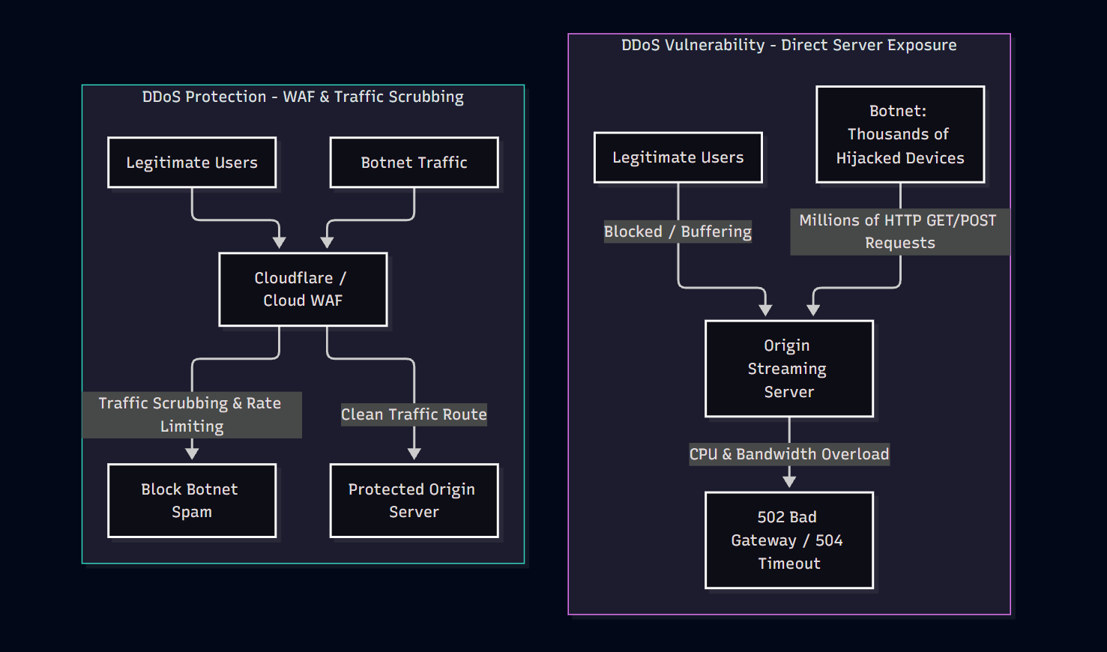
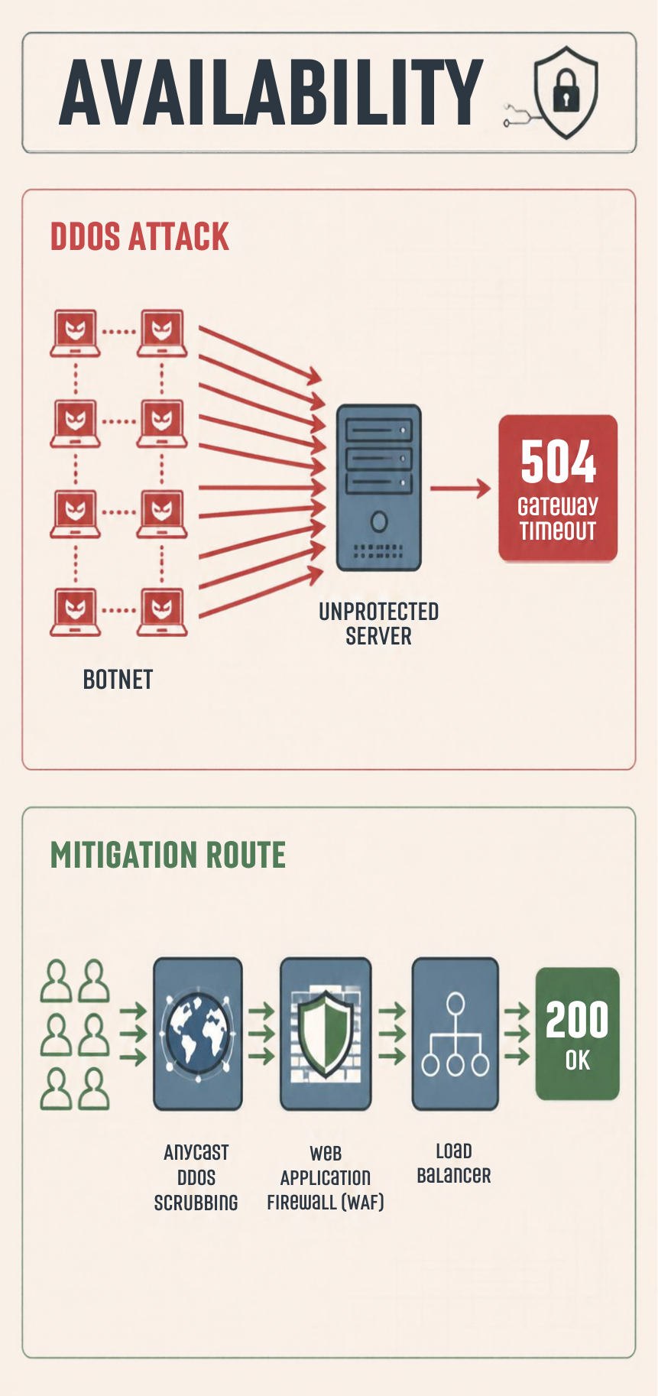

Authentication vs Authorization
Authentication:
The process of verifying or proving the identity of a user, a device or a system using passwords, OTPs or biometric scans.
Real-World Scenario:
Students attempting to access their official college app to view internal grades, attendance and course schedules.
- The Process: The student enters their institutional email (student@srm-ist.edu.in) and password into the single sign-on (SSO) portal. The authentication server validates these credentials against the principal user database.
If Two-Step Verification is enabled, the server sends a Time-based One-Time Password (TOTP) to the student's phone.
- How it is Violated: An attacker obtains a leaked list of passwords from an external breach and uses an automated script to test them against the college SSO portal. Because the portal lacked Two-Step Verification and rate limiting, the attacker successfully logs in using a student's password. The system wrongly validates the attacker as the legitimate student (Authentication failure), giving them access to the account.
- How to Fix / Prevent It: Make Multi-Factor Authentication (MFA / Two-Step Verification) mandatory for all student accounts, and enforce rate-limiting or CAPTCHAs to block automated credential-testing scripts
Authorization:
Authorization is the process of determining what roles and permissions someone has after authenticating.
Real-World Scenario:
An authenticated student joins an official college or department Discord server.
- The Normal Process: The user logs into their valid Discord account (Authenticated). Upon joining the server, they hold the @Student role, which allows them to view general discussion channels but restricts access to administrative channels (like #moderator-logs or #exam-announcements).
- How Authorization was Violated: A rogue student with only @Student permissions attempts to delete messages or access restricted channel settings.
  - If a server admin mistakenly enables the "Manage Messages" or "Administrator" toggle on the base @Student role (or fails to explicitly deny permissions on a private channel's digital keycard permissions), the student gains access to perform admin actions.
  - Even though the student's identity was proven correctly via login (Authenticated), the permission boundaries failed, allowing an unauthorized user to perform actions outside their designated tier (Authorization failure).
- How to Fix / Prevent It: Follow the Principle of Least Privilege (PoLP). Base student roles should have zero administrative permissions by default, and channel administrators must conduct regular audits of Access Control Lists (ACLs).
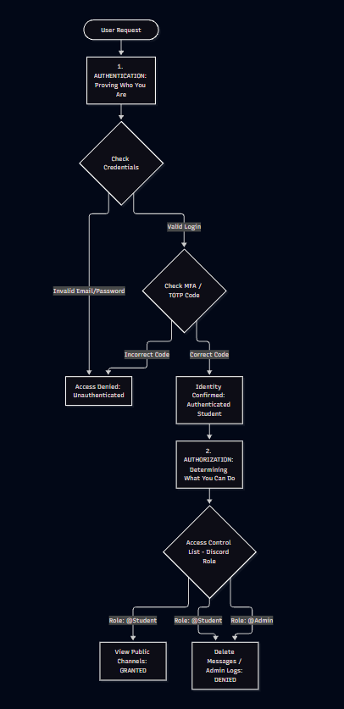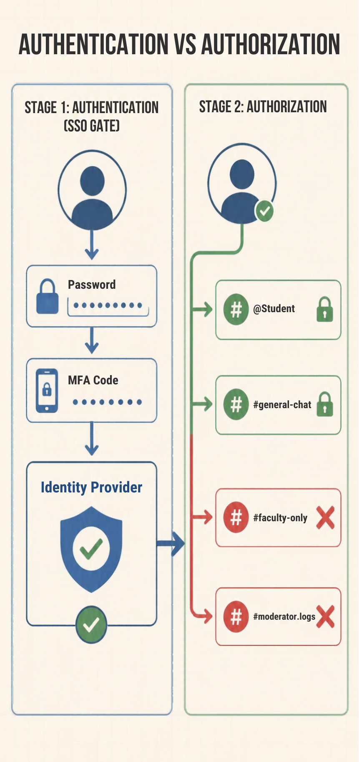

Encryption vs Hashing
Encryption:
Encryption is the process of converting data into scrambled cipher so it's unreadable. It’s completely reversible with the right decryption key. It’s used when you need to get the original data back later.
Real-World Scenario:
WhatsApp End-to-End Encrypted Messaging
When you send a message to a friend on WhatsApp, the application uses end-to-end encryption.
- The Normal Process: The message is encrypted on your device using a public/session key before leaving your phone. It travels across the internet as unreadable cipher. Only the recipient's phone possesses the corresponding private key required to decrypt and read the message.
- How Encryption was Violated: An attacker performs a Man-in-the-Middle (MITM)(Wiretapping/Eavesdropping) attack or gains unauthorized physical access to the recipient's device. If the private decryption key is exposed or hardcoded insecurely in device storage, the attacker uses the key to reverse the cipher back into plain text, completely destroying the confidentiality of the conversation.
- How to Fix / Prevent It: Store private decryption keys in hardware-backed secure enclaves on the device rather than standard file storage, and use SSL/TLS certificate pinning to prevent Man-in-the-Middle eavesdropping.
Hashing:
Hashing converts data into a fixed-length of scrambled output. It's irreversible. It is used to verify data hasn't changed, not to hide-then-reveal it.
Real-World Scenario:
A web application needs a secure mechanism to verify user passwords during login without exposing plain-text credentials.
- The Process: When a user creates a password (e.g., MySecretPass123!), the system appends a unique random string and runs it through a one-way cryptographic hash function. The database stores only the resulting hash output string. When logging in, the system hashes the newly entered attempt and compares it to the stored hash. The original password is never saved anywhere. As Hash is not reversible it becomes completely safe.
- How Hashing was Violated: A legacy web platform uses an outdated, fast hashing algorithm like MD5 or plain SHA-1 (older, outdated hashing formulas) without adding a unique random string.
  - An attacker leaks the database containing hash strings.
  - Using precomputed tables of common hashes (Pre-Made Password Sheets or Rainbow Tables) or rapid GPU brute-force attacks (using powerful graphics cards to guess millions of password combinations per second), the attacker quickly reverses the hashes back to their original plain-text passwords.
  - Furthermore, because MD5 is susceptible to hash collisions (where two different inputs yield the exact same hash output), an attacker can log in using a completely different password string that produces a matching hash output (Hashing integrity failure).
- How to Fix / Prevent It: Upgrade from legacy algorithms (MD5/SHA-1) to modern, slow password-hashing functions like Argon2 or bcrypt. Always add a unique, random string (salt) to every password before hashing to completely neutralize pre-computed Rainbow Tables. 