VELLORE INSTITUTE OF TECHNOLOGY
School of Computer Science and Engineering
BCSE331L - Exploratory Data Analysis
Course Project Report
SpendSense
Personal Expense Intelligence through Exploratory Data Analysis
Student: Keshav Gujrathi
Registration number: 23BDS0225
Course: BCSE331L - Exploratory Data Analysis
Faculty guide: Dr. Vijayanand C.

Project Links
The repository, the demonstration video and the hosted application are accessible to anyone with the link.
Table 1: Project resources
Resource | Link
GitHub repository | https://github.com/<username>/SpendSense
Demonstration video | https://drive.google.com/<demo-video-link>
Hosted application | https://<app-name>.streamlit.app

Declaration
I hereby declare that this report titled "SpendSense: Personal Expense Intelligence through Exploratory Data Analysis" is a record of the work carried out by me for the course BCSE331L - Exploratory Data Analysis under the guidance of Dr. Vijayanand C. All analyses reported here were produced by the accompanying source code, and every figure and number in this document can be regenerated by running it.
Keshav Gujrathi (23BDS0225)

Abstract
Most people can tell roughly what they earn but not where it goes. Bank statements hold the answer, yet they are long, noisy and full of cryptic narrations, duplicate entries and blanks. SpendSense is a web application that applies the complete exploratory data analysis workflow to a personal bank statement and converts it into decisions: where the money goes, which payments repeat, which transactions look unusual, what the next month will probably cost and which saving tip is worth trying first.
The system was developed and evaluated on an 18-month synthetic statement of 1,214 raw rows that deliberately contains the defects found in real exports. The pipeline removed 31 duplicates, standardised 698 inconsistent labels, resolved 1,115 narrations to canonical merchants and filled every missing category, payment mode and amount. Maximum-likelihood imputation gave the lowest error among six strategies. A Gaussian-mixture detector recovered 8 of 8 injected anomalies with precision 100%. A linear regression anchored on known recurring bills explained 88% of the variance in held-out daily spend and predicted weekly spend with 66% accuracy. A multi-armed bandit identified the most valuable budgeting nudge with far lower regret than random suggestion.
Keywords: exploratory data analysis, data transformation, maximum likelihood estimation, time series, clustering, dimensionality reduction, linear regression, reinforcement learning, personal finance.

Contents
1. Introduction
2. Foundations of Exploratory Data Analysis
3. System Design
4. Dataset
5. Data Transformation
6. Correlation Analysis and Time Series
7. Data Summarisation and Visualisation
8. Clustering and Outlier Detection
9. Dimensionality Reduction
10. Model Development and Evaluation
11. Application and Deployment
12. Contemporary Issues
13. Results and Discussion
14. Conclusion and Future Work
References
Appendix A: Syllabus Coverage
Appendix B: Repository Structure

1. Introduction

1.1 Problem statement
Personal money management is a daily problem. Salaried people and students alike discover at month end that savings fell short, without knowing which habits caused it. Banking apps list transactions but offer little analysis, and spreadsheet tracking demands manual categorisation that few sustain. Three questions come up repeatedly: where did the money go, what is going to be charged again, and is anything wrong?

1.2 Objectives
- Clean a raw, noisy statement automatically and report exactly what was repaired.
- Describe spending through univariate, bivariate and multivariate analysis with proper statistical tests.
- Expose time structure: trend, weekly rhythm, month-end effects and recurring payments.
- Group merchants into behavioural personas and flag suspicious transactions using clustering.
- Reduce the many spending categories to a few underlying behaviours.
- Forecast the next 30 days and quantify accuracy honestly.
- Recommend which saving tip to try first using reinforcement learning.

1.3 Scope and contributions
The project covers Modules 1 to 7 of the syllabus end to end in a single working application. Its main contributions are a robust statement loader that accepts common Indian bank layouts, a transformation pipeline that treats missing data with maximum-likelihood estimation, a clustering-based approach to both categorisation and anomaly detection, a regression forecaster that exploits recurring bills, and a bandit module that personalises advice. Everything runs in the browser session; no statement is stored.

2. Foundations of Exploratory Data Analysis

2.1 Steps in EDA and how SpendSense follows them
Table 2: EDA workflow mapped to the project
EDA step | Realisation in SpendSense
1. Define the question | Where does money go, what repeats, what is unusual, what comes next
2. Load and inspect | Loader maps varied column names to date, description, amount, type
3. Clean and transform | Deduplicate, replace values, bin, impute (Section 5)
4. Summarise and visualise | Statistics, contingency tables, plots (Sections 6 and 7)
5. Discover structure | Clustering, outliers, dimensionality reduction (Sections 8 and 9)
6. Model and communicate | Regression, forecast, bandit nudges, dashboard (Sections 10 and 11)

2.2 Data types and measurement scales
Numerical data may be discrete (a count such as transactions per day) or continuous (an amount in rupees). Categorical data is nominal (merchant, category, payment mode) or ordinal (amount band, weekday). The four measurement scales apply to the dataset as follows.
Table 3: Variables, data types and measurement scales
variable | type | scale | remark
date | Temporal | Interval | Ordered, equal spacing, no true zero
description | Text | Nominal | Free-text narration
merchant | Categorical | Nominal | Canonical merchant label
category | Categorical | Nominal | Spending taxonomy, no order
payment_mode | Categorical | Nominal | UPI / Card / NetBanking / Cash
type | Categorical | Nominal | Debit or credit
amount_band | Categorical | Ordinal | Micro < Small < Medium < Large < Major
weekday | Categorical | Ordinal | Cyclic ordered days
amount | Numerical (continuous) | Ratio | True zero, ratios meaningful
day_of_month | Numerical (discrete) | Interval | Counts of days, no true zero
transactions per day | Numerical (discrete) | Ratio | Counts with true zero

The scale matters for the technique: ratio data such as amounts supports means, ratios and logarithms, whereas nominal data allows only counts and chi-square tests, and ordinal data permits rank-based tests.

2.3 EDA compared with classical and Bayesian analysis
Table 4: Comparison of analytical approaches
Aspect | EDA | Classical | Bayesian
Starting point | Data first, hypotheses emerge | Model and hypothesis first | Prior belief first
Method | Plots, summaries, robust statistics | Fit assumed model, test hypotheses | Update prior with likelihood
Output | Insight and questions | Parameter estimates, p-values | Posterior distributions
Role here | Whole application | Chi-square, Kruskal-Wallis, OLS, ADF | Thompson sampling in nudges

2.4 Software tools
Python was used throughout: pandas and NumPy for data handling, SciPy and statsmodels for statistics, scikit-learn for clustering, decomposition and regression, Plotly and Matplotlib for visualisation, and Streamlit for the interface. Pytest verifies the pipeline with automated tests.

3. System Design
SpendSense is organised as a Python package whose modules correspond to the syllabus modules, with a thin Streamlit layer on top. Data flows from the loader through transformation and outlier detection into the analysis modules, and the interface calls them on demand with caching.
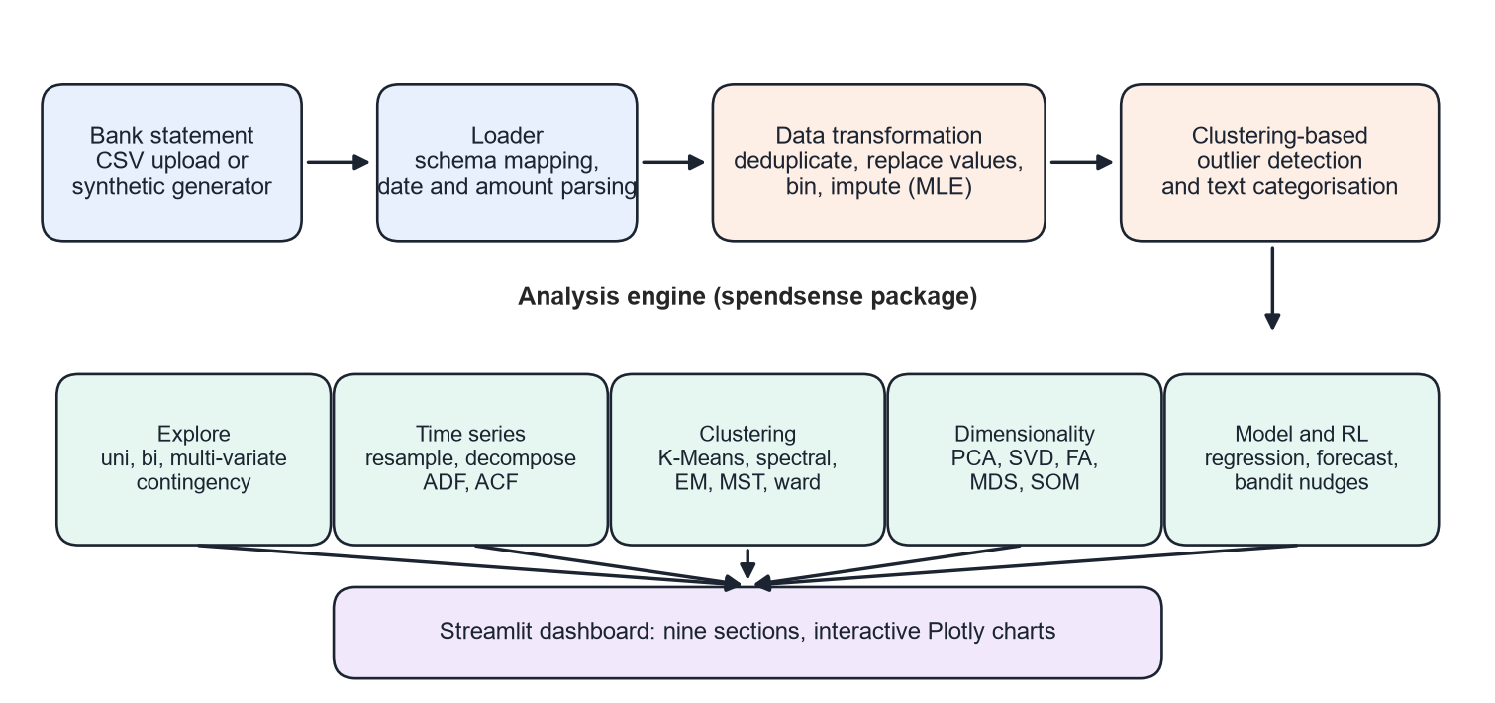
Figure 1: SpendSense architecture
Table 5: Package modules
Module | Responsibility
generator.py | Synthetic statement with latent behaviours and injected defects
preprocessing.py | Loader, deduplication, value replacement, binning, imputation, MLE
analysis.py | Summary statistics, correlation, contingency tables, tests
timeseries.py | Indexing, resampling, decomposition, ADF, ACF
clustering.py | Five clustering methods, text clustering, outlier detection
reduction.py | PCA, SVD, factor analysis, MDS, Isomap, t-SNE, SOM
modeling.py | Regression, accuracy metrics, backtest, forecast
bandit.py | Multi-armed bandit nudges
insights.py | KPIs, recurring payments, budget review

4. Dataset
Real statements contain private information, so the demonstration uses a synthetic statement from 01 April 2025 to 30 September 2026. It models a salaried professional with fixed monthly obligations (rent, utilities, subscriptions), variable spending in eleven categories, a monthly salary and occasional repayments from friends. Variable spending follows lognormal amounts, weekend effects, a festive shopping season in October and November, holiday travel peaks and three latent behavioural factors (going out, staying home, travelling) that make categories move together, as in real life.
Realistic defects were injected so that each data-preparation technique has something to repair: exact duplicate rows, blank categories, payment modes and amounts, inconsistent labels ("DR", "Debit", "upi", "Net Banking"), noisy narrations such as "POS 4274XX ZOMATO BANGALORE biryani", and eight one-off large purchases whose locations are kept as ground truth for evaluating anomaly detection. The application also accepts any user CSV with date, description and amount columns.
Table 6: Debit transactions by category after cleaning (including flagged one-offs)
category | transactions | total (Rs.) | median (Rs.) | share %
Rent | 18 | 330,000 | 18,000 | 27.4
Shopping | 54 | 200,110 | 1,566 | 16.6
Food Delivery | 330 | 132,694 | 317 | 11.0
Travel | 12 | 91,454 | 4,474 | 7.6
Dining | 107 | 77,998 | 622 | 6.5
Utilities | 54 | 58,161 | 1,049 | 4.8
Groceries | 93 | 54,878 | 481 | 4.6
Subscriptions | 90 | 48,528 | 299 | 4.0
Transport | 242 | 47,756 | 156 | 4.0
Fuel | 30 | 46,502 | 1,569 | 3.9
Health | 16 | 41,281 | 463 | 3.4
Miscellaneous | 26 | 37,189 | 401 | 3.1
Entertainment | 42 | 31,534 | 619 | 2.6
Education | 4 | 5,544 | 1,452 | 0.5

5. Data Transformation
This chapter covers Module 2: deduplication, replacing values, discretisation, and the treatment of missing data including maximum-likelihood estimation.

5.1 Deduplication and replacing values
Of 1,214 raw rows, 31 were exact duplicates, typical of overlapping statement exports, and were removed, leaving 1,183. Replacement operated at three levels. Labels for type and payment mode were mapped to canonical values (698 cells changed). Each narration was reduced to a canonical merchant using word-boundary patterns that tolerate prefixes, reference numbers, case and punctuation, resolving 94% of rows to a known merchant. Finally, 44 missing payment modes were inferred from narration prefixes (UPI, POS, NEFT, ATM) and 77 missing categories from the merchant dictionary and keyword rules.
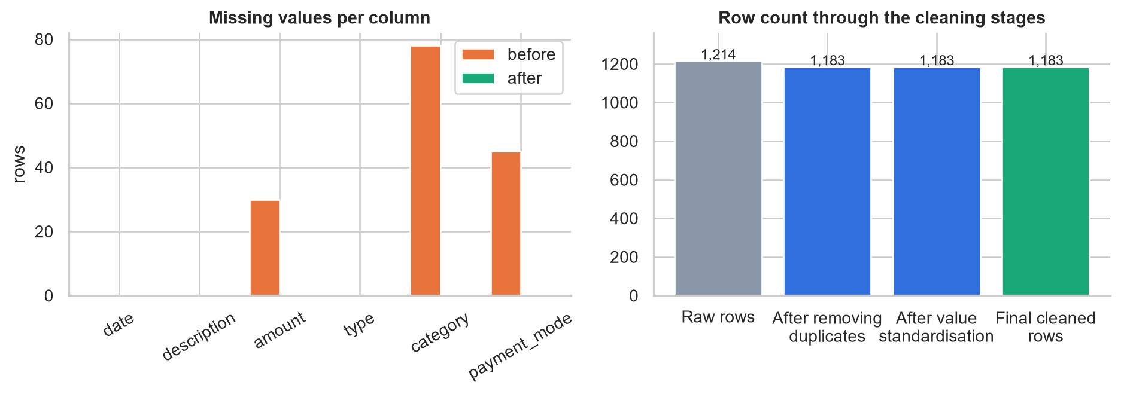
Figure 2: Missing values before and after cleaning, and row counts per stage

5.2 Discretisation and binning
Amounts are strongly right-skewed. Equal-width binning places 97% of all debits in a single bin, which conveys almost nothing. Equal-frequency bins balance counts but have meaningless edges. The application therefore uses domain bands - Micro (under Rs. 100), Small, Medium, Large (Rs. 2,000 to 10,000) and Major - which are both balanced enough to compare and meaningful to a user. The same idea bins the day of month into early, middle and late periods for the regression model.
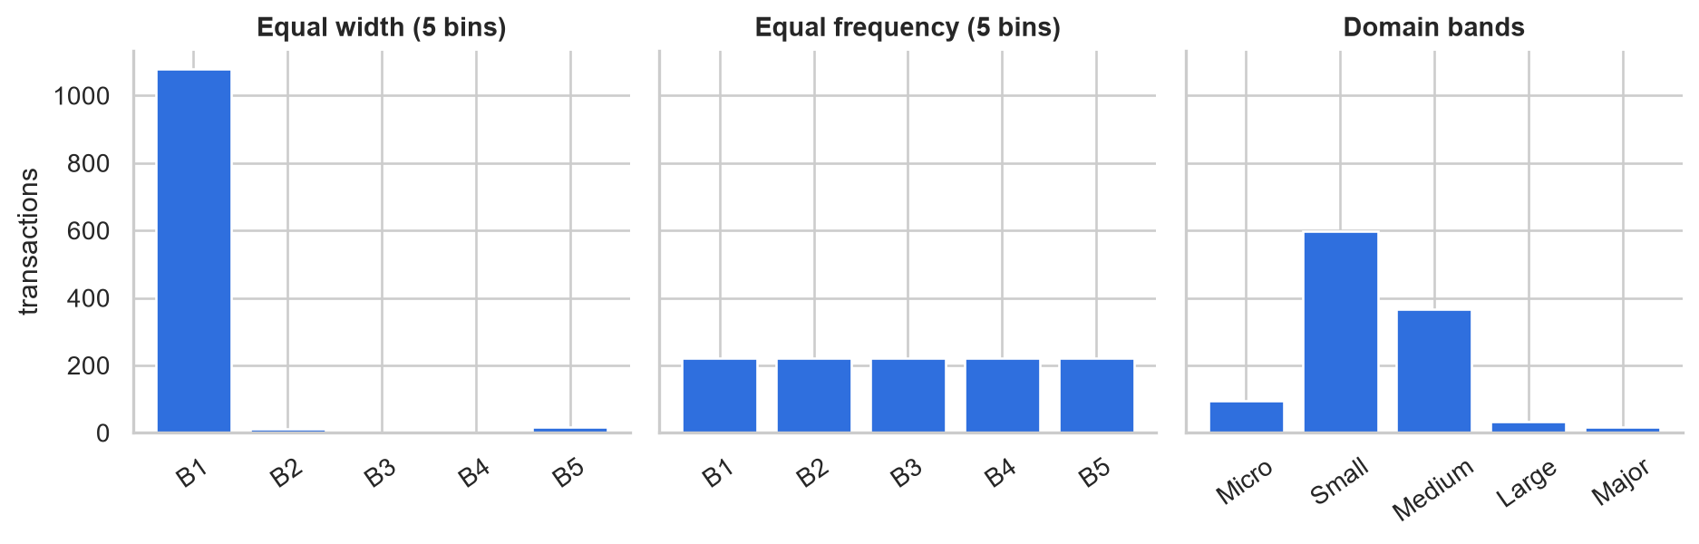
Figure 3: Three binning strategies on transaction amounts

5.3 Missing data: traditional methods
27 amounts were blank. Listwise deletion would discard those transactions and understate spend, and is available as an option. Mean imputation inserts the global average, which is dominated by large purchases and is wrong for almost every individual transaction. Median and category-wise mean or median are progressively better because they condition on context. All are implemented and compared.

5.4 Maximum likelihood estimation
Spending amounts within a merchant or category are well described by a lognormal distribution: the logarithm of the amount is normal. For observations x1..xn, the log-likelihood is maximised in closed form by mu = mean(ln x) and sigma squared = mean((ln x - mu)^2). The fitted median exp(mu) is then the imputed value. SpendSense fits this model per merchant when at least four observations exist, falls back to the category, and finally to the global fit. For the Shopping category the fit gives mu = 7.30 and sigma = 0.75, matching the observed histogram closely (see the figure below). Fixed bills such as rent have sigma near zero, so their blanks are recovered exactly.
Table 7: Imputation accuracy when 10% of known amounts are hidden (mean of 5 repeats)
method | MAE | RMSE | median % error
mle | 476 | 2,653 | 28%
category_median | 517 | 2,666 | 40%
mle_category | 520 | 2,662 | 40%
category_mean | 632 | 2,774 | 46%
median | 956 | 4,019 | 57%
mean | 1,256 | 3,946 | 175%

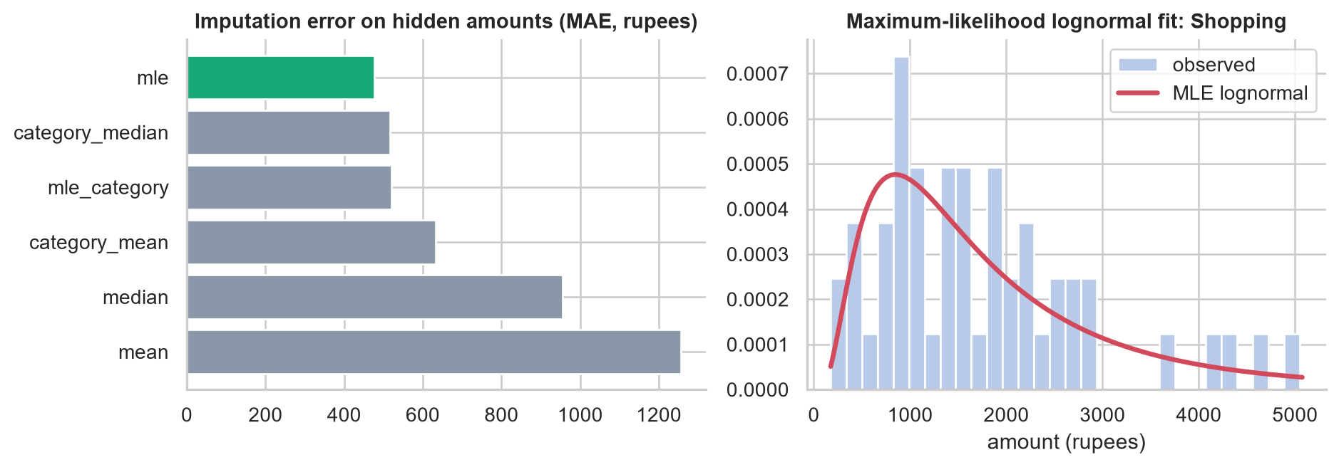
Figure 4: Imputation error by method and the maximum-likelihood lognormal fit
Hiding known amounts and re-estimating them shows that 'mle' has the lowest mean absolute error (Rs. 476), roughly 2.6 times better than mean imputation. Conditioning on the merchant is what makes the difference, and maximum likelihood supplies a principled, robust estimate even from a handful of observations.

5.5 Categorising unknown merchants with text clustering
For merchants outside the dictionary, descriptions are vectorised with TF-IDF and grouped by K-Means. Each cluster adopts the majority category of its labelled members when purity is at least 60%. Hiding 20% of labels, the method assigned 62% of them with 100% accuracy, so unfamiliar narrations are categorised without any hand-written rule.

6. Correlation Analysis and Time Series

6.1 Univariate analysis
The 1,118 debit amounts have mean Rs. 878, median Rs. 374, standard deviation Rs. 2,355, skewness 6.7 and kurtosis 46.5. The mean far above the median and the large skewness show a long right tail produced by rent, travel and shopping. On a log scale the distribution becomes close to symmetric, which justifies lognormal modelling and log-scaled features.
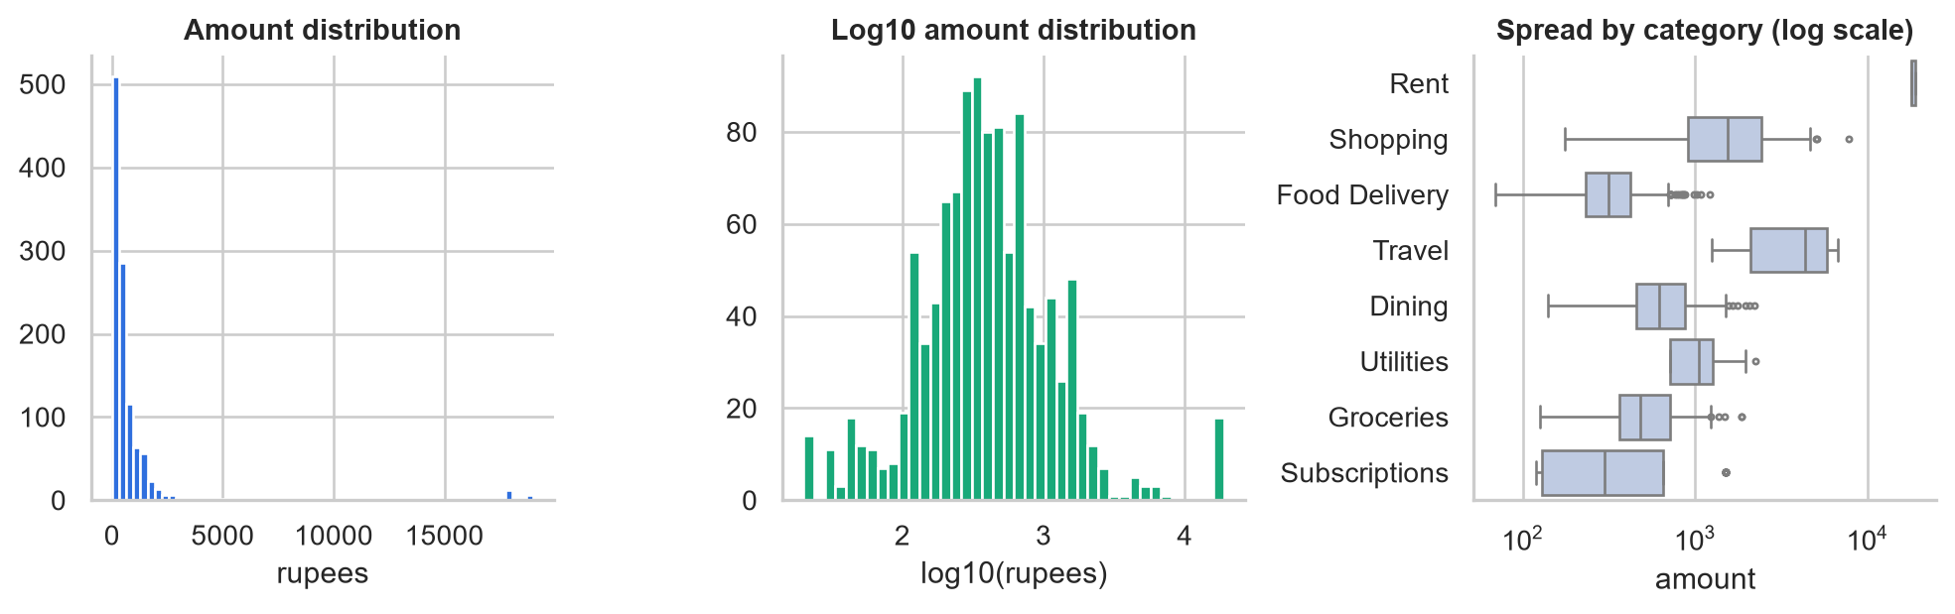
Figure 5: Distribution of amounts and spread by category

6.2 Bivariate analysis
Weekly spend per category was correlated using Spearman's coefficient, which is robust to the heavy tails. The strongest relationships reveal behaviour rather than arithmetic.
Table 8: Strongest rank correlations between weekly category spend
variable_1 | variable_2 | correlation
Food Delivery | Transport | -0.39
Rent | Subscriptions | +0.36
Dining | Food Delivery | -0.33
Subscriptions | Transport | +0.31
Dining | Transport | +0.29
Rent | Shopping | -0.28

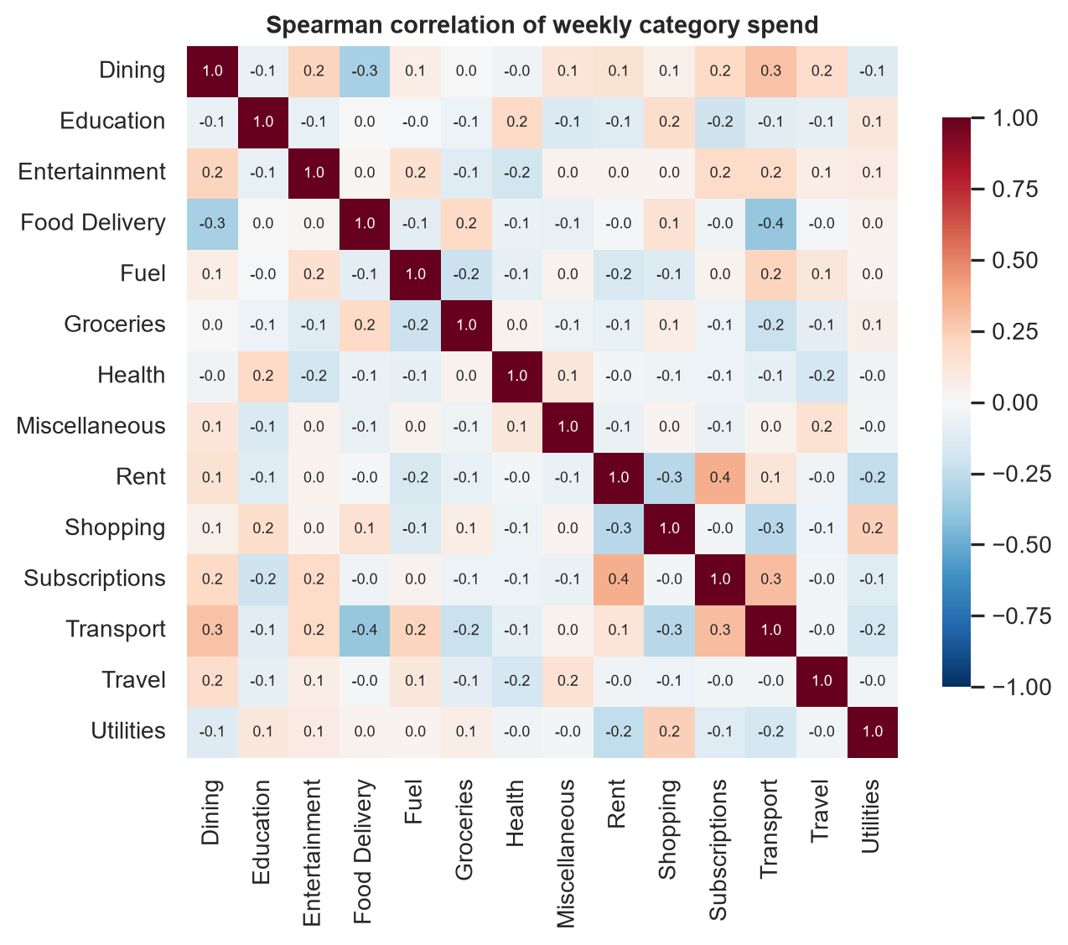
Figure 6: Spearman correlation matrix of weekly category spend
The sign pattern separates staying in from going out: food delivery moves against transport (-0.39) and against dining, so weeks heavy on deliveries are light on outings. Rent and subscriptions correlate positively only because both are fixed bills falling in the first weeks of each month, a reminder that correlation here partly reflects the calendar. Spend also differs significantly across payment modes (Kruskal-Wallis H = 65.2, p = 4.4e-14).

6.3 Multivariate analysis
Three-way tables relate category, payment mode and weekend flag. Across weekdays, average daily spend is highest on Sunday (Rs. 2,293) and Saturday (Rs. 1,924) and lowest on Friday (Rs. 1,491). The heat map on the right shows the typical transaction size for each category and weekday.
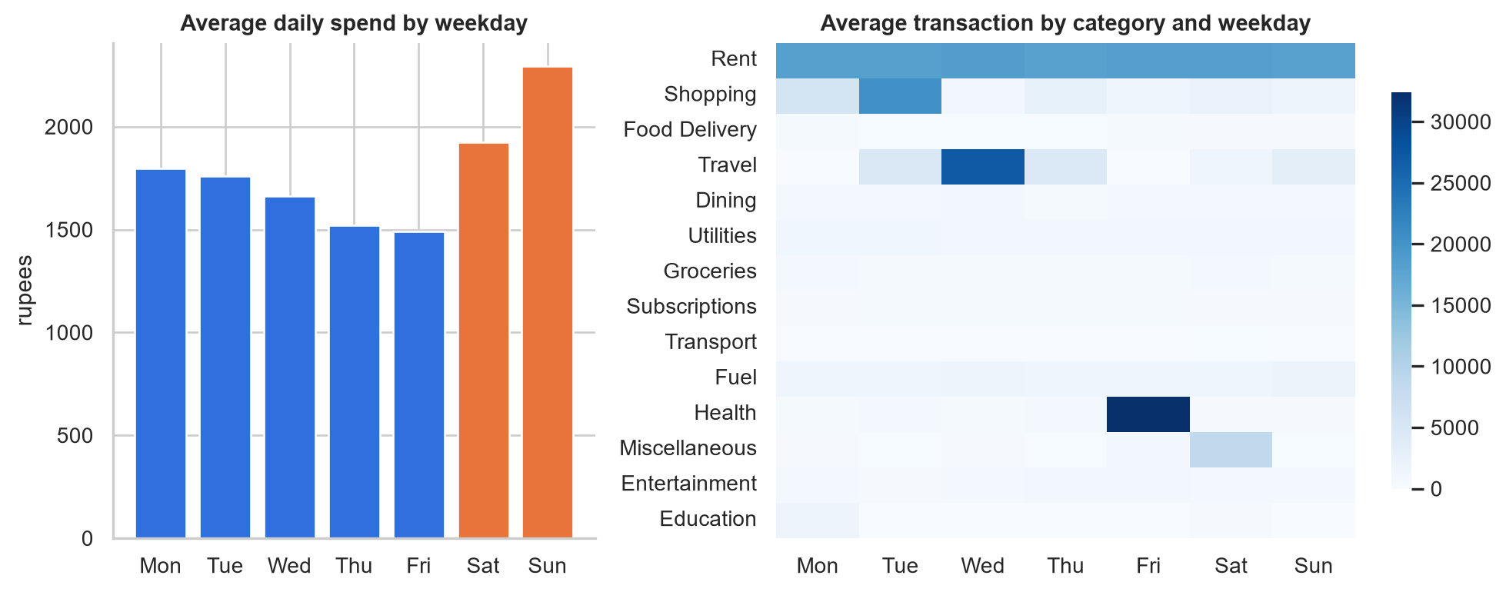
Figure 7: Average daily spend by weekday and average transaction by category and weekday

6.4 Time series fundamentals and time-based indexing
A time series is a sequence of observations indexed by time. Indexing the transactions with a DatetimeIndex enables label-based slicing, such as selecting one quarter in a single expression, frequency conversion, and calendar-aware grouping. The daily series was made gap-free by reindexing to every calendar day and filling days without spending with zero. Flagged one-off purchases are excluded so that the series describes typical behaviour.

6.5 Visualising, grouping and resampling
Resampling daily spend to months shows a typical monthly outflow of Rs. 51,596 against income of about Rs. 73,770, a median savings rate of 30%. The two weakest months were 2025-12 (0%) and 2025-11 (1%), consistent with the festive shopping and holiday travel seasons that were built into the data and recovered by the analysis.
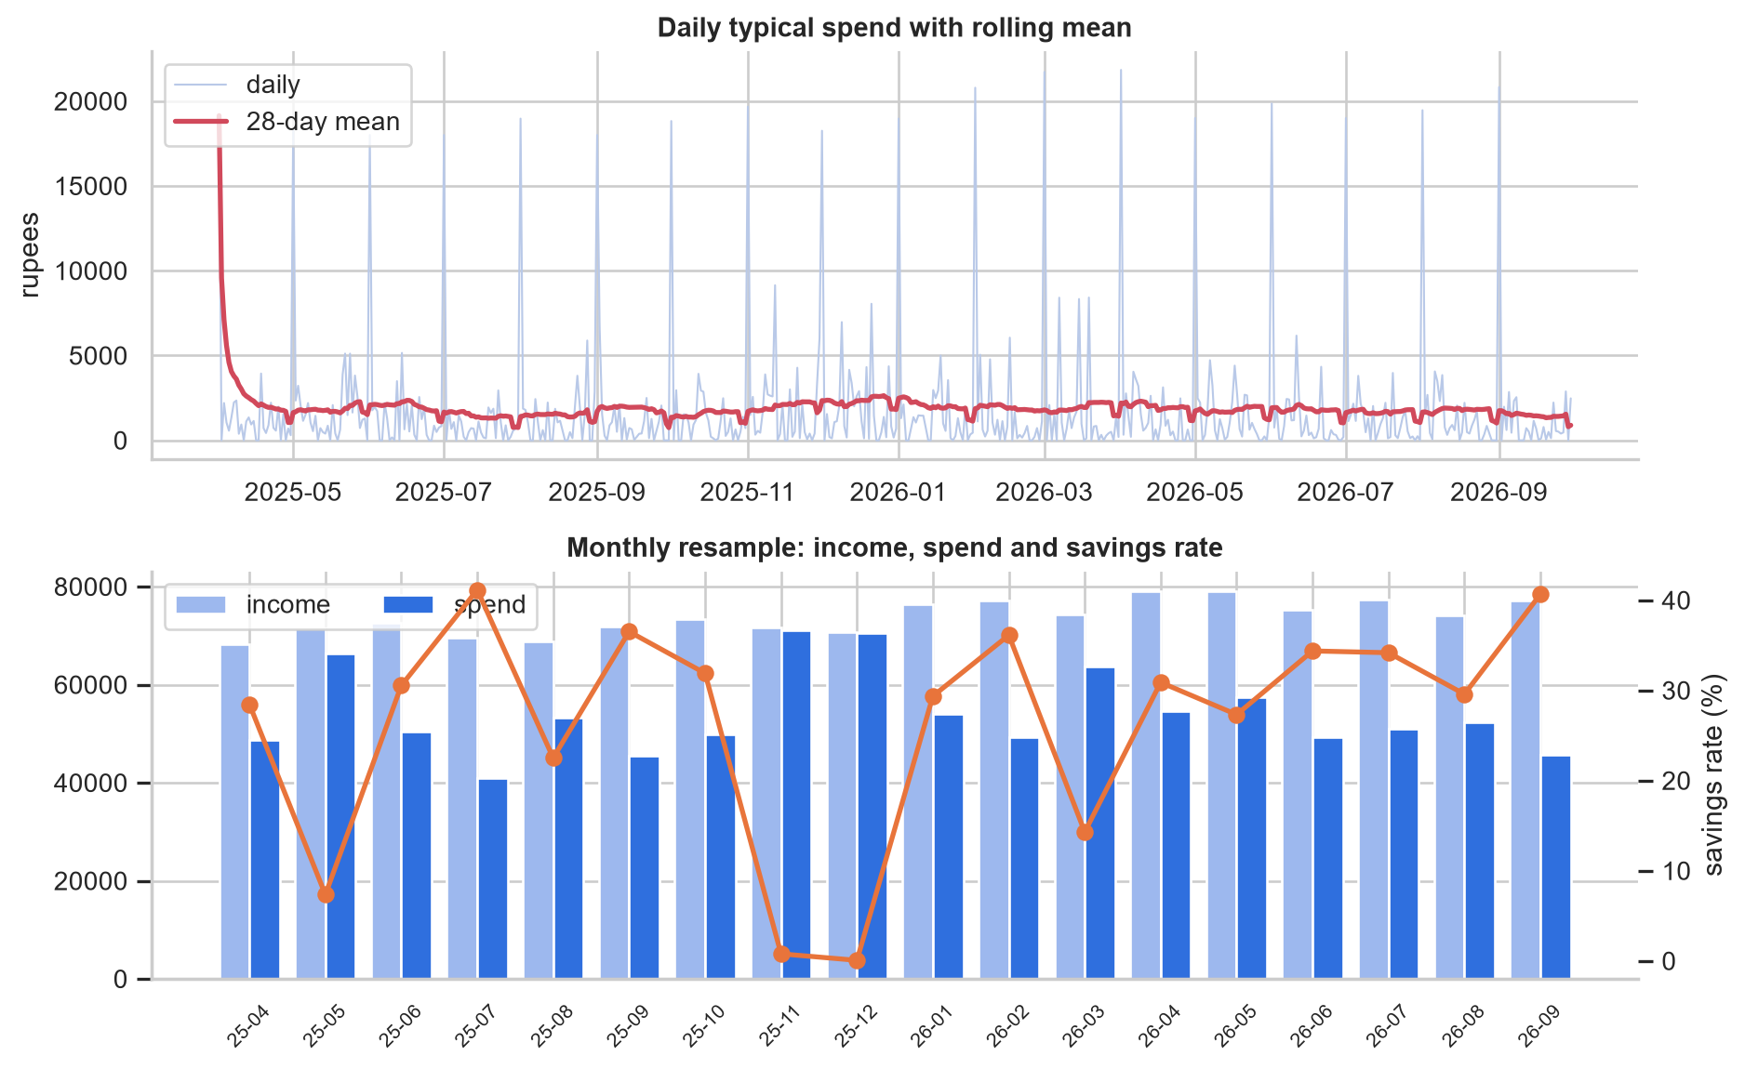
Figure 8: Daily spend with rolling mean, and monthly income, spend and savings rate

6.6 Characteristics of the series
Decomposition with a seven-day period separates trend, seasonality and residual. The weekly component ranges over Rs. 833 and peaks on Sunday. The Augmented Dickey-Fuller test gives p = 0.0000, so the series is stationary; its mean does not drift, which keeps the regression formulation simple. The autocorrelation function shows a lag-7 value of -0.02 and -0.02 at lag 1: there is essentially no serial dependence. Daily spend is therefore driven by the calendar (bill dates and weekends) rather than by momentum, which is why a calendar-feature regression is appropriate here instead of an autoregressive model.
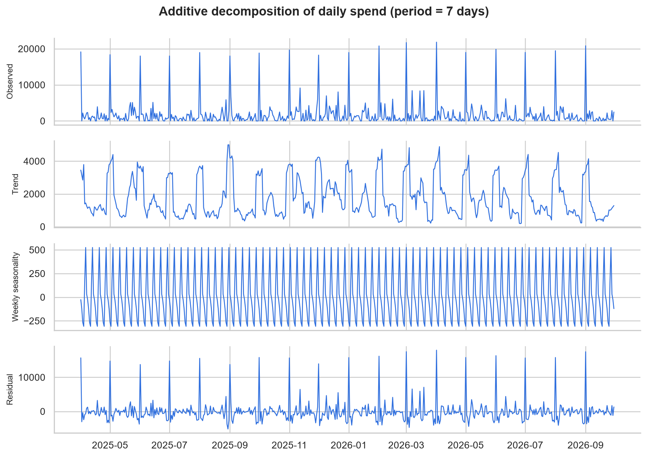
Figure 9: Additive decomposition of daily spend
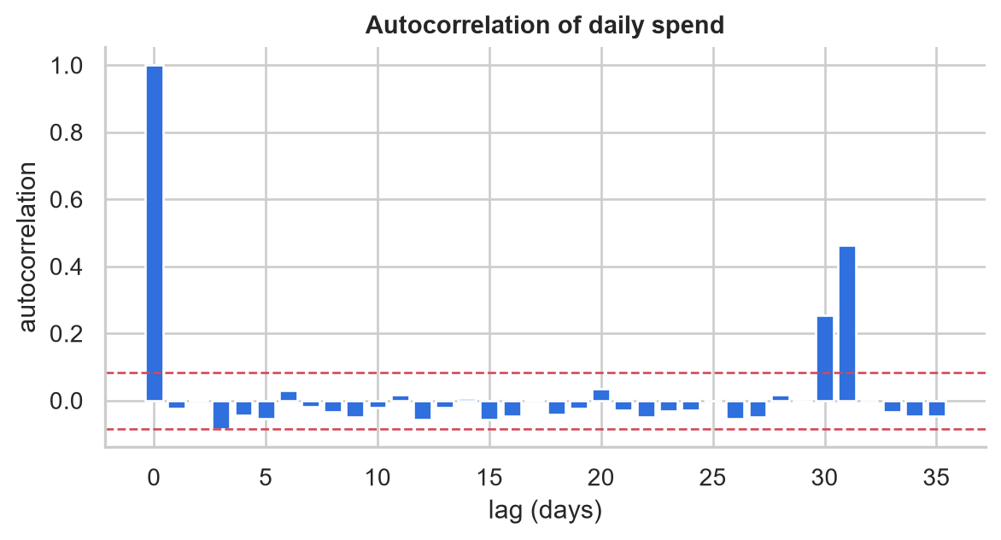
Figure 10: Autocorrelation function with 95% significance bounds

7. Data Summarisation and Visualisation

7.1 Statistical summary measures
Beyond the mean, the coefficient of variation (standard deviation over mean) summarises how predictable a category is. Rent has a coefficient of variation near zero, while shopping and travel are volatile.
Table 9: Summary statistics for the eight largest categories (rupees, including flagged one-offs)
category | mean | median | std | CV
Rent | 18,333 | 18,000 | 485 | 0.03
Shopping | 3,706 | 1,566 | 9,455 | 2.55
Food Delivery | 402 | 317 | 670 | 1.67
Travel | 7,621 | 4,474 | 12,829 | 1.68
Dining | 729 | 622 | 399 | 0.55
Utilities | 1,077 | 1,049 | 360 | 0.33
Groceries | 590 | 481 | 346 | 0.59
Subscriptions | 539 | 299 | 520 | 0.96

7.2 One-, two- and n-dimensional analysis
One-dimensional analysis studies a single variable through histograms, boxplots and summary measures (see the univariate figure in Section 6.1). Two-dimensional analysis relates pairs, as with the correlation matrix and the weekday by category matrix. n-dimensional analysis uses pivot tables with several keys, and in Sections 8 and 9 whole feature vectors.

7.3 Contingency tables
A contingency table counts transactions for each category and payment mode. The chi-square test of independence gives chi2 = 1674 on 39 degrees of freedom (p = 0) with Cramer's V = 0.71. Payment habit is therefore clearly related to category: fuel and dining lean towards cards, small daily purchases towards UPI, and rent goes through net banking.
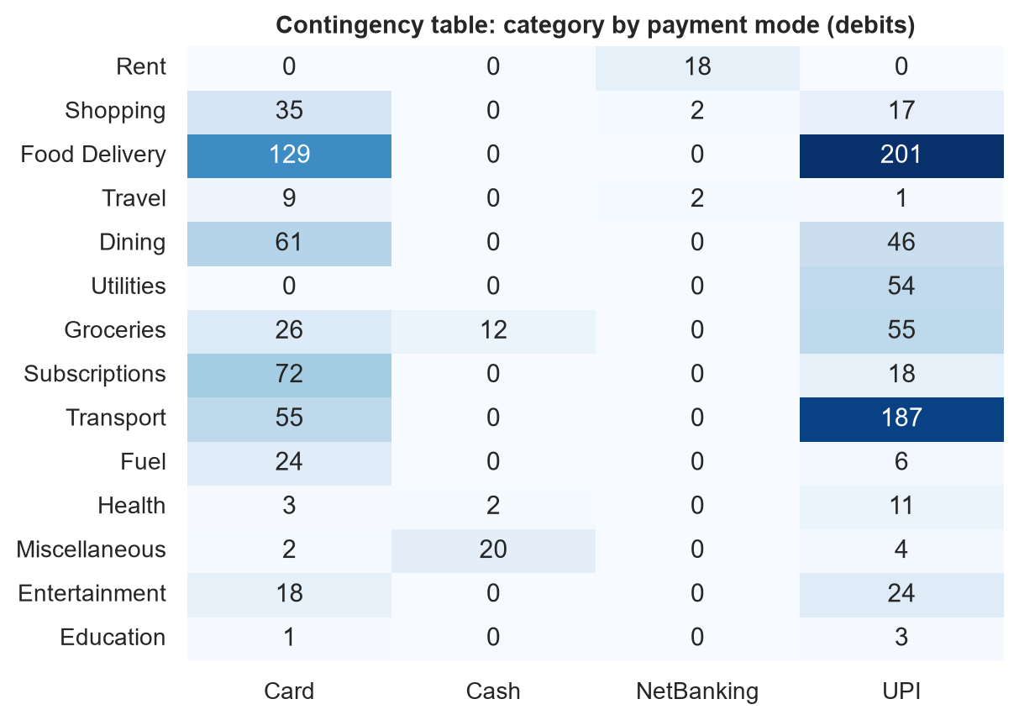
Figure 11: Contingency table of category by payment mode

7.4 Scatter plots, dot charts and bar plots
The scatter plot shows amount against day of month on a log axis, where the rent and bill cluster at the start of the month and the spread of discretionary purchases are visible. The dot chart ranks categories by total spend, which is easier to compare than a pie chart. The bar plot lists the merchants that take the most money.
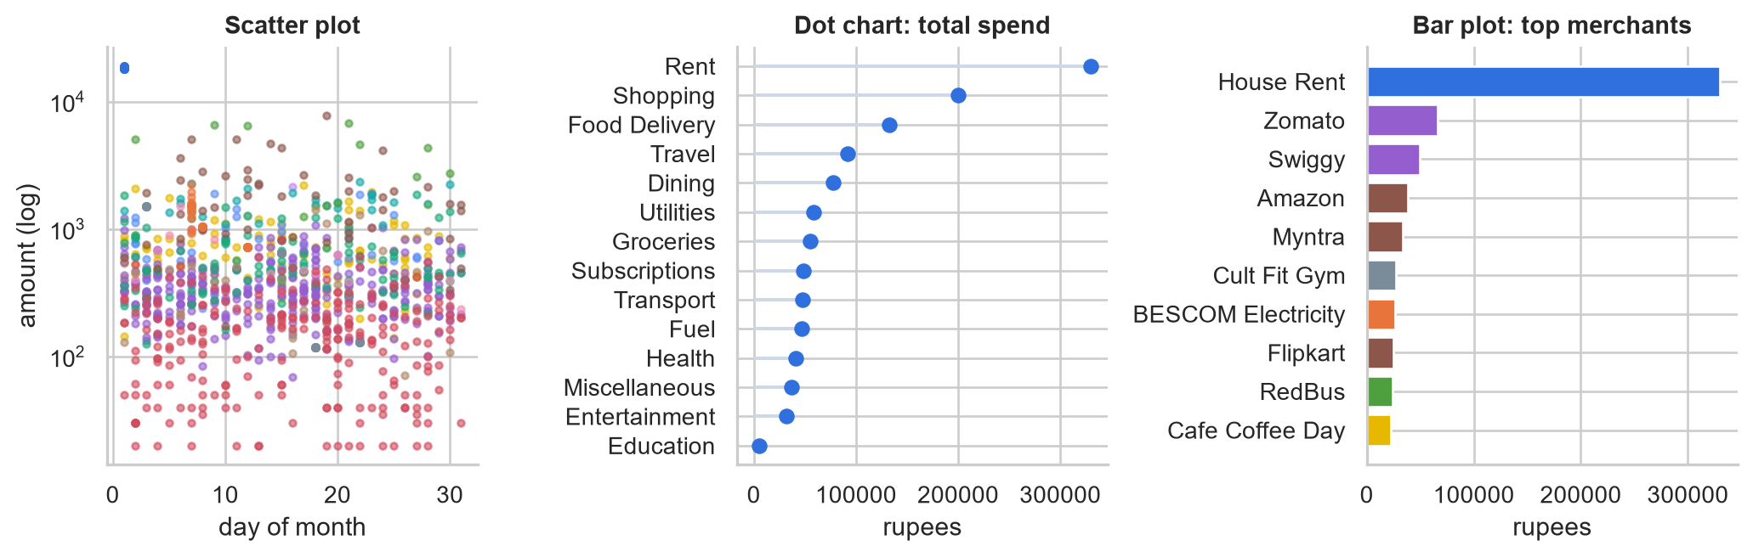
Figure 12: Scatter plot, dot chart and bar plot

8. Clustering and Outlier Detection

8.1 Merchant personas
Each of 40 merchants with at least three transactions was described by six standardised features: log transaction count, log average amount, coefficient of variation, weekend share, early-month share and share of months active. Five algorithms were compared: K-Means, spectral clustering on a nearest-neighbour graph, a Gaussian mixture fitted by the expectation-maximisation (EM) algorithm, Ward's hierarchical agglomerative clustering, and minimum-spanning-tree clustering, which removes the longest edges of the tree.
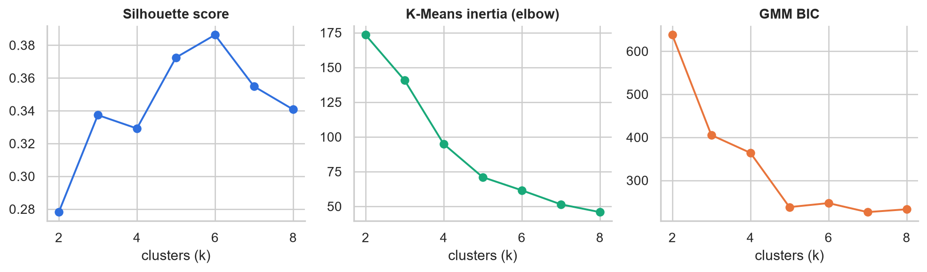
Figure 13: Choosing the number of clusters
Table 10: Cluster quality at k = 4 (higher silhouette and Calinski-Harabasz, lower Davies-Bouldin, is better)
method | clusters | silhouette | davies_bouldin | calinski_harabasz
K-Means | 4 | 0.33 | 1.03 | 18.35
Spectral | 4 | 0.28 | 1.20 | 11.88
GMM (EM) | 4 | 0.26 | 1.32 | 11.21
Hierarchical (Ward) | 4 | 0.31 | 1.03 | 17.86
MST | 4 | 0.23 | 0.60 | 4.45

K-Means gave the best balance of cohesion and separation. MST clustering has a deceptively low Davies-Bouldin value because it isolates a few distant merchants and leaves the remainder merged, which its low silhouette exposes.
Table 11: Personas found by K-Means
persona | merchants | avg txns | avg amount | CV | weekend share
Fixed recurring bills | 3 | 18.0 | 7,099 | 0.08 | 0.28
Everyday habits | 14 | 52.14 | 389 | 0.28 | 0.3
Weekend leisure and shopping | 14 | 16.64 | 1,298 | 0.57 | 0.49
Occasional essentials | 9 | 9.11 | 865 | 0.55 | 0.2

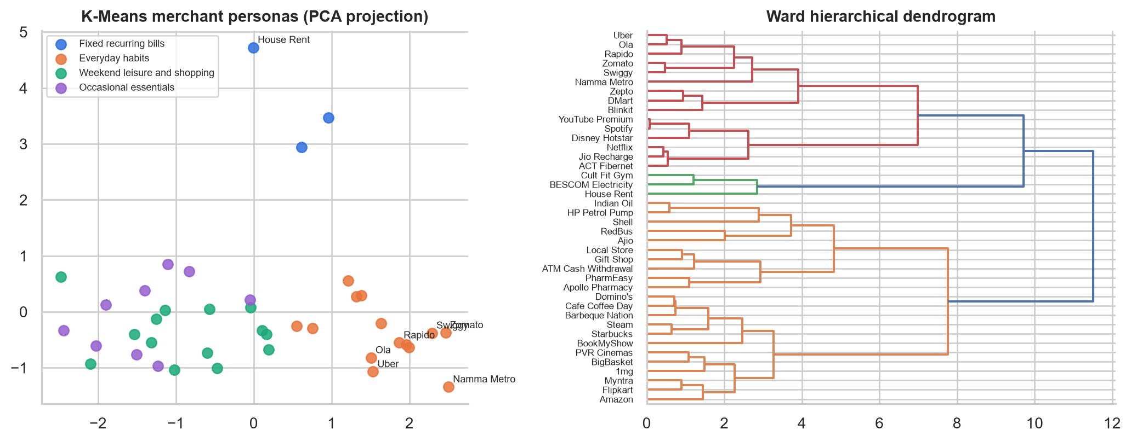
Figure 14: K-Means personas projected with PCA, and the Ward dendrogram
The personas are interpretable. Rent, the gym and electricity form a fixed-bill group with near-constant amounts. Food delivery, cabs, the metro, quick-commerce and streaming or telecom bills form an everyday-habits group with frequent, similar-sized charges. Dining, shopping and entertainment form a weekend leisure group with the highest weekend share and variable amounts. Fuel, pharmacies, cash withdrawals and local stores are occasional essentials.

8.2 Document clustering
Section 5.5 applies the same idea to text: TF-IDF vectors of the narrations are clustered and labelled by majority vote, allowing the application to categorise merchants it has never seen.

8.3 Outlier detection using clustering
Transactions are described by their log amount and a robust z-score relative to their own category (median and median absolute deviation, so that outliers do not distort the baseline). A Gaussian mixture models normal behaviour by EM, and transactions with the lowest likelihood are candidates; only unusually large debits are flagged. The K-Means variant uses the distance to the nearest centroid, and DBSCAN labels low-density points as noise. The eight injected anomalies provide ground truth.
Table 12: Outlier detection against the injected anomalies
method | flagged | caught of 8 | precision | recall
gmm | 8 | 8 | 100% | 100%
kmeans | 8 | 8 | 100% | 100%
dbscan | 8 | 8 | 100% | 100%

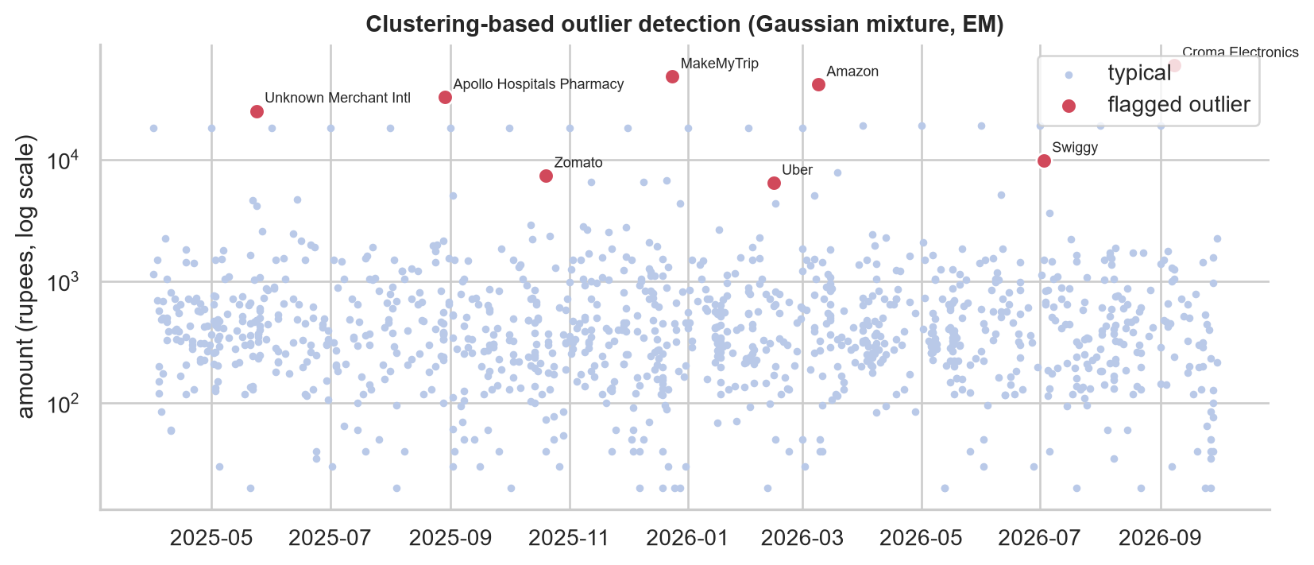
Figure 15: Debits over time with detected outliers highlighted
The mixture model flagged 8 transactions worth Rs. 228,998 in total, which are reported as one-off large spends and excluded from typical spending, forecasts and budgets.

9. Dimensionality Reduction
For this module each week is an observation and each of the 14 spending categories a variable (77 weeks), log scaled and standardised so that large categories do not dominate.

9.1 Principal component analysis
The first three components explain 37% of the variance and 12 are needed for 90%. Because many spending decisions are independent, the variance is spread across many components rather than concentrated, so the data is only moderately compressible. The loadings show that the first component contrasts going-out categories (transport, dining, entertainment) with staying-in ones (food delivery, groceries, shopping).
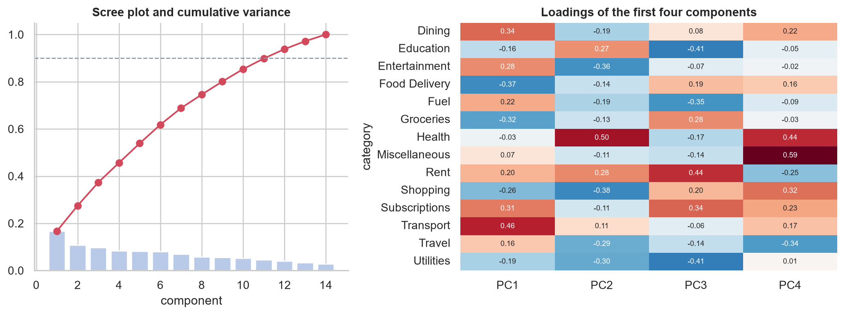
Figure 16: Scree plot and component loadings

9.2 Singular value decomposition
SVD factorises the standardised matrix as U times S times V transpose; the squared singular values equal the energy captured by each rank. A rank-12 approximation retains 90% of the energy. Because PCA of a centred matrix is its SVD, the two views agree on the explained variance.
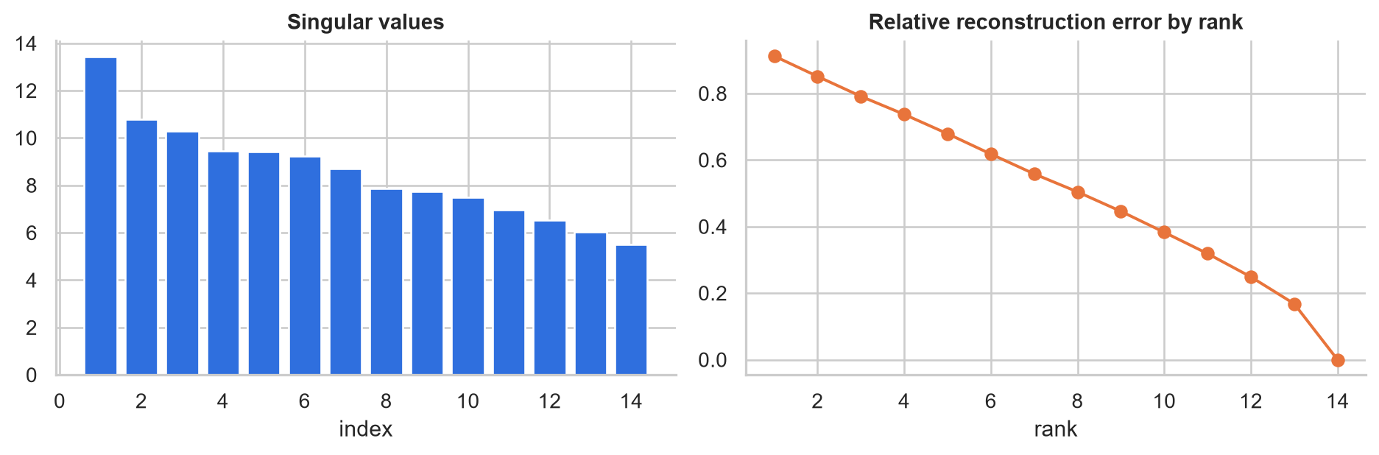
Figure 17: Singular values and reconstruction error

9.3 Factor analysis and intrinsic dimensionality
A three-factor model with varimax rotation yields interpretable latent behaviours. Factor 1 isolates shopping, which has its own seasonal driver. Factor 2 contrasts going out (dining, entertainment, transport, subscriptions) with staying in (food delivery, groceries). Factor 3 separates fixed bills (utilities against rent). Intrinsic-dimension estimates differ by method, as expected: 6 factors by the Kaiser criterion (eigenvalue above one), 8.2 by the Levina-Bickel local maximum-likelihood estimator and 12 components for 90% of the variance, against 14 observed variables. Spending is therefore driven by a handful of strong behaviours plus considerable independent variation.
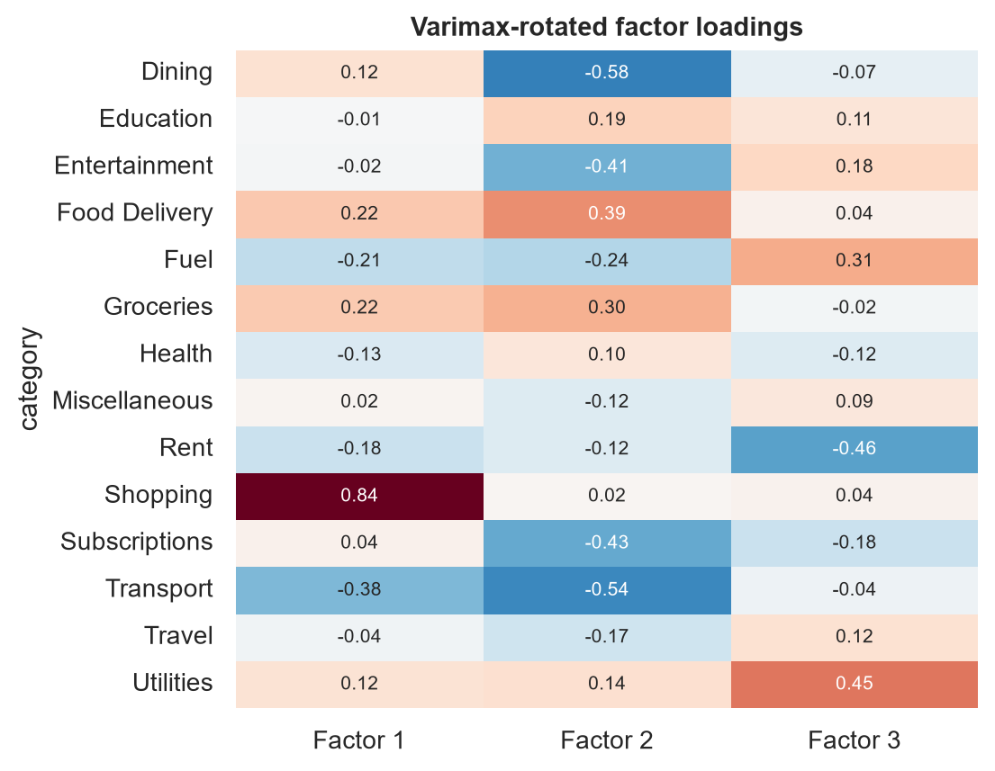
Figure 18: Factor loadings

9.4 Non-linear methods
Multidimensional scaling preserves pairwise distances, Isomap preserves geodesic distances along a neighbourhood graph, t-SNE preserves local neighbourhoods probabilistically, and a self-organising map (SOM) learns a grid of prototype vectors. Trustworthiness, the fraction of 2-D neighbours that are also true neighbours in the original space, ranks them.
Table 13: Trustworthiness of 2-D embeddings (10 neighbours)
method | trustworthiness
SOM | 0.824
t-SNE | 0.809
MDS | 0.807
Isomap | 0.771
PCA | 0.761

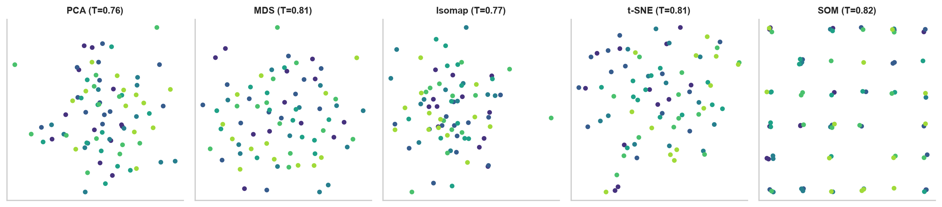
Figure 19: Two-dimensional embeddings coloured by quarter
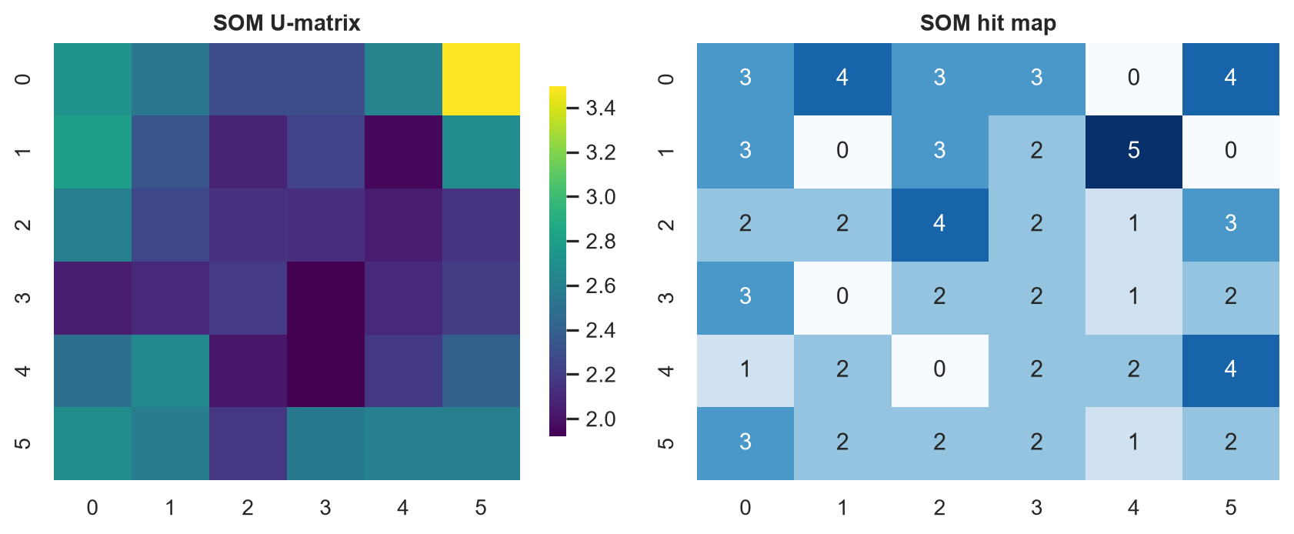
Figure 20: Self-organising map U-matrix and hit map (quantisation error 1.94)
All non-linear methods preserve neighbourhoods better than the linear PCA projection, with SOM highest, although the margins are modest, which indicates only mild curvature in the data.

10. Model Development and Evaluation

10.1 Constructing the linear regression model
The target is daily typical spend. The design matrix contains the amount of recurring bills expected on that date (from the recurring-payment detector), weekday indicators, an early-month flag and a linear trend. Using known bills as a feature lets the model concentrate on the variable part of spending. The last 90 days were held out in chronological order, and time-series cross-validation with five expanding folds checked stability.
Table 14: Ordinary least squares coefficients (training period)
term | coefficient | std_error | p_value
const | 799.4 | 211.6 | 0.000
scheduled_bills | 1.0 | 0.0 | 0.000
dow_Tue | 33.1 | 245.0 | 0.893
dow_Wed | -36.7 | 244.9 | 0.881
dow_Thu | 20.9 | 245.0 | 0.932
dow_Fri | 6.4 | 245.9 | 0.979
dow_Sat | 474.1 | 246.1 | 0.055
dow_Sun | 619.4 | 245.8 | 0.012
early_month | -134.4 | 167.7 | 0.423
trend_months | 10.0 | 14.9 | 0.500

The coefficient on scheduled bills is 1.02, essentially one, as it should be. Weekend days add roughly Rs. 619 on Sundays over Mondays (p = 0.012), which is the quantified weekend effect. The Durbin-Watson statistic is 1.91.

10.2 Evaluation and understanding accuracy
Table 15: Held-out performance (rupees)
model | MAE | RMSE | R2 | wMAPE | accuracy
Daily, linear regression | 859 | 1,058 | 0.88 | 60% | 40%
Weekly, linear regression | 3,102 | 3,767 | 0.72 | 34% | 66%
Daily, mean baseline | 1,614 | 3,045 | -0.02 | 113% | 0%

R2 is the share of variance explained; zero means no better than predicting the training mean. The baseline scores -0.02, while the model reaches 0.88 daily and 0.72 weekly. Accuracy here is one minus weighted MAPE: daily spend is inherently noisy (40%), but errors partly cancel when summed, giving 66% for weeks. Reporting both avoids the misleading impression that a single number gives.
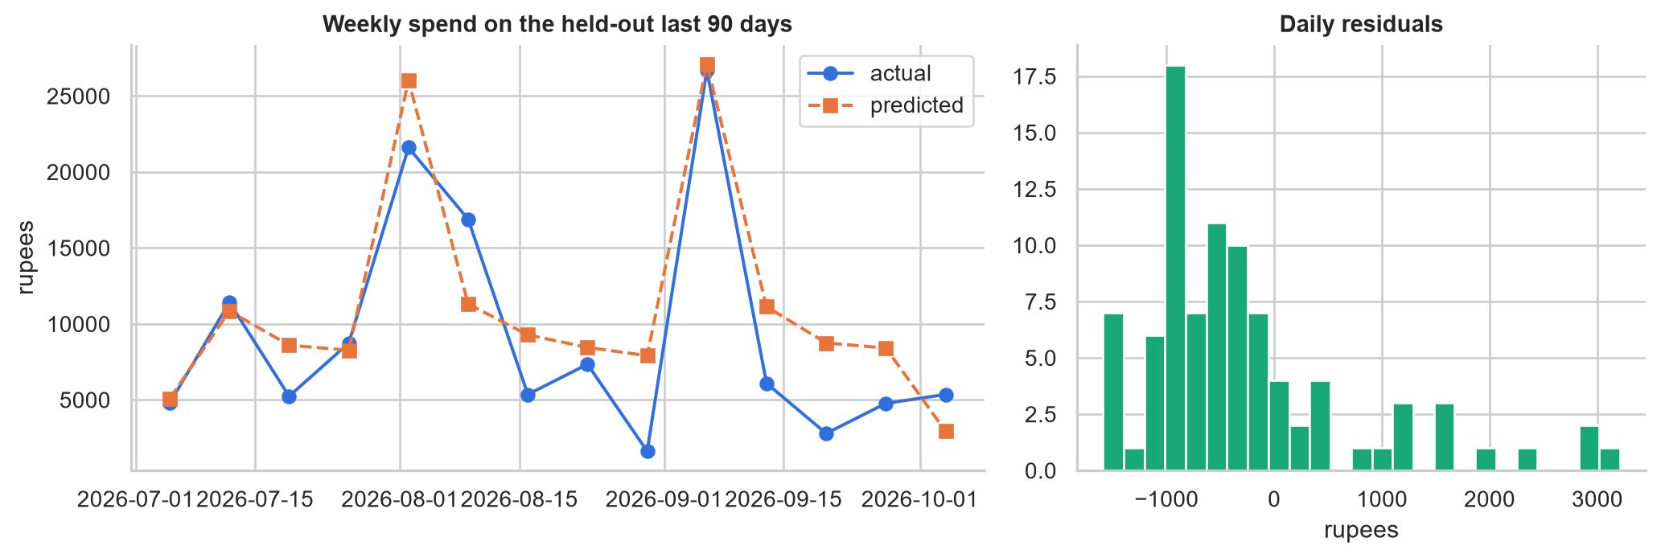
Figure 21: Weekly predictions on held-out data and residual distribution

10.3 Forecasting next month
A rolling-origin backtest forecasts each of the last complete months using only earlier data and compares the monthly total with the truth. Holt-Winters exponential smoothing with weekly seasonality, the regression model, their average and a naive last-30-days baseline were compared; Holt-Winters had the lowest error and every model beat the naive baseline. The application reports the average of regression and Holt-Winters so that the regression's interpretable drivers inform the figure. For the next 30 days the application reports Rs. 51,202, with an 80% range of Rs. 41,854 to Rs. 60,551.
Table 16: Backtest error on monthly totals (mean absolute percentage error)
model | MAPE_%
holt_winters | 6.5
ensemble | 10.8
linear_regression | 15.2
naive | 21.8

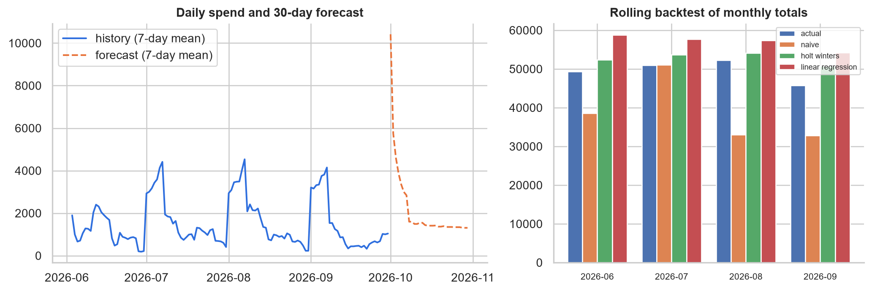
Figure 22: Thirty-day forecast and monthly backtest

10.4 Reinforcement learning: nudges as a bandit
Supervised learning learns from labelled examples; the correct answer is known for every training row. Reinforcement learning (RL) instead learns from the consequences of its own actions: an agent chooses, receives a reward, and must balance exploring unknown options with exploiting the best known one. Choosing which saving tip to show a user is exactly this problem, a multi-armed bandit, because feedback arrives only for the tip shown.
Table 17: Candidate tips, ranked by expected monthly saving (rupees)
tip | category | avg monthly spend | acceptance | expected saving
Cap food-delivery orders at a monthly limit | Food Delivery | 6,419 | 55% | 706
Apply a 24-hour wait rule before online purchases | Shopping | 5,551 | 45% | 500
Cancel subscriptions you rarely use | Subscriptions | 2,696 | 60% | 485
Cook at home two extra days a week | Dining | 4,333 | 35% | 379
Replace short cab rides with metro or walking | Transport | 2,298 | 50% | 287
Plan a weekly grocery list | Groceries | 3,049 | 65% | 198
Carpool or combine fuel trips | Fuel | 2,583 | 40% | 155

The arm's success probability is its acceptance rate times its potential saving, normalised. Four policies were simulated for 400 rounds averaged over 60 runs: random choice, epsilon-greedy, UCB1 (optimism in the face of uncertainty) and Thompson sampling (sampling from Beta posteriors, a Bayesian approach).
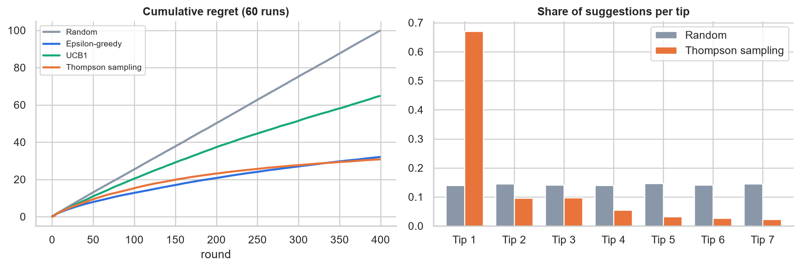
Figure 23: Cumulative regret and how often each tip is suggested
After 400 rounds the cumulative regret was 100 for random choice, 65 for UCB1, 31 for Thompson sampling and 32 for epsilon-greedy. The learning policies concentrate their suggestions on the tip with the highest expected saving, 'Cap food-delivery orders at a monthly limit', whereas random choice spreads suggestions evenly. The acceptance rates are modelled assumptions standing in for user feedback, which a deployed system would collect.

10.5 Applications of reinforcement learning
The same pattern appears widely: recommender systems and ad selection (bandits), dynamic pricing, portfolio and inventory management, energy-grid control, robotics and game playing (deep RL), and personalised health interventions. In personal finance it can adapt reminders, savings-goal schedules and alert thresholds to the individual rather than applying one rule to everyone.

11. Application and Deployment
The dashboard has nine sections: Overview (key indicators, income against spend, category mix, recurring payments, unusual transactions and a budget check), Data preparation, Explore, Time series, Patterns and anomalies, Dimensionality, Forecast and model, Smart nudges and About. The sidebar chooses the data source and three settings: the missing-amount strategy, the outlier detector and its sensitivity.
For the latest complete month (2026-09) the overview reports spend of Rs. 45,741, income of Rs. 77,087 and a savings rate of 41%. The recurring-payment detector found 9 steady monthly charges costing Rs. 287,299 a year, including every subscription.
Table 18: Recurring payments detected
merchant | category | typical_amount | annual_cost
House Rent | Rent | 18,000 | 216,000
Cult Fit Gym | Subscriptions | 1,500 | 18,000
BESCOM Electricity | Utilities | 1,478 | 17,731
ACT Fibernet | Utilities | 1,049 | 12,588
Jio Recharge | Utilities | 719 | 8,628
Netflix | Subscriptions | 649 | 7,788
Disney Hotstar | Subscriptions | 299 | 3,588
YouTube Premium | Subscriptions | 129 | 1,548
Spotify | Subscriptions | 119 | 1,428

11.1 Quality assurance
Eighteen automated tests check merchant normalisation, payment-mode inference, deduplication, flexible statement loading, binning, MLE imputation, outlier recall, statistical tests, clustering, text categorisation, dimensionality reduction, regression accuracy and the bandit's learning behaviour. Every page of the application was also exercised headlessly with Streamlit's testing framework.

11.2 Deployment
The repository is deployable on Streamlit Community Cloud directly from GitHub by selecting app.py as the entry point; the pinned dependencies are listed in requirements.txt. Analysis runs inside the user's session and uploaded statements are not written to disk.

12. Contemporary Issues
- Privacy. Bank statements are among the most sensitive personal data. SpendSense processes uploads in memory only and the sample statement is synthetic. A production system would add encryption and on-device processing.
- Data quality and bias. Models trained on one user's habits may not generalise, and merchant dictionaries reflect the markets they were built for. Transparency about repairs, as in the cleaning report, lets users judge.
- Explainability. Linear coefficients, named personas and plain-language insights were chosen over opaque models so that advice can be justified.
- Responsible advice. Nudges are suggestions, not financial advice; the bandit's rewards are simulated here and real deployment requires consent and care that tips do not cause harm.
- Synthetic data. Synthetic data protects privacy and gives ground truth, but results should be validated on real statements before drawing behavioural conclusions.

13. Results and Discussion
Table 19: Summary of results
Component | Key result
Data cleaning | 31 duplicates removed; all 153 blanks filled
Imputation | MLE MAE Rs. 476 vs mean Rs. 1,256
Time series | weekly peak on Sunday; ADF p = 0.000
Clustering | 4 personas, best silhouette 0.33
Outliers | 8 of 8 anomalies caught, precision 100%
Dimensionality | 12 components for 90% variance; best embedding SOM
Regression | daily R2 0.88; weekly accuracy 66%
Bandit | regret 31 (Thompson) vs 100 (random)

Three lessons stand out. First, preparation determines everything downstream: resolving merchants and repairing amounts made the later analyses meaningful. Second, honest evaluation matters; daily spend is noisy and the report shows both daily and weekly accuracy rather than selecting the flattering one. Third, simple, interpretable methods applied with domain knowledge, such as including known bills in the regression, beat more elaborate approaches. Limitations are that the evaluation data is synthetic, the statement covers a single person, and the bandit's feedback is simulated.

14. Conclusion and Future Work
SpendSense demonstrates that the exploratory data analysis toolbox, from deduplication to reinforcement learning, can be assembled into a practical tool that answers an everyday question. It cleans messy statements, explains behaviour, spots anomalies, forecasts and advises, all in an interactive application.
- Validate on anonymised real statements and add bank-specific parsers.
- Learn merchant categories continuously from user corrections.
- Collect genuine accept or ignore feedback to drive the bandit, and add contextual features.
- Support budgets and goals with alerts, and multi-account views.

References
Tukey, J. W. (1977). Exploratory Data Analysis. Addison-Wesley.
Hastie, T., Tibshirani, R., Friedman, J. (2009). The Elements of Statistical Learning. Springer.
McKinney, W. (2022). Python for Data Analysis, 3rd ed. O'Reilly.
Levina, E., Bickel, P. (2004). Maximum likelihood estimation of intrinsic dimension. NIPS.
Kohonen, T. (2001). Self-Organizing Maps. Springer.
Sutton, R. S., Barto, A. G. (2018). Reinforcement Learning: An Introduction, 2nd ed. MIT Press.
Hyndman, R. J., Athanasopoulos, G. (2021). Forecasting: Principles and Practice, 3rd ed. OTexts.
Pedregosa, F. et al. (2011). Scikit-learn: Machine learning in Python. JMLR 12.
Seabold, S., Perktold, J. (2010). Statsmodels: Econometric and statistical modeling with Python. SciPy.

Appendix A: Syllabus Coverage
Table 20: Mapping from syllabus to report
Module | Topic | Where covered
1 | EDA steps, data types, scales, tools | Sections 2, 7.1; Explore tab
2 | Deduplication, replacing values, binning | Sections 5.1, 5.2
2 | Missing data and MLE | Sections 5.3, 5.4
3 | Uni-, bi-, multivariate analysis | Section 6.1 to 6.3
3 | Time series, indexing, resampling | Sections 6.4 to 6.6
4 | Summary measures, contingency tables, plots | Section 7
5 | Spectral, EM, hierarchical, MST, document clustering | Sections 8.1, 8.2
5 | Outlier detection using clustering | Section 8.3
6 | PCA, SVD, factor analysis, intrinsic dimension | Sections 9.1 to 9.3
6 | MDS, manifold learning, SOM | Section 9.4
7 | Linear regression, evaluation, accuracy | Sections 10.1 to 10.3
7 | Reinforcement learning and applications | Sections 10.4, 10.5
8 | Contemporary issues | Section 12

Appendix B: Repository Structure
SpendSense/
app.py Streamlit application
spendsense/ analysis package
tests/ automated tests
data/sample_transactions.csv sample statement
report/ report builder and figures
requirements.txt dependencies
.streamlit/config.toml theme and server settings

