BCSE102L Structured and Object Oriented Programming

PROJECT REPORT
on

MediTrack: An Offline Medicine Dose Reminder, Overdose Guard and Stock Tracker Using Object-Oriented C++

Prepared by

Keshav Gujrathi - 23BDS0225

Under the supervision of
Dr. Ramesh Babu Vemuluri,
Associate Professor,



School of Computer Science and Engineering
Vellore Institute of Technology, Vellore.

October 31, 2026
Table of Contents
Abstract
1. Introduction
1.1 Domain Information
1.2 Software Libraries Used
1.3 Contributions by Team Members
1.4 Challenges Faced
1.5 Scientific / Technical Principle Note
2. Literature and Reference Log
3. Concept Sketches, Equations, and Models
3.1 Concept Sketches
3.2 Equations
3.3 Models
4. Feasibility Calculation Sheet
5. Problem Statement and Objectives
5.1 Problem Statement
5.2 Objectives
6. Use Case and Stakeholder Definition
6.1 Use Cases
6.2 Stakeholders
7. Functional / Performance Requirement Sheet
8. Analytical and Desk Study Report
8.1 Failure-mode analysis
8.2 Decision-rule analysis
8.3 Algorithm and data-structure analysis
8.4 Why the models are appropriate
9. Component Identification and Characterization Sheet
9.1 Components
9.2 Syllabus coverage
10. First-Pass Performance Prediction Document
11. Early Simulation Output (Feasibility Evidence)
12. Initial Qualitative Risk List
13. Lab Test / Simulation Report for Critical Functions
13.1 Test setup
13.2 Console output of the simulated day
13.3 Test cases and results
13.4 Key code snippets
14. Analytical Model Validation Document
14.1 Supply forecast
14.2 Adherence model
14.3 Safety invariant
14.4 Validation summary
15. Conclusion
References
Appendix A: Complete Source Code (MediTrack.cpp)

Abstract
Missed, doubled and mistimed doses are among the most common and most avoidable causes of treatment failure at home, and a patient who takes several medicines must also keep track of how much of each one is left. This project presents MediTrack, an offline console application written in C++ that converts a list of prescriptions into a sorted daily dose schedule, follows a simulated clock, and reacts to what the user does. Every prescription is checked against a safe daily limit, medicines that share an active ingredient or are known to clash are flagged, a dose that is not due cannot be logged (an overdose guard), a late dose is classified as "take now" or "skip" using a half-interval rule, and a refill alert is raised when fewer than three days of medicine remain. The implementation combines C-style structures, recursion, pointer arithmetic and dynamic memory with classes, inheritance, polymorphism, operator and function overloading, templates, the STL, exception handling and file persistence, so that every module of the BCSE102L syllabus is exercised. A scripted one-day scenario, an adherence simulation of 2,000 virtual patients and a 5,000-day overdose-guard test are used to check that the program behaves as specified.

1. Introduction
Taking the right medicine, in the right quantity, at the right time sounds trivial, yet it is one of the hardest everyday routines to sustain. A student living in a hostel, an office worker on a tight schedule, or an elderly parent on four different tablets all depend on memory alone to decide whether the 2 p.m. tablet has been taken, whether it is safe to take another, and whether there are enough tablets left for the weekend. When memory fails, the result is a skipped dose, a double dose, or an empty strip discovered at midnight.
MediTrack is a small, dependable program that removes these decisions from memory and places them in code. The user enters each prescription once. From then on the program builds the day's schedule, tells the user what is due, stops doses that should not be taken, explains what to do about a missed dose, and warns early when a medicine is running out. It needs no internet connection, no account and no special hardware, and it keeps all data in one local text file.
The project is deliberately modest in size so that its behaviour can be reasoned about and tested completely, while still being a realistic piece of software: a class hierarchy for medicines, a planner engine that owns the objects and makes the decisions, and a thin console layer for input and output.

1.1 Domain Information
Medication adherence. Adherence means taking a medicine as prescribed: the correct dose, at the correct interval, for the whole course. The World Health Organization reports that in developed countries only about half of patients with chronic illness follow their long-term treatment as recommended [1]. Poor adherence is linked to avoidable complications, repeat hospital visits and higher cost [2], [3]. Typical failure modes are forgetting a dose (omission), repeating a dose (commission), taking a dose at the wrong time, and running out of stock without noticing.
Everyday context. Many common medicines are sold under several brand names with the same active ingredient. For example, paracetamol is marketed under numerous brands, so a person may unknowingly take two products that both contain it. Patients with long-term conditions such as diabetes or high blood pressure may need two to four medicines every day for years, which makes a simple tracker valuable.
Software domain. MediTrack belongs to the class of small rule-based decision-support utilities. It uses discrete-event scheduling (a list of timed events that is processed as a clock advances), validation rules, and report generation. It is an educational tool: its guidance follows general rules printed on patient leaflets and is not a substitute for advice from a doctor or pharmacist.

1.2 Software Libraries Used
The program uses only the ISO C++17 standard library, so it builds on any platform with a standard compiler.
Table 1: Libraries and tools
Library / Tool | Used for
<iostream>, <iomanip> | Console input and output; column formatting with setw and left
<fstream>, <sstream> | Saving and loading meditrack.dat; building description strings and parsing records
<vector>, <string> | Dynamic arrays of medicines and dose events; text handling
<algorithm> | stable_sort for the schedule, sort for stock ranking, min_element, max
<cstdio>, <cctype> | C-style snprintf/sscanf for formatting and parsing times; tolower
<stdexcept> | invalid_argument for rejected prescriptions; exception handling in the menu
g++ / any C++17 compiler | Building the program (g++ -std=c++17 -Wall -o meditrack MediTrack.cpp)
Python 3 with NumPy and Matplotlib | Used only for analysis: figures, the adherence simulation and the guard simulation. Not part of the product.

1.3 Contributions by Team Members
This is an individual project. Keshav Gujrathi (23BDS0225) carried out all stages of the work: identifying the problem, studying the literature, designing the class hierarchy and algorithms, implementing the program in C++, preparing the test scenarios and simulations, and writing this report.

1.4 Challenges Faced
Representing time. A dose schedule crosses midnight easily (22:00 plus six hours). Storing time as minutes since midnight and stopping the recursion at 1440 minutes kept each day self-contained and avoided wrap-around bugs.
Deciding what to do about a missed dose. A rule that is too generous can cause a double dose. A conservative half-interval rule was chosen, and the program always prints "never double up".
Preventing double logging. Allowing the user to log a dose at any time would defeat the purpose. The solution is to tie every log entry to a scheduled event, so the number of doses logged in a day can never exceed the number prescribed.
Memory ownership. The planner owns its medicine objects through raw pointers. A destructor releases them and the copy constructor is deleted, which prevents double deletion.
Making the demonstration repeatable. A real clock would make output differ on every run, so the planner uses a simulated clock that the user (or the demo script) advances explicitly.
Keeping the scope under control. Features such as notifications, a drug database and a graphical interface were deliberately left out in favour of a smaller program whose every branch is tested.

1.5 Scientific / Technical Principle Note
MediTrack rests on five simple principles.
Periodic event generation. If a medicine is taken n times a day with a gap of g minutes starting at t₁, the dose times are t_{k} = t₁ + (k - 1)g. The program generates them recursively and drops any that fall after midnight.
Discrete-event processing. Doses are events sorted by time. Moving the clock forward changes the state of every event whose window has closed from Pending to Missed or Skipped.
Rule-based decision support. The take-or-skip rule compares the time to the next dose with half of the dosing interval. This mirrors the common leaflet advice that a missed dose should be skipped if it is nearly time for the next one.
Invariant-based safety. A prescription is accepted only if dose x doses per day does not exceed the declared safe daily limit, and a dose can be logged only against an unresolved scheduled event. Together these guarantee that logged doses per day never exceed the prescribed count.
Supply analysis. Days of medicine left equals stock divided by daily consumption. A threshold of three days triggers a refill alert and a seven-day refill suggestion.
The program is a decision aid and not a medical device. Its rules are intentionally conservative and every warning ends with the instruction to follow the doctor's advice.

2. Literature and Reference Log
The literature was reviewed from two angles: the clinical and behavioural evidence on why adherence fails and what helps, and the programming references on which the implementation rests. Table 2 summarises each source and what it contributed to the design of MediTrack.
Table 2: Literature and reference log
Ref. | Source | Key point | Use in MediTrack
[1] | World Health Organization (2003), Adherence to Long-Term Therapies: Evidence for Action | In developed countries adherence to long-term therapy averages about 50%; poor adherence reduces treatment benefit and raises cost. | Establishes the size of the problem and motivates a tool for ordinary home users.
[2] | Osterberg and Blaschke (2005), Adherence to medication, N Engl J Med 353:487-497 | Reviews causes of non-adherence (forgetfulness, complex regimens, cost) and supports simplification and reminders. | Forgetfulness is modelled directly as a per-dose probability in the adherence simulation.
[3] | Brown and Bussell (2011), Medication adherence: WHO cares?, Mayo Clin Proc 86:304-314 | Discusses barriers to adherence and practical strategies such as simpler schedules and reminders. | Supports the single daily schedule view and the concise alerts.
[4] | Nieuwlaat et al. (2014), Interventions for enhancing medication adherence, Cochrane Database Syst Rev CD000011 | Interventions found were often complex and gave modest improvements. | Motivates a simple, low-cost, low-effort tool rather than a complex system.
[5] | Vervloet et al. (2012), Effectiveness of electronic reminders for chronic medication, J Am Med Inform Assoc 19:696-704 | Most studies of electronic reminders reported improved adherence, with effects that vary between studies. | Supports a reminder-centred design; the effect size is treated as an assumption, not a claim.
[6] | Stroustrup (2013), The C++ Programming Language, 4th ed. | Authoritative reference for classes, virtual functions, templates and the standard library. | Class hierarchy, abstract classes, Stats<T>, STL usage.
[7] | Kernighan and Ritchie (1988), The C Programming Language, 2nd ed. | Reference for structured programming, pointers, arrays and strings in C. | Recursion, pointer arithmetic, struct, snprintf/sscanf helpers.
[8] | ISO/IEC 14882:2017, Programming languages - C++ | Defines the language and library behaviour used by the program. | Language level (C++17), stable_sort, inheriting constructors.

Review of existing approaches
Everyday solutions fall into four groups: paper or plastic pill organisers, phone alarms, commercial reminder apps, and dedicated dispensing hardware. Pill organisers help with sorting but do not remind. A phone alarm reminds but knows nothing about doses, stock or interactions, so it cannot say whether a dose is still safe to take. Commercial reminder apps such as Medisafe and MyTherapy provide reminders and logs, but they are generally smartphone-based and many of their features depend on an online account. Dispensing hardware is effective but specialised. The comparison in Table 3 is the author's qualitative assessment of these approaches against the features this project targets.
Table 3: Qualitative comparison of approaches (author's assessment)
Feature | Pill organiser | Phone alarm | Typical reminder app | MediTrack
Time reminder | No | Yes | Yes | Yes
Blocks a dose that is not due | Partly (physical) | No | Rarely | Yes
Advice on a missed dose | No | No | Sometimes | Yes (take or skip)
Stock forecast and refill alert | No | No | Sometimes | Yes
Same-ingredient / clash warning | No | No | Sometimes | Yes (rule table)
Works fully offline | Yes | Yes | Often needs internet | Yes
Needs account or hardware | No | No | Often an account | No

Gap addressed
The literature shows that adherence is a large and persistent problem and that simple reminders help, but existing everyday tools stop at reminding. None of the approaches in Table 3 combines, in one offline tool, a safe-limit check, an overdose guard, missed-dose guidance and stock forecasting. MediTrack targets exactly this combination.

3. Concept Sketches, Equations, and Models

3.1 Concept Sketches
Figure 1 shows the layered architecture. User input passes through a validation layer that creates medicine objects, the planner engine makes all decisions, and results go to the console or to a file. Figure 2 is the class diagram that realises this design.
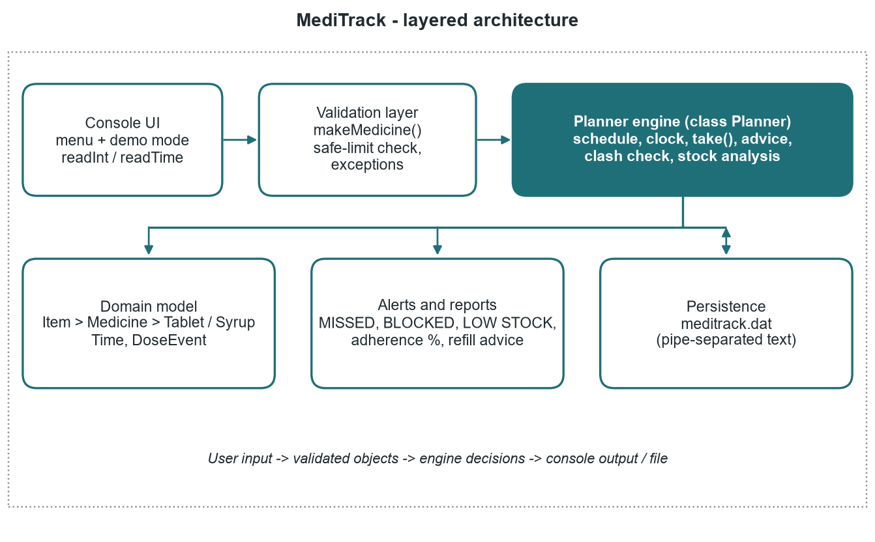
Figure 1: Layered architecture of MediTrack
The class design uses one abstract base class for the common behaviour of all medicines and small derived classes for the differences. Planner owns the medicines, builds a list of dose events that point back to them, and uses the template class Stats<T> for supply statistics.
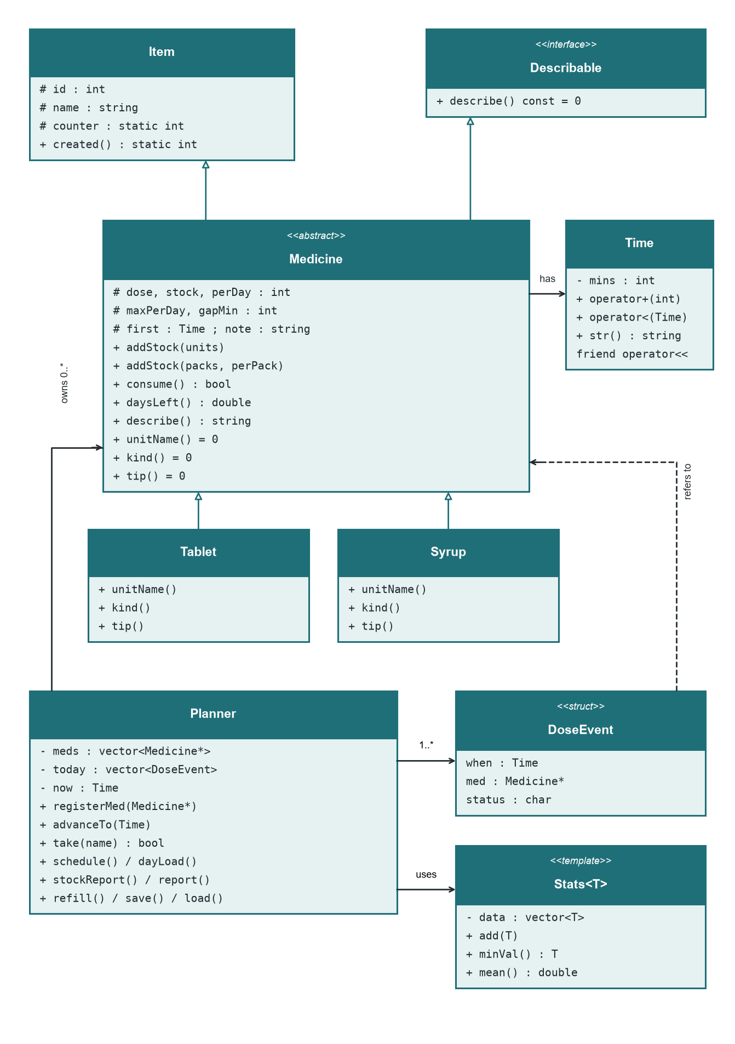
Figure 2: UML class diagram
Two flowcharts describe the two decision procedures at the heart of the program. Figure 3 follows a request to log a dose. Figure 4 follows a clock advance, which is where missed doses are detected and classified.
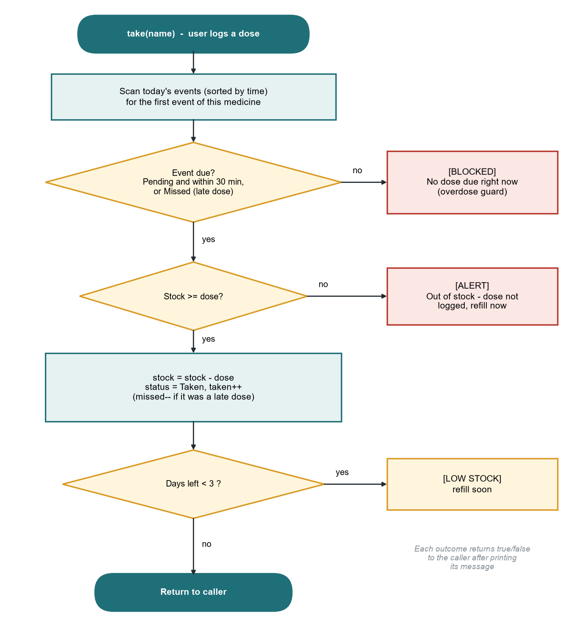
Figure 3: Flowchart of logging a dose, take(name)
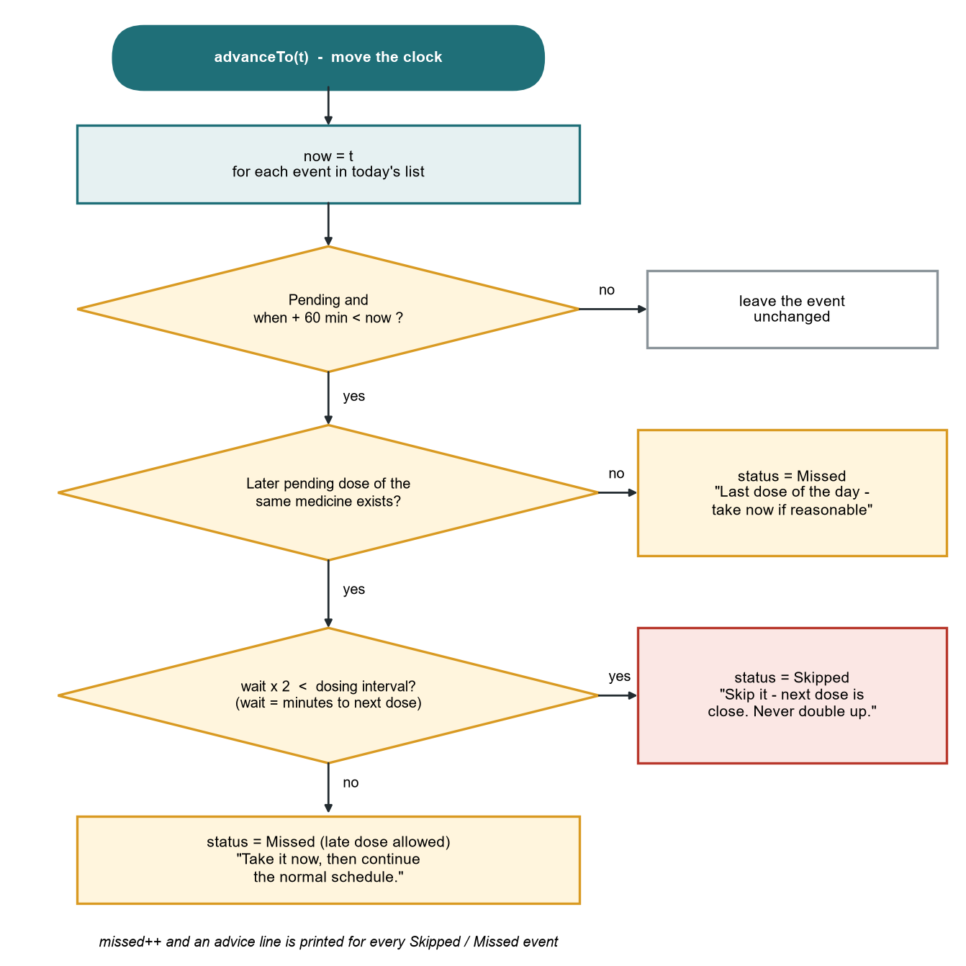
Figure 4: Flowchart of advancing the clock, advanceTo(t)

3.2 Equations
The notation is: d dose per intake, n doses per day, g interval between doses in minutes, t₁ time of the first dose in minutes after midnight, S stock in units, G = 60 minutes grace period, E = 30 minutes early window, M_{max} the safe daily limit in units.
t_{k} = t₁ + (k - 1)·g, k = 1, 2, …, n, with t_{k} < 1440 (1)
Equation 1 generates the dose times. Doses that would fall after midnight are discarded so that each day is independent.
A dose scheduled at t_{e} becomes Missed when now > t_{e} + G (2)
A dose may be logged when (status = Pending and t_{e} ≤ now + E) or status = Missed (3)
Equations 2 and 3 define the life of a dose event. The early window E lets a patient take a dose slightly before the exact time; the grace period G is how long a dose stays Pending after its scheduled time.
w = max(0, t_{next} - now); Skip if 2w < g, otherwise Take now (4)
Equation 4 is the missed-dose rule. If the time w to the next dose of the same medicine is less than half of the interval, the missed dose is skipped; otherwise it may be taken late. With g = 360 minutes the threshold is 180 minutes, and with g = 720 minutes it is 360 minutes.
D = S / (d·n) (5)
R = 7·d·n - S (suggested when D < 3 days) (6)
Equations 5 and 6 give the days of medicine left and the refill needed to cover a week.
A = 100·T / (T + M) (7)
Equation 7 is the adherence percentage for the day, where T is the number of doses taken and M the number missed or skipped. Pending doses are excluded until they resolve.
d·n ≤ M_{max} and doses logged per day ≤ n (8)
Equation 8 states the two safety invariants. The first is enforced when a prescription is registered; the second follows from tying every log to a scheduled event.
E[A] = 1 - p; SD(A) = √( p(1 - p) / N ) (9)
Equation 9 is the analytical model used in the validation of Section 14. If a patient independently forgets each dose with probability p, the expected adherence over N doses is 1 - p, and the standard deviation across patients is √(p(1-p)/N). For N = 90 and p = 0.20 the standard deviation is about 4.2 percentage points.

3.3 Models

Data model
Table 4: Entities and their attributes
Entity | Attributes | Notes
Item | id, name, static counter | Base class; counter gives each object a unique id
Medicine (abstract) | dose, stock, perDay, maxPerDay, first (Time), gapMin, note | Also inherits Describable; declares unitName(), kind(), tip() as pure virtual
Tablet, Syrup | (inherited) | Supply the unit (tablet(s) or ml) and the usage tip
Time | mins (0 to 1439) | Wraps minutes since midnight; overloads +, < and <<
DoseEvent | when (Time), med (Medicine*), status (char) | One scheduled dose; status is P, T, M or S
Planner | meds, today, now, taken, missed | Owns the medicines and runs all decisions

State model of a dose event
Each scheduled dose is in exactly one of four states. The transitions below are the complete behaviour of an event.
Table 5: State transitions of a dose event
From | Trigger | To | Counters changed
Pending (P) | User logs the dose inside the allowed window | Taken (T) | taken + 1
Pending (P) | Clock passes t + 60 min; advice is "take now" | Missed (M) | missed + 1
Pending (P) | Clock passes t + 60 min; advice is "skip" | Skipped (S) | missed + 1
Missed (M) | User logs the late dose | Taken (T) | missed - 1, taken + 1
Skipped (S) | (final state; cannot be logged) | - | -

Object-oriented model
Medicine is an abstract class that cannot be instantiated; Tablet and Syrup are concrete. A function that works with a Medicine* calls the right unitName() and tip() at run time through virtual dispatch, so the planner never needs to know which kind of medicine it is handling. Describable is a second base class, giving Medicine multiple inheritance, and the full hierarchy Item/Describable to Medicine to Tablet/Syrup combines multilevel, hierarchical and multiple inheritance.

4. Feasibility Calculation Sheet
Feasibility was assessed on technical, operational, economic, safety and schedule grounds using simple calculations based on the design and on the literature.
Table 6: Feasibility calculations
Aspect | Calculation | Result
Memory per medicine | Item (vptr, id, name) + Describable (vptr) + 5 ints + Time + note string: roughly 160 bytes on a 64-bit build (estimate) | 10,000 medicines is about 1.6 MB
Memory per dose event | Time (4 B) + pointer (8 B) + char (1 B), padded to 16 B | 1,000 events is 16 KB
Events in a household | 4 people x 5 medicines x 3 doses | N = 60 events per day
Sorting cost | N log₂ N = 60 x 5.9 | about 355 comparisons, negligible
Worst-case clock advance | Advice scans the list per missed event: N x N | 3,600 steps, far below one millisecond
Storage on disk | about 60 bytes per record x 100 records | about 6 KB
Data entry effort | 9 prompts per medicine at about 7 s each | about 1 minute per prescription, once
Daily effort | 1 command per dose (log) and 1 for the clock | 2 commands per dose
Cost | Free compiler; runs on any computer | No licence, hardware or recurring cost
Safety | Decision support only; conservative rules; disclaimers in output | Acceptable for an educational tool
Privacy | All data in a local text file; no network code | No data leaves the device

Schedule feasibility
Table 7: Work plan
Phase | Work | Duration
1 | Problem study and literature review | 1 week
2 | Requirements, class design and algorithms | 1 week
3 | Implementation of the C++ program | 2 weeks
4 | Testing, simulation and validation | 1 week
5 | Report preparation | 1 week

All figures indicate that the project is feasible with the standard C++ library alone, on ordinary hardware, within a single semester.

5. Problem Statement and Objectives

5.1 Problem Statement
People who take one or more medicines each day have no simple, offline tool that does more than ring an alarm. As a result they forget doses, repeat doses, are unsure what to do after a missed dose, take duplicate products with the same active ingredient, and discover too late that a medicine has run out. Evidence shows that roughly half of long-term patients do not follow their treatment as prescribed [1], and the available everyday aids do not combine reminders with safety checks and stock forecasting. A tool is needed that is simple to use, works without internet or an account, and actively prevents unsafe actions as well as reminding.

5.2 Objectives
Table 8: Objectives and how each is measured
No. | Objective | Success measure
O1 | Generate a sorted daily dose schedule from prescriptions | All doses of all medicines appear in time order (Section 11)
O2 | Reject unsafe prescriptions at entry | A prescription whose daily total exceeds the safe limit is refused (test T2)
O3 | Prevent overdoses by refusing doses that are not due | Logged doses per day never exceed the prescribed count over 5,000 simulated days (Section 14)
O4 | Give clear advice for every missed dose | Each missed dose is labelled take now or skip with a reason (tests T7, T8)
O5 | Forecast supply and warn before a medicine runs out | Alert when fewer than 3 days remain, with a 7-day refill suggestion (test T10)
O6 | Warn about duplicate ingredients and known clashes | A warning is printed at registration (test T3)
O7 | Work fully offline and keep data between runs | Save and reload restores all medicines (test T13)
O8 | Apply the BCSE102L syllabus in a single working program | All eight modules are used (Table 17)

6. Use Case and Stakeholder Definition

6.1 Use Cases
MediTrack addresses the everyday problem of managing a personal medicine routine safely. Figure 5 shows the use cases and the two actors. Registering a prescription includes two checks, the dose-limit check and the clash check.
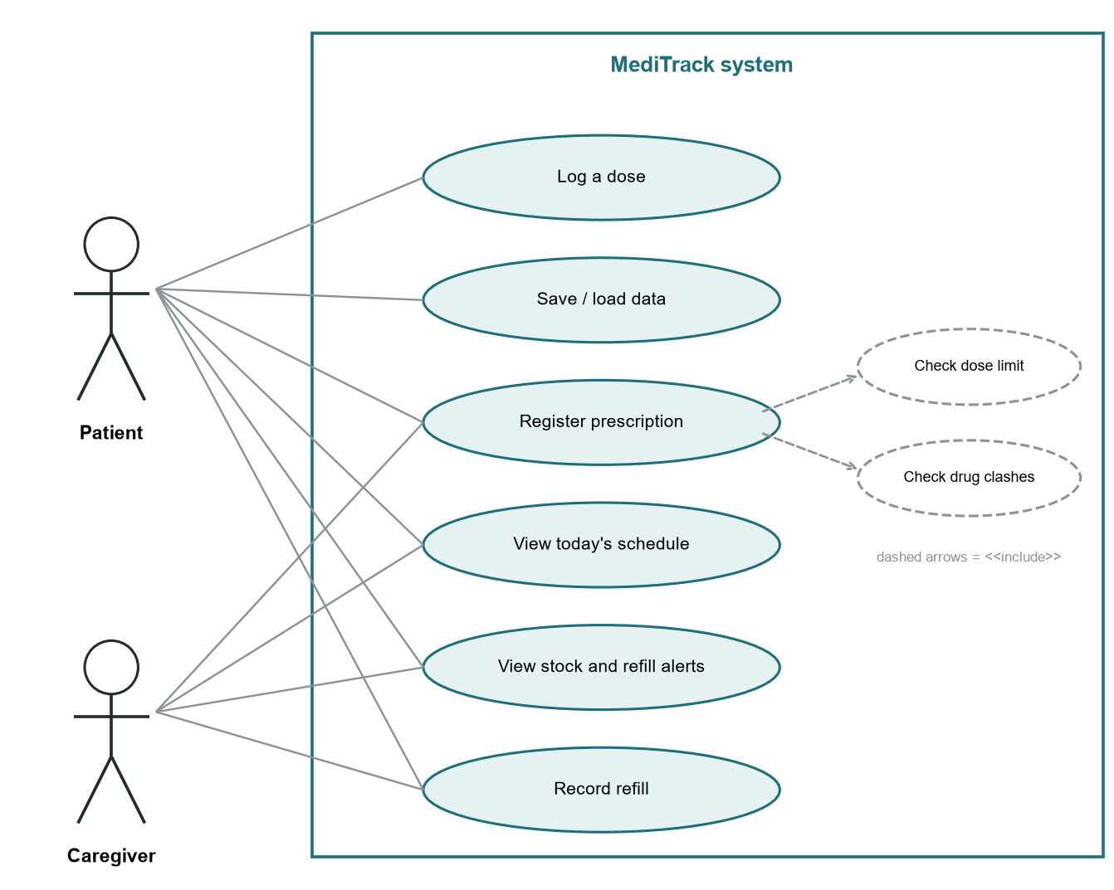
Figure 5: Use case diagram
Table 9: Use case descriptions
Use case | Description | Result
Register prescription | Enter type, name, dose, stock, doses per day, safe daily limit, first dose time, interval and note. | Medicine added and its doses scheduled, or the prescription is rejected or warned about.
View today's schedule | Show all doses in time order with their status and the load by part of day. | Table of events and a dose-load bar chart.
Log a dose | Tell the program a medicine was taken. | Dose logged and stock reduced, or blocked if no dose is due.
Set clock | Advance the simulated time. | Overdue doses are marked Missed or Skipped with advice.
View stock and refill alerts | List medicines by days of supply left. | Ranked table, low-stock flags and refill suggestions.
Record refill | Add packs of a given size to a medicine. | Stock increased.
Save / load data | Write all medicines to a file or read them back. | Data persists between runs.

6.2 Stakeholders
Table 10: Stakeholders and their use of the system
Stakeholder | How they use MediTrack | Benefit
Patient on regular medicines | Registers prescriptions, logs doses, checks stock weekly. | Fewer missed or doubled doses; no surprise stock-outs.
Elderly person and caregiver | Caregiver enters prescriptions and checks the schedule and refill list on the person's behalf. | Caregiver sees at a glance what is due and what is running low.
Student or worker living away from home | Keeps a short course of medicine on schedule without a family member to remind them. | Complete the course; avoid duplicates of home-brand medicines.
Pharmacist or doctor (indirect) | May read the adherence report the patient brings. | A clear record of taken, missed and skipped doses.
Course faculty (evaluator) | Reviews design, code and test evidence. | A compact program that exercises the whole syllabus.

7. Functional / Performance Requirement Sheet
Table 11: Functional requirements
ID | Requirement | Priority | Verified by
FR1 | The system shall accept a prescription with type, name, dose, stock, doses per day, safe daily limit, first dose time, interval and note. | Must | T1
FR2 | The system shall refuse a prescription whose dose x doses per day exceeds its safe daily limit, or whose values are not positive. | Must | T2
FR3 | The system shall warn when a new medicine shares an active ingredient or has a known clash with an existing one. | Must | T3
FR4 | The system shall build a time-sorted list of today's doses for all medicines. | Must | T4
FR5 | The system shall mark a dose Missed or Skipped once its window has closed, and print advice. | Must | T7, T8
FR6 | The system shall log a dose only when a matching event is due, reduce stock, and refuse otherwise. | Must | T5, T6
FR7 | The system shall allow a late dose to be logged after it was marked Missed, but not after it was Skipped. | Should | T9
FR8 | The system shall report days of supply left for each medicine and flag those below 3 days. | Must | T10
FR9 | The system shall report adherence as taken / (taken + missed). | Should | T11
FR10 | The system shall record refills, and save and load all medicines from a file. | Should | T12, T13

Table 12: Performance and quality requirements
ID | Requirement | Target | How assessed
PR1 | Response time for any command | Under 100 ms for up to 1,000 events | Algorithmic analysis (Section 10)
PR2 | Memory use | Under 5 MB for 10,000 medicines | Estimate (Section 4)
PR3 | Safety invariant | Logged doses per day never exceed prescribed doses | Simulation (Section 14)
PR4 | Numerical correctness of supply forecast | Equal to stepwise consumption when stock is a multiple of the dose | Randomised check (Section 14)
PR5 | Robustness to bad input | No crash on non-numeric or out-of-range input; input re-requested | Code review; input helpers loop until valid
PR6 | Portability | Builds with any ISO C++17 compiler, no third-party libraries | Library list (Section 1.2)
PR7 | Data safety | No memory leaks or double deletion | Ownership design: destructor and deleted copy

8. Analytical and Desk Study Report

8.1 Failure-mode analysis
A desk study of how home medication goes wrong gives five failure modes. Each is mapped to a concrete feature so that no part of the design exists without a reason.
Table 13: Failure modes and countermeasures
Failure mode | Example | Countermeasure in MediTrack
Omission | Evening tablet forgotten | Time-sorted schedule; clock advance marks it Missed and prints advice
Commission (double dose) | Tablet taken again an hour later | A dose can be logged only against a due event; otherwise [BLOCKED]
Duplicate ingredient | Two paracetamol brands taken together | Clash and same-ingredient rule table checked at registration
Unsafe prescription entry | 2 tablets x 3 per day with a limit of 4 | Entry validation rejects it with an exception
Supply failure | Last tablet used on a Sunday night | Days-left forecast, 3-day alert and 7-day refill suggestion

8.2 Decision-rule analysis
The take-or-skip rule (Equation 4) is a threshold at half of the dosing interval. The thresholds for the medicines used in the demonstration are:
Table 14: Skip thresholds for the demonstration medicines
Medicine | Interval g | Skip if time to next dose is below | Example in demo
Paracetamol 500 | 360 min (6 h) | 180 min | Missed 14:00, checked at 18:30; next dose in 90 min, so Skip
Cough Syrup | 480 min (8 h) | 240 min | Missed 15:00, checked at 18:30; next dose in 270 min, so Take now
Metformin 500 | 720 min (12 h) | 360 min | Missed 09:00, checked at 10:30; next dose in 630 min, so Take now

The rule is conservative on purpose: when the next dose is close, the cost of skipping a late dose is small while the cost of doubling can be high.

8.3 Algorithm and data-structure analysis
Table 15: Complexity of the main operations (N dose events, m medicines)
Operation | Method | Time | Reason
Build schedule for one medicine | Recursion, then stable_sort of N events | O(k + N log N) | k doses generated; list kept sorted
Advance clock | One pass; advice scans for the next dose | O(N) typical, O(N²) worst | Scan per missed event
Log a dose | Linear scan of sorted events | O(N) | Stops at first due event of the medicine
Stock report | Copy and sort pointers by days left | O(m log m) | Comparison on daysLeft()
Clash check | Compare against rule table | O(m x r) | r = 5 rules, constant
Save / load | One line per medicine | O(m) | Sequential file I/O

A vector was chosen for both medicines and events because the data is small, accessed sequentially and kept sorted once; a linked list or map would add overhead without benefit. Pointers (Medicine*) are stored so that Tablet and Syrup objects can live in one container and be used polymorphically. The planner owns these pointers and deletes them in its destructor.

8.4 Why the models are appropriate
The adherence model of Equation 9 treats each dose as an independent trial. This is a simplification, since real forgetfulness is clustered (a busy day affects several doses), but it gives a clean analytical reference against which the simulation can be checked, and it is the standard first model for a binary outcome repeated N times. The supply model (Equation 5) is exact when stock is a multiple of the dose and optimistic by less than one dose-interval fraction otherwise; this is quantified in Section 14.

9. Component Identification and Characterization Sheet

9.1 Components
Table 16: Components and their characteristics
Component | Kind | Responsibility | Key members
Time | Class with operator overloading | Minutes since midnight with wrap-around | operator+, operator<, str(), friend operator<<
Item | Base class | Unique id and name; counts objects | static counter, created()
Describable | Abstract interface | Promise a describe() text | describe() = 0
Medicine | Abstract class (multiple inheritance) | Dose, stock, schedule data; supply arithmetic | addStock() overloads, consume(), daysLeft()
Tablet / Syrup | Concrete derived classes | Unit name, kind and usage tip | unitName(), kind(), tip()
makeMedicine() | Factory function | Validate and create the right subclass | throws invalid_argument
DoseEvent | Structure | One scheduled dose with a status | when, med, status
Planner | Engine class | Owns medicines; schedule, clock, logging, advice, reports, persistence | registerMed, advanceTo, take, stockReport, save, load
Stats<T> | Class template | Minimum and mean of a series | add(), minVal(), mean()
clampTo<T> | Function template | Keep a value inside a range | used for the adherence percentage
buildTimes() | Recursive function | Generate dose times for a day | stops at 1440 minutes
Input helpers | C-style functions | Safe reading of integers, text and HH:MM times | readInt, readLine, readTime

9.2 Syllabus coverage
Table 17 shows where each module of the BCSE102L syllabus is applied in the program, so that the project demonstrably covers the whole course.
Table 17: Syllabus coverage map
Module | Topic | Where it is used in MediTrack
1 C fundamentals | Data types, I/O, operators, branching, loops, switch, break and continue | Menu switch, validation loops with break, if/else if chains, while(true) input loops, precedence in time arithmetic
2 Arrays and functions | 1D arrays, strings, user functions, call by value / reference, recursion, storage classes | label[4] array, string helpers (lower, has), buildTimes() recursion, reference parameter vector<int>&, static data and static const tables
3 Pointers | Pointers, arithmetic, pointers and functions, dynamic memory | new int[4]() bucket array walked with *(bucket + i), delete[], Medicine* stored in vectors, new Tablet/Syrup, delete in destructor
4 Structures and unions | Structures, arrays of structures, pointers to structures | struct DoseEvent (contains a pointer), struct Clash array, vector of structures
5 OOP basics | Classes, constructors/destructors, this, static members, friend, call by reference | Time, Item, Medicine, Planner; destructor frees objects; return *this in addStock; static counter; friend operator<<
6 Inheritance | Single, multiple, multilevel, hybrid, constructors in inheritance | Item to Medicine to Tablet/Syrup (multilevel); Medicine inherits Item and Describable (multiple); inheriting constructors
7 Polymorphism | Function and operator overloading, virtual and pure virtual functions, abstract classes | addStock overloads; operator+, <, <<; unitName(), kind(), tip() pure virtual in abstract Medicine
8 Generic programming | Function and class templates, STL, containers, iterators | clampTo<T>, Stats<T>; vector, string; sort, stable_sort, min_element; range-based loops

10. First-Pass Performance Prediction Document
Before the program was run, the expected outcome of the demonstration scenario of Section 11 was worked out by hand from Equations 1 to 7. These predictions are compared with the observed output in Sections 11 and 13.
Table 18: Predicted outcomes for the demonstration day
Quantity | Working | Predicted
Number of scheduled doses | Paracetamol 3 + Metformin 2 + Cough Syrup 3 + Dolo 1 | 9
First and last dose | 07:00 Cough Syrup; 23:00 Cough Syrup | 07:00 and 23:00
Doses in the morning bucket (05-12) | 07:00, 08:00, 09:00 | 3
Cough Syrup supply after 3 doses | 50 - 3 x 10 ml = 20 ml; D = 20 / 30 | 0.7 days (low)
Paracetamol supply after 2 doses | 10 - 2 = 8; D = 8 / 3 | 2.7 days (low)
Metformin supply after 2 doses | 30 - 2 = 28; D = 28 / 2 | 14.0 days
Dolo 650 supply after 1 dose | 6 - 1 = 5; D = 5 / 1 | 5.0 days
Refill suggestion, Cough Syrup | R = 7 x 10 x 3 - 20 | +190 ml
Refill suggestion, Paracetamol | R = 7 x 1 x 3 - 8 | +13 tablets
Rejected prescription | Aspirin: 2 x 3 = 6 > 4 | Rejected
Adherence if one dose is skipped | A = 100 x 8 / 9 | 88.9%

Predicted scaling
Table 19: Predicted cost as the number of events grows
Events N | Sorting N log₂ N | Worst-case clock advance N² | Event memory (16 B each)
10 | 33 | 100 | 160 B
100 | 664 | 10,000 | 1.6 KB
1,000 | 9,966 | 1,000,000 | 16 KB

Even at 1,000 events the worst case is about one million simple comparisons, which a modern processor completes in a few milliseconds, so the target of PR1 is predicted to be met with a wide margin.

Predicted effect of reminders (illustrative scenario)
Using Equation 9, if a patient forgets 30% of doses without any aid, expected adherence is 70%. If a reminder tool reduced the forgetting probability to 10%, expected adherence would rise to 90%. This is an illustrative scenario, not a measured result: published reminder studies [5] report improvements that vary, so the size of the real effect depends on the patient.

11. Early Simulation Output (Feasibility Evidence)
The program has a built-in demonstration mode (meditrack demo) that runs a scripted day. The first part registers four medicines, shows a rejected unsafe prescription and a duplicate-ingredient warning, and prints the day's schedule. The console output is shown below.
Console output: registration and schedule (demo mode, steps 1 and 2)
==== 1. Register prescriptions ====
Added: Tablet Paracetamol 500: 1 tablet(s) x 3/day from 08:00, every 6 h
Tip: Swallow with water. (after food)
Added: Tablet Metformin 500: 1 tablet(s) x 2/day from 09:00, every 12 h
Tip: Swallow with water. (with meals)
Added: Syrup Cough Syrup: 10 ml x 3/day from 07:00, every 8 h
Tip: Shake well and use the measuring cup. (shake well)
[WARNING] Dolo 650 + Paracetamol 500: same active ingredient (paracetamol) - risk of double dosing
Added: Tablet Dolo 650: 1 tablet(s) x 1/day from 22:00, every 6 h
Tip: Swallow with water. (at bedtime)
[REJECTED] Aspirin 75: prescribed 6 per day exceeds safe limit 4

==== 2. Today's schedule (clock 06:00) ====

TIME MEDICINE DOSE STATUS
07:00 Cough Syrup 10 ml Pending
08:00 Paracetamol 500 1 tablet(s) Pending
09:00 Metformin 500 1 tablet(s) Pending
14:00 Paracetamol 500 1 tablet(s) Pending
15:00 Cough Syrup 10 ml Pending
20:00 Paracetamol 500 1 tablet(s) Pending
21:00 Metformin 500 1 tablet(s) Pending
22:00 Dolo 650 1 tablet(s) Pending
23:00 Cough Syrup 10 ml Pending

Dose load by part of day
Morning (05-12) ### 3
Afternoon (12-17) ## 2
Evening (17-21) # 1
Night (21-05) ### 3

The output confirms the predictions of Section 10. Nine doses were scheduled in time order, the unsafe Aspirin prescription was rejected with a clear message, and registering Dolo 650 beside Paracetamol 500 produced a duplicate-ingredient warning. The dose-load chart shows that three doses fall in the morning and three at night, which helps a patient see when the day is busiest.
Figure 6 shows the later part of the same run as a timeline. Hollow circles are scheduled doses; filled circles show when the dose was actually logged. Two doses were late, one was skipped on advice, and the rest were taken on time.
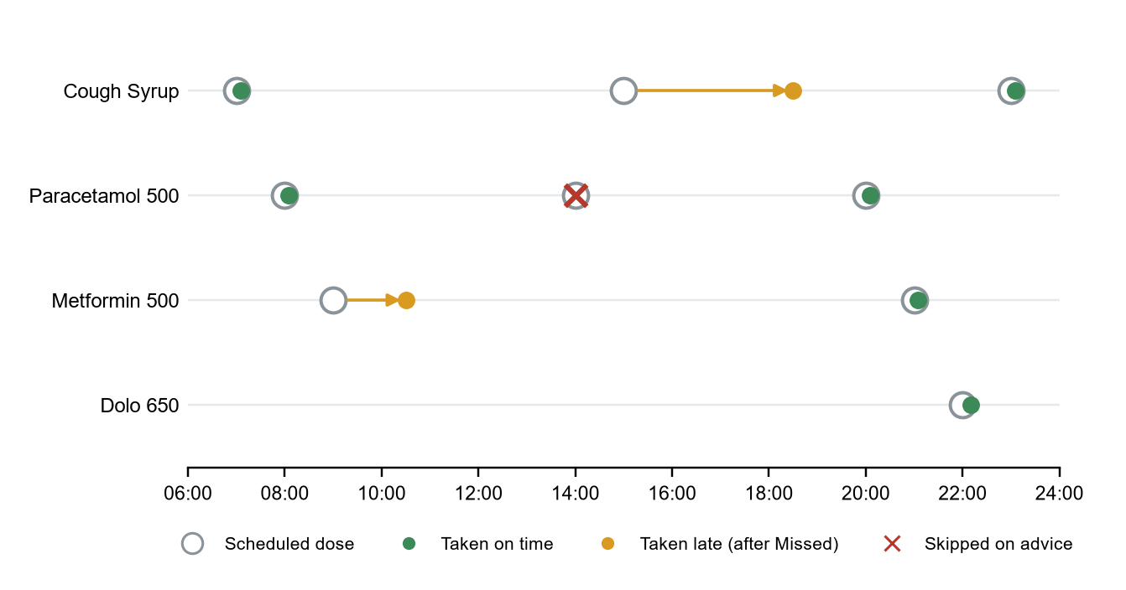
Figure 6: Timeline of the demonstration day: scheduled and actual doses
Figure 7 shows the supply position at the end of the day. Cough Syrup (0.7 days) and Paracetamol 500 (2.7 days) fall below the three-day alert line, which is exactly what the program reported.
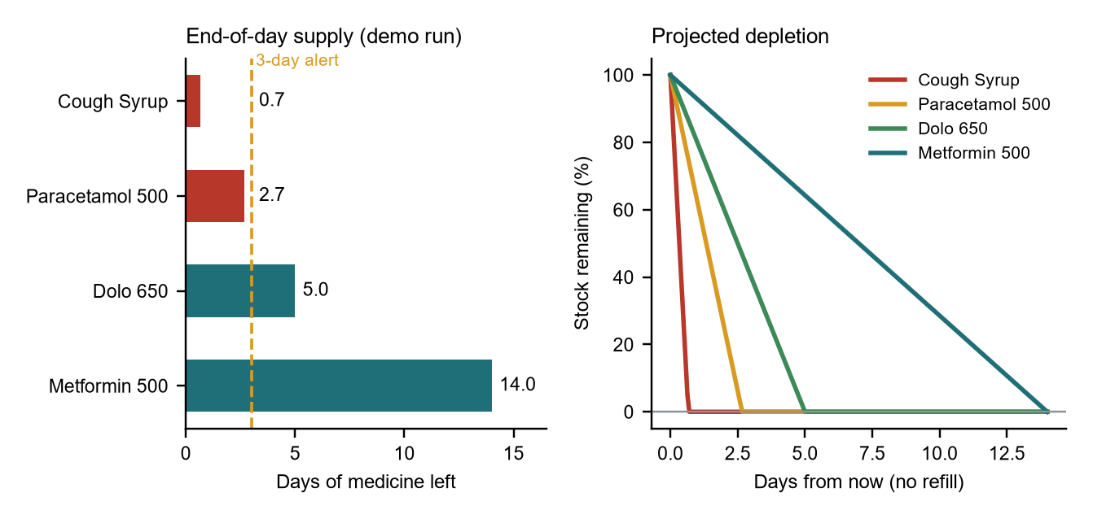
Figure 7: Days of supply left at the end of the demonstration day, with projected depletion

12. Initial Qualitative Risk List
Table 20: Risk register
ID | Risk | Likelihood | Impact | Mitigation
R1 | User treats program guidance as medical advice | Medium | High | Conservative rules; every missed-dose message says never double up; documentation states it is an aid, not advice
R2 | Wrong time or dose entered | Medium | High | Echoed back at registration (describe()); input validation; safe-limit check
R3 | Clash table is small and misses a real interaction | High | Medium | Table is data, easy to extend; output wording says warnings are not exhaustive
R4 | Simulated clock drifts from real time | High | Medium | Documented limitation; future work replaces it with <chrono>
R5 | Data file edited or corrupted | Low | Medium | Loader skips bad records and reports them; fields re-validated through the factory
R6 | Memory error from raw pointers | Low | High | Single owner (Planner), destructor deletes, copy deleted
R7 | Non-numeric or out-of-range input | High | Low | Input helpers loop until valid; exceptions caught in the menu
R8 | Personal data stored in plain text | Medium | Low | Data stays local; no names or identifiers required
R9 | Scope creep delays completion | Medium | Low | Fixed feature list (Section 7); extras listed as future work

The two highest-severity risks, R1 and R2, are both addressed by design rather than by documentation alone: the rules err on the safe side, and values are read back to the user as soon as they are entered.

13. Lab Test / Simulation Report for Critical Functions

13.1 Test setup
The program is built with g++ -std=c++17 -Wall -o meditrack MediTrack.cpp and run in demo mode with meditrack demo. The critical functions under test are the prescription validator, the dose-logging guard, the missed-dose advisor, the stock forecaster, and persistence. The clock is simulated, so the run is repeatable and its output is identical every time.

13.2 Console output of the simulated day
Console output: simulating the day (demo mode, step 3)
==== 3. Simulating the day ====

--- Clock: 07:05 ---
[OK] 07:05 Cough Syrup taken (10 ml). Stock left: 40
[LOW STOCK] Cough Syrup: 1.3 day(s) of medicine left - refill soon

--- Clock: 08:05 ---
[OK] 08:05 Paracetamol 500 taken (1 tablet(s)). Stock left: 9

--- Clock: 10:30 ---
[MISSED] 09:00 Metformin 500 (window closed 10:00): Take it now, then continue the normal schedule.
[OK] 10:30 Metformin 500 taken (1 tablet(s)). Stock left: 29
[BLOCKED] No dose of 'paracetamol' is due right now - skipping protects against an overdose.

--- Clock: 18:30 ---
[MISSED] 14:00 Paracetamol 500 (window closed 15:00): Skip it - next dose is only 90 min away. Never double up.
[MISSED] 15:00 Cough Syrup (window closed 16:00): Take it now, then continue the normal schedule.
[OK] 18:30 Cough Syrup taken (10 ml). Stock left: 30
[LOW STOCK] Cough Syrup: 1.0 day(s) of medicine left - refill soon

--- Clock: 20:05 ---
[OK] 20:05 Paracetamol 500 taken (1 tablet(s)). Stock left: 8
[LOW STOCK] Paracetamol 500: 2.7 day(s) of medicine left - refill soon

--- Clock: 21:05 ---
[OK] 21:05 Metformin 500 taken (1 tablet(s)). Stock left: 28

--- Clock: 22:10 ---
[OK] 22:10 Dolo 650 taken (1 tablet(s)). Stock left: 5

--- Clock: 23:05 ---
[OK] 23:05 Cough Syrup taken (10 ml). Stock left: 20
[LOW STOCK] Cough Syrup: 0.7 day(s) of medicine left - refill soon

Console output: end-of-day report, refill, save and reload (demo mode, steps 4 and 5)
==== 4. End-of-day report ====

TIME MEDICINE DOSE STATUS
07:00 Cough Syrup 10 ml Taken
08:00 Paracetamol 500 1 tablet(s) Taken
09:00 Metformin 500 1 tablet(s) Taken
14:00 Paracetamol 500 1 tablet(s) Skipped
15:00 Cough Syrup 10 ml Taken
20:00 Paracetamol 500 1 tablet(s) Taken
21:00 Metformin 500 1 tablet(s) Taken
22:00 Dolo 650 1 tablet(s) Taken
23:00 Cough Syrup 10 ml Taken

Taken: 8 Missed: 1 Pending: 0
Adherence: 88.9%

MEDICINE STOCK DAYS LEFT STATUS
Cough Syrup 20 ml 0.7 LOW - refill soon
Paracetamol 500 8 tablet(s) 2.7 LOW - refill soon
Dolo 650 5 tablet(s) 5.0 OK
Metformin 500 28 tablet(s) 14.0 OK
Shortest supply: 0.7 day(s), average: 5.6 day(s)
Suggested refill (7-day supply): Cough Syrup +190 ml
Suggested refill (7-day supply): Paracetamol 500 +13 tablet(s)

==== 5. Refill, save and reload ====
Refill logged: Paracetamol 500 +20 tablet(s) (2 x 10). Stock now 28
Loaded 4 medicine(s) from meditrack.dat
Medicine objects created in this session: 8
4 medicine(s) registered, clock at 23:05

13.3 Test cases and results
Table 21: Test cases for critical functions
ID | Function tested | Input / condition | Expected | Observed | Result
T1 | Registration | Valid Paracetamol 500, 1 x 3 per day | Added with description and tip | Added; tip "Swallow with water. (after food)" | Pass
T2 | Prescription validator | Aspirin 75, 2 x 3 per day, limit 4 | Rejected | [REJECTED] exceeds safe limit 4 | Pass
T3 | Clash check | Dolo 650 added after Paracetamol 500 | Same-ingredient warning | [WARNING] same active ingredient | Pass
T4 | Schedule builder | Four medicines, 9 doses | 9 events in time order | 07:00 to 23:00, sorted | Pass
T5 | Dose logging | Cough Syrup at 07:05 | Logged; stock 50 to 40 ml | [OK]; stock left 40 | Pass
T6 | Overdose guard | Paracetamol requested at 10:30 | Blocked (next dose 14:00) | [BLOCKED] no dose due | Pass
T7 | Missed advice (take) | Metformin 09:00 seen at 10:30 | Take now (630 min to next) | Take it now; then logged late | Pass
T8 | Missed advice (skip) | Paracetamol 14:00 seen at 18:30 | Skip (90 min < 180) | Skip it, next dose 90 min away | Pass
T9 | Late dose handling | Cough Syrup 15:00 logged at 18:30 | Missed becomes Taken | [OK]; missed count reduced | Pass
T10 | Low-stock alert | Cough Syrup 1.3, then 0.7 days | Alert below 3 days | [LOW STOCK] 1.3, 1.0, 0.7; Paracetamol 2.7 | Pass
T11 | Adherence | 8 taken, 1 skipped | 100 x 8 / 9 = 88.9% | Adherence: 88.9% | Pass
T12 | Refill overload | 2 packs of 10 Paracetamol | +20; stock 8 to 28 | +20 tablet(s); stock now 28 | Pass
T13 | Save and reload | Save then load into a new planner | 4 records restored | Loaded 4 medicine(s) | Pass

13.4 Key code snippets
The four snippets below are the heart of the safety logic. The complete source is listed in Appendix A.
Snippet 1: factory with prescription sanity check (exception handling, polymorphic creation)
Medicine* makeMedicine(const string& kind, const string& name, int dose, int stock, int perDay,
int maxDay, Time first, int gap, const string& note) {
if (dose <= 0 || perDay <= 0 || gap <= 0 || stock < 0)
throw invalid_argument(name + ": dose, frequency and interval must be positive");
if (dose * perDay > maxDay)
throw invalid_argument(name + ": prescribed " + to_string(dose * perDay) +
" per day exceeds safe limit " + to_string(maxDay));
if (kind == "Tablet") return new Tablet(name, dose, stock, perDay, maxDay, first, gap, note);
if (kind == "Syrup") return new Syrup(name, dose, stock, perDay, maxDay, first, gap, note);
throw invalid_argument("unknown medicine type: " + kind);
}

Snippet 2: missed-dose advisor (half-interval rule, Equation 4)
string advice(const DoseEvent& e, bool& skip) const {
skip = false;
for (const DoseEvent& o : today) {
if (o.med == e.med && o.status == 'P' && e.when < o.when) {
int wait = max(0, o.when.total() - now.total());
if (wait * 2 < e.med->getGap()) {
skip = true;
return "Skip it - next dose is only " + to_string(wait) + " min away. Never double up.";
}
return "Take it now, then continue the normal schedule.";
}
}
return "Last dose of the day - take it now if still reasonable, never double up.";
}

Snippet 3: dose logging with overdose guard and stock check
bool take(const string& name) {
string key = lower(name);
for (DoseEvent& e : today) {
if (!has(lower(e.med->getName()), key)) continue;
bool due = (e.status == 'P' && e.when.total() <= now.total() + earlyMin) || e.status == 'M';
if (!due) continue;
if (!e.med->consume()) {
cout << " [ALERT] " << e.med->getName() << " is out of stock - dose not logged. Refill now!\n";
return false;
}
if (e.status == 'M') missed--;
e.status = 'T';
taken++;
cout << " [OK] " << now << " " << e.med->getName() << " taken (" << e.med->getDose()
<< " " << e.med->unitName() << "). Stock left: " << e.med->getStock() << '\n';
if (e.med->daysLeft() < lowDays)
cout << " [LOW STOCK] " << e.med->getName() << ": " << f1(e.med->daysLeft())
<< " day(s) of medicine left - refill soon\n";
return true;
}
cout << " [BLOCKED] No dose of '" << name << "' is due right now - skipping protects against an overdose.\n";
return false;
}

Snippet 4: duplicate-ingredient and clash detection
vector<string> clashes(const Medicine& m) const {
vector<string> out;
string n = lower(m.getName());
for (const Medicine* o : meds) {
string p = lower(o->getName());
for (size_t i = 0; i < kClashCount; i++) {
string a = kClashes[i].a, b = kClashes[i].b;
if ((has(n, a) && has(p, b)) || (has(n, b) && has(p, a)))
out.push_back(m.getName() + " + " + o->getName() + ": " + kClashes[i].why);
}
}
return out;
}

14. Analytical Model Validation Document
Three analytical models were validated against independent step-by-step simulations written separately from the equations: the supply forecast (Equation 5), the adherence model (Equation 9) and the safety invariant (Equation 8). The simulations were run in Python with NumPy using fixed random seeds, so the results can be reproduced.

14.1 Supply forecast
Method. For 5,000 random prescriptions (dose 1 to 10, 1 to 6 doses a day, stock up to 300 units) the days left given by D = S / (d n) were compared with a stepwise simulation that consumes one dose at a time until the stock is exhausted and divides the number of doses taken by n.
Result. When the stock is an exact multiple of the dose, the formula and the simulation agreed in 5000 of 5000 cases (100%). When the stock is not a multiple of the dose, the formula is slightly optimistic because a partial dose cannot be taken; the largest difference found was 0.9 days (a 10-unit dose, once a day, with 9 units left). Because the alert threshold is three days, this margin does not change when an alert is raised in practice. The four demonstration medicines agree exactly:
Table 22: Supply forecast: formula versus stepwise count for the demonstration medicines
Medicine | Stock | Daily use | Formula D | Stepwise doses / n | Match
Cough Syrup | 20 ml | 30 ml | 0.67 | 2 / 3 = 0.67 | Yes
Paracetamol 500 | 8 | 3 | 2.67 | 8 / 3 = 2.67 | Yes
Dolo 650 | 5 | 1 | 5.00 | 5 / 1 = 5.00 | Yes
Metformin 500 | 28 | 2 | 14.00 | 28 / 2 = 14.00 | Yes

14.2 Adherence model
Method. For forgetting probabilities p from 5% to 50%, 2,000 virtual patients each faced 90 doses (30 days x 3). Each dose was forgotten independently with probability p. The mean adherence over patients was compared with the analytical value 1 - p of Equation 9.
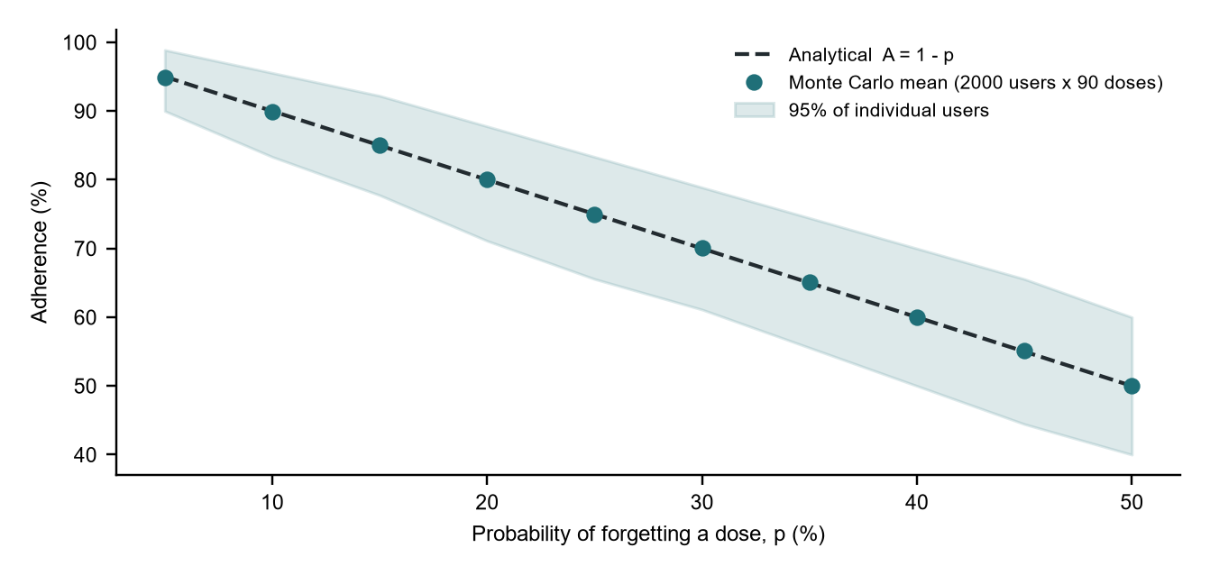
Figure 8: Simulated adherence versus the analytical model
Table 23: Adherence: analytical versus simulated
p | Analytical 1 - p | Simulated mean | Difference (percentage points)
5% | 95.0% | 94.9% | 0.08
10% | 90.0% | 89.9% | 0.09
15% | 85.0% | 85.0% | 0.01
20% | 80.0% | 80.1% | 0.05
25% | 75.0% | 74.9% | 0.07
30% | 70.0% | 70.1% | 0.08
35% | 65.0% | 65.1% | 0.10
40% | 60.0% | 60.0% | 0.05
45% | 55.0% | 55.1% | 0.10
50% | 50.0% | 50.0% | 0.05

Result. The largest difference between the simulation and the analytical model was 0.10 percentage points, and the band containing 95% of individual patients matches the prediction of Equation 9 (about plus or minus 8 points at p = 20%). The analytical model is therefore accepted for the illustrative scenarios of Section 10.

14.3 Safety invariant
Method. A day with three prescribed doses (08:00, 14:00, 20:00) and a safe daily limit of 4 was simulated 5,000 times. In each run the user pressed the "log dose" button 20 times at random moments between 06:00 and 24:00. The rules of Section 3.2 decided whether each press was accepted. A naive logger that records every press was used for comparison.
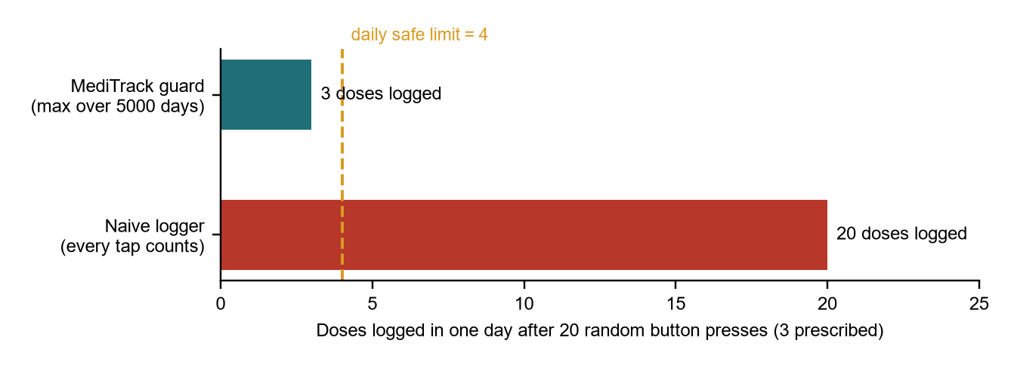
Figure 9: Doses logged in one day after 20 random presses
Result. MediTrack never logged more than 3 doses in a day (mean 3.00), never exceeded the prescribed count of 3, and never approached the limit of 4, whereas the naive logger recorded all 20 presses. The invariant of Equation 8 held in all 5,000 simulated days.

14.4 Validation summary
Table 24: Summary of model validation
Model | Method | Acceptance criterion | Result | Verdict
Supply forecast (Eq. 5) | 5,000 random prescriptions vs stepwise count | Exact when stock is a multiple of the dose | 5,000 of 5,000 exact; worst-case gap 0.9 day otherwise | Accepted
Adherence (Eq. 9) | Monte Carlo, 2,000 patients x 90 doses | Mean within 1 point of 1 - p | Largest difference 0.10 points | Accepted
Safety invariant (Eq. 8) | 5,000 days x 20 random presses | Logged doses never exceed prescribed | Maximum logged: 3 | Accepted

Limitations. The adherence model assumes independent forgetting, and the safety simulation uses uniformly random presses; real behaviour is more clustered. The results validate the equations and rules, not the clinical effect of using the program.

15. Conclusion
This project set out to build a small, reliable tool for a task that nearly everyone performs and many perform badly: taking the right medicine at the right time and never running out. MediTrack achieves this with a compact C++ program that builds a sorted daily schedule, rejects unsafe prescriptions, warns about duplicate ingredients, refuses doses that are not due, gives conservative advice for missed doses, forecasts supply and keeps its data in a local file.
All eight objectives of Section 5 were addressed. The demonstration day produced exactly the outcomes predicted by hand in Section 10, and the models were checked in Section 14: the supply formula matched a stepwise count, the adherence simulation agreed with theory within a fraction of a percentage point, and the safety invariant held in every one of 5,000 simulated days.
From a learning point of view, the project brought the whole syllabus into one design: structured programming and recursion for schedule generation, pointers and dynamic memory for the bucket array and object ownership, structures for dose events, classes with inheritance and polymorphism for medicines, operator and function overloading for time and stock, and templates and the STL for statistics and containers.

Limitations
The clock is simulated; the user advances it instead of the program reading the system time.
The clash table has five rules and is not a drug database; absence of a warning does not mean a combination is safe.
Guidance follows a general rule and is not tailored to individual drugs or patients.
Data is stored as plain text and the interface is a console menu.

Future work
Read the system clock with <chrono> and raise audible or on-screen reminders.
Replace the rule table with a maintained interaction database and per-drug missed-dose rules.
Add a graphical or mobile front end, and caregiver sharing of the schedule.
Add automated unit tests and export of the adherence report for a doctor.

References
[1] E. Sabate (Ed.), Adherence to Long-Term Therapies: Evidence for Action. Geneva: World Health Organization, 2003.
[2] L. Osterberg and T. Blaschke, "Adherence to medication," New England Journal of Medicine, vol. 353, no. 5, pp. 487-497, 2005.
[3] M. T. Brown and J. K. Bussell, "Medication adherence: WHO cares?," Mayo Clinic Proceedings, vol. 86, no. 4, pp. 304-314, 2011.
[4] R. Nieuwlaat et al., "Interventions for enhancing medication adherence," Cochrane Database of Systematic Reviews, no. 11, CD000011, 2014.
[5] M. Vervloet et al., "The effectiveness of interventions using electronic reminders to improve adherence to chronic medication: a systematic review of the literature," Journal of the American Medical Informatics Association, vol. 19, no. 5, pp. 696-704, 2012.
[6] B. Stroustrup, The C++ Programming Language, 4th ed. Boston, MA: Addison-Wesley, 2013.
[7] B. W. Kernighan and D. M. Ritchie, The C Programming Language, 2nd ed. Englewood Cliffs, NJ: Prentice Hall, 1988.
[8] ISO/IEC 14882:2017, Programming languages - C++. International Organization for Standardization, 2017.

Appendix A: Complete Source Code (MediTrack.cpp)
Build with g++ -std=c++17 -Wall -o meditrack MediTrack.cpp. Run meditrack for the interactive menu or meditrack demo for the scripted scenario.
/* MediTrack - Offline Medicine Dose Reminder, Overdose Guard and Stock Tracker
BCSE102L Structured and Object Oriented Programming

Build : g++ -std=c++17 -Wall -o meditrack MediTrack.cpp
Run : meditrack (interactive menu)
meditrack demo (scripted one-day scenario) */

#include <iostream>
#include <fstream>
#include <sstream>
#include <vector>
#include <string>
#include <algorithm>
#include <iomanip>
#include <cstdio>
#include <cctype>
#include <stdexcept>
using namespace std;

/* ======================= C-style helpers (Modules 1-3) ======================= */

string lower(string s) {
for (size_t i = 0; i < s.size(); i++) s[i] = (char)tolower((unsigned char)s[i]);
return s;
}

bool has(const string& s, const string& t) { return s.find(t) != string::npos; }

string f1(double v) { // one-decimal formatting
char buf[32];
snprintf(buf, sizeof buf, "%.1f", v);
return buf;
}

/* Recursive generation of dose times (minutes since midnight) */
void buildTimes(int startMin, int gap, int left, vector<int>& out) {
if (left == 0 || startMin >= 1440) return;
out.push_back(startMin);
buildTimes(startMin + gap, gap, left - 1, out);
}

/* ======================= Generic programming (Module 8) ======================= */

template <typename T>
T clampTo(T v, T lo, T hi) { return v < lo ? lo : (v > hi ? hi : v); }

template <typename T>
class Stats {
vector<T> data;
public:
void add(T v) { data.push_back(v); }
bool empty() const { return data.empty(); }
T minVal() const { return *min_element(data.begin(), data.end()); }
double mean() const {
double sum = 0;
for (const T& v : data) sum += v;
return data.empty() ? 0.0 : sum / data.size();
}
};

/* ======================= Time of day: operator overloading ======================= */

class Time {
int mins; // 0..1439
public:
Time(int h = 0, int m = 0) : mins(((h * 60 + m) % 1440 + 1440) % 1440) {}
int hour() const { return mins / 60; }
int total() const { return mins; }
Time operator+(int addMinutes) const { return Time(0, mins + addMinutes); }
bool operator<(const Time& o) const { return mins < o.mins; }
string str() const {
char b[16];
snprintf(b, sizeof b, "%02d:%02d", mins / 60, mins % 60);
return b;
}
friend ostream& operator<<(ostream& os, const Time& t) { return os << t.str(); }
};

/* ======================= Class hierarchy (Modules 5, 6, 7) ======================= */

class Item { // base class with a static counter
protected:
int id;
string name;
static int counter;
public:
Item(const string& n) : id(++counter), name(n) {}
virtual ~Item() {}
int getId() const { return id; }
const string& getName() const { return name; }
static int created() { return counter; }
};
int Item::counter = 0;

class Describable { // second base -> multiple inheritance
public:
virtual ~Describable() {}
virtual string describe() const = 0;
};

class Medicine : public Item, public Describable { // abstract class
protected:
int dose; // units per intake
int stock; // units in hand
int perDay; // intakes per day
int maxPerDay; // safe units per day
Time first; // first dose of the day
int gapMin; // minutes between doses
string note;
public:
Medicine(const string& n, int d, int s, int pd, int maxDay, Time f, int gap, const string& nt)
: Item(n), dose(d), stock(s), perDay(pd), maxPerDay(maxDay), first(f), gapMin(gap), note(nt) {}

virtual string unitName() const = 0; // pure virtual functions
virtual string kind() const = 0;
virtual string tip() const = 0;

int getDose() const { return dose; }
int getStock() const { return stock; }
int getPerDay() const { return perDay; }
int getMax() const { return maxPerDay; }
int getGap() const { return gapMin; }
Time getFirst() const { return first; }
const string& getNote() const { return note; }

Medicine& addStock(int units) { stock += units; return *this; } // overloaded
Medicine& addStock(int packs, int perPack) { stock += packs * perPack; return *this; }

bool consume() {
if (stock < dose) return false;
stock -= dose;
return true;
}
double daysLeft() const { return perDay == 0 ? 0.0 : (double)stock / (dose * perDay); }

string describe() const override {
ostringstream os;
os << kind() << " " << name << ": " << dose << " " << unitName() << " x " << perDay
<< "/day from " << first << ", every " << gapMin / 60 << " h";
return os.str();
}
};

class Tablet : public Medicine {
public:
using Medicine::Medicine;
string unitName() const override { return "tablet(s)"; }
string kind() const override { return "Tablet"; }
string tip() const override { return "Swallow with water."; }
};

class Syrup : public Medicine {
public:
using Medicine::Medicine;
string unitName() const override { return "ml"; }
string kind() const override { return "Syrup"; }
string tip() const override { return "Shake well and use the measuring cup."; }
};

/* Factory with prescription sanity check (exception handling) */
Medicine* makeMedicine(const string& kind, const string& name, int dose, int stock, int perDay,
int maxDay, Time first, int gap, const string& note) {
if (dose <= 0 || perDay <= 0 || gap <= 0 || stock < 0)
throw invalid_argument(name + ": dose, frequency and interval must be positive");
if (dose * perDay > maxDay)
throw invalid_argument(name + ": prescribed " + to_string(dose * perDay) +
" per day exceeds safe limit " + to_string(maxDay));
if (kind == "Tablet") return new Tablet(name, dose, stock, perDay, maxDay, first, gap, note);
if (kind == "Syrup") return new Syrup(name, dose, stock, perDay, maxDay, first, gap, note);
throw invalid_argument("unknown medicine type: " + kind);
}

/* ======================= Planner: the engine ======================= */

struct DoseEvent { // structure holding a pointer (Module 4)
Time when;
Medicine* med;
char status; // P pending, T taken, M missed, S skipped on advice
};

struct Clash { const char* a; const char* b; const char* why; };
static const Clash kClashes[] = {
{"aspirin", "ibuprofen", "both are NSAIDs - together they raise bleeding risk"},
{"aspirin", "warfarin", "aspirin strengthens the blood-thinning effect"},
{"paracetamol", "dolo", "same active ingredient (paracetamol) - risk of double dosing"},
{"paracetamol", "crocin", "same active ingredient (paracetamol) - risk of double dosing"},
{"dolo", "crocin", "same active ingredient (paracetamol) - risk of double dosing"},
};
static const size_t kClashCount = sizeof(kClashes) / sizeof(kClashes[0]);

const char* statusText(char s) {
switch (s) {
case 'T': return "Taken";
case 'M': return "Missed";
case 'S': return "Skipped";
default: return "Pending";
}
}

class Planner {
vector<Medicine*> meds; // owned objects, freed in destructor
vector<DoseEvent> today;
Time now;
int taken = 0, missed = 0;
static constexpr int graceMin = 60; // how long a dose stays "pending"
static constexpr int earlyMin = 30; // how early a dose may be taken
static constexpr double lowDays = 3.0; // low-stock threshold

void addEvents(Medicine* m) {
vector<int> slots;
buildTimes(m->getFirst().total(), m->getGap(), m->getPerDay(), slots);
for (size_t i = 0; i < slots.size(); i++) {
DoseEvent e = { Time(0, slots[i]), m, 'P' };
today.push_back(e);
}
stable_sort(today.begin(), today.end(),
[](const DoseEvent& a, const DoseEvent& b) { return a.when < b.when; });
}

vector<string> clashes(const Medicine& m) const {
vector<string> out;
string n = lower(m.getName());
for (const Medicine* o : meds) {
string p = lower(o->getName());
for (size_t i = 0; i < kClashCount; i++) {
string a = kClashes[i].a, b = kClashes[i].b;
if ((has(n, a) && has(p, b)) || (has(n, b) && has(p, a)))
out.push_back(m.getName() + " + " + o->getName() + ": " + kClashes[i].why);
}
}
return out;
}

string advice(const DoseEvent& e, bool& skip) const {
skip = false;
for (const DoseEvent& o : today) {
if (o.med == e.med && o.status == 'P' && e.when < o.when) {
int wait = max(0, o.when.total() - now.total());
if (wait * 2 < e.med->getGap()) {
skip = true;
return "Skip it - next dose is only " + to_string(wait) + " min away. Never double up.";
}
return "Take it now, then continue the normal schedule.";
}
}
return "Last dose of the day - take it now if still reasonable, never double up.";
}

public:
Planner() : now(6, 0) {}
~Planner() { for (Medicine* m : meds) delete m; }
Planner(const Planner&) = delete;
Planner& operator=(const Planner&) = delete;

friend ostream& operator<<(ostream& os, const Planner& p) {
return os << " " << p.meds.size() << " medicine(s) registered, clock at " << p.now;
}

void registerMed(Medicine* m) {
for (const string& w : clashes(*m)) cout << " [WARNING] " << w << '\n';
meds.push_back(m);
addEvents(m);
cout << " Added: " << m->describe() << '\n' << " Tip: " << m->tip();
if (!m->getNote().empty()) cout << " (" << m->getNote() << ")";
cout << '\n';
}

void advanceTo(const Time& t) {
if (t < now) { cout << " Time cannot move backwards.\n"; return; }
now = t;
cout << "\n--- Clock: " << now << " ---\n";
for (DoseEvent& e : today) {
if (e.status == 'P' && e.when.total() + graceMin < now.total()) {
bool skip;
string adv = advice(e, skip);
e.status = skip ? 'S' : 'M';
missed++;
cout << " [MISSED] " << e.when << " " << e.med->getName()
<< " (window closed " << (e.when + graceMin) << "): " << adv << '\n';
}
}
}

bool take(const string& name) {
string key = lower(name);
for (DoseEvent& e : today) {
if (!has(lower(e.med->getName()), key)) continue;
bool due = (e.status == 'P' && e.when.total() <= now.total() + earlyMin) || e.status == 'M';
if (!due) continue;
if (!e.med->consume()) {
cout << " [ALERT] " << e.med->getName() << " is out of stock - dose not logged. Refill now!\n";
return false;
}
if (e.status == 'M') missed--;
e.status = 'T';
taken++;
cout << " [OK] " << now << " " << e.med->getName() << " taken (" << e.med->getDose()
<< " " << e.med->unitName() << "). Stock left: " << e.med->getStock() << '\n';
if (e.med->daysLeft() < lowDays)
cout << " [LOW STOCK] " << e.med->getName() << ": " << f1(e.med->daysLeft())
<< " day(s) of medicine left - refill soon\n";
return true;
}
cout << " [BLOCKED] No dose of '" << name << "' is due right now - skipping protects against an overdose.\n";
return false;
}

void schedule() const {
cout << "\n " << left << setw(7) << "TIME" << setw(20) << "MEDICINE" << setw(14) << "DOSE" << "STATUS\n";
for (const DoseEvent& e : today) {
string d = to_string(e.med->getDose()) + " " + e.med->unitName();
cout << " " << setw(7) << e.when.str() << setw(20) << e.med->getName()
<< setw(14) << d << statusText(e.status) << '\n';
}
cout << right;
}

void dayLoad() const {
static const char* label[4] = {"Morning (05-12)", "Afternoon (12-17)", "Evening (17-21)", "Night (21-05)"};
int* bucket = new int[4](); // dynamic array, pointer arithmetic
for (const DoseEvent& e : today) {
int h = e.when.hour();
int b = h < 5 ? 3 : h < 12 ? 0 : h < 17 ? 1 : h < 21 ? 2 : 3;
(*(bucket + b))++;
}
cout << "\n Dose load by part of day\n";
for (int i = 0; i < 4; i++)
cout << " " << left << setw(20) << label[i] << string(*(bucket + i), '#') << " " << *(bucket + i) << '\n';
cout << right;
delete[] bucket;
}

void report() const {
int pending = 0;
for (const DoseEvent& e : today) if (e.status == 'P') pending++;
int resolved = taken + missed;
cout << "\n Taken: " << taken << " Missed: " << missed << " Pending: " << pending << '\n';
if (resolved == 0) cout << " Adherence: n/a\n";
else cout << " Adherence: " << f1(clampTo(100.0 * taken / resolved, 0.0, 100.0)) << "%\n";
}

void stockReport() const {
vector<Medicine*> v = meds;
sort(v.begin(), v.end(), [](const Medicine* a, const Medicine* b) { return a->daysLeft() < b->daysLeft(); });
Stats<double> st;
cout << "\n " << left << setw(20) << "MEDICINE" << setw(14) << "STOCK" << setw(12) << "DAYS LEFT" << "STATUS\n";
for (const Medicine* m : v) {
st.add(m->daysLeft());
string flag = m->getStock() < m->getDose() ? "OUT - refill now"
: (m->daysLeft() < lowDays ? "LOW - refill soon" : "OK");
string s = to_string(m->getStock()) + " " + m->unitName();
cout << " " << setw(20) << m->getName() << setw(14) << s << setw(12) << f1(m->daysLeft()) << flag << '\n';
}
cout << right;
if (!st.empty())
cout << " Shortest supply: " << f1(st.minVal()) << " day(s), average: " << f1(st.mean()) << " day(s)\n";
for (const Medicine* m : v)
if (m->daysLeft() < lowDays)
cout << " Suggested refill (7-day supply): " << m->getName() << " +"
<< 7 * m->getDose() * m->getPerDay() - m->getStock() << " " << m->unitName() << '\n';
}

bool refill(const string& name, int packs, int perPack) {
for (Medicine* m : meds) {
if (!has(lower(m->getName()), lower(name))) continue;
if (perPack == 1) m->addStock(packs); else m->addStock(packs, perPack);
cout << " Refill logged: " << m->getName() << " +" << packs * perPack << " " << m->unitName()
<< " (" << packs << " x " << perPack << "). Stock now " << m->getStock() << '\n';
return true;
}
cout << " No medicine matching '" << name << "'.\n";
return false;
}

bool save(const string& file) const {
ofstream out(file);
if (!out) return false;
for (const Medicine* m : meds)
out << m->kind() << '|' << m->getName() << '|' << m->getDose() << '|' << m->getStock() << '|'
<< m->getPerDay() << '|' << m->getMax() << '|' << m->getFirst().total() << '|'
<< m->getGap() << '|' << m->getNote() << '\n';
return true;
}

int load(const string& file) {
ifstream in(file);
if (!in) return -1;
string line;
int count = 0;
while (getline(in, line)) {
vector<string> f;
stringstream ss(line);
string tok;
while (getline(ss, tok, '|')) f.push_back(tok);
if (f.size() < 8) continue;
try {
Medicine* m = makeMedicine(f[0], f[1], stoi(f[2]), stoi(f[3]), stoi(f[4]), stoi(f[5]),
Time(0, stoi(f[6])), stoi(f[7]), f.size() > 8 ? f[8] : "");
meds.push_back(m);
addEvents(m);
count++;
} catch (const exception& ex) {
cout << " Skipped bad record: " << ex.what() << '\n';
}
}
return count;
}
};

/* ======================= Console input helpers ======================= */

struct InputClosed {};

string readLine(const string& prompt) {
cout << prompt;
string s;
if (!getline(cin, s)) throw InputClosed();
for (char& ch : s) if (ch == '|') ch = '/';
return s;
}

int readInt(const string& prompt, int lo, int hi) {
while (true) {
string s = readLine(prompt);
try {
int v = stoi(s);
if (v >= lo && v <= hi) return v;
} catch (const exception&) {}
cout << " Enter a whole number between " << lo << " and " << hi << ".\n";
}
}

Time readTime(const string& prompt) {
while (true) {
string s = readLine(prompt);
int h, m;
if (sscanf(s.c_str(), "%d:%d", &h, &m) == 2 && h >= 0 && h < 24 && m >= 0 && m < 60)
return Time(h, m);
cout << " Use 24-hour HH:MM, for example 08:30.\n";
}
}

/* ======================= Menu and demo ======================= */

void runMenu(Planner& p) {
while (true) {
cout << "\n===== MediTrack =====\n"
<< " 1 Add medicine 2 Today's schedule 3 Set clock\n"
<< " 4 Log a dose 5 Stock report 6 Adherence\n"
<< " 7 Refill stock 8 Save 9 Load\n"
<< " 0 Exit\n";
int c = readInt("Choice: ", 0, 9);
if (c == 0) break;
try {
switch (c) {
case 1: {
string kind = readInt("Type (1 Tablet, 2 Syrup): ", 1, 2) == 1 ? "Tablet" : "Syrup";
string name = readLine("Name: ");
int dose = readInt("Dose per intake: ", 1, 1000);
int stock = readInt("Units in stock: ", 0, 100000);
int perDay = readInt("Doses per day: ", 1, 12);
int maxDay = readInt("Safe maximum units per day: ", 1, 10000);
Time first = readTime("First dose (HH:MM): ");
int hours = readInt("Hours between doses: ", 1, 24);
string note = readLine("Note (optional): ");
p.registerMed(makeMedicine(kind, name, dose, stock, perDay, maxDay, first, hours * 60, note));
break;
}
case 2: p.schedule(); p.dayLoad(); break;
case 3: p.advanceTo(readTime("Set clock to (HH:MM): ")); break;
case 4: p.take(readLine("Medicine name: ")); break;
case 5: p.stockReport(); break;
case 6: p.report(); break;
case 7: {
string name = readLine("Medicine name: ");
int packs = readInt("Packs bought: ", 1, 1000);
int per = readInt("Units per pack: ", 1, 10000);
p.refill(name, packs, per);
break;
}
case 8: cout << (p.save("meditrack.dat") ? " Saved to meditrack.dat\n" : " Could not write file.\n"); break;
case 9: {
int n = p.load("meditrack.dat");
if (n < 0) cout << " No saved file found.\n"; else cout << " Loaded " << n << " medicine(s).\n";
break;
}
}
} catch (const invalid_argument& ex) {
cout << " [REJECTED] " << ex.what() << '\n';
}
}
}

void banner(const string& t) { cout << "\n==== " << t << " ====\n"; }

void runDemo(Planner& p) {
banner("1. Register prescriptions");
p.registerMed(makeMedicine("Tablet", "Paracetamol 500", 1, 10, 3, 4, Time(8, 0), 360, "after food"));
p.registerMed(makeMedicine("Tablet", "Metformin 500", 1, 30, 2, 3, Time(9, 0), 720, "with meals"));
p.registerMed(makeMedicine("Syrup", "Cough Syrup", 10, 50, 3, 40, Time(7, 0), 480, "shake well"));
p.registerMed(makeMedicine("Tablet", "Dolo 650", 1, 6, 1, 3, Time(22, 0), 360, "at bedtime"));
try {
p.registerMed(makeMedicine("Tablet", "Aspirin 75", 2, 20, 3, 4, Time(9, 0), 480, ""));
} catch (const invalid_argument& ex) {
cout << " [REJECTED] " << ex.what() << '\n';
}

banner("2. Today's schedule (clock 06:00)");
p.schedule();
p.dayLoad();

banner("3. Simulating the day");
p.advanceTo(Time(7, 5)); p.take("cough syrup");
p.advanceTo(Time(8, 5)); p.take("paracetamol");
p.advanceTo(Time(10, 30)); p.take("metformin");
p.take("paracetamol");
p.advanceTo(Time(18, 30)); p.take("cough syrup");
p.advanceTo(Time(20, 5)); p.take("paracetamol");
p.advanceTo(Time(21, 5)); p.take("metformin");
p.advanceTo(Time(22, 10)); p.take("dolo");
p.advanceTo(Time(23, 5)); p.take("cough syrup");

banner("4. End-of-day report");
p.schedule();
p.report();
p.stockReport();

banner("5. Refill, save and reload");
p.refill("paracetamol", 2, 10);
p.save("meditrack.dat");
Planner q;
cout << " Loaded " << q.load("meditrack.dat") << " medicine(s) from meditrack.dat\n";
cout << " Medicine objects created in this session: " << Item::created() << '\n';
cout << p << '\n';
}

int main(int argc, char* argv[]) {
Planner p;
try {
if (argc > 1 && string(argv[1]) == "demo") runDemo(p);
else runMenu(p);
} catch (const InputClosed&) {
cout << "\nInput closed. Goodbye.\n";
} catch (const exception& ex) {
cout << "Fatal: " << ex.what() << '\n';
return 1;
}
return 0;
}

