**Prerequisites:**

1. Visual Studio 2017 or later
2. .Net Core 2.2
3. SQL Server 2016 or later
4. Node.js

**How to run the application:**

1. Run the areamanegement.sql file on local SQL server instance
2. Open the downloaded solution on VS17 and press F5
3. That’s it. Application will be up and running on IIS Express server

**How to use application:**

1. By default, no area will be there in table. Click on + button to add a new area

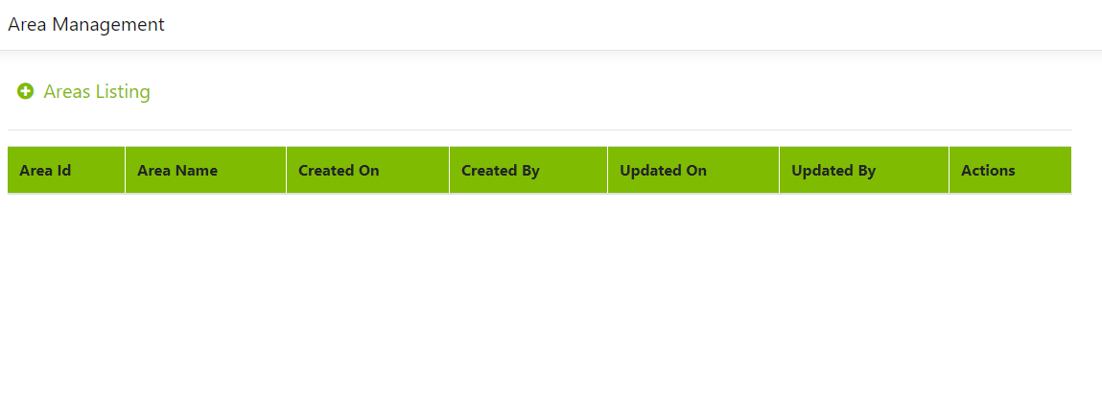

1. Type area name and click on save

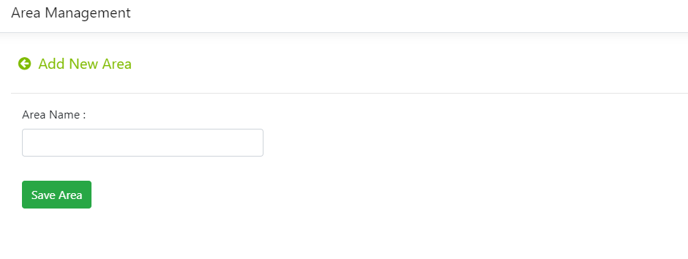

1. To edit the area name, click on Edit button in the action column

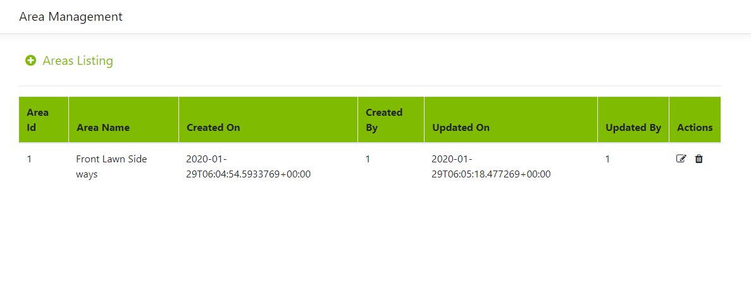

1. Only area name is editable, rest all columns are read-only.

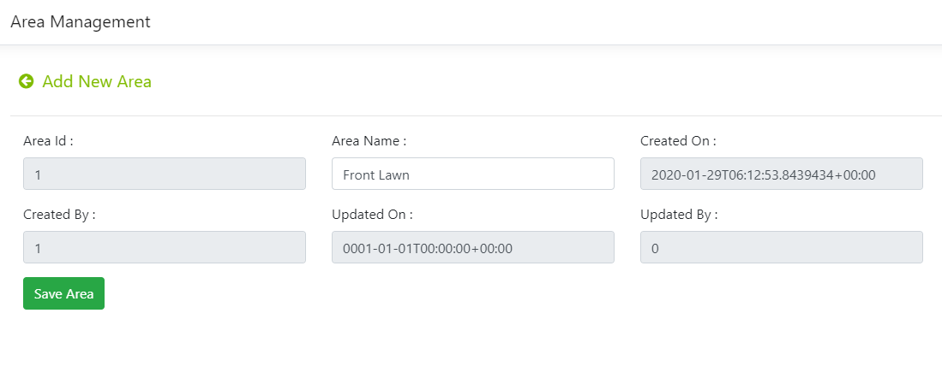

1. Click on delete button on the action column to delete the record.

