Online Pharmacy Management System

Revision History
Version No. | Date | Prepared by / Modified by | Significant Changes
1 | 16 March 2022 | Keshav Gupta  K.Srivarun  Logeshwari  Keshava  Sruthi Kowkuntila | Draft version
2 | 12 May 2022 | Keshav Gupta  K.Srivarun  Logeshwari  Keshava  Sruthi Kowkuntila | Draft version

Glossary
Abbreviation | Description
OPMS | Online Pharmacy Management System

Table of Contents
1 Introduction 3
2 Scope of Change 3
3 List of impacted modules 3
4 Design and Detailed technical updates 4
4.1 Process model 4
4.1.1 Use case Model 4
4.1.1.1 Registration Page………...…………………….………………………………5
4.1.1.2 Login Page…………..…………………………………………………………6
4.1.1.3 View Medicines 7
4.1.1.4 Add Medicines 8
4.1.1.5 Update Medicines 9
4.1.1.5 View Category 10
4.1.1.7 Add Category 11
4.1.1.8 Update Category 12
4.1.2 Architecture Diagram 13
4.1.2.1 Presentation Layer 14
4.1.2.2 Application Layer 14
4.1.2.3 Data Layer 14
4.1.3 Class Diagram 15
4.1.4 Sequence Diagram 16
4.2 Database design changes 17
4.2.1 ER Diagram 17

Introduction
Online pharmacy management system is a management system that is designed to improve accuracy and to enhance safety and efficiency in the pharmaceutical store. It is a computer based system which helps the Pharmacist to improve inventory management, cost, medical safety etc. The system allows the user to enter a manufacturing and expiry date for a particular product or drug during opening stock and sales transaction. The system will also give report showing the list of products expiry after a specified date before the product eventually expires. It also involves manual entry upon arrival of new batches of drugs and upon drug movement out of the pharmacy for a certain period, e.g. every month, the pharmacist may want to generate report for the movement of drugs in and out of the pharmacy, getting information about the drugs e.g. expiry date, date purchased, number of drug type left, location of a drug in the pharmacy. At present, manual system is being utilized in the pharmacy. It requires the pharmacist to manually monitor each drug that is available in the pharmacy. This usually leads to mistakes as the workload of the pharmacist increases.

Scope of Change
The scope of this project is limited to the activities of a pharmaceutical store which includes will improving health outcomes, reduce hospital and long term care admissions, enhance access and care in the Estate and surrounding communities and ensuring best use of resources, the use of a computer based management system for improving the efficiency of a pharmacy is needed and it is an essential part of any modern continuously evolving society. The system will not be able to handle drug prescription, drug to drug interaction. The system will not be able to handle contraindication and poly pharmacy in a prescription; this implies that these services will be manually completed by the pharmacist.

List of impacted modules
All the functional modules will be created from scratch.

Design and Detailed technical updates

Process model

Use case Model

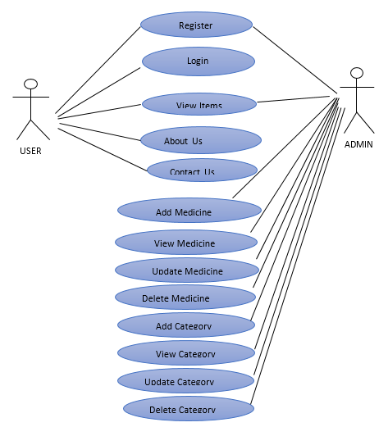

Figure 4.1 Snapshot of Use case model of OPMS

Registration Page

Brief Description | Registration
Basic Flow | This use case describes how a user log-in in to the system  - The user/admin has to register himself/herself into the system.  - The following information is required to register.  - Name  - Password  - Mobile Number  - Email Id  - User Role  - Age  - Gender
Alternate Flow | The system will validate the information provided. If any invalid data is found, the input form will be redirected with error message.
Validation | Valid contact number, email id and password must be given
Pre-Conditions | User should have network access and Browser with latest updates.
Post-Conditions | Successful registration message has to be displayed.

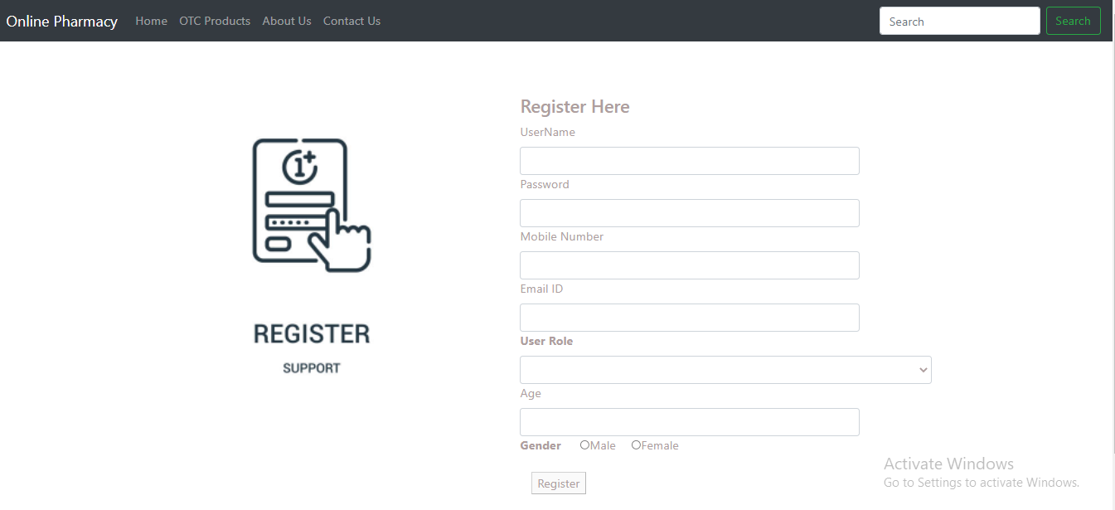

Figure 4.2 Snapshot of Registration Page

Login Page

Brief Description | Login(User/Admin)
Basic Flow | This use case describes how a user log-in in to the system  - The user/admin has to register himself/herself into the system.  - After the successful login, user/admin will be taken to the appropriate landing page.  - The following information is required to login.  - Username  - Password
Alternate Flow | - The system will validate the credentials provided. If credentials are invalid, login form will be redirected again with error message.
Validation | - Valid username  - Valid password
Pre-Conditions | User should have network access and Browser with latest updates.
Post-Conditions | Landing page has to be displayed.

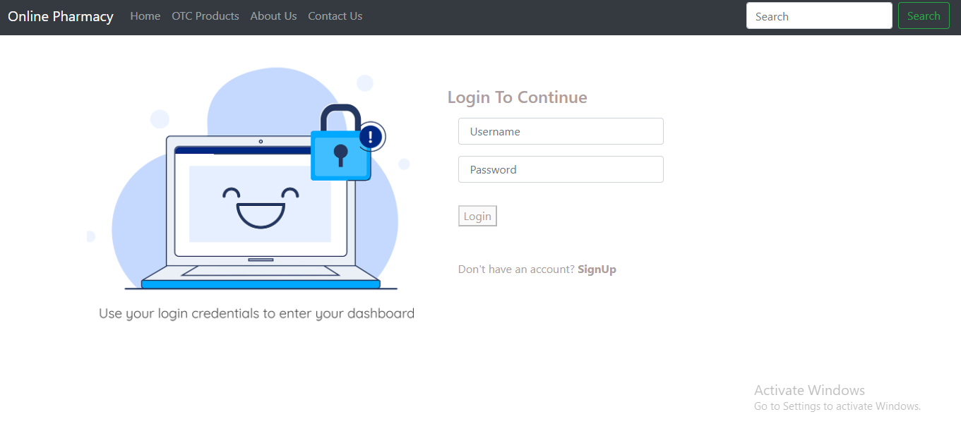

Figure 4.3 Snapshot of Login Page

View Medicines

Brief Description | View Medicines
Basic Flow | This use case describes how the user view medicines.  - The user has to login into the system.  - The following information are seen during view medicines.  - Medicine Id  - Medicine Name  - Category  - Manufacturer  - Price
Alternate Flow | Not Applicable
Validation | Not Applicable
Pre-Conditions | User should have already logged into the system.
Post-Conditions | Not Applicable

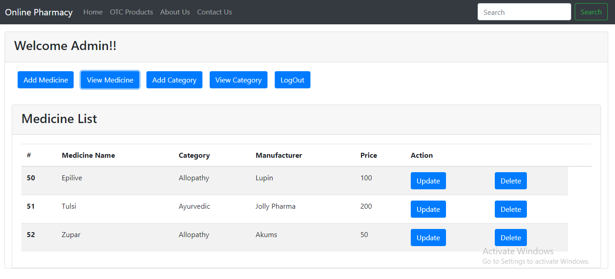
Figure 4.4 Snapshot of View Medicines

Add Medicine

Brief Description | Add Medicine
Basic Flow | This use case describes how the admin add medicine.  - The admin has to login into the system.  - The following information is required during add medicine.  - Medicine Id  - Medicine Name  - Category  - Manufacturer  - Price
Alternate Flow | Not Applicable
Validation | Medicine Id, Medicine Name, Category, Manufacturer and Price is required.
Pre-Conditions | Admin should have already logged into the system.
Post-Conditions | Successful medicine added message has to be displayed.

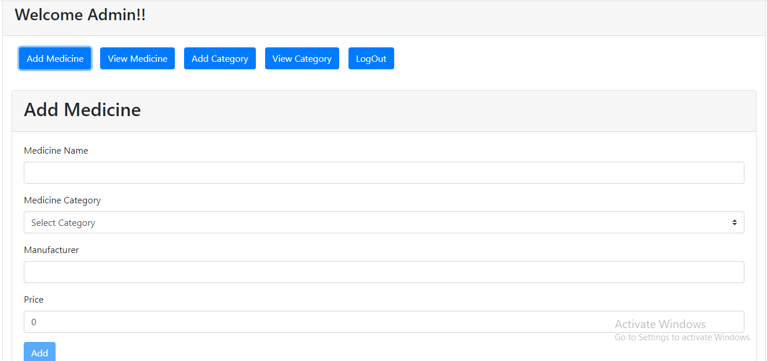
Figure 4.5 Snapshot of update medicine

Update Medicines

Brief Description | Update Medicines
Basic Flow | This use case describes how the admin update medicines.  - The admin has to login into the system.  - The following information is required during update medicines.  - Medicine Id  - Medicine Name  - Category  - Manufacturer  - Price
Alternate Flow | Not Applicable
Validation | Medicine Id, Medicine Name, Category, Manufacturer and Price is required.
Pre-Conditions | Admin should have already logged into the system.
Post-Conditions | Successful medicine updated message has to be displayed.

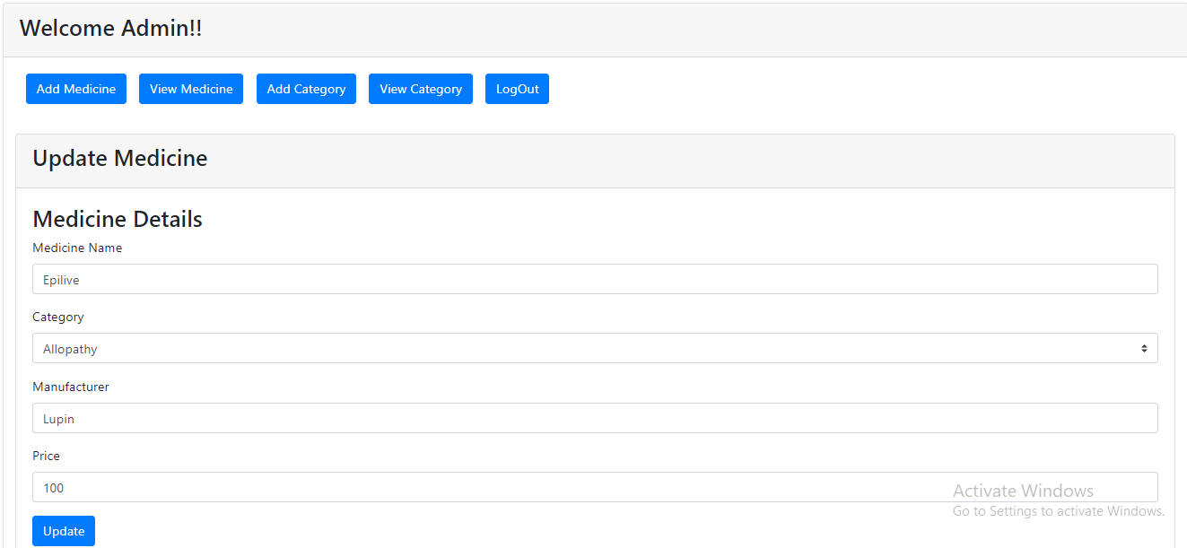
Figure 4.6 Snapshot of Update medicine

View Category

Brief Description | View Category
Basic Flow | This use case describes how the admin view category.  - The admin has to login into the system.  - The following information is seen during view category.  - Category Id  - Category Name  - Description
Alternate Flow | Not Applicable
Validation | Not Applicable
Pre-Conditions | Admin should have already logged into the system.
Post-Conditions | Not Applicable

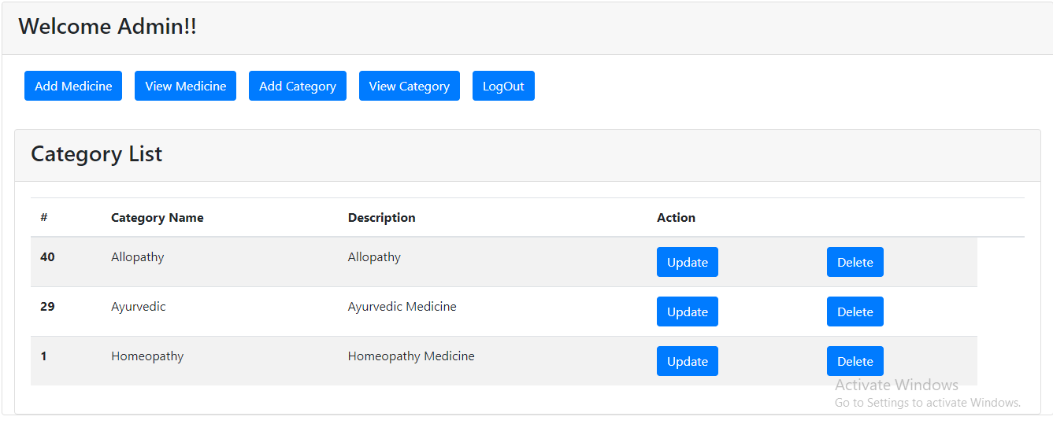
Figure 4.7 Snapshot of View category

Add Category

Brief Description | Add Category
Basic Flow | This use case describes how the admin add category.  - The admin has to login into the system.  - The following information is required during view medicines.  - Category Name  - Description
Alternate Flow | Not Applicable
Validation | Category Name and Description is required.
Pre-Conditions | Admin should have already logged into the system.
Post-Conditions | Successful Category added message has to be displayed.

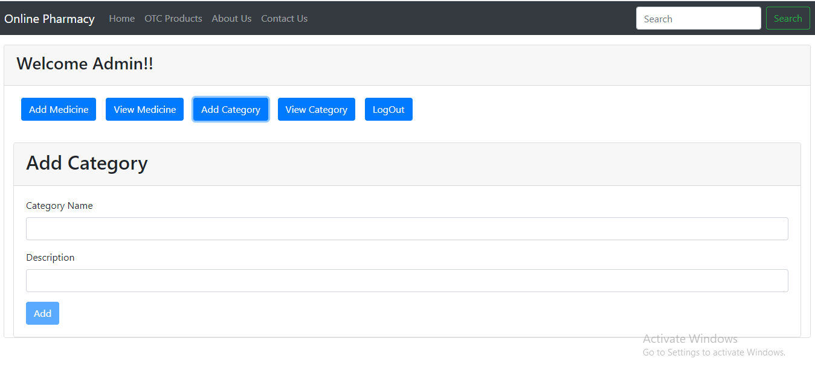
Figure 4.8 Snapshot of Add category

Update Category

Brief Description | Update Category
Basic Flow | This use case describes how the admin add category.  - The admin has to login into the system.  - The following information is required during view medicines.  - Category Name  - Description
Alternate Flow | Not Applicable
Validation | Category Name and Description is required.
Pre-Conditions | Admin should have already logged into the system.
Post-Conditions | Successful category updated message has to be displayed.

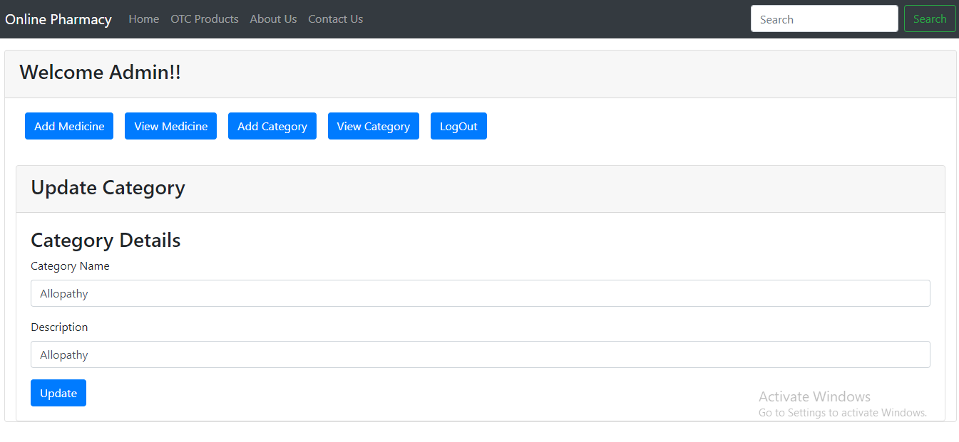
Figure 4.9 Snapshot of Update category

Architecture Diagram

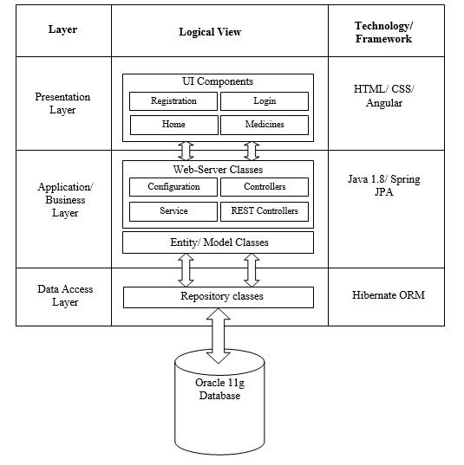

Figure 4.10 Snapshot of Architecture diagram of OPMS

Presentation Layer
This layer consists of all UI components.
- Register Component: Users can use a register component to create an account.
- Login Component: Users can use a login component to login to the website.
- Product Component: Users can use a product component to view medicines.
- Cart Component: Users can use a cart component to add medicines to the cart.

Application Layer
This layer comprises of all server and business classes.
- Configuration settings (XML or class based) will define the application and server configuration.
- Spring Controllers define the server classes, which are required to process the incoming http requests.
- Service classes are required to perform the required business services.
- REST Controllers process HTTP AJAX requests.
- Model classes are used to define the functions of the entities present in the system.

Data Layer
The data layer is implemented through Spring Data JPA. It will contain the repository classes, which provides interface to the table.

Class Diagram

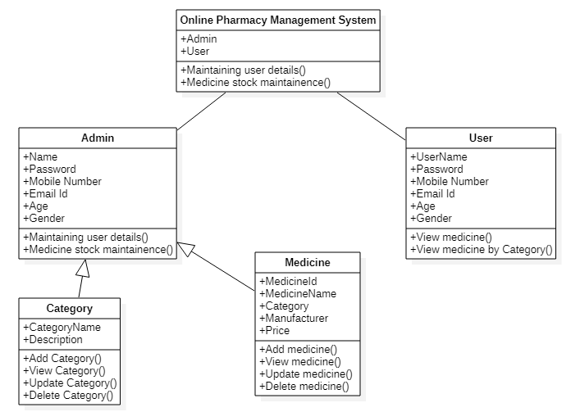

Figure 4.11 Snapshot of Class Diagram of OPMS

Sequence Diagram

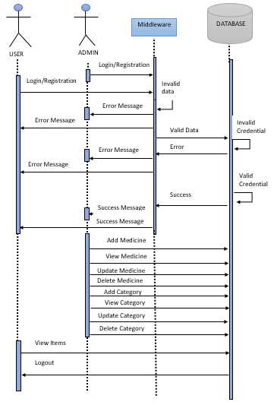

Figure 4.12 Snapshot of Sequence Diagram of OPMS

Database design changes

ER Diagram

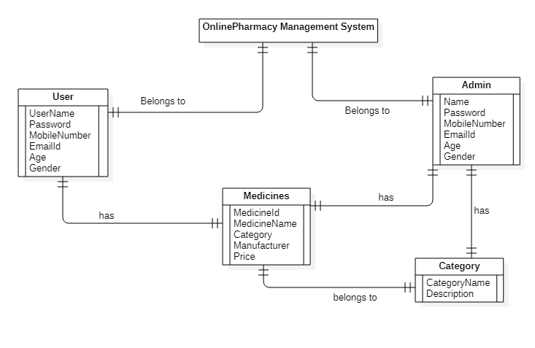

Figure 4.13 Snapshot of ER Diagram of OPMS

