ParkSense
Parking-Induced Congestion Intelligence
for Traffic-Enforcement Command Centres
Flipkart Gridlock 2.0
Theme: Poor Visibility on Parking-Induced Congestion

Live application | parksense-e1w1.onrender.com
Source code | github.com/keshavhacker1609/parksense
API documentation | parksense-e1w1.onrender.com/docs
Team | Keshav Singla · Aadya Jain · Purva Jain · Shravani Singh

Table of Contents

1. The Team
ParkSense was designed and built by a four-member team. The work spans a reproducible data pipeline, a typed analytical API, a machine-learning forecast, and a production-grade single-page command console — integrated into one deployable product.
Keshav Singla | Team lead · backend, analytics engine (CIS, enforcement gap), deployment
Aadya Jain | Data pipeline · parsing, feature engineering, forecasting model
Purva Jain | Frontend · map console, deck.gl visualisation, UI/UX
Shravani Singh | Analytics & validation · methodology, testing, documentation

2. Executive Summary — What We Made
ParkSense is a decision tool, not a dashboard. It converts a raw log of ~298,000 Bengaluru parking-violation records into a ranked, explainable list of where traffic enforcement should act first — and where it is currently failing to act.
The product is built around three computed instruments:
- Congestion Impact Score (CIS) — a transparent per-location score that ranks every geographic cell by how much it obstructs traffic flow, weighting what the violation is (not merely how many).
- Enforcement Efficiency Gap — a per-station measure that exposes high-impact, under-enforced zones — the single most actionable insight for reallocating patrols.
- Short-horizon hotspot forecasting — a backtested model that predicts each hotspot's next-day intensity, plus an emerging-hotspot detector for watch zones.
These are surfaced through a dark, data-dense command console: a full-bleed impact heatmap, a filter rail, and an insight panel delivering the prioritised action list with an audit-grade breakdown of every score.

Headline figures (all computed from the data)
Incidents analysed | 298,450
Violations (multi-label, exploded) | 348,455
Distinct vehicles tracked | 231,890
H3 impact cells (resolution 9) | 2,534
Police stations profiled | 54
Under-enforced high-impact stations flagged | 18
Emerging-hotspot watch zones | 28
Observed window | 9 Nov 2023 – 8 Apr 2024 (Asia/Kolkata)
Forecast accuracy | MAE 3.77 vs. naïve 4.23 (+11% skill)

The command console
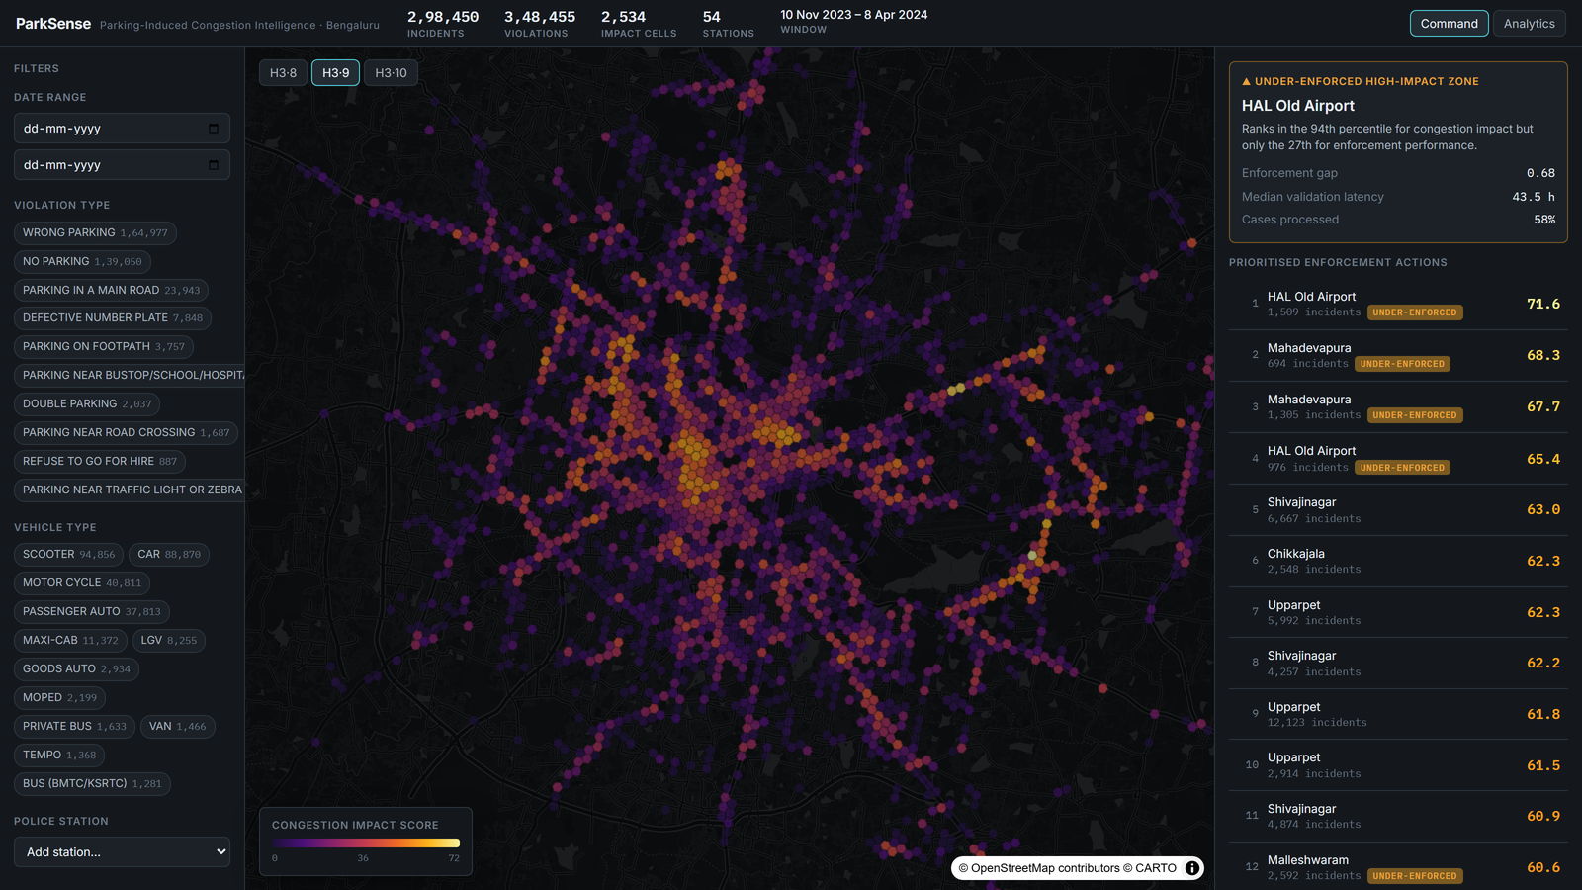
The live impact heatmap, filter rail, and prioritised enforcement panel.

3. The Problem and Why It Matters
Illegal and careless parking is one of the largest, least-managed contributors to urban congestion. A single vehicle stopped on a main road, a footpath, or near a junction can throttle a lane for hours, cascading delays across a corridor.
The Gridlock 2.0 brief frames it precisely: quantify the impact of parking violations on traffic flow to enable targeted enforcement. The key word is impact.
Why most approaches fall short. The violations in the dataset are already detected and labelled. Plotting them on a map only re-states what is already known — a wall of dots with no priority, no explanation, and no link to enforcement effectiveness. A command centre cannot act on 298,000 undifferentiated points.
The real, unanswered question is therefore not “where are violations?” but: which locations are doing the most damage to traffic flow, and where is enforcement effort failing to match that damage?
ParkSense exists to answer exactly that — turning an opaque log into visible, ranked, explainable priorities, directly addressing the chosen theme, Poor Visibility on Parking-Induced Congestion.

4. Our Solution
ParkSense treats the problem as a prioritisation and resource-allocation problem, solved with three layers that build on each other.

4.1 Measure impact (CIS)
Every location is scored by how much it actually obstructs flow — combining violation severity, vehicle footprint, density, persistence and peak-hour pressure — rather than by raw count. A bus blocking a main road outranks a scooter on a quiet lane, which is how a traffic officer would triage.

4.2 Expose the enforcement gap
We compare each station's congestion impact against its enforcement performance. The output is a ranked list of zones that are high-impact but under-enforced — precisely where redeploying patrols yields the most benefit.

4.3 Look ahead (forecast + anomalies)
We forecast next-day intensity per hotspot and flag cells whose recent activity is spiking versus their own baseline, so teams can pre-position rather than react.

5. The Dataset
A single CSV of Bengaluru parking-violation records. The schema and its quirks drove many of our engineering decisions. Parsing challenges we handled robustly:
- JSON arrays inside CSV cells — violation_type and offence_code are JSON-encoded arrays; one row can carry several violations. We parse and explode them, taking per-incident severity as the maximum over its types.
- Literal "NULL" tokens — normalised to real missing values rather than treated as text.
- Timezone-aware timestamps — source times are UTC; converted to Asia/Kolkata before any temporal analysis.
- Date range from the data, not the filename — the true window (9 Nov 2023 – 8 Apr 2024) is computed from created_datetime.
- Coordinate sanity bounds — rows outside Bengaluru are dropped.
- Stable anonymised vehicle_number — used for repeat-offender and chronic-location analysis.
A critical data-quality finding. On inspection, action_taken_timestamp and closed_datetime are 100% NULL across the dataset. Rather than fabricate enforcement metrics, we pivoted the enforcement analytics to the field that is populated (~58% coverage): validation_status / validation_timestamp. Enforcement latency is therefore measured as created → validation. Where a value genuinely cannot be computed, we do not display it. This honesty is a deliberate design principle.

6. How It Works — The Analytics Layer

6.1 Congestion Impact Score (CIS)
CIS is a transparent weighted composite, computed per H3 cell, normalised to 0–100, and damped by a recurrence-confidence factor.
CIS_raw = w_sev·severity + w_foot·footprint + w_dens·density + w_pers·persistence + w_peak·peak_pressure
CIS = (CIS_raw / Σw) · 100 · confidence, confidence = n / (n + k), k = 25
Severity | 0.35 | Mean flow-obstruction ordinal of the cell's violation mix (footpath / main-road / crossing highest; non-obstructive offences lowest).
Vehicle footprint | 0.20 | Mean carriageway width consumed by the vehicle mix (scooter 1.0 → bus 6.5).
Density | 0.20 | Incident volume per cell, log-compressed then min-max normalised.
Persistence | 0.10 | Fraction of the observed window the cell was active — chronic vs. one-off.
Peak pressure | 0.15 | Share of incidents in the data-derived peak hours.

Data-derived peak hours. Rather than assuming rush hours, we take the top quartile of hours by volume — for this dataset, 04, 05, 08, 09, 10, 11 (local) — surfaced explicitly in the UI.
Why the confidence factor? Severity, footprint and peak pressure can be high for a single unlucky incident. A prioritisation tool must not rank that beside a chronic hotspot, so the composite is shrunk by n/(n+k): a cell needs roughly k incidents to reach half weight. This removed low-evidence one-offs from the top of the ranking.
Transparency. Each component's contribution is stored and shown on hover, so any score is auditable in one glance. The same formula is implemented once in Python and faithfully re-implemented in SQL so filtered map views recompute the score for exactly the slice on screen.

6.2 Enforcement Efficiency Gap
- Impact = sum of the CIS of every cell the station is responsible for.
- Enforcement performance = mean of two percentile ranks — cases processed (validation rate) and turnaround speed (low median validation latency). Rejection rate is reported but not penalised.
- Gap = impact percentile − performance percentile. A large positive gap → flagged under-enforced.
This produces the product's sharpest line, e.g. “HAL Old Airport ranks in the 94th percentile for congestion impact but only the 27th for enforcement performance.” 18 stations are flagged — a ready-made patrol-reallocation list.

6.3 Hotspot Forecasting
A daily per-cell intensity model over the busiest cells: LightGBM with a Tweedie objective, on lag (1/2/3/7/14 d), rolling mean/std (7/14 d), calendar, and a spatial-neighbour signal (H3 ring-1, lagged). Evaluated on a held-out final 21 days — the model never sees the test window during training.
MAE | 3.77
MAE — naïve persistence baseline | 4.23
Skill vs. naïve | +11.0%
MAPE | 96.8% (inflated by many low-count days; MAE is the honest headline)

We publish the persistence baseline alongside the model so the gain is provable, not asserted.

6.4 Emerging-hotspot / Anomaly Detection
We flag cells whose recent-window mean exceeds their own historical baseline by a rolling z-score threshold. These become watch zones (28 detected) — locations trending up before they become established hotspots.
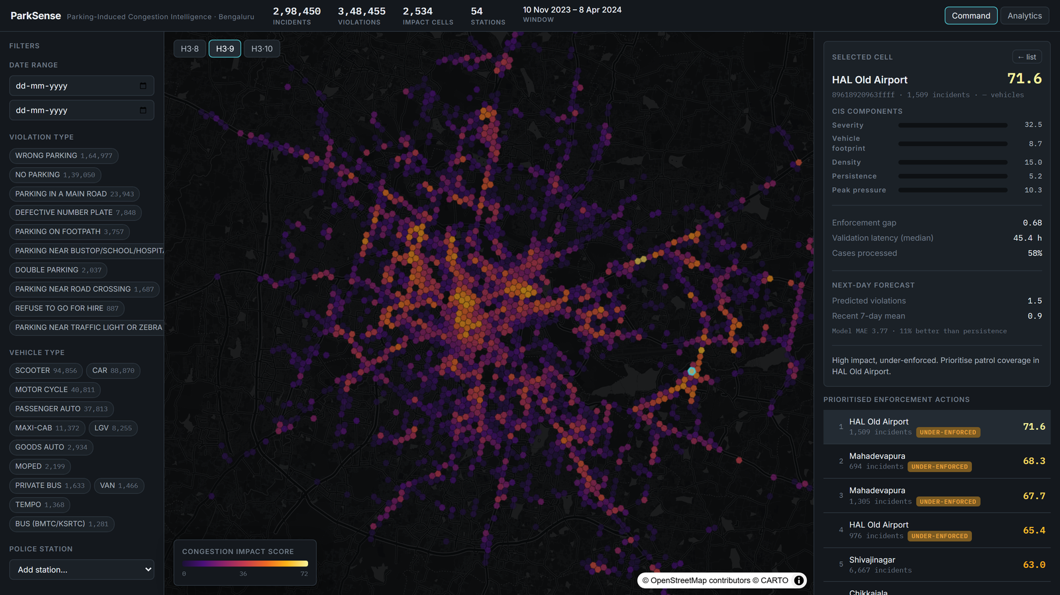
Selecting a hotspot reveals its CIS components, enforcement gap and next-day forecast.

7. System Architecture
Two-phase design. Heavy computation (parsing, scoring, model training) runs once in the offline pipeline and is persisted as Parquet/JSON artifacts. The API then serves these instantly and recomputes only filter-dependent aggregates on demand — keeping the live product fast and the analytics reproducible.
pipeline/ingest.py | Clean CSV · explode JSON · UTC→IST · H3 index → violations.parquet
pipeline/features.py | CIS · enforcement gap · anomalies · meta → hex/station/anomaly.parquet + meta.json
pipeline/forecast.py | LightGBM training + backtest → forecast.parquet
DuckDB + FastAPI | In-process columnar SQL over Parquet; typed REST with server-side aggregation
React SPA | MapLibre GL + deck.gl (H3HexagonLayer) + ECharts

Single-service deployment. For the live demo, the built frontend is served by the same FastAPI process that serves the API — one URL, no CORS, one container. The Docker image ships the precomputed artifacts, so the deployed service needs no raw CSV.

8. Technology Stack and Why We Chose It
Analytical engine | DuckDB | Columnar, in-process, zero-setup SQL over Parquet; runs instantly, no DB server.
Geospatial index | Uber H3 | Hexagonal cells give uniform, distortion-free spatial aggregation.
Backend | FastAPI + Pydantic | Typed, async, automatic OpenAPI docs, fast.
Forecasting | LightGBM + scikit-learn | Strong, fast gradient boosting; Tweedie objective fits the count target.
Data processing | pandas + pyarrow | Robust parsing and Parquet I/O.
Frontend | React + TypeScript + Vite | Type-safe, fast dev/build.
Mapping | MapLibre GL + deck.gl | GPU-accelerated H3HexagonLayer; free, key-less basemap.
Charts | ECharts | Restrained, control-room-grade charts.
Packaging / hosting | Docker / Render | One image hosts UI + API; free, blueprint-driven deploy.

No paid APIs are required to run. Everything works offline from the CSV; the basemap is a free MapLibre raster style.

9. API Reference
Base URL: parksense-e1w1.onrender.com · Interactive docs: /docs. All aggregation is server-side — the browser never receives raw rows.
GET /health | Liveness + total incident count.
GET /api/v1/meta | Date range, distinct filter values, totals, peak hours, CIS quantile breaks, backtest.
GET /api/v1/hexes | H3 cells with filter-aware CIS and full component breakdown.
GET /api/v1/hotspots/priority | Ranked enforcement action list with CIS, station, gap, recommendation.
GET /api/v1/enforcement/gap | Per-station impact vs. enforcement performance, with under-enforced flag.
GET /api/v1/forecast | Per-cell next-day forecast + backtest error.
GET /api/v1/anomalies | Emerging-hotspot watch zones.
GET /api/v1/trends | Time series grouped by hour / dow / month / vehicle / violation.
GET /api/v1/enforcement/latency | Validation-latency distribution.
GET /api/v1/incident/{id} | Single-record drill-down.

10. The User Interface
A single-purpose command console, not a marketing site.

Command view
- A full-bleed dark impact heatmap (deck.gl H3HexagonLayer) with a legend tied to real CIS quantiles and a resolution switch (H3 8 / 9 / 10).
- A left filter rail — date range, violation type, vehicle type, station — populated from /meta, multi-select, instant; every change recomputes the score server-side.
- A right insight panel — prioritised enforcement list, selected-cell CIS breakdown, next-day forecast, and the under-enforced high-impact zone callout.
- A top bar with live computed totals and the true data date range.

Analytics view
- Hourly violation pressure with the derived peak windows highlighted; day-of-week and monthly trends; violation and vehicle composition; enforcement validation-latency distribution.
Design language. Deep neutral slate base, one disciplined amber signal colour, a perceptually-uniform inferno ramp for impact (colour-blind safe), Inter + IBM Plex Mono with tabular numerals, and designed empty/loading/error states. It is meant to feel like an internal tool a traffic department paid for.

11. How We Built It — Engineering Process
We followed a strict execution order so each layer rested on a verified one:
- Pipeline first — robust parsing (JSON arrays, NULLs, timezones) → Parquet → validated schema → meta queries, with computed meta printed to confirm parsing.
- Scoring + enforcement gap, with unit tests on the provably-correct core.
- FastAPI endpoints over DuckDB, with OpenAPI.
- Map console consuming the real endpoints.
- Forecasting + anomaly models, wired into the insight panel with honest error reporting.
- Polish + deploy — designed states, legend, reproducibility, Docker, live hosting.

Principles we held throughout
- Zero hardcoding — every threshold, weight, resolution and ranking is derived at runtime or lives in one typed config.
- Accuracy over flash — no invented metrics; every chart traces to a real query.
- Reproducibility — the whole pipeline rebuilds from the raw CSV in ~30 seconds.

Issues we found and fixed during verification
- Domain tables (severity/footprint) initially didn't match the dataset's exact category strings (e.g. BUS (BMTC/KSRTC)); corrected against distinct queries.
- A single DuckDB connection caused intermittent 500s under FastAPI's concurrent threadpool; fixed with a lock.
- UNNEST inside SELECT … GROUP BY is rejected by DuckDB; rewritten as a subquery.

12. Running the Project

Option A — Live demo (no setup)
Open parksense-e1w1.onrender.com. API docs at /docs. (Free tier sleeps after 15 min idle; first request may take ~50 s to wake.)

Option B — Docker (one command)
docker build -t parksense . && docker run -p 8000:8000 parksense

Option C — Local development
Prerequisites: Python 3.11+, Node 18+. Place the dataset at data/violations_raw.csv, then:
python -m venv .venv
.venv\Scripts\python -m pip install -r backend\requirements.txt
.venv\Scripts\python -m pipeline.run_all # build parquet + scores + model (~30s)
.venv\Scripts\python -m uvicorn backend.app.main:app --port 8011
cd frontend && npm install && npm run dev # open http://localhost:5181

13. Testing and Quality
The provably-correct core is covered by unit tests: JSON-array and NULL-token parsing; violation-severity and vehicle-footprint mapping; scoring helpers; data-derived peak-hour selection; and monotonicity of the confidence-shrinkage factor (11 tests pass). The frontend is fully typed and type-checks clean, and builds for production without errors. The Docker image was built and run locally before deployment to verify the single-service setup end to end.

14. Project Structure
parksense/
├─ backend/ app/api/routes.py · app/core/{config,store}.py · app/main.py · tests/
├─ pipeline/ ingest.py · features.py · forecast.py · run_all.py
├─ frontend/ src/components · api.ts · config.ts · theme.css
├─ data/ parquet + meta artifacts (raw CSV gitignored)
├─ docs/ documentation · methodology · screenshots · deck
├─ Dockerfile · render.yaml · README.md

15. Design Decisions and Trade-offs
- CIS as a transparent composite, not a learned score — a command centre must trust and explain the priority, so we chose an auditable, weighted composite with visible components.
- Confidence shrinkage over a hard cutoff — degrades low-evidence cells smoothly instead of discarding them.
- Validation lifecycle instead of empty action/closed fields — forced by the data; the alternative would mislead.
- Precompute + DuckDB rather than a live OLAP DB — zero-setup, instantly runnable, fast enough that filtered CIS recomputes in milliseconds.
- Single-service deployment — simpler, one URL, no CORS.

16. Limitations and Honest Caveats
- action_taken / closed lifecycle fields are empty, so true closure latency cannot be measured; we use validation latency as the best available proxy.
- The forecast targets the busiest cells; MAPE is high due to many near-zero days — MAE and skill-vs-baseline are the honest measures.
- Severity and footprint ordinals encode domain judgement; they are fully visible in config and easily tuned by a traffic authority.
- The free hosting tier sleeps when idle, adding a one-time cold-start delay.

17. Future Work
- Ingest live feeds for rolling, real-time CIS and same-day forecasts.
- Calibrate severity/footprint weights against measured traffic-speed data per corridor.
- Route-aware impact (network effects of a blockage on connected roads).
- Officer-facing mobile view with turn-by-turn patrol routing over the priority list.
- Closed-loop evaluation: measure congestion change after enforcement is reallocated to flagged zones.
ParkSense — from a 298,000-row log to a daily patrol plan.

