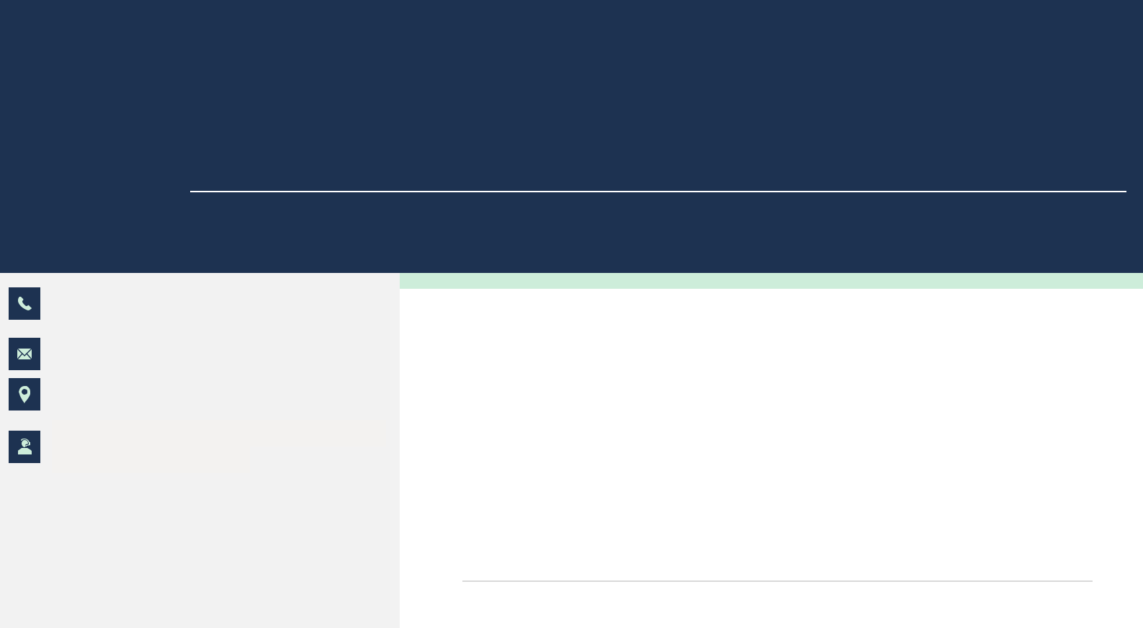
LC Luvkush Chaudhary
AWS Architecture & DevOps Engineer

9368398338

Chaudharyluvkush39@gmail.com Khair/Uttar Pradesh/India

https://www.linkedin.com/in/luvkush-chaudhary-15072a234

ABOUT ME

I love to work with people having creative mindset, facilitating new ideas, intuitive concepts and maintaining friendly atmosphere for mutual growth.

PROFESSIONAL E X P E R I E N C E

SKILLS

Git (Distributed version control system)
Linux (Command line interface)

Chef/Ansible (Configuration tool)

Docker (Containerisation tool)

Kubernetes (Orchestration tool)

Terraform (Infrastructure as a code)

Jenkins (CI/CD)
Python (Scripting language)

AWS Services (Lambda, CloudFront, VPC, Load balancer, autoscaling, Ec2 instance, LightSail, S3,

ECS, ECR, Athena)

EDUCATION

Bachelor of Technology (2019-2023)

Dr.A.P.J Abdul kalam Technical University, Lucknow

Intermediate (2017-2018)

S D INTERMEDIATE VISYALAY USRAM ALIGARH

High School | (2014-2015)

R P HSS ALIASHPUR ALIGARH

STRENGTHS

Punctual & Sincere

Confident & Eager to learn

PERSONAL DETAILS

DOB: - 10 October 2004

Hobbies: - writing, Learn new things from the internet

Nationality: - Indian

Gender: - Male

Language: - Hindi & English both speak and write

Nativebyte Software LLP /Delhi / Feb-2023

I have 2 year of Experience in Nativebyte as a DevOps Engineer profile, Now currently, I am working on Sony project where My role and responsibility is deployment of code on dev and stage.
  - Provisioning and configuring cloud resources.

  - Deploying and managing applications.

  - Monitoring and troubleshooting infrastructure and applications.

  - Automating DevOps tasks.

  - Troubleshooted and resolved issues related to infrastructure and deployments.

  - Automated infrastructure provisioning using tools like Terraform and Ansible.

  - Lead the implementation of CI/CD pipelines, reducing deployment time by 30%.

DECLARATION

I hereby declare that the above given information is true and best of my Knowledge & belief.

