Supporting Information
to
The Influence of Spacer Arm Identity on Salt Transport in Charged Nanofiltration Membranes
Laurianne Estradaª, Jonathan A. Ouimetª, Michael P. Dugas^{b}, Quinn Mcculloch^{b}, Rian Nguy^{b}, William A. Phillipª
ª Department of Chemical and Biomolecular Engineering, University of Notre Dame, Notre Dame, IN, 46556, United States of America
^{b} Material Synthesis and Integrated Devices, Los Alamos National Laboratory, Los Alamos, NM, 87545, USA
E-mail: wphillip@nd.edu
Table of Contents
Section S1: Copolymer Fabrication, Functionalization, and Nanostructure Determination S2
Figure S1: ¹H-NMR Spectra S2
Figure S2: ATR-FTIR Spectra S3
Figure S3: Hydrophilic Domain Size Determination S5
Figure S4: Hydraulic Permeability S6
Section S2: Zeta Potential and Fixed Membrane Charge S7
Figure S5: Zeta Potential Measurements S8
Table S1: Charge Density Calculations S9
Section S3: High Throughput Diafiltration Experiments S10
Figure S6: Conductivity Calibration Curves S12
Figure S7: NaCl Transport at Various pH for PEG6 S13
Figure S8: Na₂SO₄ Transport at Various pH for PEG6 S14
Figure S9: NaCl and Na₂SO₄ Transport at Various pH for ALK2 S15
Figure S10: NaCl and Na₂SO₄ Transport at Various pH for PEG6 versus ALK2 S17
Figure S11: Comparing Spacer Arm Chemistry for NaCl and Na₂SO₄ Transport S18
Figure S12: Comparing Monovalent Ion Transport S20
Figure S13: Water Flux S21
Section S4: Water Contact Angle Measurements S22
Figure S14: Water Contact Angle S22
Table S2: Water Contact Angle Values S23
Section S5: Water Volume Fraction Measurements S24
Figure S15: Water Volume Fraction S25
Table S3: Water Volume Fraction S25
Section S6: References S25

Section S1: Copolymer Fabrication, Functionalization, and Nanostructure Determination
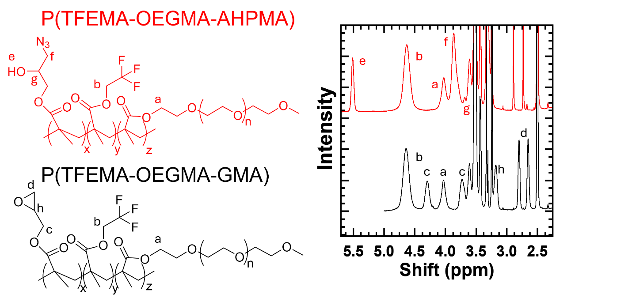
Figure S1: ¹H-NMR spectra of the P(TFEMA-OEGMA-GMA) and P(TFEMA-OEGMA-AHPMA) copolymers. Peaks associated with protons within the copolymer structures are labeled. The P(TFEMA-OEGMA-GMA) is the parent copolymer, where the peaks labeled a, b, and d were used to determine the relative composition of OEGMA, TFEMA, and GMA, respectively. The composition of the parent copolymer (by weight) was determined to be 44.7% TFEMA, 41.8% OEGMA, and 13.5% GMA. Upon conversion from GMA to AHMPA, the peaks labeled c, h, and d disappear. Consequently, the peaks e, f, and g form.

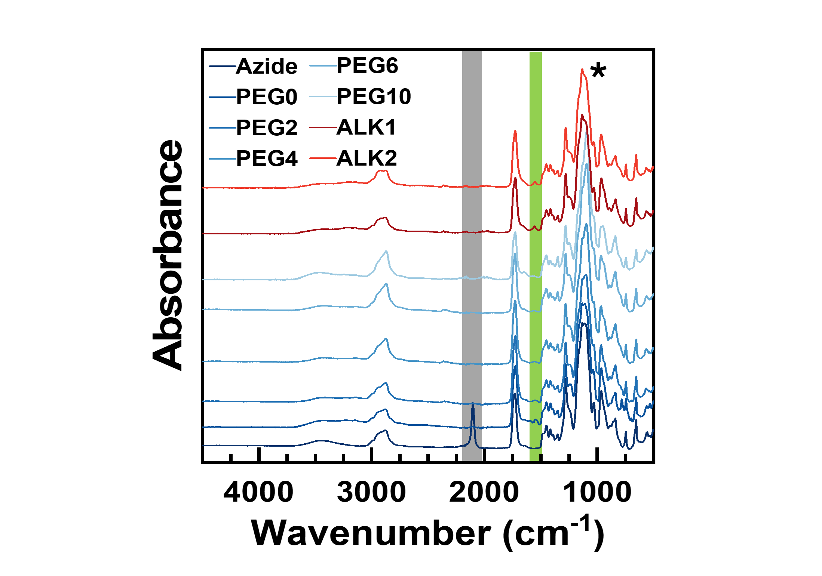Figure S2: ATR-FTIR is used to identify changes in membrane surface chemistry. Absorbance versus wavenumber spectra are shown for the parent, azide and functionalized membranes. The absorbance was normalized using the trifluoroethyl peak at 1126 cm⁻¹ (*). The characteristic azide peak is found at 2100 cm⁻¹ and is highlighted in grey. The disappearance of the azide peak in the PEG0, PEG2, PEG4, PEG6, PEG10, ALK1, and ALK2 membranes is consistent with full conversion of the azide. The peaks highlighted in green at 1725 cm⁻¹ are attributed to the C=O bond appearing from the addition of a carboxylic group in the functionalized membranes.

The size of the hydrophilic domain within each membrane was estimated using hindered transport theory developed by Zeman and Wales^{1,2}. This theory relates the actual solute rejection (R) to the ratio of the hydrodynamic size of the solute to the size of the hydrophilic domains (Equations S1 and S2).
$$R=1-\left[\left\{1-{\left(λ\left(λ-2\right)\right)}^{2}\right\}\exp\left(-0.7146λ^{2}\right)\right]$$ | Eq. S1
$$λ=\frac{d_{solute}}{d_{domain}}$$ | Eq. S2
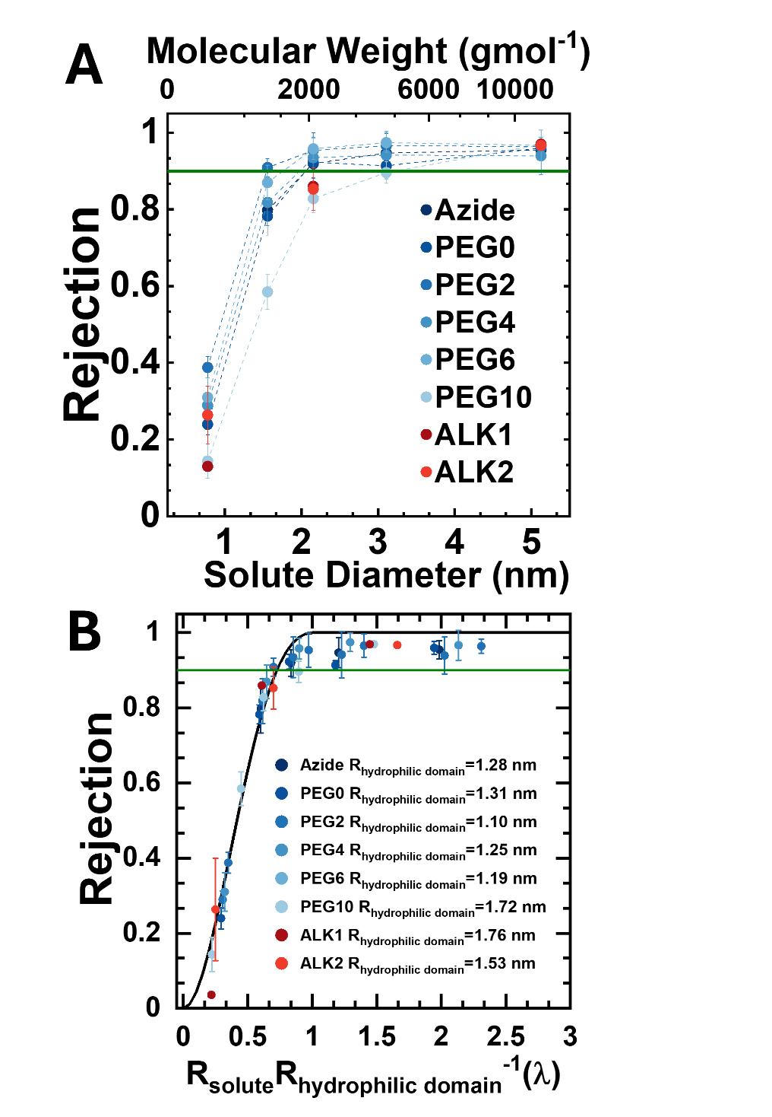
Figure S3: Neutral solute rejection curves for the parent and functionalized copolymer membranes used in this study. (A) Neutral solute rejection as a function of molar mass and solute diameters. Results are shown for each membrane investigated in this study. The green line at 90% rejection represents the molecular weight cutoff. Sucrose (324 g mol⁻¹) and PEG samples ranging from 1200 to 10,200 g mol⁻¹ were used as neutral solutes. The steep decline in rejection under 2 nm indicates a narrow size distribution for the hydrophilic domain. (B) Membrane hydrophilic domain diameters ranging between 1.10 nm and 1.76 nm were regressed using a hindered transport model. An average hydrophilic domain size of 1.39 ± 0.23 nm was then determined for the membranes in this study. The overlapping rejection curves between the azide and functionalized membranes suggests that functionalization does not alter hydrophilic domain size.
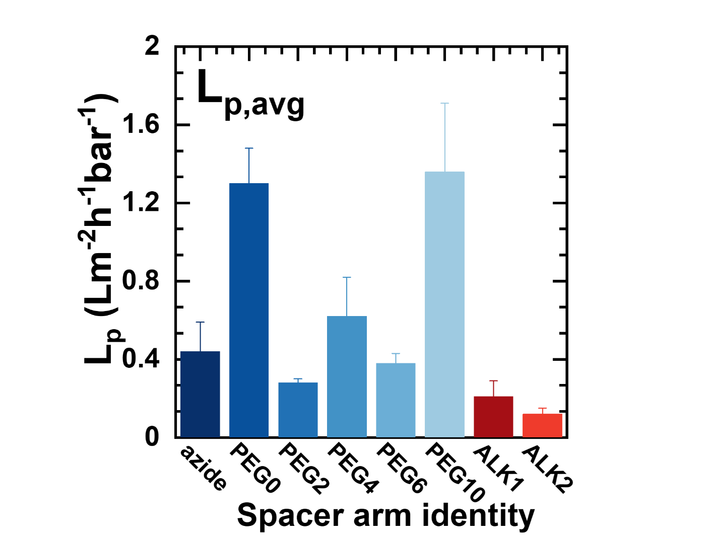
Figure S4: Hydraulic permeability as a function of the spacer arm identity. Hydraulic permeability for each membrane was measured on four separate samples; Error bars indicate one standard deviation. The azide membrane serves as a point of reference. Generally, as the PEG spacer arm increases, becoming more hydrophilic, permeability increases. Hydrophobic ALK ligands show a decrease in permeability. The deviation from the anticipated trend with PEG0 and between PEG4 and PEG6 are attributed to batch-to-batch variability.

Section S2: Zeta Potential Measurements
Surface zeta potential measurements were performed on three membrane samples using an Anton Paar SurPASS 3 analyzer equipped with an adjustable gap cell. The instrument was operated in voltage mode with a maximum calculation cap of 300 mbar. Membrane samples were cut into 20 mm × 10 mm rectangles and mounted for analysis. Measurements were conducted using 1 mM KCl in DI water as the background electrolyte. The initial scan was automated from pH 2 to pH 10.5. To reach pH 12, manual titrations were performed in pH 0.5 increments. Each zeta potential data point is the average of four measurement cycles, rinsing with DI water between each scan. Zeta potential measurements are shown in Figure S5.
The membrane fixed surface charge density ($χ$) for azide, PEG0, and PEG10 membranes are calculated using the Gouy-Chapman equation³ (Equation S4) and shown in Table S1.
$$σ_{eff} ({C m}^{-2})=sqrt\left(8c_{f}N_{A}ϵ_{r}ϵ_{0}K_{B}T\right)sinh\left(\frac{z_{i}eζ}{2k_{B}T}\right)⁡$$ | Eq. S3
$$χ \left(mM\right)=\frac{σ_{eff}}{\frac{d_{domain}}{2}F}$$ | Eq. S4
Where $c_{f}$ is the KCl concentration used in the zeta potential measurements, $N_{A}$ is Avogadro’s number, $ϵ_{r}$ is the relative permittivity of water, $ϵ_{0}$ is the vacuum permittivity, $k_{B}$ is the Boltzmann constant, T is temperature, $z_{i}$ is the ion charge, e is elemental charge, $ζ$ is the zeta potential, $\frac{d_{domain}}{2}$ is the hydrophilic domain radius, and F is Faraday’s constant.
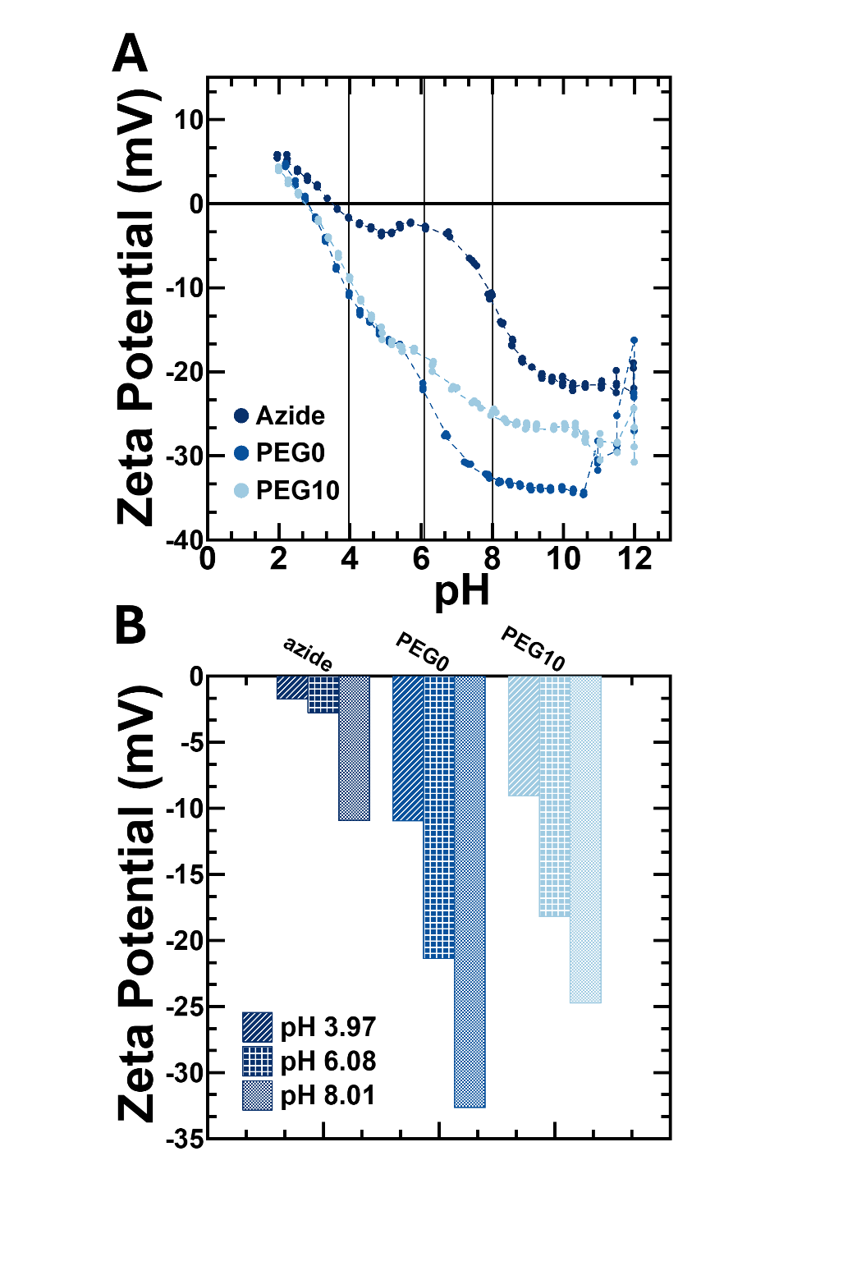
Figure S5: Zeta potential as a function of solution pH. (A) The zeta potential for azide, PEG0, and PEG10 membranes are plotted across the evaluated pH range. (B) Zeta potential measurements for pH 4, pH 6, and pH 8 are highlighted. Zeta potential becomes more negative with increasing pH, consistent with the deprotonation of carboxylic acids within the membrane for PEG0 and PEG10. The azide membrane sees an increase in negative zeta potential due to the possible adsorption of hydroxide ions on the P(TFEMA-OEGMA-AHPMA) copolymer in increasingly basic solutions.

Table S1: Surface Charge Density, $χ$, at pH 4, pH 6, and pH 8 calculated using Eq. S4.
Membrane | Surface Charge, $χ$ (mM)
 | pH 3.97 | pH 6.08 | pH 8.01
Azide | -1.00 | -1.93 | -6.45
PEG0 | -6.32 | -12.60 | -20.01
PEG10 | -3.97 | -7.79 | -11.22

Section S3: High Throughput Diafiltration Experiments
Diafiltration experiments are conducted to evaluate membrane performance across feed solution concentrations ranging from 1 – 100 mM NaCl or Na₂SO₄. For NaCl, the assumption that all ions are fully dissociated aligns with the Manning/Donnan model⁴. Furthermore, activity coefficients for the studied concentration range are calculated to be 0.94 ± 0.03 using the Davies equation⁵ (Equation S5), indicating near ideal behavior in solution. On the other hand, roughly 5% of Na₂SO₄ ions are paired at 10 mM and increases to ~20% at 100 mM. Activity coefficients are estimated at 0.86 ± 0.03, indicating notable deviations from ideality. Here, it is assumed that ion pairing effects are negligible within the studied concentration range, a simplification made allowing the focus to remain on differences in membrane nanostructure. However, it is acknowledged that the presence of Na₂SO₄ ion-pairing can enhance salt transport⁴.
$$-\log\left(γ\right)=0.5z_{1}z_{2}[\frac{\sqrt{I}}{1+\sqrt{I}}-0.2I]$$ | Eq. S5
$$Ionic strength \left(I\right)=0.5\sum{z_{i}^{2}c_{i}}$$ | Eq. S6
Where $γ$ is the activity coefficient, $z_{i}$ is the ion charge, and $c_{i}$ is the concentration of each ion, respectively.
A thin film model⁶ was used to calculate interfacial concentration from bulk salt concentrations obtained via retentate conductivity probes (Equations S7 and S8), thereby accounting for concentration polarization.
$$c_{int}=c_{p}+(c_{f}-c_{p})exp\left(\frac{J_{w}}{k}\right)⁡$$ | Eq. S7
$$k=0.23\frac{{(v^{0})}^{0.57}D^{0.67}}{ν^{0.24}b^{0.43}}$$ | Eq. S8
Where c_{p} is the bulk permeate concentration, c_{f} is the feed concentration, J_{w} is the water flux, k is the mass transfer coefficient, v⁰ is the average velocity of the system, $ν$ is the kinematic viscosity of water, and D is the diffusion coefficient of the solute (i.e., NaCl, Na₂SO₄).
The permeate probe reservoir is filled with DI water at the start of each experiment, yielding diluted bulk permeate conductivity measurements. To account for dilution, a residence time, $τ=\frac{V_{p}}{J_{w}A_{m}}$, where V_{p} is the permeate reservoir volume, J_{w} is the water flux and A_{m} is the membrane area, is calculated⁷. One residence time is sufficient to describe the rate at which the incoming salt solution displaces the DI water. In this manner, $τ$ is incorporated into the mass balance allowing for interfacial permeate concentrations to be calculated⁷. Spikes in the permeate probe data represent the passage of bubbles through the reservoir. Furthermore, these spikes have been removed, represented by gaps in the plotted raw data, to show the data more clearly. The omission of these data points does not influence the general trend or trajectory of the data set in its entirety.
Changes in conductivity measurements resulting from adjustments in solution pH are accounted for in the calibration curves. A stock solution of 100 mM NaCl and Na₂SO₄ was made. Using an I3-620-AP50A Fisher Scientific pH probe, solution pH was monitored untiled the desired pH was reached. NaOH was added to each salt solution until pH 8 was reached. To reach pH 4, HCl was added to the NaCl solution while H₂SO₄ was added to the Na₂SO₄ solution. The choice of acid and base was selected to ensure a fourth ion was not introduced, possibly skewing the interpretation of the transport results. Serial dilutions were performed in increments of 10 mM at higher concentrations and 2 mM in the lower concentration region.
Figure S6 compares measured calibration curves for NaCl and Na₂SO₄ at each pH value and the predicted conductivity measurements at solution pH 6. The Shedlovsky conductivity model^{8,9}, which assumes that ions are fully dissociated in solution, shows strong agreement with the experimental calibration curve at pH 6 for both NaCl and Na₂SO₄. Deviations up to 7% from the model are seen for NaCl at pH 4 and pH 8. Deviations of 13% are seen for Na₂SO₄ at pH 4 and pH 8, likely attributed to ion speciation.
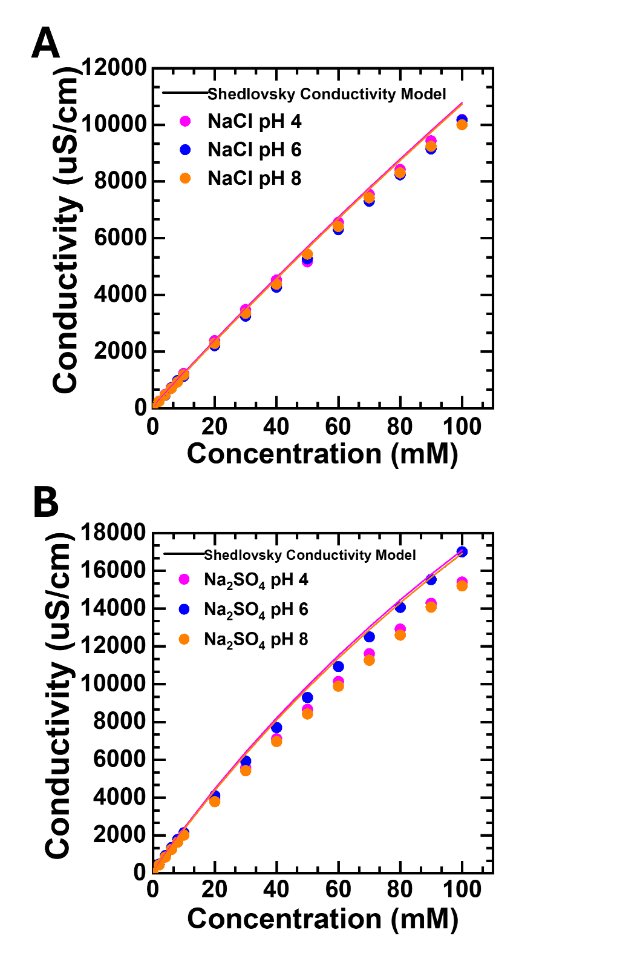
Figure S6: Conductivity calibration curves at pH 4, pH 6, and pH. Conductivity calibration curves were obtained by preparing a 100 mM salt solution, measuring its conductivity, and performing serial dilutions with conductivity measurements in 10 mM increments. This procedure was repeated for each salt and each solution pH. Conductivity probe measurements show good agreement with the Shedlovsky conductivity model.

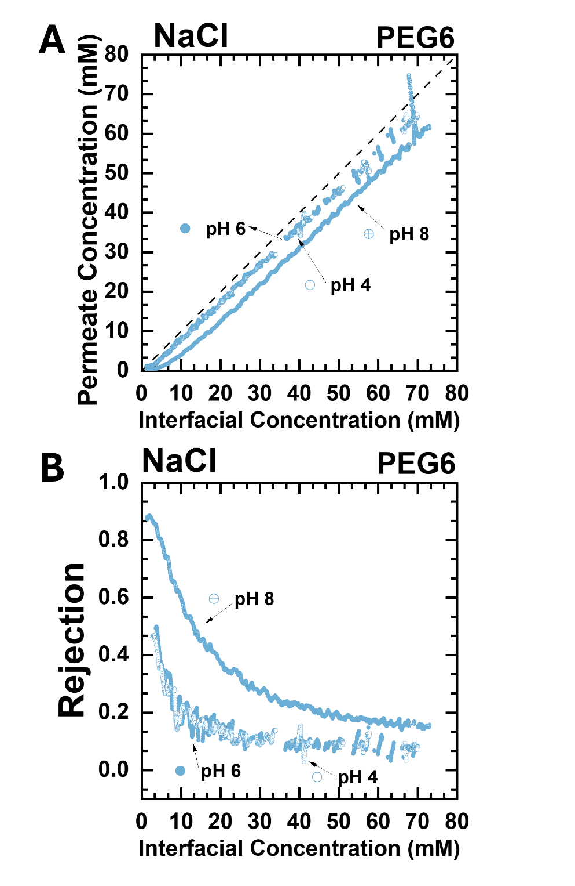
Figure S7: NaCl transport at pH 4, pH 6, and pH 8 for a PEG6 membrane. (A) NaCl permeate concentration is plotted against interfacial concentration for a PEG6 membrane at pH 4, pH 6 (unaltered), and pH 8. Unless otherwise stated, each experiment was conducted using a 1 mM NaCl feed and 100 mM NaCl diafiltrate. The pH was adjusted using HCl or NaOH. The gaps in the data represent data points removed due to bubbles. These have been omitted for clarity and do not change the interpretation of the observed data trends. (B) Rejection versus interfacial concentration. The rejection profiles for pH 4 and pH 6 overlap, indicating no difference in NaCl transport within uncertainty bounds. On the other hand, NaCl is rejected more strongly at pH 8.

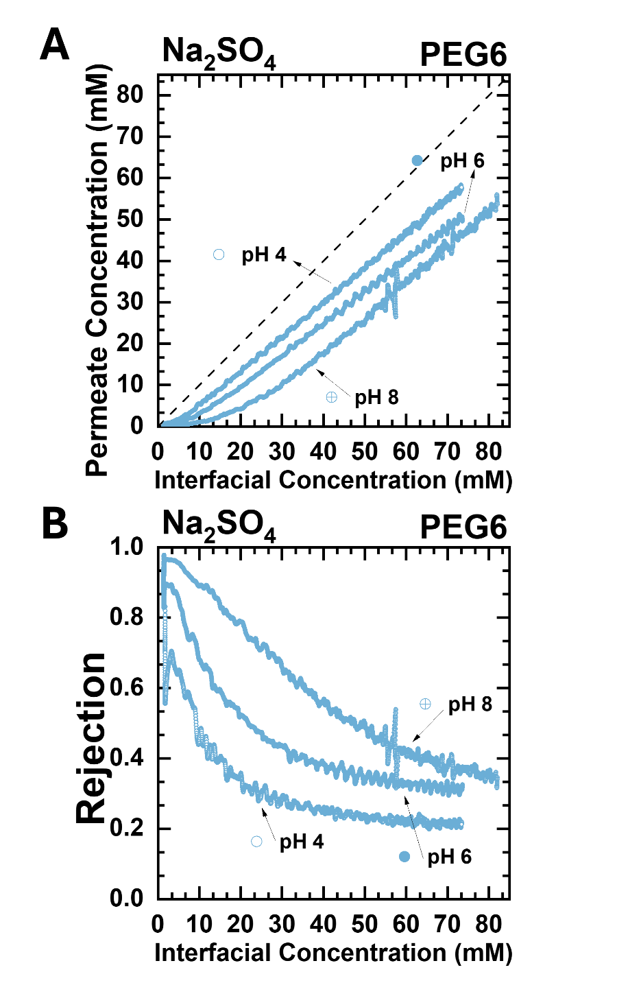
Figure S8: Na₂SO₄ transport at pH 4, pH 6, and pH 8 for a PEG6 membrane. (A) Na₂SO₄ permeate concentration is plotted against interfacial concentration for a PEG6 membrane at pH 4, pH 6 (unaltered), and pH 8 is shown. Unless otherwise stated, each experiment was conducted using a 1 mM Na₂SO₄ feed and 100 mM Na₂SO₄ diafiltrate. The pH was adjusted using H₂SO₄ or NaOH. The peaks in the data represent spikes in the conductivity measurements due to bubbles passing through the permeate reservoir. (B) Rejection versus interfacial concentration. There are three distinct rejection profiles for each solution pH explored. Rejection increasing with increasing carboxylic acid deprotonation.

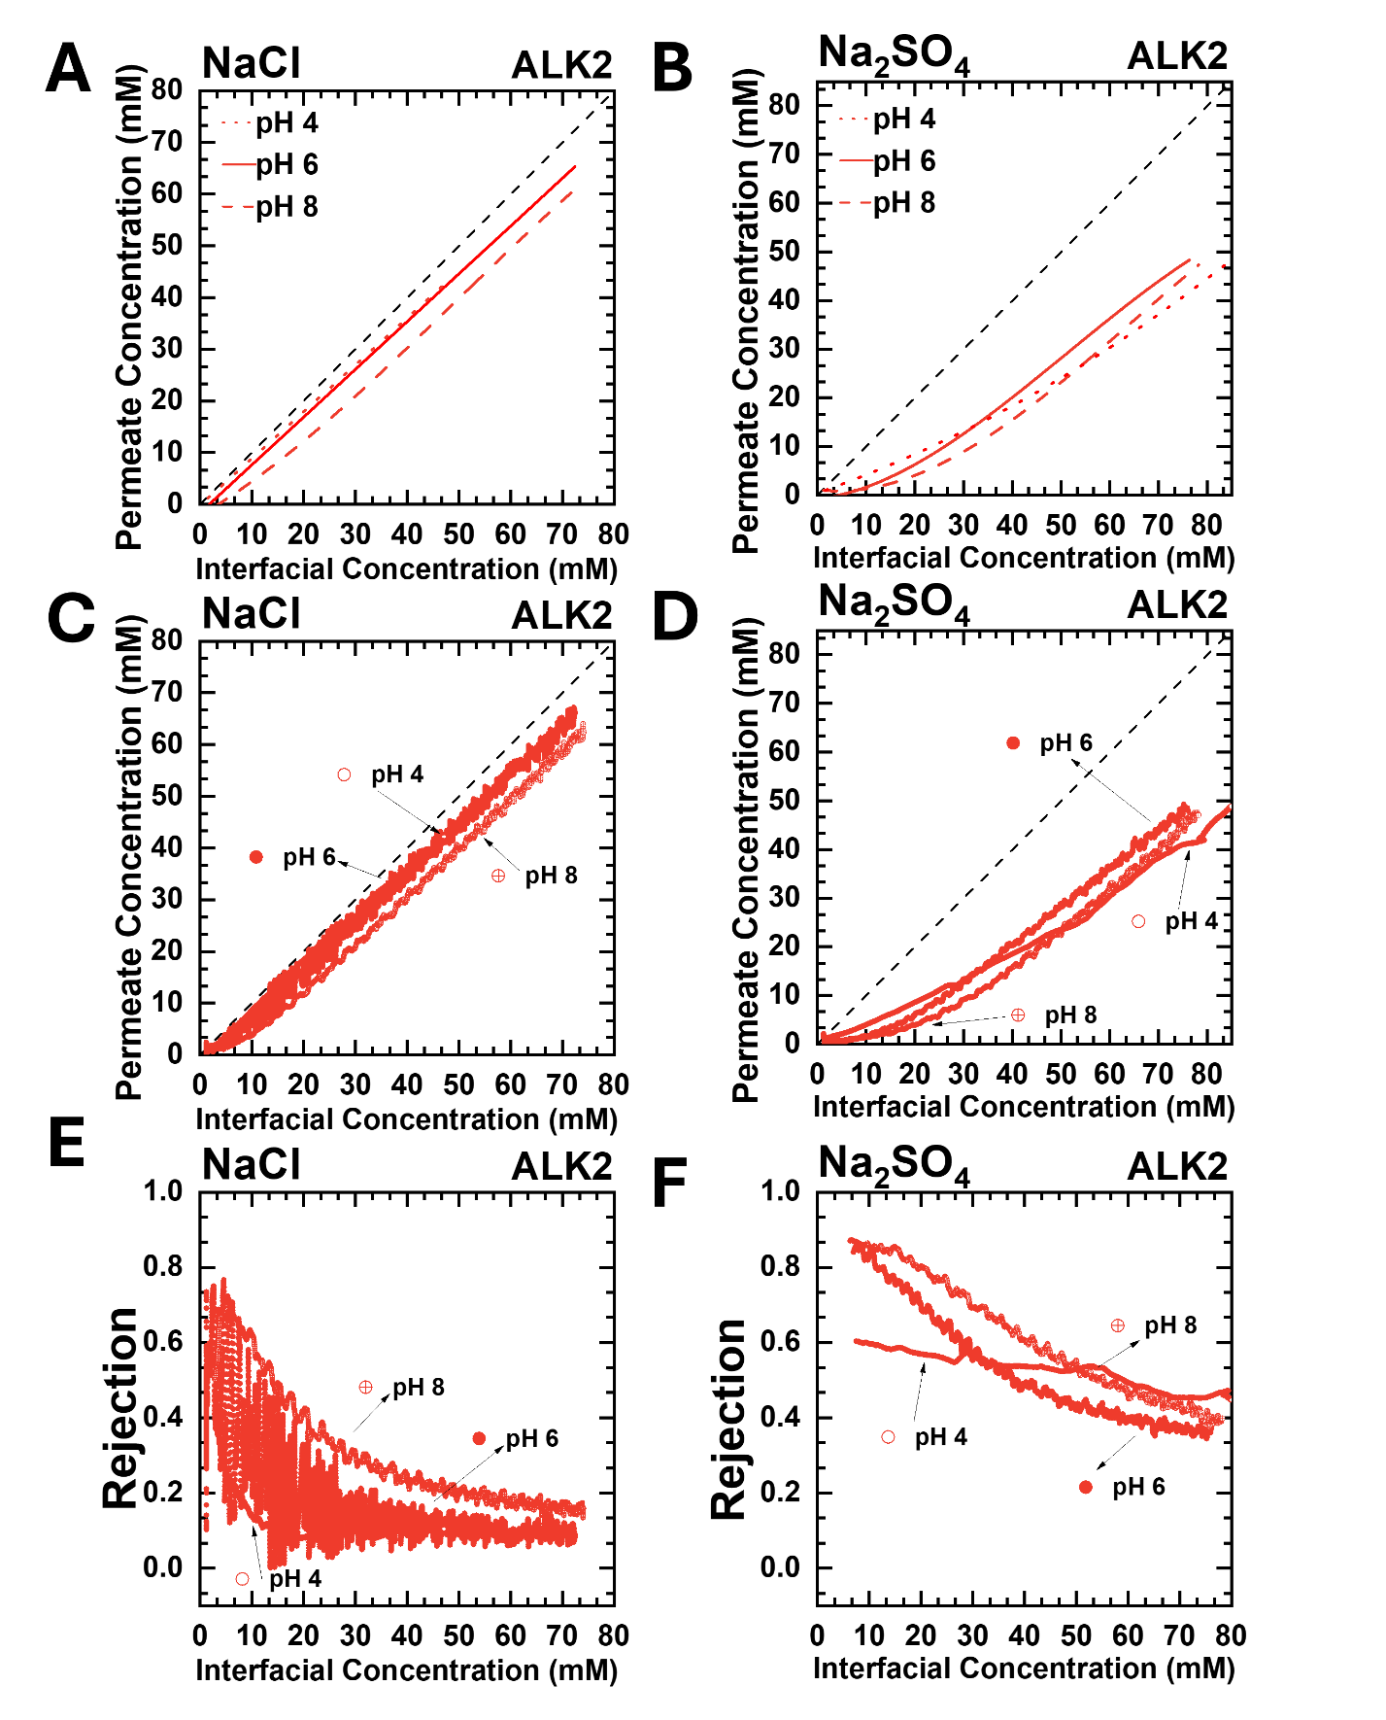
Figure S9: NaCl and Na₂SO₄ transport at pH 4, pH 6, and pH 8 for an ALK2 membrane. NaCl (A) and Na₂SO₄ (B) concentration profiles for an ALK2 membrane at pH 4 (dotted line), pH 6 (unaltered) (solid line), and pH 8 (dashed line). Unless otherwise stated, each experiment was conducted using a 1 mM salt feed and 100 mM salt diafiltrate. For (A), the pH was adjusted using HCl or NaOH. Data sets were linearly fit for clarity. The experiment at pH 4 was terminated partly through due prolonged experimental time. Regardless, the trajectory of this experiment follows that of pH 6, as expected. For (B), the pH was adjusted using H₂SO₄ or NaOH. The data sets were fit to a third order polynomial for clarity and to capture the transient behavior at low concentrations. Plots (C), (D), (E), and (F) depict pH 4 as open circles, pH 6 as filled circles, and pH 8 as circles with a cross. (C) and (D) show the raw data from (A) and (B) plots. The data appears as a line due to the high density of data points collected within each experiment. (E) and (F) depicts NaCl and Na₂SO₄ rejection profiles. Noise from the conductivity measurements for pH 6 in (E) is exacerbated when transformed into a rejection, leading to the large oscillating behavior. Albeit, the general rejection trend can still be identified.

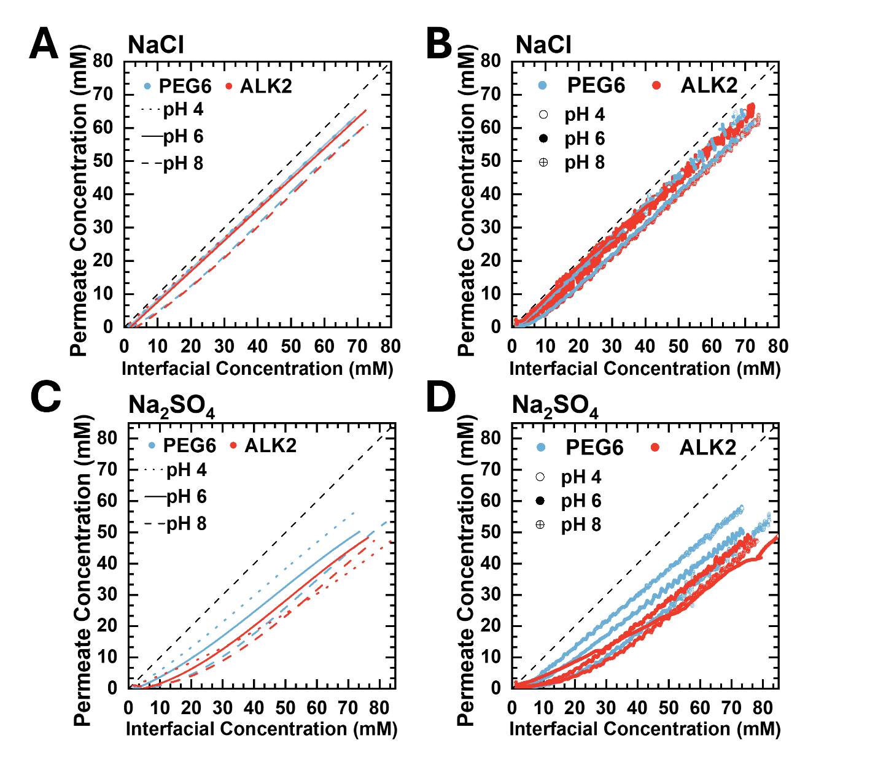
Figure S10: Comparing NaCl and Na₂SO₄ transport at pH 4, pH 6, and pH 8 between PEG6 and ALK2 membranes. The PEG6 and ALK2 NaCl (A) and Na₂SO₄ (C) concentration profiles at pH 4 (dotted line), pH 6 (solid line), and pH 8 (dashed line) are shown. Unless otherwise stated, each experiment was conducted using a 1 mM salt feed and 100 mM salt diafiltrate. The pH was adjusted using HCl (NaCl), H₂SO₄ (Na₂SO₄), or NaOH. The data sets were fit linearly to clarify experimental trends. (B) and (D) show the raw data for plots (A) and (C), where pH 4 is represented by open circles, pH 6 by filled circles, and pH 8 by circles with a cross. Due to the high density of data points collected within each experiment, the data appears as a line. The oscillating behavior within the data sets are due to noise from the conductivity probes.

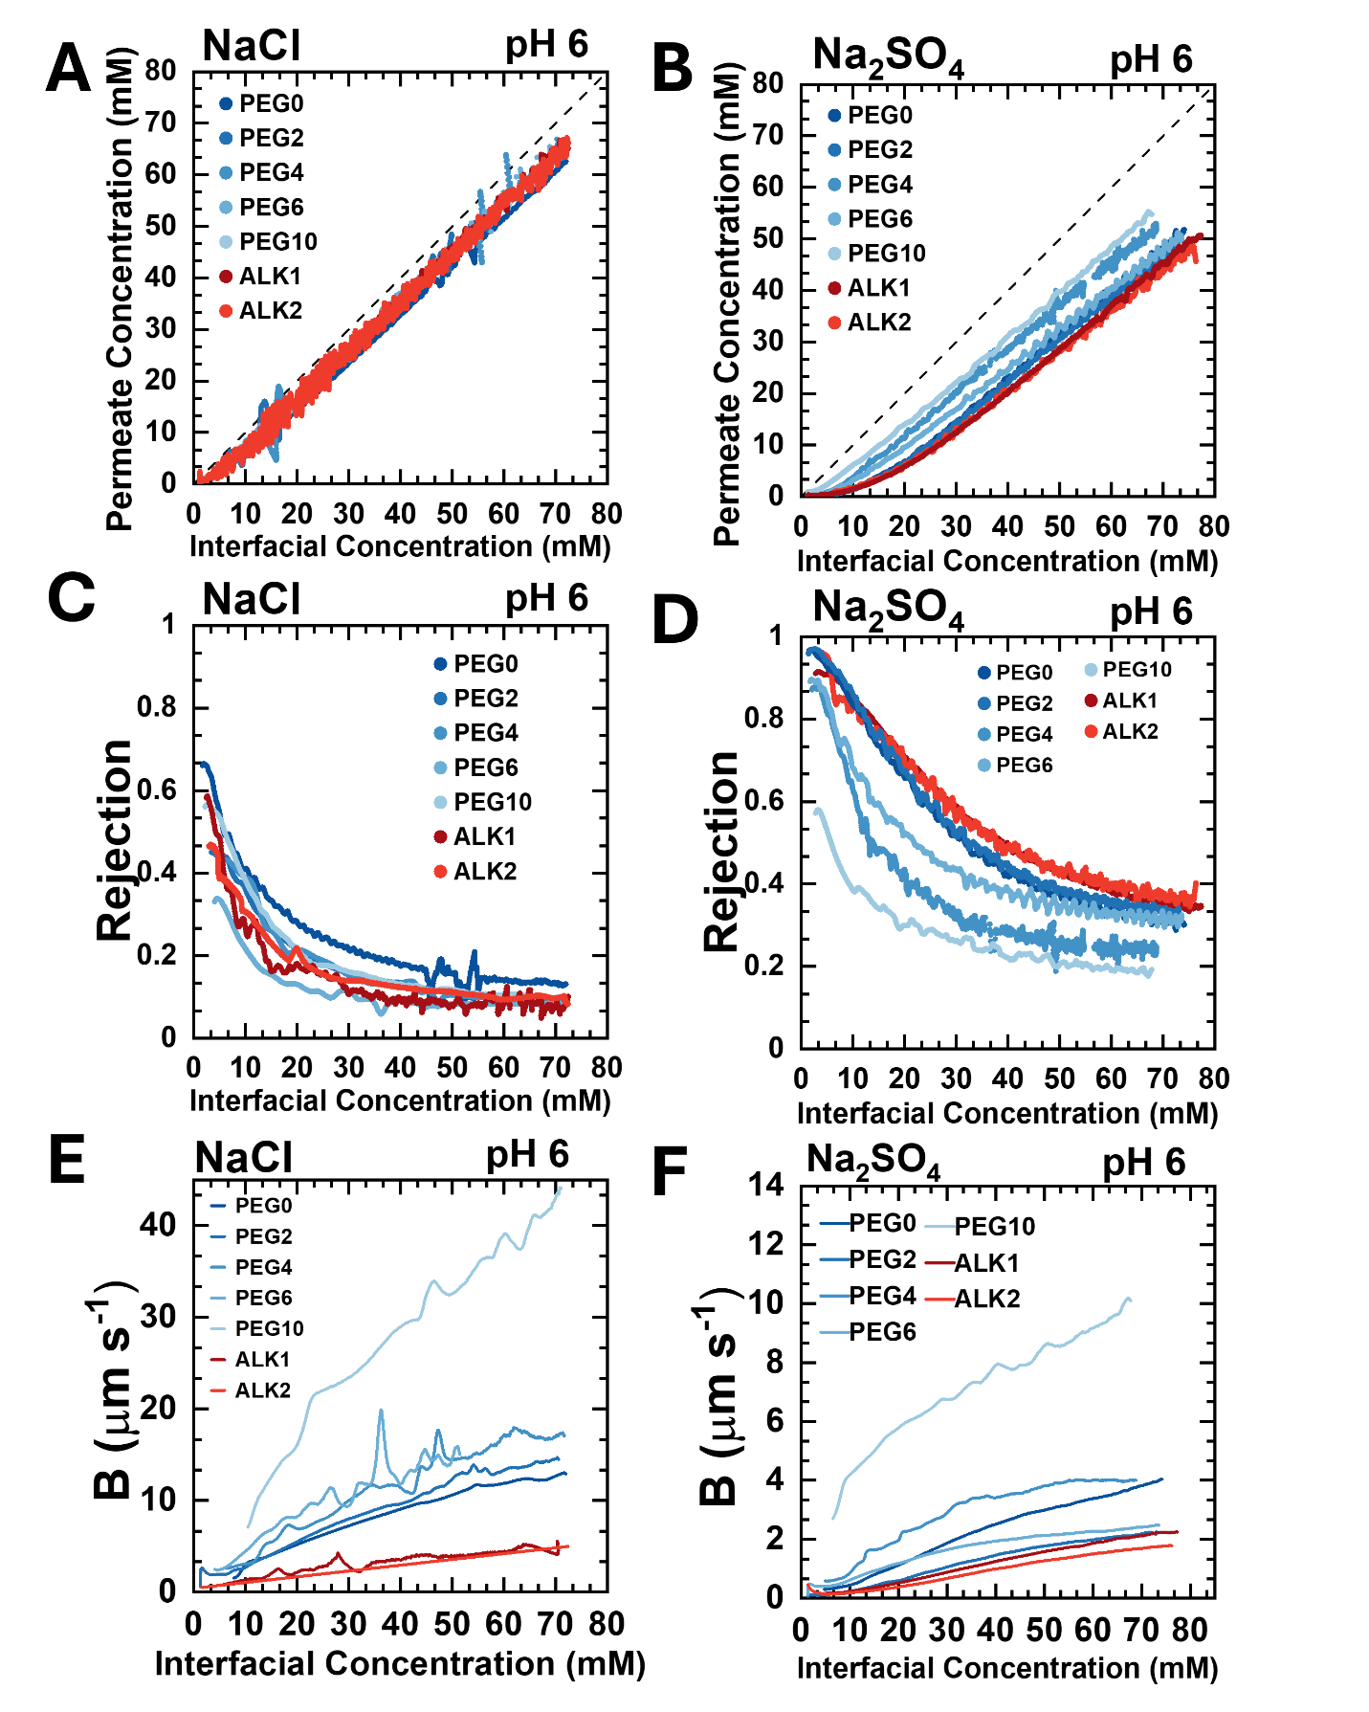
Figure S11: Comparing spacer arm chemistry for NaCl and Na₂SO₄ transport at pH 6. The raw NaCl (A) and Na₂SO₄ (B) concentration profiles for each spacer arm functionalized onto the membrane is shown. Unless otherwise stated, each experiment was conducted at pH 6 using a 1 mM salt feed and 100 mM salt diafiltrate. The oscillating behavior within the data sets are due to noise from the conductivity probes. Gaps in the raw data represent data points removed due to bubbles. These have been omitted for clarity and do not change the interpretation of the observed data trends. NaCl (C) and Na₂SO₄ (D) rejection profiles for each membrane. The solute permeability coefficient for NaCl (E) and Na₂SO₄ (F) are plotted against interfacial concentration for each spacer arm chemistry investigated.

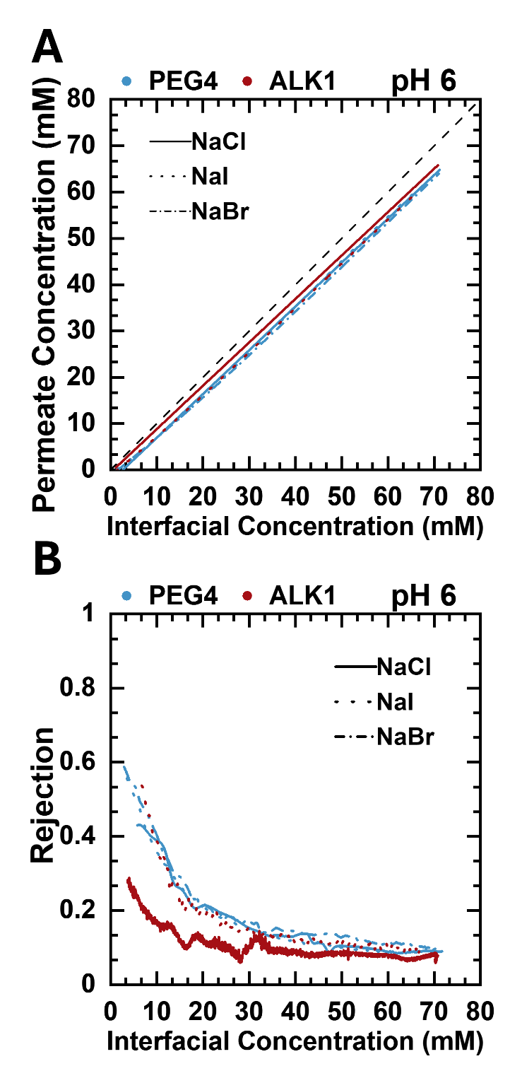
Figure S12: Comparing monovalent ion rejection for PEG4 and ALK1 membranes at pH 6. The PEG4 and ALK1 NaCl (solid), NaI (dot), and NaBr (dash dot) concentration (A) and rejection (B) profiles at pH 6 are shown. Unless otherwise stated, each experiment was conducted using a 1 mM salt feed and 100 mM salt diafiltrate.

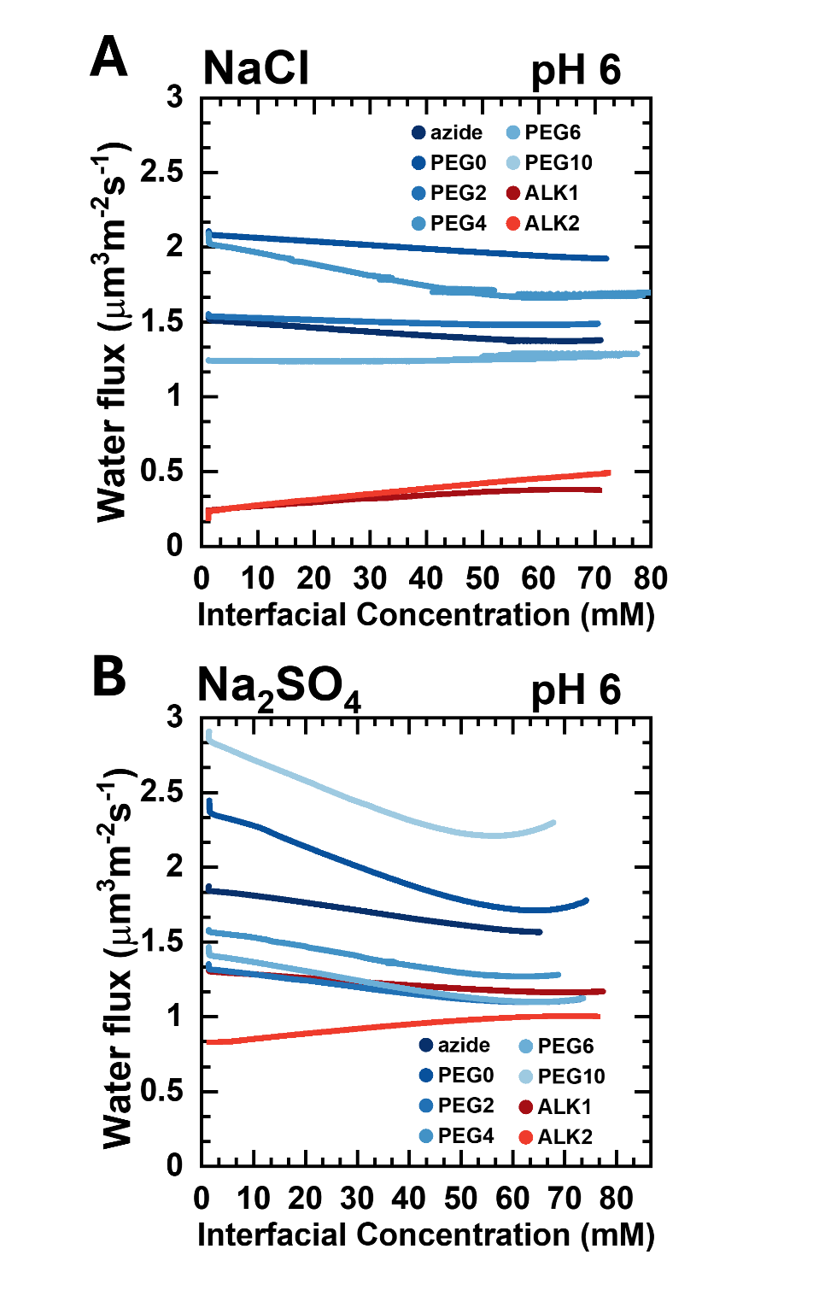
Figure S13: Water flux as a function of interfacial concentration for each membrane chemistry studied at pH 6. Water flux is plotted against interfacial concentration for NaCl (A) and Na₂SO₄ (B). The water flux is calculated using the time, mass, and pressure data collected from the diafiltration experiments represented in Figure S11A and S11B. The water flux remains relatively constant throughout the course of each experiment.

Section S4: Water Contact Angle Measurements
Water contact angle measurements were used to estimate surface hydrophilicity. In this process, the membranes were carefully removed from a DI water solution and placed onto a goniometer. A 1.5 μL droplet of water was then dispensed onto the membrane surface, and the contact angle between the droplet and the surface was measured. Three measurements were made for each sample to quantify uncertainty spread in the data.
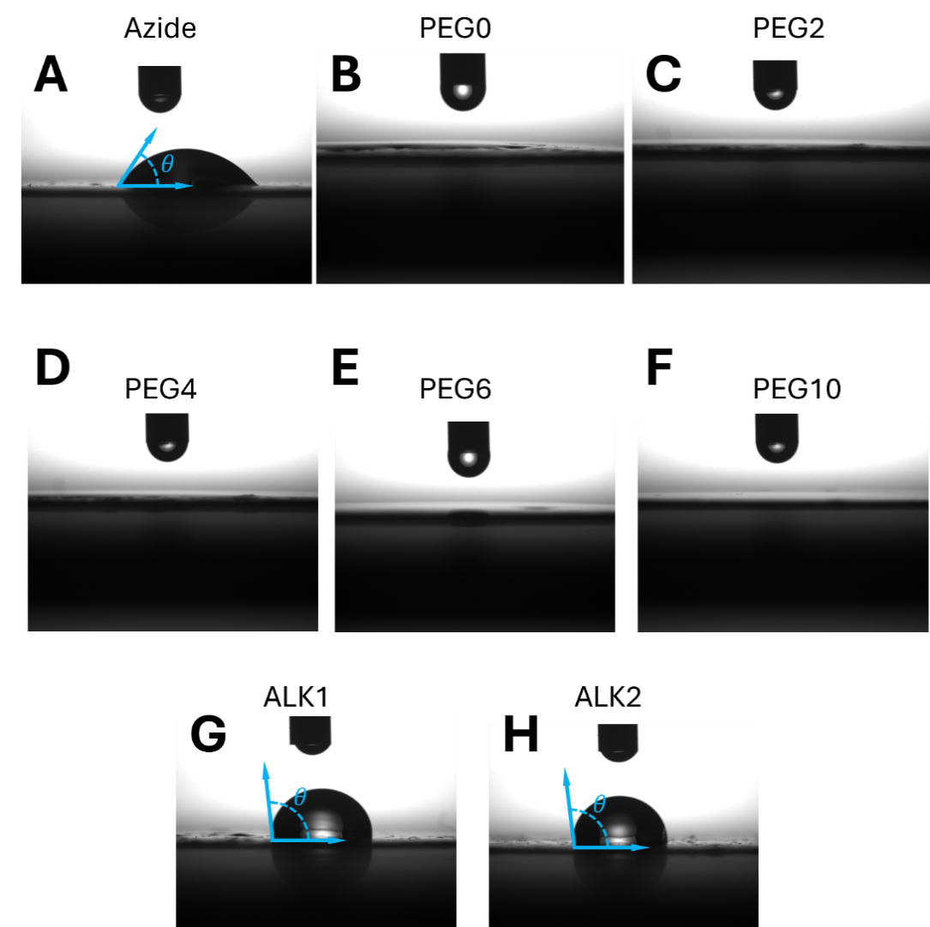
Figure S14: Static water contact angle measurements measure surface hydrophilicity. A DMo series contact angle meter by Kyowa Interfacial Sciences Inc. was used to obtain static water contact angles for each membrane in this study. The membrane was removed from a water bath and placed directly onto the instrument platform without removing excess water from the surface. The membrane was held flat as a 1.5 μL aliquot of water was deposited onto the membrane. For PEG0, PEG2, PEG4, PEG6, and PEG10 membranes the water droplet immediately spread across the surface, leading to no distinguishable droplet and indicating a highly hydrophilic surface.
Table S2: Water contact angles for each membrane sample investigated.
Membrane | Water contact angle (°)
Azide | 10.6 ± 1.0
PEG0 | 7.0 ± 0.1
PEG2 | 10.8 ± 0.2
PEG4 | 7.0 ± 0.4
PEG6 | 14.9 ± 2.3
PEG10 | 6.0 ± 1.0
ALK1 | 92.7 ± 2.9
ALK2 | 97.1 ± 0.1

Section S5: Water Volume Fraction Measurements
To calculate the water volume fraction, $ϕ_{w}$, the wet and dry membrane thicknesses were measured using an optical profilometer. Membranes were cast onto a PVDF support such that the copolymer was flanked by exposed PVDF regions on both sides. Azide, PEG0, PEG4, and ALK1 membranes were stored in DI water overnight to ensure equilibrium swelling prior to measurement. The wet samples were placed on the platform of a S neox Sensofar optical profilometer. Three cross-sectional line scans were performed on each membrane. The height difference between the PDVF support and copolymer was measured on both the left- and right-hand sides for each scan, and the resulting values were averaged to calculated the wet thickness. Each membrane was placed under vacuum overnight, and the measurements were repeated to obtain dry thickness. $ϕ_{w}$was calculated using Equation 4; This process was repeated for azide, PEG0, PEG4, and ALK1 membranes. Table S3 shows $ϕ_{w}$ estimates for the membranes used in this study. Additionally, membranes from the literature show comparable $ϕ_{w}$ values.
$$ϕ_{water}=\frac{l_{wet}-l_{dry}}{l_{wet}}$$ | Eq. 4

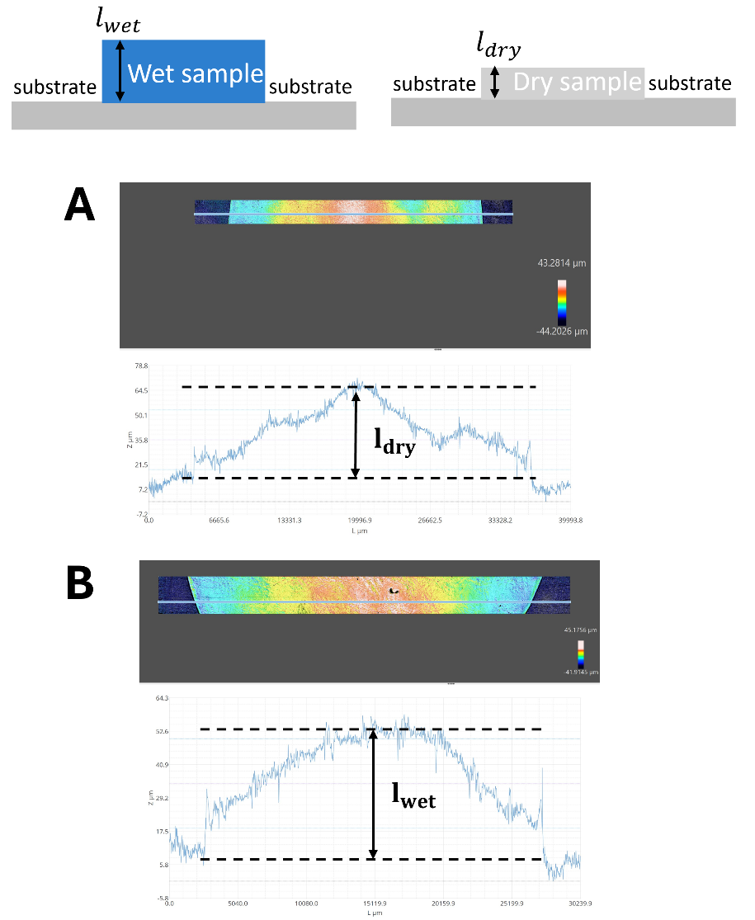
Figure S15: Optical profilometer measurements estimate water volume fraction. A sample scan for the azide membrane is shown, plotting height against the length. Dry (A) sample and wet (B) sample scans are shown. The dry sample thickness was subtracted from the wet sample thickness and normalized by the wet thickness to obtain water volume fraction. These measurements were performed for the azide, PEG0, PEG4, and ALK1 membranes.

Table S3: Water volume fraction for each membrane sample investigated.
Membranes in this Study | Water Volume Fraction, $ϕ_{w}$ | Membranes from Literature | Literature $ϕ_{w}$ Values
Azide | 0.23 ± 0.07 | NF270¹⁰ | 0.26
PEG0 | 0.41 ± 0.05 | XL-PEGDA¹¹ | 0.35
PEG4 | 0.51 ± 0.02 | AA-PEGDA¹² | 0.07 – 0.39
ALK1 | 0.06 ± 0.02 | CR61¹³ | 0.50

Section S6: References
(1) Zeman, L.; Wales, M. Steric Rejection of Polymeric Solutes by Membranes with Uniform Pore Size Distribution. Separation Science and Technology 1981, 16 (3), 275–290. https://doi.org/10.1080/01496398108068519.
(2) Waldman, R. Z.; Gao, F.; Phillip, W. A.; Darling, S. B. Maximizing Selectivity: An Analysis of Isoporous Membranes. Journal of Membrane Science 2021, 633, 119389. https://doi.org/10.1016/j.memsci.2021.119389.
(3) Ge, Z.; Wang, Y. Estimation of Nanodiamond Surface Charge Density from Zeta Potential and Molecular Dynamics Simulations. J. Phys. Chem. B 2017, 121 (15), 3394–3402. https://doi.org/10.1021/acs.jpcb.6b08589.
(4) Sujanani, R.; Nordness, O.; Miranda, A.; Katz, L. E.; Brennecke, J. F.; Freeman, B. D. Accounting for Ion Pairing Effects on Sulfate Salt Sorption in Cation Exchange Membranes. J. Phys. Chem. B 2023, 127 (8), 1842–1855. https://doi.org/10.1021/acs.jpcb.2c07900.
(5) Davies, C. W. 397. The Extent of Dissociation of Salts in Water. Part VIII. An Equation for the Mean Ionic Activity Coefficient of an Electrolyte in Water, and a Revision of the Dissociation Constants of Some Sulphates. J. Chem. Soc. 1938, 2093. https://doi.org/10.1039/jr9380002093.
(6) Zeman, L. J.; Zydney, A. Microfiltration and Ultrafiltration: Principles and Applications; 2017; p 618. https://doi.org/10.1201/9780203747223.
(7) Ouimet, J. A.; Al-Badani, F.; Liu, X.; Lair, L.; Muetzel, Z. W.; Dowling, A. W.; Phillip, W. A. Automated Membrane Characterization: In-Situ Monitoring of the Permeate and Retentate Solutions Using a 3D Printed Permeate Probe Device. Journal of Membrane Science Letters 2024, 4 (2), 100087. https://doi.org/10.1016/j.memlet.2024.100087.
(8) Shedlovsky, T. AN EQUATION FOR ELECTROLYTIC CONDUCTANCE. J. Am. Chem. Soc. 1932, 54 (4), 1405–1411. https://doi.org/10.1021/ja01343a019.
(9) R. A., R.; R. H., S. Electrolyte Solutions, Second Revised Edition.; Dover Publications, 2002.
(10) Freger, V. Swelling and Morphology of the Skin Layer of Polyamide Composite Membranes: An Atomic Force Microscopy Study. Environ. Sci. Technol. 2004, 38 (11), 3168–3175. https://doi.org/10.1021/es034815u.
(11) Quigley, A. E.; Zofchak, E. S.; Dycha, K. J.; Lynd, N. A.; Ganesan, V.; Freeman, B. D. Predicting Mixed Binary Alkali Halide Salt Transport in Uncharged Poly(Ethylene Oxide)-Based Membranes. Journal of Membrane Science 2026, 739, 124918. https://doi.org/10.1016/j.memsci.2025.124918.
(12) Kim, Y.; Kim, T.; Kang, D. E.; Kracaw, R. B.; Lukaszewski, A. J.; Szymanski, J. S.; Rahman, C. M.; Shaqfeh, M. A.; Tierney, K. M.; Doan, H.; Collins, L.; Oh, H. J. Weak Polyelectrolyte Membranes with a Wide Ion-Exchange Capacity (IEC) Range and Limited Water Swelling in Clean Technologies for Sustainability. ACS Appl. Polym. Mater. 2024, 6 (18), 11334–11349. https://doi.org/10.1021/acsapm.4c01877.
(13) Kamcev, J.; Paul, D. R.; Manning, G. S.; Freeman, B. D. Predicting Salt Permeability Coefficients in Highly Swollen, Highly Charged Ion Exchange Membranes. ACS Appl. Mater. Interfaces 2017, 9 (4), 4044–4056. https://doi.org/10.1021/acsami.6b14902.

