Keshav kumar Darbhanga, Bihar 84705 +91-6203954780 keshavkumar2512@gmail.com www.linkedin.com/in/keshavkumar3 https://github.com/keshavkumar6 Training Summer Training May 2024 - July 2024 Board Infinity - Gained hands-on focusing on relational database systems (RDBMS) and Structured Query Language (SQL). -Designed and executed 15+ complex SQL queries on a real-world HR database of 107 employees across 11 departments to extract actionable workforce insights. - Applied 3rd Normal Form (3NF) principles in schema design to minimize redundancy and maintain data integrity. - Calculated key insights such as average salary by job role (~$6,500) and filtered employees with 15+ years of experience using nested subqueries. - Demonstrated ACID-compliant transactions, constraints, and aggregate functions to solve HR analytics use cases. -Certificate Link: https://drive.google.com/file/d/1vLsQoRuKdJJmr0VnMi3LuiXnVajvz226/view?usp=sharing Projects HR analytics Dashboard | Power BI, MS-excel April 2025 - Built an HR dashboard in Power BI analyzing data from 1,470 employees to uncover key attrition trends - It was identified that 16% of employees left, with higher attrition in Sales and R&D roles. - Used Power Query and DAX to calculate KPIs like average tenure is around 3.6 years and job satisfaction scores. - Created dynamic visuals and slicers to explore attrition by age, gender, department and income. - Helped HR stakeholders make better retention decisions with clear, interactive insights. - Link: https://github.com/keshavkumar6/hr-analytics-dashboard-powerbi Analysis of Heart Disease | R, Knn, Decision tree, Random forest November 2024 - Developed and tested ML models in R to predict heart disease risk, achieving up to 89% accuracy. - Used a dataset of 303 patient records with health metrics like age, cholesterol, and blood pressure -Applied algorithms such as Logistic Regression, KNN, Decision Tree, Random Forest, and SVM. - Evaluated models using confusion matrix and visualized results with ggplot2. - Improved model performance through data preprocessing, feature encoding, and proper splitting - Link: https://github.com/keshavkumar6/heart-disease-prediction Certificates Software Testing October 2024 NPTEL —https://drive.google.com/file/d/1O-1kSI9pBj-7_6b4Azeo38w3UbT9de9v/view?usp=sharing Data analysis with Tableau November 2024 Coursera —https://drive.google.com/file/d/1mTErl6uysMSXTevmIPPif6GYlYI6z19-/view?usp=sharing Technical Skills Languages: C, c++, Java, R, Python Technologies/Frameworks: MySQL, Tableau, MS-Excel, Git, GitHub, Power Bi, Vs-code Skills: Data Structures and Algorithms, Problem-Solving Education Lovely Professional University Punjab 2022 – 2026 Computer Science and Engineering — CGPA: 7.39 Jalandhar, Punjab Sacred Heartschool Sitamarhi 2019 – 2021 12th with PCM — Percentage: 70.2% Sitamarhi, Bihar Madonna English school Darbhanga 2017 – 2019 10th with Science — Percentage: 87.16% Darbhanga, Bihar



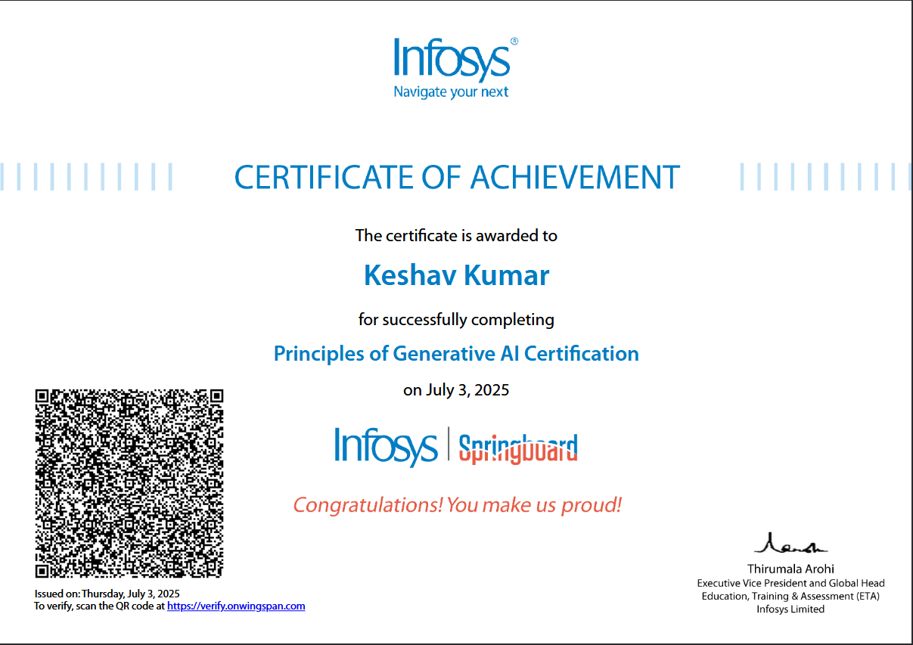

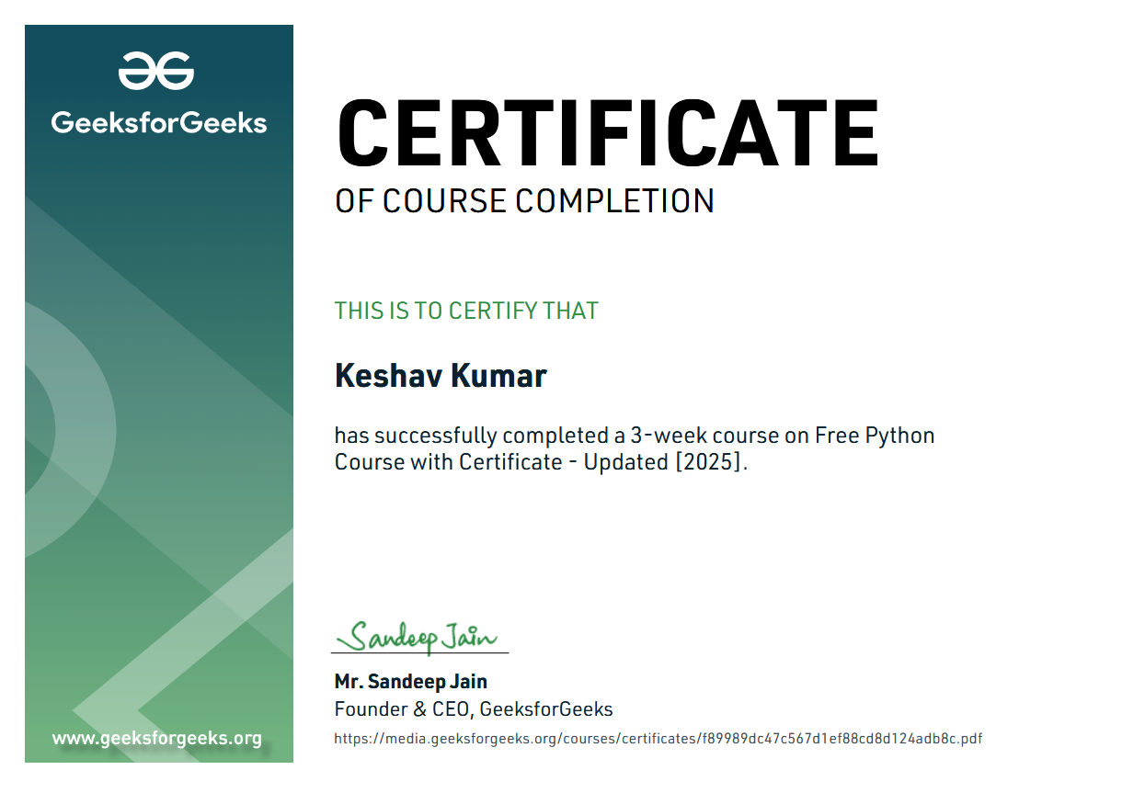

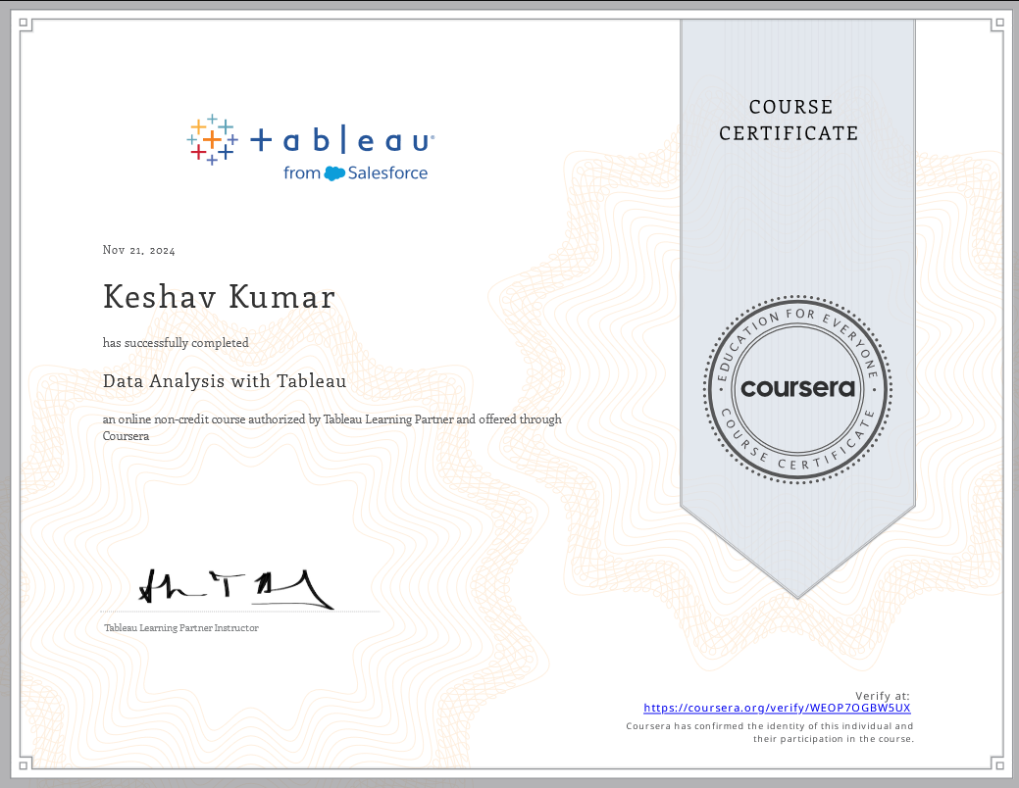

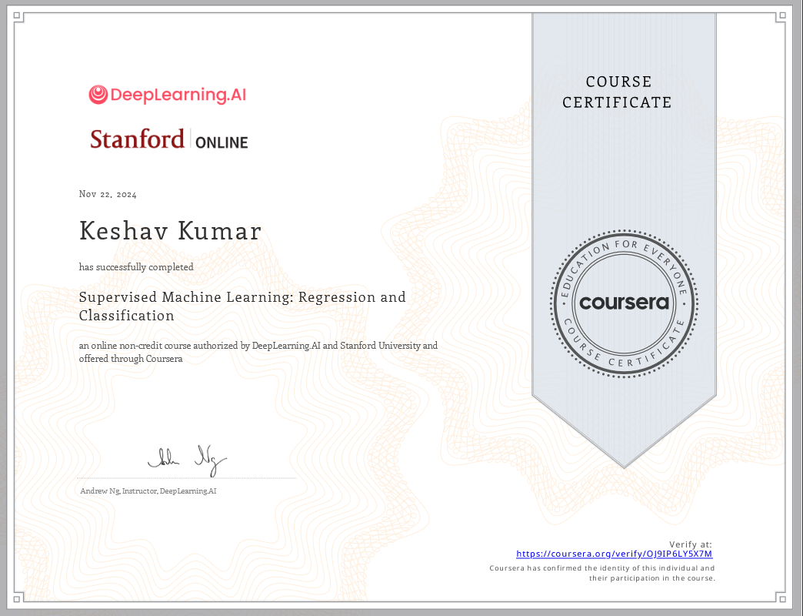

Introducytion-**Hi, I’m Keshav Kumar — a passionate Computer Science Engineering student at Lovely Professional University, specializing in Data Science.**  
I enjoy building smart, user-friendly, and visually appealing digital experiences. With hands-on experience in **Python, Flask, SQL, and tools like Tableau, Power BI, and Git**, I’ve created projects ranging from **ML-based heart disease prediction models** to **interactive dashboards and full-stack portfolio websites**.

I have a strong foundation in **data structures, algorithms, UI/UX design, and full-stack development**, and I constantly push myself to learn and grow through real-world projects and internships. I’m currently focused on enhancing my skills in **Machine Learning and Python Full Stack Development**.