

Brand Website & Content Strategy

1. EXECUTIVE SUMMARY
The work already looks like the work of a serious architect. What's inconsistent is the presentation around it. This document is about closing that gap — not by adding more content or more animation, but by making everything that already exists read as one deliberate voice instead of several different ones.
Two things drive this: a tightened visual identity, and a content system that turns each finished project into weeks of consistent material — rather than one-off posts made under deadline pressure.
2. BRAND AUDIT
What's already working
- The built projects — Madhavam and others — show real material and proportion sense, not just render quality
- A neutral, warm material palette (stone, wood, marble) already exists across the actual project photography
- Site execution and finished-project photos are present, not just concept renders — this is a real, working practice
What's inconsistent — with evidence
Two different logo treatments are currently in active use on the same feed:
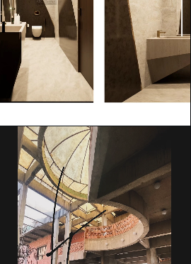  Version A — gold serif script wordmark | 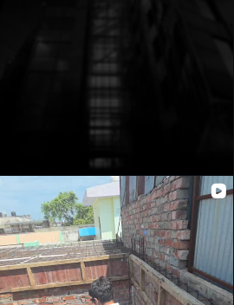  Version B — bold white sans-serif on black
Both are on the same profile. Neither is wrong on its own — the issue is that a visitor sees two different studios depending which post they land on.
The caption voice shifts the same way — some posts read like considered captions, others like social-media marketing copy (“ASK WHAT'S IN YOUR PLAYLIST”, “BEST MATERIALS FOR ELEVATION FACADE” in large bold overlay text). That style works for reach; it works against the idea of a ₹1–5Cr-project studio being the calm, confident authority in the room.
3. BRAND POSITIONING — A REAL DECISION, NOT A DEFAULT
One genuine strategic fork worth putting in front of Harshit directly, rather than deciding on his behalf:
Option | What it means | Trade-off
Keep ‘Studio HA Architects’ as the primary brand | Current direction. Reads as an established firm/practice rather than one person. | Slightly harder to build personal authority (press, speaking, awards attach to a name more easily than a studio name)
Lead with ‘Harshit Agarwal’, studio as the company behind him | His Instagram bio already credits him by name — this would make that the headline, not a credit line. | For high-end residential work, clients often hire a person, not a firm — this can compound faster over a few years, but is a bigger identity shift to commit to
Recommendation: worth a direct conversation with him before locking the logo/site — this is his call to make, not one to make for him.
4. VOICE — WHISPER, NOT SELL
The concrete shift is in how work gets captioned and introduced. Same photo, different voice:
Current style | Suggested direction
“BEST MATERIALS FOR ELEVATION FACADE” | “Facade Study — Sandstone, Morning Light”
“10 THINGS YOU NEED TO DO BEFORE DESIGNING YOUR HOME” (listicle overlay) | A short, unhurried caption under the image itself — let the photo lead, text follows quietly
This doesn't mean removing personality or humour from the account entirely — it means the project photography (the actual sales tool) gets treated with more restraint than the reels.

5. VISUAL IDENTITY SYSTEM
Colour
Sampled from his own project photography, not invented — carried over from the earlier direction document:
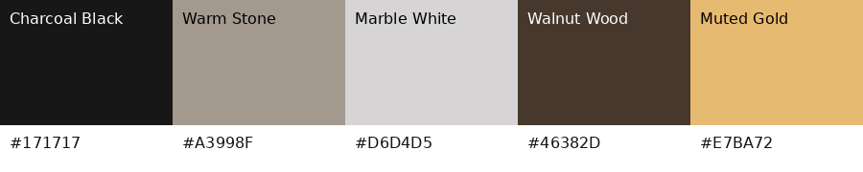
Typography
A refined serif for headings that echoes the existing wordmark, paired with a clean neutral sans for body copy. Confirm a licensing-safe web font pairing at design stage.
Photography & Videography Direction
- Consistent colour grading across all projects — currently varies shoot-to-shoot
- Golden-hour or blue-hour exterior shots prioritised over harsh daylight (Madhavam's twilight shot is the benchmark)
- Material close-ups treated as their own shots, not just details within a wider photo — stone, wood grain, jaali shadow patterns
- A short (30–45s) cinematic walkthrough per flagship project — slow, minimal cuts, no trending audio

6. DIGITAL EXPERIENCE PRINCIPLES
Calibrated specifically to the brief he gave you — few features, high polish — not a generic ‘luxury site’ checklist. Restraint is the point, so this list is intentionally short:
- Slow, minimal transitions (page fades, subtle image scale on hover) — already specified in the PRD's entry animation and motion sections
- No autoplay audio
- No counters, testimonial sliders, popups, or gradient/shadow-heavy UI — these read as template defaults, not craft
Cursor effects, parallax, and heavier animation libraries were considered and deliberately left out — they add build time and page weight without serving a 4-page, few-features brief. Worth revisiting only if scope expands to a larger site.
7. CONTENT PRODUCTION ENGINE
The highest-leverage recommendation in here: treat every finished project as a content system, not a single post.
- Hero image set (20–30 photographs) — exterior, interior, material detail
- One long-form case study for the website's Project Detail page
- A journal entry — a short, specific piece (“Choosing Stone for a North-Facing Facade”), not a generic blog post
- 4–6 Instagram posts drawn from the same shoot, spaced over weeks rather than posted all at once
One well-documented project can realistically carry the account and site content for a month or more — this reduces pressure to manufacture content between projects.
8. SEO & GROWTH STRATEGY
A separate workstream from the build itself, as flagged earlier — the technical foundation (schema, meta, alt text) is already specified in the PRD. The keyword direction:
- Location-first terms: ‘luxury architect Bareilly’, ‘villa architect Uttar Pradesh’, ‘residential architect Bareilly’
- Once local rankings are established, broaden to regional/national terms: ‘contemporary residential architecture India’, ‘luxury villa architect India’
- Google Business Profile, consistent name/address/phone across directories
- Journal content (above) is what actually feeds this over time — search engines need text to index, and this gives them well-targeted text instead of generic filler
9. PHASED ROADMAP
Phase | Covers | Depends on
1 — Brand Strategy | Positioning decision, logo consolidation, voice/caption system | Harshit's input on the positioning fork above
2 — Website Design & Build | Per the PRD — 4 pages, entry animation, Framer build | Phase 1 sign-off; content checklist from PRD
3 — Content Production | Re-shoot/grade existing projects if needed; new project documentation system going forward | Access to 3–5 fully shot projects
4 — Growth | SEO setup, Google Business Profile, journal cadence | Live site from Phase 2
10. REFERENCE STUDIES
Verified, currently live, and worth studying for tone
- Vincent Van Duysen — vincentvanduysen.com — the clearest benchmark for restraint and material honesty in residential work
- John Pawson — johnpawson.com — minimal to the point of austerity; useful upper bound for how little a luxury site can say
- Studio MK27 — studiomk27.com.br — large-scale photography carrying almost the entire page
- Foster + Partners — fosterandpartners.com — useful for how a practice presents scale and range without losing restraint (not a material match, but a structure reference)
- Rooshad Shroff — rooshadshroff.com — closest match to the arch /jaali material language
- Sanjay Puri Architects — https://sanjaypuriarchitects.com —sculptural stone forms, similar warm palette
11. CONSOLIDATED CLIENT ASK LIST
Brand
- Positioning decision: studio-forward or personal-name-forward (see fork above)
- Brand story, vision, and the kind of client/project he wants more of
- Architects or studios he personally admires, beyond what's already been discussed
Projects
- 3–5 fully documented projects: professional photos, material close-ups, any drone/video footage, plans/sketches if he wants them shown
Logo & Brand Assets
- Vector logo files (AI/SVG/EPS), light and dark versions
- Any existing brand guideline, font, or colour reference beyond Instagram
Content
- About / philosophy paragraph in his own words
- Press, awards, or publications, if any
Technical
- Domain ownership status and preference
- Preferred contact method: direct only, or a form
- Google Business Profile status — claimed or not

