RESUME

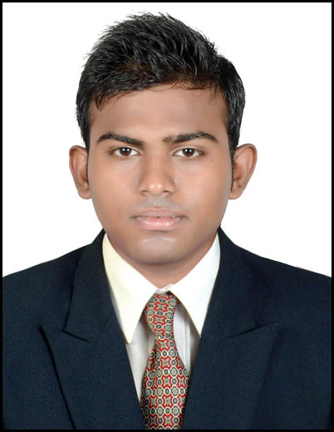
Rana nikunjkumar pravinchandra
Joshi fali, Ranavas, Near Rayfal Choke,
Lunawada-389230
Dist:Mahisagar
Gujarat, India.
Mo: +918141943435
E-mail: rnikunj039@gmail.com

CAREER OBJECTIVE

I have an urge of learning new concepts and grow in area of extreme knowledge, gain expertise skills and implement skills acquired and thus make myself as an asset of the company.

EDUCATION QUALIFICATION

- Graduation Detail: -
B.E. ( Electronics & comm Engineering) from Government Engineering College , Godhra

Examination | Semister | Year of passing | Board / University | SPI | CGPA
Bachelor of  Engineering  (B.E.Electronics & comm) | 8th sem. | May-2014 | Gujarat Technological University  (GTU) | 8.40 |  | 7.34
Bachelor of  Engineering  (B.E.Electronics & comm) | 7th sem. | Dec-2013 | Gujarat Technological University  (GTU) | 7.79 | 7.00
Bachelor of  Engineering  (B.E.Electronics & comm) | 6th sem. | May-2013 | Gujarat Technological University  (GTU) | 6.40 | 6.55
Bachelor of  Engineering  (B.E.Electronics & comm) | 5th sem. | Jan-2012 | Gujarat Technological University  (GTU) | 6.70 | 6.70

- Under Graduation Detail: -

Examination | Percentage | Board / University | Year
S.S.C. | 77.69 % | G.S.H.E.B., Gandhinagar | March-2008
H.S.C. | 59.80 % | G.S.H.E.B., Gandhinagar | March-2010

Distinctions and Achievements

- Have participated in various technical events at various colleges
- Participated in various Seminars and Science Fairs at School level.
- Visited “vishawkarma engineering college ”.
- I Qualify In AIEEE Exam

Academic Projects & Training

- Have done project on “ECO-FRIENDLY POTABLE AUTOMATIC WATER SYSTEM FOR PEOPLE” In Final YEAR.

- Attended Practical sessions at L.D ENGINEERING COLLEGE, and VGEC
GANDHINAGAR.

- Have Done Vocational training At Kadana Dem, MGVCL for 20days.

PERSONAL DETAILS

- DATE OF BIRTH 10th april, 1993

- GENDER Male

- RELEGION Hindu

- MARITAL STATUS Single

- LANGUAGES English, Hindi & Gujarati

- COLLEGE Government Engineering College, Godhra.

- NATIONALITY Indian

- HOBBIES Watching Movies, cricket,writing.

Computer Skills
- Basic computer Applications
- Simulation & Design softwares:- basic c,c++
- Basic circuit designing and simulation

DECLARATION

I here by declare that the above mentioned information is correct up to my knowledge & I bear the responsibility for the correctness of the above mentioned particulars.

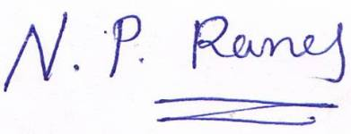

(Rana Nikunj p)

