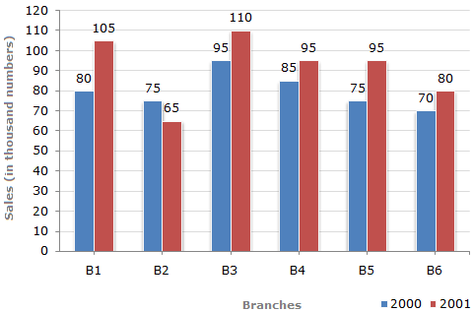

The bar graph given above shows the sales of pencils (in thousand number) from six branches of a manufacturing company during two consecutive years 2000 and 2001.

Sales of pencils (in thousand numbers) from Six Branches - B1, B2, B3, B4, B5 and B6 of a manufacturing Company in 2000 and 2001.

1.

What is the ratio of the total sales of branch B4 for both years to the total sales of branch B6 for both years?

A. 3:7 B. 3:8

C. 4:5 D. 6:5

Answer: Option D

Explanation:

Required ratio = (85 +95) /(70+80) = 180/150 = 6/5

2. Total sales of branch B6 for both the years is what percent of the total sales of branches B4 for both the years?

A. 65.56% B. 55.11%

C. 83.33% D. 75.55%

**Answer:** Option **C**

**Explanation:**

**[(70+80)/(85+95) x 100]% = [(150/180)x 100]% = 83.33 %**

**3.**

|  |  |
| --- | --- |
|  | **What percent of the average sales of branches B1, B2 and B4 in 2000 is the average sales of branches B2, B5 and B6 in 2001?** |
| |  |  |  |  | | --- | --- | --- | --- | | [**A.**](javascript:%20void%200;) | **65%** | [**B.**](javascript:%20void%200;) | **75.5%** | | [**C.**](javascript:%20void%200;) | **81.5%** | [**D.**](javascript:%20void%200;) | **92.30%** | |

**Answer:** Option **D**

**Explanation:**

**Average sales (in thousand number) of branches B2, B5 and B6 in 2001**

**= 1/3 x (65+95+80) = 240/3**

**Average sales (in thousand number) of branches B1, B3 and B4 in 2000**

**=1/3 x (80+95+85)= 260/3**

**Therefore Required percentage = [ (240/3) / (260/3) x 100] % = 92.30%**

4.

|  |  |
| --- | --- |
|  | Total sales of branches B1, B3 and B6 together for both the years (in thousand numbers) is? |
| |  |  |  |  | | --- | --- | --- | --- | | [A.](javascript:%20void%200;) | 455 | [B.](javascript:%20void%200;) | 555 | | [C.](javascript:%20void%200;) | 335 | [D.](javascript:%20void%200;) | 495 |   **Answer:** Option **D**  **Explanation:**  Total sales of branches B2, B3 and B6 for both the years (in thousand numbers)      = (75+65) + (95 + 110) + (70 + 80)      = 495. |

4.

|  |  |
| --- | --- |
|  | What is the average sales of all even numbered branches (in thousand numbers) for the year 2001? |

1. 67
2. 80
3. 77
4. 88

**Answer:** Option **B**

**Explanation:**

Average sales of 3 even numbered branches (in thousand numbers) for the year 2001

|  |  |
| --- | --- |
| = | 1/3 x [65+95+80] |
|

    = 80.

5.

|  |  |
| --- | --- |
|  | Total sales of branch B2 for both the years is what percent of the total sales of branches B3 for both the years? |
| |  |  |  |  | | --- | --- | --- | --- | | [A.](javascript:%20void%200;) | 62.343% | [B.](javascript:%20void%200;) | 70.11% | | [C.](javascript:%20void%200;) | 68.292% | [D.](javascript:%20void%200;) | 80.55% | |

Answer: Option C

Explanation:

Required percentage

= [(75+ 65) / (95+110) x 100 ] %

= [140/205 x 100 ]%

=68.292%