**Software Design Document (SDD)**

**Online Music System**

*Master of Technology(Information Technology)*

*Semester X*

*Session January-May, 2014*

**Under the guidance of Submitted By**Mr. Shaligram Prajapat Ashwini Varma(IT-2K9-07) Project Incharge Keshav Patidar(IT-2K9-20)   
 Prathmesh Dubey(IT-2K9-29)

**International Institute of Professional Studies  
Devi Ahilya Vishwavidyalaya, Indore, M.P.  
2014**

**Table of Contents**

|  |  |
| --- | --- |
| **Topic** | **Page No.** |
| 1. Introduction    1. Purpose    2. References    3. Overview 2. Use Case 3. Gantt Chart 4. Activity Diagram 5. Sequence Diagram 6. Data Flow Diagram    1. Data Flow Diagram Symbols    2. Context Data Flow Diagram    3. Level 1 Data Flow Diagram 7. Class Diagram 8. Data Design    1. E R Diagram    2. Conceptual Data Design    3. Physical Data Design | 3 - 4 3 3 4 4 - 5 6 6 - 12 13 - 14 15 - 17 15 15 16 - 17 18 19 - 21 19 19 20 - 21 |

**1. Introduction**

**1.1. Purpose :**

The purpose of this software design document is to provide a low-level description of the

Online Music system, providing insight into the structure and design of each component. This document aids in following manners :

* Following design principles promotes better understanding of requirements, cleaner designs, and more maintainable systems.
* Here the software is organized as a collection of discrete object that incorporate both data structure and behaviour.
* The essence of development (analysis, design and development) is the identification and organization of application-domain concepts.
* This development approach encourages software developers to work and think in terms of the application through most of the software development life cycle.
* Its greatest benefits come from helping to express abstract concepts clearly and communicate them to each other.
* It can serve as a medium for specification, analysis, documentation and interfacing as well as for programming.
* In short, this document is meant to equip the reader with a solid understanding of the inner workings of the Online Music System.

**1.2. References :**

* IEEE. IEEE Std 830-1998 IEEE Recommended Practice for Software Design Document IEEE Computer Society, 1998.
* Online Music System SRS.

**1.3. Overview :**

The design document will contain :

* Use Case Diagram
* Gantt Chart
* Data Flow Diagram
* Class Diagram
* Activity Diagram
* Sequence Diagram
* E-R Diagram
* Conceptual Data Design
* Physical Data Design (Data Dictionary)

**2. Use Case Diagram**

**2.1. For Admin**

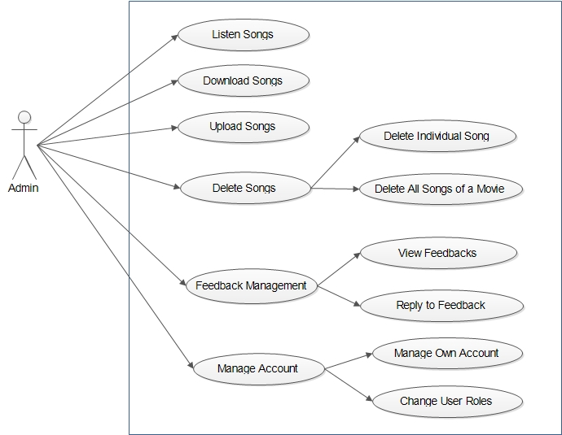

**2.2. For User**

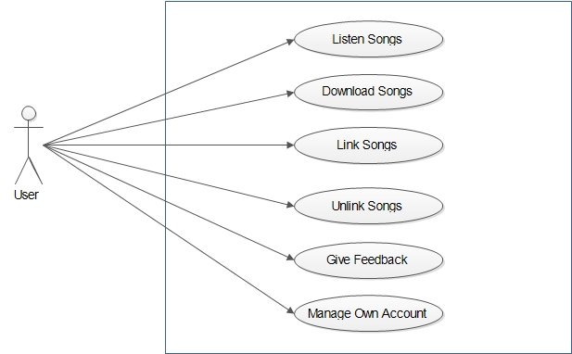

**2.3. For Guest**

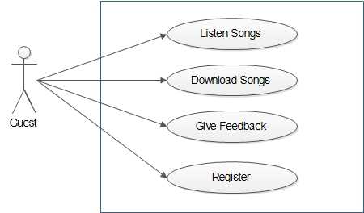

**3. Gantt Chart** 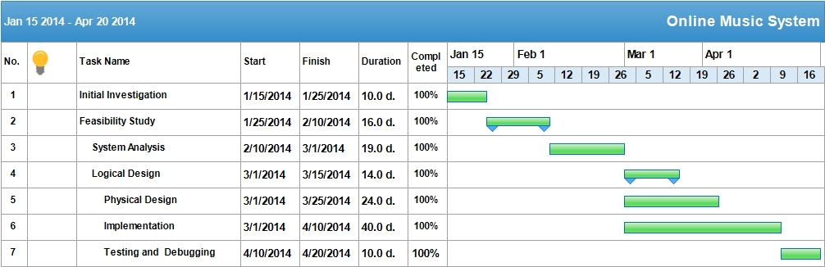

**4. Activity Diagram**

**4.1. Activity Diagram Symbols :**

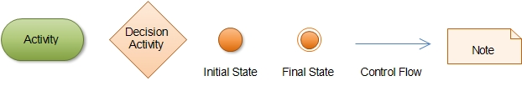

**4.2. Activity : Play or Download Songs**

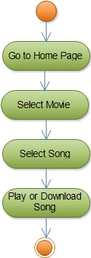

**4.3. Activity : Register**

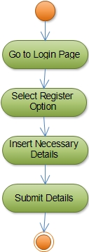

**4.4. Activity : Give Feedback**

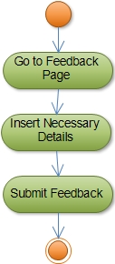

**4.5. Activity : Upload Songs**

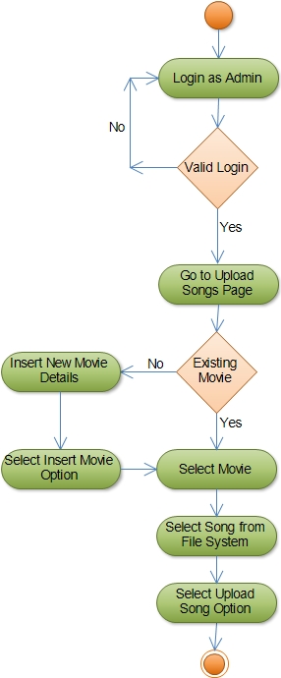

**4.6. Activity : Delete Songs**

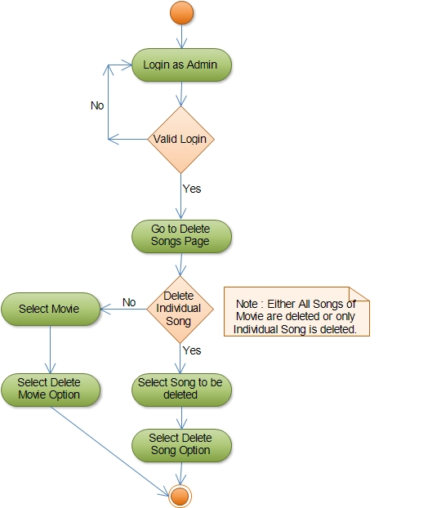

**4.7. Activity : Feedback Management**

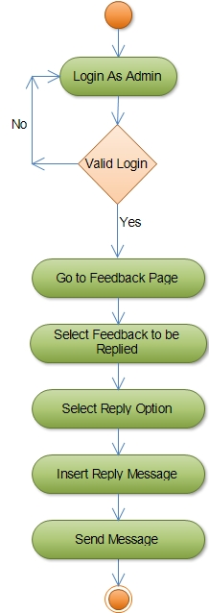

**4.8. Activity : Change User Roles**

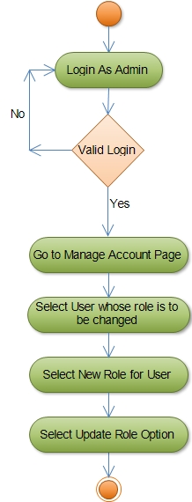

**4.9. Activity : Link Songs**

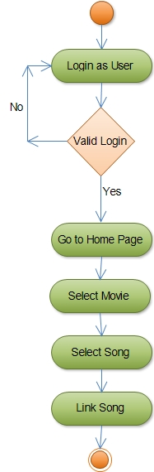

**4.10. Activity : Unlink Songs :**

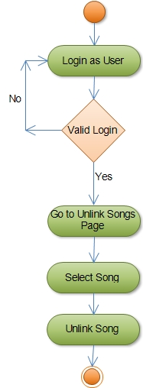

**4.11. Activity : Manage Own Account**

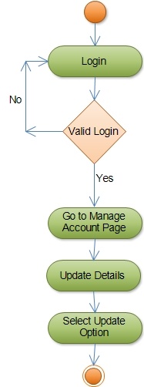

**5. Sequence Diagram :**

**5.1. For Admin**

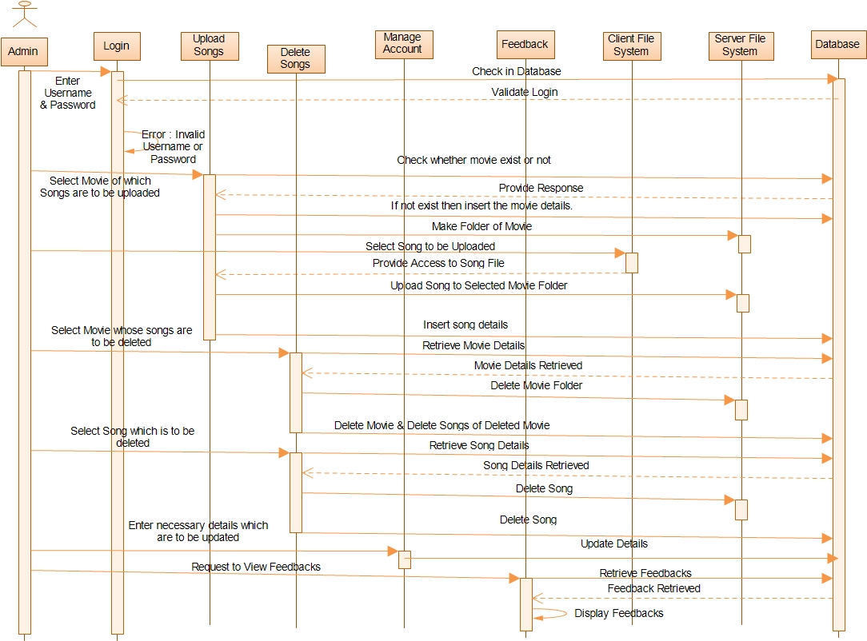

**5.2. For User**

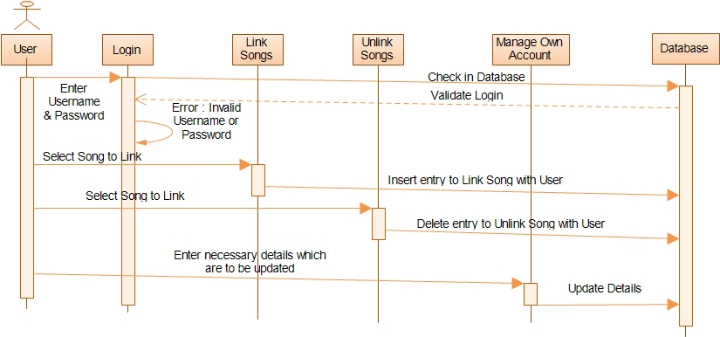

**5.3. For Guest**

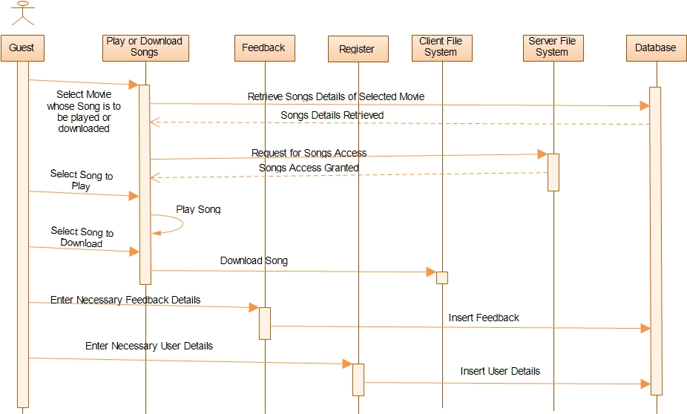

**6. Data Flow Diagram :**

**6.1. Data Flow Diagram Symbols :**

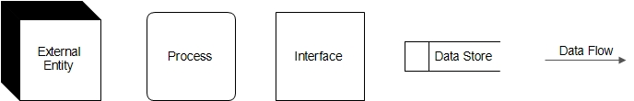

**6.2. Context Data Flow Diagram :**

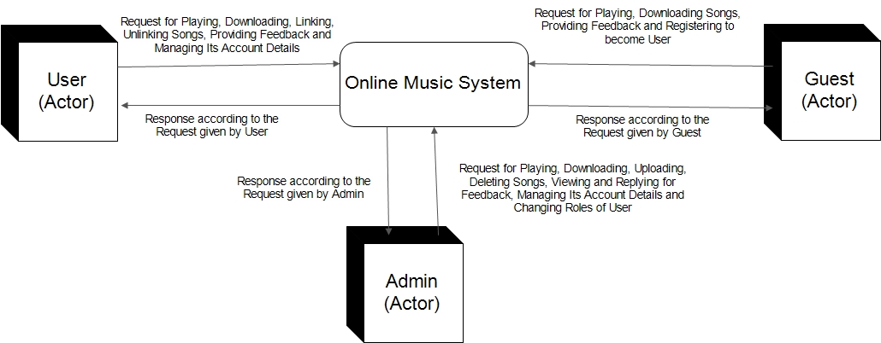

**6.3. Level 1 Data Flow Diagram :**

**a. For Admin :**

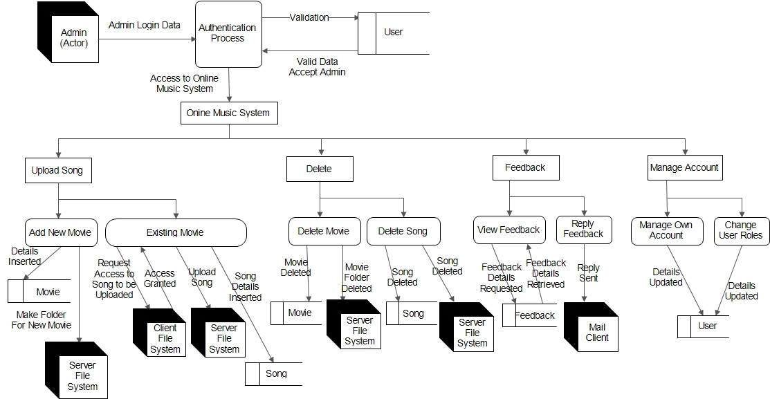

**b. For User :**

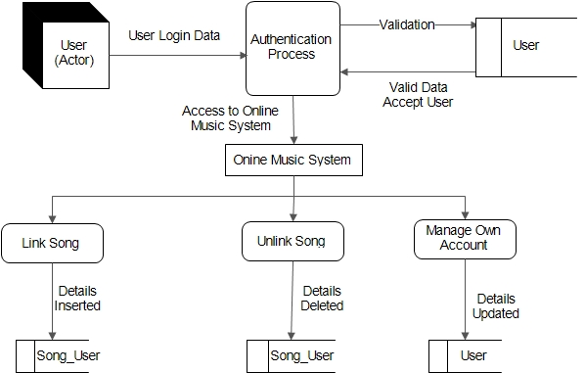

**c. For Guest :**

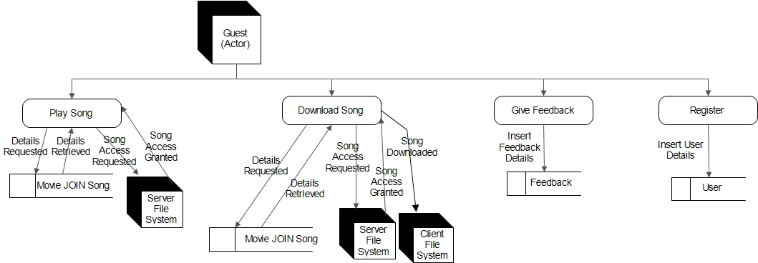

**7. Class Diagram :**

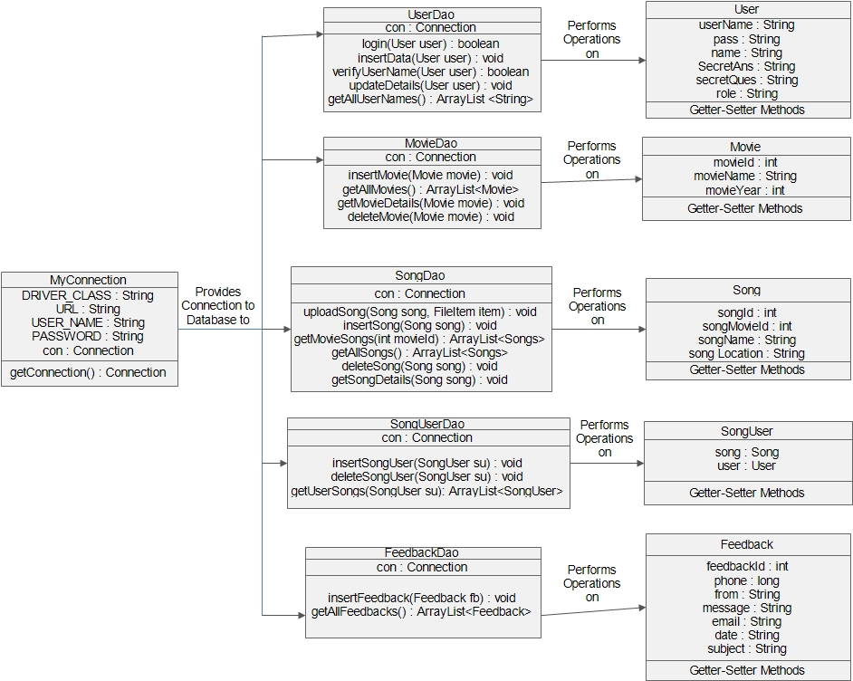

**8. Data Design :**

**8.1. E-R Diagram :**

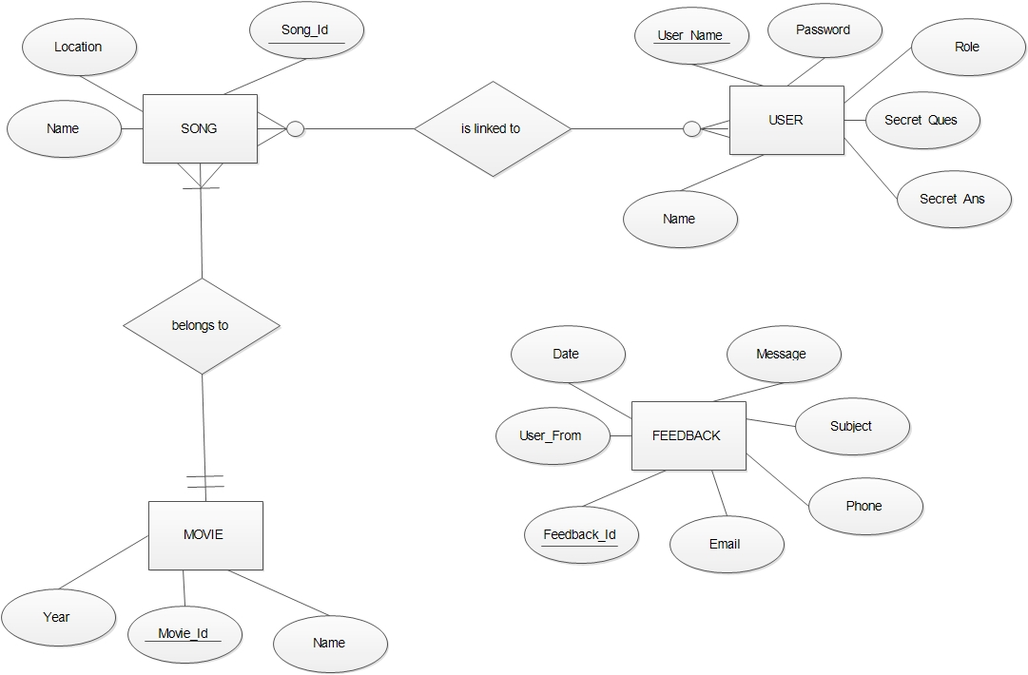

**8.2. Conceptual Data Design :**

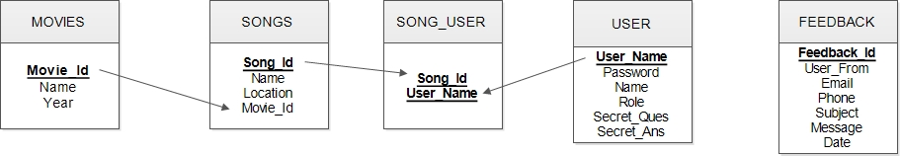

**8.3. Physical Data Design :**

**USER TABLE**

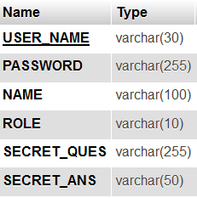

**MOVIES TABLE**

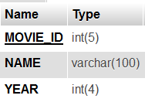

**SONGS TABLE**

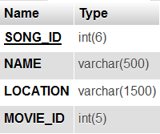

**SONG_USER TABLE**

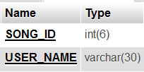

**FEEDBACK TABLE**

