**Software Requirements Specifications (SRS)**

# Online Music System

Master of Technology (Information Technology)

*Semester X*

## *Session Jan – May, 2014*

**Under the guidance of Submitted By**

Mr. Shaligram Prajapat Ashwini Varma (IT-2K9-07)

Project Incharge Keshav Patidar (IT-2K9-20)

Prathmesh Dubey (IT-2K9-29)

**International Institute of Professional Studies**

**Devi Ahilya Vishwavidyalaya, Indore, M.P.**

**2014**

Table of Contents

|  |  |
| --- | --- |
| Topic | Page No. |
| 1. Introduction    1. Product Overview    2. Purpose    3. Intended Audience    4. Product Scope    5. References 2. Functional Requirements 3. Non-Functional Requirements    1. Performance Requirements       1. Static Requirements       2. Dynamic Requirements    2. External Interface Requirements       1. User Interfaces       2. Hardware Interfaces       3. Software Interfaces       4. Communication Protocols    3. Design Constraints       1. Software Design Constraints       2. Hardware Design Constraints    4. Software Quality Attributes       1. Reliability       2. Usability       3. Security       4. Reusability       5. Correctness | 3 - 4  3  3  3  4  4  5 - 6  6 - 10  6 - 7  6  7  7 - 8  7  7  7  8  8  8  8  9 - 10  9  9  9  9  10 |

# Introduction

# Product Overview

This Software Requirements Specification provides a complete description of all the functions and specifications of the Online Music System needed by software engineers to adequately design and implement the software. Software Requirements Specification (SRS) completely describes all of the functions of a proposed system and the constraints under which it must operate.

## Purpose

This project is made for music lovers who would like to listen to music anytime. Presently they issue is that music could not be made available everytime to users. Moreover, latest songs are not available with users. So there is a need for system which can provide users with latest songs. and can make music available to them everytime.

In existing system, users use music CDs or computer hard disk to store songs. So they have to carry these CDs or hard disk and song playing instruments like CD player or laptop with them to listen to songs. In this system, it is difficult to organise songs, moreover users cannot keep these things all the time with them. So, music is not available to them all the time. And as new songs arrives more music CDs are needed to be purchased which increases users expense. And music CDs can also get easily damaged resulting in loss of data (songs).

The Purpose of Online Music System is to overcome the entire problem which users are currently facing by making live music available to user.

## Intended Audience

The expected audiences of this document are the Users of Online Music System (Admin, User, Guest) and the software developers.

## Product Scope

In Scope :

* Authentication : Admin/User have to login before accessing their respective features of online music system.
* Listen Songs : Users/Guest can listen to songs online.
* Download Songs : Users/Guest can download songs.
* Upload Songs : New Songs can be uploaded by admin.
* Delete Songs : Corrupt or non-essential songs can be deleted in case of server overload by admin.
* Favourite Songs List : Users can manage their favourite songs list.
* Feedback Management : Users/Guest can give feedback and Admin can check the feedbacks and reply accordingly.
* Register : Guest can register to become member (user) of Online Music System.
* Account Management : Users/Admin can manage their account details like Name, Authentication Password, etc.
* Change User Roles : Admin have authority to give another user admin privledges.

Out Scope :

* In Online Music System songs are classified only according to movies. That means, in online music system only movies songs are present. Songs are not classified according to Albums or Artist.

## References

IEEE. IEEE Std 830-1998 IEEE Recommended Practice for Software Requirements Specifications IEEEE Computer Society, 1998.

1. **Functional Requirements**
   1. **Use Case Diagram**

* **For Admin**

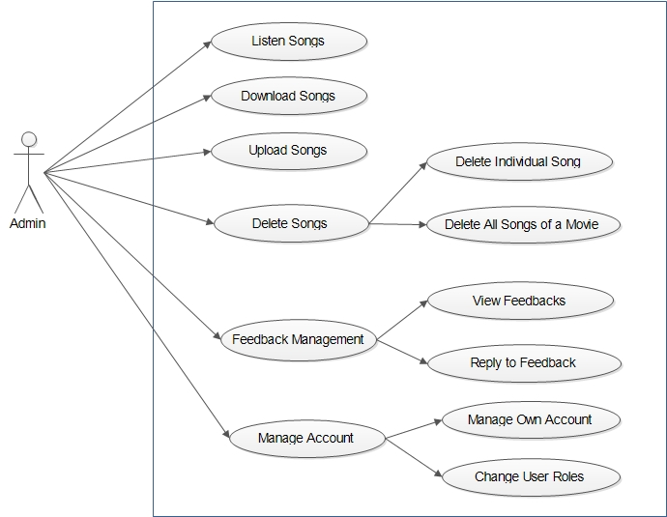

* **For User**

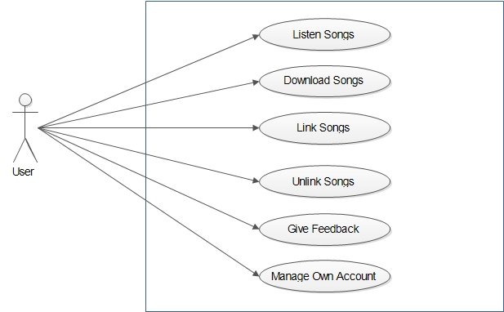

* **For Guest**

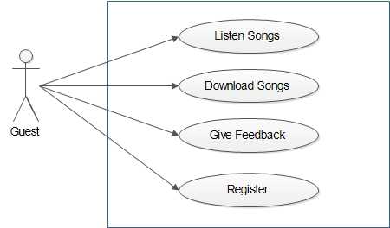

1. **Non-Functional Requirements**
   1. **Performance Requirement**
      1. **Static Requirements**

* Number of terminals supported : Multiple
  + One server for Database and for keeping Songs.
  + And any numbers of terminals can be used by users. As at any time any number of users should be able to use online music system.
* Number of simultaneous users to be supported : Multiple
  + Database and Songs Administrator.
  + And any numbers of simuntaneous users should be supported by online music system. As at any time any number of users should be able to use online music system. In case, server starts getting overloaded due to many simuntaneous users. Online Music System developers should keep in mind about future enhancements like increasing the number of servers or increasing the capacity of server.
    1. **Dynamic Requirements**
* Response Time : Response Time will depend on time in which data can be retrieved, updated or added to the database. Faster this will happen, lesser will be response time and more will be performance of the system. So for this, software developer should use powerful DBMS and powerful Server.

* Throughput constraints : Since, the data passing through the system will be in MBs in case of less simuntaneous users. But if number of simuntaneous users it can go to GBs. So, there is need for applying constraint on the data passing through the system. And this constraint is dependent on the Server capacity.
  1. **External Interface Requirement**
     1. **User Interface**

User Interface for this system should be a Web Application which should fulfill all the requirements of users. This Web Application can be implemented using technologies like JSP, HTML, CSS, JavaScript, etc. And Users can access Online Music System using any web browser.

* + 1. **Hardware Interface**

The Server should be powerful enough to support multiple simuntaneous users. And Users can access Online Music System only if they have Internet Connection.

* + 1. **Software Interface**

Software should be Web Application which is made to run on any platform.

* + 1. **Communication Interface**

The communication between End User Terminals and Database Server should be done through API which are in built with Front End of the software.

* 1. **Design Constraints**
     1. **Software Design Constraints**
* There are no constraints on program size and data size.
* As Software is to be made for any platform therefore, JSP would be preferred application to develop this software.
* As in this case response time is of major concern as multiple users would be simultaneously giving request. So, the API which allows fastest communication between Database and user's request should be chosen. For example, in case JSP is being used, then Pure Java API should be used for database connectivity.
  + 1. **Hardware Design Constraints**
* Server have following configuration :
  + 4 GB RAM
  + 512 GB Hard Disk
  + Intel i7 Processor
  1. **Software Quality Attributes**
     1. **Reliability**
* The system should provide mechanism to detect any invalid values and should be able handle exceptions very efficiently.
* Moreover, system should use powerful DBMS and Server which donot crash.
  + 1. **Usability**
* This system should be very easy to use. It should use graphical user interface components like combo box, list, radio buttons, etc. which are very easy to understand by user.
* Moreover, songs should be categorized according to their movies. It will increase readability and decrease complexity of the system.
  + 1. **Security**
* System should provide measures to prevent software from unauthorized access of data.
  + 1. **Reusability**
* The software should be made on concept of Object Oriented Programming and Component Based Assembly so that its Components can be reused again.
  + 1. **Correctness**
* System should also provide features to check integrity and consistency of data before adding, updating or deleting of data in database.
* System should provide user with exact amount of data which he seeks i.e. system should not provide user with any extra data nor it should provide user with less data.