**Software Project Management Plan (SPMP)**

# Counseling Portal

Master of Technology (Information Technology)

*Semester VI*

## Session Jan – May, 2012

**Under the guidance of Submitted By**

### Mrs. Yasmin Shaikh Ashwini Varma (IT-2K9-07)

Keshav Patidar (IT-2K9-20)

Prathmesh Dubey (IT-2K9-29)

**International Institute of Professional Studies**

**Devi Ahilya Vishwavidyalaya, Indore, M.P.**

**2012**

**Table of Contents**

|  |  |
| --- | --- |
| Topic | Page No. |
| Cover Page  Table of Contents  List of Figures  List of Tables   1. Introduction    1. Project Overview       1. Business Goals and Objectives       2. Project Goals and Objectives    2. Budget Summary    3. Project Deliverables 2. Project Organization    1. Software Process Model    2. Roles and Responsibilities    3. Tools and Techniques 3. Project Management Plan    1. Tasks       1. Description       2. Deliverables and Milestones       3. Resources Needed       4. Dependencies and Constraints       5. Risks and Contingencies    2. Time Table 4. Control Plan    1. Requirements Control Plan    2. Schedule Control Plan | 1  2  3  4  5 - 6  5  5  5  6  6  6 – 8  6 – 7  7  7 – 8  8 – 14  8 – 13  8 – 9  10 – 11  11 – 12  12  12 – 13  13 – 14  14 – 15  14  15 |

**List of Figures**

|  |  |
| --- | --- |
| Figure | Page No. |
| 1. SDLC 2. Milestone 3. Gantt Chart | 7  11  13 |

**List of Tables**

|  |  |
| --- | --- |
| Figure | Page No. |
| 1. SDLC 2. Tasks Description 3. Deliverables and Milestones | 6  8 – 9  10 |

1. **INTRODUCTION**
   1. **Project Overview**

#### Business Goals and Objectives

The business goals and objectives for this project will focus on implementing counseling process that:

* Enhances the ability and effectiveness of staff to perform their jobs.
* Facilitates coordination and information sharing between counseling staff and students in counseling process.
* Less time consuming.
* Enhances data security and integrity.
* Facilitates the electronic capture of data.
* Is easy to use.
* Eliminate redundant data entry.
* Stores data electronically for future use.

#### Project Goals and Objectives

* Ensure that counseling staff inputs into the design process.
* Accomplish project business goals and objectives within time parameters.
* Provide security constraints like login page to ensure unauthorized access to data.
* Provide facilities for prevention against some hacking techniques like sql injection, etc.
* To provide dynamic linking between web pages.
  1. **Budget Summary**

“No budget required”.

* 1. **Project Deliverables**

The list of project deliverables:

* Project Management Plan
* Software Requirement Specifications
* Software Design Description
* Software Testing Description
* Working System with MySQL Database
* Final Project Report

1. **PROJECT ORGANIZATION**
   1. **Software Process Model**

Software Model used for implementing and executing Counseling Portal is System Development Life Cycle (SDLC).

Table 1

|  |  |
| --- | --- |
| SDLC Phases | Completion Date |
| Initial Investigation | 1-Feb-2012 |
| Feasibility Study | 10-Feb-2012 |
| System Analysis | 1-Mar-2012 |
| Logical Design | 15-Mar-2012 |
| Physical Design | 25-Mar-2012 |
| Implementation | 10-Apr-2012 |
| Testing and Debugging | 15-Apr-2012 |

Figure 1

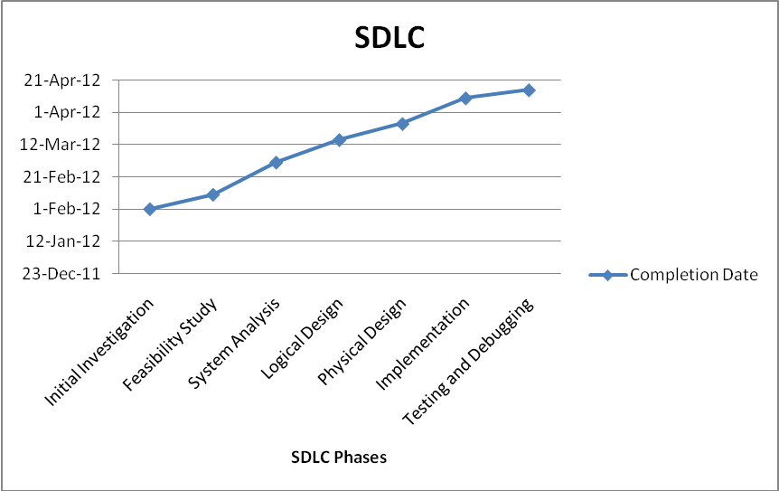

* 1. **Roles and Responsibilities**

The software developers are responsible for all documentation to be developed and for all work to be done.

* 1. **Tools and Techniques**

This project adapts the system for use on Personal Computers using a Visual Interface that would be built using following tools and techniques:

* HTML and CSS will be used for Designing
* JavaScript and AJAX will be used for Browser Side Scripting
* PHP will be used for Server Side Scripting
* MySQL will be used as Database Management System
* Apache HTTP Server will be used as Web Server.

Since, WampServer comprises of PHP, MySQL and Apache HTTP Server in a single package. So, we will use WampServer in this project.

For testing purpose, we will require only a JavaScript enabled web browser like Mozilla Firefox, Google Chrome, etc.

1. **PROJECT MANAGEMENT PLAN**
   1. **Tasks**
      1. **Description**

Table 2

|  |  |  |  |
| --- | --- | --- | --- |
| Activity Title | Task Title | Task Description | Task Sequence Number |
| Analysis | Initial Investigation | Descriptive view of intended project is established and its goals and objectives are determined. | 1 |
| Analysis | Feasibility Study | The proposed system is tested in the light of its workability, meeting user’s requirements, effective use of resources and cost effectiveness. The aim of this task is to achieve the scope of project. | 2 |
| Analysis | System Analysis | This involves a detailed study of the current system, leading to specifications of a new system. Analysis is a detailed study of various operations performed by a system and their relationships within and outside the system. | 3 |
| System Design | Logical Design | All the functionalities and operations are described in detail by using process diagrams like data flow diagrams (DFD), entity relationship (ER) diagrams, flowcharts, decision tree, etc. | 4 |
| System Design | Physical Design | With the help of logical design we develop physical design of the system. For example, ER Diagrams are converted into tables. | 5 |
| Implementation | Implementation | All the theory part of the project is turned into practice. During this task, all the programs of the system are loaded onto the user’s computer. | 6 |
| Testing and Debugging | Testing | The system is checked for any unexpected error, improper functioning of the system. | 7 |
| Testing and Debugging | Debugging | The problems occurred during testing task are solved. | 8 |

* + 1. **Deliverables and Milestones**

Table 3

|  |  |  |
| --- | --- | --- |
| Milestone Title | Milestone Description | Milestone Date |
| Project Management Plan | Initial Investigation is performed, according to which a plan is made on how to manage the project. | March 19, 2012 |
| Software Requirements Specifications | Feasibility Study and System Analysis are performed, and accordingly all the requirements of the project are identified. | March 26, 2012 |
| Software Design Description | System Design is described on the basis of logical and physical designs of the system. | April 3, 2012 |
| Software Implementation | All the programs are created and documentation is done. Fully working system is developed. | April, 10 2012 |
| Software Testing Description | The errors occurred during Testing of system are described with their solution. | April, 15 2012 |
| Final Presentation | The project is demonstrated. | April, 17 2012 |
| Final Report | A Report is made which includes all the information of the project. | April, 19 2012 |

Figure 2

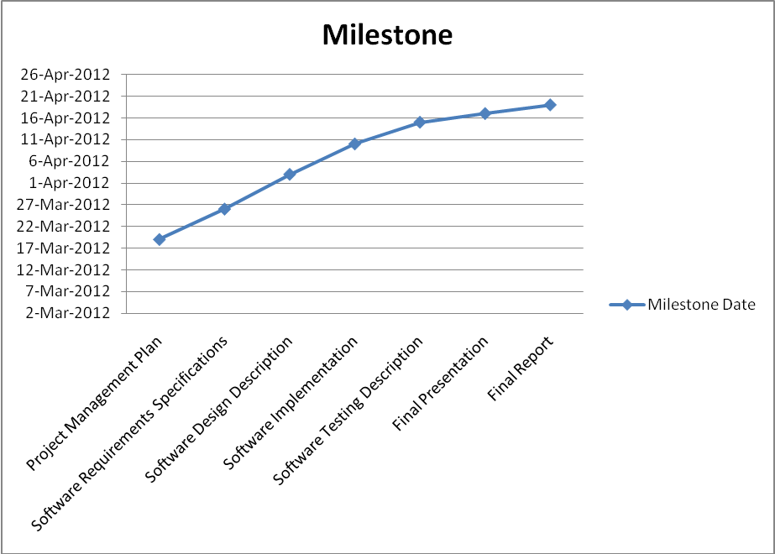

* + 1. **Resources Needed**
* This project will use resources in the form of time and effort that we will spend developing the project deliverables.
* Hardware Requirements:
  + Six Personal Computers with
    - At least 333MHz Pentium computers
    - Running Windows 98/ XP/ Vista/ 7 Operating System
    - At least 128 MB RAM and a minimum of 1 GB of disk space.
* Software Requirements:
  + WampServer
    - PHP
    - MySQL
    - Apache HTTP Server
  + Adobe Dreamweaver
  + JavaScript Enabled Web Browser like Google Chrome, etc.
* Office Facilities:
  + Internet
* Budget Allocation:
  + None
    1. **Dependencies and Constraints**
* Project Constraints
  + To be submitted before 20th April 2012
  + CET result database should be provided in advance
  + Due to the nature of law enforcement, resource availability is inconsistent.
* Critical Project Barriers
  + Due to inefficiency of the institution, the required resources cannot be supplied for the project. For example, if the hardware provided in the computer lab is of lower configuration than required it could be destructive to project’s initiative
  + Project title should be accepted by the project guide
    1. **Risks and Contingencies**
* “Improper Time Management”, which means that the developers do not understand the importance of time. This could affect the project drastically. If the project is not submitted on time, it could get cancelled. So, proper time table should be maintained and developers should perform in such a way that all checkpoints are crossed before or on the day allotted to them. So that project could finish on time.
* “Deficiency in the knowledge and understanding of the problem and its solution” indicates that the developers do not have the complete understanding of the problem. This will affect the quality of the project in terms of requirements of the product and their fulfillment, which is not desirable. Building a prototype for the project model and doing an extensive literature search can overcome this. This will help the developers in delivering an efficient and quality product.
* “Lack of Skills and knowledge of tools needed for statistical analysis”, which means that the developers do not have knowledge about the tools and knowledge of working on statistical analysis. In this case, the developers are expected to update their knowledge of tools available for this purpose and decide the one that will be used in the project and master it. The developers may consult the faculty and other members of the committee especially, Mrs. Yasmin Shaikh for this purpose.
  1. **Time Table**

Gantt chart:

|  |  |  |  |
| --- | --- | --- | --- |
|  | Today's Date: | 16-Mar-2012 | Friday |
| [42] | Start Date: | 25-Jan-2012 | Wednesday |

Figure 3

IIPS Counseling System Project Schedule

Due Date: April 20th, 2012

|  |  |  |  |  |  |  |  |  |  |  |  |
| --- | --- | --- | --- | --- | --- | --- | --- | --- | --- | --- | --- |
| Task | % Complete | Status | Dates | | | | | | | | Duration |
| 25 Jan | 1 Feb | 10 Feb | 1 Mar | 15 Mar | 25 Mar | 10 Apr | 15 Apr |
| II | 100 | C | S | E |  |  |  |  |  |  | 7 days |
| FS | 100 | C |  | S | E |  |  |  |  |  | 10 days |
| SA | 100 | C |  |  | S | E |  |  |  |  | 20 days |
| LD | 50 | AS |  |  |  | S | E |  |  |  | 15 days |
| PD | 50 | OS |  |  |  | S |  | E |  |  | 25 days |
| I | 25 | OS |  |  |  | S |  |  | E |  | 40 days |
| T | 0 | OS |  |  |  |  |  |  | S | E | 5 days |
| D | 0 | OS |  |  |  |  |  |  | S | E | 5 days |

* Symbols
  + II: Initial Investigation
  + FS: Feasibility Study
  + SA: System Analysis
  + LD: Logical Design
  + PD: Physical Design
  + I: Implementation
  + T: Testing
  + D: Debugging
  + C: Completed
  + AS: After Schedule
  + OS: On Schedule
  + S: Start Date
  + E: End Date

1. **CONTROL PLAN**
   1. **Requirements Control Plan**

When changes are to be made in the requirements after the SRS has been released, the changes shall be brought to the attention of the committee and discussed. Any changes that are to be made will be with the prior approval of the committee and only if feasible and permissible within the constraints of the project, and resources in terms of knowledge and skill of developers required. Once the changes have been made to the SRS document, an updated version of the SRS shall be released and circulated to the committee. However, no changes shall be made to the requirements once the SDD is completed.

* 1. **Schedule Control Plan**

If the work scheduled gets behind, developers are ready to spend extra time on the project in between and after the schedules to make up for the lost time and deliver the final project on time.