**Software Requirements Specifications (SRS)**

# Counseling Portal

Master of Technology (Information Technology)

*Semester VI*

## *Session Jan – May, 2012*

**Under the guidance of Submitted By**

Mrs. Yasmin Shaikh Ashwini Varma (IT-2K9-07)

Keshav Patidar (IT-2K9-20)

Prathmesh Dubey (IT-2K9-29)

**International Institute of Professional Studies**

**Devi Ahilya Vishwavidyalaya, Indore, M.P.**

**2012**

**Table of Contents**

|  |  |
| --- | --- |
| Topic | Page No. |
| Cover Page  Table of Contents  List of Figures  List of Tables   1. Introduction    1. Product Overview    2. Purpose    3. Scope 2. Functional Requirements    1. Introduction    2. Inputs and Outputs    3. Processing    4. Error Handling    5. Database Requirements 3. Non-Functional Requirements    1. Performance Requirements       1. Static Requirements       2. Dynamic Requirements       3. Capacity Requirements    2. External Interface Requirements       1. User Interfaces       2. Hardware Interfaces       3. Software Interfaces       4. Communication Protocols    3. Design Constraints       1. Software Design Constraints       2. Hardware Design Constraints       3. User Interfaces Design Constraints    4. Detailed Non-Functional Requirements    5. Software System Attributes       1. Reliability and Fault Tolerance       2. Availability       3. Security       4. Software Quality Attributes       5. Performance | 1  2 – 3  4  5  6 – 7  6  6  6 – 7  8 – 19  8 – 9  10 – 14  14 – 18  19  19  19 – 29  19 – 21  19 – 20  20  20 – 21  21 - 22  21  21 – 22  22  22  23 – 24  23  23 – 24  24  24 – 27  27 – 29  27  28  28  28 – 29  29 |

**List of Figures**

|  |  |
| --- | --- |
| Figure | Page No. |
| 1. Login Table 2. CET Table 3. Rank Table 4. Attendance Table 5. Document Table 6. Course Table 7. Fees Table 8. Seats Table | 24  25  25  26  26  26  26  27 |

**List of Tables**

|  |  |
| --- | --- |
| Table | Page No. |
| 1. Functional Requirements Introduction 2. Functional Requirements Inputs and Outputs 3. Functional Requirements Processing | 8 – 9  10 – 14  14 – 18 |

1. **INTRODUCTION**
   1. **Product Overview**

This Software Requirements Specification provides a complete description of all the functions and specifications of the International Institute of Professional Studies (IIPS) Counseling Portal needed by software engineers to adequately design and implement the software. Software Requirements Specification (SRS) completely describes all of the functions of a proposed system and the constraints under which it must operate.

* 1. **Purpose**

IIPS Counseling Portal is intended to simplify the complex counseling process by performing most part of the faculties job automatically and hence, reducing the work load of the faculties. This document is meant to delineate the features of IIPS Counseling Portal, so as to serve as a guide to the developers on one hand and a software validation document for the prospective client on the other.

The expected audiences of this document are the faculties of IIPS, mainly the project guide Mrs. Yasmin Shaikh and the faculties who will use this system (Counseling Attendance Incharge, Document Submission Incharge, Course Selection Incharge and Fees Submission Incharge) and the software developers.

* 1. **Scope**

In Scope:

* User Authentication.
* Facility to take Attendance.
* Facility to sort students on the basis of their ranks (like if all, All India Seats are occupied then we can sort students on the basis of their MP Rank. So, this reduces time as all those students who are not of MP will be skipped even if their ranks are better than MP student’s ranks as there are no seats left for them).
* Facility to make document submission procedure very easy in which eligibility criteria (like 10th and 12th percentage should be greater than 50%) are automatically checked and also provides facility for required modifications in case of non submission of optional documents (like if any reserved category student is unable to show its caste certificate, his category should be automatically changed to General, etc).
* Facility to perform course selection procedure.
* Facility to perform fees submission procedure.
* Facility to dynamically link web pages i.e. the response of one web page is used by the other web page (like if the student is present then only he/she can go for document submission).
* Facility to show seats status to students i.e. how many and which seats of which course are available.

Out of Scope:

* Facility to edit the details of the students i.e. if some details of student (like name, score, rank, etc.) are wrong so, it cannot be edited using this software.
* Facility to modify the data already entered (like if a student tells to choose MCA as course and the course selection incharge has submitted his choice and later he/she changes his mind and wishes to opt for M.Tech, then it cannot be done, he/she will be allotted MCA seat only).
* Any information related to the scholarship is not included in this software.

1. **FUNCTIONAL REQUIREMENTS**
   1. **Introduction**

There are mainly seven functions to be employed in this project:

Table 1

|  |  |
| --- | --- |
| Function | Purpose |
| User Authentication | This function will prevent the portal from unauthorized access. Moreover, this function will help to redirect the authorized personnel’s to their respective field of work. For example, if Attendance Incharge logs in with his/her username and password then he/she will be redirected to the web page designed for attendance purpose and in case of Document Submission Incharge he/she will be redirected to the web page designed for document submission purpose and so on. |
| Attendance | This function will be used by Attendance Incharge. This function will enable Attendance Incharge to take the attendance of the students. This function will also contain feature to sort students on the basis of their ranks (like if all, All India Seats are occupied then we can sort students on the basis of their MP Rank. So, this reduces time as all those students who are not of MP will be skipped even if their ranks are better than MP student’s ranks as there are no seats left for them). |
| Attendance Search | This function will also be used by Attendance Incharge. This function will enable Attendance Incharge to modify the attendance of the students whose attendance has already been marked. This function is useful when a student gets late for the counseling process. If the student gets late and his/her attendance has been marked as “Absent”. This webpage will enable Attendance Incharge to change the attendance of the student from “Absent” to “Present” using his/her Roll Number. |
| Document | This function will be used by Document Submission Incharge. By using this function, Document Submission Incharge will check whether the student has all the documents or not. If student is unable to present mandatory documents (like 10th Mark sheet, 12th Mark sheet, Transfer Certificate, Migration Certificate), then this web page will not allow Document Submission Incharge to accept the documents of the student, in that case document submission incharge will have to reject the documents of the student. If student is unable to present optional documents (like MP Domicile, Caste Certificate) then Document Incharge can accept the documents but required actions will be performed automatically (like if any reserved category student is unable to show its caste certificate, his category should be automatically changed to General). |
| Course | This function will be used by Course Selection Incharge. This function enables Course Selection Incharge to submit the course selected by the student and to notify if seat for that course is not available so that student can choose other course. This web page should also provides facility to reject the admission of student in case student did not get his/her desired course. |
| Fees | This function is used by Fees Submission Incharge. This function enables fees submission incharge to accept the admission if the student pays fees and to reject the admission if the student is unable to pay fees. |
| Seats | This function will not require user authentication. It will be available to all personnel’s as well as students. This function will show the status of seats i.e. how many and which seats of which course are available. |

* 1. **Inputs and Outputs**

Products that will be provided:

* The CET Students database (including Roll No, Name, Father’s Name, Nationality, MP Citizen Status, Category, Sub Category and Score)
* Rank database (including All India Rank, All India Female Rank, All India SC Rank, All India SC Female Rank, All India ST Rank, All India ST Female Rank, All India OBC Rank, All India OBC Female Rank, MP Rank, MP Female Rank, MP SC Rank, MP SC Female Rank, MP ST Rank, MP ST Female Rank, MP OBC Rank, MP OBC Female Rank and NRI Rank)

Table 2

|  |  |  |
| --- | --- | --- |
| Function | Input | Output |
| User Authentication | * Username Text Box * Password Text Box * Login Button | Checks whether the Username and Password are valid or not from Login table (Contains login id, password and the website linked to corresponding username and password)   * If the Username and Password are valid, then redirect the webpage to website linked to corresponding username and password. * If the Username and Password are not valid, then show a message that on User Authentication Page, “Invalid Username/Password”. |

|  |  |  |
| --- | --- | --- |
| Attendance | On page load, the details of the student whose All India Rank is best and whose attendance has not been marked will be displayed using CET_Student, Rank and Attendance tables.  And following options will be provided:   * Option between Absent and Present * Attendance Submit Button * Sort By Options * Sort Button * Search Student by Roll No Textbox * Search Button | * If Attendance Submit Button is pressed then attendance of that student will be marked in the Attendance table on the basis of the option chosen between absent and present. And details of student of next rank will be displayed on the screen * If Sort button is pressed then the details of student with best rank on the basis of chosen sort by option will be displayed on the screen. * If Search button is pressed then the Attendance Search web page will be opened and the Roll No entered in Search Students by Roll No Textbox will be sent as input to Attendance Search webpage. |
| Attendance Search | This webpage takes Roll No as input through Attendance webpage. And using that Roll No, the details of the student will be displayed, only when the attendance has been marked for that Roll No else a message is displayed “Roll Number is not valid”.  And Following options will be provided.   * Option between Present and Absent * Submit Button | If submit button is pressed, then attendance for the respective Roll No is modified on the basis of the option between Present and Absent in Attendance table. |
| Document | On page load, the details of the student whose All India Rank is best and whose attendance has been marked as Present and whose documents are not submitted will be displayed using CET_Student, Rank, Attendance and Document tables.  And following options will be provided:   * 10th Percentage Textbox * 12th Percentage Textbox * Transfer Certificate Checkbox * Migration Certificate Checkbox * MP Domicile Checkbox * Caste Certificate Checkbox * Income Certificate Checkbox * Income Textbox * Accept Button * Reject Button | * If Accept Button is pressed then it is checked that all the mandatory documents are submitted or not and all the eligibility criteria’s are fulfilled or not, in case all the document are correct then entry is made in document table showing that documents are accepted else message is displayed on the document page that “Mandatory Documents are not submitted or Eligibility Criteria not fulfilled”. * If Reject Button is pressed then entry is made in document table showing that documents are rejected. |
| Course | On page load, the details of the student whose All India Rank is best and whose documents have been accepted and whose course is not selected will be displayed using CET_Student, Rank, Document and Course tables.  And following options will be provided:   * Options between courses offered. * Options between seats available. * Submit Button * Reject Button | * If Submit button is pressed, then course then the student is allotted a seat chosen by seats option of course chosen by courses option by making entry in Course table which includes Roll No, Course Selection Status, Course Name and Allotted Seat and by decrementing chosen seat of chosen course by one in Seats table. * If Reject button is pressed, then entry is made in course table indicating that no seat is allotted to the student. |
| Fees | On page load, the details of the student whose All India Rank is best and whose course have been selected and whose fees is not paid will be displayed using CET_Student, Rank, Course and Fees tables.  And following options will be provided:   * DD Amount Textbox * DD Number Textbox * DD Date Textbox * DD Bank Textbox * Accept Button * Reject Button | * If Accept button is pressed, then entry is made in Fees table indicating that the admission of the student is confirmed. * If Reject button is pressed, in case the student is unable to pay the fees then entry is made in the Fees table indicating that the admission of student could not be done. And respective seat of respective course is incremented by one in seats table by using the seat and course entries done in Course table. |
| Seats | On page load, details of Seats table are fetched and are used as input for this webpage. | The fetched records of Seats table are displayed in tabular form showing details about how many and which seats of which course are still available. |

* 1. **Processing**

Table 3

|  |  |  |  |  |
| --- | --- | --- | --- | --- |
| Function | Validation of Input Data | Exact Sequence of Operations | Responses of Abnormal Situations | Methods to be Used to Transform Inputs to Outputs |
| User Authentication | Username and Password textboxes can contain any type of text. So, no validation is required. | * Enter Username. * Then Enter Password. * Then Press Login Button. | Reload the webpage or check Browser settings or check Servers settings. | * Username and Password are taken as Input. * Then they are checked in Login table. * If found redirect to respective webpage. * Else print Invalid Username or Password. |

|  |  |  |  |  |
| --- | --- | --- | --- | --- |
| Attendance | Since all the inputs are in the form of either combo box or radio buttons so, in this validation of input is not required. Only, in case of Search by Roll No validation is required that only numbers can be entered in this textbox and that can be done through JavaScript. | * Choose whether the student is Present or Absent. * Then Press Submit Button. | Reload the webpage or check Browser settings or check Servers settings. | * Select data from Cet_Student, Rank and Attendance table using table join ordering it by All India Rank and then display it on webpage. * When Submit button is pressed, insert into Attendance the Roll No of student with its attendance status. |
| Attendance Search | Since all the inputs are in the form of either combo box or radio buttons so, in this validation of input is not required. | * Choose whether the student is Present or Absent * Then Press Submit Button. | Reload the webpage or check Browser settings or check Servers settings. | * Select data from Cet_Student, Rank and Attendance table using table join and the Roll No entered in attendance table and then display it on webpage. * When Submit button is pressed, Update attendance status of the respective student in attendance table. |
| Document | In this 10th and 12th Percentage and Income should be number. This can be checked using JavaScript. And rest part is of checkbox which do not requires any validation. | * Enter 10th Percentage. * Enter 12th Percentage. * Check/Uncheck Transfer Certificate checkbox. * Check/Uncheck Migration Certificate checkbox. * Check/Uncheck MP Domicile Certificate checkbox. * Check/Uncheck Caste Certificate checkbox. * Check/Uncheck Income Certificate checkbox. * Enter Income. * Then click Submit or Reject button. | Reload the webpage or check Browser settings or check Servers settings. | * Select data from Cet_Student, Rank, Attendance and Document table using table join where attendance is Present ordering it by All India Rank and then display it on webpage. * When Submit button is pressed, insert into Document the Roll No of student with its document submission status. |
| Course | Since all the inputs are in the form of either combo box or radio buttons so, in this validation of input is not required. | * Select the course. * Select the available seat. * Click Submit or Reject button. | Reload the webpage or check Browser settings or check Servers settings. | * Select data from Cet_Student, Rank, Document and Course table using table join where documents are submitted ordering it by All India Rank and then display it on webpage. * When Submit button is pressed, insert into Course the Roll No of student with its course selection status, course and seat allotted. |
| Fees | DD Number and DD Amount are numbers. So its validation can be done by JavaScript. And DD Date is date so it can be validated to HTML5 input type=”date” feature or JavaScript can also be used for this purpose. And DD Bank can contain only alphabets. So this can be also checked using JavaScript. | * Enter DD Number * Enter DD Amount * Enter DD Date * Enter DD Bank * Then Press Submit or Reject button. | Reload the webpage or check Browser settings or check Servers settings. | * Select data from Cet_Student, Rank, Course and Fees table using table join where course is selected ordering it by All India Rank and then display it on webpage. * When Submit button is pressed, insert into Fees the Roll No of student with its Fees submission status. |
| Seats | No validation required. | It is information display page. So, no actions need to be taken on this page. | Reload the webpage or check Browser settings or check Servers settings. | * Select data from Seats table. And display it on the webpage in tabular form. |

* 1. **Exception Handling**

As per software analysis till now, undesired situation will occur only when the server could not connect to database or server could not fetch records from the record set or tables. So, when these sort of undesired situations occur an alert box can be used to display the problem or a division can be used to display error that has occurred.

* 1. **Database Requirements**

In this project, Database will play most important role. And all our Database work can be effectively done by MySQL Relational Database Management System. Now, taking MySQL as our RDBMS the database requirements are as follows:

* + Requires 209 MB of disk space.
  + Since, for counseling many students data is to be stored in database. So, around 50 MB of disk space is kept for the data to be entered in database.
  + MySQL version which will be used by us can operate on Windows XP or Windows Vista or Windows 7.
  + 256MB RAM is minimum requirement for MySQL. And 1GB RAM is optimum requirement for MySQL.
  + At least, Pentium 4 Processor should be used for MySQL.

1. **NON-FUNCTIONAL REQUIREMENTS**
   1. **Performance Requirement**
      1. **Static Requirements**

The requirements that do not impose constraints on the execution characteristics of the system are considered as static requirements. It includes requirements as:

* Number of terminals to be supported : Six
  + One Server.
  + Four Terminals for Incharge.
  + One Terminal for showing seats information to the students.
* Number of simultaneous users to be supported : Five
  + All except for Server.
* Number of files that the system has to process and their sizes:
  + Each terminal has to process only one file at a time.
  + The server has to process around six to nine files at same time.
  + Each file size will range from 300KB to 2MB.
    1. **Dynamic Requirements**

Specify constraints on the execution behavior of the system. It includes requirements as:

* Response Time: Response time will depend on the speed of Server and speed of Internet. More the speed of Server and Internet less will be response time, which results in more effective and fast working of our system. So, there is no need to put constraints on the Response Time of the system.
* Throughput constraints: Since, the data passing through the system will be of only few Kilo bytes. So, there is no need for applying any constraints on the data passing through the system.
  + 1. **Capacity Requirements**
* Number of simultaneous users, processing requirements for normal and peak hours, static storage capacity:
  + One Server
  + Five Simultaneous Users
    - Four Incharge.
    - One for showing the seat information to the students.
  + For this software, normal and peak hours are same. The processing requirement are as follows:
    - The terminals should be of at least Pentium 4.
    - The terminals should have minimum of 256MB RAM. 1GB is optimum RAM for the terminals.
    - Server should have at least 1GB of free space while other terminals should have at least 512MB of free space. As all the data is stored on server. Only few Kilo bytes of data are retrieved from the server on the terminal.

* System priorities for user and functions
  + All the terminals of incharge should get equal priority.
  + And the terminal showing seat information to the students should get less priority.
  1. **External Interface Requirements**

* + 1. **User Interfaces**

There are no special user commands to be used in this software. Maximum Portion is to be done using mouse clicks and keyboard is used only for entering data. The optimum screen resolution for this software is 1024 x 768 pixels.

* + 1. **Hardware Interfaces**
* The terminals should be of at least Pentium 4.
* The terminals should have minimum of 256MB RAM. 1GB is optimum RAM for the terminals.
* Server should have at least 1GB of free space while other terminals should have at least 512MB of free space. As all the data is stored on server. Only few Kilo bytes of data are retrieved from the server on the terminal.
  + 1. **Software Interfaces**

The software to be used by terminals are as follows:

* Operating System: Windows XP, Vista or 7
* WampServer only for server
  + PHP (Server Side Scripting Language)
  + MySQL (Relational Database Management System)
  + Apache HTTP Server (Web Server)
* JavaScript, AJAX and Flash enabled Web browser
  + 1. **Communication Protocols**

The terminals on which this software will operate should have

* Communication standard that will be used is HTTP.
* Web Browser
  + JavaScript Enabled
  + AJAX Enabled
  + Flash Enabled
  + Most Preferred Web Browsers are latest version of Google Chrome and Mozilla Firefox
* Encryption Technique to be used for password in RDBMS should be md5 encryption.
  1. **Design Constraints**
     1. **Software Design Constraints**
* No constraints are applied on program size, data size etc.
* Specific application package will be used but on server only i.e WampServer.
  + PHP (Server Side Scripting Language)
  + MySQL (Relational Database Management System)
  + Apache HTTP Server (Web Server)
* Operating System should be Windows XP or its higher versions like Windows Vista or Windows 7.
  + 1. **Hardware Design Constraints**
* Reliable Hardware Requirements are as follows:
  + Type of machine to be used: Desktop/Laptop
  + Processor: Pentium Core 2 Duo
  + Primary Memory
    - For Server: 1GB
    - For Terminals: 1GB
  + Secondary Memory
    - For Server: 5GB
    - For Terminals: 2GB
* The software may have to operate on some existing or predetermined hardware, thus imposing restrictions on the design. In such cases, Minimum Hardware Requirements are as follows:
  + Type of machine to be used: Desktop
  + Processor: Pentium 4
  + Primary Memory
    - For Server: 256MB
    - For Terminals: 256MB
  + Secondary Memory
    - For Server: 1GB
    - For Terminals: 512MB
    1. **User Interface Design Constraints**
* In case of Attendance website, user screen will be split vertically into two panes. In left pane details of student will be shown with two radio buttons for selecting whether the student is present or absent and in the right pane facility to sort the students on the basis of their ranks is provided.
* In Document Submission website, user screen will be split vertically into two panes. In left pane details of student will be shown and in the right pane facility to submit documents will be provided.
* In Course Selection website, user screen will be split vertically into two panes. In left pane details of student will be shown and in the right pane facility to select course will be provided.
* In Fees Submission website, user screen will be split vertically into two panes. In left pane details of student will be shown and in the right pane facility to deposit fees will be provided.
  1. **Detailed Non Functional Requirements**

Fig. 1 LOGIN Table

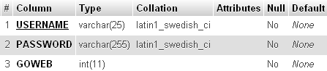Fig. 2 CET Table

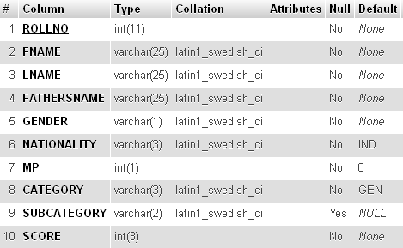

Fig. 3 RANK Table

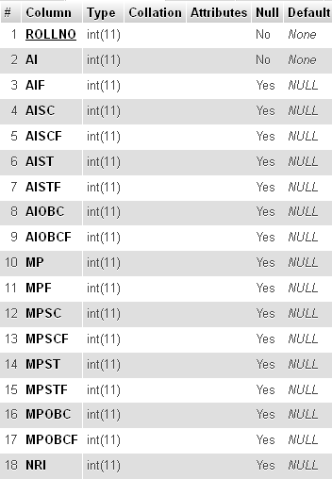

Fig. 4 ATTENDANCE Table

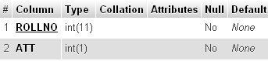

Fig. 5 DOCUMENT Table

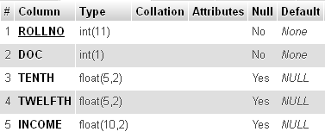

Fig. 6 COURSE Table

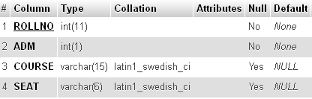

Fig. 7 FEES Table

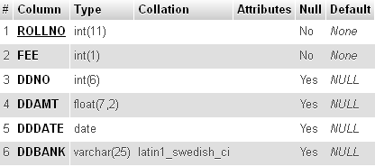

Fig. 8 SEATS TABLE

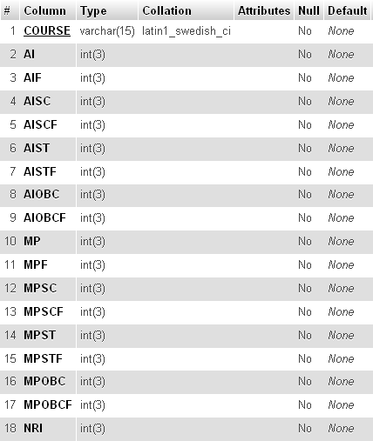

* 1. **Software System Attributes**
     1. **Reliability and Fault Tolerance**
* The software should be reliable, many facilities should be provided for checking the data redundancy, data integrity and data security, etc. This software should also include many error handling functions.
* No work should be kept pending, data should be inserted or updated into database as soon as button will be pressed. So, in case of power failure or crash, there will be no loss of data.
  + 1. **Availability**

This project should be totally based on web pages. So, if the server is connected to internet, then the project can be used from any part of the world using internet.

* + 1. **Security**

The files should be secured against malicious deformations. In case of user authentication password should be stored in RDBMS in encrypted form (like md5) and the web site should be protected from some hacking techniques like SQL Injection, etc.

* + 1. **Software Quality Attributes**
* Adaptability: Since the counseling portal will be made with top priority that it should be easy to use and perform most of the complex jobs on its own. So, it will be easy to adapt as there will be nothing in this project that will confuse the user.
* Availability: This project will be totally based on web pages. So, if the server is connected to internet, then the project can be used from any part of the world using internet.
* Correctness: Most of the data entries will be in form of checkbox, combo box and radio buttons. So in these cases, wrong data entry cannot happen. And in case of textboxes, they will be checked twice. Firstly, using JavaScript, then if by chance JavaScript cannot detect wrong data entry, then again data is checked by RDBMS.
* Maintainability and Testability: The software will be very easy to maintain. As in counseling, same procedure is to be followed for each and every student. And using few students data, the software can be tested for errors and the errors can be debugged.
* Portability: The software will be portable as it works on web browsers. And web browser can work on many platforms whether it is Windows, Linux, Mac OS, etc.
* Reliability and Robustness: The software will be reliable as many facilities will be provided for checking the data redundancy, data integrity and data security, etc. This software will be robust as many error handling functions will be included in this software.
  + 1. **Performance**
* Fault Tolerance: No work should be kept pending, data should be inserted or updated into database as soon as button will be pressed. So, in case of power failure or crash, there will be no loss of data.
* Security: The files should be secured against malicious deformations. In case of user authentication password should be stored in RDBMS in encrypted form (like md5) and the web site should be protected from some hacking techniques like SQL Injection, etc.