**Visvesvaraya Technological University**

**Belagavi, Karnataka-590 018**



# WEB TECHNOLOGY & ITS APPLICATION (18CS63)

# LAB REPORT

# Submitted

# in partial fulfilment requirments for the award of the Degree

# of

# BACHELOR OF ENGINEERING

# IN

# COMPUTER SCIENCE AND ENGINEERING

by

**KESHAV R KARANTH**

# Under the Guidance of

# Mr. ALOK RANJAN

# Assistant Professor



**Department of Computer Science and Engineering**

**Canara Engineering College , Benjanapadavu**

**2021-2022**

**CANARA ENGINEERING COLLEGE**

**BENJANAPADAVU, BANTWAL- 574219 – KARNATAKA**

**DEPARTMENT OF COMPUTER SCIENCE & ENGINEERING**



**CERTIFICATE**

This is to certify that **KESHAV R KARANTH (4CB18CS033)** has successfully completed the Lab Report on ‘**WEB TECHNOLOGY & ITS APPLICATIONS (18CS63)**’ and submitted in partial fulfillment of the requirements of 6th Semester B.E., Computer Science and Engineering, prescribed by the VISVESVARAYA TECHNOLOGICAL UNIVERSITY during the academic year 2021-2022. It is verified that all corrections/suggestions indicated for internal assessment have been incorporated in the report deposited in the department library. The lab report has been approved as it satisfies the academic requirements in respect of lab report work prescribed by Bachelor of Engineering Degree.

**Faculty H.O.D**

**Mr. Alok Ranjan Dr. Demian Antony D’Mello Assistant Professor Professor**

**Name of the Examiners Signature with Date**

**1. Mr. Alok Ranjan**

**2**. **Dr. Demian Antony D'Mello**

**ACKNOWLEDGEMENT**

We are indebted to our **Principal, Dr. Ganesh V. Bhat** and management of Canara Engineering College for providing an environment with all facilities that helped us in completing our mini project.

We are extremely grateful to **Dr. Demian Antony D’Mello, Head of Computer Science & Engineering Department** for his moral support and encouragement.

We wish to express our sincere gratitude to our professor **Prof. Alok Ranjan** from Computer Science & Engineering Department, for the guidance and suggestions.

We thank all the teaching and non-teaching staff of Department of Computer Science & Engineering for their kind help.

Last but not the least; we would like to add some personal note. If there is a driving force that kept us going, and what has not changed it is the constant support and blessing of our parents, family and friends. There is no doubt, in spite of my strenuous efforts error might remain in mini project. Naturally, we alone take full responsibility for any lack of clarity, occasional erratum or inexactness that may occur.

**Keshav R Karanth**

**4CB18CS033**

**TABLE OF PROGRAMS**

|  |  |
| --- | --- |
| **CONTENTS** | **PAGE NO.** |
| 1. **Simple Calculator** | 1-5 |
| 1. **HTML Table** | 6-8 |
| 1. **Font-Size Changer** | 9-11 |
| 1. **Left-most vowel and** | 12-15 |
| **5. XML** | 16-18 |
| 1. **No.of Visitors** | 19-20 |
| 1. **Php Clock** | 21-22 |
| 1. **Php Calculator and Matrix functions** | 23-27 |
| 1. **Php Strings** | 28-29 |
| 1. **Selection sort in MySql database** | 30-32 |

## *1.Write a JavaScript to design a simple calculator to perform the following operations: sum, product, difference and quotient.*

**Code:**

<!DOCTYPE html>

<html lang="en">

<head>

    <meta charset="UTF-8">

    <meta http-equiv="X-UA-Compatible" content="IE=edge">

    <meta name="viewport" content="width=device-width, initial-scale=1.0">

    <title>Simple caluclator</title>

    <style>

        .main-div {

            width: 100%;

            height: 100%;

        }

        p {

            margin: 0;

            color: #fff;

            font-family: sans-serif;

            padding-left: 25px;

        }

        .section {

            position: absolute;

            width: 300px;

            height: auto;

            margin-top: 50px;

            margin-left: 450px;

            border-radius: 25px;

            background-color: maroon;

            box-shadow: 5px 10px 10px 2px burlywood;

            z-index: 3;

            display: flex;

            flex-direction: column;

        }

        #answer {

            margin: 10px;

            border-radius: 25px;

            border: none;

            text-decoration: none;

            outline: none;

            padding-top: 3px;

            text-align: end;

            text-justify: distribute;

            color: black;

            background: white;

        }

        .input-box {

            display: flex;

            flex-direction: row;

            flex-wrap: wrap;

        }

        .section .input-box .css-input {

            padding: 5px;

            margin: 5px 5px 5px 25px;

            height: 25px;

            width: 100px;

            font-size: 11px;

            border-width: 0px;

            border-color: #cccccc;

            background-color: #ffffff;

            color: #000000;

            border-style: hidden;

            border-radius: 11px;

            box-shadow: 1px 0px 3px rgba(66, 66, 66, 0.63);

            text-shadow: -7px 0px 5px rgba(66, 66, 66, 0.75);

        }

        .section .input-box .css-input:focus {

            outline: none;

        }

        .operators {

            display: flex;

            flex-direction: row;

            flex-wrap: wrap;

            margin: 5px;

            justify-content: center;

        }

        .operators>button {

            width: 120px;

            height: 120px;

            background-color: white;

            margin: 7px;

            border-radius: 25px;

            text-align: center;

            display: flex;

            justify-content: center;

            align-items: center;

            font-family: monospace;

        }

        #clear {

            background-color: #ffb6e6;

            margin: 7px 25px;

            border-radius: 25px;

            font-family: monospace;

            color: #ffffff;

            font-size: 20px;

            background: #ff99fc;

            padding: 10px 18px 10px 20px;

            text-decoration: none;

        }

        #add,

        #sub,

        #mul,

        #div,

        #clear {

            background-color: maroon;

            color: white;

        }

    </style>

</head>

<body>

    <div class="main-div">

        <div class="section">

            <textarea id="answer" rows="2" cols="50" disabled>Res</textarea>

            <p>ENTER TWO NUMBERS</p>

            <div class="input-box">

                <input type="number" class="css-input" name="first" id="num1" />

                <input type="number" class="css-input" name="second" id="num2" />

            </div>

            <div class="operators">

                <button onclick="printhello(this.id)" id="add">Addition</button>

                <button onclick="printhello(this.id)" id="sub">Substraction</button>

                <button onclick="printhello(this.id)" id="mul">Multipliction</button>

                <button onclick="printhello(this.id)" id="div">Division</button>

            </div>

            <button id="clear">

                CLEAR

            </button>

        </div>

    </div>

    <script>

        function printhello(operator) {

            let val1 = parseInt(document.getElementById("num1").value);

            let val2 = parseInt(document.getElementById("num2").value);

            if (document.getElementById("num1").value.length === 0 || document.getElementById("num2").value.length === 0) {

                window.alert("Enter two numbers");

            }

            else if (operator == "add")

                document.getElementById("answer").innerHTML = String(val1 + val2);

            else if (operator == "sub")

                document.getElementById("answer").innerHTML = String(val1 - val2);

            else if (operator == "mul")

                document.getElementById("answer").innerHTML = String(val1 * val2);

            else if (operator == "div")

                document.getElementById("answer").innerHTML = String(val1 / val2);

        }

        document.getElementById("clear").onclick = () => {

            document.getElementById("num1").value = "";

            document.getElementById("num2").value = "";

            document.getElementById("answer").innerHTML = "";

        }

    </script>

</body>

</html>

**Output:**

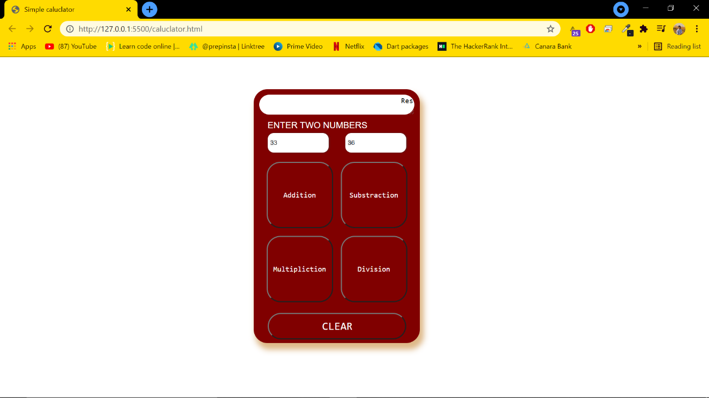

***2. Write a JavaScript that calculates the squares and cubes of the numbers from 0 to 10 and outputs HTML text that displays the resulting values in an HTML table format.***

**Code:**

<!DOCTYPE html>

<html lang="en">

<head>

    <meta charset="UTF-8">

    <meta http-equiv="X-UA-Compatible" content="IE=edge">

    <meta name="viewport" content="width=device-width, initial-scale=1.0">

    <title>Squre and Cube</title>

    <link rel="stylesheet" href="https://stackpath.bootstrapcdn.com/bootstrap/4.1.3/css/bootstrap.min.css"

        integrity="sha384-MCw98/SFnGE8fJT3GXwEOngsV7Zt27NXFoaoApmYm81iuXoPkFOJwJ8ERdknLPMO" crossorigin="anonymous">

    <style>

        * {

            margin: 0;

            padding: 0;

            box-sizing: border-box;

            font-size: 100%;

        }

        body {

            height: 100vh;

            width: 100vw;

        }

        .main-div h1 {

            display: flex;

            font-size: 2rem;

            justify-content: center;

            color: #590d22;

            font-family: cursive;

            margin-bottom: 50px;

        }

    </style>

</head>

<body>

    <div class="container">

        <h1>Squares and Cubes of Number 1-10</h1>

        <table class="table table-hover" id="table-1">

            <thead>

                <tr class="bg-warning">

                    <th scope="col">Number</th>

                    <th scope="col">Square of Number</th>

                    <th scope="col">Cube of Number</th>

                </tr>

            </thead>

            <tbody class='bg-danger'></tbody>

        </table>

    </div>

    <script>

        const tableBody = document.getElementById('table-1').getElementsByTagName("tbody")[0];

        for (let index = 1; index <= 10; index++) {

            const nodeRow = tableBody.insertRow();

            const cell1 = nodeRow.insertCell(0);

            const cell2 = nodeRow.insertCell(1);

            const cell3 = nodeRow.insertCell(2);

            cell1.innerHTML = index;

            cell2.innerHTML = index * index;

            cell3.innerHTML = index * index * index;

        }

    </script>

</body>

</html>

**Output:**

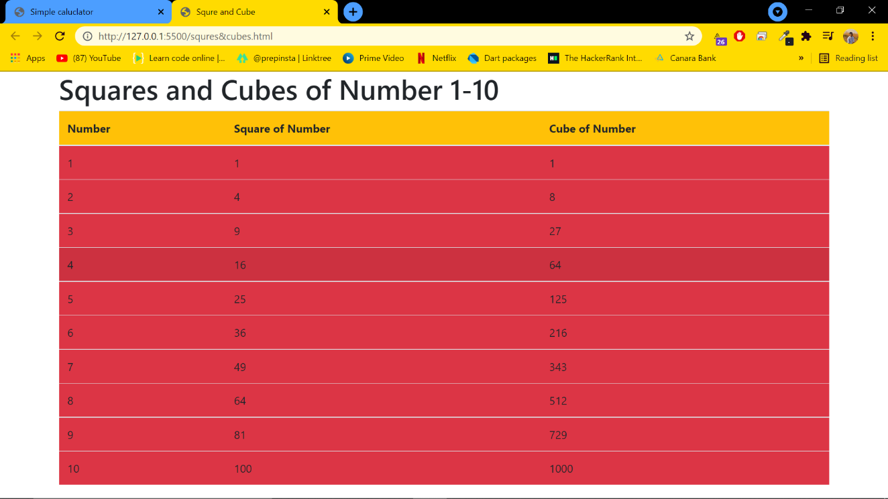

***3. Write a JavaScript code that displays text “TEXT-GROWING” with increasing font size in the interval of 100ms in RED COLOR, when the font size reaches 50pt it displays “TEXT SHRINKING” in BLUE color. Then the font size decreases to 5pt.***

**Code:**

Index.html

<!DOCTYPE html>

<html lang="en">

<head>

    <meta charset="UTF-8">

    <meta http-equiv="X-UA-Compatible" content="IE=edge">

    <meta name="viewport" content="width=device-width, initial-scale=1.0">

    <title>TEXT-ANIMATION</title>

    <style>

        * {

            margin: 0;

            padding: 0;

            box-sizing: border-box;

        }

        div {

            width: 100vw;

            height: 100vh;

        }

        div h1 {

            width: 100%;

            height: 100%;

            display: grid;

            place-items: center;

            color: red;

        }

    </style>

</head>

<body>

    <div>

        <h1 id="header">

            TEXT-GROWING

        </h1>

    </div>

    <script>

        var id = null;

        const ele = document.getElementById("header");

        var fontsize = 5;

        let inc;

        clearInterval(id);

        id = setInterval(changeFont, 30);

        function changeFont() {

            if (fontsize === 50) {

                inc = true;

                ele.innerHTML = "TEXT-SHRINKING"

                ele.style.color = "blue";

            }

            if (fontsize === 5) {

                inc = false;

                ele.innerHTML = "TEXT-GROWING"

                ele.style.color = "red";

            }

            inc ? --fontsize : ++fontsize;

            ele.style.fontSize = fontsize + "pt"

        }

    </script>

</body>

</html>

**Output:**

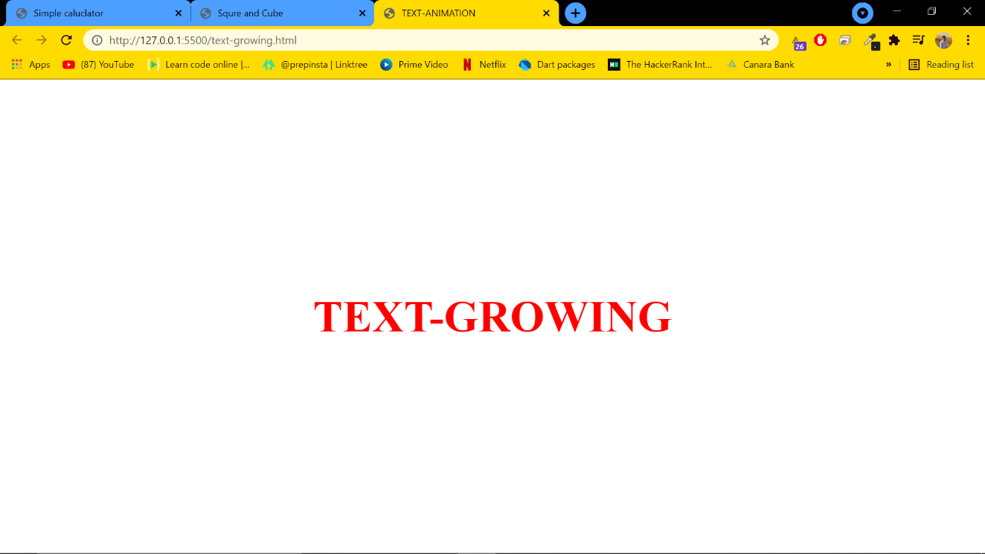

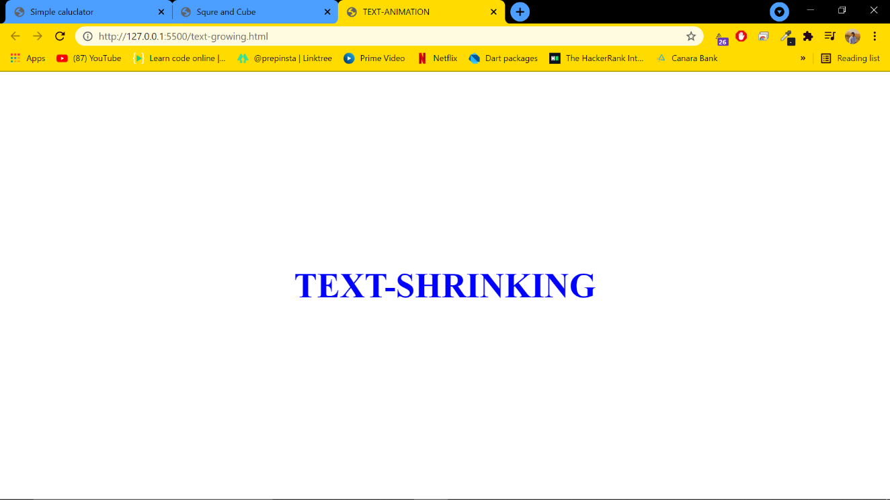

***4. Develop and demonstrate a HTML5 file that includes JavaScript script that uses functions for the following problems:***

***a. Parameter: A string***

***b. Output: The position in the string of the left-most vowel***

***c. Parameter: A number***

***d. Output: The number with its digits in the reverse order***

**Code:**

<!DOCTYPE html>

<html lang="en">

<head>

    <meta charset="UTF-8">

    <meta http-equiv="X-UA-Compatible" content="IE=edge">

    <meta name="viewport" content="width=device-width, initial-scale=1.0">

    <title>Palindrome</title>

    <link rel="stylesheet" href="https://stackpath.bootstrapcdn.com/bootstrap/4.1.3/css/bootstrap.min.css"

        integrity="sha384-MCw98/SFnGE8fJT3GXwEOngsV7Zt27NXFoaoApmYm81iuXoPkFOJwJ8ERdknLPMO" crossorigin="anonymous">

</head>

<body style="background-color: #99738E;">

    <br><br>

    <div class="container">

        <div class="input-group mb-3">

            <input type="text" class="form-control" placeholder="String/Number" aria-label="Recipient's username"

                aria-describedby="button-addon2" id="text-ele">

            <div class="input-group-append">

                <button class="btn btn-warning" type="button" id="button-addon2" onclick="evalu()">Submit</button>

            </div>

        </div>

        <div class="answer-div">

            <h1 class="answer" id="print-answer"></h1>

        </div>

    </div>

    <script>

        function evalu() {

            let inp = document.getElementById("text-ele").value;

            let z = parseInt(inp);

            let rev = 0;

            if (inp.length === 0) {

                alert("String/Number cannot be null ")

            } else {

                if (z) {

                    rev = inp.split("").reverse().join("")

                    document.getElementById("print-answer").innerHTML =

                        "Reverse of number is : " + rev;

                }

                else {

                    let ans = inp.search(/[aeiouAEIOU]/)

                    document.getElementById("print-answer").innerHTML =

                        "First vowel is found at position :" + (ans + 1);

                    console.log(ans + 1)

                }

            }

        }

    </script>

    <script src="https://code.jquery.com/jquery-3.3.1.slim.min.js"

        integrity="sha384-q8i/X+965DzO0rT7abK41JStQIAqVgRVzpbzo5smXKp4YfRvH+8abtTE1Pi6jizo"

        crossorigin="anonymous"></script>

    <script src="https://cdnjs.cloudflare.com/ajax/libs/popper.js/1.14.3/umd/popper.min.js"

        integrity="sha384-ZMP7rVo3mIykV+2+9J3UJ46jBk0WLaUAdn689aCwoqbBJiSnjAK/l8WvCWPIPm49"

        crossorigin="anonymous"></script>

    <script src="https://stackpath.bootstrapcdn.com/bootstrap/4.1.3/js/bootstrap.min.js"

        integrity="sha384-ChfqqxuZUCnJSK3+MXmPNIyE6ZbWh2IMqE241rYiqJxyMiZ6OW/JmZQ5stwEULTy"

        crossorigin="anonymous"></script>

</body>

</html>

**Output:**

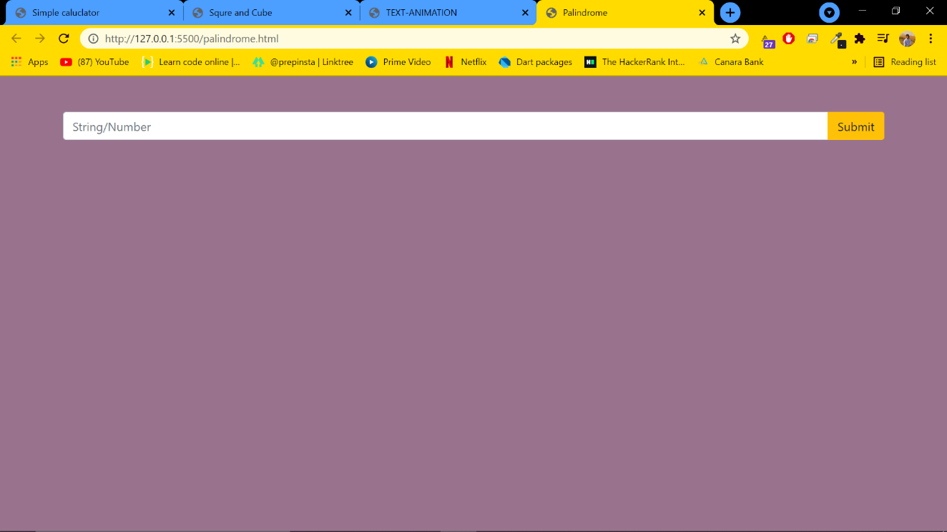

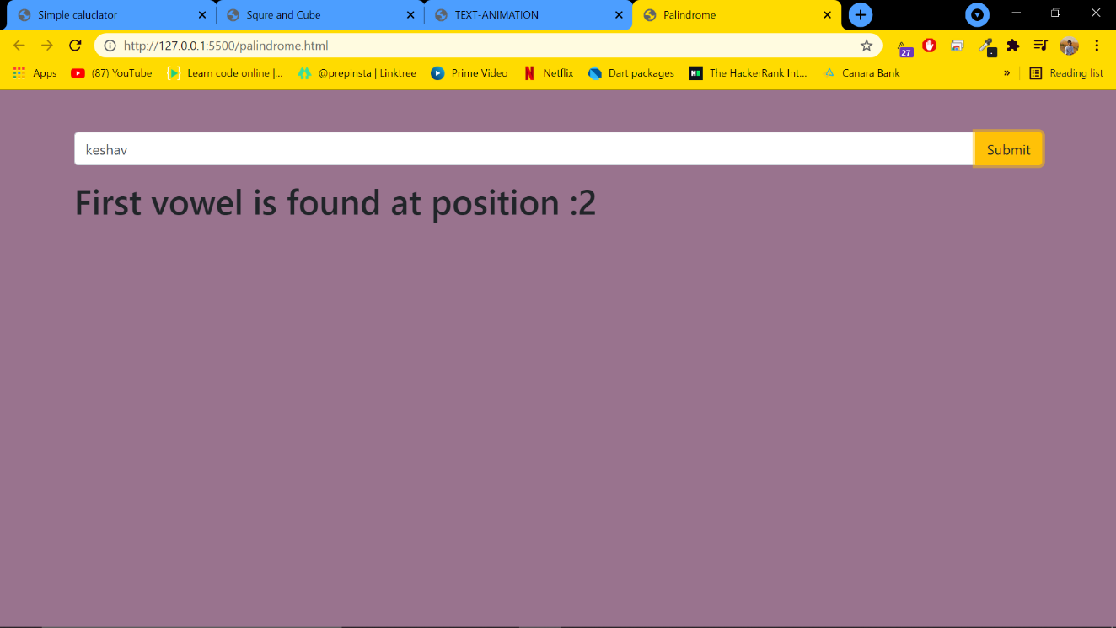

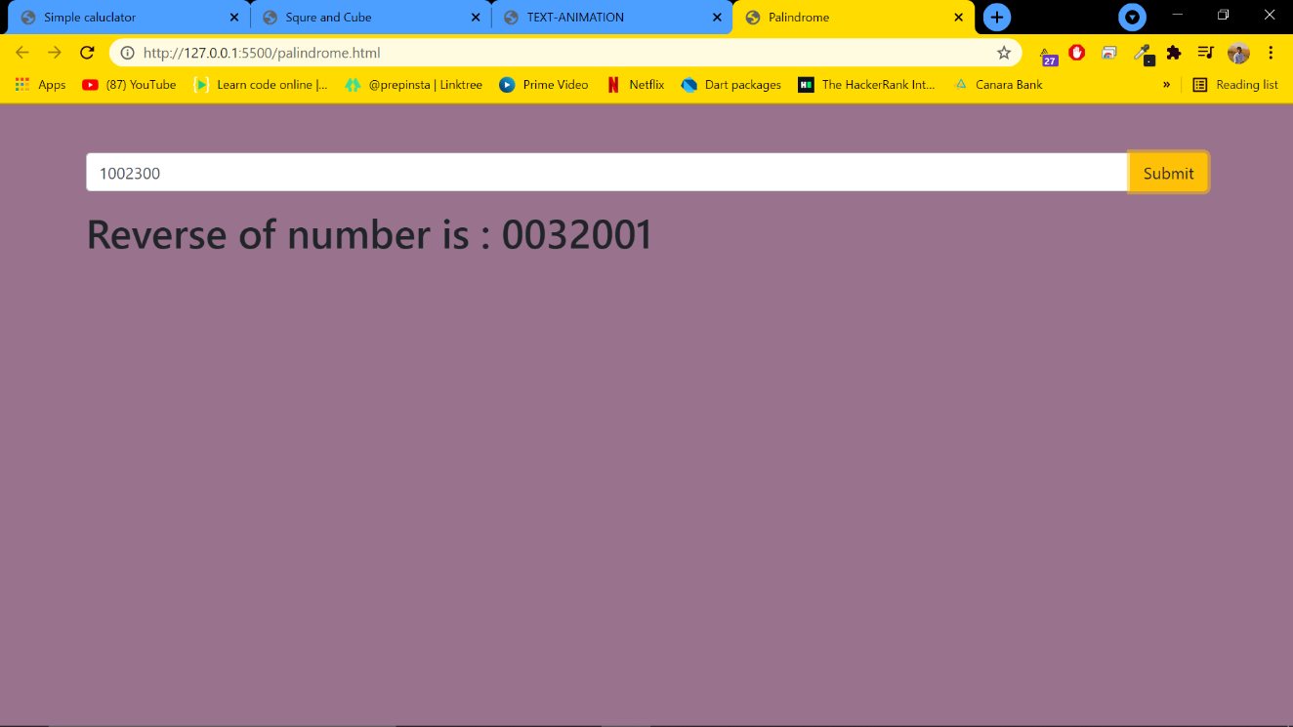

***5. Design an XML document to store information about a student in an engineering college affiliated to VTU. The information must include USN, Name, and Name of the College, Programme, Year of Joining, and email id. Make up sample data for 3 students. Create a CSS style sheet and use it to display the document.***

**Code:**

index.xml

<?xml version="1.0" encoding="UTF-8"?>

<?xml-stylesheet type="text/css" href="styles.css"?>

<STUDENTDATA>

    <STUDENT>

        <USN>USN   : 4CB18CS033</USN>

        <NAME>NAME : KESHAV R KARANTH</NAME>

        <COLLEGE>COLLEGE :CEC</COLLEGE>

        <BRANCH>BRANCH :CSE</BRANCH>

        <YEAR>YEAR : 2022</YEAR>

        <EMAIL>E-MAIL : keshavarkarantha@gmail.com</EMAIL>

    </STUDENT>

    <STUDENT>

        <USN>USN : 4CB18EC063</USN>

        <NAME>NAME : SHARAN </NAME>

        <COLLEGE>COLLEGE : CEC</COLLEGE>

        <BRANCH>BRANCH :ECE</BRANCH>

        <YEAR>YEAR : 2022</YEAR>

        <EMAIL>E-MAIL : sharanbillava@gmail.com</EMAIL>

    </STUDENT>

    <STUDENT>

        <USN>USN   : 4CB18CS077</USN>

        <NAME>NAME : SACHIN</NAME>

        <COLLEGE>COLLEGE : CEC</COLLEGE>

        <BRANCH>BRANCH :CSE</BRANCH>

        <YEAR>YEAR : 2022</YEAR>

        <EMAIL>E-MAIL : sachin@gmail.com</EMAIL>

    </STUDENT>

</STUDENTDATA>

styles.css

* {

    margin: 0;

    padding: 0;

    box-sizing: border-box;

    font-size: 100%;

}

STUDENTDATA{

    width: 100vw;

    height: 100vh;

    display: flex;

    flex-direction: row;

    flex-wrap: wrap;

}

STUDENT{

    width: 300px;

    height: 200px;

    padding: 30px;

    margin: 30px;

    display: flex;

    flex-direction: column;

    background-color: rgb(216, 213, 213);

    box-shadow: rgba(99, 99, 99, 0.2) 0px 2px 8px 0px;

    border-radius: 5px;

}

USN,NAME,COLLEGE,BRANCH,YEAR,EMAIL{

    margin-bottom: 5px;

    color: black;

    font-weight: 500;

}

**Output:**

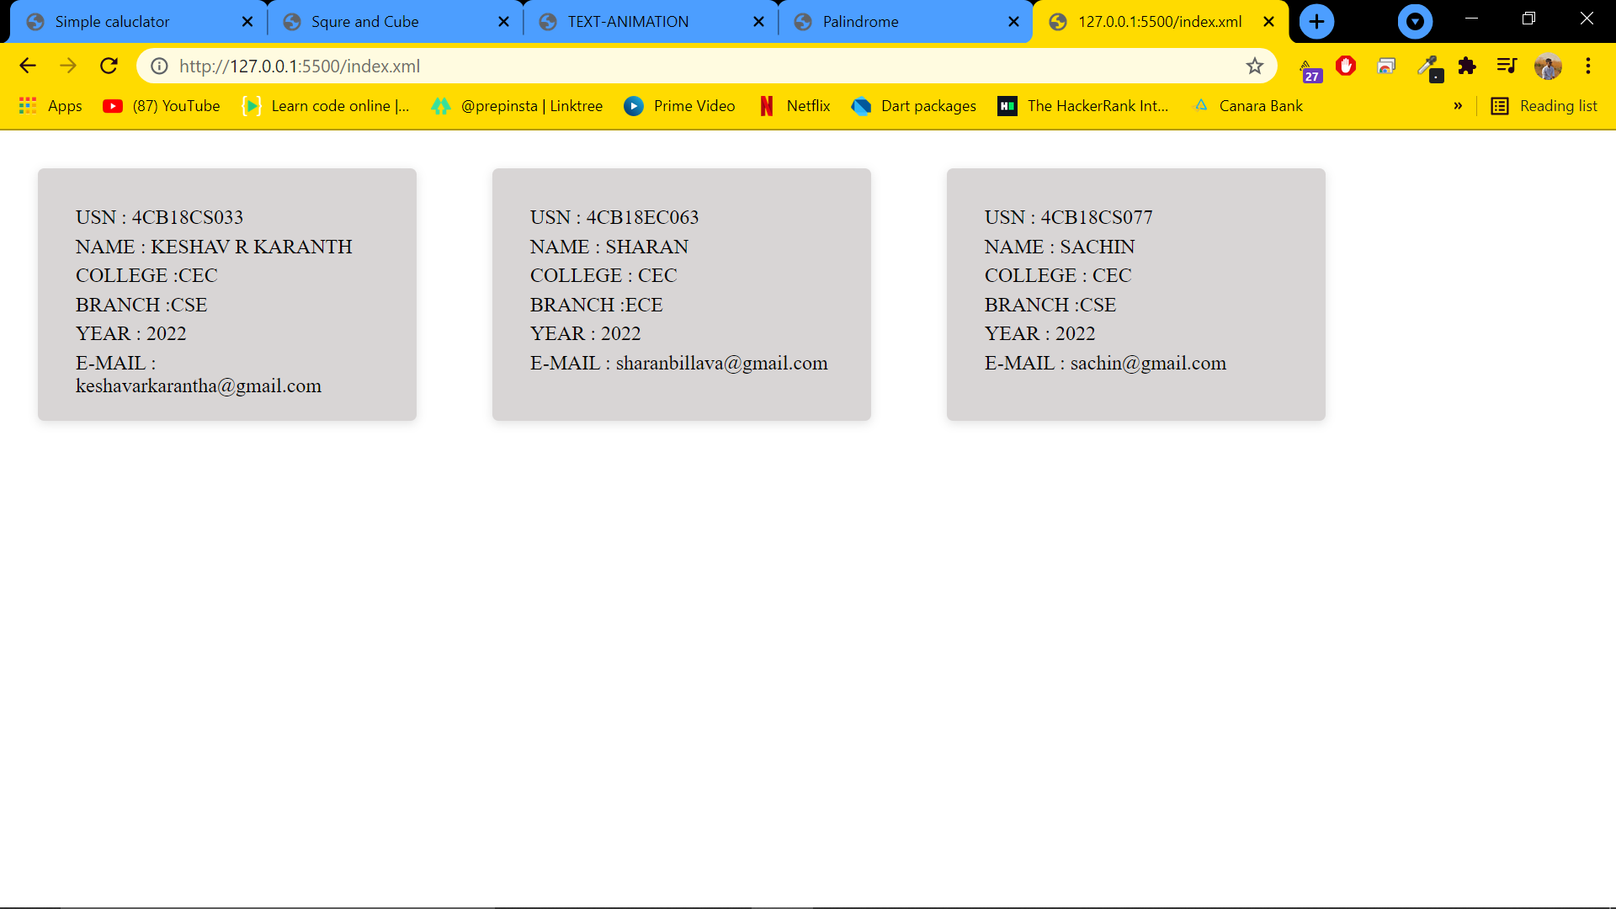

***6. Write a PHP program to keep track of the number of visitors visiting the web page and to display this count of visitors, with proper headings***

**Code:**

<!DOCTYPE html>

    <head>

        <title> Counter</title>

    </head>

    <style>

        body{

            background-color:#d1edf2;

            text-align:center;

        }

        h1{

            color:maroon;

        }

        p{

        }

    </style>

    <body>

<?php

    $handle = fopen("count.txt", "r");

    if(!$handle) {

        echo "could not open file";

    }

    else  {

        $cnt = fgets($handle);

        fclose($handle);

        $cnt += 1;

        echo "<h1> You are visitor no $cnt </h1>";

        echo "<p> Refresh page </p>";

        $handle = fopen("count.txt", "w");

        fwrite($handle, $cnt);

        fclose($handle);

    }

?>

</body>

</html>

**Output:**

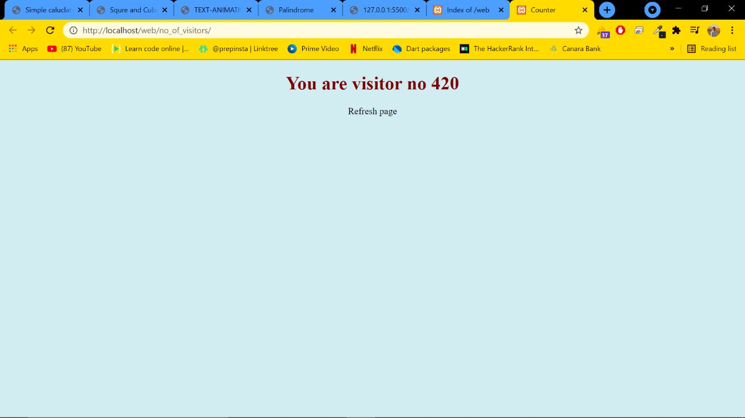

***7. Write a PHP program to display a digital clock which displays the current time of the server.***

**Code:**

7.php

<!DOCTYPE html>

<html>

<head>

<meta charset="UTF-8">

<meta http-equiv="refresh" content="1">

<title>Digital clock</title>

</head>

<body>

<center>

<h1>Display Current Date & Time</h1>

<h2>

<?php

echo "The time from the server is <span style='color:tomato';> " . date("h:i:sa")."

</span>";

echo '<br />';

echo "Today's Date is <span style='color:tomato';>" . date("d-m-Y");

date_default_timezone_set('Asia/Kolkata');

echo " </span> and Current Time is <span style='color:red';>" . date("h:i:s a") .

"</span>";

?>

</h2>

</center>

</body>

</html>

**Output:**

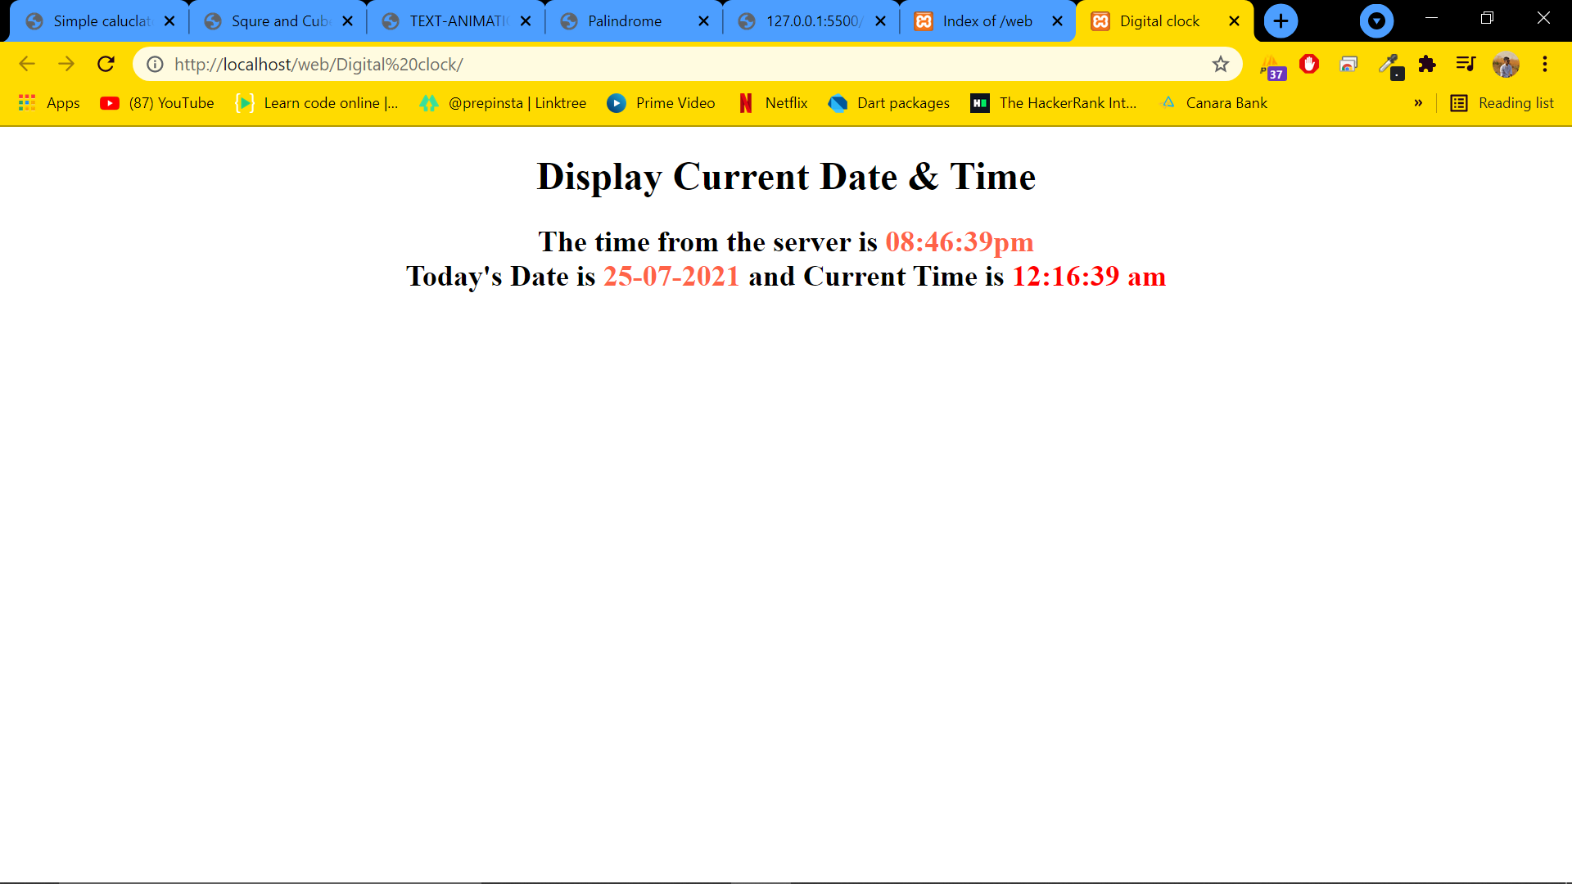

***8. Write the PHP programs to do the following:***

***a. Implement simple calculator operations.***

**Code:**

<!DOCTYPE html>

<html>

<head>

<meta charset="UTF-8">

<title>Simple caluclator</title>

<!-- CSS only -->

<link href="https://cdn.jsdelivr.net/npm/bootstrap@5.0.2/dist/css/bootstrap.min.css" rel="stylesheet" integrity="sha384-EVSTQN3/azprG1Anm3QDgpJLIm9Nao0Yz1ztcQTwFspd3yD65VohhpuuCOmLASjC" crossorigin="anonymous">

</head>

<body>

<div class="container">

<h1>Simple Calculator Using PHP</h1>

<form action="index.php" method="post">

<table>

<tr><td>Enter First Number: </td><td><input type="text" name="first" required

autocomplete="off"/></td></tr>

<tr><td>Enter Second Number: </td><td><input type="text" name="second"

required

autocomplete="off"/></td></tr>

<tr><td>Select Operator: </td><td>

<select name="op">

<option>Select Operation</option>

<option value="+">Addition</option>

<option value="-">Subtraction</option>

<option value="*">Multiplication</option>

<option value="/">Division</option>

<option value="%">Remainder</option>

</select>

</td></tr>

<tr><td colspan="2"><input type="submit" name="pop" value="Perform

Operation"/></td></tr>

</table>

</form>

<?php

if(isset($_POST['pop'])) {

echo "<h1>Result is: </h1>";

$num1 = $_POST["first"];

$num2 = $_POST["second"];

$op = $_POST["op"];

$result = 0;

switch($op) {

case '+' : $result = $num1 + $num2;

echo "<h1>Addition of two Numbers: " . $result . "</h1>";

break;

case '-' : $result = $num1 - $numtwo;

echo "<h1>Subtraction of two Numbers: " . $result . "</h1>";

break;

case '*' : $result = $num1 * $num2;

echo "<h1>Product of two Numbers: " . $result . "</h1>";

break;

case '/' : $result = $num1 / $num2;

echo "<h1>Division of two Numbers: " . $result . "</h1>";

break;

case '%' : $result = $num1 % $num2;

echo "<h1>Remainder of two Numbers: " . $result . "</h1>";

break;

default : echo "<h1 style='color:red;'>Sorry, No Operation Found</h1>";

break;

}

}

?>

</div>

</body>

</html>

**Output:**

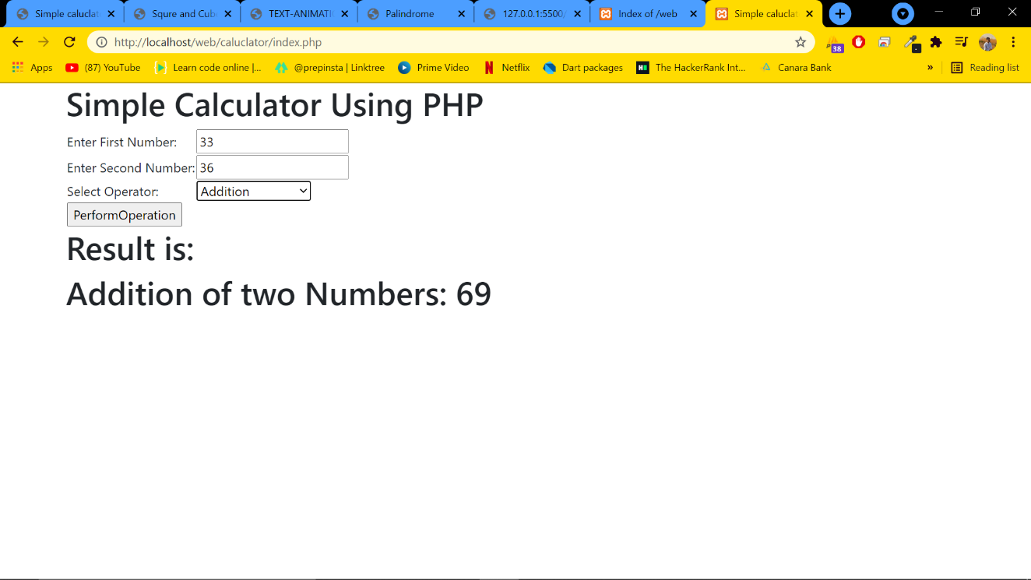

***8. Write the PHP programs to do the following:***

***b. Find the transpose of a matrix.***

***c. Multiplication of two matrices.***

***d. Addition of two matrices.***

**Code:**

<?php

header('Content-Type: text/plain'); //without this header "\t and \n" wont work

// transpose matrix

$matrix1 = array(array(1, 2), array(4, 5));

$matrix2 = array(array(1, 2), array(4, 5));

echo "\n\n\n";

echo "The order of the matrix A is:" . count($matrix1) . "x" . count($matrix1[0]);

echo "\n";

echo "The order of the matrix B is:" . count($matrix2) . "x" . count($matrix2[0]);

echo "\n";

$rowCount = count($matrix1); //Provides the rowcount of matrix

$colCount = count($matrix1[0]); //Provides the column count of matrix

echo "The input matrix A is:\n";

for ($r = 0; $r < $rowCount; $r++) {

for ($c = 0; $c < $colCount; $c++) {

echo $matrix1[$r][$c] . " \t";

}

echo "\n";

}

echo "The input matrix B is:\n";

for ($r = 0; $r < $rowCount; $r++) {

for ($c = 0; $c < $colCount; $c++) {

echo $matrix2[$r][$c] . " \t";

}

echo "\n";

}

//The transpose of the matrix

echo "\nThe output Transpose of matrix is:\n";

for ($r = 0; $r < $colCount; $r++) {

for ($c = 0; $c < $rowCount; $c++) {

echo $matrix1[$c][$r] . " \t";

}

echo "\n";

}

$rowCount = count($matrix1); //Provides the rowcount of matrix

$colCount = count($matrix1[0]); //Provides the column count of matrix

$rowCount2 = count($matrix2);

$colCount2 = count($matrix2[0]);

//The sum of the matrix

echo "\nThe sum of matrix is:\n";

for ($r = 0; $r < $rowCount; $r++) {

for ($c = 0; $c < $colCount; $c++) {

$val = $matrix1[$r][$c] + $matrix2[$r][$c];

echo $val . "\t";

}

echo "\n";

}

$rowCount = count($matrix1); //Provides the rowcount of matrix

$colCount = count($matrix1[0]); //Provides the column count of matrix

$rowCount2 = count($matrix2);

$colCount2 = count($matrix2[0]);

//The Multiplication of the matrix

echo "\nThe Multiplication of matrix is:\n";

if($colCount == $rowCount2)

{

for($r = 0;$r < $rowCount;$r++)

{

for($c = 0;$c < $colCount;$c++)

{

$val = $matrix1[$r][$c] * $matrix2[$r][$c];

echo $val."\t";

}

echo "\n";

}

} else {

echo "The matrix multiplication is not possible.";

}

?>

**Output:**

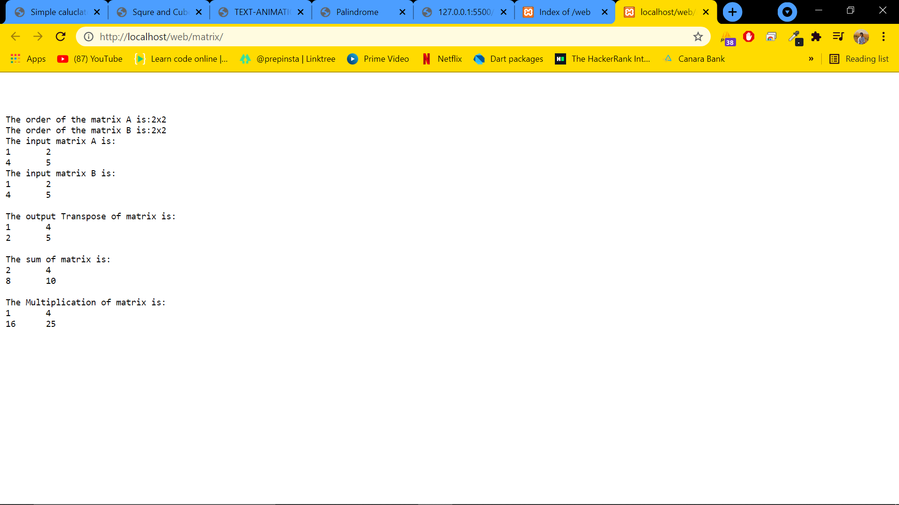

***9. Write a PHP program named states.py that declares a variable states with value "Mississippi Alabama Texas Massachusetts Kansas". write a PHP program that does the following:***

***a. Search for a word in variable states that ends in xas. Store this word in element 0 of a list named statesList.***

***b. Search for a word in states that begins with k and ends in s. Perform a case-insensitive comparison. [Note: Passing re.Ias a second parameter to method compile performs a case-insensitive comparison.] Store this word in element1 of statesList.***

***c. Search for a word in states that begins with M and ends in s. Store this word in element 2 of the list.***

***d. Search for a word in states that ends in a. Store this word in element 3 of the list.***

**Code:**

<?php

header('Content-Type: text/plain');

$allTheStates = "Mississippi Alabama Texas Massachusetts Kansas";

$statesArray = Array();

$states1 = explode(' ', $allTheStates);

$i = 0;

//states that ends in xas

foreach ($states1 as $state)

{

if (preg_match('/xas$/', ($state)))

{

$statesArray[$i] = ($state);

$i = $i + 1;

print "\nThe States that ends in xas:" . $state;

}

}

//states that begins with k and ends in s

foreach ($states1 as $state)

{

if (preg_match('/^k.*s$/i', ($state)))

{

    $statesArray[$i] = ($state);

$i = $i + 1;

echo "\nThe states that begins with k ans ends in s:" . $state;

}

}

//states that begins with M and ends in s

foreach($states1 as $state)

{

if (preg_match('/^M.*s$/', ($state)))

{

$statesArray[$i] = ($state);

$i = $i + 1;

echo "\nThe states that begins with M and ends in s:" . $state;

}

}

//states that ends in a

foreach($states1 as $state)

{

if (preg_match('/a$/', ($state)))

{

$statesArray[$i] = ($state);

$i = $i + 1;

echo "\nThe states that ends in a:" . $state;

}

}

foreach ($statesArray as $element => $value)

{

print( "\n" . $value . " is the element " . $element);

}

?>

**Output:**

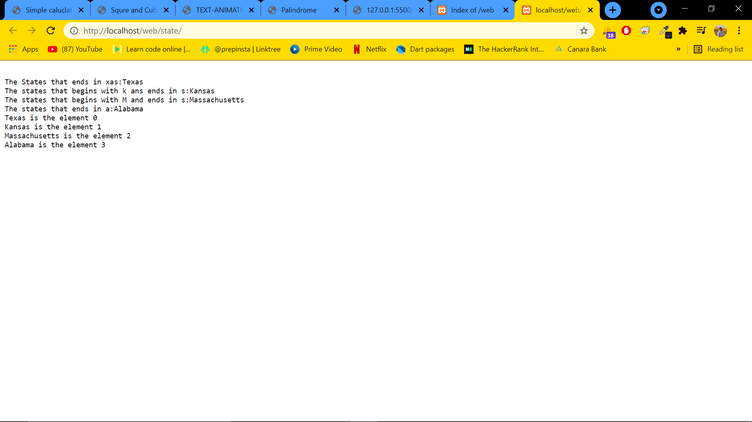

***10. Write a PHP program to sort the student records which are stored in the database using selection sort***

**Code:**

10.php

<html>

    <head>

        <title>Student DB</title>

    </head>

<body>

<style> table, td, th

{

border: 1px solid black; width: 33%;

text-align: center; border-collapse:collapse;

background-color:lightblue;

}

table { margin: auto; }

</style>

<?php

$servername = "localhost";

$username = "root";

$password = "";

$dbname = "weblab";

$a=[];

$conn = mysqli_connect($servername, $username, $password, $dbname);

if ($conn->connect_error)

die("Connection failed: " . $conn->connect_error);

$sql = "SELECT * FROM student";

$result = $conn->query($sql); echo "<br>";

echo "<center> BEFORE SORTING </center>"; echo "<table border='2'>";

echo "<tr>";

echo "<th>USN</th><th>NAME</th><th>Address</th></tr>";

if ($result->num_rows> 0)

{

while($row = $result->fetch_assoc()){

echo "<tr>";

echo "<td>". $row["usn"]."</td>";

echo "<td>". $row["name"]."</td>"; echo "<td>". $row["addr"]."</td></tr>"; array_push($a,$row["usn"]);

}

}

else

echo "Table is Empty"; echo "</table>";

$n=count($a);

$b=$a;

for ( $i = 0 ; $i< ($n - 1) ; $i++ )

{

$pos= $i;

for ( $j = $i + 1 ; $j < $n ; $j++ ) { if ( $a[$pos] > $a[$j] )

$pos= $j;

}

if ( $pos!= $i ) {

$temp=$a[$i];

$a[$i] = $a[$pos];

$a[$pos] = $temp;

}

}

$c=[];

$d=[];

$result = $conn->query($sql);

if ($result->num_rows> 0)// output data of each row

{

while($row = $result->fetch_assoc()) { for($i=0;$i<$n;$i++) { if($row["usn"]== $a[$i]) {

$c[$i]=$row["name"];

$d[$i]=$row["addr"];

}

}

}

}

echo "<br>";

echo "<center> AFTER SORTING <center>"; echo "<table border='2'>";

echo "<tr>";

echo "<th>USN</th><th>NAME</th><th>Address</th></tr>"; for($i=0;$i<$n;$i++) {

echo "<tr>";

echo "<td>". $a[$i]."</td>";

echo "<td>". $c[$i]."</td>";

echo "<td>". $d[$i]."</td></tr>";

}

echo "</table>";

$conn->close();

?>

</body>

</html>

**Output:**

