1. Pattern prediction
   1. Did
      1. Trained computer vision pattern prediction model on forex dataset using inpredo. (The test showed it predicts only buy or sell for all data)
      2. Trained model again on inpredo’s sample dataset. (This test showed same result)
   2. To do
      1. Actually, inpredo is not finding specific patterns in stock.

It tried to find all stock price change.

This problem can be solved by limiting target patterns into a few, like bearish or bullish.

* + 1. The other problem in pattern prediction models is that it’s not providing sufficient information to decide when to buy.

It can only predict whether the price would go up or down, can’t predict how much it will go up or down.

1. Timeseries forecasting
   1. Did
      1. Trained deep learning models of lstm, grum, vanilla and its variant models (bidirectional, dual path, seq2seq), agents on google dataset to check its performance with the default dataset.
      2. Trained deep learning models and agents on ES dataset and check performance.
   2. To do
      1. Train models and check performance on the NQ and forex data
      2. Implement saving and loading of deep learning model and agent with tf session (This need should be considered again)
      3. Calculate exit parameter, maximum drawdown and other things (for this one, freelancing might be better option)

One thing to note is that time series forecasting models are not specific to pattern prediction.

This calls the inconsistent problems in prediction.

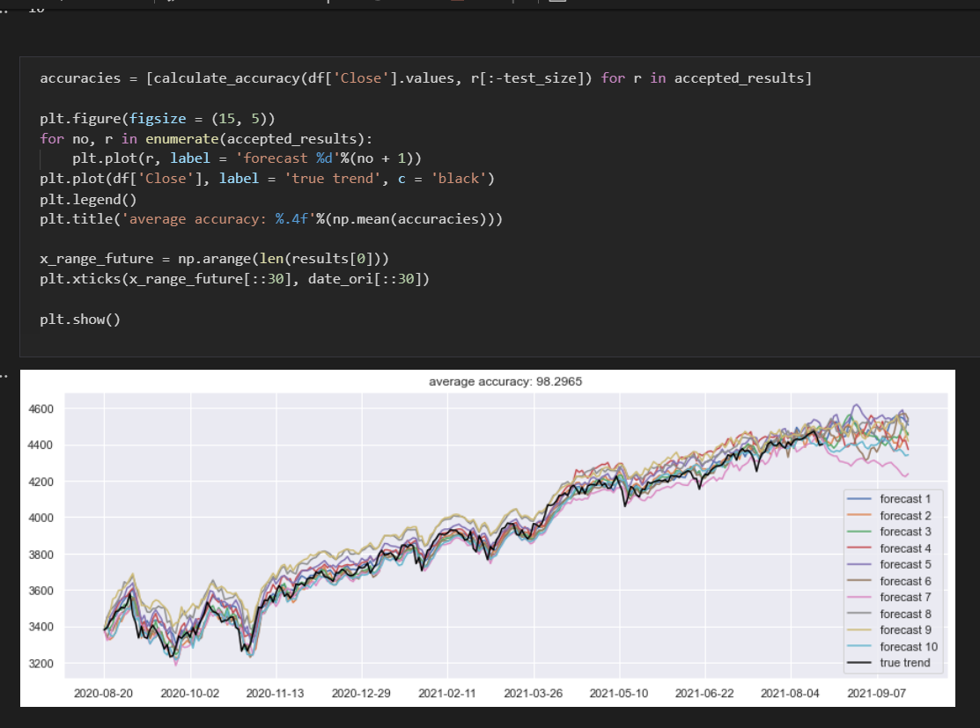

In above fig, the first 90% of data were used for training and 10% were used for validation, and it showed not much variant on test data.  
But for the following unknown time, variance of predicted values is high. (it accounts for there is no actual patterns in stock trend in fact)

In order to minimize the side effect, the model shouldn’t be used for more than 1 day prediction and should be updated every day. (Well, this is how the real time forecasting model are used and updated actually, and that’s why we should consider the need of ii again)