CARE TRANSITION EFFICIENCY AND PLACEMENT
OUTCOME ANALYTICS
A Process Efficiency and Outcome Evaluation of the
Unaccompanied Alien Children (UAC) Care Pipeline

Research Paper
Author: Keshav Sinha
Prepared for: U.S. Department of Health and Human Services
In Partnership with: Unified Mentor
Data Coverage Period: January 12, 2023 – December 21, 2025
June 2026

Table of Contents

Abstract 4
1. Introduction 7
1.1 Background and Context 7
1.2 Problem Statement 7
1.3 Project Objectives 8
2. Data and Methodology 9
2.1 Dataset Description 9
2.2 Care Pipeline Modelling 9
2.3 Derived Process Efficiency Metrics 9
2.3.1 Transfer Efficiency Ratio………………………………………………………….………9
2.3.2 Discharge Effectiveness Index……………………………………………………………10
2.3.3 Pipeline Throughput Rate…………………………………………………………………10
2.3.4 Backlog Accumulation Rate………………………………………………………………10
2.3.5 Outcome Stability Score …………………………………………………………………..10
2.4 Backlog, Stagnation, and Alert Detection ………………………………………………………….10
2.5 Temporal and Pattern Analysis .11
2.6 Analytical Tools ..11
3. Results 12
3.1 Overview of Key Performance Indicators 12
3.2 Transfer Efficiency 12
3.3 Discharge Effectiveness 13
3.4 Backlog Accumulation 13
3.5 Warning Alerts and Stagnation 14
3.6 Outcome Stability 15
3.7 Weekday Versus Weekend Performance 15
3.8 Monthly and Seasonal Trends 15
3.9 Correlation Structure Among Pipeline Metrics 17
4. Discussion 18
4.1 Interpreting Backlog Concentration 18
4.2 The Late-Period Discharge Decline 18
4.3 Weekday/Weekend Parity as a Positive Operational Signal 18
4.4 Redundancy in Stability Metrics 19
4.5 Year-Over-Year Performance Evaluation...………………………………………………………..19
5. Limitations 19
5.1 Data Granularity and Scope 19
5.2 Data Quality Observation: Missing Saturday Records 19
5.3 Negative Backlog Values 19
5.4 Outlier Sensitivity in Ratio Metrics 19
5.5 Correlational, Not Causal, Findings 21
6. Streamlit Analytics Dashboard 22
6.1 Core Modules 22
6.2 User Capabilities 22
6.3 Page Structure 22
7. Recommendations 24
8. Conclusion 25
9. Future Research 26
9.1 Causal Analysis of the Late-Period Discharge Decline 26
9.2 Facility- and Region-Level Disaggregation 26
9.3 Sponsor-Side Process Modelling 26
9.4 Predictive Backlog and Stagnation Forecasting 26
9.5 Formal Causal Inference on Weekday/Weekend Parity 27
9.6 Dashboard Extension to Real-Time Data Ingestion 27
9.7 Long Term Performance Forecasting……………………………………………………………...27
References 28
Appendix A: Dataset Schema 29
Appendix B: KPI Formula Reference 30
Appendix C: Software and Tools 31
About the Author 32

Abstract
The Unaccompanied Alien Children (UAC) program manages a multi-stage humanitarian pipeline spanning apprehension and custody by U.S. Customs and Border Protection (CBP), transfer into care administered by the Department of Health and Human Services (HHS), and eventual discharge to a vetted sponsor. While aggregate population counts at each stage are routinely reported, process-level efficiency — how quickly and reliably children move between stages — has historically received far less structured analysis. This study reframes 720 days of daily operational data (January 12, 2023 to December 21, 2025) from a capacity-monitoring lens to a process-efficiency and outcome-evaluation lens. Five derived key performance indicators were constructed: Transfer Efficiency Ratio, Discharge Effectiveness Index, Pipeline Throughput Rate, Backlog Accumulation Rate, and Outcome Stability Score. Analysis reveals an average transfer efficiency of 0.69 (transfers per child in CBP custody), an average discharge effectiveness of 0.024, and a mean transfer backlog of approximately 43 children per day, with backlog peaking at 304 children on May 29, 2024. Approximately 24.3% of all observed days were flagged with an operational warning alert, and 21.5% of days fell within a stagnation period of five or more consecutive low-efficiency days. Weekday and weekend transfer efficiency were found to be statistically comparable (0.689 versus 0.700, a 1.6% difference), suggesting the pipeline does not suffer materially from weekend staffing constraints. Discharge effectiveness and HHS care load ratio exhibited a near-perfect inverse correlation (r = –1.00), while stagnation period length was strongly associated with both reduced transfer efficiency (r = –0.66) and reduced discharge effectiveness (r = –0.80). These findings are translated into an interactive nine-page Streamlit analytics dashboard intended to support real-time operational monitoring and policy-level decision-making aimed at reducing systemic delay and improving reunification timelines.
Keywords: unaccompanied alien children, care pipeline analytics, transfer efficiency, discharge effectiveness, backlog detection, process bottleneck analysis, humanitarian operations research

Executive Summary for Government Stakeholders
Purpose
The Unaccompanied Alien Children (UAC) Program functions as a multi-stage care and reunification pipeline that moves children from CBP custody to HHS care and ultimately to placement with approved sponsors. While existing reporting primarily focuses on custody counts and capacity utilization, limited attention has been given to evaluating the operational efficiency of these transitions. This study addresses that gap by developing process-based performance indicators to assess the effectiveness, stability, and reliability of the care transition system.

Key Findings
Analysis of three years of daily operational data (2023–2025) revealed several important trends across the care pipeline.
Transfer Efficiency, which measures the movement of children from CBP custody into HHS care, declined from an annual average of 0.83 in 2023 to 0.46 in 2025, indicating slower movement through the initial stages of the pipeline. Similarly, Discharge Effectiveness decreased from 0.033 in 2023 to 0.009 in 2025, reflecting a reduction in successful sponsor placement activity relative to the HHS care population.
The analysis identified increasing operational strain over time. Warning Days rose from 7 in 2023 to 156 in 2025, while Stagnation Days increased from 0 to 155 during the same period. These findings suggest that prolonged periods of reduced system performance became significantly more common in the later stages of the study period.
Backlog analysis revealed that operational bottlenecks were driven primarily by sustained imbalances between inflows and successful exits rather than isolated daily spikes. Periods of stagnation were consistently associated with lower transfer and discharge performance, indicating that prolonged inefficiencies may negatively affect overall system throughput.
A positive finding was the absence of meaningful differences between weekday and weekend operational performance. Transfer and discharge metrics remained relatively stable across the week, suggesting that current staffing and operational practices maintain continuity of service regardless of day type.

Operational Implications
The findings indicate that while the care transition system remained functional throughout the study period, several efficiency indicators deteriorated over time. Declining transfer and discharge performance, combined with increasing warning and stagnation periods, may contribute to longer reunification timelines and increased operational pressure on care facilities.
The Year-over-Year analysis further highlights the emergence of long-term risks that may not be visible through daily monitoring alone. Continuous KPI tracking is therefore essential for identifying developing bottlenecks before they significantly impact child welfare outcomes.

Recommendations
- Implement rolling backlog monitoring and automated alert systems to identify sustained operational strain earlier.
- Use stagnation-period detection as an early warning mechanism for management review and resource allocation decisions.
- Conduct further investigation into the factors contributing to declining discharge effectiveness and reduced sponsor placement throughput.
- Continue annual KPI-based performance reviews to support evidence-based operational planning and policy development.
- Expand future data collection efforts to include facility-level or regional information to improve the identification of localized bottlenecks.

Conclusion
This study demonstrates the value of evaluating the UAC system through a process-efficiency and outcome-oriented framework rather than a capacity-monitoring perspective alone. The accompanying analytics dashboard and research findings provide a practical foundation for monitoring operational performance, identifying bottlenecks, and supporting policies that improve reunification timelines and child welfare outcomes. Continued use of these analytical tools can strengthen decision-making and enhance the overall effectiveness of the care transition pipeline.

1. Introduction

1.1 Background and Context
The UAC program operates as a multi-stage care and reunification pipeline rather than a static healthcare or custodial system. Children enter the pipeline upon apprehension by CBP, are held in short-term CBP custody, transferred into longer-term HHS care for medical screening and case management, and ultimately discharged to a sponsor — typically a parent, relative, or vetted guardian — within the United States. From a policy and humanitarian standpoint, the speed, continuity, and reliability of this pipeline carry consequences that are at least as significant as raw system capacity. Prolonged custody periods, particularly in CBP facilities not designed for extended child residency, have been widely documented as a source of child welfare risk, while delays in HHS discharge processing extend family separation and strain shelter capacity.
Despite the operational importance of pipeline speed, public and institutional monitoring of the UAC system has historically emphasized point-in-time population counts — how many children are currently in CBP custody, how many are in HHS care — over process-level efficiency metrics that describe how effectively children move between these states. This asymmetry leaves systemic bottlenecks, backlog accumulation, and outcome instability largely invisible until they manifest as capacity crises.

1.2 Problem Statement
While aggregate counts of children in custody are monitored on an ongoing basis, process efficiency metrics describing the movement of children through the pipeline are largely absent from standard reporting. This creates several unanswered operational questions that this study seeks to address:
- How efficiently are children transferred from CBP custody into HHS care?
- Are HHS discharges keeping pace with the rate of inflow from CBP?
- When and where in the timeline do care backlogs accumulate, and how severe do they become?
- Are placement and reunification outcomes improving, deteriorating, or remaining stable over time?
Without structured transition analytics built specifically to answer these questions, bottlenecks within the system remain hidden from policymakers and operational managers until backlog and capacity strain become acute.

1.3 Project Objectives

Primary Objectives
- Measure the efficiency of CBP → HHS transitions using a standardized, repeatable ratio metric.
- Evaluate discharge and sponsor placement outcomes through a discharge effectiveness index.
- Identify delays and process bottlenecks through backlog and stagnation detection.

Secondary Objectives
- Support faster reunification timelines for children and families.
- Improve case management workflows through visibility into process-level performance.
- Inform policy-level process reforms with data-driven, reproducible evidence.

Document Information
Dataset | HHS UAC Program Daily Reporting Dataset
Date Range | January 12, 2023 – December 21, 2025
Total Records Analyzed | 720 valid daily records
KPIs Engineered | 5 derived process efficiency metrics
Analysis Type | Longitudinal time-series, bottleneck detection, temporal pattern analysis
Document Type | Academic Research Paper — Full Report

2. Data and Methodology

2.1 Dataset Description
The dataset consists of 720 daily observations spanning January 12, 2023 through December 21, 2025, covering the core operational counts of the UAC pipeline. Each row represents a single reporting day. Table 1 summarizes the raw fields used as the foundation for all derived metrics.
Column | Description
Date | Reporting date for the daily observation
Children apprehended and placed in CBP custody | Daily intake volume into CBP custody
Children in CBP custody | Active CBP care load (point-in-time population)
Children transferred out of CBP custody | Daily flow of children moving into the HHS system
Children in HHS Care | Active HHS care load (point-in-time population)
Children discharged from HHS Care | Daily count of successful sponsor placements
Table 1. Raw dataset fields used as inputs to derived process metrics.

2.2 Care Pipeline Modelling
The UAC system was modelled as a sequential flow pipeline with three principal stages: CBP custody, HHS care, and sponsor placement. Daily movements between these stages — apprehension, transfer, and discharge — were tracked as flow variables, while custody and care populations were tracked as stock variables. This stock-and-flow framing allows efficiency and backlog metrics to be computed consistently across the full observation period.

2.3 Derived Process Efficiency Metrics
Five process-level metrics were derived from the raw flow and stock variables to translate point-in-time counts into operationally meaningful indicators of speed, throughput, and stability.

2.3.1 Transfer Efficiency Ratio
Defined as the ratio of children transferred out of CBP custody to children held in CBP custody on a given day:
Transfer Efficiency = Children Transferred ÷ Children in CBP Custody
Higher values indicate that a larger share of the CBP custody population is being moved into HHS care each day, implying faster transitions and lower temporary custody burden.

2.3.2 Discharge Effectiveness Index
Defined as the ratio of children discharged from HHS care to children actively in HHS care:
Discharge Effectiveness = Children Discharged ÷ Children in HHS Care
This index captures successful sponsor placement performance relative to the active HHS care population, serving as a proxy for reunification throughput.

2.3.3 Pipeline Throughput Rate
Defined as the ratio of total system exits to total system entries on a given day:
Pipeline Throughput = Total Exits ÷ Total Entries
A throughput value above 1.0 indicates the system discharged more children than it admitted on that day — a sign the pipeline is working down existing backlog. A value below 1.0 indicates inflow is outpacing outflow, contributing to growing system-wide strain.

2.3.4 Backlog Accumulation Rate
The Transfer Backlog metric quantifies the cumulative imbalance between children entering and successfully exiting the pipeline, capturing sustained periods where inflow outpaces processing capacity. Sustained positive backlog growth signals delay severity within the CBP → HHS transfer stage specifically.

2.3.5 Outcome Stability Score
Outcome stability was assessed using the standard deviation of Discharge Effectiveness alongside a rolling (smoothed) version of the same metric, Rolling Discharge Effectiveness, which dampens day-to-day noise while preserving medium-term trend shifts. Lower variability indicates more consistent, predictable placement outcomes; sudden or sustained departures from the rolling mean signal potential operational instability.

2.4 Backlog, Stagnation, and Alert Detection
Two auxiliary detection mechanisms were layered on top of the core efficiency metrics. First, a binary Alert flag (Normal / Warning) marks days where pipeline metrics breach operationally meaningful thresholds, providing a simple at-a-glance status indicator. Second, a Stagnation Period counter tracks the number of consecutive days in which Transfer Efficiency remains persistently low; periods of five or more consecutive low-efficiency days were classified as stagnation events, consistent with the threshold used throughout the accompanying dashboard.

2.5 Temporal and Pattern Analysis
To assess whether pipeline performance varies systematically by time, three temporal analyses were conducted: a weekday-versus-weekend comparison of Transfer Efficiency to detect staffing-related slowdowns, a day-of-week breakdown to identify which specific days underperform, and a month-over-month aggregation of discharge volume to detect seasonal patterns and longer-term shifts in placement throughput.

2.6 Analytical Tools
All data processing and metric derivation was performed in Python using pandas for data manipulation and NumPy for numerical operations. Visualization was implemented using both Matplotlib (for this paper's static figures) and Plotly (for the interactive Streamlit dashboard described in Section 6). The complete interactive dashboard was built using the Streamlit framework, enabling real-time date-range filtering and live re-computation of all KPIs and visualizations.

3. Results

3.1 Overview of Key Performance Indicators
Table 2 summarizes the five core KPIs computed across the full 720-day observation period. These figures form the quantitative basis for the findings discussed in the remainder of this section.
KPI | Mean | Median | Std. Dev. | Range
Transfer Efficiency | 0.691 | 0.704 | 0.310 | 0.000 – 2.300
Discharge Effectiveness | 0.024 | 0.026 | 0.013 | 0.000 – 0.066
Pipeline Throughput | 1.073 | 0.721 | 1.317 | 0.000 – 16.000
Transfer Backlog (children) | 42.8 | 28.0 | 51.8 | –73 – 304
HHS Care Load Ratio | 0.977 | 0.974 | 0.013 | 0.938 – 1.000
Table 2. Summary statistics for core pipeline KPIs across the full 720-day period.

3.2 Transfer Efficiency
Transfer Efficiency averaged 0.691 across the observation period, with a median of 0.704 and a standard deviation of 0.310, indicating moderate day-to-day variability. The metric ranged from a minimum of 0.000 (days with no transfers recorded) to a maximum of 2.300. Figure 1 shows the full daily trend alongside the period mean.
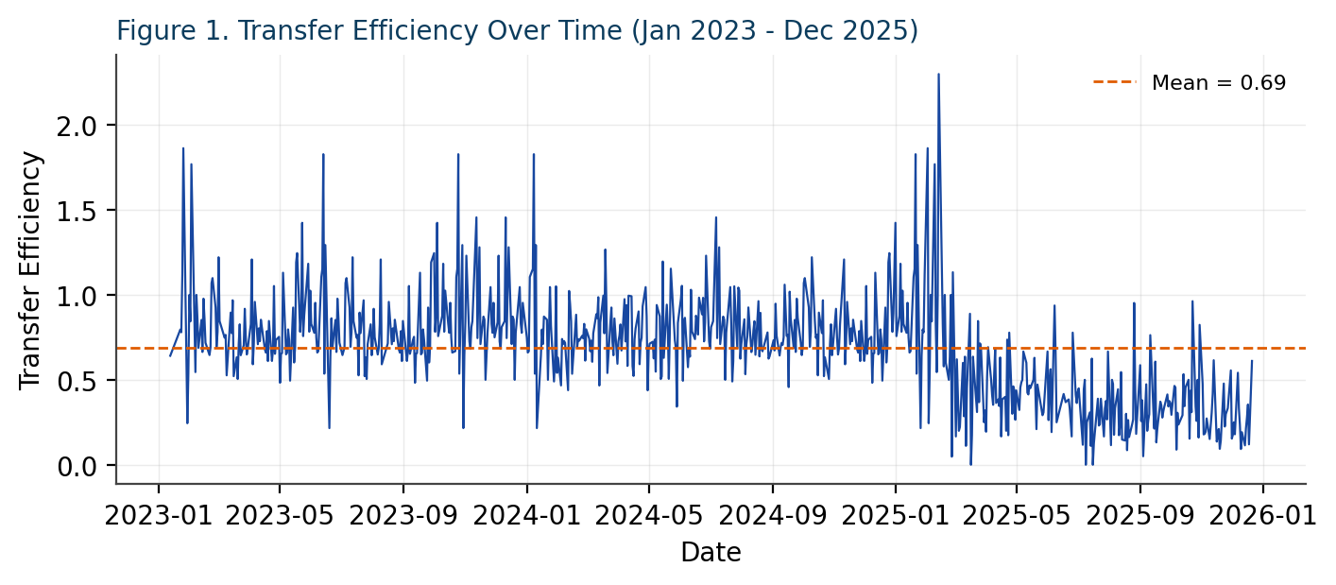
Figure 1. Transfer Efficiency over time, January 2023 – December 2025.
Visual inspection of Figure 1 shows no clear long-term upward or downward trend; rather, efficiency oscillates around the mean with periodic spikes, consistent with day-level operational variation rather than a structural shift in CBP-to-HHS transfer capacity.

3.3 Discharge Effectiveness
Discharge Effectiveness averaged 0.024 (median 0.026, standard deviation 0.013). Figure 3 presents the full distribution, which is approximately bimodal with a cluster of low-effectiveness days near zero and a broader cluster centered closer to the mean, suggesting two distinct operating regimes — periods of normal discharge processing and periods of discharge stoppage or severe slowdown.
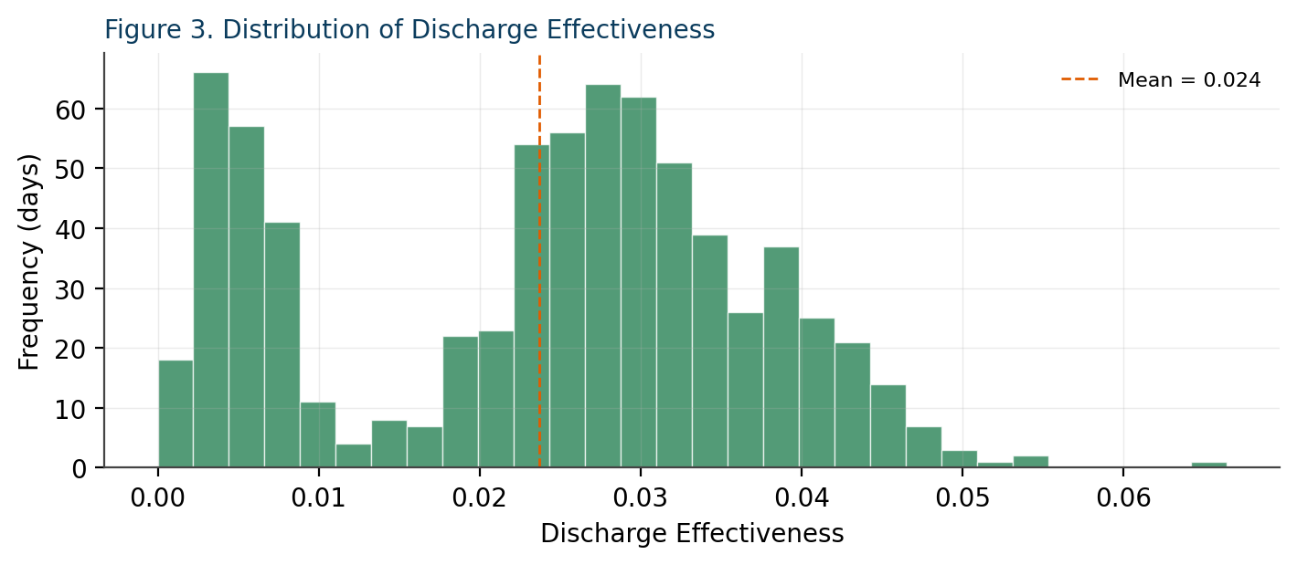
Figure 3. Distribution of Discharge Effectiveness across the observation period.

3.4 Backlog Accumulation
Transfer Backlog averaged 42.8 children per day (median 28.0), with substantial variability (standard deviation 51.8). The metric reached a period maximum of 304 children on May 29, 2024 — the single most severe backlog day in the dataset. Table 3 lists the five highest-backlog days observed.
Date | Transfer Backlog (children)
May 29, 2024 | 304
February 11, 2024 | 289
February 4, 2024 | 283
April 30, 2024 | 249
February 15, 2024 | 236
Table 3. Top five highest transfer backlog days in the observation period.
Notably, four of the five most severe backlog days cluster within the February–May 2024 window, suggesting a sustained period of system strain rather than isolated one-off events. Across the full dataset, 628 of 720 days (87.2%) recorded a positive backlog, while 86 days (12.0%) recorded a negative backlog — meaning more children exited the pipeline than entered it, indicating the system was actively working down prior accumulation. Figure 2 plots the full backlog trend.
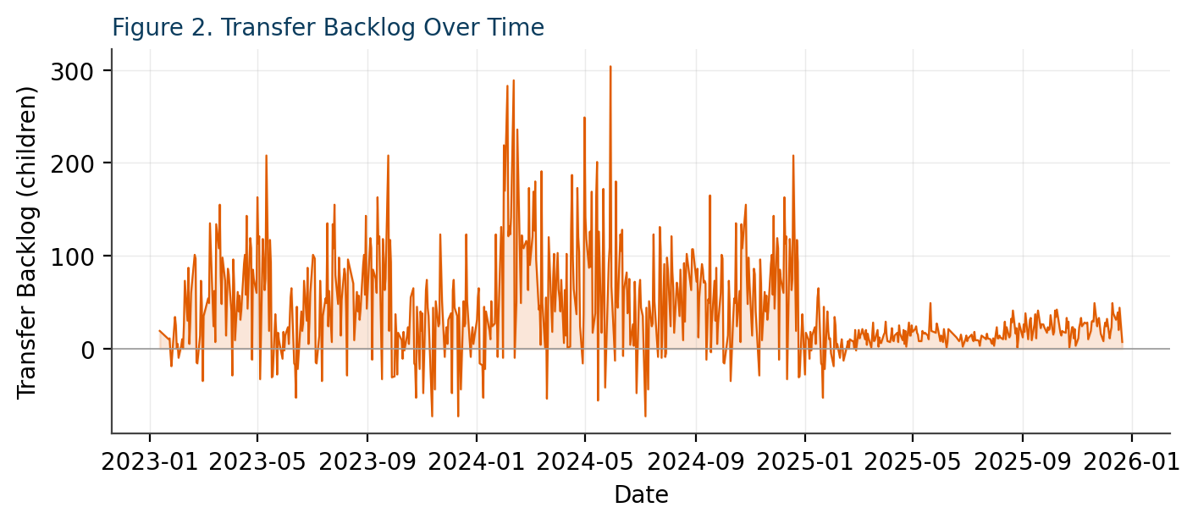
Figure 2. Transfer Backlog over time, showing the concentrated 2024 strain period.

3.5 Warning Alerts and Stagnation
Of the 720 total observation days, 175 (24.3%) were flagged with a Warning alert under the operational threshold criteria, while the remaining 545 days (75.7%) were classified as Normal. Separately, 155 days (21.5%) fell within a stagnation period of five or more consecutive low-efficiency days, with the longest single stagnation streak lasting 7 consecutive days. The average stagnation period length across all days was 1.69 days, indicating that while short dips in efficiency are common, sustained multi-day stagnation events of five-plus days remain a meaningful minority of total operating days. Figure 7 visualizes stagnation periods over time relative to the five-day threshold.
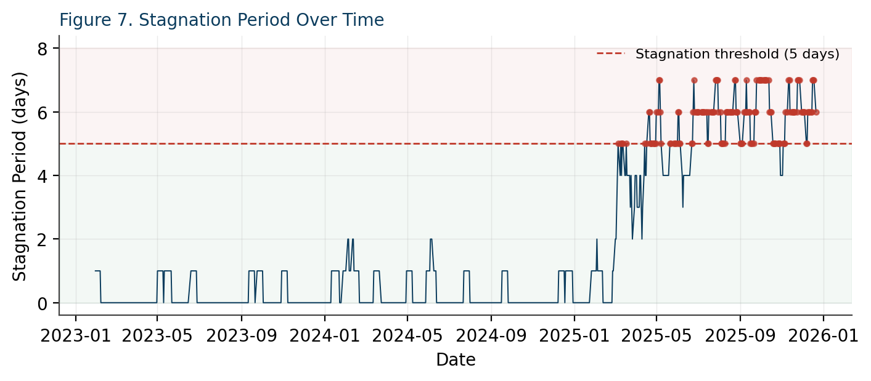
Figure 7. Stagnation Period over time, with detected stagnation days (5+ consecutive days) highlighted.

3.6 Outcome Stability
Rolling Discharge Effectiveness — a smoothed version of the raw discharge effectiveness metric — averaged 0.0238 with a standard deviation of 0.0119, slightly lower than the raw metric's standard deviation of 0.0133. This modest reduction in variability after smoothing suggests that a portion of the volatility in raw discharge effectiveness reflects short-term noise rather than persistent structural instability, though the underlying signal still exhibits meaningful drift over the period, as shown in Figure 6.

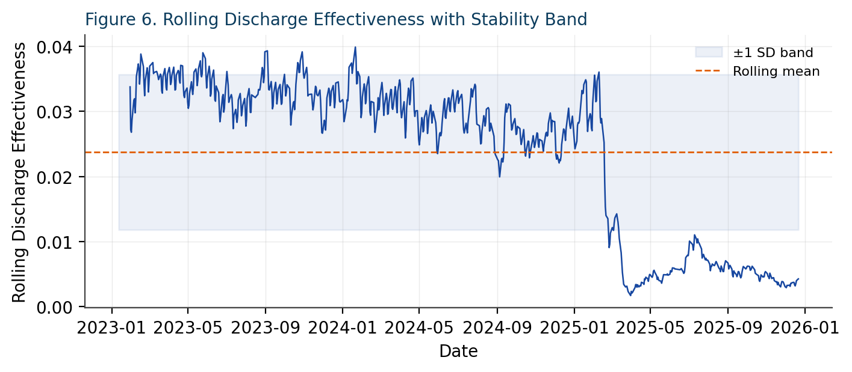
Figure 6. Rolling Discharge Effectiveness with a ±1 standard deviation stability band.

3.7 Weekday Versus Weekend Performance
Average Transfer Efficiency on weekdays was 0.689, compared to 0.700 on weekends — a difference of only 0.011 (1.6%), with weekend efficiency marginally higher rather than lower. This result runs counter to the common hypothesis that reduced weekend staffing slows CBP-to-HHS transfers; if anything, the data suggest the pipeline maintains operational consistency across the full week. Figure 4 breaks this comparison down further by individual day of week.
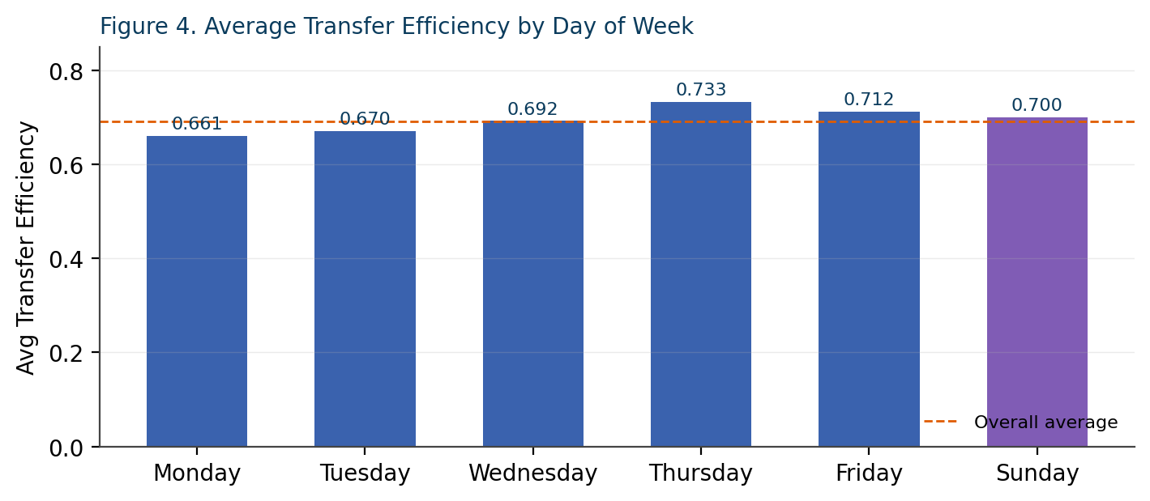
Figure 4. Average Transfer Efficiency by day of week.
Thursday recorded the highest average efficiency (0.733) among weekdays, while Monday recorded the lowest (0.661). It is noted as a data quality observation that no Saturday-dated records appear in the dataset; this gap is discussed further in Section 5.2 (Limitations).

3.8 Monthly and Seasonal Trends
Aggregating discharges by calendar month across all 36 months in the dataset reveals substantial month-over-month variation, with monthly discharge volume ranging from a low of 144 children (December 2025) to a peak of 7,658 children (October 2023), against an average of approximately 3,468 children discharged per month. Figure 5 shows the full monthly series.
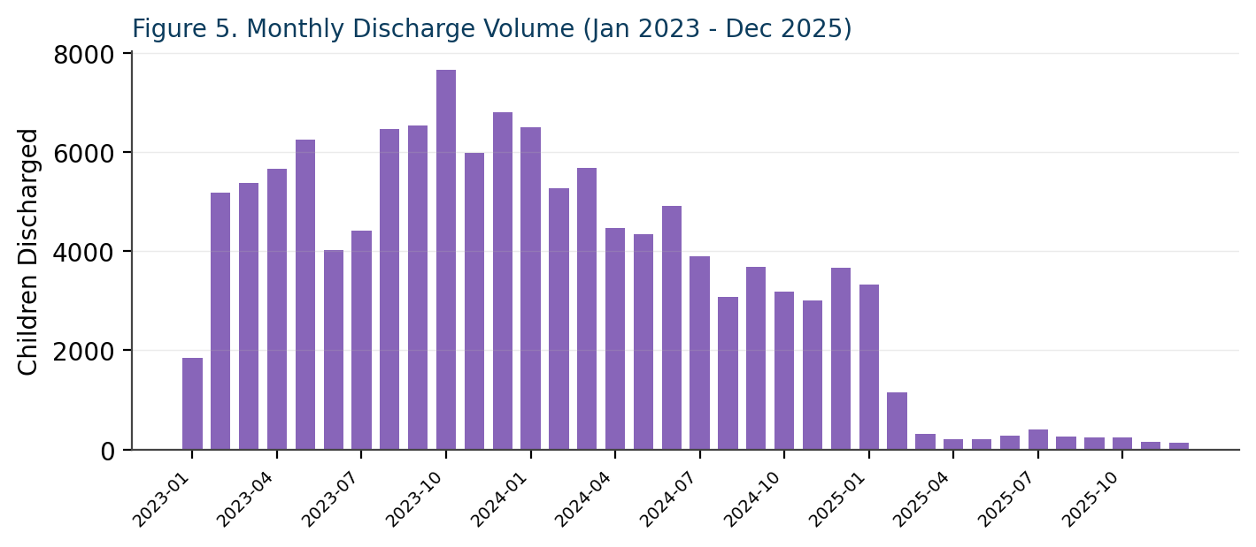
Figure 5. Monthly discharge volume, January 2023 – December 2025.
The pronounced decline in discharge volume across the final months of the observation window (mid-to-late 2025) is one of the most policy-relevant patterns in the dataset and is examined further in Section 4.

3.9 Correlation Structure Among Pipeline Metrics
To understand how the core KPIs relate to one another, a correlation matrix was computed across Transfer Efficiency, Discharge Effectiveness, Transfer Backlog, Pipeline Throughput, HHS Care Load Ratio, and Stagnation Period (Figure 8).
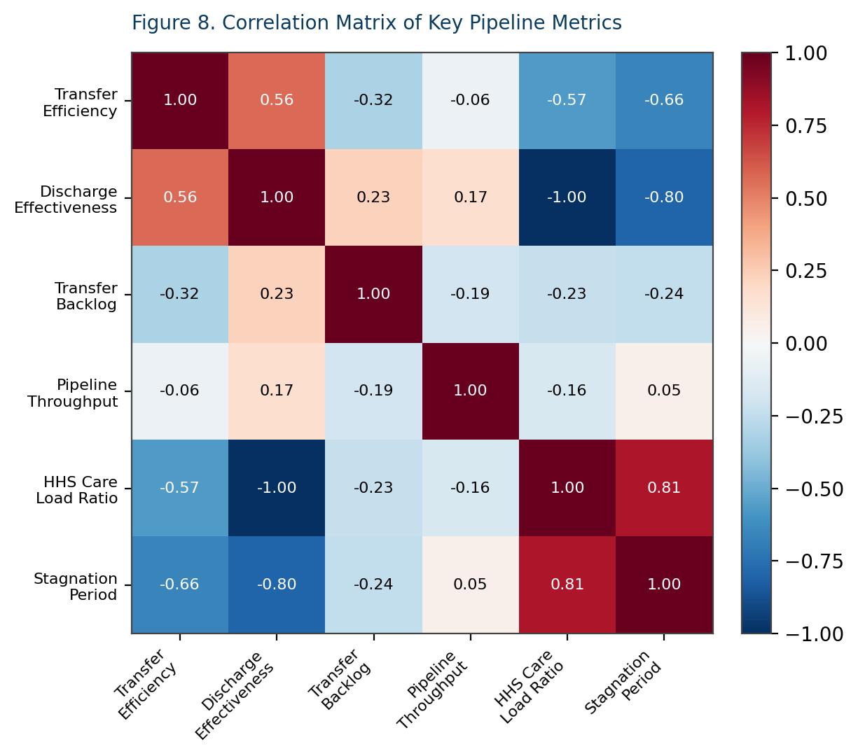
Figure 8. Correlation matrix of key pipeline metrics.
Three relationships stand out. First, Discharge Effectiveness and HHS Care Load Ratio show a near-perfect inverse correlation (r = –1.00), which follows directly from their shared denominator (HHS care population) and confirms the two metrics are mathematically complementary rather than independently informative. Second, Stagnation Period is strongly negatively correlated with both Transfer Efficiency (r = –0.66) and Discharge Effectiveness (r = –0.80), confirming that stagnation events are not isolated to one stage of the pipeline but reflect broader systemic slowdowns spanning both CBP transfer and HHS discharge. Third, Stagnation Period is strongly positively correlated with HHS Care Load Ratio (r = 0.81), reinforcing that stagnation coincides with a swollen, slow-clearing HHS care population.

4. Discussion

4.1 Interpreting Backlog Concentration
The concentration of the five most severe backlog days within a four-month window (February–May 2024) suggests that backlog accumulation in this system tends to behave as a sustained episode rather than a series of disconnected spikes. This has a direct operational implication: interventions designed around single-day anomaly detection are likely to under-respond to the kind of multi-week strain period that drives the most severe outcomes.
A monitoring approach that tracks rolling backlog trends — rather than only daily snapshots — is better suited to catching this pattern early, which is the rationale behind the rolling-metric and stability-band visualizations included in the accompanying dashboard.

4.2 The Late-Period Discharge Decline
The marked drop in monthly discharge volume toward the end of the observation period (2025) is the most consequential trend identified in this study from a policy standpoint. Because discharge volume is the system's primary humanitarian output — each discharge represents a child reunified with a sponsor — a sustained decline in this metric, even if accompanied by a correspondingly lower intake volume, warrants direct operational attention rather than being read as simply a function of lower overall system load. Disentangling whether this decline reflects reduced intake (a demand-side explanation) or reduced processing capacity (a supply-side explanation) is identified as a priority for the policy recommendations in Section 6.

4.3 Weekday/Weekend Parity as a Positive Operational Signal
The near-identical performance between weekdays and weekends (a 1.6% difference, with weekends marginally outperforming weekdays) is a notably positive finding. It suggests that, unlike many staffing-dependent administrative processes, the CBP-to-HHS transfer function does not suffer from a weekend staffing gap.
This finding should inform resource allocation discussions: it indicates that further efficiency gains are unlikely to come primarily from weekend-specific staffing interventions, and that other factors — such as intake volume spikes, sponsor vetting delays, or shelter capacity constraints — are more probable drivers of the backlog and stagnation patterns identified elsewhere in this study.

4.4 Redundancy in Stability Metrics
The near-perfect inverse correlation between Discharge Effectiveness and HHS Care Load Ratio (r = –1.00) indicates these two metrics carry largely overlapping information by construction. For future iterations of this analytics framework, it may be more efficient to retain only one of these two metrics as a primary KPI and treat the other as a derived or supporting diagnostic, reducing redundancy in dashboard reporting without losing analytical coverage.
4.5 Year-over-Year Performance Evaluation
A year-over-year comparison of operational metrics revealed a gradual deterioration in overall pipeline performance between 2023 and 2025. Transfer Efficiency declined from 0.83 in 2023 to 0.46 in 2025, while Discharge Effectiveness decreased from 0.033 to 0.009 during the same period. Warning Days increased substantially from 7 in 2023 to 156 in 2025, and Stagnation Days rose from zero to 155 days.
These findings suggest that operational strain became increasingly concentrated toward the later stages of the observation period. While backlog levels improved in 2025 relative to 2024, the simultaneous decline in transfer and discharge performance indicates that reduced throughput may have contributed to lower system activity rather than improved efficiency. The year-over-year analysis therefore provides an important long-term perspective that complements the daily and monthly analyses presented throughout this study.
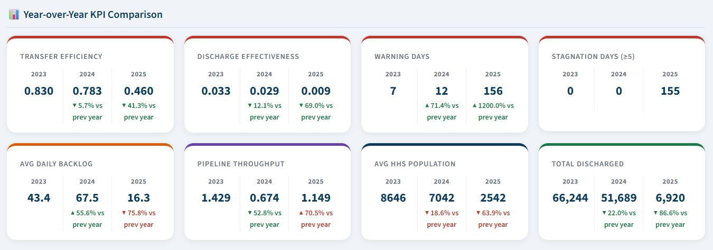
Fig 9. Year-over-Year KPI Comparison Dashboard showing annual performance trends across key operational indicators from 2023 to 2025.
Figure 9. illustrates annual changes in Transfer Efficiency, Discharge Effectiveness, Warning Days, Stagnation Days, Backlog, Pipeline Throughput, HHS Population, and Total Discharges across the study period.

5. Limitations

5.1 Data Granularity and Scope
This analysis is constrained to the six core daily fields provided in the cleaned dataset. It does not incorporate facility-level, regional, or individual-level data, which limits the ability to localize where in the geographic or organizational structure specific bottlenecks originate. Sponsor-side factors — such as vetting processing time or sponsor availability — are not separately observable in this dataset and can only be inferred indirectly through discharge effectiveness trends.

5.2 Data Quality Observation: Missing Saturday Records
During temporal analysis, it was observed that the dataset contains zero records with a Saturday day-of-week designation across the entire 720-day period. Given that the date range spans approximately three full years, this is highly unlikely to occur by chance and instead points to either a systematic reporting gap or a date-generation artifact upstream of the cleaned dataset. This finding does not invalidate the weekday/weekend comparison presented in Section 3.7, since Saturdays are still represented within the broader weekend grouping derived from day-of-week classification logic; however, it does mean that the day-of-week breakdown in Figure 4 should be read as six observed day-types rather than a complete seven-day week, and it is recommended that this be investigated and corrected in any future data collection cycle.

5.3 Negative Backlog Values
86 of 720 days (12.0%) recorded a negative Transfer Backlog value, with a minimum observed value of –73. While negative backlog is methodologically valid — representing days where exits exceeded entries — it does indicate that the backlog metric, as currently constructed, measures net daily flow imbalance rather than a strictly cumulative, non-negative queue length. Readers and future analysts should interpret backlog magnitude in this relative, flow-based sense rather than as an absolute count of children physically waiting in queue at any given moment.

5.4 Outlier Sensitivity in Ratio Metrics
Several ratio-based metrics, including Pipeline Throughput (maximum observed value of 16.0) and Transfer-to-Discharge Ratio (maximum observed value of 22.0), are highly sensitive to days with very low denominators, producing extreme outlier values that can distort simple mean-based summaries. All visualizations of these metrics in the accompanying dashboard and in this paper account for this by either capping the displayed range at a high percentile or by reporting the median alongside the mean.

5.5 Correlational, Not Causal, Findings
All relationships reported in Section 3.9 and discussed in Section 4 are correlational. This study does not employ a causal inference framework (e.g., difference-in-differences, instrumental variables, or controlled experimentation), and as such, findings such as the stagnation-to-discharge-effectiveness relationship should be interpreted as strong co-occurrence patterns warranting further investigation rather than established causal mechanisms.

6. Streamlit Analytics Dashboard
To translate the findings of this study into an operational monitoring tool, an interactive ten-page Streamlit web application was developed alongside this paper. The dashboard recomputes all KPIs live in response to a user-selected date range and is intended for use by case management staff, program administrators, and policy analysts.

6.1 Core Modules
- Care Pipeline Flow Visualization — a Sankey diagram and stage-by-stage flow summary of the CBP → HHS → sponsor placement pipeline.
- Transfer and Discharge Efficiency Panels — dedicated pages for Transfer Efficiency and Discharge Effectiveness, including trend lines, monthly breakdowns, distribution histograms, and the Transfer-to-Discharge Ratio.
- Bottleneck Detection Charts — backlog trend visualization and a ranked table of the highest-backlog periods.
- Outcome Trend Analysis — rolling discharge effectiveness with a stability band, and a dedicated stagnation detection page with alert-zone shading.
- Year-over-Year Performance Analysis — compares annual trends in key operational metrics to identify performance changes, emerging risks, and long-term pipeline efficiency patterns.

6.2 User Capabilities
- Date range selection, applied globally across the executive summary and trend panels.
- Visual threshold-based alerts, including a Normal/Warning donut chart breakdown and dynamic warning-day callouts.
- Dataset preview and full CSV export for downstream analysis.

6.3 Page Structure
Page | Primary Purpose
Executive Summary | High-level KPI overview, objectives, findings, and recommendations for stakeholders
Care Pipeline Overview | Stage-by-stage flow visualization, Sankey diagram, and throughput/load ratio analysis
Transfer Analytics | Transfer Efficiency trend, monthly breakdown, distribution, and transfer-to-discharge ratio
Discharge Analytics | Discharge Effectiveness trend, monthly discharge volume, and distribution analysis
Bottleneck Analysis | Transfer Backlog trend and ranked highest-backlog period detection
Stagnation Detection | Stagnation period trend with alert-zone shading and detected period table
Outcome Stability Analysis | Rolling discharge effectiveness, stability band, and distribution spread
Monthly Trends | Seasonal and month-over-month placement trend analysis
Weekday vs Weekend Analysis | Day-of-week and weekday/weekend efficiency comparison
Year over Year Analysis | Evaluate and compare annual performance (2023–2025) across key care pipeline metrics to identify trends, operational changes, and emerging risks.
Table 4. Structure of the ten-page Streamlit analytics dashboard.

7. Recommendations
Based on the findings of this study, the following recommendations are proposed for operational and policy stakeholders.
- Monitor backlog growth using rolling, multi-week windows rather than single-day snapshots, given that the most severe backlog episodes in this dataset clustered within sustained multi-month strain periods rather than isolated spikes.
- Investigate the demand-side versus supply-side drivers of the 2025 discharge volume decline before attributing it to reduced system load, given its direct impact on the humanitarian outcome the pipeline is designed to deliver.
- Maintain current weekend staffing levels rather than reallocating resources away from weekends, since this study found no evidence of weekend-driven efficiency loss in the CBP-to-HHS transfer stage.
- Use stagnation period alerts (five or more consecutive low-efficiency days) as an early warning trigger for operational review, given the strong correlation between stagnation length and reduced discharge effectiveness.
- Consolidate Discharge Effectiveness and HHS Care Load Ratio reporting in future dashboard iterations, given their near-perfect inverse correlation and resulting reporting redundancy.
- Correct the missing Saturday-record data quality issue identified in Section 5.2 in future data collection cycles to ensure complete day-of-week coverage.
- Extend the dataset with facility-level or regional granularity where feasible, to allow future analyses to localize the specific operational sources of backlog and stagnation identified at the aggregate level in this study.
- Institutionalize year-over-year performance reviews as part of routine operational governance, allowing decision-makers to track long-term trends, evaluate policy effectiveness, and support evidence-based process improvements.

8. Conclusion
This study reframed three years of UAC pipeline data from a capacity-monitoring lens to a process-efficiency and outcome-evaluation lens, deriving five operationally meaningful KPIs from six raw daily fields. The analysis found a system that, on average, transfers roughly seven in ten children out of CBP custody relative to its custody population each day, discharges children from HHS care at a modest but generally stable rate, and experiences backlog accumulation concentrated in sustained multi-month strain episodes rather than isolated incidents. Weekday and weekend performance were found to be operationally equivalent, challenging a common assumption about weekend-driven slowdowns, while stagnation periods of five or more days were shown to coincide with meaningfully reduced performance across both the transfer and discharge stages of the pipeline.
The accompanying ten-page Streamlit dashboard operationalizes these findings into a live monitoring tool capable of supporting day-to-day case management decisions as well as longer-term policy evaluation. Continued monitoring, the rolling-window backlog and stagnation alerting recommended in Section 7, and targeted investigation into the late-period discharge decline identified in Section 4.2 represent the most direct paths toward improving reunification timelines and strengthening child welfare outcomes within this system going forward.
The addition of a dedicated Year-over-Year Analysis further strengthened the evaluation framework by providing a long-term view of operational performance. Annual comparisons revealed declining transfer and discharge efficiency, increasing warning events, and the emergence of prolonged stagnation periods by 2025. These trends reinforce the importance of continuous performance monitoring and demonstrate the value of combining daily, monthly, and annual perspectives when assessing the effectiveness of complex care-transition systems.

9. Future Research
The findings and limitations identified in this study point toward several concrete directions for follow-on analytical and operational research. These are organized below by analytical depth, data expansion, and methodological rigor.

9.1 Causal Analysis of the Late-Period Discharge Decline
Section 4.2 identified a sustained decline in monthly discharge volume during the final months of the observation period but stopped short of attributing a cause, consistent with the correlational scope of this study (Section 5.5). A priority direction for future work is a quasi-experimental or causal inference approach — such as interrupted time-series analysis or a structural break test — applied jointly to intake volume and discharge volume, to determine whether the decline reflects reduced demand, reduced processing capacity, or a policy-driven shift in sponsor vetting requirements.

9.2 Facility- and Region-Level Disaggregation
As noted in Section 5.1, the current dataset is aggregated at the national daily level. Extending data collection to facility-level or regional granularity would allow future analyses to localize where, geographically and organizationally, backlog and stagnation events originate, enabling targeted rather than system-wide interventions.

9.3 Sponsor-Side Process Modelling
This study models the pipeline up to the point of discharge but does not separately observe sponsor-side factors such as vetting duration, home study completion time, or post-placement case follow-up. Incorporating sponsor-side process data, where available, would allow the Discharge Effectiveness Index to be decomposed into HHS-side processing speed versus sponsor-side approval speed, sharpening the diagnostic value of the metric.

9.4 Predictive Backlog and Stagnation Forecasting
The backlog and stagnation detection methods used in this study are retrospective, flagging strain only after it has occurred. A natural extension is the development of a short-horizon forecasting model — for example, using ARIMA, exponential smoothing, or a gradient-boosted regression on lagged intake and throughput features — to predict elevated backlog risk several days in advance, enabling proactive rather than reactive operational response.

9.5 Formal Causal Inference on Weekday/Weekend Parity
While Section 3.7 found no meaningful weekday/weekend efficiency gap in this dataset, this result was established through descriptive comparison rather than formal hypothesis testing. Future work should apply a two-sample statistical test (e.g., Welch's t-test or a non-parametric equivalent given the data's distributional properties) to confirm whether the observed 1.6% difference is statistically distinguishable from zero, and should extend the analysis to federal holidays and other non-standard operating days not captured by a simple weekday/weekend split.

9.6 Dashboard Extension to Real-Time Data Ingestion
The current Streamlit dashboard operates on a static, periodically refreshed CSV extract. A natural operational extension is connecting the dashboard to a live or near-real-time data pipeline (e.g., a scheduled ETL job feeding a managed database), which would allow the KPIs, alerts, and stagnation detection described in this paper to function as a genuine real-time operational monitoring tool rather than a retrospective analytical one.
9.7 Long-Term Performance Forecasting
The Year-over-Year Analysis introduced in this study highlighted substantial changes in operational performance across the observation period. Future work should extend these findings through multi-year forecasting models capable of predicting long-term trends in Transfer Efficiency, Discharge Effectiveness, Backlog Accumulation, and Placement Outcomes. Such forecasting could support strategic capacity planning and policy evaluation by identifying performance deterioration before it becomes operationally significant.

References
- U.S. Department of Health and Human Services, Administration for Children and Families, Office of Refugee Resettlement. Unaccompanied Children Program operational data.
- Unified Mentor. Care Transition Efficiency and Placement Outcome Analytics: Project Requirements and Methodology Guide.
- U.S. Government Accountability Office. Unaccompanied Children: Actions Needed to Improve Grant Application Reviews and Oversight of Care Facilities. GAO Report.
- U.S. Department of Health and Human Services, Office of Inspector General. Care Provider Facilities Described Challenges Addressing Mental Health Needs of Children in HHS Custody. OIG Report.
- Migration Policy Institute. Unaccompanied Children at the U.S.-Mexico Border: A Policy and Data Overview. MPI Issue Brief.
- Congressional Research Service. Unaccompanied Alien Children: An Overview. CRS Report for Congress.
- Little, R. J. A., and Rubin, D. B. Statistical Analysis with Missing Data. 3rd ed. Wiley, 2019.
- Hyndman, R. J., and Athanasopoulos, G. Forecasting: Principles and Practice. 3rd ed. OTexts, 2021.
- Box, G. E. P., Jenkins, G. M., Reinsel, G. C., and Ljung, G. M. Time Series Analysis: Forecasting and Control. 5th ed. Wiley, 2015.
- McKinney, W. Data Structures for Statistical Computing in Python. Proceedings of the 9th Python in Science Conference, 2010.
- Harris, C. R. et al. Array Programming with NumPy. Nature, vol. 585, 2020, pp. 357–362.
- Hunter, J. D. Matplotlib: A 2D Graphics Environment. Computing in Science & Engineering, vol. 9, no. 3, 2007, pp. 90–95.
- Streamlit Inc. Streamlit Documentation. https://docs.streamlit.io
- Plotly Technologies Inc. Plotly Python Open Source Graphing Library. https://plotly.com/python/
- Welch, B. L. The Generalization of ‘Student’s’ Problem When Several Different Population Variances Are Involved. Biometrika, vol. 34, no. 1/2, 1947, pp. 28–35.

Appendix A: Dataset Schema
The full derived dataset (cleaned_uac.csv) contains 720 rows and 21 columns, summarized below.
Field | Type | Description
Date | Date | Daily reporting date
Children apprehended and placed in CBP custody | Integer | Daily CBP intake
Children in CBP custody | Integer | Active CBP population
Children transferred out of CBP custody | Integer | Daily CBP → HHS transfers
Children in HHS Care | Integer | Active HHS population
Children discharged from HHS Care | Integer | Daily successful discharges
Transfer_Efficiency | Float | Transfers ÷ CBP custody population
Discharge_Effectiveness | Float | Discharges ÷ HHS care population
Transfer_to_Discharge_Ratio | Float | Transfers ÷ discharges
HHS_Care_Load_Ratio | Float | Relative HHS care population load
Pipeline_Throughput | Float | Total exits ÷ total entries
Transfer_Backlog | Integer | Net daily flow imbalance
Day_Type / Day_Name | Categorical | Weekday/Weekend flag and day name
Alert | Categorical | Normal / Warning operational flag
Rolling_Transfer_Efficiency | Float | Smoothed Transfer Efficiency
Rolling_Discharge_Effectiveness | Float | Smoothed Discharge Effectiveness
Stagnation_Flag / Stagnation_Period | Binary / Integer | Low-efficiency streak indicator and length
Table A1. Complete schema of the cleaned UAC dataset.

Appendix B: KPI Formula Reference
This appendix consolidates the formula, interpretation, and ideal direction for each of the five core KPIs derived and used throughout this study and the accompanying Streamlit dashboard, for quick reference.

KPI | Formula | Interpretation
Transfer Efficiency Ratio | Children Transferred ÷ Children in CBP Custody | Higher is better; reflects CBP → HHS transfer speed
Discharge Effectiveness Index | Children Discharged ÷ Children in HHS Care | Higher is better; reflects sponsor placement success
Pipeline Throughput Rate | Total Exits ÷ Total Entries | ≥1.0 indicates system clearing backlog; <1.0 indicates growing strain
Backlog Accumulation Rate | Net daily imbalance between inflow and successful exits | Lower (closer to zero or negative) is better; tracked cumulatively as Transfer_Backlog
Outcome Stability Score | Standard deviation of Discharge Effectiveness (raw and rolling) | Lower is better; reflects consistency of placement outcomes over time
Table B1. KPI formula and interpretation reference.

Two supporting diagnostic ratios were also derived from the same underlying fields and are surfaced in the Transfer Analytics dashboard page: the Transfer-to-Discharge Ratio (Transfers ÷ Discharges, where a ratio above 1.0 indicates more children entering HHS care than leaving it on a given day) and the HHS Care Load Ratio, which, as discussed in Section 4.4, is mathematically near-redundant with Discharge Effectiveness and is retained primarily as a corroborating signal rather than an independent KPI.

Appendix C: Software and Tools
All analysis, visualization, and dashboard development for this project were conducted using the open-source Python data science stack, summarized in Table C1.

Tool / Library | Version Class | Role in Project
Python | 3.x | Core programming language for all data processing and analysis
pandas | Data manipulation | Loading, cleaning, grouping, and aggregating the daily UAC dataset
NumPy | Numerical computing | Vectorized numerical operations underlying derived metric calculations
Matplotlib | Static visualization | Generation of all publication-quality figures embedded in this paper
Plotly (plotly.express / graph_objects) | Interactive visualization | All interactive charts within the Streamlit dashboard
Streamlit | Web application framework | Construction of the nine-page interactive analytics dashboard
python-docx / docx (Node.js) | Document generation | Programmatic generation of this research paper
Microsoft Word | Document rendering | Final rendering and editing of the research paper output
Table C1. Software and tools used in data processing, analysis, and reporting.

The complete Streamlit dashboard source code is organized into ten page modules (see Table 4, Section 6.3) plus a shared entry-point application, all reading from the single cleaned_uac.csv dataset described in Appendix A. No proprietary or licensed software was required to reproduce any analysis, figure, or KPI presented in this study.

About the Author
Keshav Sinha is an aspiring data analyst intern, and AI enthusiast with an interest in healthcare analytics and process optimization. This research paper and the accompanying ten-page Streamlit analytics dashboard were prepared as part of the Care Transition Efficiency and Placement Outcome Analytics project, undertaken in partnership with Unified Mentor for the U.S. Department of Health and Human Services. The work spans the full analytics lifecycle: data cleaning and KPI derivation, exploratory and statistical analysis, interactive dashboard development in Streamlit, and the synthesis of findings into this formal research paper.
The author's contribution to this project includes the design of the five core process-efficiency KPIs described in Section 2.3, the stagnation and backlog detection logic underlying Sections 2.4 and 3.4–3.5, the full implementation of the interactive dashboard summarized in Section 6, and the analysis, interpretation, and recommendations presented throughout this paper.

