CS520: Question 1

## Question 1

In the beginning, the likelihood of the drone’s position is equally spread across all non-blocked positions in the reactor. So, the probability of the drone being in the top left corner is 1/(# of ‘_’ spaces in the reactor) = 1/199

## Question 2

Upon issuing the ‘DOWN’ command, the likelihoods shift downwards. The spaces that are just below a blocked space or just below the out of bounds region have zero likelihood, while the spaces that have blocked spaces/the out of bounds region below them have double the prior probability.

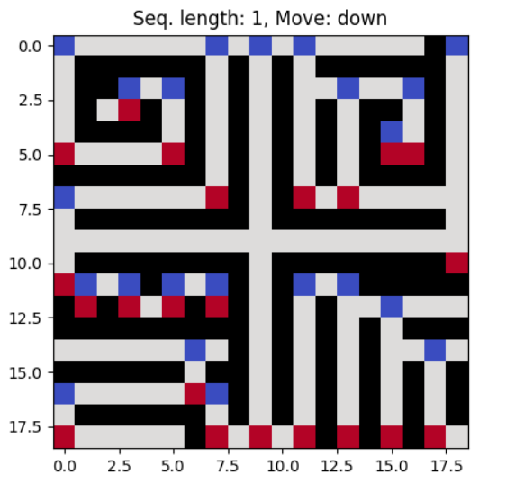

DOWN (Red is the highest probability, blue is zero probability)

Probability Matrix of the reactor

## Question 3

Design:

* The probabilities shift by moving in the specified direction.
* A sequence of commands can be generated by defining a heuristic to select the direction to choose.
* The selected heuristic is to take the next direction in the actual path between the first node of the lowest non-zero probability and the first node of the highest probability.

Implementation:

* The environment is made using the ‘Reactor’ class. Each node in the ‘Reactor' class is made of ‘Space’ objects.
* The probability of 1 is evenly spread across all 199 unblocked spaces.
* All non-zero probabilities are stored in a list.
* The first space of lowest (non-zero) probability and the first space of highest probability are considered. If they tie, then the next node in the list of probabilities is taken.
* The BFS path between the two is computed. The next node in the path determines the direction to take.
* Once the direction is picked, the probabilities are shifted in that direction.
* The process is repeated until the probabilities converge into 1 space with probability 1; we know for sure the drone exists in this node

Results:

* The probability converges in 219 commands.

Does this methodology find the shortest sequence of commands?

* No, it is not the most optimal solution. Since the used heuristic does not consider every possible state, it simply follows the BFS path between the found min and max probability spaces.
* On trialing with different heuristics, I believe that the implementation finds the shortest possible sequence.

## Question 4

The attempted implementation does not give the shortest possible sequence. Based on the implementation, I believe a reactor configuration that has many warped, spiraling blocks in different directions would make the sequence very long.