Private Network Service Platform — Project Report
Oct 5, 2026 · @Shivam
Course: Computer Networks, Course Project (two-phase, team-based local networking project) Team: team1 · private domain team1.test · Members: Keshav, Rohit, Sarvesh Environment: 4 × macOS laptops on one private Wi-Fi LAN, fully local, no cloud
Core principle: the application stays simple. The network is the project.

1. Project Purpose & Overview
We built a small private service environment from scratch on our own laptops, then observed how one request travels from a client to a server and back.
When the project is finished, a client Mac on the team LAN can:
- type https://app.team1.test into a browser or curl,
- resolve that name through our own DNS server (dnsmasq on Mac 1),
- open a secure HTTPS connection to our reverse proxy / load balancer (nginx on Mac 2),
- get a response from one of two backend servers (Mac 3 = A, Mac 4 = B),
- let us observe every step (DNS → TCP → TLS → HTTP) with dig, curl -v, tcpdump, and Wireshark.
Phase | Theme | Topics
Phase 1 | Build & Observe | DNS · HTTP(S) · TCP · TLS · Load Balancing · Packet Analysis
Phase 2 | Harden & Recover | Backup DNS · TTL · Service Isolation · HA Failover · DNS Cutover · Troubleshooting
Final | Explain & Defend | Live demo · Packet evidence · Individual viva

2. Learning Objectives
Objective | How the project meets it
Turn classroom theory into a working configuration | We configured and ran DNS (dnsmasq), TLS (OpenSSL CA + nginx), TCP services, and a load balancer ourselves.
Explain where each protocol fits in a real request | Section 4 maps each protocol to its OSI/TCP-IP layer and walks through one request end to end.
Prove behaviour with tools | Every task has a script that produces evidence: dig, curl -v/-I, tcpdump → Wireshark, nginx access logs.
Diagnose failures by isolating layers | scripts/diagnose.sh checks DNS → IP → TCP → TLS → HTTP in order and reports the first layer that fails.
Every member understands the whole system | Each Mac holds an identical copy of the repo. docs/viva-prep.md covers every component.

3. Constraints & Design Decisions
Constraint (from brief) | Our decision
≤ 4 students, ≤ 4 macOS laptops | 4 Macs, one network role each (Section 4).
Same private Wi-Fi / LAN | All Macs on one hotspot/router. Private Wi-Fi address = Fixed so MAC/IP stay stable.
No cloud | Everything runs locally. Cloud equivalents are explained, not used.
Admin access on DNS + edge | Homebrew installs dnsmasq and nginx. sudo is used for port 53/443, resolver settings, and pf.
Simple application | One file, standard-library-only Python REST server (backend/server.py).
Ports 80/443 may be blocked | Ports are set in config.env (HTTPS_PORT=443, fallback 8443).
Use .test, never .local | Domain team1.test (.local conflicts with macOS mDNS/Bonjour).
Suggested tools | Homebrew, dnsmasq, nginx, OpenSSL, Python 3, curl, dig/nslookup, tcpdump, Wireshark.
Single source of truth. All IPs, ports, team name, and TTL live in one file, config.env. render.sh substitutes them into every template (*.tmpl) and writes the result to build/. If an IP changes, we edit one file, re-render, and re-install.

4. Network Architecture
Four Macs on one Wi-Fi LAN each take one network role. The client only ever talks to the DNS server and the edge, never to a backend directly.

4.1 Machine roles
Machine | Primary role | Services running | Cloud equivalent
Mac 1 | Primary private DNS + test client | dnsmasq (53/UDP+TCP), dig, nslookup, curl, browser | Amazon Route 53 (private hosted zone)
Mac 2 | Edge: reverse proxy + TLS termination + load balancer | nginx (443/TCP, 80/TCP → 301), TLS certificate | AWS ALB / GCP Load Balancer / CDN edge
Mac 3 | Backend A (Phase 2: backup DNS + standby edge) | Python REST app on 3001/TCP; Ph2: dnsmasq 53, nginx 443 | EC2 instance in a target group, secondary DNS
Mac 4 | Backend B + test client + packet capture | Python REST app on 3002/TCP, curl, Wireshark/tcpdump | EC2 instance in a target group

4.2 Topology and request flow
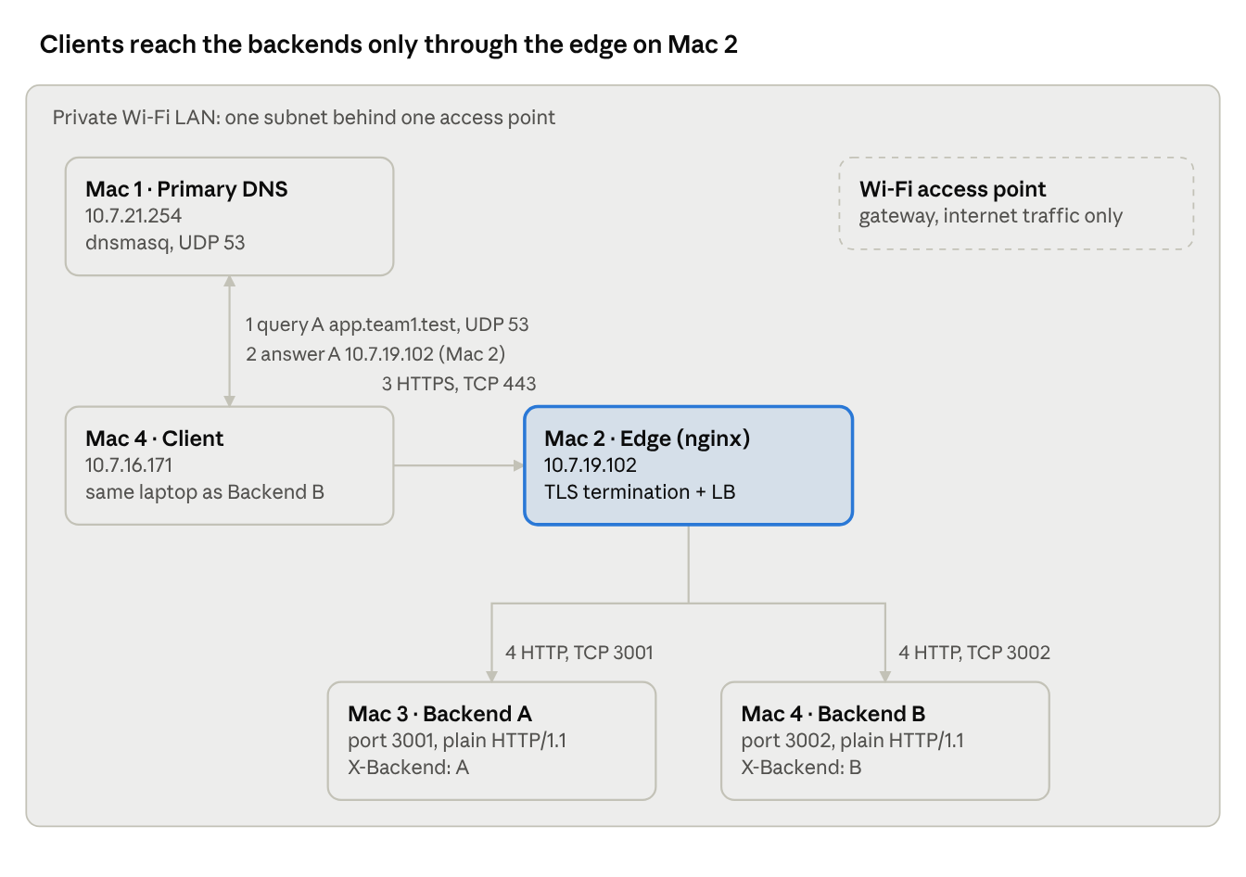
team1 topology · demo network, numbered request flow
The client asks Mac 1 for the edge's address, then speaks HTTPS only to Mac 2; nginx opens its own connections to the two backends.

4.3 IP & service inventory
The project ran on two Wi-Fi networks. Every IP lives in config.env, so moving networks meant editing one file and re-running ./render.sh.
Demo network (4 Oct, 10.7.x.x Wi-Fi, Ruckus access point). Values taken from the Wireshark captures (Figures 1–5):
Machine | Role | IPv4 | MAC address (private Wi-Fi address) | Seen in capture
Mac 1 | Primary DNS | 10.7.21.254 | 6e:4d:a5:73:f3:12 | dnsmasq 53/UDP (Fig. 1)
Mac 2 | Edge nginx | 10.7.19.102 | de:18:32:22:fd:bd | nginx 443/TCP (Fig. 2–5)
Mac 3 | Backend A | ________ | ________ | 3001/TCP
Mac 4 (backend-b) | Backend B + client | 10.7.16.171 | 32:8b:e8:5a:f3:0e | client; Backend B 3002/TCP (Fig. 2)
Default gateway | Wi-Fi AP | — | c0:c5:20:6f:38:ee (Ruckus Wireless) | internet traffic only
Packets from Mac 4 to Mac 1 and Mac 2 are addressed to their own MAC addresses, not the gateway's, so all three sit on the same subnet. Only internet-bound packets (e.g. to 98.91.66.56 in Fig. 9) go to the gateway's MAC.
Earlier setup network (3 Oct, 10.142.107.0/24). Values from config.env and evidence/phase1/A1-netinfo-*.txt:
Machine | Interface | IPv4 / prefix | Gateway | MAC address | Services
Mac 1 | en0 | 10.142.107.114/24 | 10.142.107.38 | ________ | dnsmasq :53
Mac 2 | en0 | 10.142.107.105/24 | 10.142.107.38 | ________ | nginx :443, :80
Mac 3 | en0 | 10.142.107.97/24 | 10.142.107.38 | ________ | Backend A :3001 · Ph2: dnsmasq :53, nginx :443
Mac 4 | en0 | 10.142.107.96/24 | 10.142.107.38 | 9e:28:37:36:f9:34 | Backend B :3002
Mac 4's MAC differs between the networks (9e:28:… vs 32:8b:…) because macOS's Private Wi-Fi address gives each network its own randomised MAC.

4.4 DNS records
dns/team.hosts.tmpl, TTL 30 s, values on the demo network:
Name | Type | Value
app.team1.test | A | Mac 2 (10.7.19.102), seen in Fig. 1
api.team1.test | A | Mac 2 (10.7.19.102)
edge.team1.test | A | Mac 2
dns1.team1.test | A | Mac 1
dns2.team1.test | A | Mac 3 (backup DNS)
backend-a.team1.test | A | Mac 3
backend-b.team1.test | A | Mac 4

4.5 One request, step by step
What happens during one curl https://app.team1.test/api/status:
- Mac 4 → Mac 1: DNS query A app.team1.test (UDP, ephemeral port → 53).
- Mac 1 → Mac 4: answer A 10.7.19.102, TTL 30.
- Mac 4 ↔ Mac 2: TCP SYN → SYN-ACK → ACK on port 443.
- Mac 4 → Mac 2: TLS ClientHello (SNI app.team1.test, ALPN h2).
- Mac 2 → Mac 4: ServerHello, Certificate, key exchange, Finished. The client verifies the certificate against the team CA.
- Mac 4 → Mac 2: HTTP/2 GET /api/status, encrypted.
- Mac 2 → Mac 3 or Mac 4: a new TCP connection, plain HTTP/1.1 GET with X-Forwarded-For.
- Backend → Mac 2: 200 JSON with X-Backend: A or B.
- Mac 2 → Mac 4: 200 (encrypted) plus X-Backend, X-Edge, X-Upstream headers.
The client only ever learns Mac 2's IP. The edge opens a separate TCP connection to the backends, so the client never needs or sees their addresses.

4.6 Protocol-to-layer map
Protocol in this project | OSI layer | TCP/IP layer | Where it appears
HTTP/1.1, HTTP/2 (REST, Cache-Control, ETag) | 7 Application | Application | client ↔ nginx (inside TLS), nginx ↔ backend (plain HTTP/1.1)
DNS | 7 Application | Application | client ↔ dnsmasq
TLS 1.2 / 1.3 | 5–6 Session/Presentation | between Application and Transport | client ↔ nginx only (terminated at the edge)
TCP (443, 3001, 3002), UDP (53) | 4 Transport | Transport | every hop; ports identify the service
IPv4, ICMP (ping) | 3 Network | Internet | addressing between Macs
802.11 Wi-Fi frames, ARP, MAC addresses | 2 Data link | Link | each Mac ↔ access point
Radio | 1 Physical | Link | Wi-Fi

5. Repository / Configuration Bundle
Each Mac has an identical copy (MAC1/ … MAC4/). The only differences are the YOU_ARE_MAC_N.txt marker and that Mac's quick-start README.md.
config.env ← the ONLY file where IPs/ports/team/TTL are set
render.sh ← renders every *.tmpl into build/ using config.env
backend/
server.py ← REST backend (Python stdlib only)
run.sh ← run.sh A (Mac 3, :3001) | run.sh B (Mac 4, :3002)
dns/
dnsmasq.conf.tmpl ← resolver config (primary + backup use the same file)
team.hosts.tmpl ← project A-records
install-dns.sh ← installs/starts dnsmasq, self-tests with dig
nginx/
edge-phase1.conf.tmpl ← TLS termination + round-robin upstream
edge-phase2.conf.tmpl ← + passive health checks, retries, /edge-health
install-edge.sh ← install-edge.sh phase1|phase2
tls/
make-certs.sh ← team root CA + server cert (SAN app/api.team1.test)
trust-ca.sh ← adds CA to macOS System keychain on each client
firewall/
backend-pf.conf.tmpl ← pf rules: backend ports reachable only from edge
isolate.sh ← apply | status | rollback
scripts/
netinfo.sh pingall.sh ← Task A evidence
client-dns.sh ← primary | both | bogus | reset | flush | show
dns-set-record.sh ← change a record live (SIGHUP to dnsmasq)
lb-test.sh ← N requests, counts X-Backend A/B
cache-demo.sh ← 200 vs 304 conditional request demo
capture.sh ← tcpdump of DNS+TCP+TLS for one request → .pcap
ttl-watch.sh ← OS-cached answer vs live DNS answer every 3 s
diagnose.sh ← layer-by-layer fault diagnosis
docs/
architecture.md phase2-report-template.md viva-prep.md
evidence/
phase1/ phase2/ captures/

6. Phase 1: Build & Observe
Gate: a client resolves app.team1.test, connects over HTTPS, and receives responses from both backends through the load balancer.
Start order: backends (Mac 3, Mac 4) → DNS (Mac 1) → certificates + nginx (Mac 2) → distribute and trust ca.crt → point clients at Mac 1 → test.

Task A: Establish the private LAN
- All Macs joined the same Wi-Fi/hotspot.
- scripts/netinfo.sh records IPv4 address, subnet mask, prefix, default gateway, interface, MAC address, and DNS servers.
- scripts/pingall.sh pings every team Mac (3 echo requests each) and prints OK/FAIL with RTT stats.
- The topology diagram is in Section 4.2.
Evidence: evidence/phase1/A1-netinfo-<host>.txt, evidence/phase1/A2-pingall-<host>.txt (one per Mac).

Task B: Private DNS server (Mac 1)
Directive (dns/dnsmasq.conf.tmpl) | Purpose
local=/team1.test/ | We are authoritative for *.team1.test. Unknown names get NXDOMAIN and are never forwarded.
addn-hosts=…/team.hosts | Records live in a hosts-style file and can be changed live with pkill -HUP dnsmasq.
local-ttl=30 | Short TTL so record changes are observable (Phase 2).
server=1.1.1.1, no-resolv | Everything else is forwarded upstream, so clients keep normal internet access.
domain-needed, bogus-priv | Don't leak single-label names or private reverse lookups upstream.
log-queries, log-facility=/tmp/dnsmasq.log | Live query log as evidence (tail -f).
Clients are pointed at Mac 1 with scripts/client-dns.sh primary, which runs networksetup -setdnsservers Wi-Fi <Mac1> and flushes the OS cache. At least two clients (Mac 1, Mac 4) use it. dig app.team1.test then shows ANSWER: app.team1.test. 30 IN A <Mac 2> and SERVER: <Mac 1>#53.
DNS resolution vs connection. DNS only turns a name into an IP address, using UDP/53 to Mac 1. The TCP/TLS/HTTP connection that follows goes to a different machine (Mac 2, TCP/443). DNS is never on the data path.
Evidence: DNS query and response on the wire
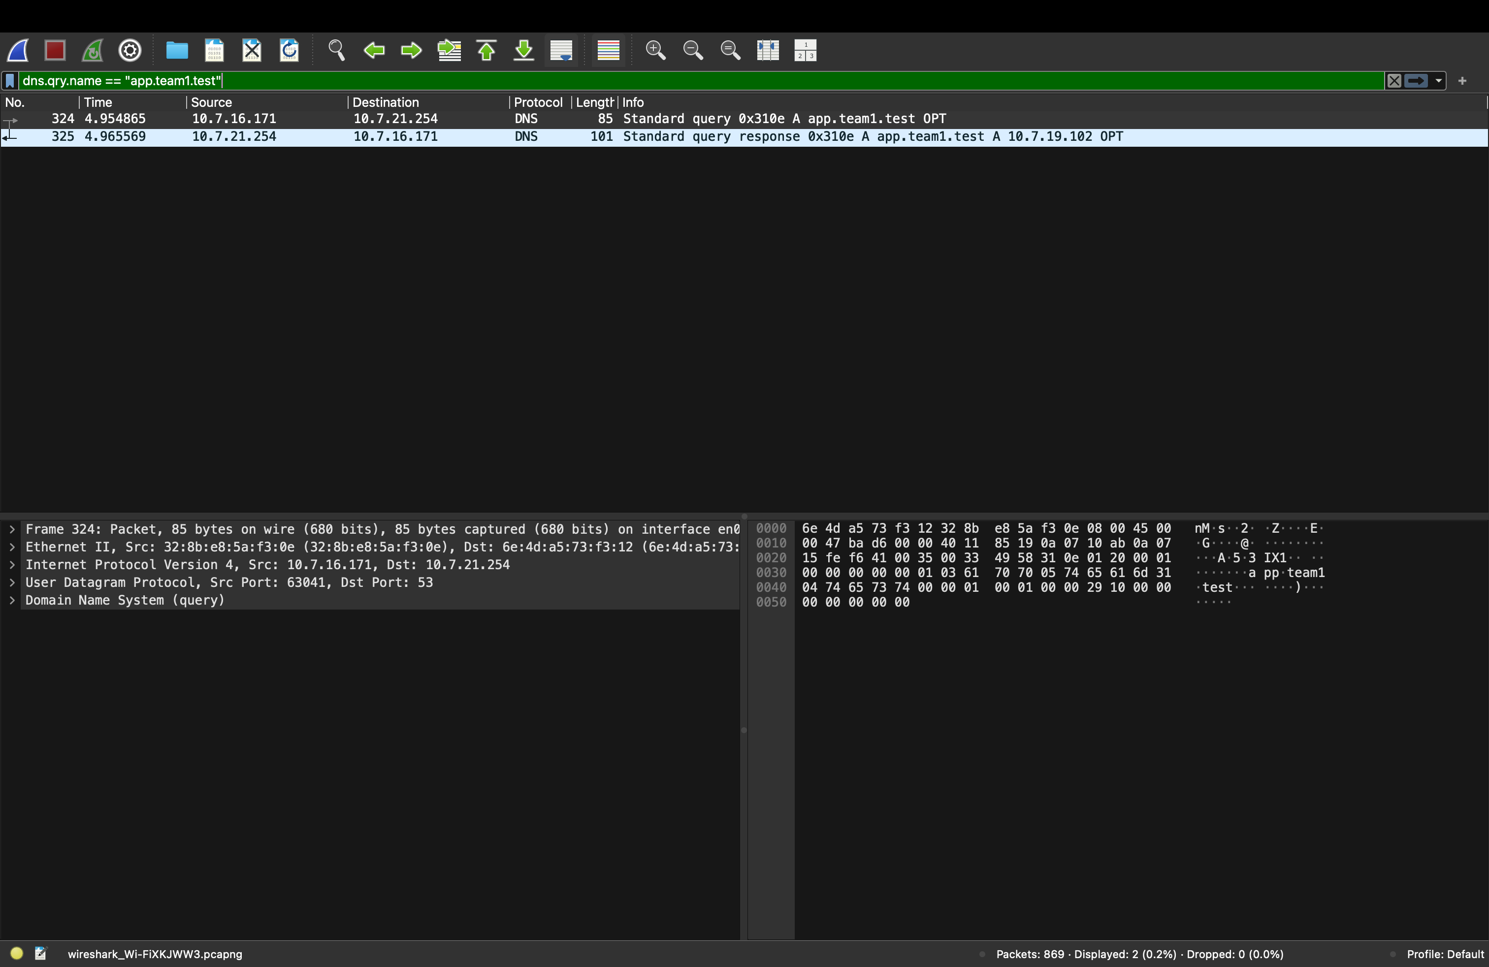
Figure 1. Wireshark filter dns.qry.name == "app.team1.test".
Frame | Time (s) | Source → Destination | What it shows
324 | 4.954865 | 10.7.16.171 (Mac 4) → 10.7.21.254 (Mac 1) | Standard query 0x310e A app.team1.test. UDP src port 63041 (ephemeral) → dst port 53
325 | 4.965569 | 10.7.21.254 → 10.7.16.171 | Standard query response 0x310e A app.team1.test A 10.7.19.102: the answer is Mac 2, the edge
- The response arrives in about 10.7 ms. Both packets carry transaction ID 0x310e, which is how the client matches reply to question.
- The detail pane shows the full stack in one packet: Ethernet II → IPv4 → UDP → DNS (Link, Network, Transport, Application).
- The DNS server (Mac 1) and the IP it returns (Mac 2) are different machines. DNS only supplies the address; the connection is made in Figure 2.

Task C: Two simple backends (Mac 3, Mac 4)
backend/server.py uses Python's ThreadingHTTPServer, bound to 0.0.0.0 (all interfaces, never 127.0.0.1), on fixed ports 3001 (A) and 3002 (B).
Endpoint | Response | Caching
GET / | HTML "Served by Backend A/B" | Cache-Control: no-store
GET /api/status | JSON {backend, status:"ok", host, port, uptime_s, tcp_peer_ip, x_forwarded_for, x_forwarded_proto, host_header} | no-store
GET /api/catalog | Static JSON catalog | public, max-age=60 + ETag + Last-Modified → supports 304
GET /health | ok | —
any response | header X-Backend: A or X-Backend: B | —
/api/status exposes tcp_peer_ip (always the edge's IP) next to x_forwarded_for (the real client). That shows the proxy ends the client's TCP connection and opens its own.

Task D: Edge reverse proxy & load balancer (Mac 2)
- upstream team_backends { server <Mac3>:3001; server <Mac4>:3002; } uses round robin (nginx default); least_conn is the alternative.
- proxy_set_header Host / X-Real-IP / X-Forwarded-For / X-Forwarded-Proto passes client context to the backends.
- add_header X-Edge $hostname and X-Upstream $upstream_addr show which edge and backend served each response.
- Port 80 returns 301 to HTTPS. The team_lb access log records upstream=, up_status=, tls=, rt= per request.
Evidence: round robin. In the caching demo (Figure 7), successive requests are answered by A → B → (A) → B → A. The (A) is a request cache-demo.sh makes silently to read the ETag before step 3, so the sequence is strict A/B alternation. Every request went to https://app.team1.test; the client never used a backend IP.
Evidence: the edge opens its own connection. In Figure 2, frames 56653–56654, 0.1 s after the client connects to the edge, show 10.7.19.102:62963 → 10.7.16.171:3002 [SYN] and [SYN, ACK]. That is nginx on Mac 2 opening a new TCP connection to Backend B on Mac 4.

Task E: HTTPS / TLS
tls/make-certs.sh builds a small private PKI with OpenSSL:
- Team root CA: RSA 4096, self-signed, CA:TRUE, keyCertSign, 825 days.
- Server certificate: RSA 2048, signed by the CA, CN=app.team1.test, SAN = app.team1.test, api.team1.test, extendedKeyUsage = serverAuth, 397 days (what macOS/Chrome require).
- openssl verify -CAfile ca.crt server.crt confirms the chain.
nginx terminates TLS (listen 443 ssl; http2 on; ssl_protocols TLSv1.2 TLSv1.3); backends get plain HTTP on the LAN. tls/trust-ca.sh adds ca.crt to each client's System keychain. The demo never uses curl -k. ca.key and server.key are never shared or committed.
What we observed (Figures 4 and 5). The handshake was negotiated as TLS 1.3. The server's first flight is one segment holding Server Hello, Change Cipher Spec, Application Data, Application Data; the Certificate and Finished are already encrypted inside it. The ClientHello is still readable:
- SNI = app.team1.test: how nginx knows which certificate to present.
- ALPN = h2, http/1.1: the client offers HTTP/2 and the edge accepts it (responses are HTTP/2 200, Fig. 7).
For a capture where the Certificate is visible in plain text, use scripts/capture.sh 1.2 (saved as MAC4/evidence/captures/flow-tls1.2-*.pcap).

Task F: HTTP caching
scripts/cache-demo.sh on Mac 4 against /api/catalog (text copy in MAC4/evidence/phase1/D1-caching.txt):
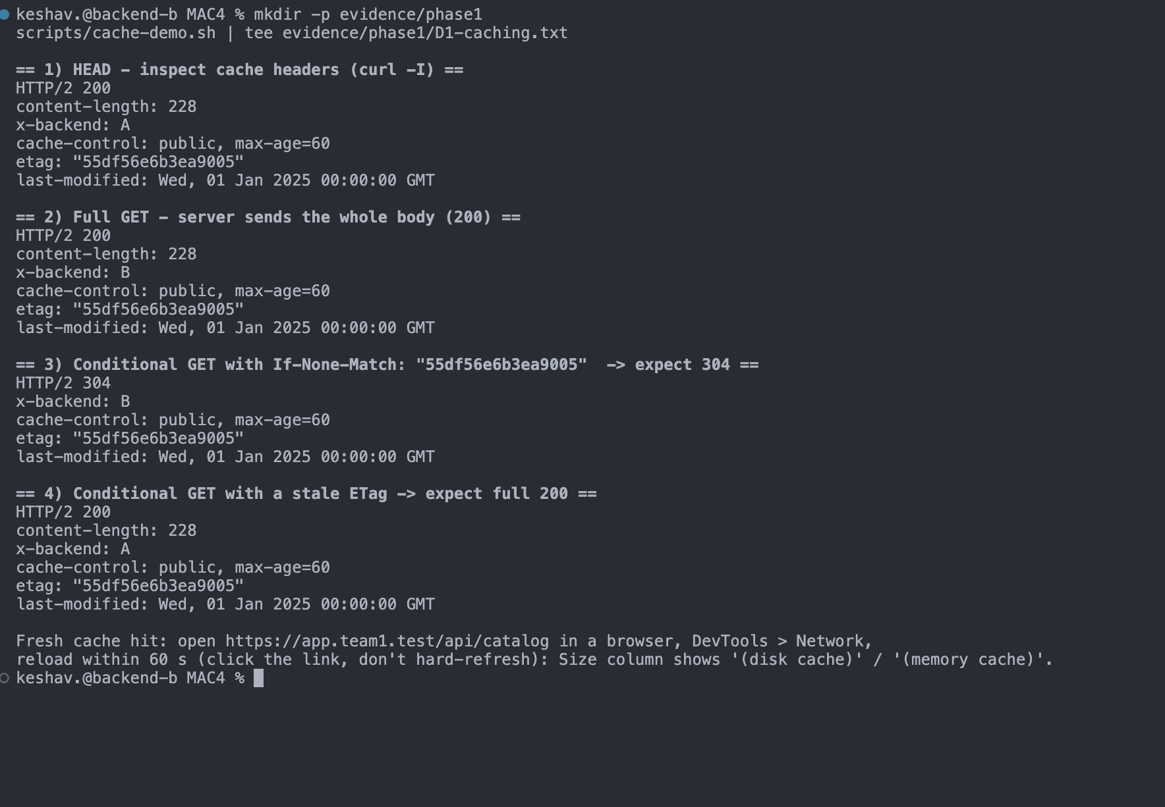
Figure 7. scripts/cache-demo.sh against https://app.team1.test/api/catalog.
Step | Response | Served by | Key headers | Meaning
1 HEAD (curl -I) | HTTP/2 200 | A | cache-control: public, max-age=60, etag: "55df56e6b3ea9005", last-modified: Wed, 01 Jan 2025 00:00:00 GMT | Cache headers present
2 Full GET | HTTP/2 200, content-length: 228 | B | same ETag | Full body sent
3 GET + If-None-Match: "55df56e6b3ea9005" | HTTP/2 304 | B | no content-length, no body | Conditional request: copy still valid
4 GET + stale ETag | HTTP/2 200, content-length: 228 | A | same ETag | Mismatch, so full new response
- A and B return the same ETag, so the 304 works whichever backend the load balancer picks. The ETag is a SHA-256 of the identical body.
- Every response is HTTP/2; the backends only speak HTTP/1.1 and nginx translates.
- Fresh cache hit: within max-age the browser serves from cache with no request at all (DevTools: (disk cache)). Conditional request: stale copy, ask with If-None-Match, get 304. Full new request: no copy or mismatch, get 200 with the body.

Task G: Capture the complete protocol flow
scripts/capture.sh runs on Mac 4 (on Mac 1 the DNS query would go over loopback). It flushes the OS DNS cache to force a real query, runs tcpdump with filter udp port 53 or (host <Mac2> and tcp port 443), makes one curl -v request, and saves a .pcap.
Layer / event | What to point at in Wireshark | Filter
DNS | Query A app.team1.test → response with Mac 2's IP | dns
TCP handshake | SYN → SYN-ACK → ACK; client ephemeral port → 443 | tcp.flags.syn==1
TLS handshake | ClientHello, ServerHello, Certificate, ChangeCipherSpec | tls.handshake
Encrypted data | Application Data records; HTTP payload not readable | tls.record.content_type==23
HTTP headers | Visible only client-side via curl -v (client holds the session keys) | —
Ports | DNS: ephemeral → 53/UDP; HTTPS: ephemeral → 443/TCP | —
Reliability | Seq/Ack numbers grow by bytes sent; ACKs confirm receipt | Statistics → Flow Graph

G.1 Capturing the request
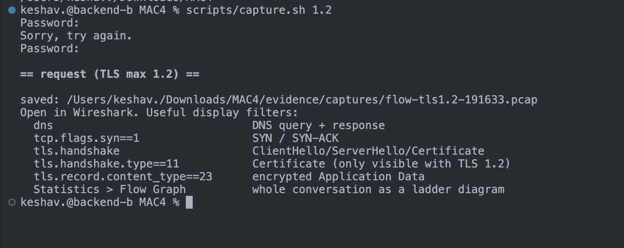
Figure 8. scripts/capture.sh 1.2 on Mac 4 asks for sudo (tcpdump needs it), makes one request, and saves flow-tls1.2-191633.pcap. All captures are in MAC4/evidence/captures/: flow-tls1.2-191633.pcap, flow-tls1.3-191732.pcap, flow-tls1.2-192632.pcap.

G.2 DNS (Application layer, UDP/53)
See Figure 1 in Task B: Mac 4 asks Mac 1 for app.team1.test (UDP 63041 → 53) and gets back 10.7.19.102 (Mac 2).

G.3 TCP three-way handshake (Transport layer)
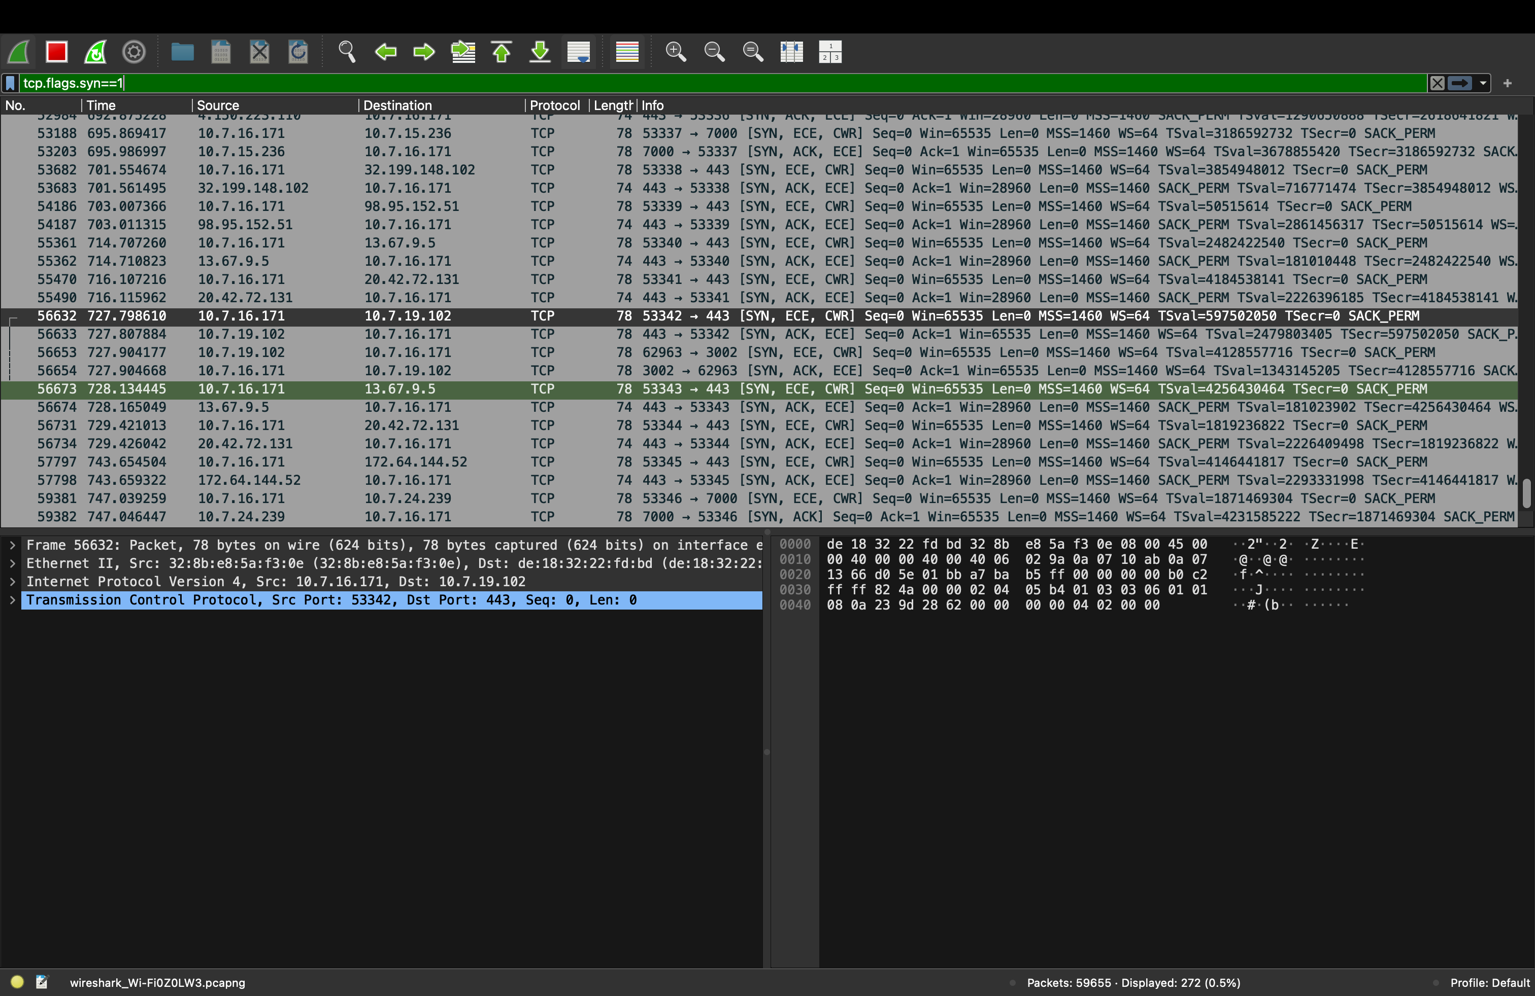
Figure 2. Filter tcp.flags.syn==1. The selected row is the client's SYN to the edge.
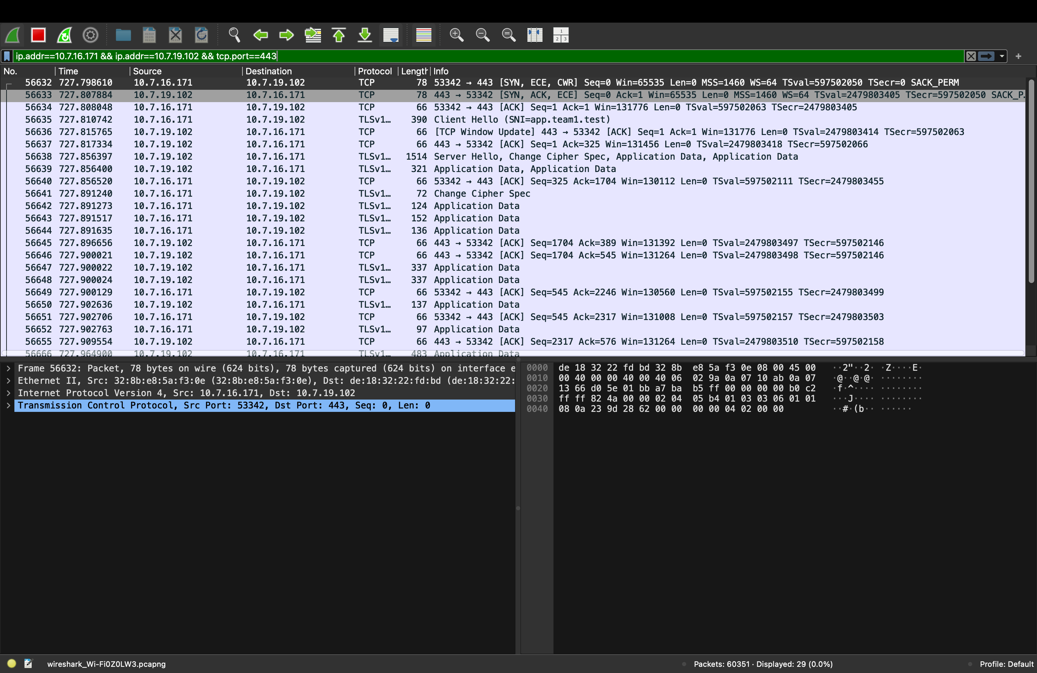
Figure 3. Filter ip.addr==10.7.16.171 && ip.addr==10.7.19.102 && tcp.port==443: one complete HTTPS conversation (29 packets).
Frame | Time (s) | Direction | Flags / content | Seq | Ack
56632 | 727.798610 | Mac 4 :53342 → Mac 2 :443 | SYN (MSS=1460, WS=64, SACK_PERM) | 0 | —
56633 | 727.807884 | Mac 2 :443 → Mac 4 :53342 | SYN, ACK | 0 | 1
56634 | 727.808048 | Mac 4 → Mac 2 | ACK: handshake complete | 1 | 1
56635 | 727.810742 | Mac 4 → Mac 2 | TLS Client Hello (TCP payload 324 bytes) | 1 | 1
56637 | 727.817334 | Mac 2 → Mac 4 | ACK | 1 | 325
56640 | 727.856520 | Mac 4 → Mac 2 | ACK after server's first flight | 325 | 1704
56645 / 56646 | 727.896–.900 | Mac 2 → Mac 4 | ACKs for client's encrypted records | 1704 | 389, 545
- Socket pair: client 10.7.16.171:53342 (ephemeral) ↔ server 10.7.19.102:443 (well-known HTTPS). SYN → SYN-ACK took 9.3 ms.
- No application data before the handshake: the Client Hello is the first segment with a payload, after the final ACK (56634).
- Reliability: every ACK number equals 1 + total bytes received. Client Hello = 324 bytes → Ack 325. Server's first flight = 1448 + 255 = 1703 bytes → client acks 1704. Client then sends 6 + 58 bytes → server acks 389, then 86 + 70 more → 545. A gap would trigger a retransmission.
- Flow control: WS=64 and [TCP Window Update] (56636) are the receiver advertising its buffer space.

G.4 TLS handshake
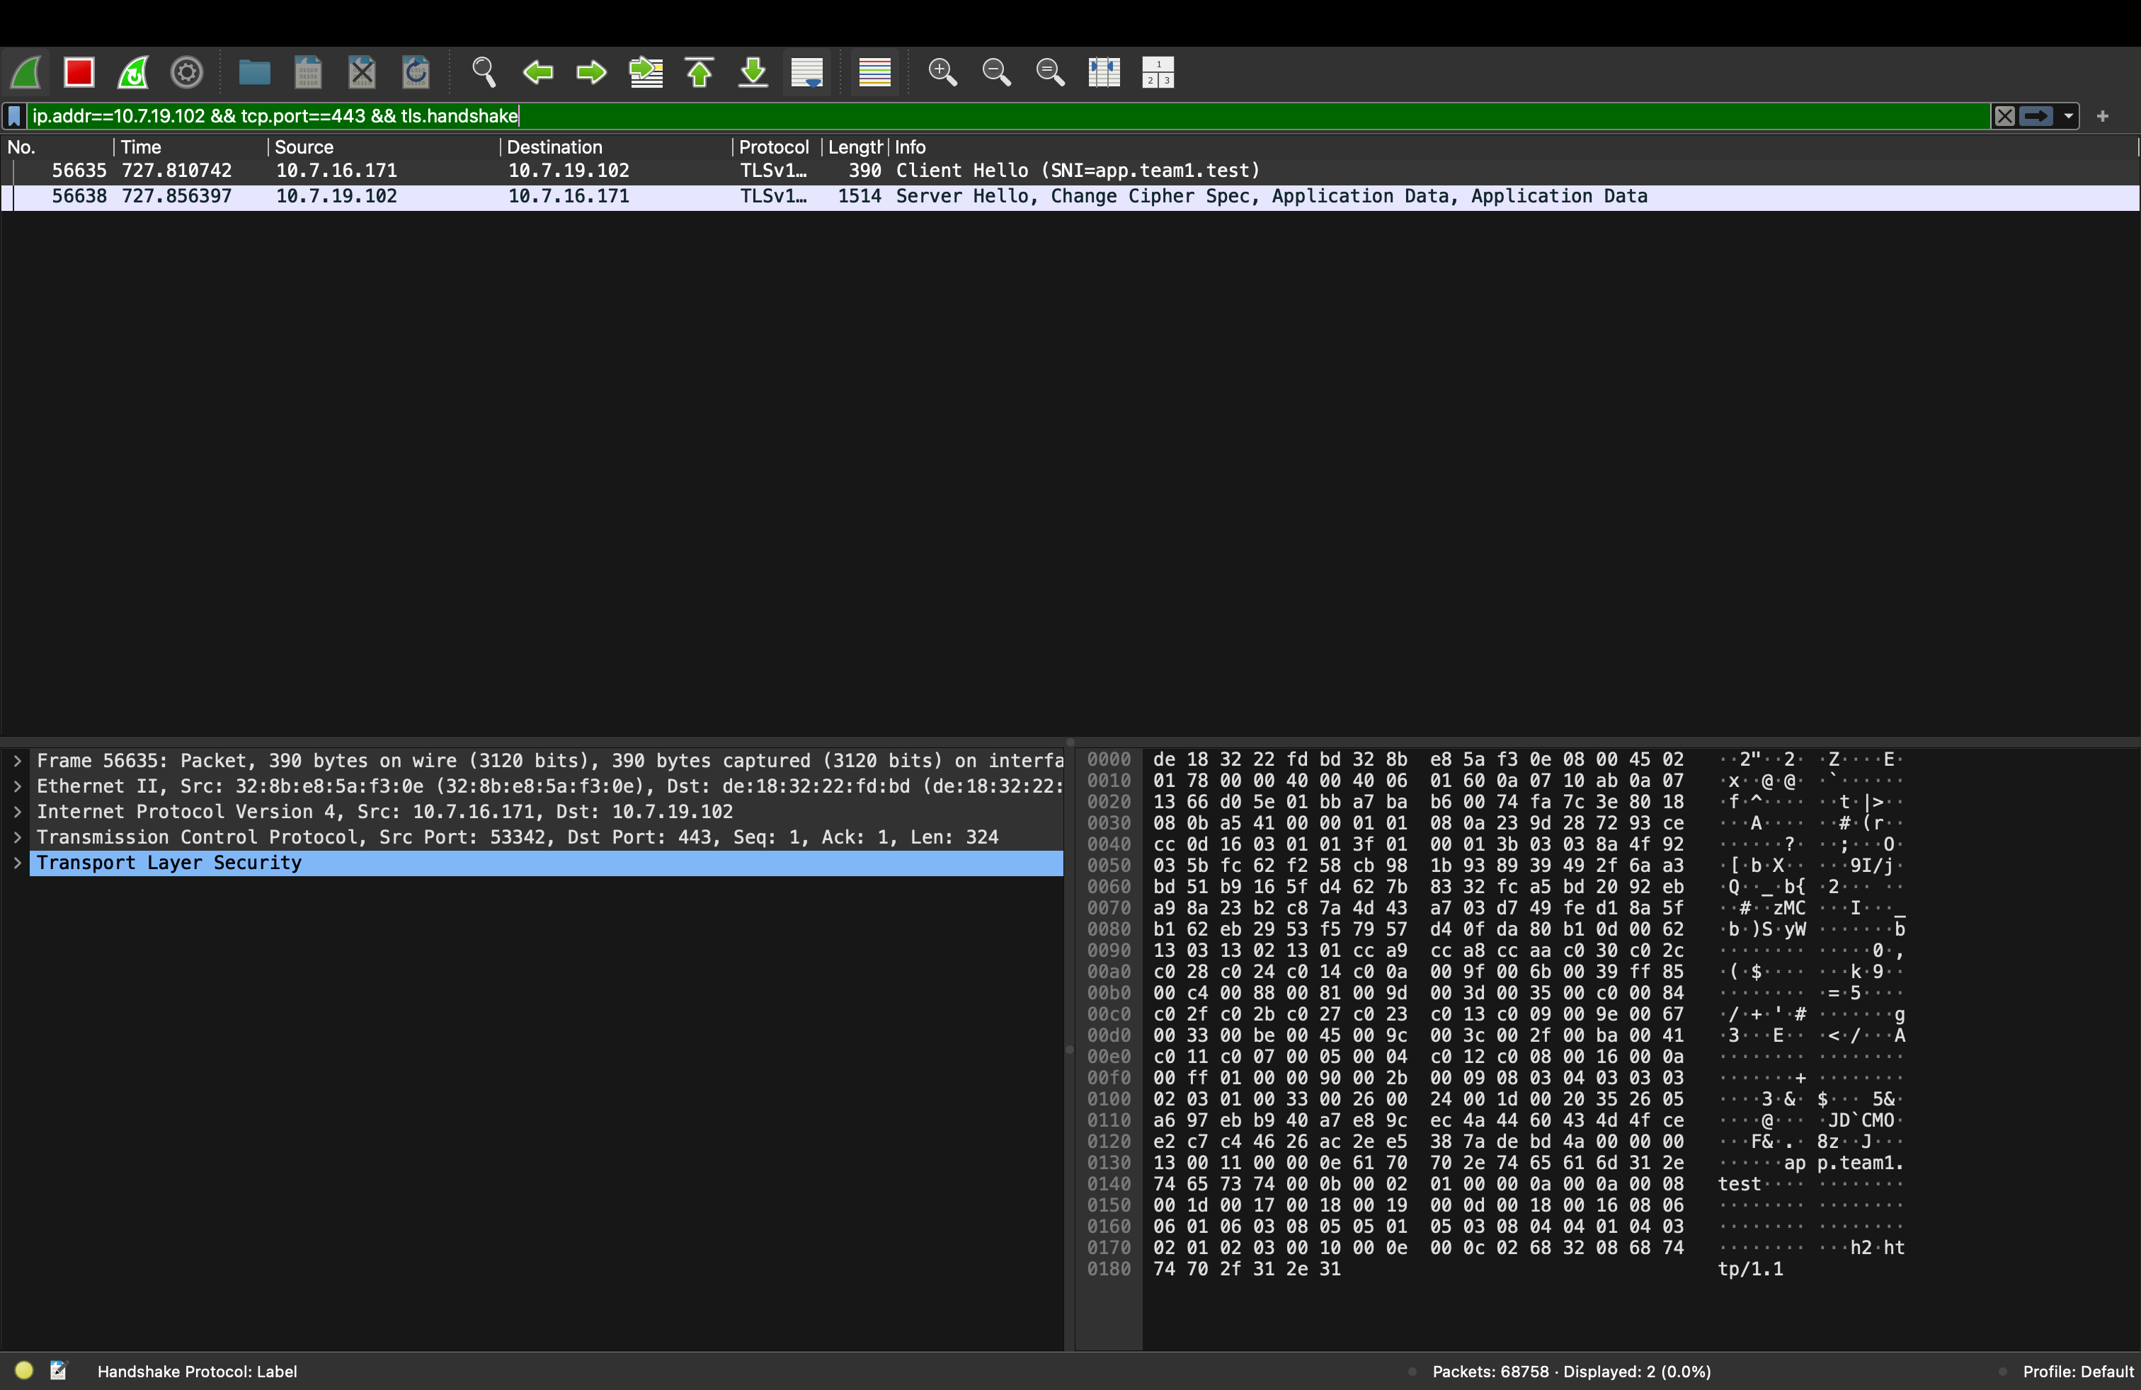
Figure 4. Filter ip.addr==10.7.19.102 && tcp.port==443 && tls.handshake. The hex pane shows app.team1.test (SNI) and h2 http/1.1 (ALPN) in plain text.
Frame | Time (s) | Direction | TLS message
56635 | 727.810742 | client → edge | Client Hello (SNI app.team1.test, ALPN h2/http1.1, cipher suites, key share)
56638 | 727.856397 | edge → client | Server Hello, Change Cipher Spec, + encrypted Certificate / CertificateVerify / Finished
56641 | 727.891240 | client → edge | Change Cipher Spec + encrypted client Finished
56642 → | 727.891+ | both | Application Data: the HTTP/2 request and response
The handshake took about 80 ms (Client Hello 727.811 → client Finished 727.891). The client checked the edge's certificate against the team CA in its keychain, with no -k flag.

G.5 HTTP is encrypted on the wire
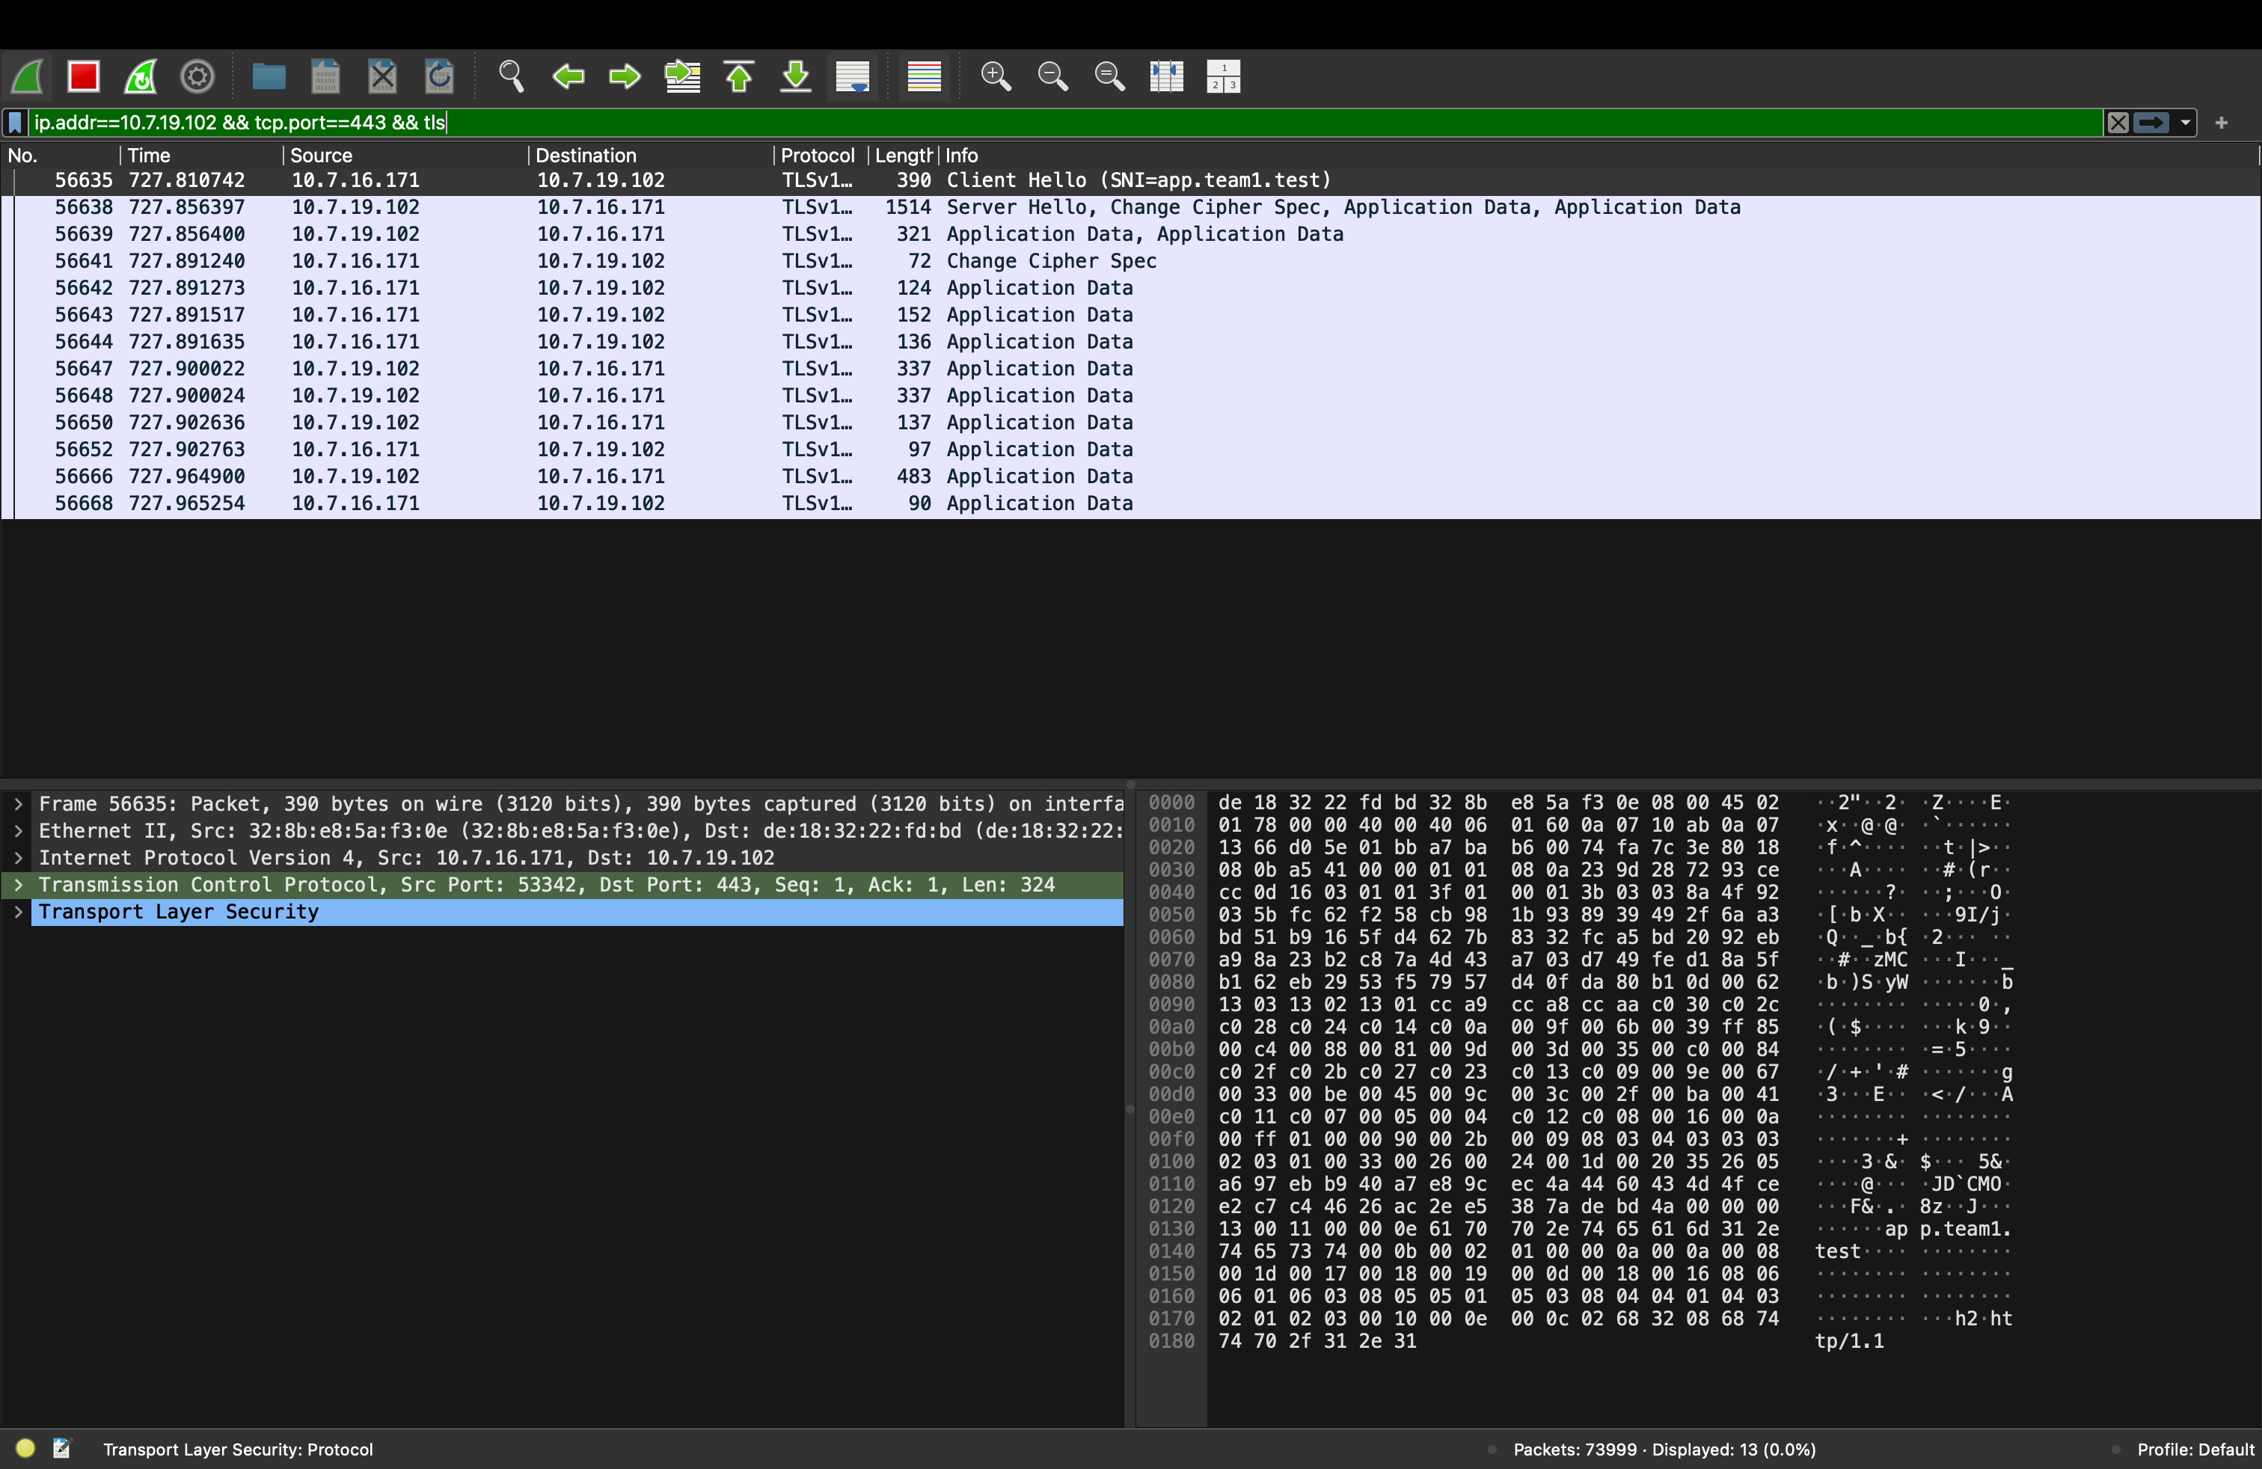
Figure 5. Filter ip.addr==10.7.19.102 && tcp.port==443 && tls. After the handshake every record is "Application Data"; Wireshark cannot see the method, path, or headers.
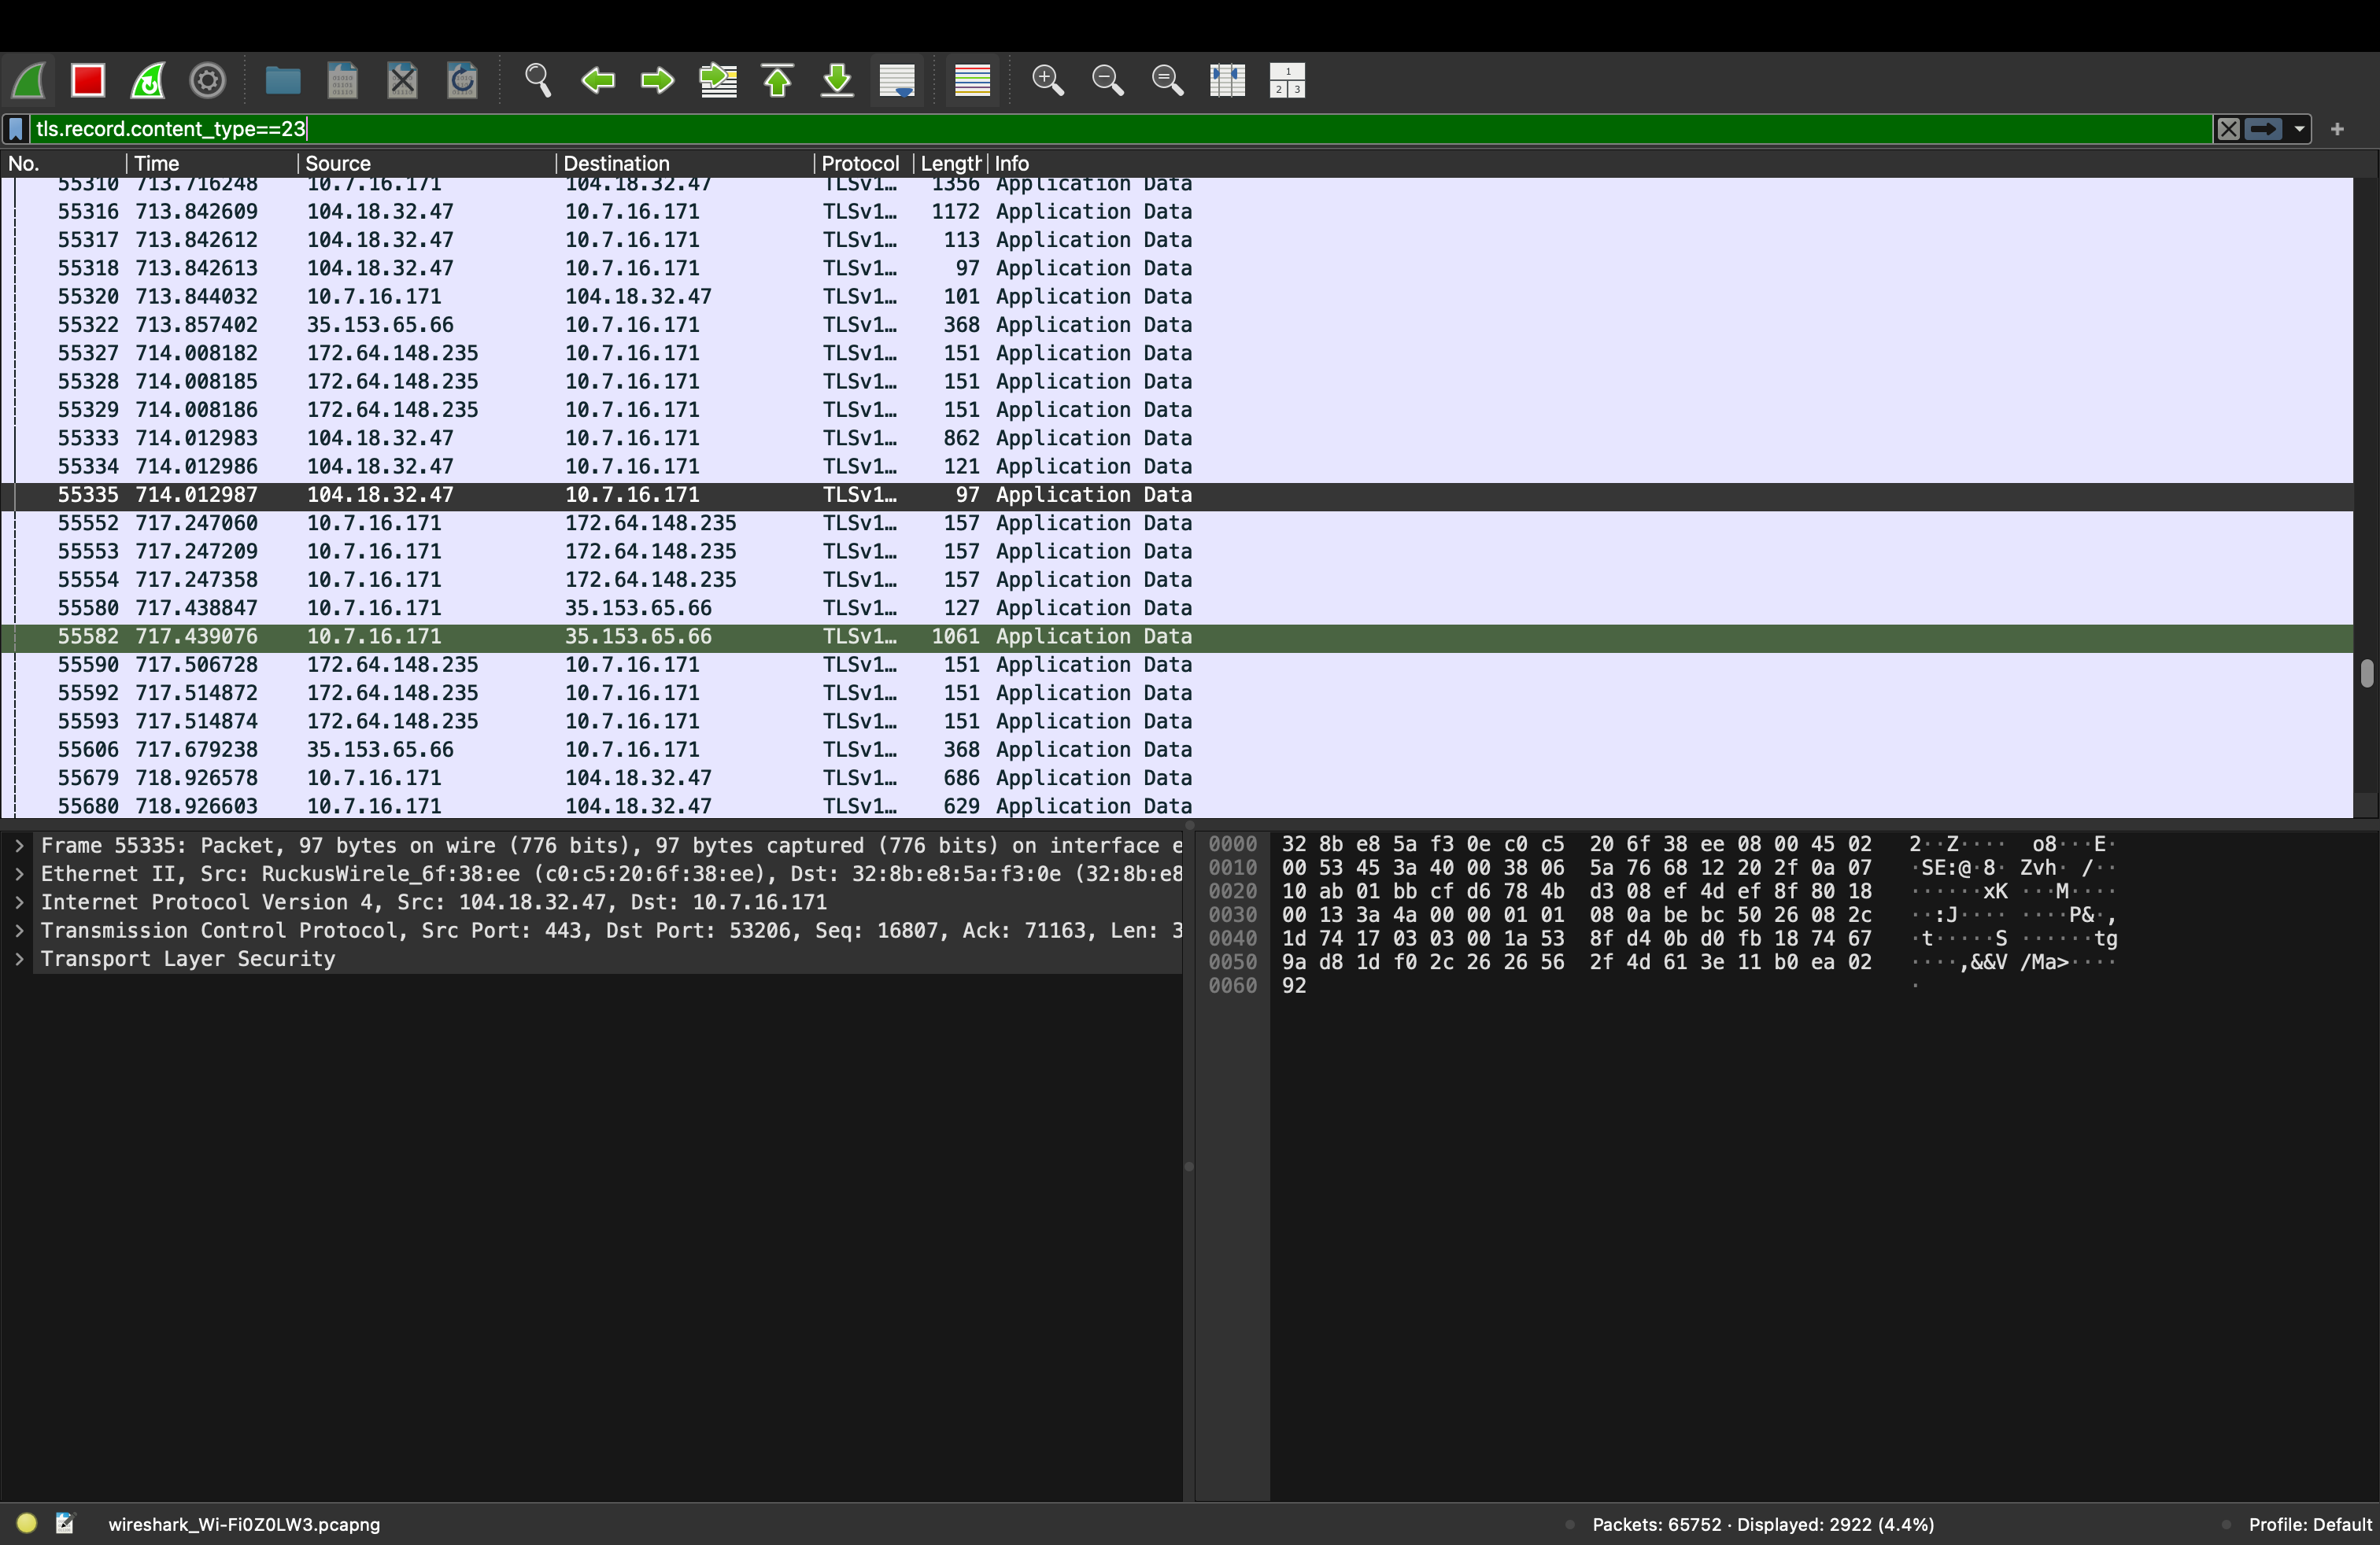
Figure 6. Filter tls.record.content_type==23 over the whole Wi-Fi interface also matches other HTTPS traffic from the laptop (e.g. 104.18.32.47, 172.64.148.235). The hex pane is unreadable ciphertext. This is why the filters in Figures 2–5 include the edge IP 10.7.19.102.
The HTTP headers (X-Backend, Cache-Control, ETag, HTTP/2 200) are visible only on the client (Figure 7), which holds the session keys. Encryption covers everything above TCP; IP addresses, ports, and TCP flags stay visible because routers need them.

G.6 Ports used in one request
Leg | Source (ephemeral) | Destination (well-known / fixed) | Protocol | Figure
DNS query | 10.7.16.171:63041 | 10.7.21.254:53 | UDP | 1
HTTPS to edge | 10.7.16.171:53342 | 10.7.19.102:443 | TCP + TLS | 2, 3
Edge to backend | 10.7.19.102:62963 | 10.7.16.171:3002 (Backend B) | TCP, plain HTTP/1.1 | 2

G.7 What went wrong on the first capture attempt
The first Wireshark capture did not contain our request.
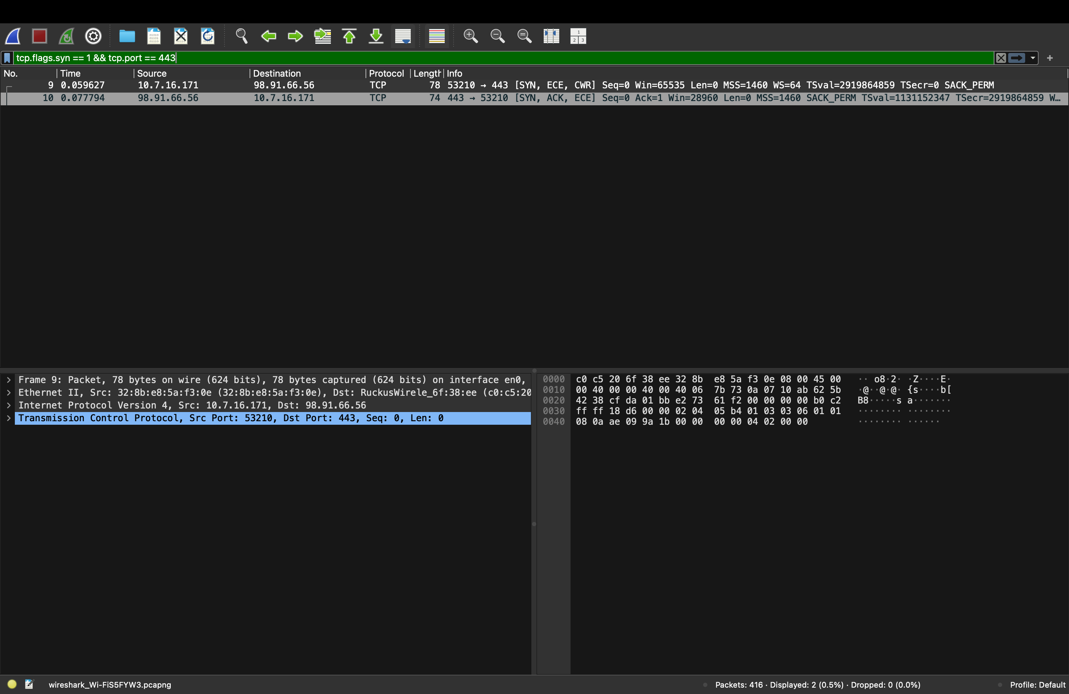
Figure 9. First capture, filter tcp.flags.syn == 1 && tcp.port == 443. The only handshake is to 98.91.66.56, an internet server (destination MAC = the Ruckus gateway). Unrelated background traffic, not our edge.
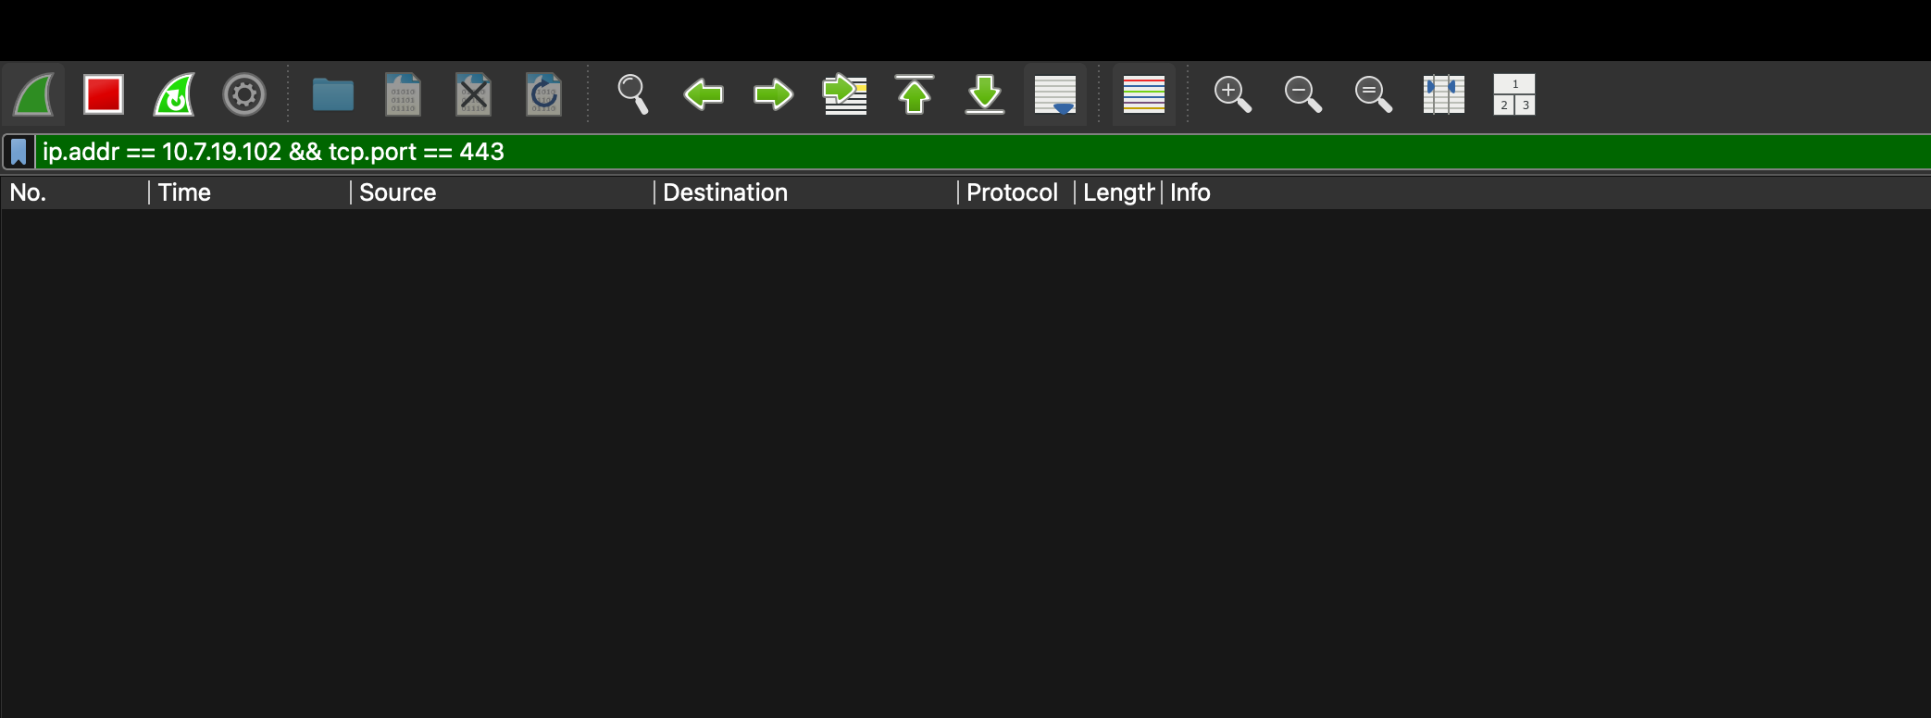
Figure 10. The same capture filtered on ip.addr == 10.7.19.102 && tcp.port == 443 shows zero packets: the request was not made while this capture ran.
Fix: we started a new capture, made the request to https://app.team1.test while it ran, and filtered on the edge's IP. That produced Figures 2–5. Lesson: a capture only holds what happened during it, and a Wi-Fi laptop always sends other HTTPS traffic; filtering by our edge's IP and port is what isolates our flow.

7. Phase 1: Failure Demonstrations
Each fault breaks exactly one layer, run from a client (Mac 4) and restored afterwards.
# | Fault injected | How | Expected observation | What it proves
1 | Wrong DNS server on client | client-dns.sh bogus | dig times out, curl → Could not resolve host, but ping <Mac 2 IP> works | DNS and IP connectivity are independent layers
2 | DNS record → wrong IP | on Mac 1: dns-set-record.sh app <Mac 4 IP>; client flushes | dig succeeds with the wrong IP; curl → Connection refused (nothing on 443 at Mac 4) | DNS is a directory, not a connection
3 | One backend stopped | Ctrl+C Backend A | lb-test.sh → all X-Backend: B, all 200 | nginx retries the other upstream
4 | Both backends stopped | stop A and B | DNS ✓, TCP ✓, TLS ✓, then 502 Bad Gateway | shows where the edge ends and the backend begins
5 | Wrong destination port | curl https://app.team1.test:8444/ | Connection refused; Wireshark shows SYN → RST | IP address and port are separate identifiers
Observed results / screenshots: evidence/phase1/fail-1..5-*.png (to be attached).

