Creating a SOAP webservice with arithmetic operations

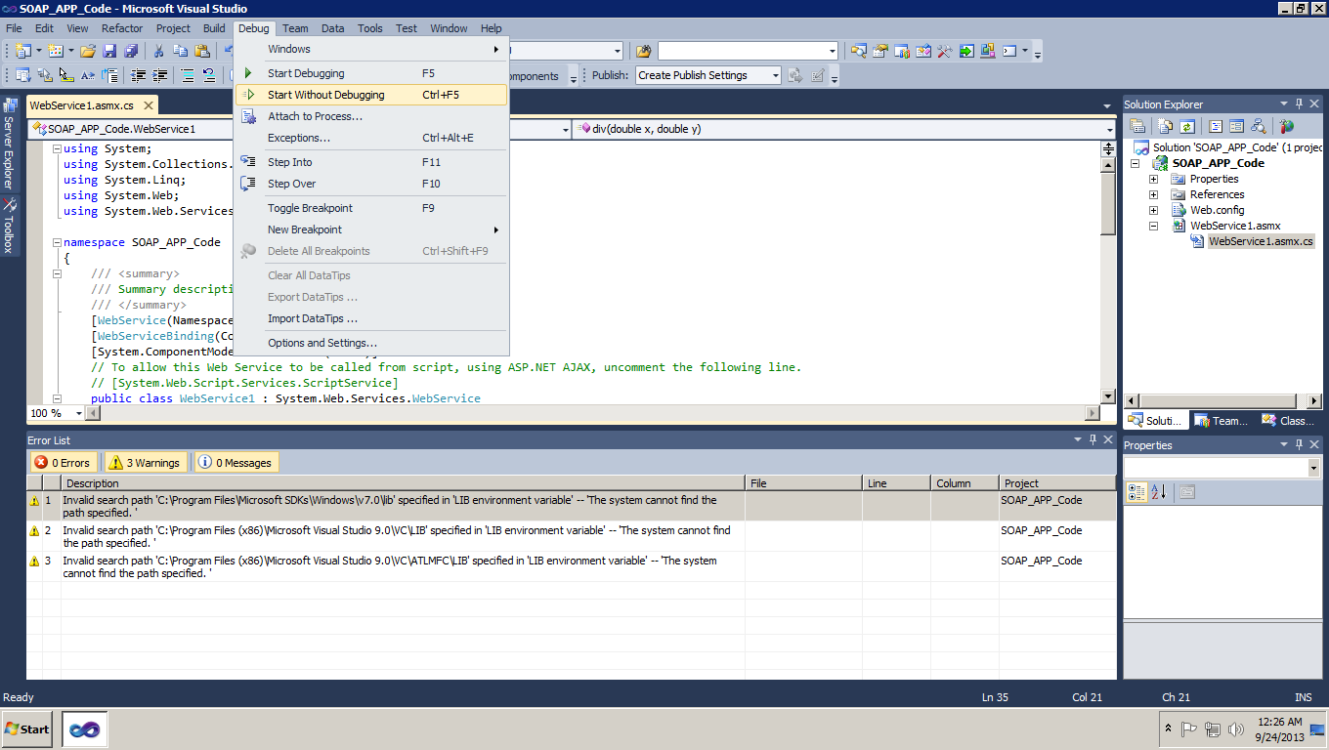

Run the webservice in local

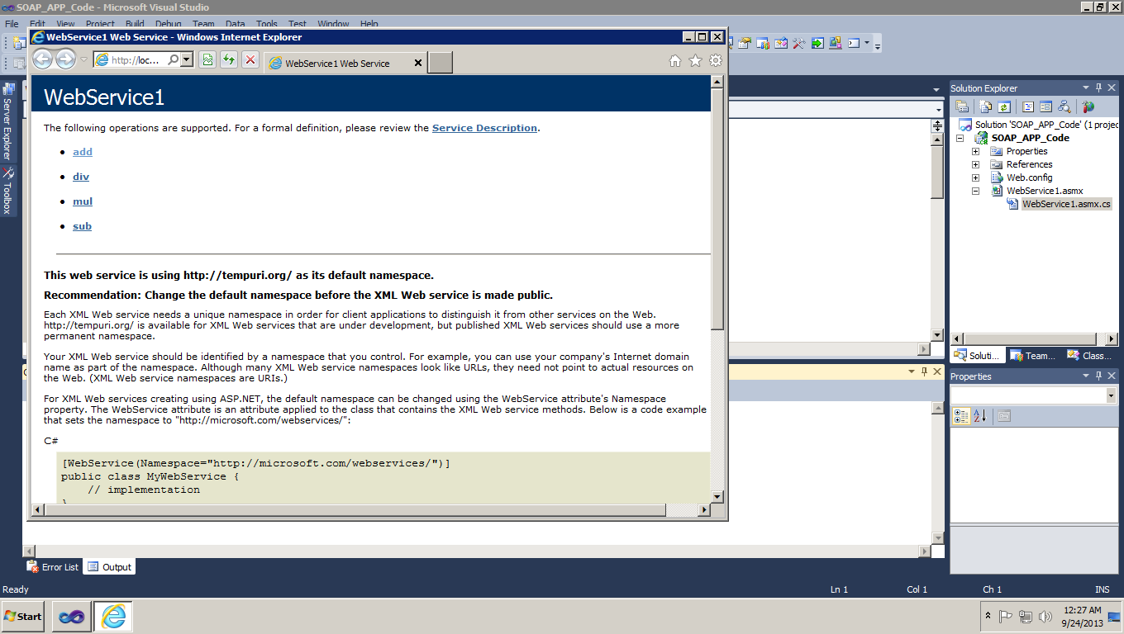

Deploying the SOAP webservice in cloud instance

Run the webservice in through cloud  
