Creating a webform for the webclient to access the webservice

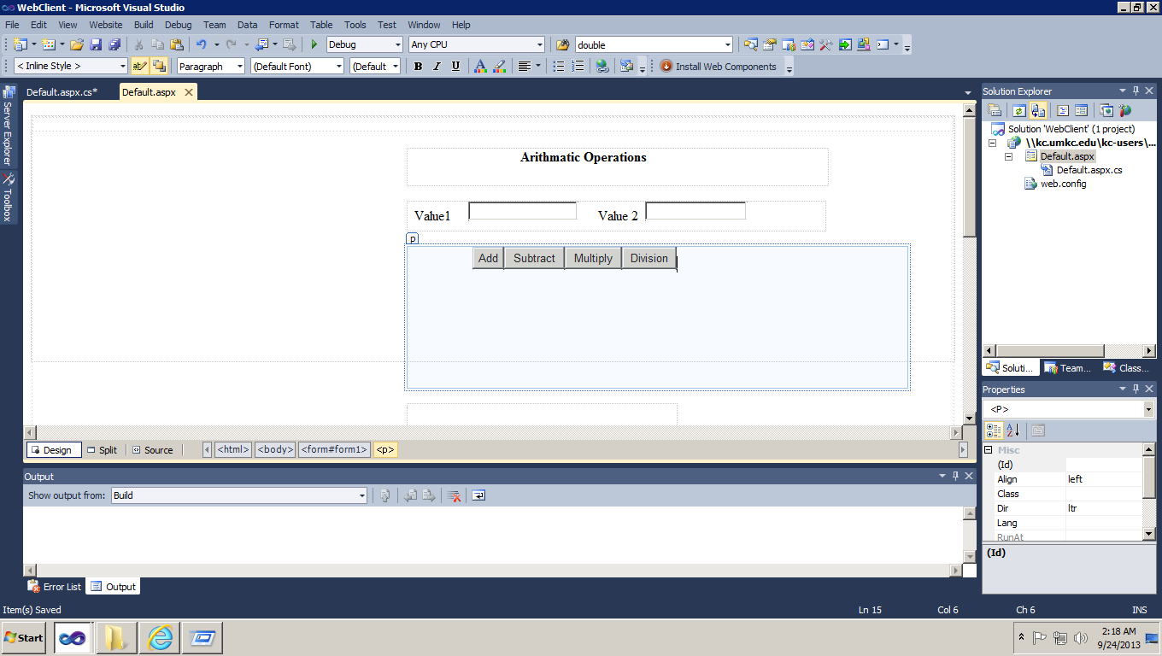  
Using the webservice for the client requests

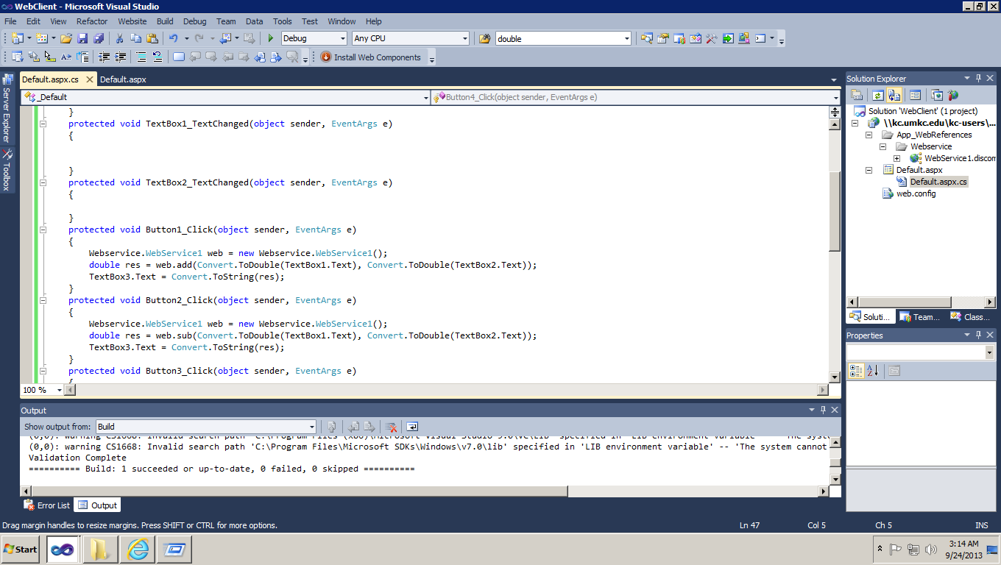

Testing it in local

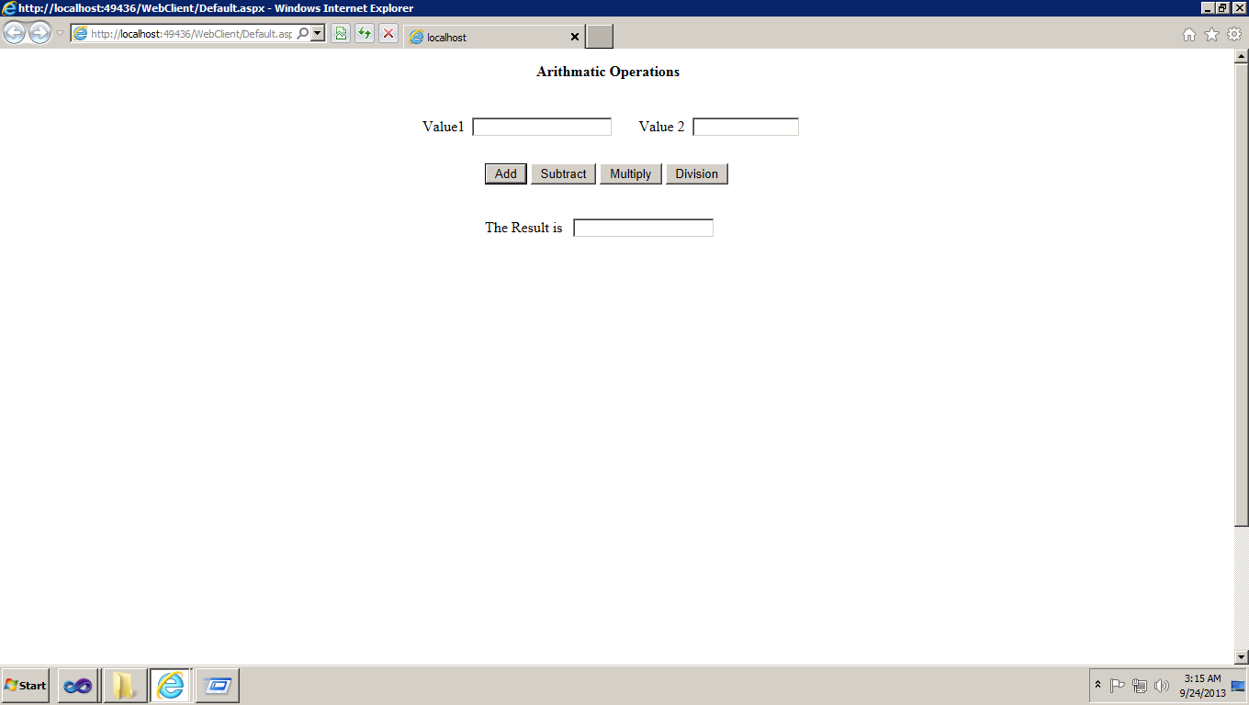  
  
  
  
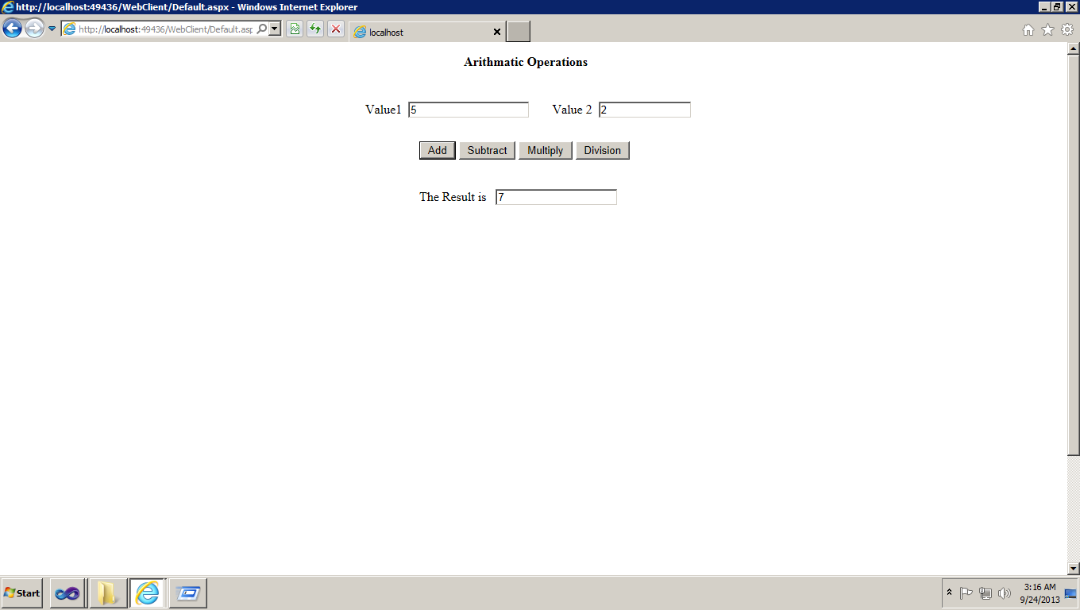

Deploying the code in cloud instance

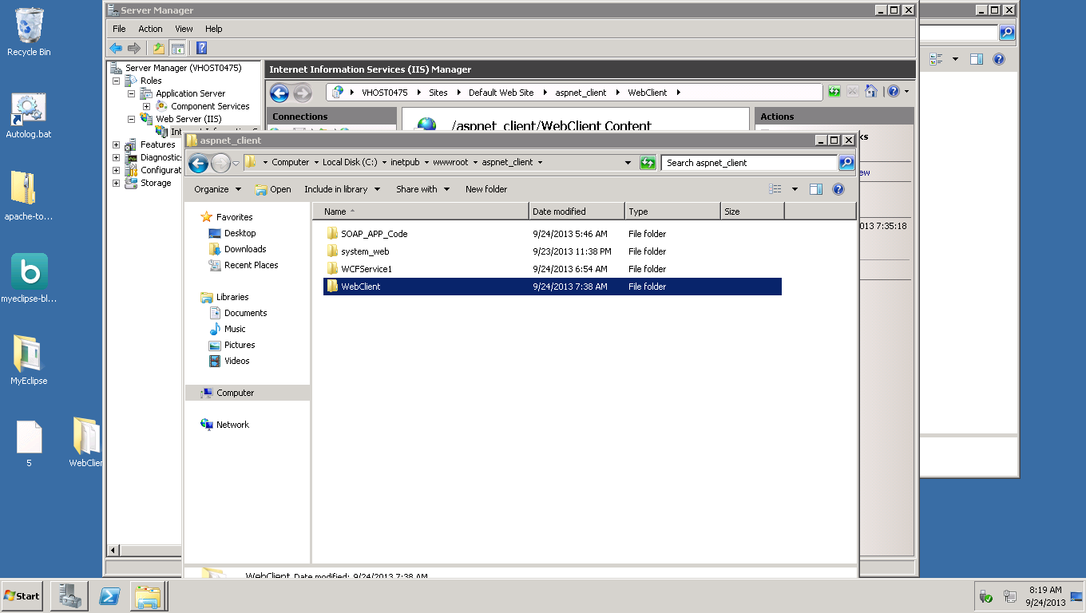

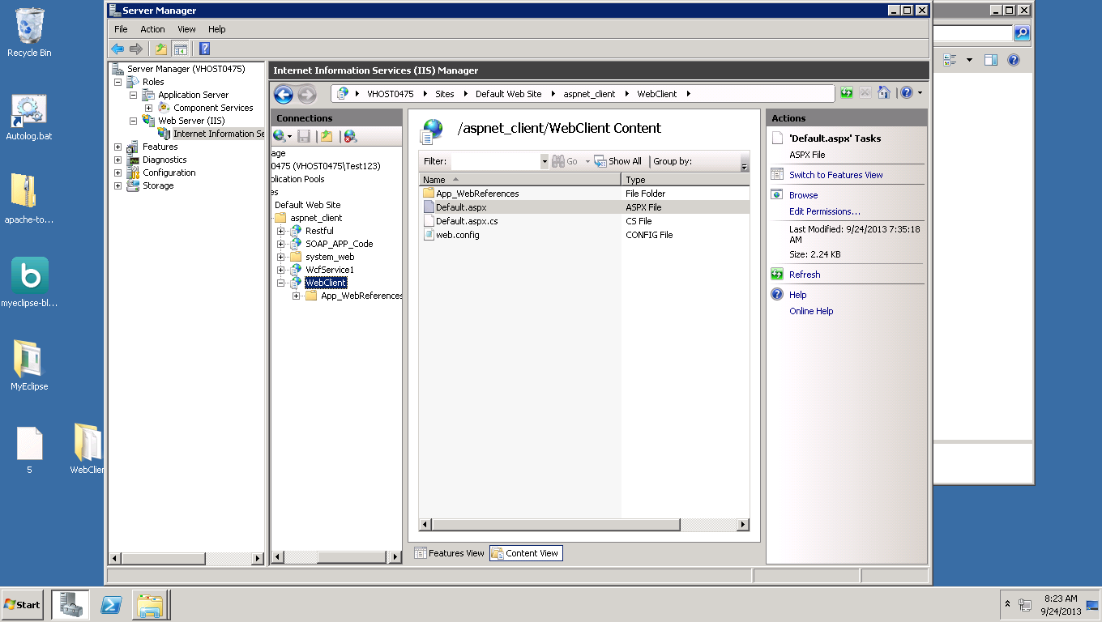  
  
  
  
  
  
  
  
  
  
  
  
  
  
  
  
  
  
  
  
  
  
  
  
  
  
  
  
Run the application through cloud instance  
  
  
  
  
