AI Assisted Coding
Name: Srinija
Batch : 39
Htno:2303A52474

1 . write a Python program that uses a loop to print all even numbers between 1 and N. Clearly specify whether a for loop or while loop is used, and include sample input and output to validate the program

Code:

def print_even_numbers(n):
print("\nEven numbers between 1 and", n, "are:")
# Using a for loop to iterate through numbers
for i in range(1, n + 1):
if i % 2 == 0:
print(i, end=" ")
print() # Move to next line after printing numbers
def validate_input():
try:
value = int(input("Enter a positive integer N: "))
if value <= 0:
print("Error: Number must be greater than 0.")
return None
return value
except ValueError:
print("Error: Invalid input. Please enter an integer.")
return None

def main():
print("EVEN NUMBER PRINTING PROGRAM ")
n = validate_input()
if n is None:
print("Program terminated due to invalid input.")
else:
print_even_numbers(n)
print("\nProgram execution completed successfully.")
# Entry point of the program
if __name__ == "__main__":
main()
0utput:
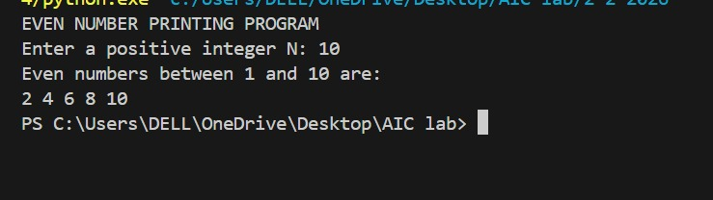
Analysis:
printing Even Numbers Between 1 and N .The objective of this program is to print all even numbers between 1 and a user-given positive integer N using a loop, while validating user input.
2. write a Python program that uses a loop and if conditionals to count how many numbers in a given list are even and how many are odd. Display the counts and include a brief explanation of the logic flow along with sample input and output for validation.
Code:
def count_even_odd(numbers):
even_count = 0
odd_count = 0
if num % 2 == 0
even_count += 1
else: # If not even, it must be odd
odd_count += 1

return even_count, odd_count
def main():
print("EVEN AND ODD NUMBER COUNT PROGRAM")
try:
input_list = input("Enter a list of integers separated by spaces: ")
numbers = list(map(int, input_list.split()))
except ValueError:
print("Invalid input! Please enter integers only.")
return
even_count, odd_count = count_even_odd(numbers)
print(f"Total Even Numbers: {even_count}")
print(f"Total Odd Numbers: {odd_count}")
print("\nLogic Flow Explanation:")
print("1. The program takes a list of integers as input.")
print("2. It initializes two counters: one for even numbers and one for odd numbers.")
print("3. It loops through each number in the list, checking if it is even or odd using the modulus operator (%).")
print("4. Depending on the result, it increments the respective counter.")
print("5. Finally, it displays the counts of even and odd numbers.")
if __name__ == "__main__":
main()'''

output:
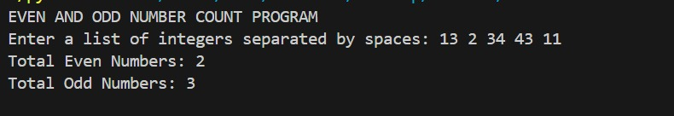
Analysis:
Even and Odd Number Counter The main objective of this program is to count how many numbers in a given list are even and how many are odd using loops and conditional statements.
3. write a Python class named User that uses conditional statements to validate user attributes such as age and email. The class should ensure the age is a positive integer and the email follows a basic valid format. Include test cases that demonstrate correct handling of both valid and invalid inputs, along with brief explanations of the validation logic.
Code:
lass User:

def __init__(self, name, age, email):
self.name = name
self.age = age
self.email = email

def validate_name(self):

if isinstance(self.name, str) and len(self.name.strip()) > 0:
return True
return False

def validate_age(self):

if isinstance(self.age, int) and self.age > 0:
return True
return False

def validate_email(self):

if "@" in self.email and "." in self.email:
return True
return False

def validate_user(self):

name_valid = self.validate_name()
age_valid = self.validate_age()
email_valid = self.validate_email()
return name_valid and age_valid and email_valid

def display_header():
print(" USER VALIDATION SYSTEM ")
def get_user_input():
name = input("Enter name: ")
try:
age = int(input("Enter age: "))
except ValueError:
age = -1
email = input("Enter email: ")
return name, age, email

def display_results(user):
print("\nValidation Results:")
print("Name valid :", user.validate_name())
print("Age valid :", user.validate_age())
print("Email valid:", user.validate_email())
print("Overall validation:", user.validate_user())
def main():
display_header()
name, age, email = get_user_input()

user = User(name, age, email)

display_results(user)

if user.validate_user():
print("\nUser data is valid.")
else:
print("\nUser data is invalid. Please check inputs.")

print("\nProgram execution completed.")

# Entry point
if __name__ == "__main__":
main()

output:
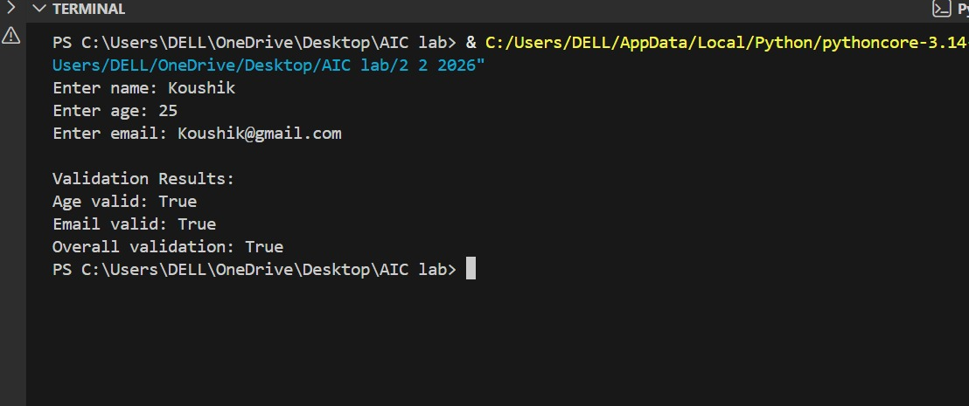
Analysis:
User Validation System. The objective of this program is to validate user details such as name, age, and email using class methods and conditional statements. The program ensures that the entered data follows basic validity rules before accepting it.
4. write a Python class named Student with attributes name, roll_number, and marks. Implement methods to calculate the total marks and average marks. Include example usage to verify correctness of the class structure, and suggest minor improvements if needed with brief justification.
Code:
class Student:
def __init__(self, name, roll_number, marks):
self.name = name
self.roll_number = roll_number
self.marks = marks

def calculate_total(self):
return sum(self.marks)

def calculate_average(self):
if len(self.marks) == 0:
return 0
return round(self.calculate_total() / len(self.marks), 2)

# User input
name = input("Enter student name: ")
roll_number = int(input("Enter roll number: "))
n = int(input("Enter number of subjects: "))

marks = []
for i in range(n):
mark = int(input(f"Enter marks for subject {i + 1}: "))
marks.append(mark)

student = Student(name, roll_number, marks)

# Output
print("\nStudent Details")
print("Name:", student.name)
print("Roll Number:", student.roll_number)
print("Marks:", student.marks)
print("Total Marks:", student.calculate_total())
print("Average Marks:", student.calculate_average())
output:
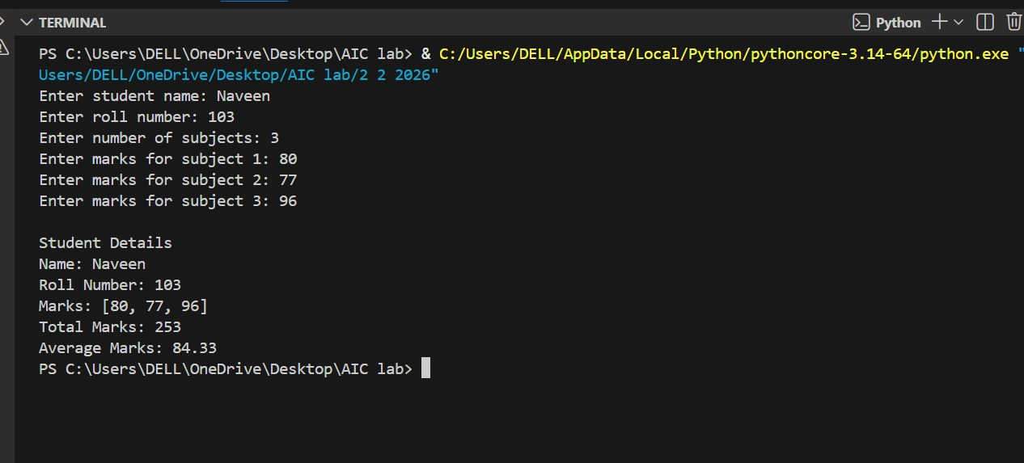
Analysis:
Student Class for Marks Calculation. The objective of this program is to design a Python class named Student that stores student details and calculates the total marks and average marks using class methods. The program also verifies correctness through user input and displayed output.

5. write a Python program for a simple bank account system using classes, loops, and conditional statements. The program should accept user input for account operations such as deposit, withdrawal, and balance inquiry through a menu-driven loop. After the code, identify the strengths and limitations of the AI-generated solution and briefly reflect on how AI assistance improves coding productivity.
Code:
lass BankAccount:
def __init__(self, name, balance=0):
self.name = name
self.balance = balance

def deposit(self, amount):
if amount > 0:
self.balance += amount
print("Deposit successful.")
else:
print("Invalid deposit amount.")

def withdraw(self, amount):
if amount <= 0:
print("Invalid withdrawal amount.")
elif amount > self.balance:
print("Insufficient balance.")
else:
self.balance -= amount
print("Withdrawal successful.")

def display_balance(self):
print("Current Balance:", self.balance)

# User input
name = input("Enter account holder name: ")
account = BankAccount(name)

while True:
print("\n--- Bank Menu ---")
print("1. Deposit")
print("2. Withdraw")
print("3. Check Balance")
print("4. Exit")

choice = input("Enter your choice (1-4): ")

if choice == "1":
amount = float(input("Enter deposit amount: "))
account.deposit(amount)

elif choice == "2":
amount = float(input("Enter withdrawal amount: "))
account.withdraw(amount)

elif choice == "3":
account.display_balance()

elif choice == "4":
print("Thank you for using the bank system.")
break

else:
print("Invalid choice. Please try again.")

output:
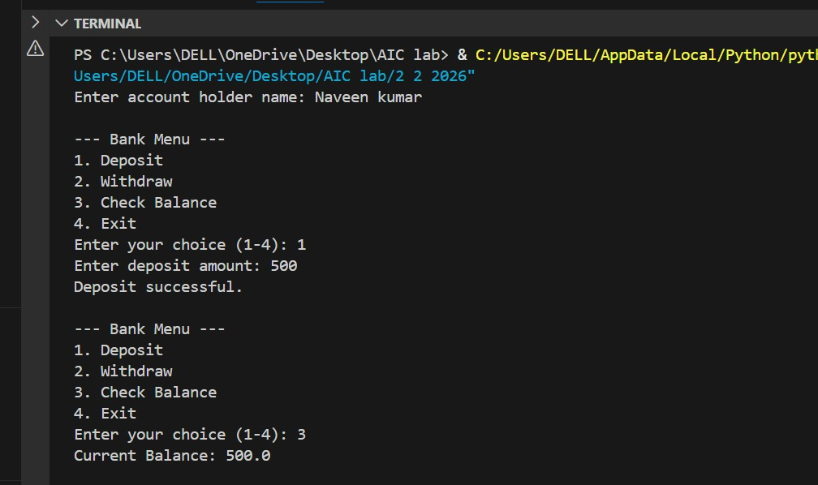
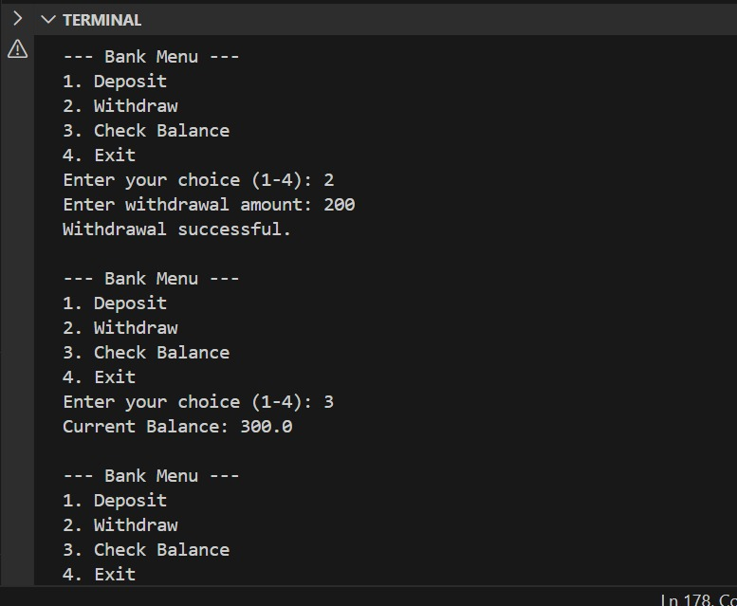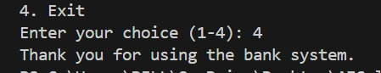
Analysis:
Bank Account System he objective of this task is to use an AI tool to generate a complete Python program that combines classes, loops, and conditional statements to implement a simple bank account system and to evaluate the effectiveness of AI-assisted coding.

