**J.C. BOSE UNIVERSITY OF**

**SCIENCE & TECHNOLOGY, YMCA**



**Report on the Physical Significance of Gamma and Beta Distributions**

**STATISTICS ASSIGNMENT**

**Submitted By:**   **Submitted To:**

Name : Keshav Kumar Ms Jyoti Rathee

Roll No : 23001016029

Branch : BTECH CEDS (4th sem)

**Table of Contents**

1. Introduction
2. Definitions and Mathematical Formulations
3. Historical Context
4. Probability Mass Function (PMF) and Probability Density Function (PDF)
5. Cumulative Distribution Function (CDF)
6. Moment Generating Function (MGF)
7. Properties of Gamma and Beta Distributions
8. Parameter Estimation Techniques
9. Applications of Gamma and Beta Distributions
10. Notations and Symbols Used
11. Conclusion
12. References

**Introduction**

Probability distributions are essential tools in understanding and modeling real-world phenomena. Among them, the **Gamma** and **Beta** distributions are widely used in physics, engineering, biology, and reliability analysis. While both are defined over the positive real numbers or within the [0,1] interval, their applications are distinct due to their shapes and properties. This report explores the **physical significance** of these two important distributions.

**Definitions and Mathematical Formulations**

**1. Gamma Distribution**

Definition:

The Gamma distribution is a two-parameter family of continuous probability distributions defined for positive real numbers. It is used to model the waiting time until α events occur, where each event happens independently at a constant average rate.

Mathematical Formulation

The probability density function (PDF) of the Gamma distribution is given by:



Where:

* xx is the random variable (e.g., time, distance)
* α\alpha is the shape parameter
* β\beta is the rate parameter (inverse of scale)
* Γ(α)\Gamma(\alpha) is the Gamma function:

Γ(α)=∫0∞tα−1e−tdt\Gamma(\alpha) = \int_0^\infty t^{\alpha-1} e^{-t} dt

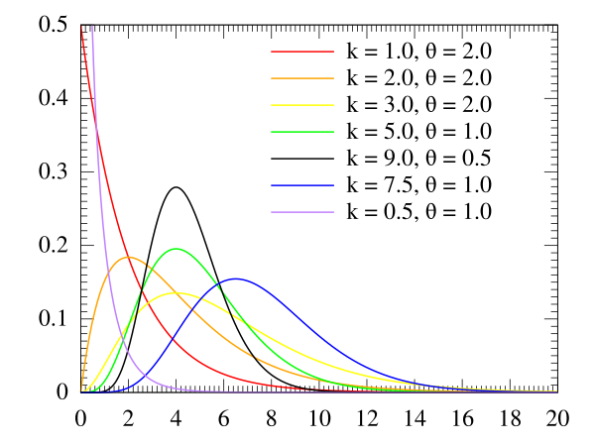

*The shape of the distribution varies significantly based on the value of α and β.*

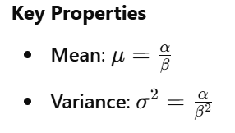

**2. Beta Distribution**

Definition:

The Beta distribution is a family of continuous probability distributions defined on the interval [0, 1]. It is particularly useful for modeling random variables that represent proportions or probabilities.

Mathematical Formulation

The probability density function (PDF) of the Beta distribution is:



Where:

* α\alpha and β\beta are shape parameters
* B(α,β)B(\alpha, \beta) is the Beta function, a normalization constant:

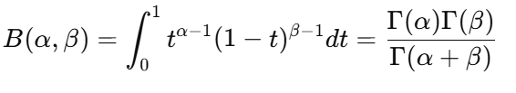

*The shape of the distribution can be skewed left, right, or even U-shaped depending on the values of α and β.*

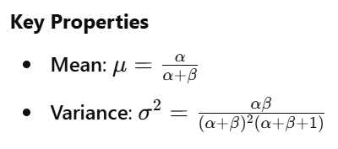

**Historical Context of Gamma and Beta Distributions**

The Gamma and Beta distributions have rich mathematical histories, deeply rooted in the development of probability theory and mathematical statistics.

**Gamma Distribution: Origins and Evolution**

The Gamma distribution was first introduced in the context of mathematical analysis and complex integrals. The foundation of this distribution lies in the Gamma function, denoted by Γ(n), which was generalized by the renowned mathematician Leonhard Euler in the 18th century. The Gamma function extends the concept of factorials beyond integers, allowing it to be applied to real and complex numbers:

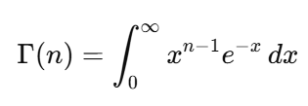

Euler's work laid the groundwork for what would later be recognized as the Gamma distribution, which appears naturally in problems related to waiting times and processes involving the sum of exponential variables. It wasn't until the 20th century that the distribution took on its modern probabilistic form, thanks to contributions from statisticians and applied mathematicians like Jacques Hadamard and Pearson.

The Gamma distribution became especially prominent in queueing theory, reliability engineering, and Bayesian statistics. In the Bayesian framework, it serves as a conjugate prior for the exponential and Poisson distributions, making it a vital tool in inference problems.

**Beta Distribution: Emergence and Development**

The Beta distribution, like the Gamma, also derives from an integral expression — the Beta function, denoted as B(α, β), which is defined as:

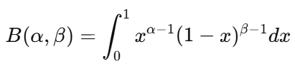

This function, too, was studied by Euler in the 18th century, but the Beta distribution itself emerged in the early 1900s as part of Karl Pearson's efforts to classify a wide range of empirical distributions. Pearson introduced the Beta distribution as part of his Pearson distribution family, which aimed to model various types of skewed data observed in real-life phenomena.

One of the key reasons for the Beta distribution's importance is its flexibility in modeling random variables bounded between 0 and 1. It found applications in modeling probabilities, proportions, and Bayesian posterior distributions, especially when the prior beliefs are themselves represented as continuous distributions.

**Integration into Statistical Theory**

Both the Gamma and Beta distributions gained further prominence as mathematical tools when Bayesian statistics rose to popularity in the mid-20th century. They were particularly admired for their conjugacy properties, which greatly simplified analytical computations in Bayesian inference.

Furthermore, with the advent of modern computing, these distributions are now easily implemented and analyzed using software like R, Python (SciPy), and MATLAB, reinforcing their importance in both theoretical research and applied fields such as finance, medicine, machine learning, and engineering.

**Probability Mass Function (PMF) and Probability Density Function (PDF)**

In probability theory, the Probability Mass Function (PMF) is used for discrete random variables, while the Probability Density Function (PDF) is used for continuous random variables. Since Gamma and Beta distributions are continuous, we describe their PDFs, not PMFs.

**Gamma Distribution – PDF and Derivation**

The Gamma distribution models the sum of multiple independent exponentially distributed random variables. It is commonly used to represent waiting times, reliability, and stochastic processes.

Definition:

Let X be a continuous random variable that follows a Gamma distribution with shape parameter α>0\alpha > 0α>0 and scale parameter θ>0\theta > 0θ>0. Its PDF is given by:

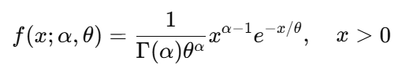

Alternatively, using rate parameter ​ 

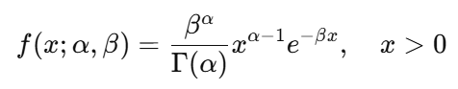

Proof (Sketch of Derivation):

The Gamma function is defined as:

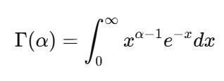

To make this a probability distribution, we normalize the function so that the total area under the curve is 1. Thus:

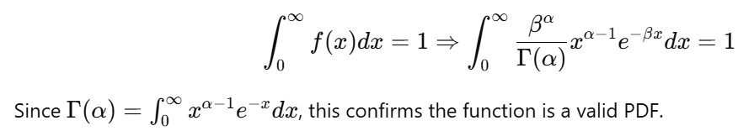

4.2 Beta Distribution – PDF and Derivation

The Beta distribution is used for modeling probabilities and proportions in the interval [0, 1]. It is defined by two shape parameters: α>0\alpha > 0α>0 and β>0\beta > 0β>0.

Definition:

Let X∈[0,1]X \in [0,1]X∈[0,1] be a continuous random variable following the Beta distribution. Its PDF is:

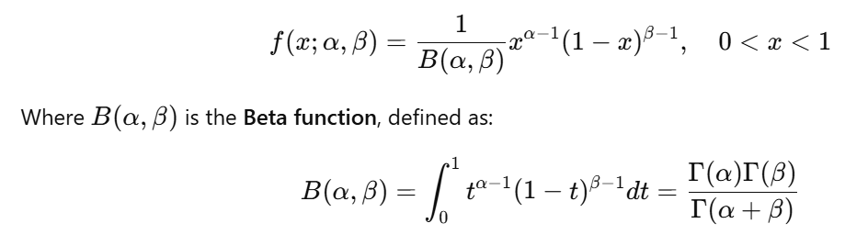Proof (Sketch of Derivation):

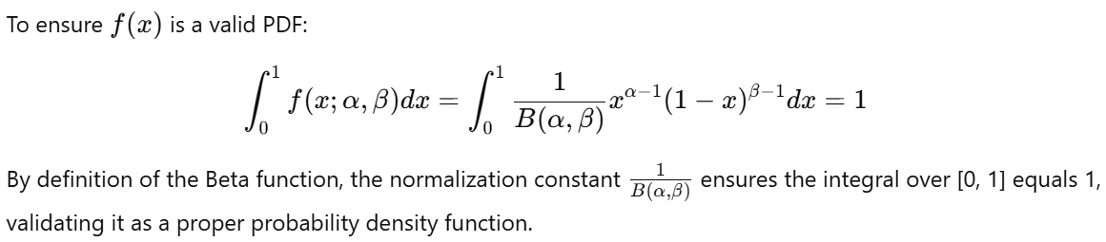

**Cumulative Distribution Function (CDF)**

The Cumulative Distribution Function (CDF) of a continuous random variable provides the probability that the variable takes a value less than or equal to a specific value. It is defined as:

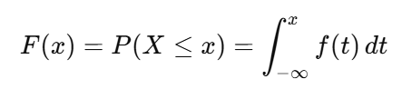

For distributions like Gamma and Beta, which are defined over specific intervals, the limits of integration and evaluation of the CDF follow their domain.

**Gamma Distribution – CDF**

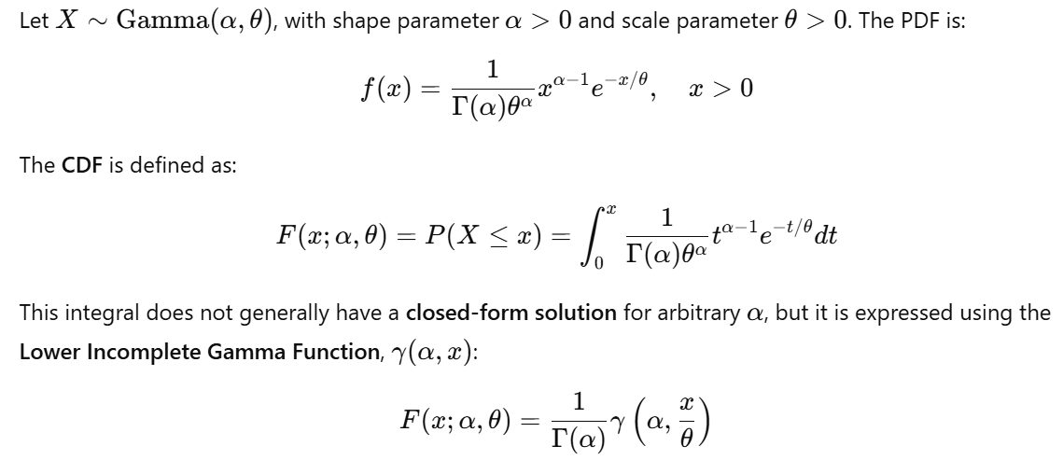Where the lower incomplete Gamma function is:

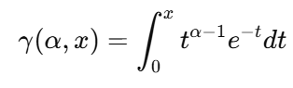

Thus, the CDF can be written compactly as:

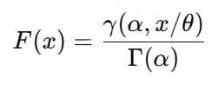

Key Points:

* The Gamma CDF is monotonically increasing.
* It approaches 1 as x→∞x \to \inftyx→∞.
* It is used to determine waiting time probabilities and reliability in engineering contexts.

**Beta Distribution – CDF**

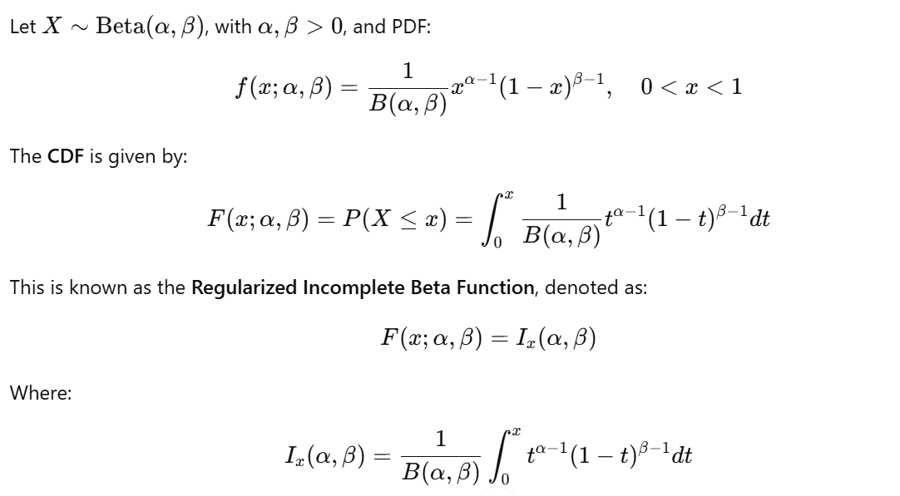The Beta function B(α,β)B(\alpha, \beta)B(α,β) is related to the Gamma function:

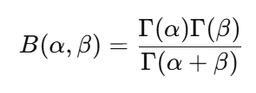

Key Points:

* The Beta CDF is bounded in [0, 1].
* It represents the probability of proportions, making it useful in Bayesian analysis.
* The CDF is flexible in shape depending on the values of α\alphaα and β\betaβ (U-shaped, skewed, uniform, etc.).

**Moment Generating Function (MGF)**

The Moment Generating Function (MGF) of a random variable X is a function that encodes all of the moments (mean, variance, etc.) of a distribution. It is defined as:

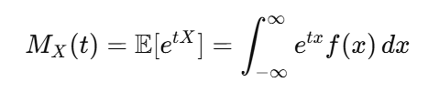

* If it exists, the MGF uniquely determines the probability distribution.
* The nthn^{th}nth moment of a random variable can be found by differentiating the MGF nnn times and evaluating at t=0t = 0t=0:

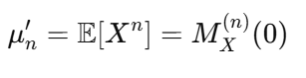

**MGF of Gamma Distribution**

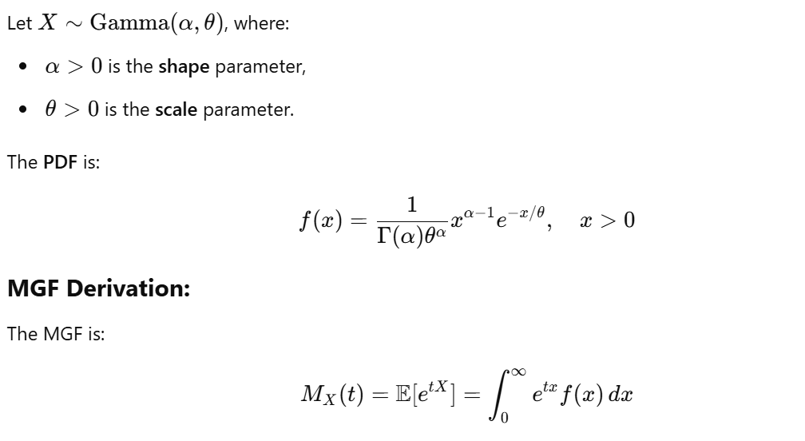

Substitute the PDF:

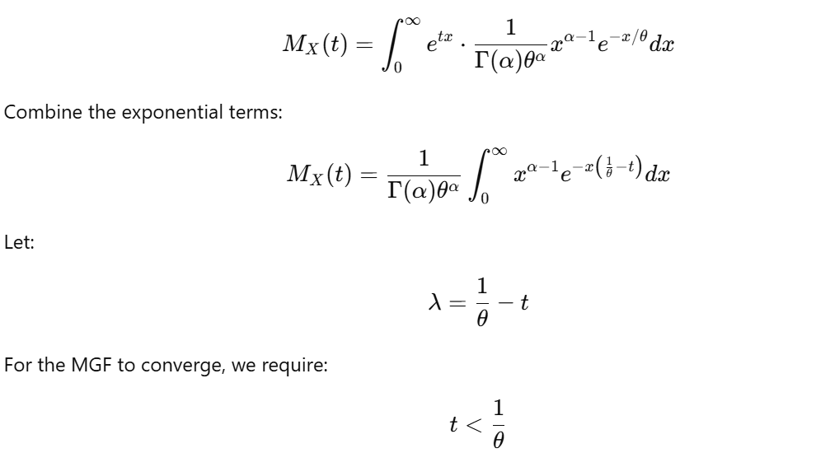

Now, this integral becomes:

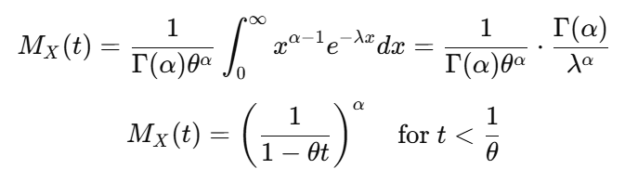

**MGF of Gamma Summary:**

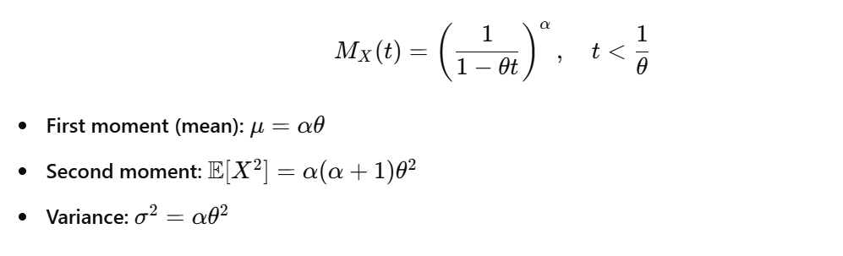

**MGF of Beta Distribution**

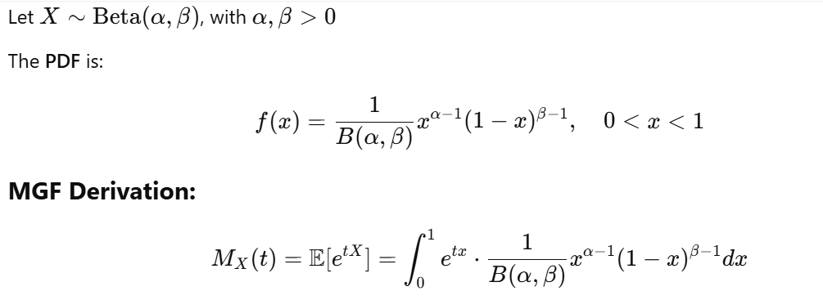This integral does not simplify to a closed form in terms of elementary functions. However, it is expressed as a confluent hypergeometric function or evaluated numerically.

Therefore, the MGF of the Beta distribution exists for all real ttt, but has no closed form in general.

Moments of Beta Distribution:

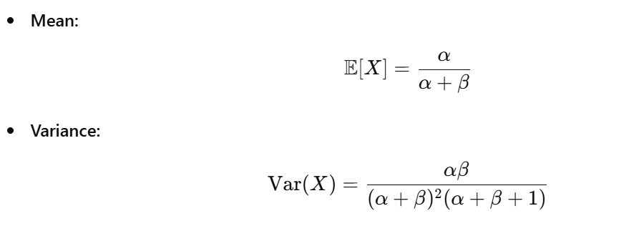

**Properties of Gamma and Beta Distributions**

The Gamma distribution is a two-parameter family of continuous probability distributions. It is defined by:

* Shape parameter α>0\alpha > 0α>0
* Scale parameter θ>0\theta > 0θ>0

**1. Support**



The distribution is defined only for positive values, making it ideal for modeling waiting times, lifespans, and accumulated events.

**2. Probability Density Function (PDF)**

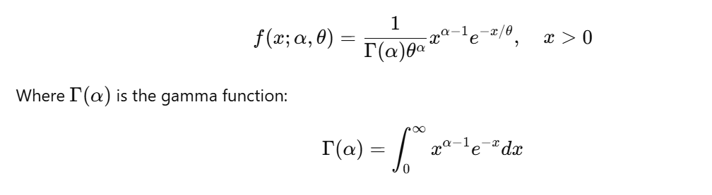

**3. Cumulative Distribution Function (CDF)**

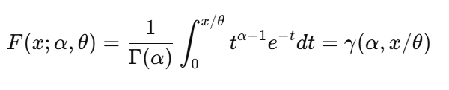

Where γ(α,x/θ)\gamma(\alpha, x/\theta)γ(α,x/θ) is the lower incomplete gamma function.

**4. Mean and Variance**

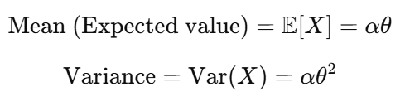

**5. Skewness and Kurtosis**

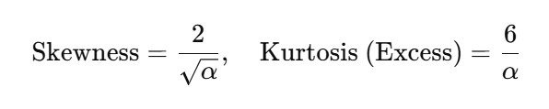As α\alphaα increases, the distribution becomes more symmetric.

**6. Additivity Property**

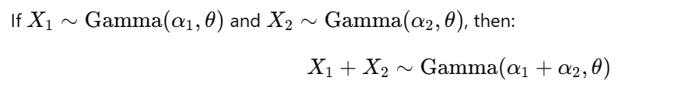This is useful in modeling total waiting times or sums of exponential variables.

**7. Memorylessness (Special Case)**

Although the gamma distribution itself is not memoryless, when α=1\alpha = 1α=1, it reduces to the exponential distribution, which is memoryless.

**8. Applications**

* Modeling waiting time until α\alphaα events happen (e.g., Poisson process)
* Rainfall, insurance claims, queuing systems
* Bayesian statistics (as a conjugate prior for rate parameters)

**Properties of the Beta Distribution**

The Beta distribution is a family of continuous probability distributions on the interval (0,1)(0, 1)(0,1), defined by:

* Shape parameters: α>0\alpha > 0α>0, β>0\beta > 0β>0

**1. Support**

x∈(0,1)x \in (0, 1)x∈(0,1)

This makes it ideal for modeling proportions, probabilities, and fractions.

**2. Probability Density Function (PDF)**

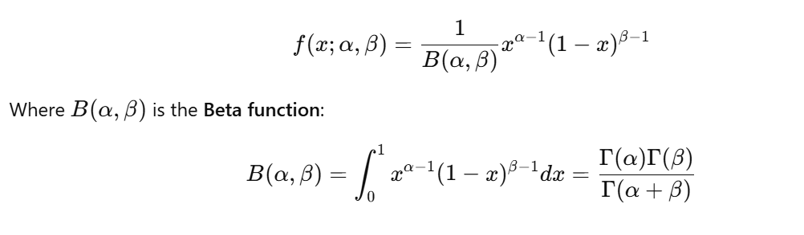

**3. Cumulative Distribution Function (CDF)**

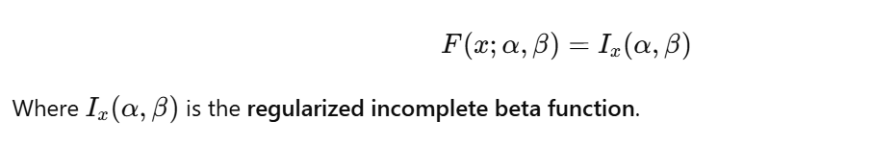

**4. Mean and Variance**

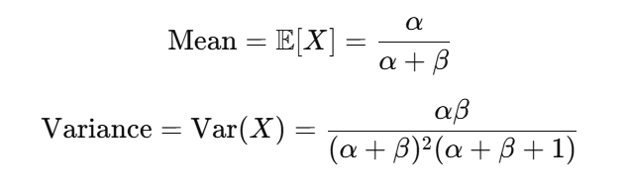

**5. Mode**

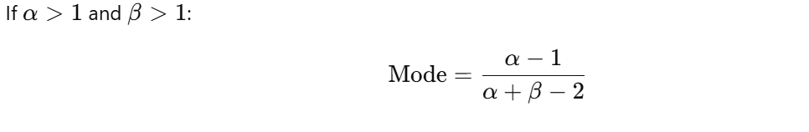

**6. Symmetry**

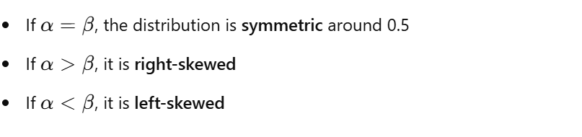

**7. Conjugacy (Bayesian Property)**

The Beta distribution is the conjugate prior for the binomial and Bernoulli likelihoods in Bayesian inference.

If the prior is Beta(α,β)\text{Beta}(\alpha, \beta)Beta(α,β) and we observe xxx successes in nnn trials, the posterior becomes:

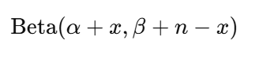

**8. Flexibility of Shape**

The Beta distribution is highly flexible. Depending on the values of α\alphaα and β\betaβ, it can be:

* Uniform (α=β=1\alpha = \beta = 1α=β=1)
* U-shaped
* Bell-shaped
* J-shaped or reverse J-shaped

**9. Applications**

* Modeling probabilities, success rates, proportions
* Bayesian estimation of probabilities
* Modeling task completion ratios, time allocation (in project management)

**Parameter Estimation Techniques**

Parameter estimation is a critical step in statistical modeling. It involves using observed data to estimate the parameters of a probability distribution. For Gamma and Beta distributions, the common techniques used are:

* Method of Moments (MoM)
* Maximum Likelihood Estimation (MLE)

Each method has its own advantages depending on the context and nature of data.

**A. Gamma Distribution**

Let X1,X2,…,XnX_1, X_2, \ldots, X_nX1​,X2​,…,Xn​ be independent and identically distributed (i.i.d.) random variables from a Gamma distribution with shape parameter α\alphaα and scale parameter θ\thetaθ.

**1. Method of Moments (MoM)**

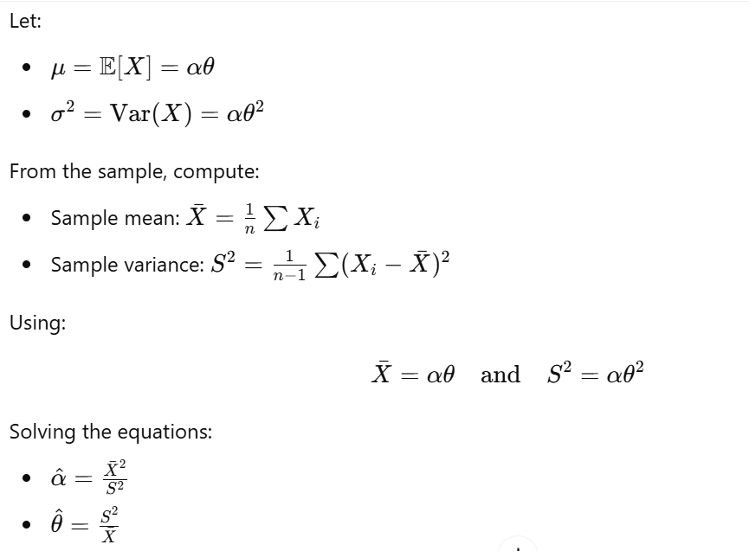

**2. Maximum Likelihood Estimation (MLE)**

The likelihood function for the Gamma distribution:

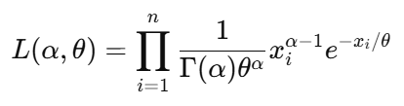

The log-likelihood:

To estimate α\alphaα and θ\thetaθ, we solve:

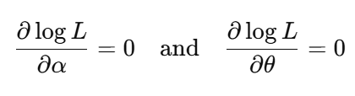

This leads to a transcendental equation involving the digamma function ψ(α)\psi(\alpha)ψ(α). Iterative numerical methods such as Newton-Raphson are used for solving α\alphaα. Once α\alphaα is known, estimate θ\thetaθ as:

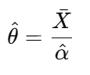

**B. Beta Distribution**

Let X1,X2,…,XnX_1, X_2, \ldots, X_nX1​,X2​,…,Xn​ be i.i.d. random variables from a Beta distribution with parameters α\alphaα and β\betaβ.

**1. Method of Moments (MoM)**

Let:

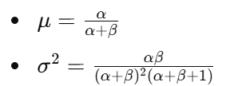

From the sample:

* Sample mean: Xˉ\bar{X}Xˉ
* Sample variance: S2S^2S2

Now define:

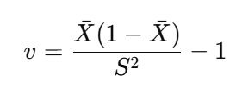

Then:

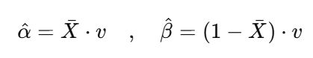This method works well for initial approximations and small samples.

**2. Maximum Likelihood Estimation (MLE)**

The likelihood function for the Beta distribution is:

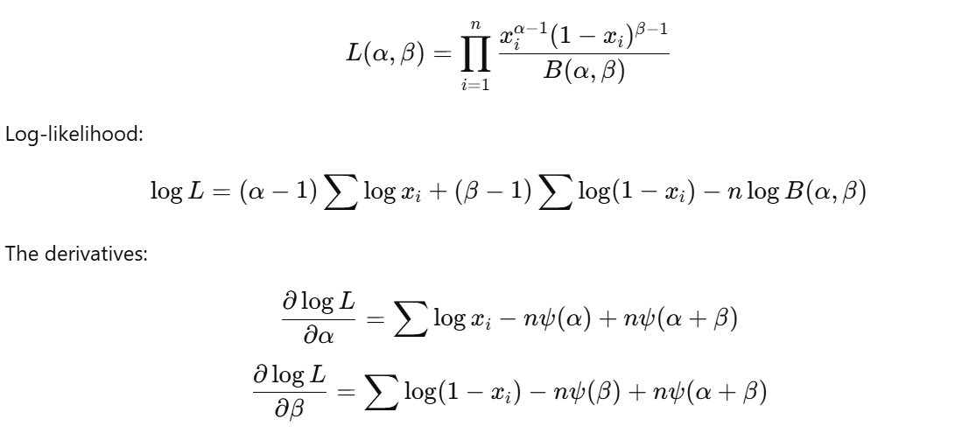Where ψ(⋅)\psi(\cdot)ψ(⋅) is the digamma function. These equations are solved using iterative methods (e.g., Newton-Raphson).

**3. Numerical Estimation Techniques**

For both distributions, especially when MLE becomes complex due to non-linear equations, estimation is done using numerical techniques:

* Newton-Raphson
* Method of Scoring
* Expectation-Maximization (EM) Algorithm

Statistical software such as R, Python (SciPy), or MATLAB can be used to obtain precise parameter estimates.

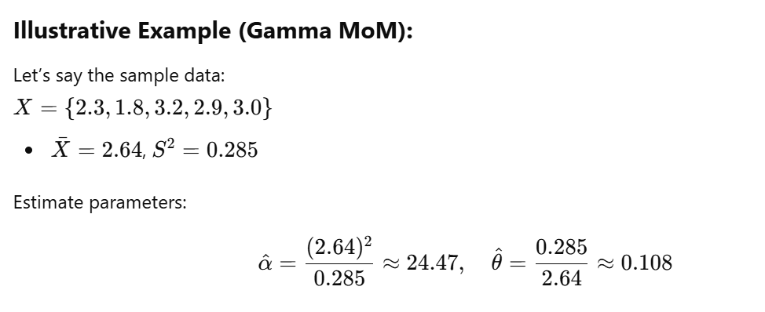

**Key Takeaways**

* MoM is simple but can be inaccurate with skewed distributions or small sample sizes.
* MLE is statistically efficient but computationally intensive.
* Choosing the method depends on data quality, sample size, and computational resources.

**Notations and Symbols Used**

In statistical theory and probability distribution analysis, consistent and clear notation is essential for expressing mathematical formulations, derivations, and theoretical concepts. Below is a comprehensive list of commonly used symbols and notations in the context of Gamma and Beta Distributions, along with their descriptions.

1. **Common Mathematical Symbols**

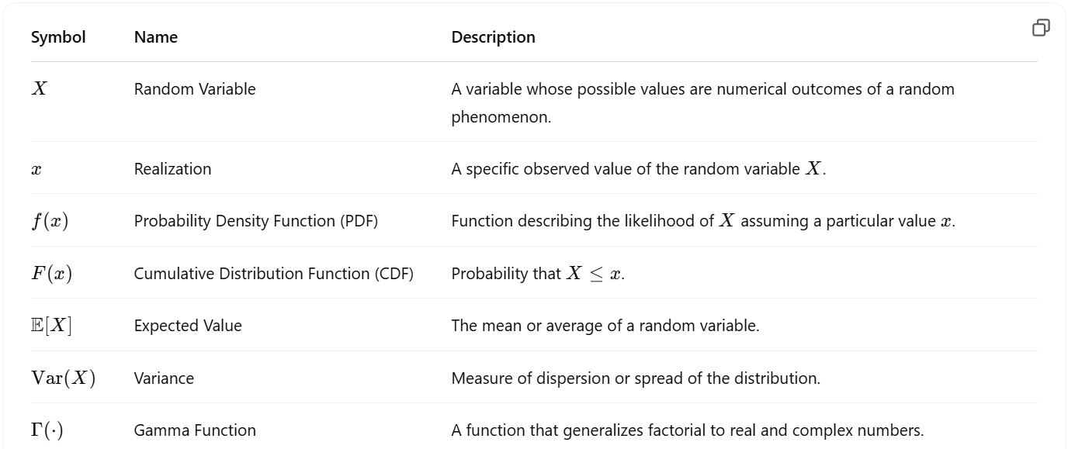

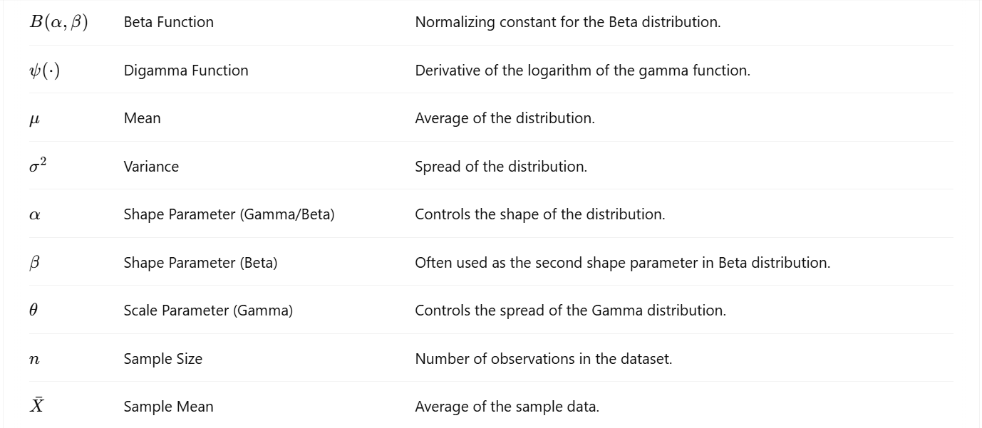

**Conclusion: Comparative Analysis of Gamma and Beta Distributions**

The Gamma and Beta distributions are two of the most significant continuous probability distributions in the field of statistics and applied mathematics. While they share some similarities in their formulation and mathematical underpinnings, they serve fundamentally different purposes and are used in different contexts. This report has delved into their definitions, formulations, historical development, probability functions, moment generating functions, properties, parameter estimation methods, and applications—revealing both their unique strengths and complementary roles.

**Domain and Support**

* Gamma Distribution: Defined on the interval (0,∞)(0, \infty)(0,∞), making it suitable for modeling positive continuous variables such as waiting times, life spans, or energy levels.
* Beta Distribution: Defined on the interval (0,1)(0, 1)(0,1), making it ideal for modeling proportions and probabilities, such as success rates and confidence scores.

**Parameterization and Shape**

* Both distributions use shape parameters α\alphaα (and β\betaβ for Beta), but their interpretations vary:
  + In Beta, α\alphaα and β\betaβ control the skewness and concentration of probability within [0,1][0,1][0,1].
  + In Gamma, α\alphaα (shape) and θ\thetaθ (scale) influence the rate of decay and peak of the distribution.
* Gamma becomes exponential when α=1\alpha = 1α=1, and Beta becomes uniform when α=β=1\alpha = \beta = 1α=β=1.

**Probability Functions**

* The PDF of both distributions includes a gamma function in their denominator for normalization, but the shapes of the functions vary drastically depending on parameters.
* CDFs in both distributions do not generally have closed-form expressions, but they are computable via numerical methods or incomplete gamma/beta functions.
* MGFs exist for the Gamma distribution (for t<1/θt < 1/\thetat<1/θ), but the Beta distribution does not have a closed-form MGF, often relying on series expansion.

**Properties and Moments**

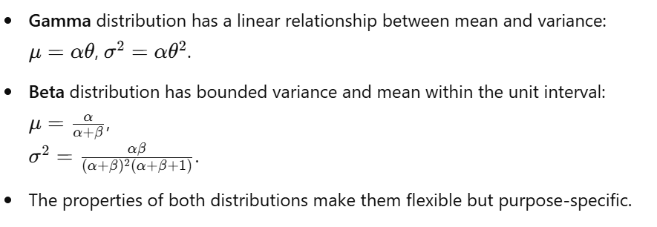

**Estimation Techniques**

* Both employ Maximum Likelihood Estimation (MLE) and Method of Moments (MoM) for parameter estimation, though the procedures differ due to the structure of their respective likelihood functions.
* Gamma's estimation often involves digamma functions; Beta may require numerical root-finding techniques.

**Applications**

* Gamma Distribution is widely used in:
  + Queuing models
  + Reliability engineering
  + Meteorology (e.g., rainfall modeling)
  + Bayesian priors for Poisson rates
* Beta Distribution is used in:
  + Bayesian inference (priors for binomial proportions)
  + Proportion modeling
  + A/B testing
  + Machine learning (conjugate priors)

**Symbolism and Notation**

* Both distributions share some mathematical symbols such as Γ(⋅)\Gamma(\cdot)Γ(⋅) (Gamma function), but their application in formulas and behavior differs.
* Proper understanding of notation like f(x)f(x)f(x), μ\muμ, σ2\sigma^2σ2, and normalization constants is essential for working with either distribution.

**Graphical Representation**

* Beta distributions are bounded between 0 and 1 and show great versatility in shapes (U-shaped, bell-shaped, J-shaped).
* Gamma distributions are right-skewed and become more symmetric with increasing α\alphaα.
* Visual tools and graphs highlight how parameter values influence the behavior of both distributions.

**Final Thoughts**

In conclusion, the Gamma and Beta distributions are not competitors but rather complementary tools in the statistician's toolkit. Where Gamma shines in modeling time and skewed continuous data, Beta excels in modeling uncertainty in probabilities and proportions. Their deep mathematical structure, including reliance on the Gamma function, ties them together, but their use cases and characteristics clearly differentiate them.

A solid understanding of these distributions allows practitioners to choose the right model for the right scenario, improving the quality and interpretability of statistical modeling, machine learning, and real-world decision-making processes.

**References**

1. Johnson, N. L., Kotz, S., & Balakrishnan, N. (1994). *Continuous Univariate Distributions, Volume 1*. Wiley-Interscience.
2. Casella, G., & Berger, R. L. (2002). *Statistical Inference* (2nd ed.). Duxbury Press.
3. Mood, A. M., Graybill, F. A., & Boes, D. C. (1974). *Introduction to the Theory of Statistics* (3rd ed.). McGraw-Hill.
4. DeGroot, M. H., & Schervish, M. J. (2011). *Probability and Statistics* (4th ed.). Pearson.
5. Ross, S. M. (2014). *Introduction to Probability Models* (11th ed.). Academic Press.
6. Papoulis, A., & Pillai, S. U. (2002). *Probability, Random Variables and Stochastic Processes* (4th ed.). McGraw-Hill.
7. Gelman, A., Carlin, J. B., Stern, H. S., Dunson, D. B., Vehtari, A., & Rubin, D. B. (2013). *Bayesian Data Analysis* (3rd ed.). CRC Press.
8. Wikipedia contributors. (2023). *Gamma distribution*. In *Wikipedia, The Free Encyclopedia*. Retrieved from <https://en.wikipedia.org/wiki/Gamma_distribution>
9. Wikipedia contributors. (2023). *Beta distribution*. In *Wikipedia, The Free Encyclopedia*. Retrieved from <https://en.wikipedia.org/wiki/Beta_distribution>
10. Wolfram Research. (2024). *Gamma Distribution*. Wolfram MathWorld. Retrieved from https://mathworld.wolfram.com/GammaDistribution.html
11. Wolfram Research. (2024). *Beta Distribution*. Wolfram MathWorld. Retrieved from https://mathworld.wolfram.com/BetaDistribution.html
12. Rice, J. A. (2006). *Mathematical Statistics and Data Analysis* (3rd ed.). Duxbury Press.
13. Abramowitz, M., & Stegun, I. A. (1972). *Handbook of Mathematical Functions with Formulas, Graphs, and Mathematical Tables*. National Bureau of Standards.