Virtual Cinema Platform Documentation

# Introduction

We are thrilled to announce the latest enhancements to our website, including the Video Upload feature and the ability to watch videos online. This documentation provides insights into the development of these features, the seamless integration with our backend, and the utilization of IBM Cloud services to ensure a comprehensive user experience.

# Project Objective

Our project's main objective is to create an immersive virtual cinema platform where users can upload, share, and watch videos. We aim to provide a user-centered experience that fosters creativity and community engagement.

# Design Thinking Process

The design thinking process guided our project, focusing on understanding user needs and providing solutions that enhance their virtual cinema experience.

# Development Phases

We executed the project in distinct phases, from initial ideation to final implementation, ensuring a smooth and structured development journey.

# Platform Features

## Overview

Our platform offers a range of features designed to enrich the user experience:

**User Registration:** Users can securely create accounts to access the platform.

**Video Upload**: A user-friendly process for sharing videos.

**Streaming Integration**: Real-time streaming for an immersive movie-watching experience.

**Online Viewing:** The ability to watch videos directly on our platform.

User Registration

Users can register for accounts, providing their email and password securely. We've implemented robust backend authentication mechanisms to safeguard user data.

## Video Upload

Our video upload process is user-friendly and seamlessly integrated with our backend. IBM Cloud services, including IBM Cloud Object Storage, ensure reliability and security in handling user-generated content.

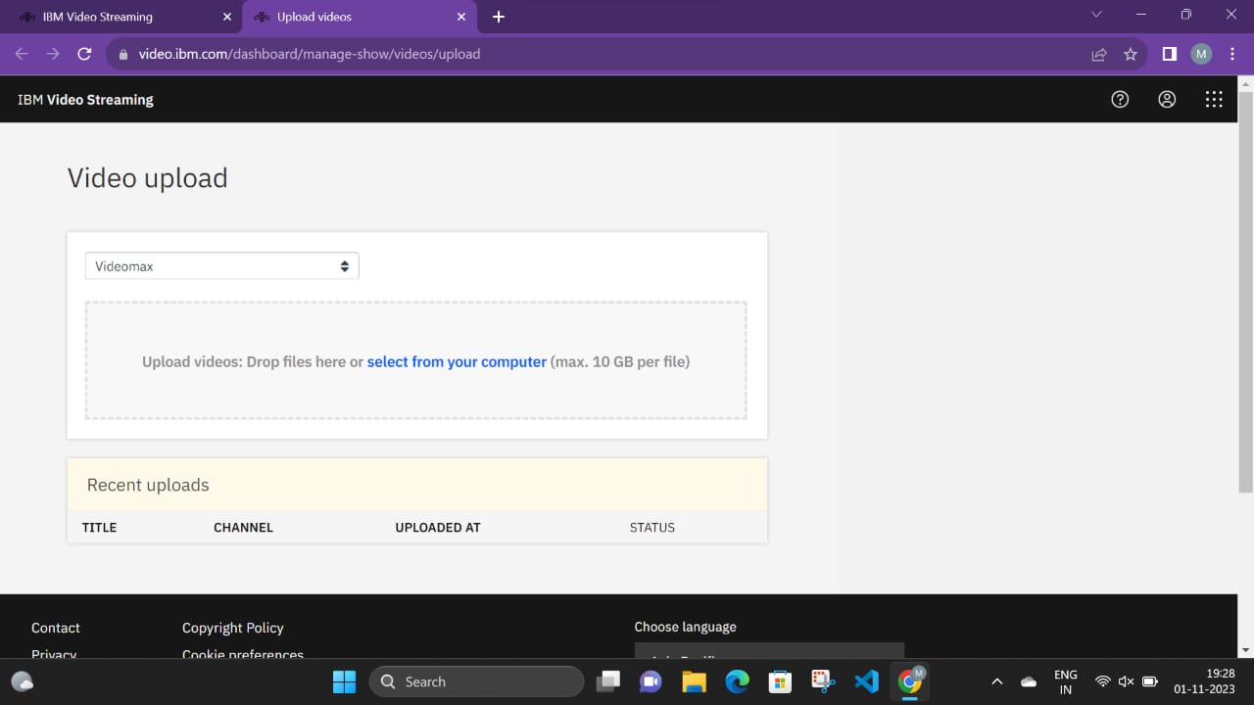

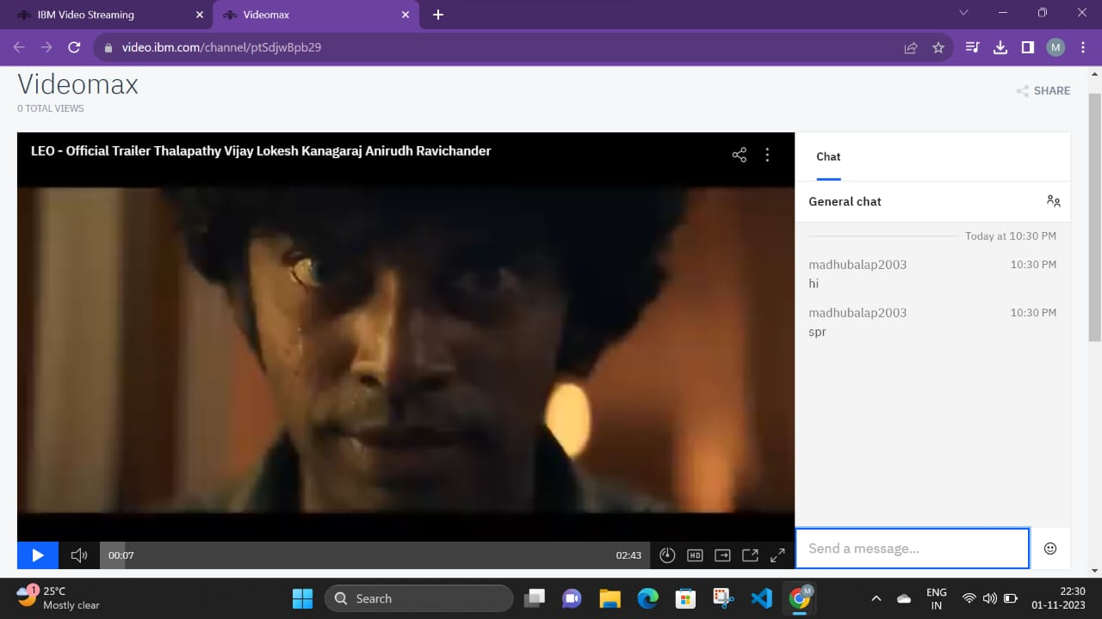

## Streaming Integration

We've leveraged streaming technology and IBM Cloud services to provide a seamless and immersive movie-watching experience.

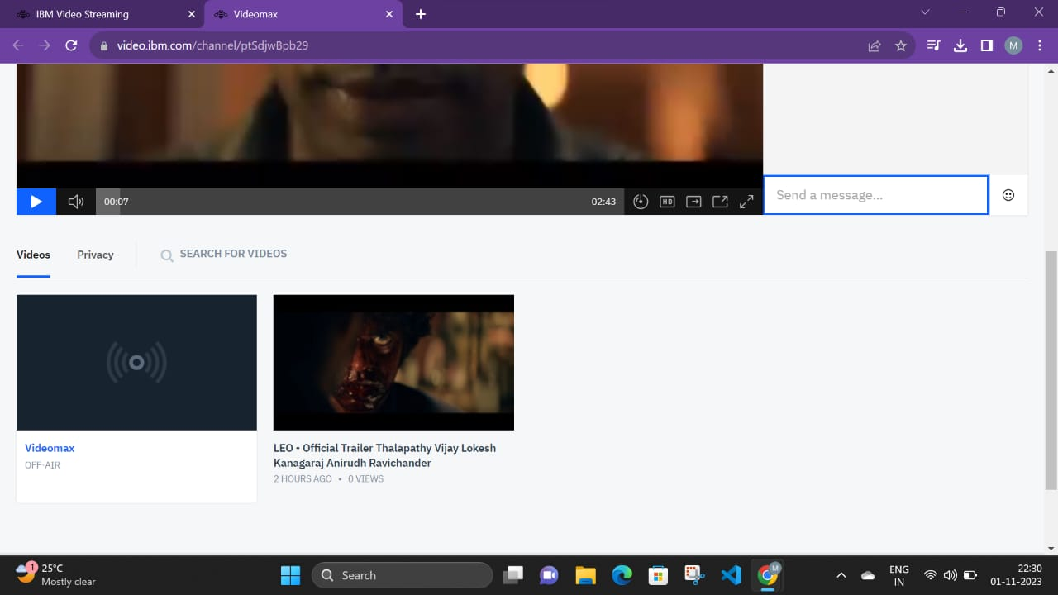



# User Interface Design

## Intuitive Layout

Our user interface is thoughtfully designed with an intuitive layout that makes navigation and content access straightforward.

## Navigation Bar

The navigation bar provides easy access to different sections of the platform, enhancing the user experience.

## Movie Listings

Movies are presented in a grid, allowing users to browse and select content effortlessly.

# Frontend:

HTML: The HTML code structures the content and layout of the platform.

**Index.html**

<!DOCTYPE html>

<html lang="en">

<head>

<meta charset="UTF-8">

<meta name="viewport" content="width=device-width, initial-scale=1.0">

<title>Virtual Cinema Platform</title>

<link rel="stylesheet" href="styles.css">

</head>

<body>

<div class="container">

<h1>Welcome to Virtual Cinema</h1>

<div class="options">

<a href="registration.html" class="option">Create Account</a>

<a href="login.html" class="option">Log In</a>

</div>

</div>

<script src="script.js"></script>

</body>

</html>

Registration.html  
<!DOCTYPE html>

<html lang="en">

<head>

<meta charset="UTF-8">

<meta name="viewport" content="width=device-width, initial-scale=1.0">

<title>User Registration</title>

<link rel="stylesheet" href="registrationstyles.css">

</head>

<body>

<div class="container">

<h1>User Registration</h1>

<form id="registration-form">

<div class="form-group">

<label for="username">Username:</label>

<input type="text" id="username" name="username" required>

</div>

<div class="form-group">

<label for="email">Email:</label>

<input type="email" id="email" name="email" required>

</div>

<div class="form-group">

<label for="password">Password:</label>

<input type="password" id="password" name="password" required>

</div>

<div class="form-group">

<label for="confirm-password">Confirm Password:</label>

<input type="password" id="confirm-password" name="confirm-password" required>

</div>

<button type="submit">Register</button>

</form>

</div>

<script src="script.js"></script>

</body>

</html>

Login.html

<!DOCTYPE html>

<html lang="en">

<head>

<meta charset="UTF-8">

<meta name="viewport" content="width=device-width, initial-scale=1.0">

<title>Login</title>

<link rel="stylesheet" href="loginstyles.css">

</head>

<body>

<div class="container">

<h1>Login to Your Account</h1>

<form id="login-form">

<div class="form-group">

<label for="email">Email:</label>

<input type="email" id="email" name="email" required>

</div>

<div class="form-group">

<label for="password">Password:</label>

<input type="password" id="password" name="password" required>

</div>

<button type="button" onclick="login()">Log In</button>

</form>

</div>

<script src="script.js"></script>

</body>

</html>

Homepage.html

<!DOCTYPE html>

<html lang="en">

<head>

<meta charset="UTF-8">

<meta name="viewport" content="width=device-width, initial-scale=1.0">

<title>Home Page</title>

<link rel="stylesheet" href="homestyles.css">

</head>

<body>

<header>

<h1>Welcome to Virtual Cinema</h1>

</header>

<nav>

<ul>

<li><a href="home.html">Home</a></li>

<li><a href="profile.html">Profile</a></li>

<li><a href="logout.html">Logout</a></li>

</ul>

</nav>

<main>

<section class="search-section">

<h2>Search</h2>

<input type="text" id="search-input" placeholder="Search for movies">

<button id="search-button">Search</button>

</section>

<section class="movie-section">

<h2>Recent Movies</h2>

<div class="movie-container">

<a href="movie_details.html">

<div class="movie">

<img src="https://m.media-amazon.com/images/M/MV5BNDA5YzlhNjItMDgxNC00MjQ4LWIzMDMtYTUyMzBhNjViNDk3XkEyXkFqcGdeQXVyMTY3ODkyNDkz._V1_.jpg" alt="Movie 1">

<p class="movie-name">Jailer</p>

</div>

</a>

<a href="movie_details.html">

<div class="movie">

<img src="https://m.media-amazon.com/images/M/MV5BMWZlMTY0YjItMDczMC00Mzk1LWEyMDgtM2M5YWJmYTU4Y2I2XkEyXkFqcGdeQXVyMTEzNzg0Mjkx._V1_.jpg" alt="Movie 2">

<p class="movie-name">Leo</p>

</div>

</a>

<!-- Add more movie entries as needed -->

</div>

</section>

<section class="movie-section">

<h2>Popular Movies</h2>

<div class="movie-container">

<a href="movie_details.html">

<div class="movie">

<img src="https://www.nowrunning.com/content/movie/2022/mark-26088/Stills/markantony_2023126.jpg" alt="Movie 3">

<p class="Mark Antony">Mark Antony</p>

</div>

</a>

<a href="movie_details.html">

<div class="movie">

<img src="https://m.media-amazon.com/images/M/MV5BMWZkMjE2OTktOGQ4Zi00OWQ1LTgwNjAtZTFjOGExYWQyMTU5XkEyXkFqcGdeQXVyMTQ3Mzk2MDg4._V1_FMjpg_UX1000_.jpg" alt="Movie 4">

<p class="movie-name">Chittha</p>

</div>

</a>

<!-- Add more movie entries as needed -->

</div>

</section>

</main>

<script src="script.js"></script>

</body>

</html>

CSS: The CSS code provides styling for a visually appealing user interfac

.

JavaScript: JavaScript adds functionality and interactivity to the platform.

# Video Playback

Users can click on movie names to watch videos, benefiting from real-time streaming capabilities for a seamless experience.

# Video Upload Process

## User-Friendly Submission

We've simplified the video submission process, making it convenient for users to share their content.

## Backend Integration

Our backend seamlessly integrates video uploads, ensuring secure storage and accessibility. Docker Hub is leveraged for containerization, allowing efficient deployment and scaling.

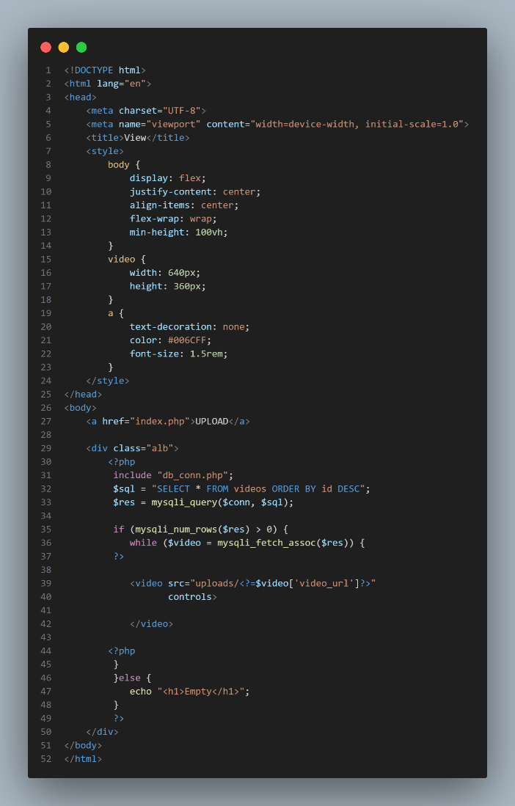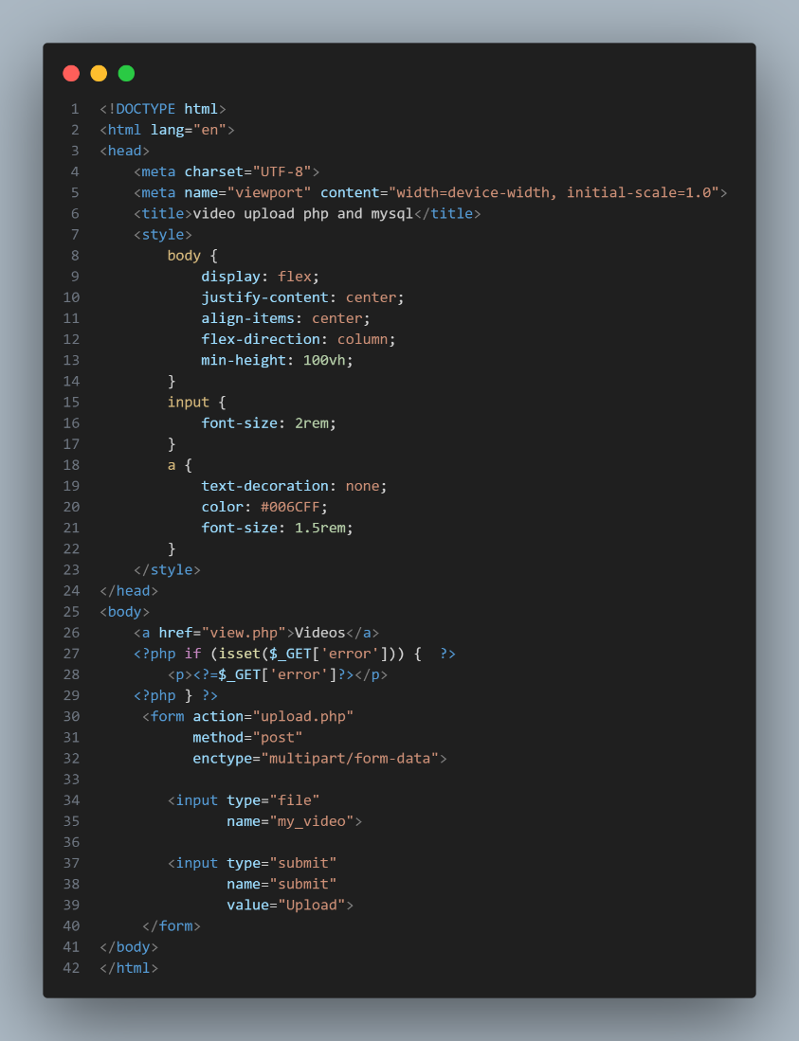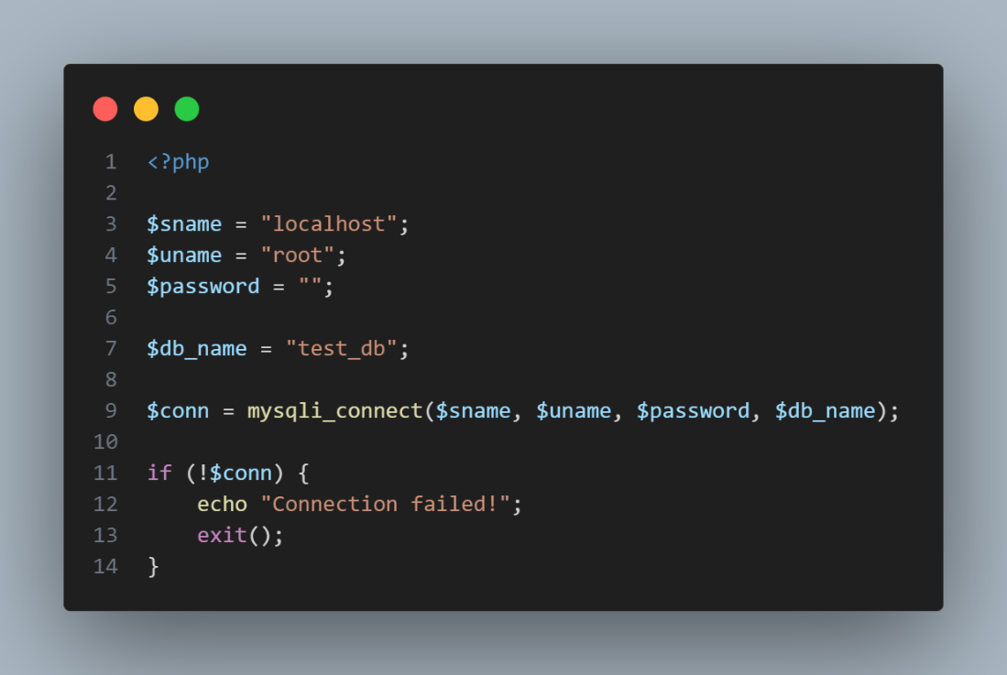

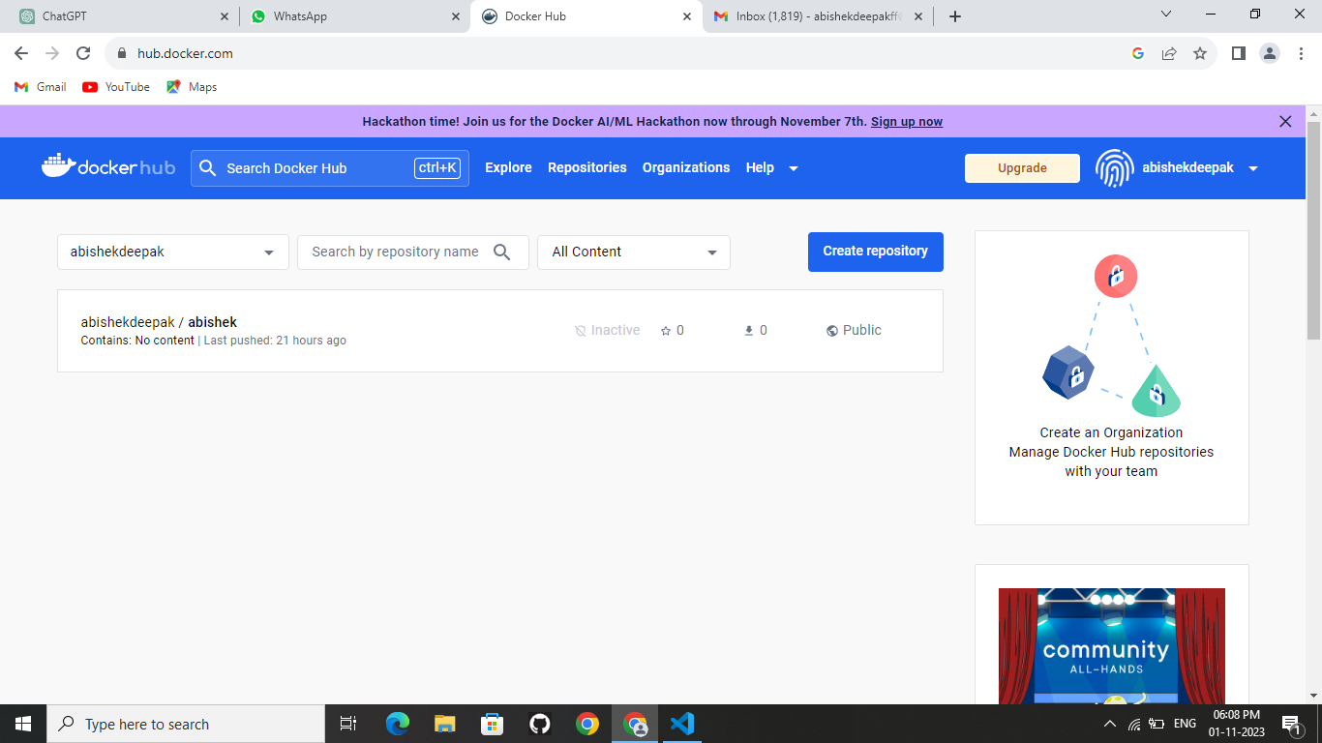

## IBM Cloud Services

IBM Cloud services, including IBM Cloud Object Storage, are instrumental in providing reliability, scalability, and security for video uploads.

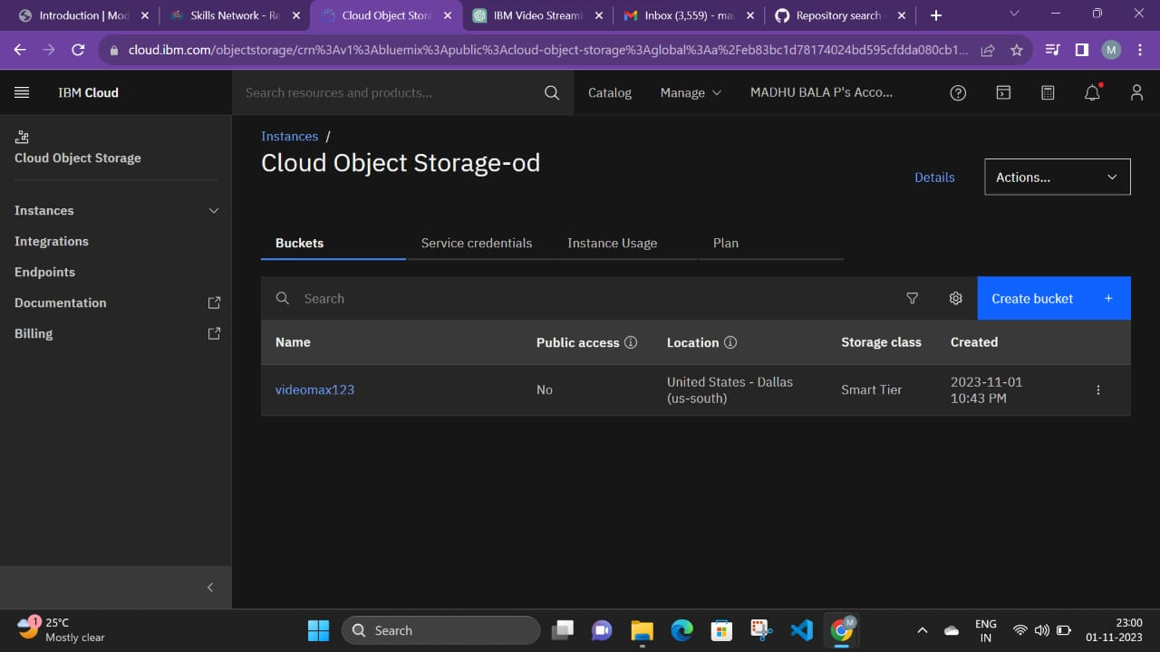

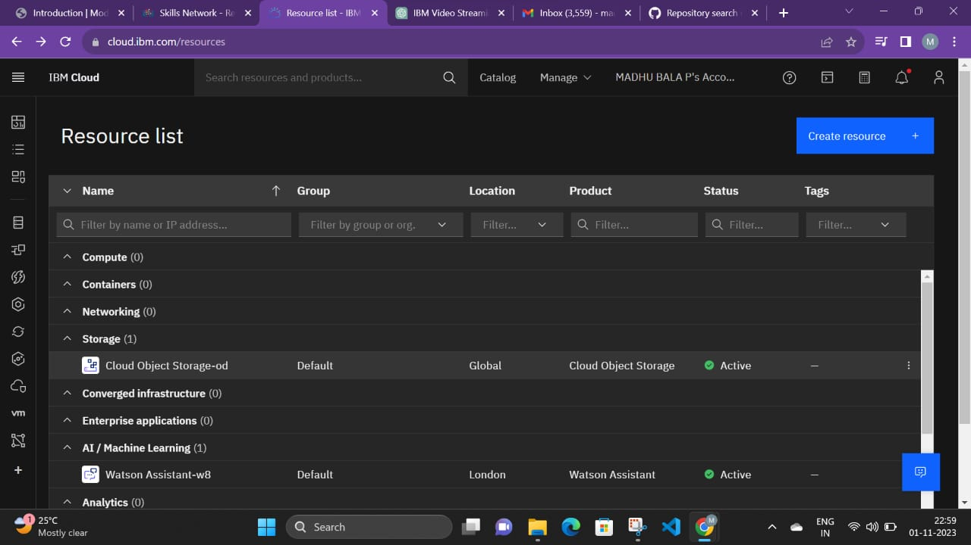

# Seamless Movie-Watching Experience

## Real-Time Streaming

The platform offers real-time streaming capabilities, providing an immersive movie-watching experience.

## Online Viewing

Users can watch videos directly on the platform, eliminating the need for third-party players.

## Comprehensive User Library

Our content library is enriched by user-uploaded videos, creating a diverse and engaging community.

Screenshots:

Home page:

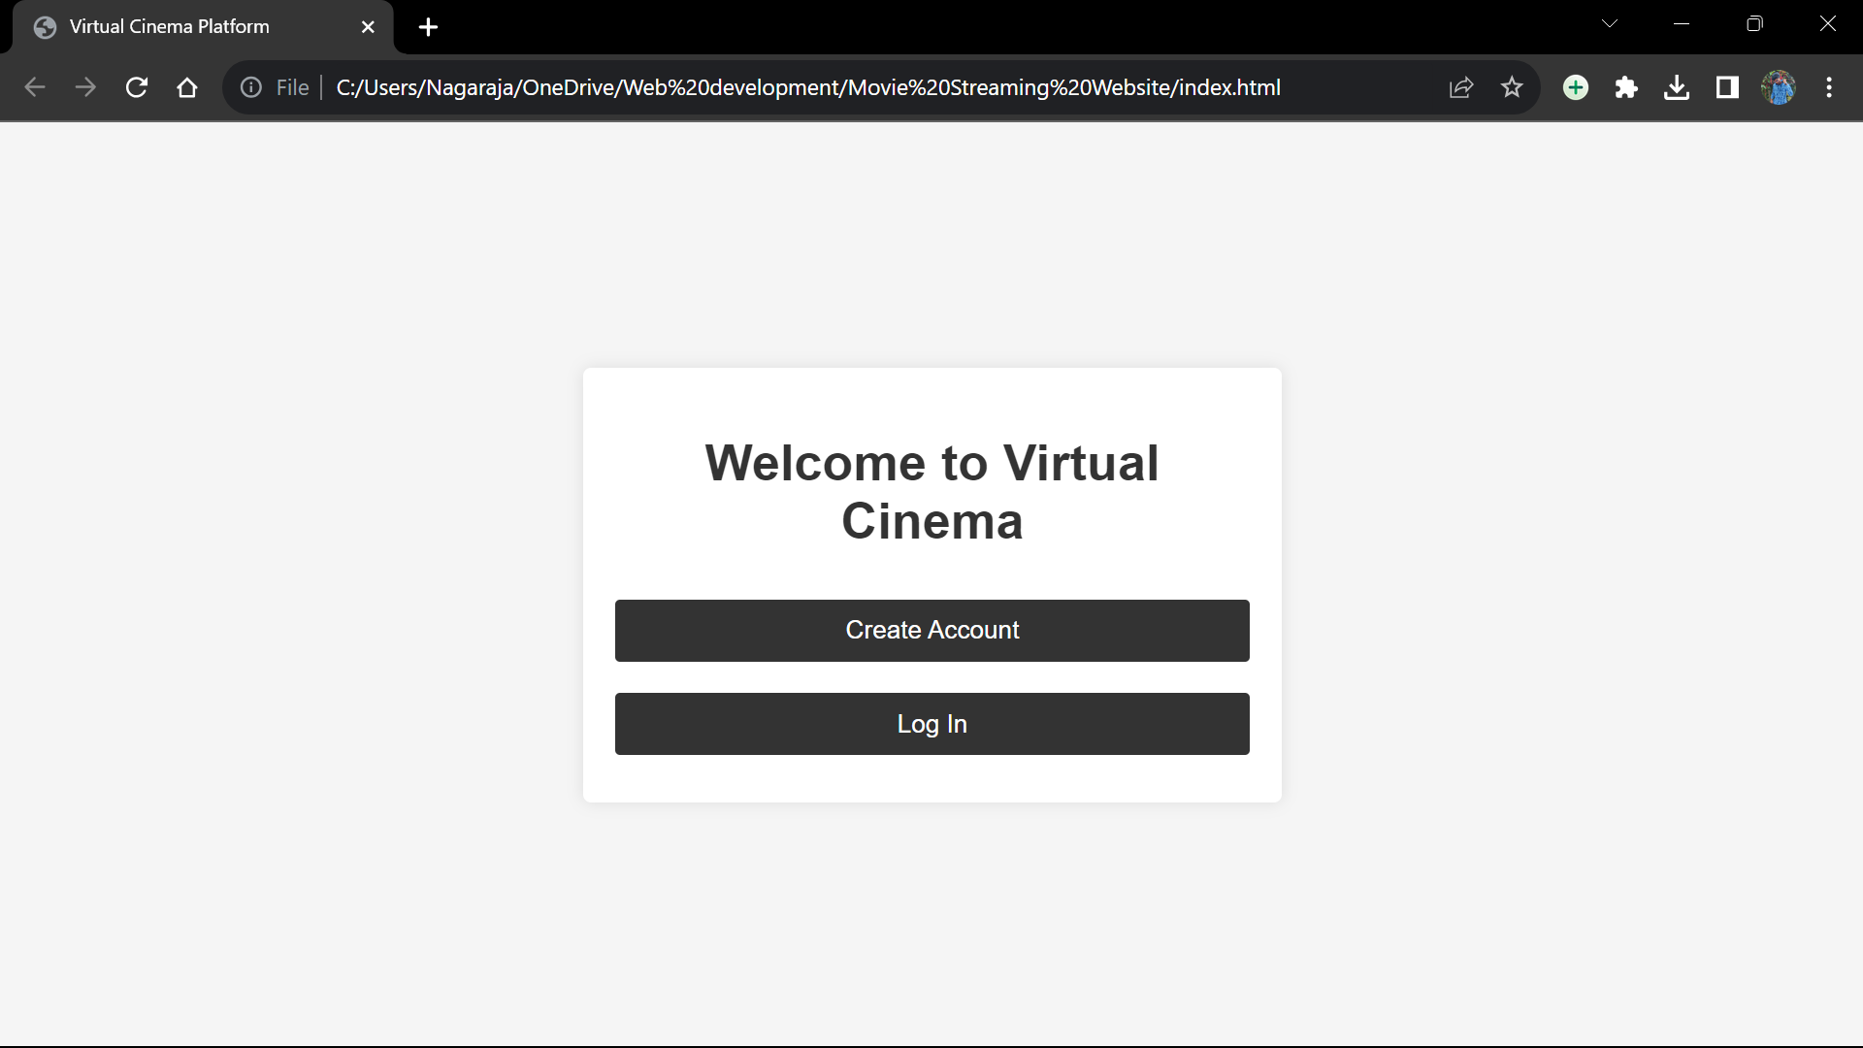

User Registration:

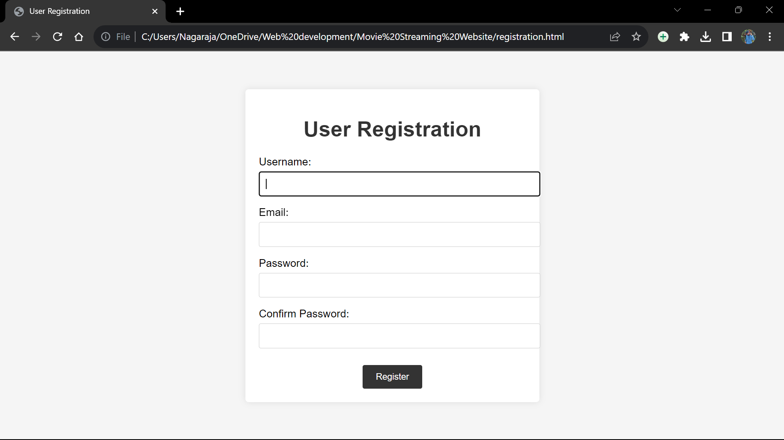

Log in portal:

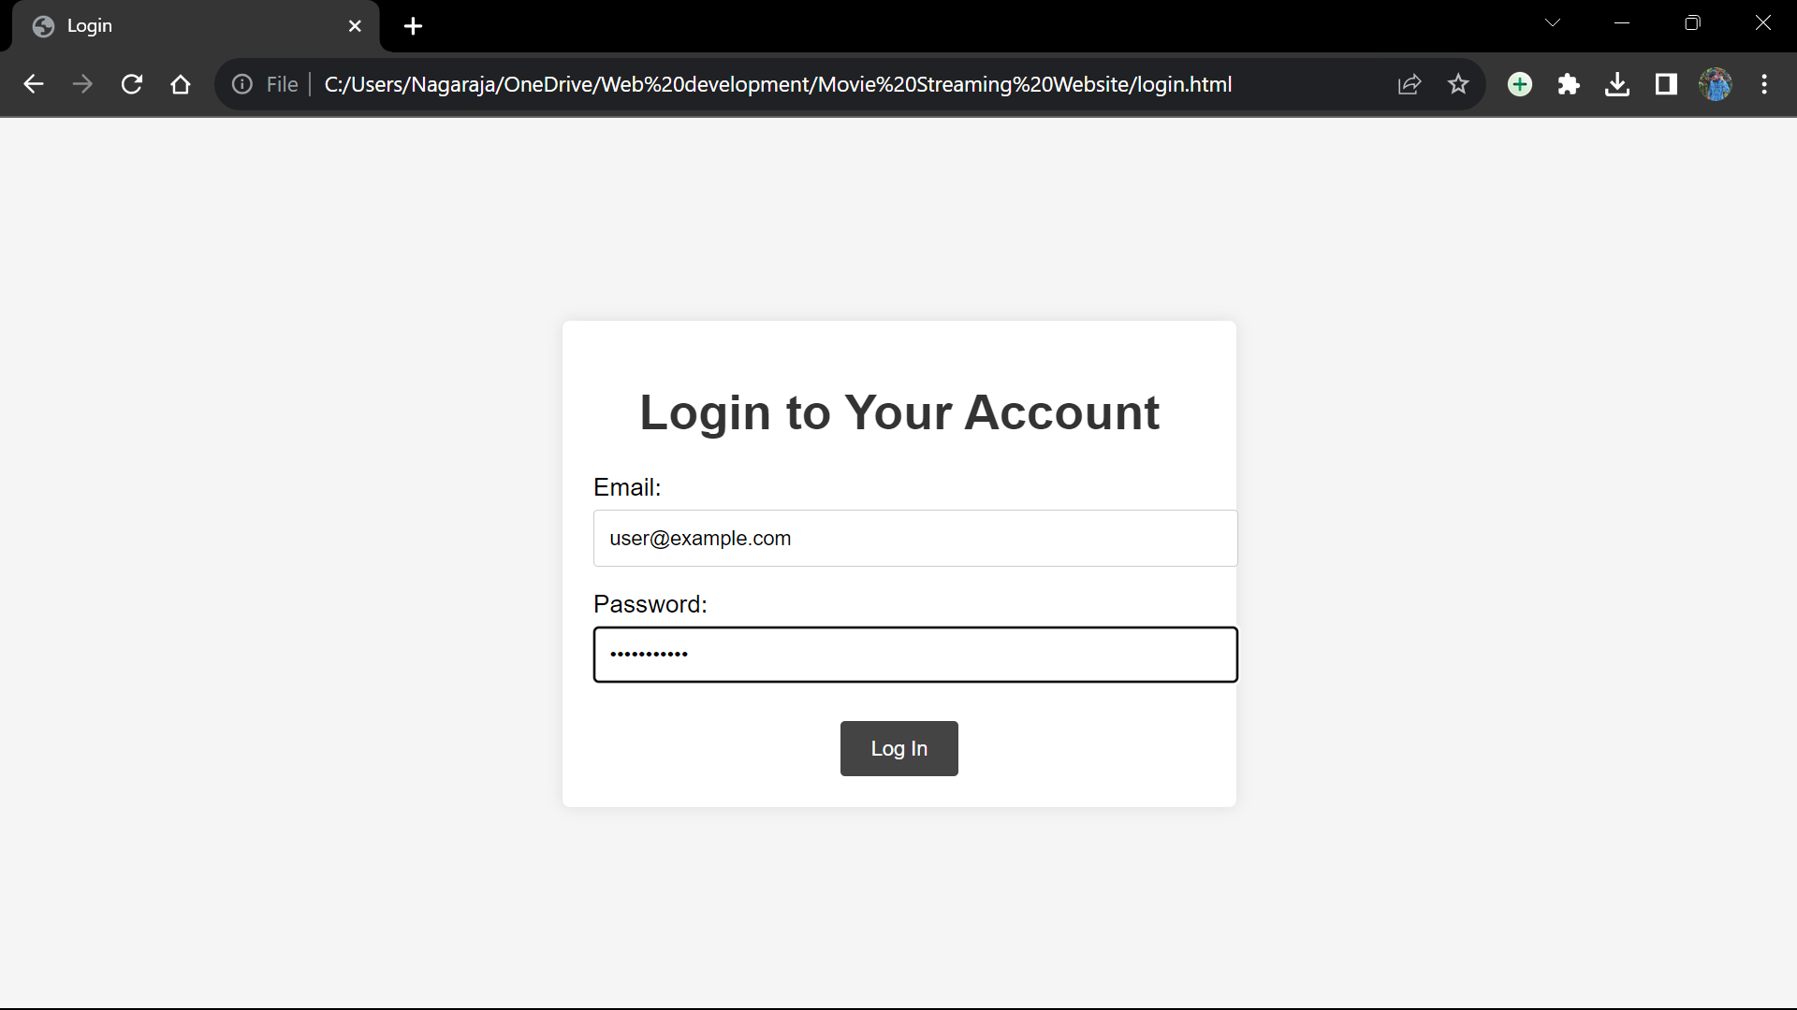

Website interface:

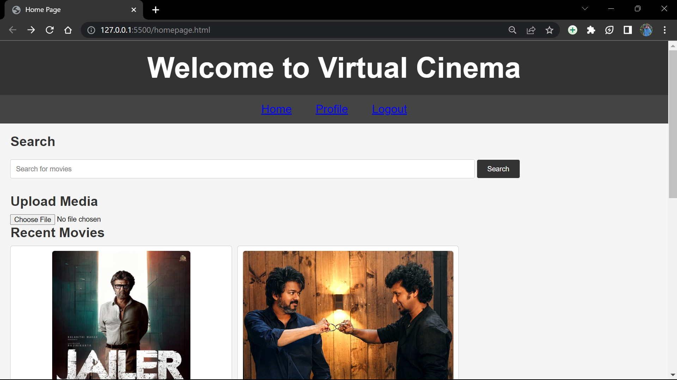

Uploading Video:

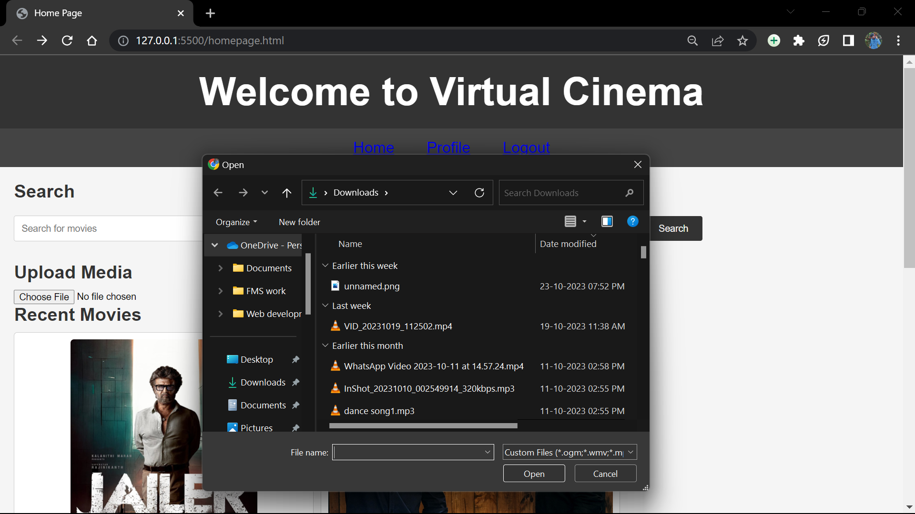

Video streaming:

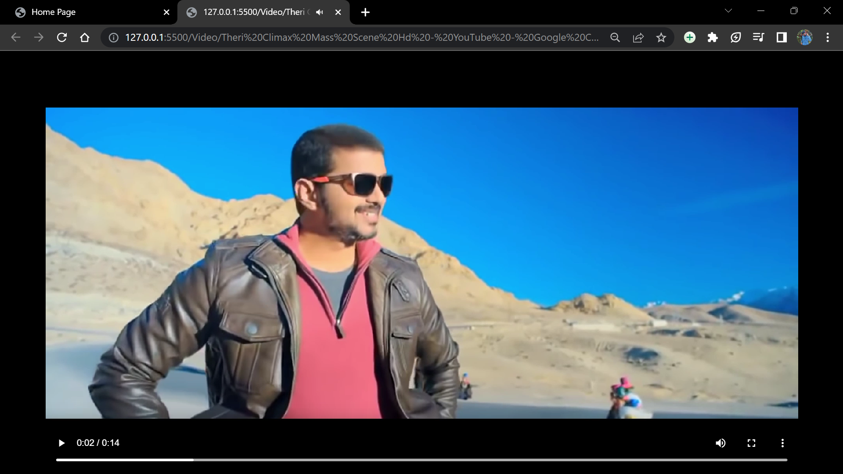

# Conclusion

## Community Engagement

The platform encourages user engagement and community building through the sharing of creative content.

## Ongoing Innovation

We are committed to ongoing innovation, adapting to user needs and creativity, and staying at the forefront of virtual cinema experiences.