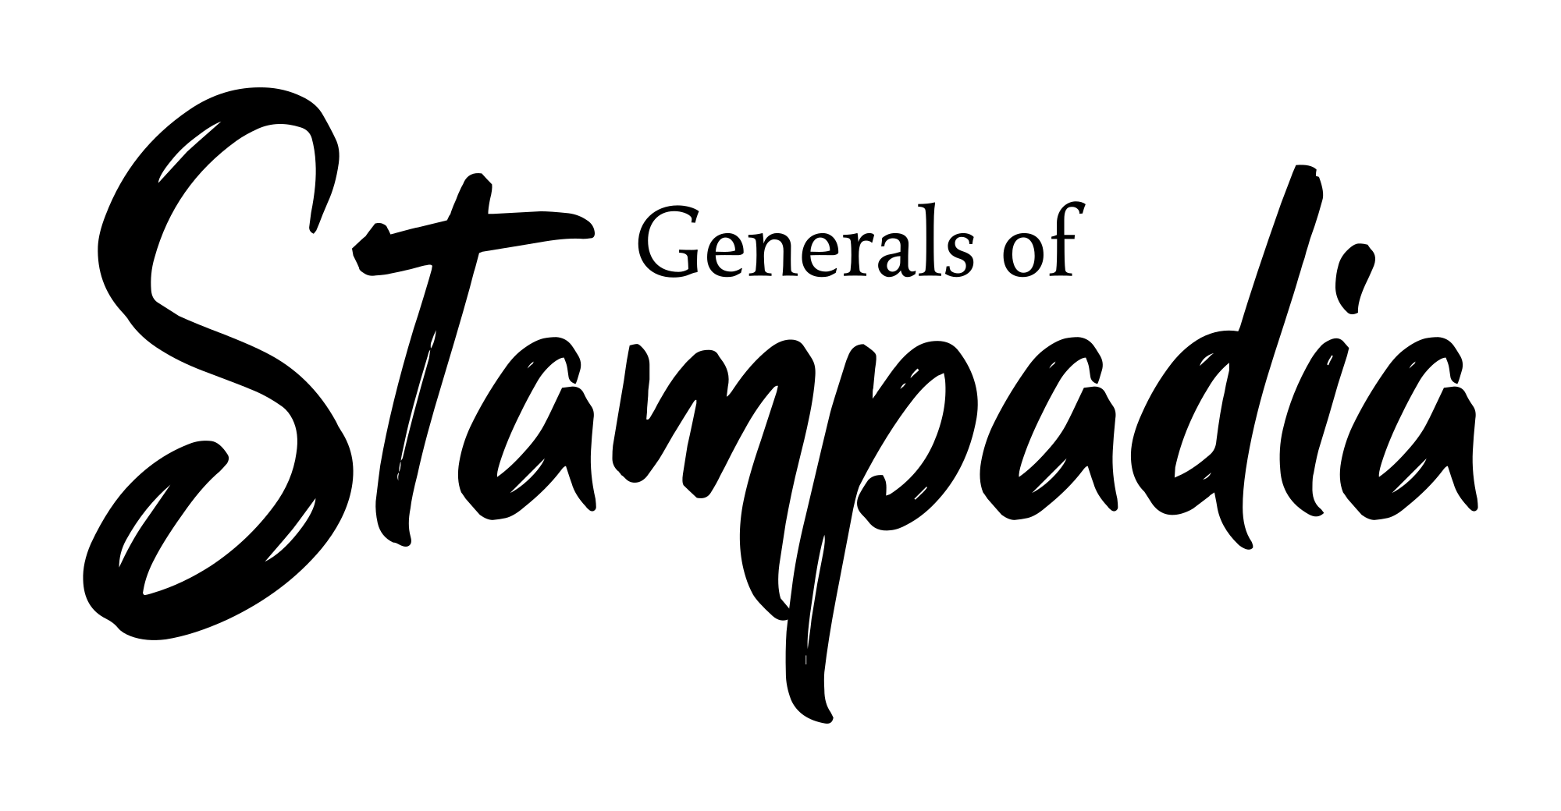
Game version: 0.1 - Manual version: 0.2
You can find an updated digital version of this manual, FAQs, and more information about Generals Of Stampadia at https://www.kesiev.com/stampadia-generals/learn.html

Stampadia is in danger!

One day, a lonely Stampadian explorer finally found the Sacred Printer, a fabled construct that can change everything in the world as you order. With the heart filled with fear and excitement, its shaking hands touched the machine.

Then, a horrific buzz. Something inside its plastic box was nervously moving left and right, shaking the entire dungeon. The torches went out, leaving just a red blinking eye in the darkness.

A long deadly silence. The explorer took a couple of steps back, holding its breath.

Suddenly, the horrific buzz came back: a neverending stream of blocky pictures started popping out from the Sacred Printer, depicting scary monsters, fearless soldiers, and strange creatures! As soon as the ink dried, the images came to life and began their march out of the dungeon!

The explorer was frozen in fear: a raging horde was going to invade Stampadia and there was no hope for the explorer to block it! It closed its eyes, jumped into the cloud of papers, grabbed some of them, and ordered the just-born creatures to attack back. They responded with a nod and entered the fray, defending the exit. A spark of hope lit up the novice general's face.

This is the story of how a humble explorer became a legendary general, saving Stampadia from destruction.

The Game

Generals Of Stampadia is an open-source print-and-play single-player Expandable Card Game. Head to the project homepage (https://www.kesiev.com/stampadia-generals/), visit the Print Shop, select the sets you want to play, print them in the style you like, and you're ready to go!

Core Sets contain all you need to start playing, but you can print and mix Expansion Sets to enrich your experience. Anybody can create a new Core Set or Expansion Set and print it from the Print Shop... and you can even propose your set to be added to the online catalog!

This manual will explain to you how to play the game. If you want to know more about making sets, head to the Print Shop!

The Cards

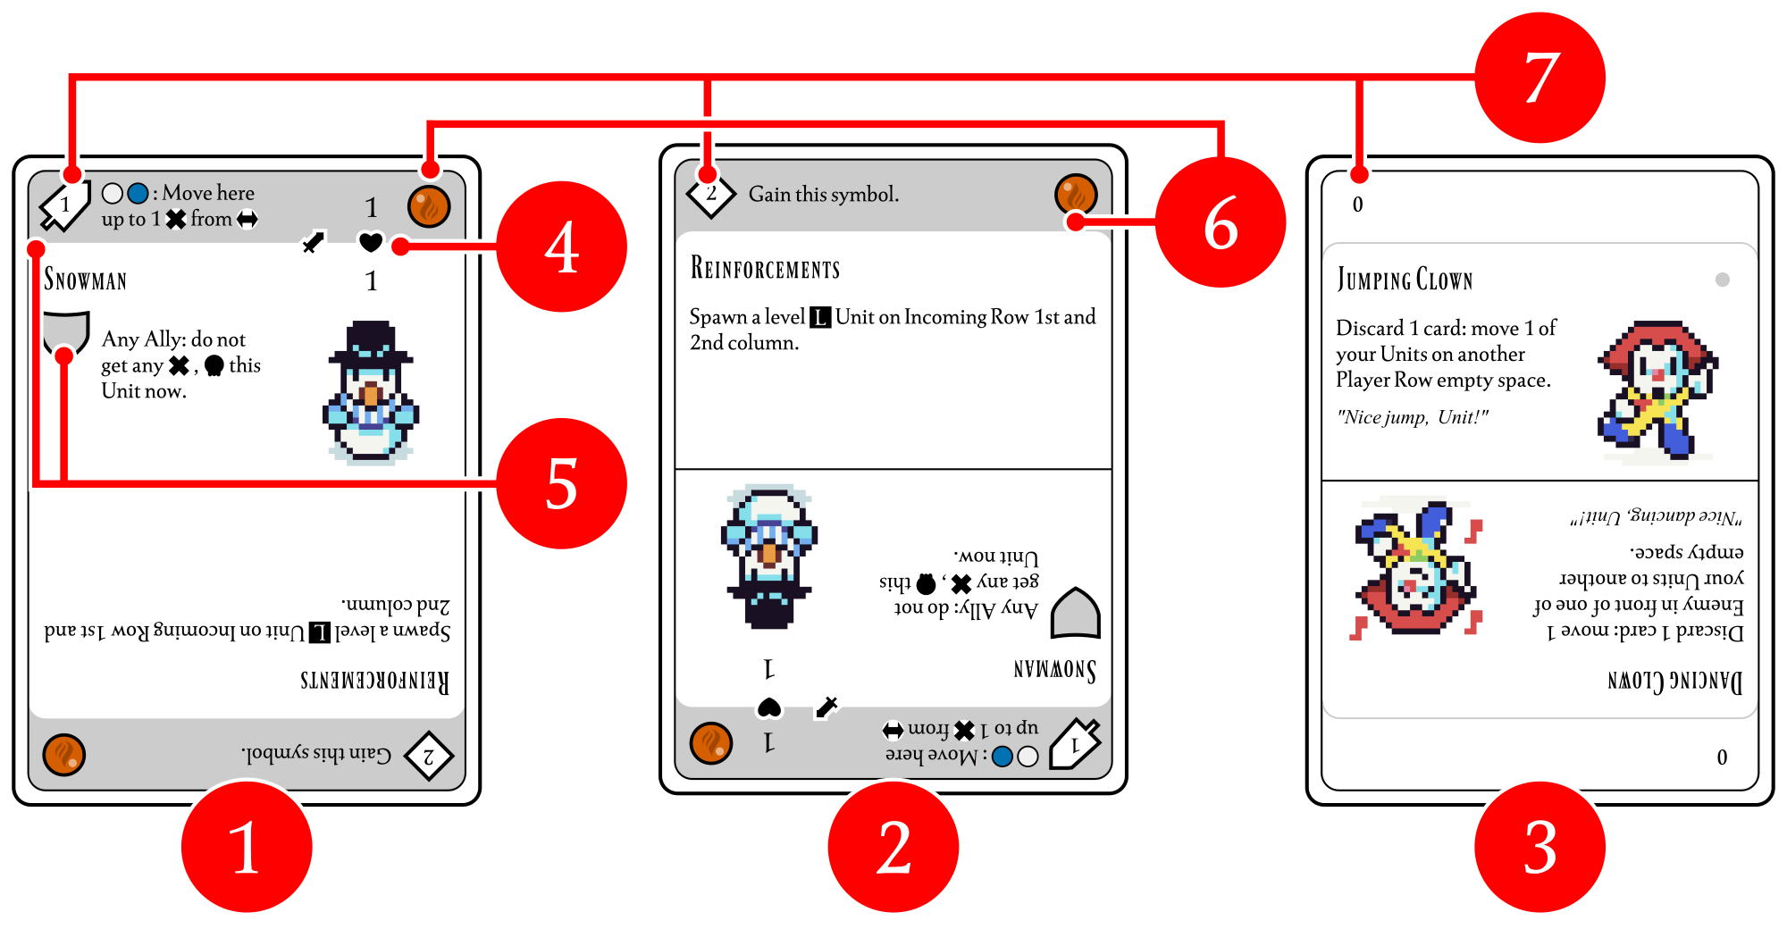
In Generals Of Stampadia, there are 2 types of double-sided cards: the Unit Cards with a filled header bar and a single illustration on the top-right  and the Event Cards with an empty header bar and 2 illustrations - one on the top-right and one on the bottom-left . An upside-down Unit Card (i.e. with the illustration on the bottom left) is called a Place Card .

Unit Cards have 2 columns on top-right part : the Unit attack value () and the Unit life value ().

Cards may have 1 or 2 Skills .

Symbol on top-left part of the Unit card  describes when it is enabled:  when Unit attacks,  when it defends,  when its Life is evaluated,  when is defeated,  when an Enemy attacks it, and 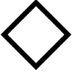 during all phases. You'll learn more about them later in this manual.

The Skill text describes its effect and some of these descriptions may have a condition before a colon: the Unit must meet that to activate the effect.

Some cards may infuse a Unit with one or more Elements . Elements are Fire (/), Earth (/), Water (/), and Air (/) and are often used to satisfy Skills conditions.

Cards also have a Level value printed on the top-left corner that may be a positive or negative number (i.e. A Level 2 Unit Card is a Unit Card with a 2 printed on its top-left).

The golden rule of Card Games: if any text on a card goes against the rules of this manual, the text on the card always takes precedence!

Stacks

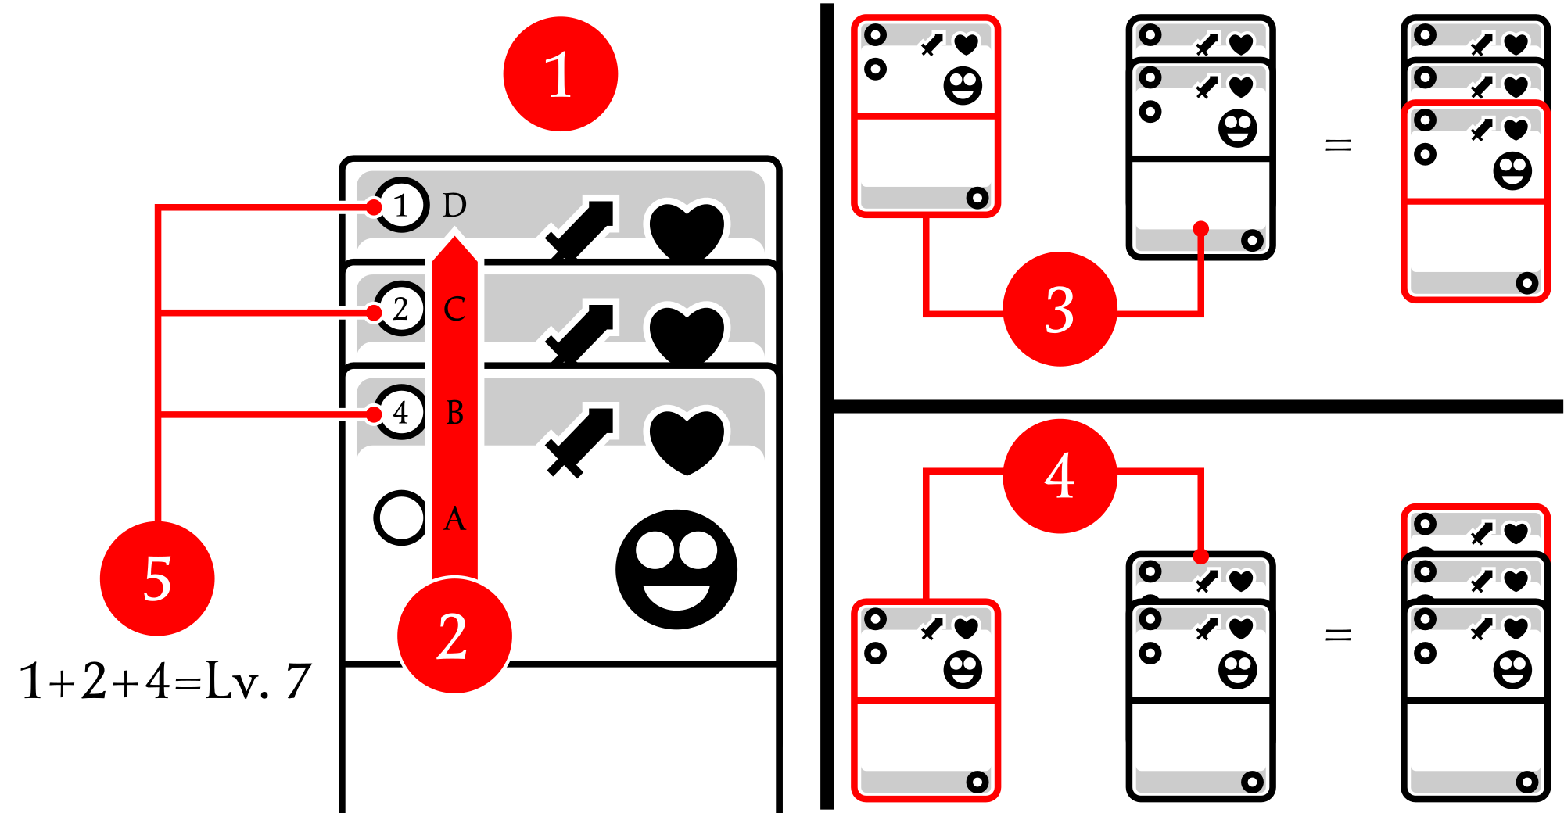
In Generals Of Stampadia cards are usually arranged in vertical stacks so the header bars of the cards in the back are visible and the bottom card only is fully visible .

A stack acts like a single long card, to be read from the bottom to the top . A stack may just have one card. Unreadable stack card features, such as upside-down halves or covered parts under the header bar, are considered blank. To discard a stack, discard all of its cards.

Cards or stacks may be added to a stack placing its top just under the destination stack bottom card header bar.

It's pretty rare, but cards or sets may also be merged with a stack : move it to slide its bottom card part behind the destination stack top card, extending the destination stack chain of visible header bars upwards.

The sum of the Level value of the stack cards gives the Stack Level .

For a stack of Unit Cards, this manual and the cards' text omit the "stack" word, so it's just called a Unit. That means that a Level 7 Unit is a stack of Unit Cards whose cards Level sum is 7.

Setup

Make sure you've printed at least one Generals Of Stampadia Core Set and as many Expansion Sets as you want.

Pick all of the Unit Cards, orient them with the illustration on the top-right, and shuffle them to form the Printer Deck .

If it contains less than 40 cards, you're playing the game Lite version:

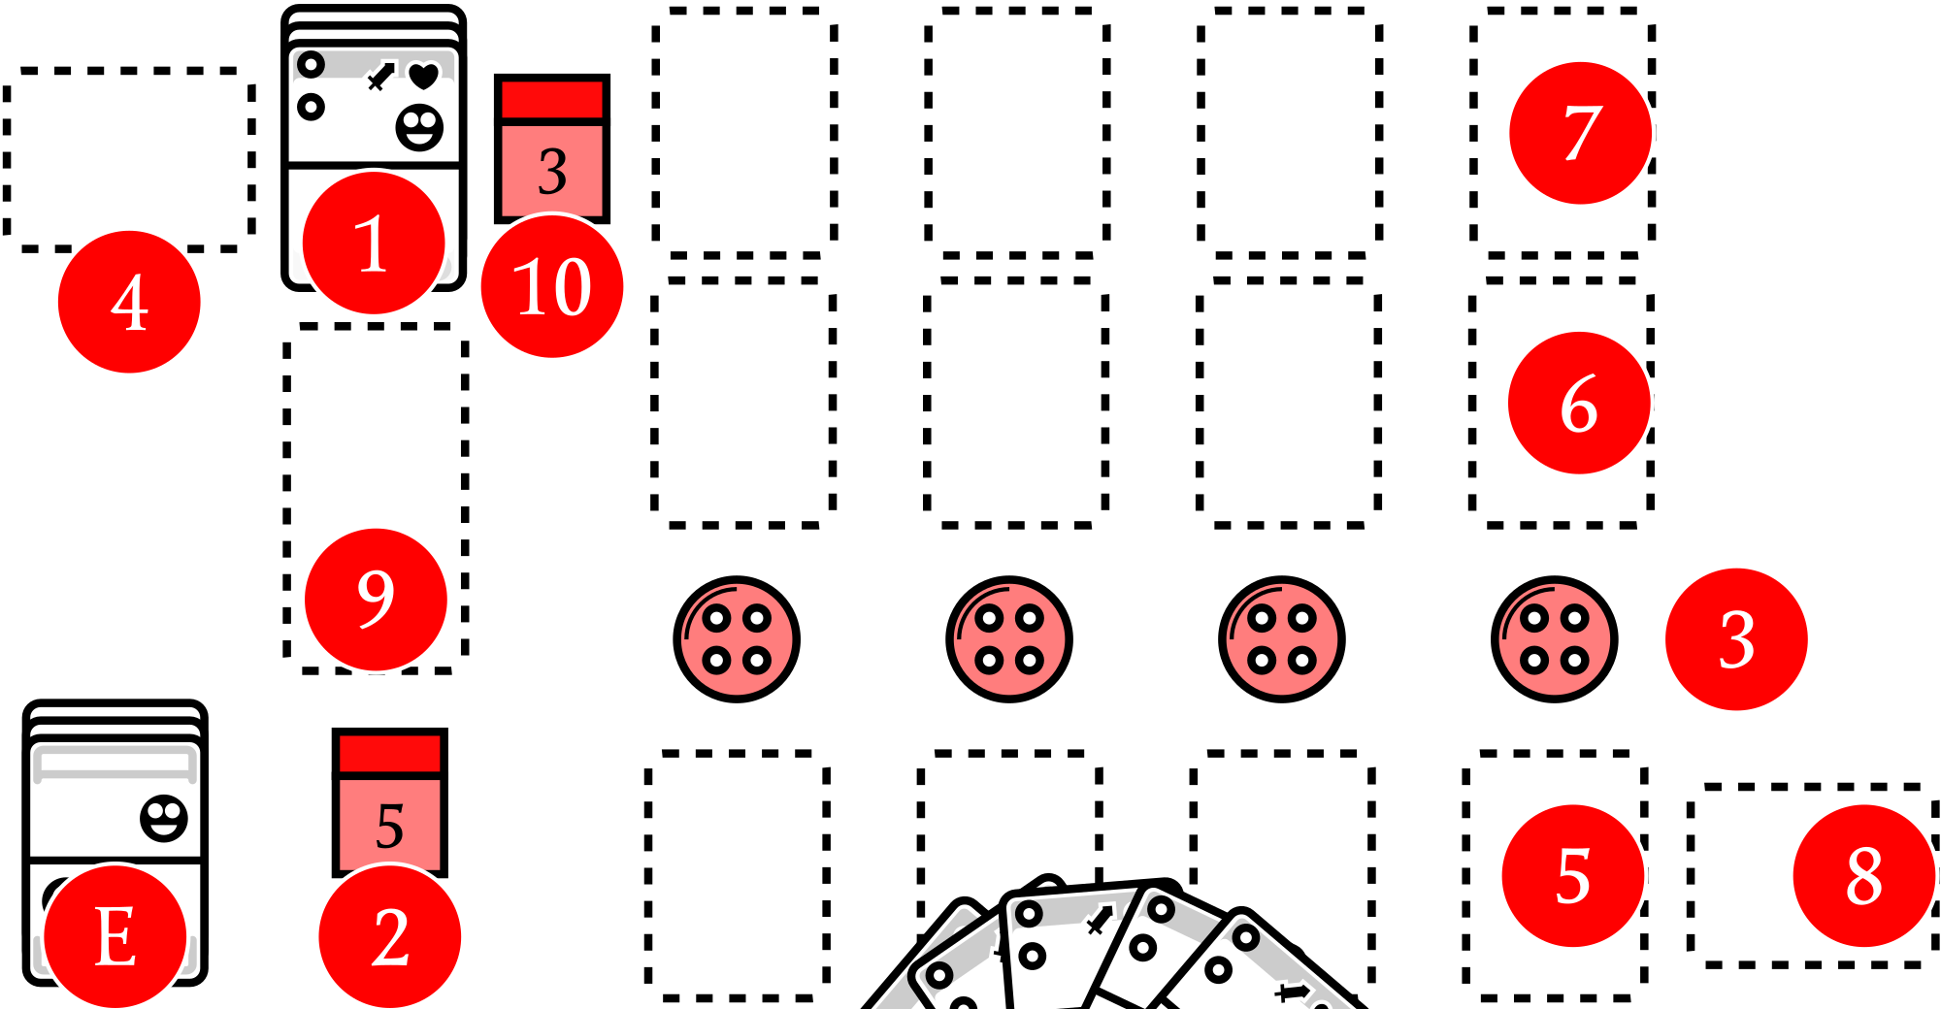
- Pick a dice (or any other counter), set it to 5, and put it in front of you. It will keep track of your Life .
- Use 4 small markers (like a button, a shell, a cube, or any small object you like) to form a long horizontal line. These will mark the Battlefield Columns . The Battlefield Columns are numbered from 1 to 4 from the left to the right.

If it contains 40 cards or more, you're playing the game Full version:

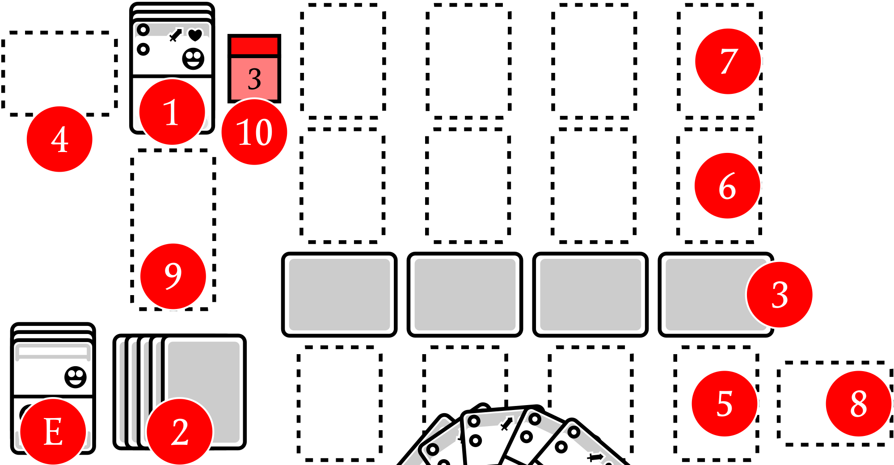
- Flip the Printer Deck face-down.
- Draw 5 face-down cards and put them in front of you. These will keep track of your Life Cards .
- Draw 4 more face-down cards, orient them horizontally, and arrange them to form a horizontal line. These will mark the Battlefield Columns . The Battlefield Columns are numbered from 1 to 4 from the left to the right.
- Flip the Printer Deck back face-up.

Anytime you've to draw a Unit Card, draw it from the top of the Printer Deck : its top card is always face-up so you always have a preview of any draw actions. Place Cards are drawn from the same deck - just draw a card and turn it upside down.

Unit Cards (and so the Place Cards) are discarded horizontally on the left of the Printer Deck , with the Unit side to the right. When the last card of the Printer Deck is drawn, shuffle this discard pile to form a new deck.

Event Cards. Event Cards are discarded turning them upside down and placing them face-up on the bottom of the Event Deck.

The 4 spaces below the lined-up horizontal cards or tokens form the Player Row: you'll play your Units here . Right over the line, there is the Front Row : the Sacred Printer Units will attack your Units on the Player Row from there and vice versa.

All Units on the same row are Ally, the other row is the Opposing Row, and all Units in the Opposing Row are Enemy. A Unit is not its own Ally.

Behind the Front Row there is the Incoming Row : these are the Sacred Printer's freshly printed Units. They won't have any effect but they will advance the next turn to the Front Row, when the space in front of them will be empty.

Near the battlefield Player Row there is the Shields Area : there you'll store the Shields earned by attacking. You'll discard them to defend against direct attacks and gain one of them if you manage to spare some.

Under the Printer Deck, there will be the Place Stack , a vertical stack of cards that keeps track of the Sacred Printer consumed ink and special effects that affect the battlefield.

Pick a dice (or any other counter), set it to 3, and put it on the right of the Printer Deck . It keeps track of the Ink Level () that limits the battle length and intensity. If it's your first game, set the Ink Level to 2 instead. This counter will also move along the Place Stack to keep track of the Sacred Printer Pressure level: when it reaches its maximum, it will depressurize eliminating all of your Units!

Finally, draw 5 Unit Cards to form your starting hand. Ready for the battle?

Event Cards. It seems that more Stampadians, hearing the noise, are about to join you at the dungeon entrance!

If you've any Event Cards, separate them from the others keeping the orientation of your previous game to form the Event Deck, shuffle it, and place it face-up next to you .

No Event Cards? Don't worry: you will face the threat alone! Event Cards give you little challenges and rewards to spice up the battle, so consider visiting the Print Shop and printing some of them!

How To Play

The Sacred Printer will keep printing Units and send them against you, so you've to hold your ground... By stealing its paper and printing your army! The Sacred Printer will run out of ink from time to time, so you'll have little time to take a breath. Then the Sacred Printer will raise the Ink Level and start printing even stronger Units! Survive the 6th Ink Level to exhaust the Sacred Printer once and for all, save Stampadia, and win! ...or die trying!

Every turn follows these 6 phases:

- Check Phase: Check the winning or losing conditions and add a Place Card to the Place Stack or increase the Pressure.
- Play Phase: You will play cards from your hand on the Player Row or decrease your Life to steal Unit Cards from the Printer Deck.
- Attack Phase: The leftmost not exhausted unit Player Row Units will attack the Sacred Printer Units on the Front Row or collect Shields and then the Unit is exhausted. Repeat this phase until all Player Row Units are exhausted. Then, all Player Row Units are restored.
- Advance Phase: Move the Sacred Printer Units from the Incoming Row to the Front Row if possible.
- Defense Phase: The Sacred Printer leftmost not exhausted Units on the Front Row will attack your Player Row Units, depleting your Shields or forcing you to lose Life and then the Unit is exhausted. Repeat this phase until all Front Row Units are exhausted. Then, all Front Row Units are restored.
- Recover Phase: Gain 1 card from the spared Shields and discard the rest.

Repeat these phases until you exhaust the Sacred Printer and win or you run out of Life and lose.

Event Cards. Event Cards can be activated at any time, as long as the conditions preceded by the colon are respected. Once an Event Card is activated, it's added to the Place Stack as for the Place Cards.

Check Phase

First, check the the Place Stack level: if it's lower than the current Ink Level you will evolve the Place Stack, or you will check the battle end conditions instead. If there is no Place Stack, the Place Stack level is 0.

To evolve the Place Stack draw one new Place Card, add it to the Place Stack, and follow the new card instructions. Place Cards often ask to Print level Units somewhere: to do that, check if the required space in the Incoming Row is empty and create a new stack of Unit Cards adding them until the Stack Level reaches or surpasses the current Ink Level (). If the space is not empty, do not Print in that space. After following the Place Card, go on to the Play Phase.

To check the battle end conditions, check if there is any Unit on the Incoming Row or the Front Row: if yes increase the Pressure, else end the battle.

To increase the Pressure:

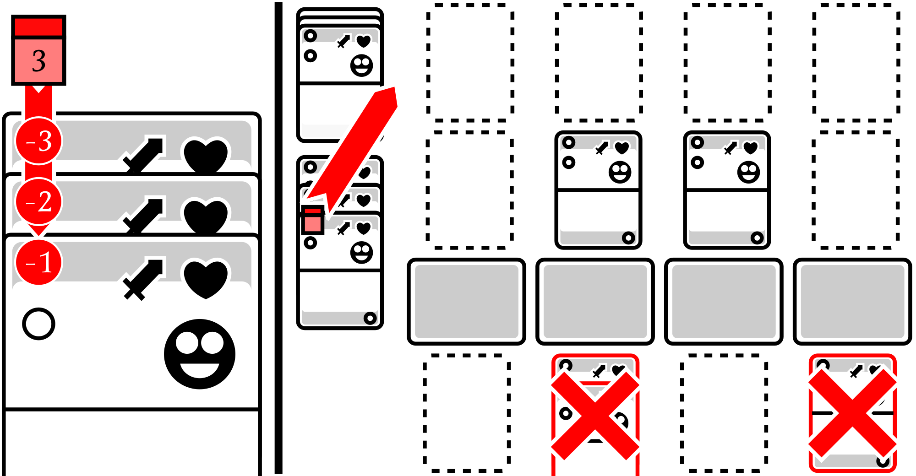
- If the Ink Level counter is on the right of the Printer Deck: move it on the first card of the Place Stack.
- If the Ink Level counter is on a card of the Place Stack and there is another card below: move the dice down on that card.
- If the Ink Level counter is on a card of the Place Stack and there are no more cards below: discard all the Units on the Player Row and move the dice back on the right of the Printer Deck.

After increasing the Pressure, go on to the Play Phase.

To end the battle discard all of the units on the Player Row and the Place Stack. Now check the Ink Level: if it's 6 the Sacred Printer is exhausted and you won, else start the next battle.

To start the next battle raise the Ink Level counter by 1, move it back on the right of the Printer Deck, perform the Healing Action twice, and perform this whole Check Phase again.

Check Phase: Healing Action

To perform a Healing Action decide on 1 of these options:

- Life-up: If your Life is less than 5, you may decide to gain 1 Life.
- Power-up: If you've less than 7 cards in your hand, you may decide to draw the Printer Deck top card.
- Leave: You may decide to just discard the Printer Deck top card.

Check Phase: Your Life

On the game Lite version, Life works this way:

- To gain 1 Life: Discard the top card of the Printer Deck and increase the Life counter value by 1.
- To lose 1 Life: If the Life counter value is 1 or more, decrease its value by 1. If it's 0, set the counter apart. If the counter is set apart and you've to lose Life the game ends and you lose.

The Full version works this way instead:

- To gain 1 Life: Draw the top card of the Printer Deck and add it face-down to your remaining Life Cards.
- To lose 1 Life: Pick one of your Life Cards and discard it face-up. If you've to lose Life and you don't have any Life Card the game ends and you lose.

At any time you can't own more than 5 Life so, once you've 5 Life, ignore any "gain Life" action.

Check Phase: Your hand

Your hand is mostly made with Unit Cards and you're going to play them to build your Units. You can't ever have more than 7 cards in hand so, once you've reached this limit ignore any card-drawing action.

Play Phase

You may add Unit Cards in your hand to your Units on the Player Row as many times as you want.

You can add it to an empty space or a Unit but you cannot add a Unit Card to a Unit whose Level is equal to or higher than the current Ink Level. This check is done before adding the Unit Card, so the Unit Card you add may raise the Unit Level over the current Ink Level.

If you have at least 1 Life you can choose to lose 1 Life to draw the top card of the Printer Deck as many times as you want.

You can also decide to sacrifice one of your Units: you may draw 1 of its Unit Cards except the bottom one and discard the rest, freeing its space. If the sacrificed Unit is made by just 1 card, discard it drawing no cards.

Once you're done, go to the Attack Phase.

Attack Phase

Your leftmost restored Units on the Front Row will perform an attack action until all of them are exhausted. These are the Unit attack phases:

- Calculate the attacker's attack value: sum the numbers on the column and apply all of the and Skills, from the bottom to the top.
- Check if the unit attacks: if the attack value is less or equal to 0, the Unit doesn't attack and skip to the Check attacker unit defeat phase.
- Define the attack target space: if the Skills so far didn't mention any targeted space, it will be the space in the same column of the attacker on the Front Row.
- Check the Unit on target space: if there is no Enemy on the target gain 1 Shield and skip to the Check attacker unit defeat phase, otherwise that Unit becomes the target Unit.
- Apply target Unit defense Skills: On the target unit apply the and Skills.
- Add wounds: Add as many wounds () as the resulting attack on the target card. You may place one dice on wounded units to keep track of their value. If the attack is less or equal to 0, do not add any wound.
- Check target Unit defeat: sum the numbers on the column and apply all of the and Skills, from the bottom to the top. If the on the Unit are greater or equal to its the unit is defeated (): apply all and Skills on the defeated Unit, from the bottom to the top, and discard the Unit.
- Check attacker Unit defeat: do the previous step on the attacker Unit.
- Exhaust the attacker Unit: if the attacker Unit is not defeated, exhaust it.

Keep in mind that defeat is checked only on the attacking and the attacked unit (if any), so some Units involved in the battle may survive even if their exceeds their !

When all of the Front Row Units are exhausted, restore all of them and the Attack Phase ends.

Attack Phase: Multiple attacks

Unit's Skill effects may let the Unit perform multiple attacks on the same space or different spaces. For each attacked target space you've to perform the whole phase-attack.

Attack Phase: Exhaust and Restore

To exhaust a unit you've to orient its bottom card horizontally. To restore a Unit you've to orient its bottom card vertically to the Unit side. Units are exhausted after attacking and restored after the Attack Phase but some effects can do the same.

Attack Phase: Jump

Some Units can Jump from their own space to another one in the same row. Jumps are usually followed by a destination (i.e. "Jump to highest Enemy" means the space in front of the Enemy with the highest ) or a direction and an amount of spaces (i.e. "Jump 2 spaces " means the 2nd space on the Unit right).

To do that, check the destination space: if it's empty, move the Jumping Unit there. If the space isn't empty, the Jump is not performed. If multiple destinations are valid, you decide.

Attack Phase: The Shields

Shields are Unit Cards kept in your Shields Area. There is no limit on how many Shields you can have.

- To gain 1 Shield: draw 1 Unit Card and add it to your Shields Area.
- To lose 1 Shield: discard 1 Unit Card in your Shields Area.

You're going to use Shields to defend yourself from the Sacred Printer Units' direct attacks during the Defense Phase. In the Recover Phase you may add one of your spared Shields to your hand and the rest of them will be lost.

Attack Phase: The Skills

Many Skills apply only if a condition described before the colon is true. Most of these conditions are about a certain Elements infusion on the Unit: the condition "" requires the Unit to be infused by at least 1 Fire symbol () and 1 Water symbol () by the spheres on its right side. Element symbols are not consumed by conditions, so they may be reused to validate conditions on other Skill.

A single Skill can be activated just once per attack phase but some Skill effects may be improved if its condition is verified multiple times. The effect ": + " gives +1 for every pair of Elements the Unit is infused with.

Attack Phase: Area Skills

Some Skills may affect other Units on the battlefield and are checked at the beginning of their attack phase:

- The Place Stack Skills: all Place Stack Skills are applied to all of the Units on the battlefield.
- The  Skills: Unit Cards Skill effects with a long red banner on the left are applied to all of the Units on the battlefield: Allies, Enemies, and themselves. Units on the Incoming Row are never active, so their banner Skill doesn't apply.
- The Skills: Skills effects are applied on the Unit on the Opposing Row, when evaluating the effects and attributes on their cards.

Area Skills are applied even by exhausted Units.

If multiple area Skills are affecting a Unit, apply them following this list order.

Advance Phase

From the left to the right, fetch all of the Units on the Incoming Row and check if the same column on the Opposing Row is empty: if so, move that Unit to the empty space.

Defense Phase

Repeat the Attack Phase, but this time the Opposing Row Units will attack the Player Row. The Sacred Printer doesn't gain Shields, so when a Unit lands its attack on an empty space of the Front Row you may discard as many Shields as the incoming attack or lose 1 Life (regardless of the incoming attack ).

Recover Phase

If you've any Shield in your Shields Area you may add 1 of them to your hand. Remember that your hand has a 7-card limit, so you can't add any of your Shields if you've already 7 cards in your hand.

Then lose all of your remaining Shields.

GOS is a MIT licensed open-source project: https://github.com/kesiev/stampadia-generals. Very special thanks to Bianca, Preuk, and the Discord and BGG defenders of Stampadia for sharing their efforts and ideas.

