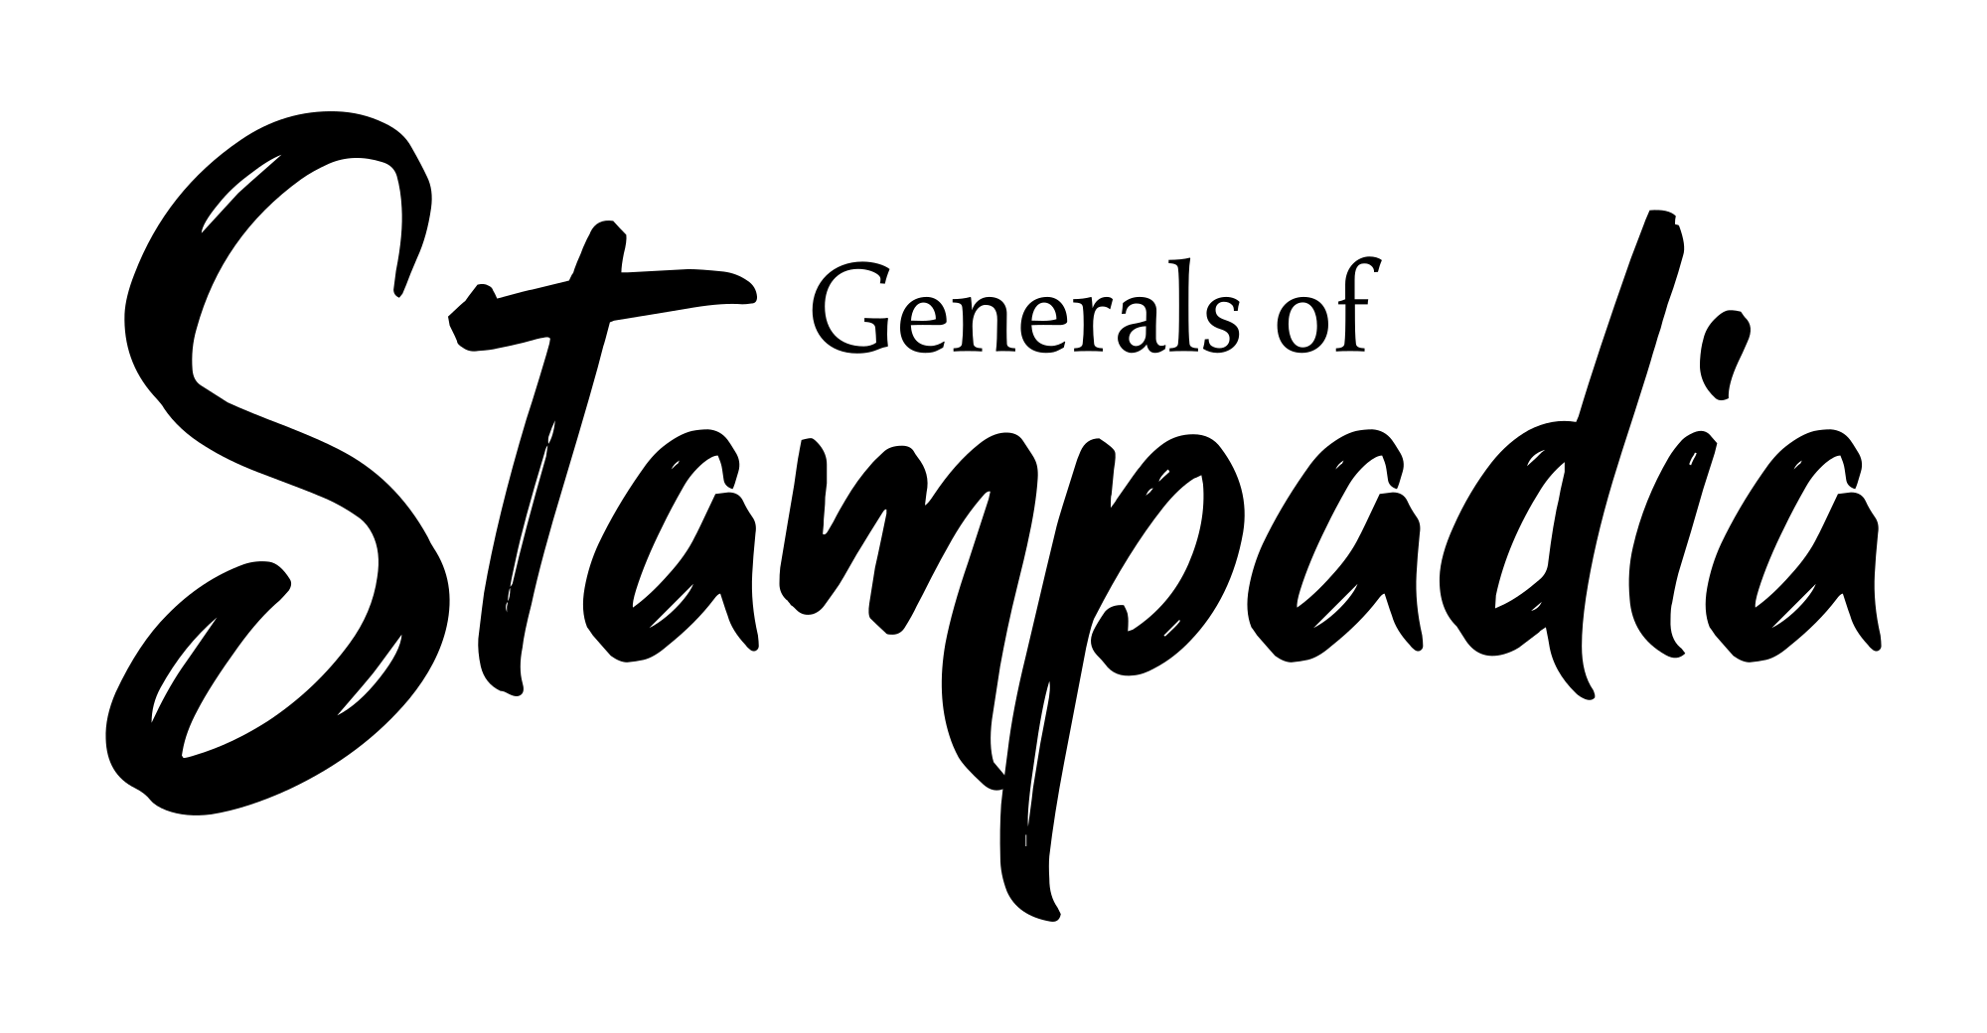
Game version: 0.1 - Variants Lab version: 0.1
You can find manuals, FAQs, and more information about Generals Of Stampadia at https://www.kesiev.com/stampadia-generals/learn.html

Welcome to the Variants Lab!

This manual collects some Generals Of Stampadia experimental game variants you can play. Feel free to give it a shot and share your impressions. If a game mode listed here is fun enough it will be moved to the Game Manual!

2 Players: Printer Player vs. General Player

By: Preuk

2 Players Co-op: Printer vs. 2 General Players

By: KesieV

A friendly voice echoes through the dungeon: "Hold on! I'm coming!". A fellow Stampadian adventurer joined the battle!
Will you be able to coordinate and defeat the Sacred Printer?

This variant aims to allow 2 players to play Generals Of Stampadia cooperatively, applying a few changes to the basic rules. This game mode is not suited for the game Lite version so the game's Full version is required.

During the game Setup, instead of drawing 5 Unit Cards, each player draws 4 Unit Cards to form their starting hand.

At the beginning of the Play Phase, the players decide who the First General and the Second General is. The First General then performs a single action (Add a Unit card from its hand to the battlefield, lose 1 health to draw a Unit card, sacrifice 1 Unit, or declare the Play Phase end) and then passes the turn to the Second General. The two generals alternate turns until one of them declares the Play Phase ends.

During the Recover Phase, each player may draw up to 1 shield from the Shields Area.

During the game, both generals share the same Life pool. When a card effect or condition asks the player to draw or discard cards, the players may split every single action of that effect or condition as they want. That means that if an effect asks the player to discard 2 cards, both players may discard 1 card or one of them may discard 2 cards.

Event Cards. Event Cards can be still activated anytime by both players. The card effects and costs splitting rule applies to Event Cards too.

