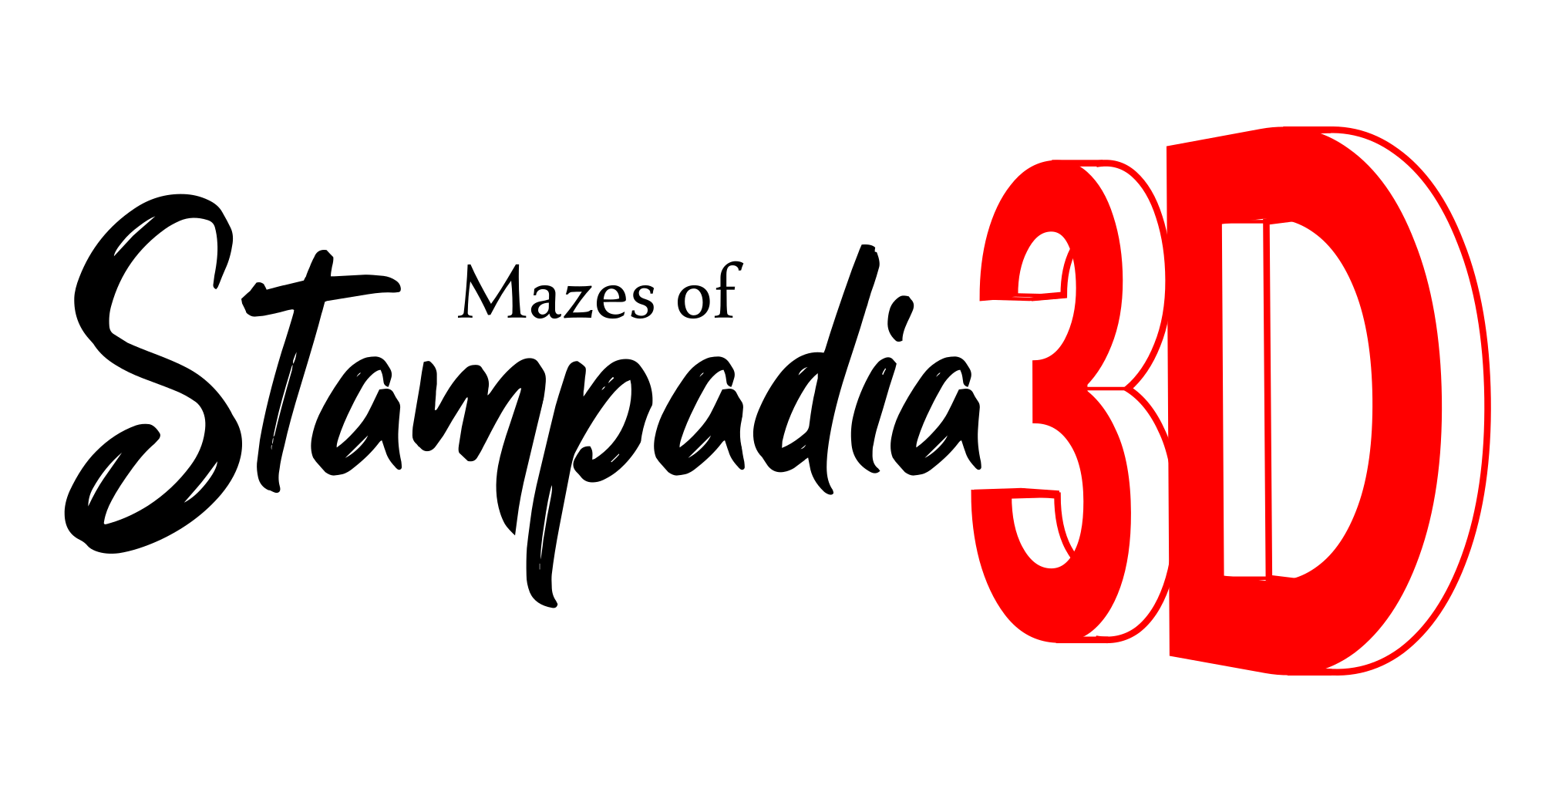
Game version: 0.1b - Manual version: 0.1b
You can find an updated digital version of this manual and more information about Mazes of Stampadia 3D at https://www.kesiev.com/stampadia-mazes/learn.html

In the darkest depths of Stampadia...

The Stampadia kingdom's oldest stories tell of a powerful artifact, stolen from the dungeons again and again by valiant Heroes.

Or at least, that's what we've managed to figure out. This time, we're as confused as you are.

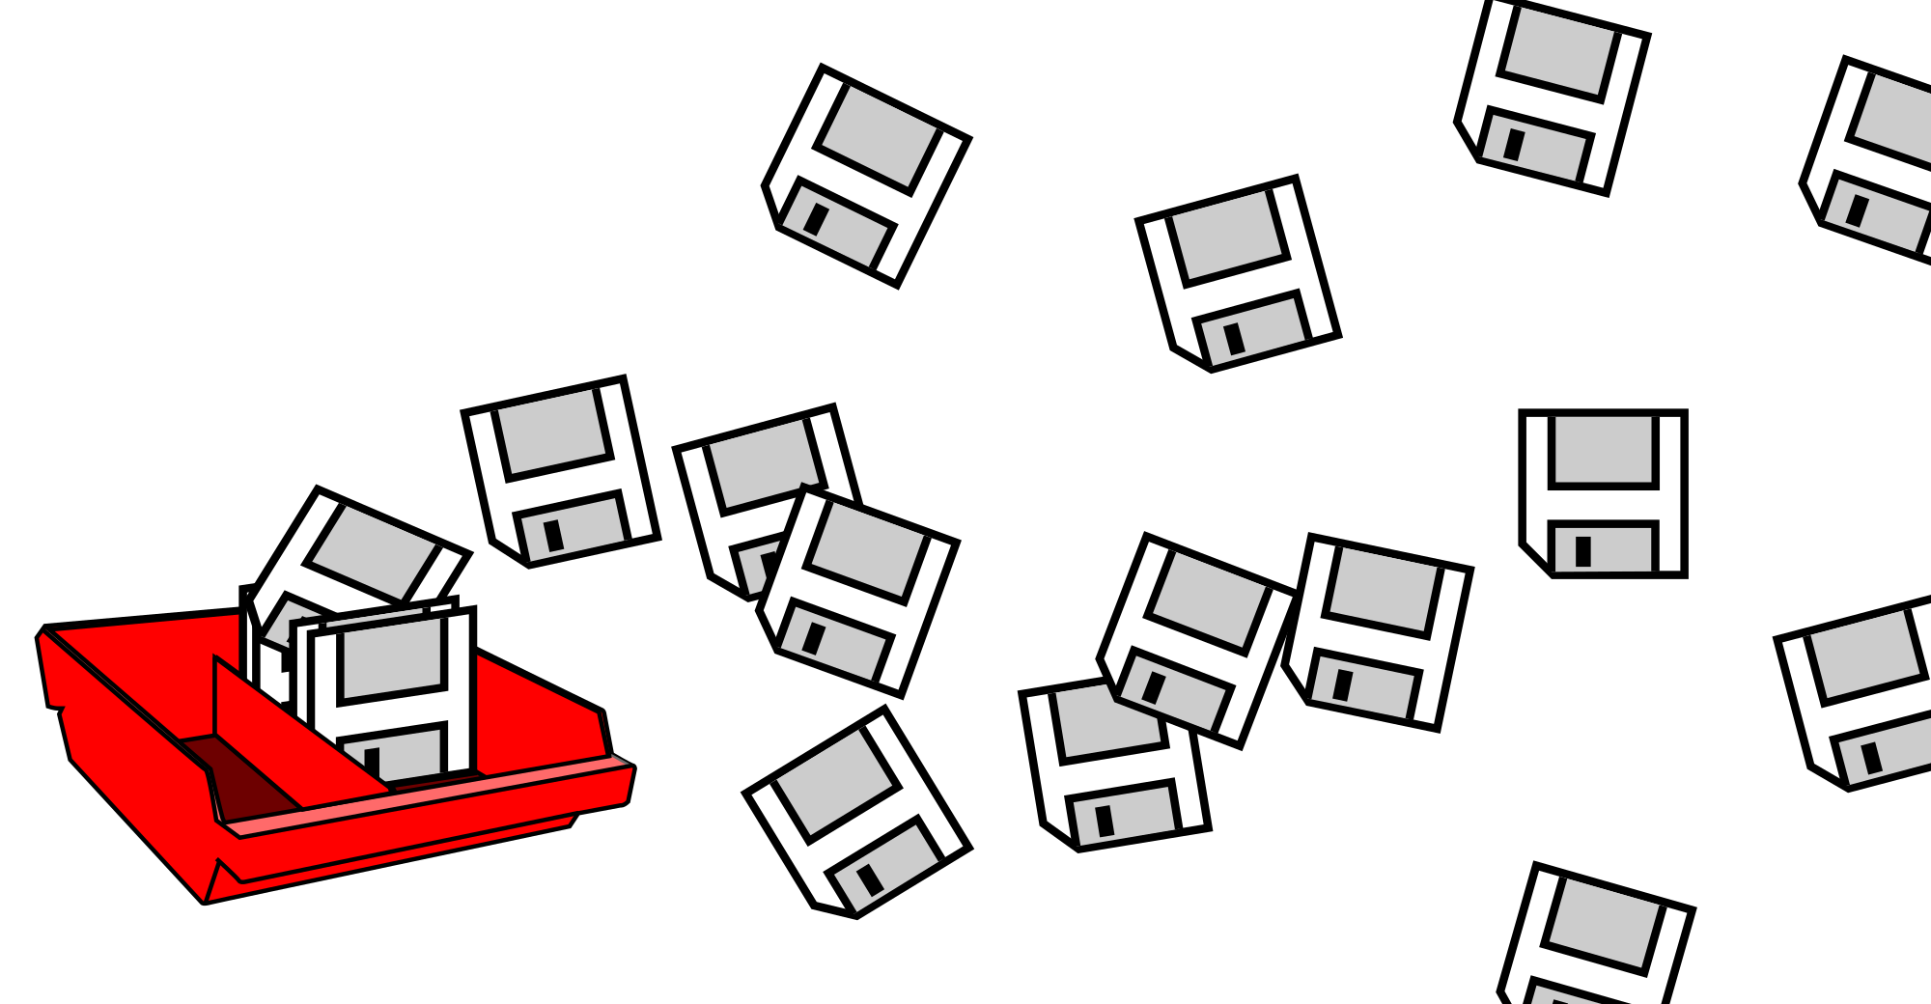
We found a large stock of boxes containing unlabeled floppy disks. Each contains a single .Y file that, in our opinion, stores a digital copy of an Ancient Stampadian's memory fragments: scattered images and moments of their attempted escape from the bowels of the earth, experienced through their own eyes.

Even these floppy disks seem imbued with Stampadia's strange magic: the reader can relive them firsthand with a token, some dice, and a pencil. But, this time, maybe with something else...

We apologize. Since these are memories and not written texts, we were unable to identify all the rules and the materials needed to play them and to create a reliable translator. We will provide you with the information exactly as we found it, and we'll share everything we've discovered so far.

We will share one of these Memory Dumps daily at https://www.kesiev.com/stampadia-mazes/. Good luck!

From time to time, we will report in these boxes some of the notes we have collected during the preliminary studies of the disks data.

Setting up the Brain

To play a Memory Dump, you need 5 6-sided dice, a small token, a pencil, and an eraser. You may need other supplies, but we can't say for sure. We suggest you keep your smartphone and scissors handy, just to be safe.

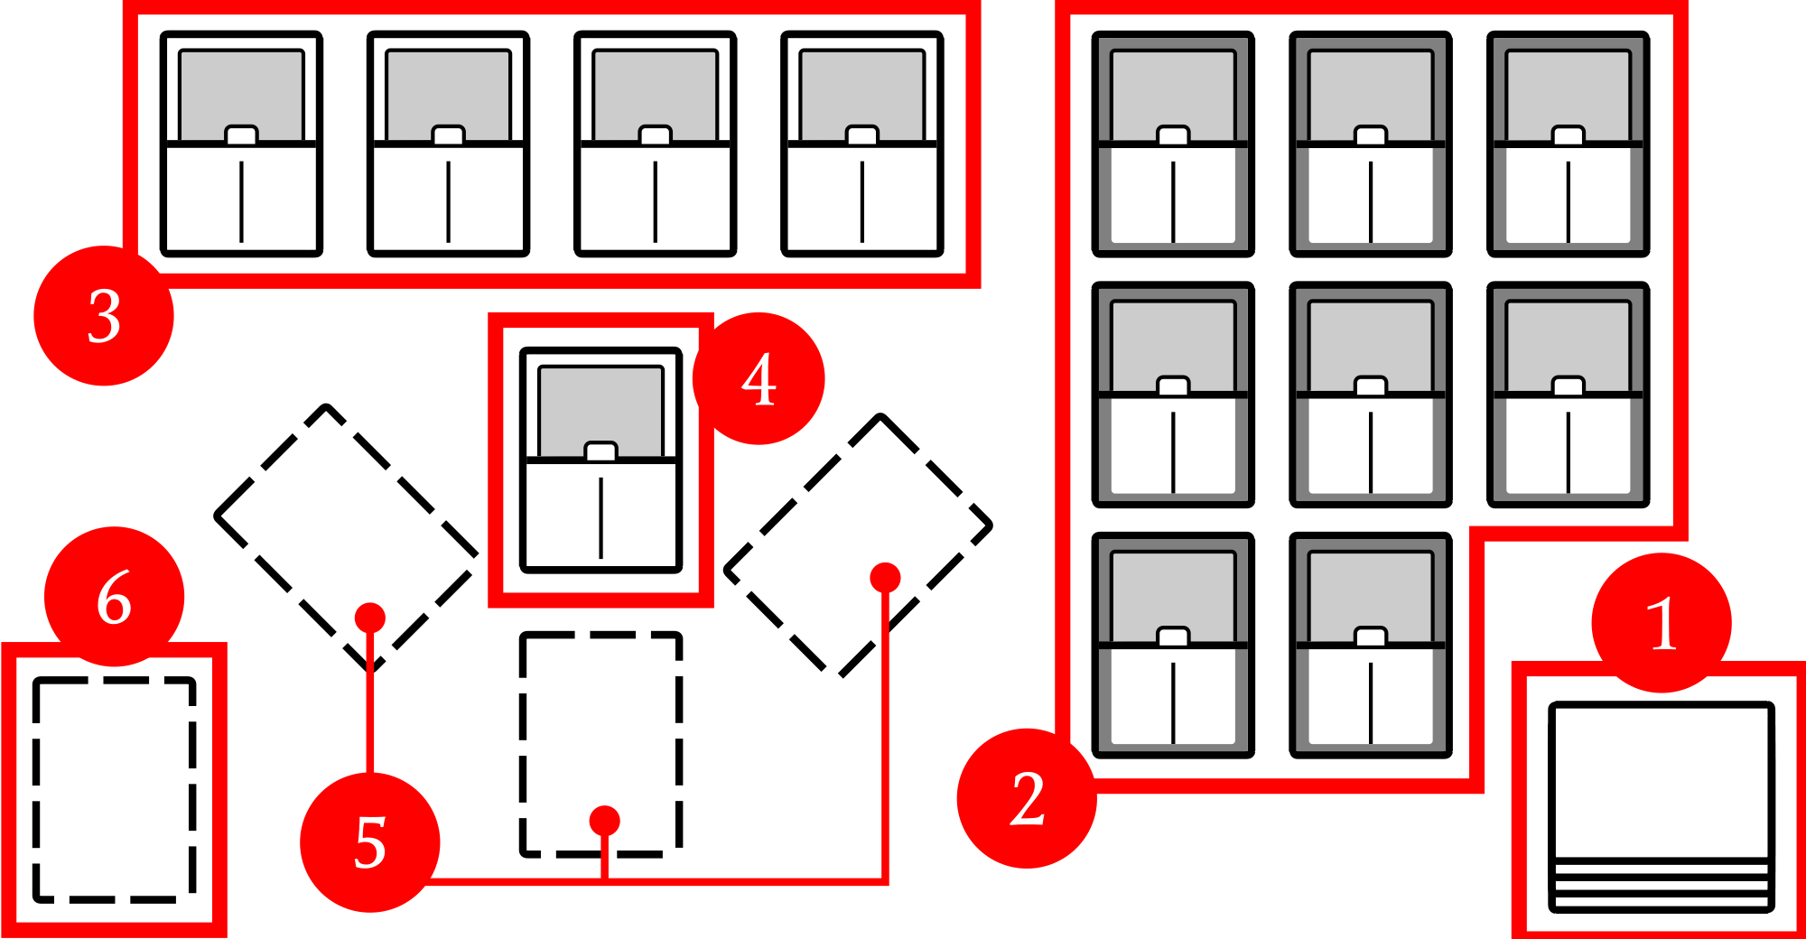
Download the daily Memory Dump PDF, print it, and cut all of the cards on the first 2 pages - there usually are 18 of them.

If you prefer a more guided approach for your first adventure, we've prepared a tutorial dungeon for you to print, cut, and play. You can find it at kesiev.com/stampadia-mazes/learn.html. Start reading the Welcome! card and keep this manual aside. It will help you learn the basics of the game as you venture through your first maze!

Cut the cards outlines only. Keep the 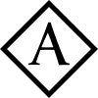 cards set face-up, and the others face-down in a pile  to form the Forgotten Deck.
Then, lay out the dark border cards (numbered from 10 and up) face-up in numerical order and in a grid on your right side  to form the Long Term Area, and the remaining cards face-up in a line near the grid 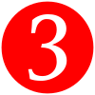 to form the Short Term Area.
Take the  card from the line and arrange it in front of you 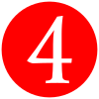. Leave some empty spaces around this card, forming a Y 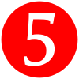. This is the Sight Area.
Finally, leave one card space on the bottom left of the Y: this will host the Hippocampus Area .

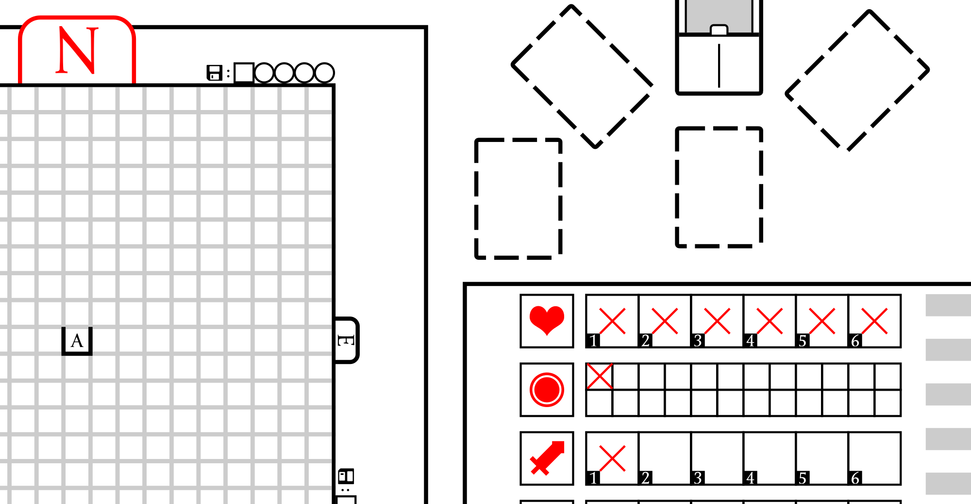
Cut the third page along the dashed line to create the Map Sheet and the Character Sheet. Place the Map Sheet on your left side pointing North. Place the Character Sheet right under the Sight Area and tick 6 , 1 , and 1 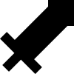.
The Stampadian brain is now initialized. We're ready to go!

The original files contained in the floppy disks have the .Y extension, and we are confident that this suggests the Sight Area and Hippocampus Area layout. That said, we're not sure about the layout of the other game elements. The one we've suggested is what we've found most effective during our experiments, but feel free to move the materials wherever you see fit.

The Sight Area

The Stampadian dungeons are divided into a grid of cells, each one identified by a single letter name and surrounded by one or more walls.
Every Ancient Stampadian will start in a dead end on cell A () and facing North. This dead end is already marked in the center of the map, with an A letter surrounded by walls.
If you're sitting down right in front of the Sight Area, you're already seeing what the Ancient Stampadian sees right now. Yes, you're going to explore the dungeon from their very eyes.

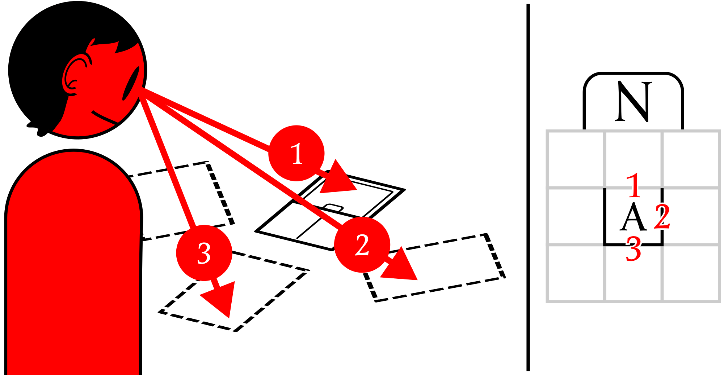
The card in front of you is showing your first corridor .
Tilting your head to the right, you will see an empty space : the Ancient Stampadian have no meaningful memory of that place, so we assume it was a plain wall. You can do the same, tilting your head left to see the wall on the other side.
Tilting your head down, you will look behind you to see a third wall .
So, every time you start a new exploration, you will be surrounded by walls except for the North, in which there is a corridor diving into the dark...

Activating a card

The top half of each card shows what you can see in a given direction. In the bottom center, there may be a round-shaped 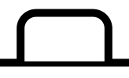 or a star-shaped 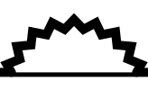 tab that may contain an icon.

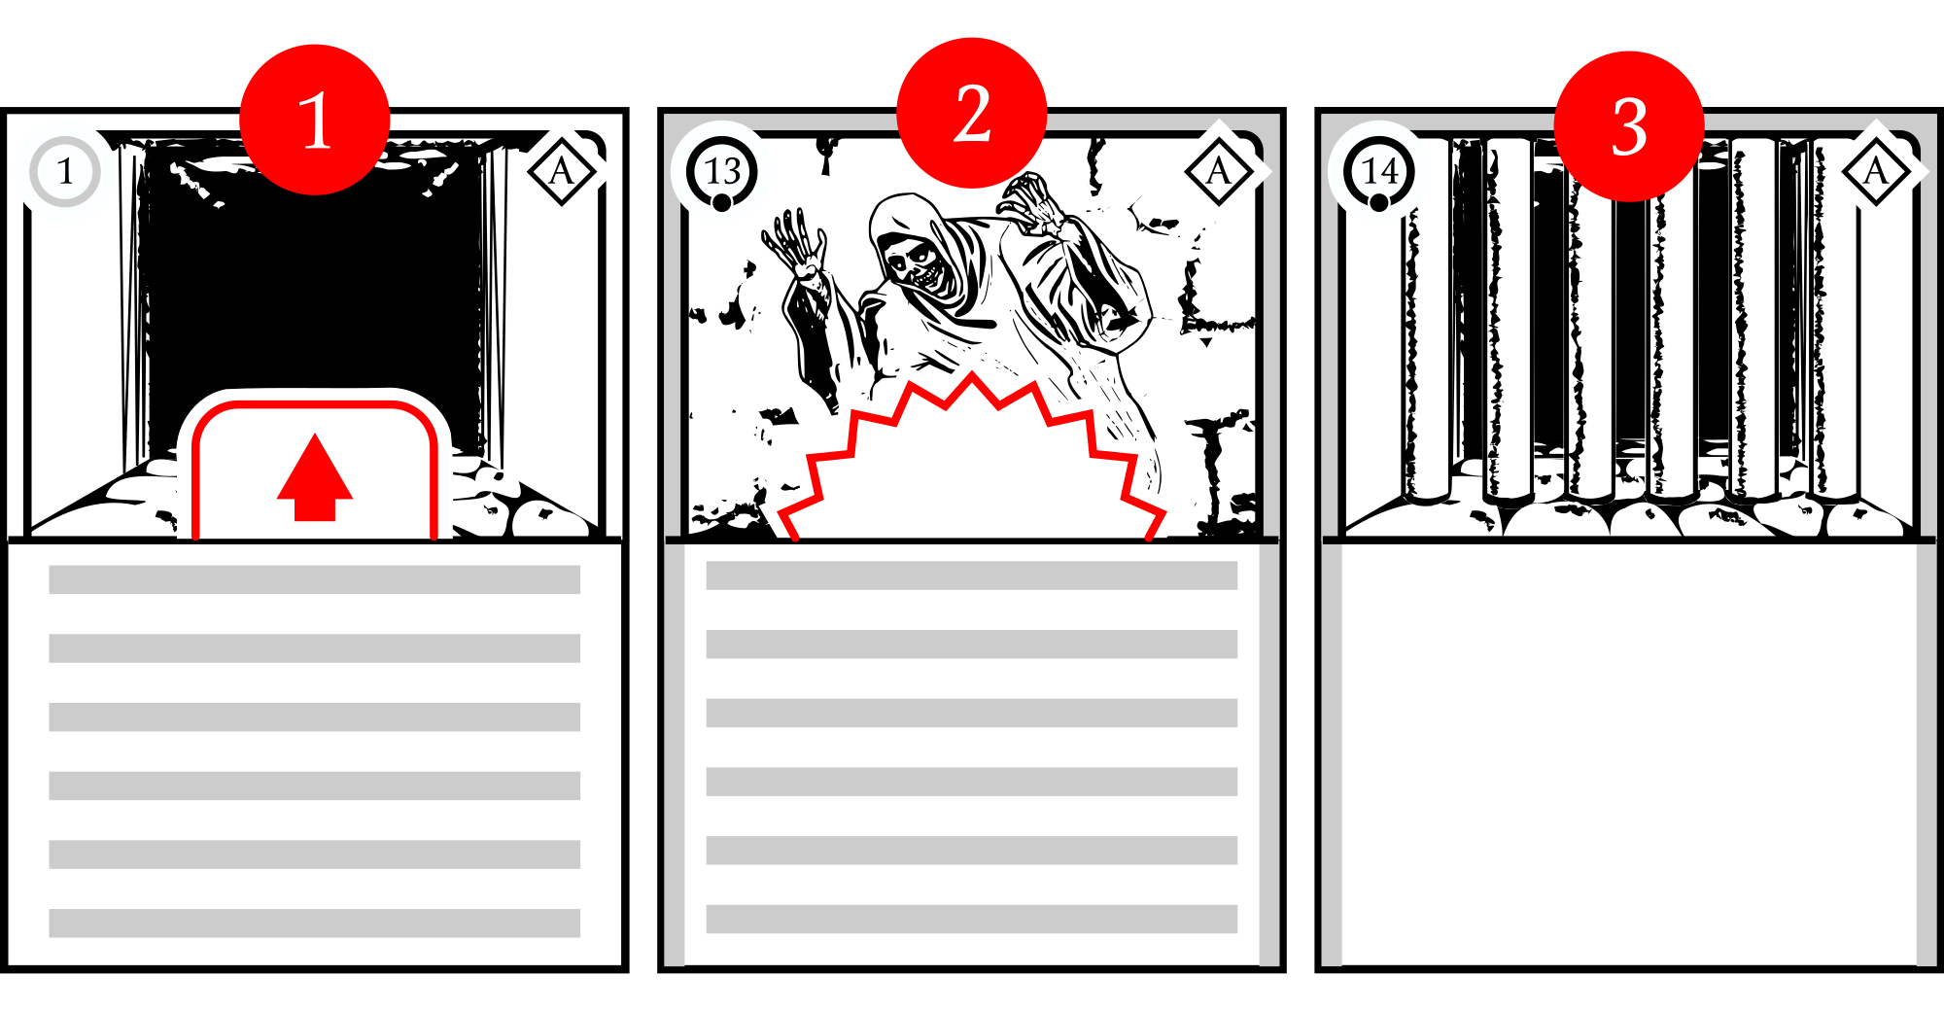
You can activate any round-shaped or star-shaped tab card with an icon in it . The icon represents the type of action you are going to perform:  Move action,  Talk action,  Use action, etc. If you wish to perform it, follow the instructions on the bottom half of the card.
Cards with a star-shaped tab automatically activate one by one in any order right after you've arranged them in the Sight Area.
Cards with no space and an icon don't provide any interaction, and they act like walls.
Cards activate one after another, so you can't choose to activate a card if an activation is already in progress or a card is waiting to be activated. (For example, in the case of multiple star-shaped tab cards.)

While these are the 3 most common types, during our analysis, we encountered several other combinations of symbols and tabs on the cards.

The card always shows a corridor with a symbol: this means that you can perform a Move action on that corridor facing that direction.

Conditions and Effects

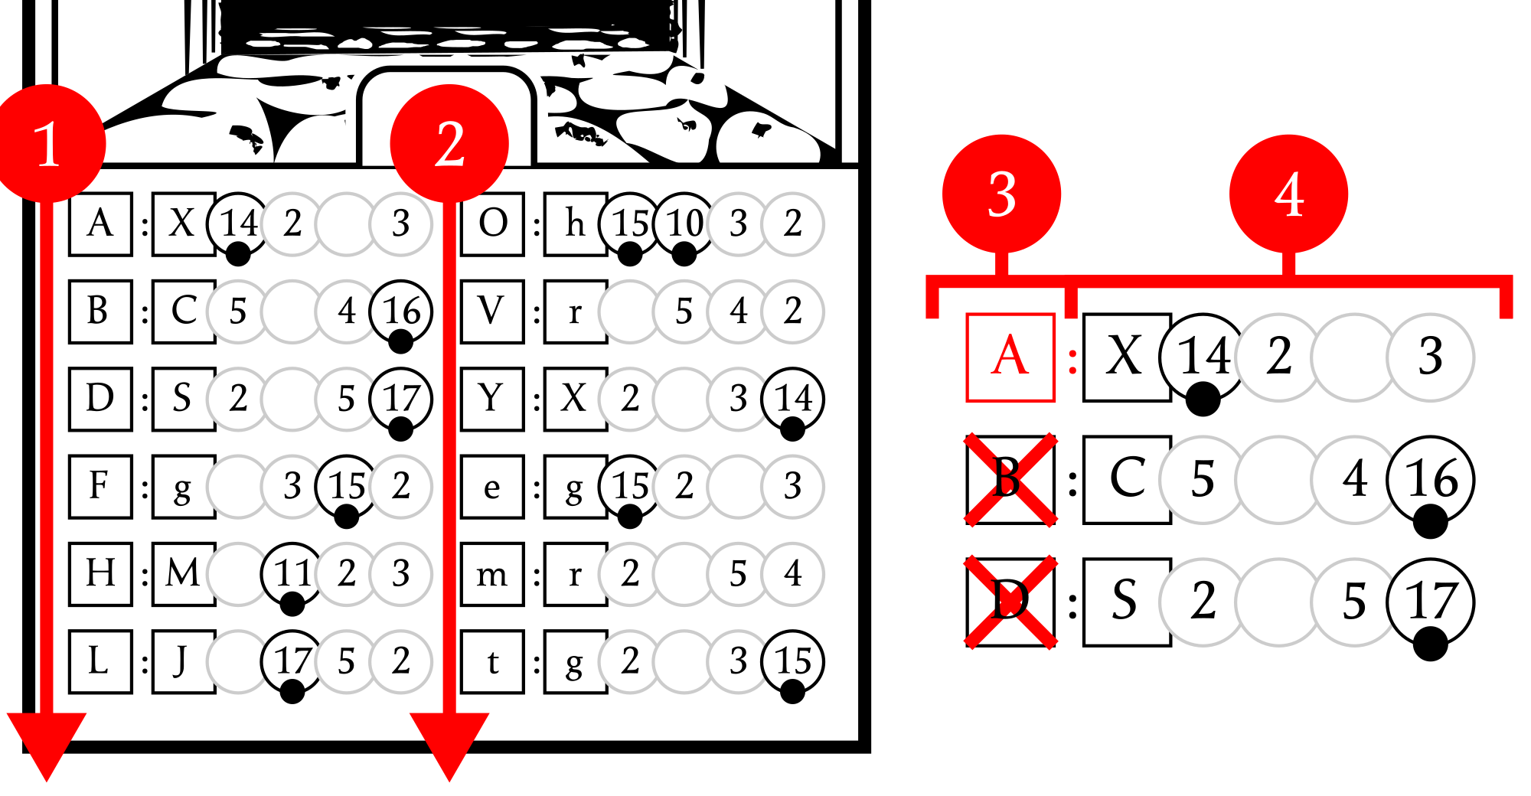
Although there are different types of cards, they are all activated the same way: reading, evaluating, and executing each line, starting from top to bottom , and then the second column after the first .

Lines may include one or more conditions and always include one or more effects . There are 2 kinds of conditions: mandatory conditions, ending with a colon ":", that always trigger the effect if the condition is fully verified, and optional conditions, ending with a question mark "?", that trigger the effect when the condition is fully verified and if you wish to perform that. If no condition is described, the effect is always triggered.

In the card (and in most of the Short Term Area cards), there is a list of lines with mandatory conditions that perform different Move effects depending on the cell you are in. Since you are in , only the first line of the list is triggered.

Both conditions and effects are often expressed solely using symbols. We've encountered dozens of them, some intuitive and others almost indecipherable. Unfortunately, we don't have enough data to explain them all: the most important ones are summarized in the Character Sheet. We believe it is quite clear that the Stampadian loved playing dice...

Move Effects

"The hippocampus plays important roles in the consolidation of information from short-term memory to long-term memory, and in spatial memory that enables navigation." - Wikipedia.

The most common action is the Move action, which usually triggers a Move effect that lets you walk around the dungeon. As you move, your current cell, your sight, and your orientation may change. Movement effects are described by a cell name, like 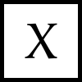, indicating which cell you will be in, followed by a sequence of 4 circles like 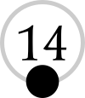 describing how to update the Sight Area.

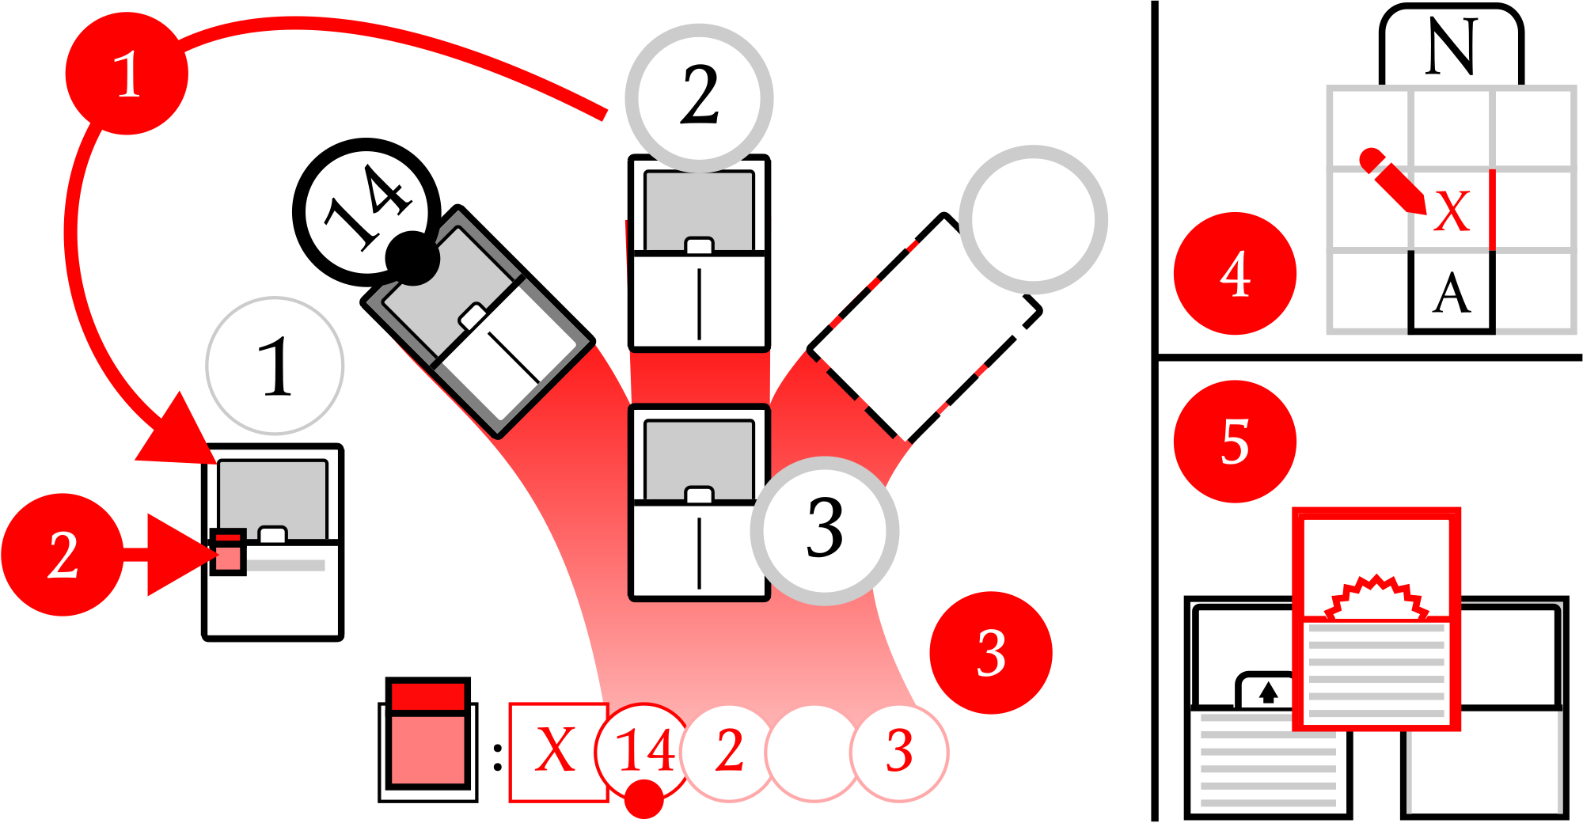
To perform a Move effect, move the card with the instructions into the Hippocampus Area (in your first Move action, it will be the card), moving the previous one back to the Long Term Area or the Short Term Area if present. Place the small token on the starting cell name and, from left to right, arrange the Sight Area following the circles : first the one in the left slot, the second one in the middle slot, the third one in the right slot, and the fourth one in the bottom slot. Cards with a number in a black circle and a dot move back and forth from the Long Term Area, cards with a number in a gray circle move back and forth from the Short Term Area, and empty circles indicate an empty space. Cards may come from any area, including the Sight Area, but never from the Forgotten Deck.
Update your map and finally activate all of the star-shaped tab cards in the Sight Area one by one in any order.

Getting lost was the Ancient Stampadians' greatest fear, as evidenced by missing information about orientation in Move effects, but this made them real experts at creating maps. The entrance cell name, for example, is always an "A" - a letter that resembles an arrow pointing North.

Change Effects

Ancient Stampadians have memories of the dungeon changing, buried in the Forgotten Deck. Change effects may bring them back, allowing you to explore even deeper.

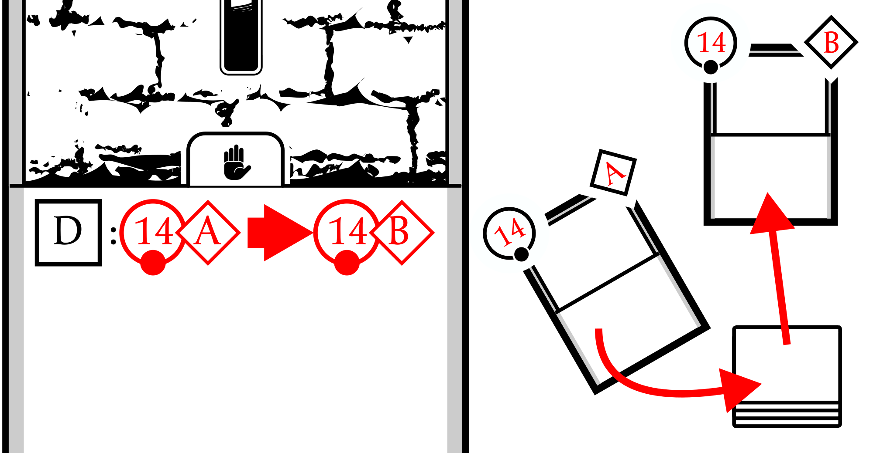
Change effects 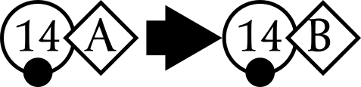 are described by a first card and a set , an arrow pointing to the right , and a second card with another set 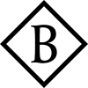. To perform a Change effect, look for the first card in any area and, if you find it, swap it with the second card in the Forgotten Deck. To be valid, the card must be straight, with the card number in the top left and the card set in the top right. The effect is one-way only, so if you can't find the first card because it has already been swapped, ignore the Change effect.

The  Rotate action triggers a special Change effect that flips the card upside-down, showing a different set. The card can only be flipped back if the Rotate action is present in the upper half of the new card, as for any other card.

The Emergency Teleport

We've added an emergency  Teleport action to the memory exploration system: you can find it in the bottom left of your Character Sheet.

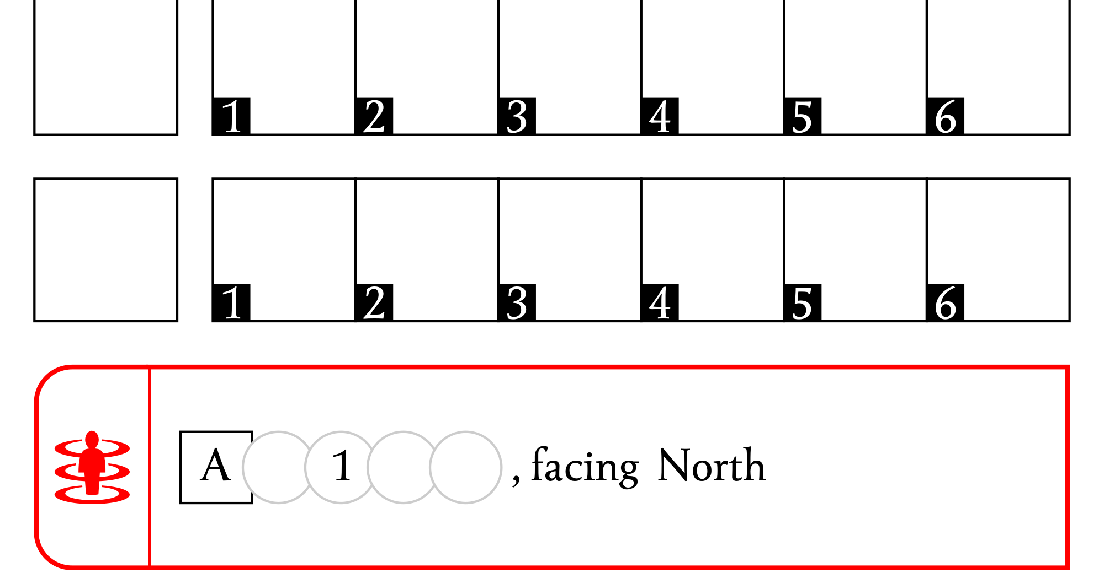
Instead of performing an action, you can teleport back to the A cell, facing North.

The Ancient Stampadians didn't have this help, finding themselves having to retrace their steps over and over again... with all that entailed. If you want a more authentic experience, just ignore this system.

Resources

The Ancient Stampadian culture is rich in extremely peculiar myths and traditions, where everything, from fruit to jewelry, is part of a complex ritual and could be worth as much as life itself.

In the world of the Ancient Stampadians, everything was a resource: from your health and strength to keys, jewelry, and fish. Your resources are tracked by your Character Sheet. As you start the game, you already have 6 Health resources , 1 Gold resource , and 1 Strength resource . Via effects and conditions, you can add, lose, or manipulate resources at specific inventory boxes.

This chapter explains the resource management rules. They're simple to apply but difficult to explain. Feel free to skip it and to come back to it later: some players prefer to learn the rules by playing and from the Character Sheet, coming back to the rulebook later for clarifications, while others prefer to read the full explanation first.

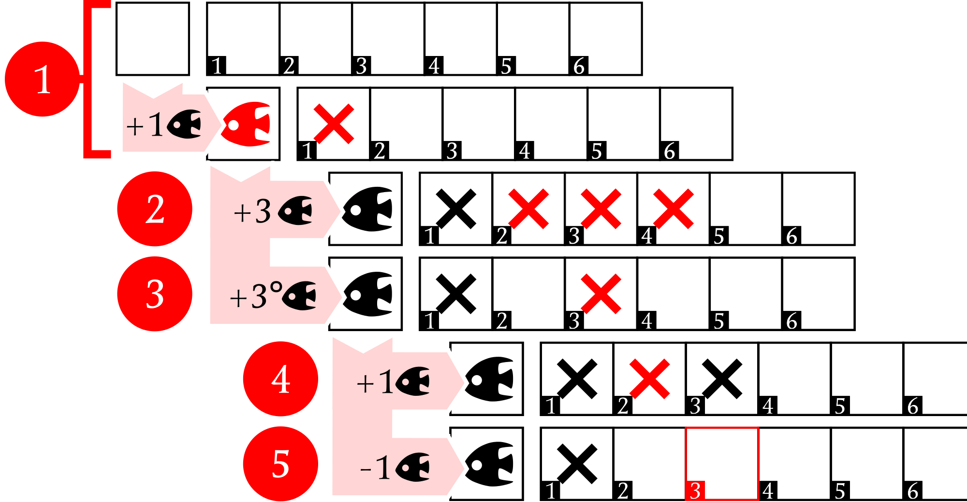
The +X  effect adds X resources of the type to your inventory. The first time you add a resource, draw the resource symbol on the first box and tick as many numbered boxes as the resources you added from left to right . You can have no more than 6 resources of each type (except for Gold, which has no limit). As you add more resources of the same type, keep ticking boxes starting from the leftmost empty box . All resources beyond the 6th are lost. Although the sheet only shows a few pre-printed spaces, you can bring unlimited resource types with you.
The +X° effect will give you a single resource at the Xth box . Adding a resource to an already ticked box has no effect. As you add more resources with the +X effect, always start ticking the leftmost empty boxes first .
The -X effect will remove X resources of type from your inventory. Resources are removed, clearing the rightmost ticked boxes first . If an effect tells you to lose more resources than you have, lose them all instead.

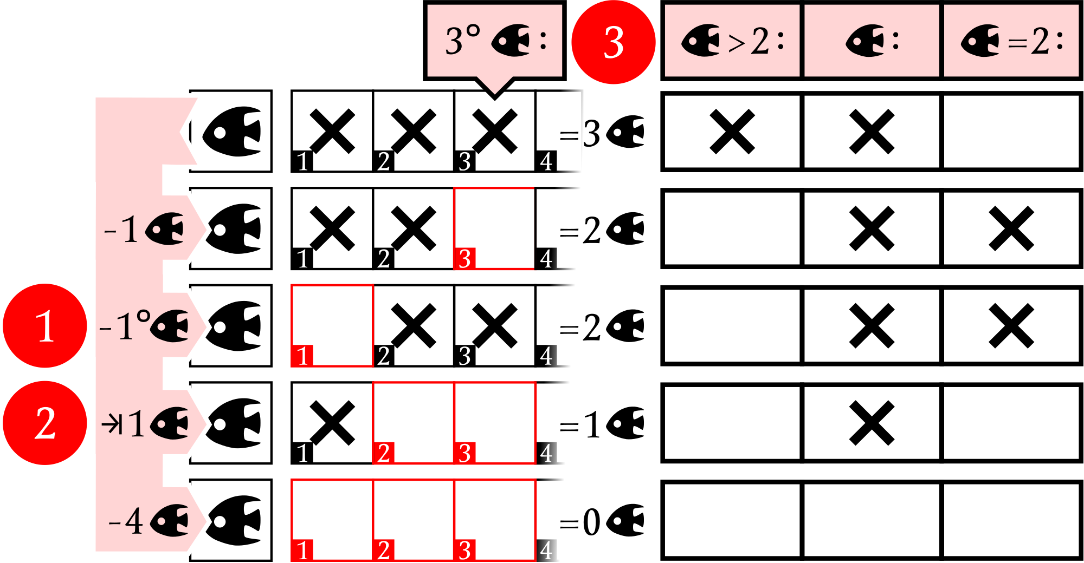
The -X° effect will remove a single resource at the Xth box . Removing a resource on an empty box has no effect.
The X effect will set the amount of resource you have , adding or removing them following the +X and -X rules (add by ticking the leftmost empty boxes, lose by clearing the rightmost ticked boxes).
Resources often appear in conditions too , to check if you have a resource on a specific box, more or less than, at least one, or the exact amount of a specific resource.

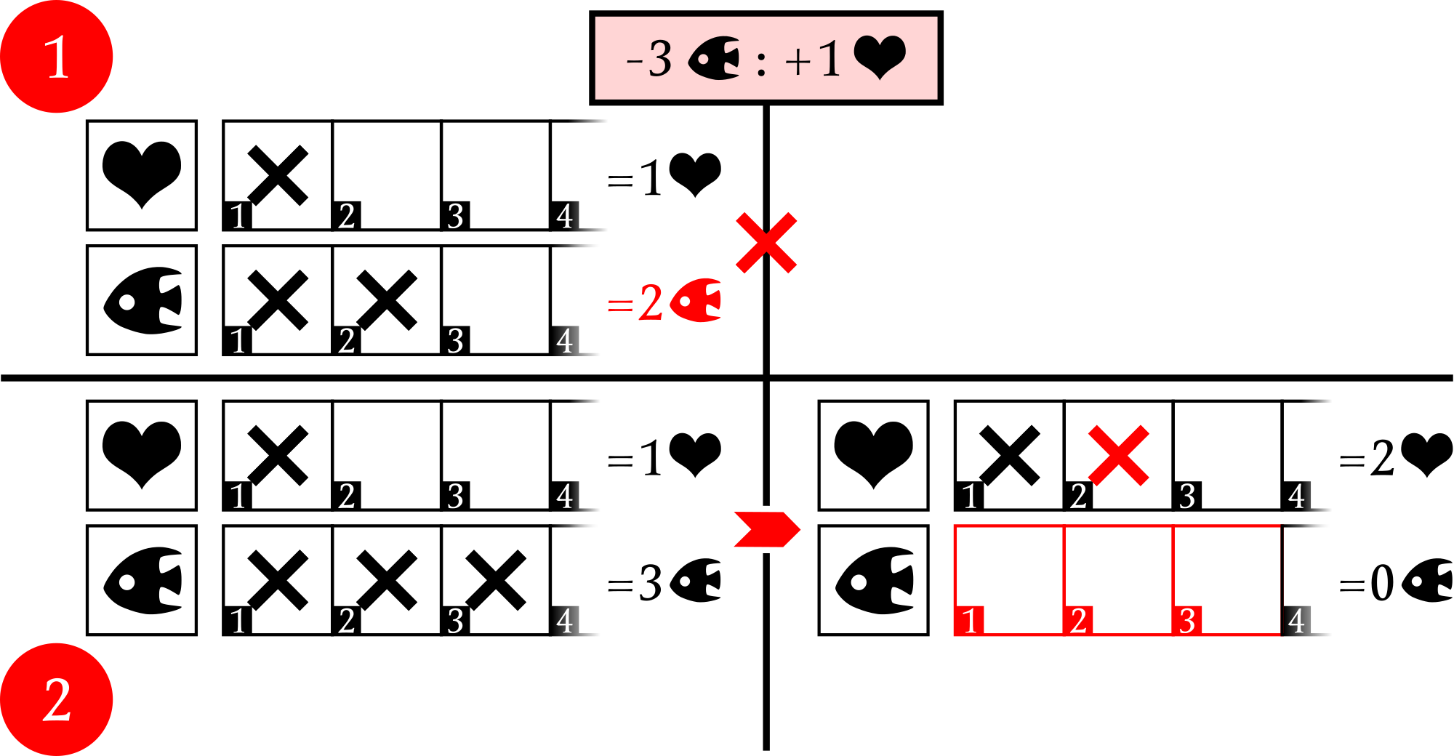
Resource effects may also appear as conditions, both testing a condition and changing your inventory if that change can be performed entirely. For example, the -3 effect will remove 3 from your inventory. As an exception, it will remove all of your if you have less than 3 of them.
The -3 :... condition, like -3 :+1 , will trigger if 3 resources can be removed from your inventory entirely. So it won't be verified if you have 2 or fewer and nothing will happen to your inventory . If you have 3 resources or more, the condition will remove 3 of them to be verified, and it will trigger its effect - in the example, it will give you 1 .
Any resource effect may appear as a condition, so a +3° condition will trigger if your 3rd can be ticked, a +3 condition will trigger if you can add 3 resources without losing any of them, and so on.

Offerings, Power, and Order

The 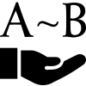 Offer effect and condition allow you to decide to remove any amount of a requested resource between A and B. The amount spent usually affects an  Action Power, which is calculated following a sequence of operations in a specific order.

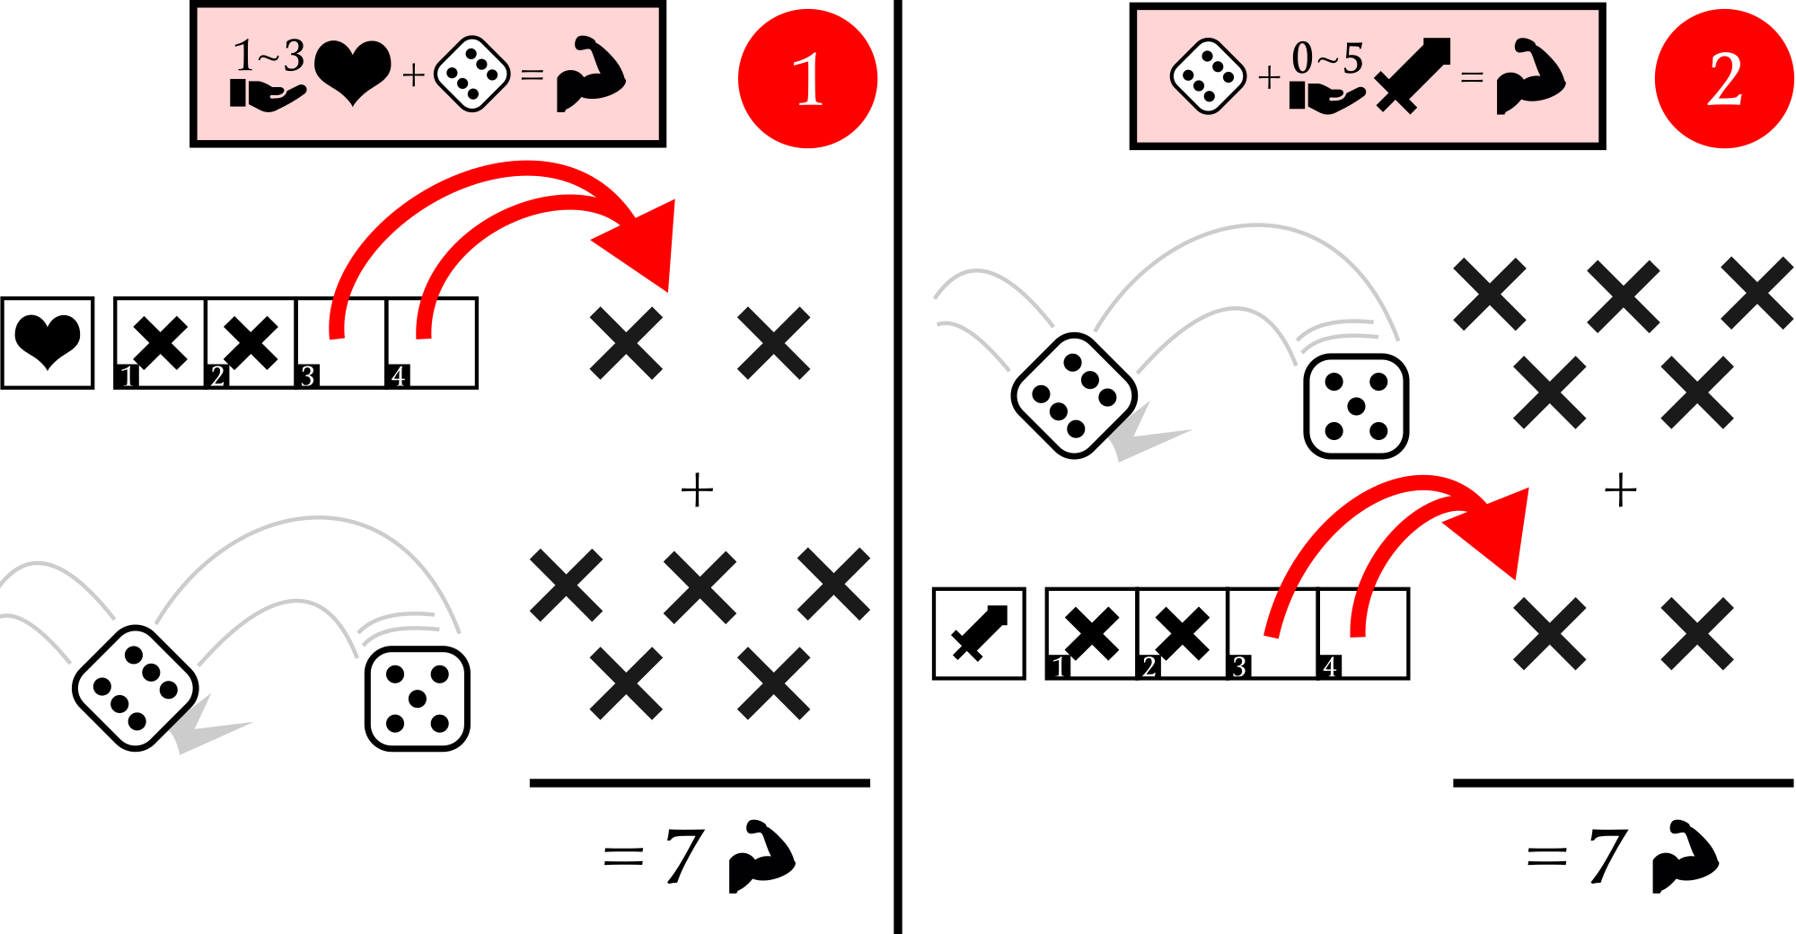
In these examples, both and are asking to calculate the Action Power by rolling a die and offering some resources, but the different steps order greatly impact how to do that.
In , you have to place your offering before seeing the die result, and in you have to place your offering after seeing the die result. As the Action Power is usually used by following conditions, and usually the higher the better, offering first is more risky than offering later .

Strictly following the order of operations applies both to calculating the Action Power and to the many other Stampadian rituals recounted in the memories...

Golden Rules

Cards have no memory so, every time you activate a new card, consider no dice rolled or in game, zero resources Offered, and zero Action Power.

Winning and Losing

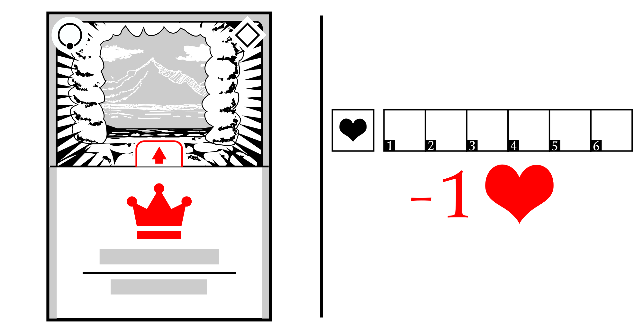
A Memory Dump is considered explored successfully if you manage to perform a Move action on the card with a crown. If you have to lose 1 or more Health resources, but you have none, the Memory Dump exploration ends with a failure.

Often, the crowned card features an illustration of some sort of exit - from which we assumed that was the purpose of the Ancient Stampadians. A mathematical formula is also printed to calculate some sort of score. Since these are dumps of past events, we don't know exactly what this score is for. For now, you can use it to compare the results of your exploration with your friends.

Saving and Loading

If no cards are activating or are about to activate, you can save the current game to resume later.

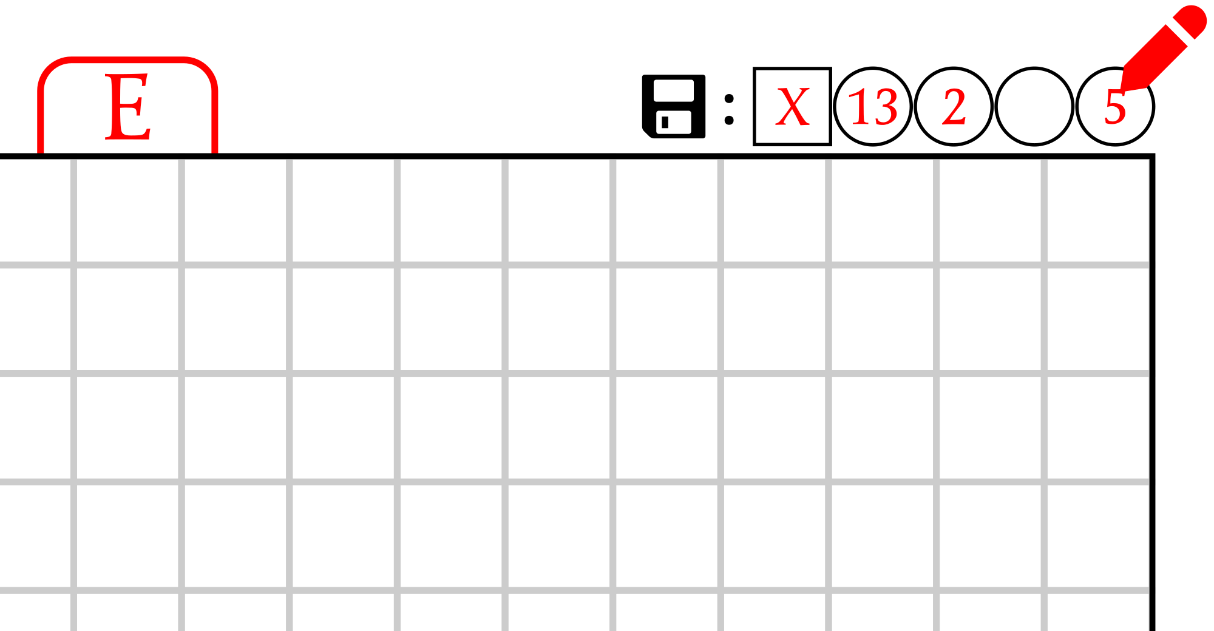
To save your game, write your current cell name and the card number arranged in the Sight Area on the top right of the Map Sheet as it is oriented, following the Move effect format. Form a face-up deck with all of the face-up cards on the table (Sight Area, Long Term Area, Short Term Area, and Hippocampus Area) and put it on the face-down Forgotten Deck. Store this deck, the Map Sheet, and the Character Sheet together.
To load your game, collect all the materials and split the deck into two. The smallest deck is the Forgotten Deck and must be kept aside face-down. Form the Long Term Area and Short Term Area with the remaining cards. Rotate the map to the saved game side and arrange the Sight Area according to the instructions you wrote in the top right, leaving the Hippocampus Area empty. Finally, put the Character Sheet under the Sight Area and erase the instructions.

There is no need to save and restore the Hippocampus Area zone: its purpose is to help you prepare the Sight Area as you move from zone to zone.

Extra Game Modes

Want to see who the fastest explorer is? Start a timer at the beginning of the game and successfully explore a Memory Dump the fastest you can!

Do you prefer a more relaxed exploration? When you have to lose more Health than you have, lose Strength by the remaining amount instead. If you run out of Strength too, gain  by the remaining amount instead.

That's All...


This is the information we've gleaned from analyzing the floppy disks so far: it should be enough to begin exploring your first memory dumps. But there's much more to discover: there are symbols to interpret, procedures and rituals to reconstruct, people to identify, and monsters to fight. Don't be afraid to get creative. Don't even be afraid to cheat a little when things get complicated, especially in your first few games. And don't give up, because we need you. Help us discover the purpose of these memory dumps.

MOS3D is an open-source project: https://github.com/kesiev/stampadia-mazes. Very special thanks to Bianca, Preuk, and all the Stampadians out there.
Our Translations

Understanding the meaning behind some of the cards can be a daunting challenge. That's why we've decided to share our interpretation of some of the cards we found during our analysis. If you'd rather test yourself and do it on your own, don't read on!

Card 1

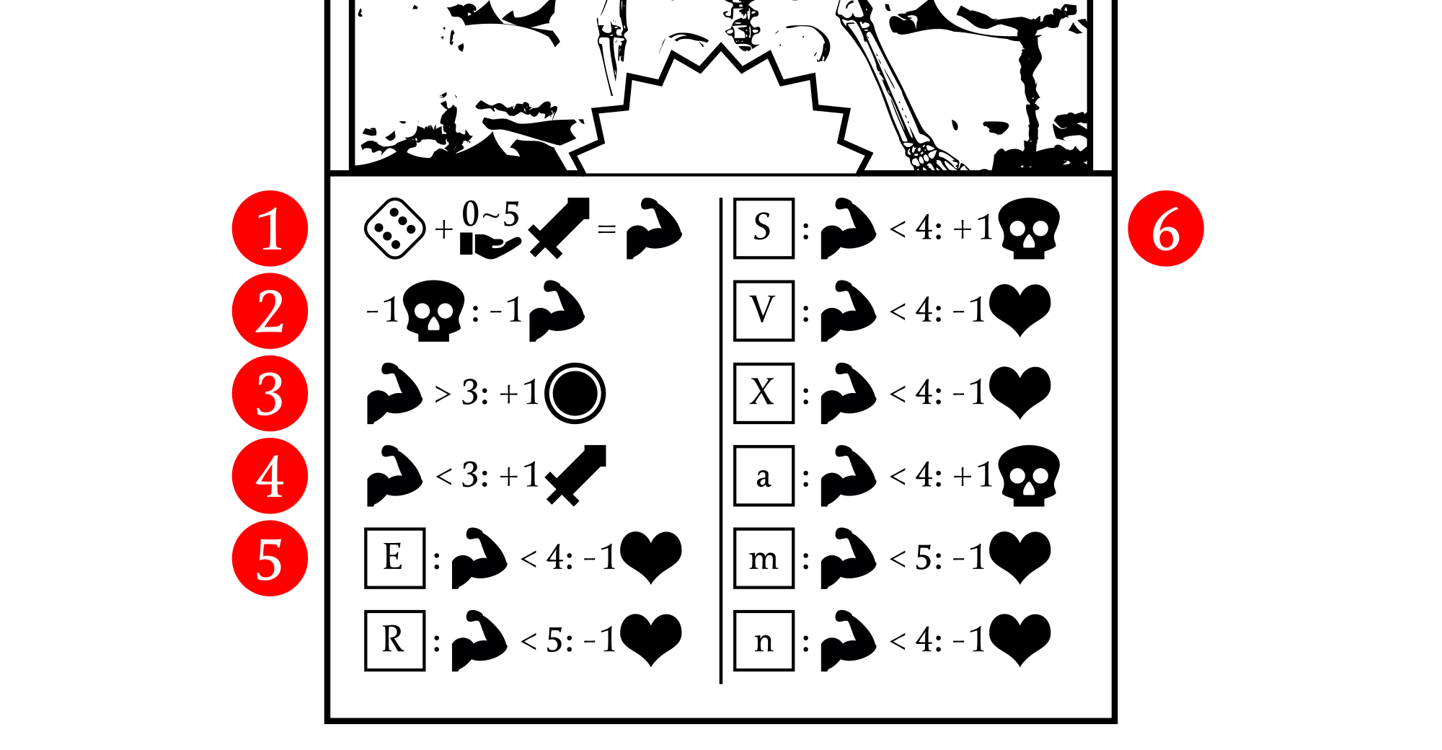
As this card has a star-shaped tab, it activates as it is arranged into the Sight Area. There is no symbol in the center, so it can't be activated in any other way.

First, roll one die. Then, decide to offer from 0 to 5 Strength resources. Sum these values to get the Action Power.
If you can lose one Curse resource, do it and reduce the Action Power by one. As the condition ends with a colon, you must do it if possible.
If the resulting Action Power is greater than 3, gain 1 Gold resource.
If the resulting Action Power is less than 3, gain 1 Strength resource.
If you are in Cell E and the Action power is less than 4, lose 1 Health resource. Conditions can trigger another condition instead of an action!
If you are in Cell S instead and the Action power is less than 4, gain 1 Curse resource.

We think that these rules schematize some kind of combat, where the fighter can react by applying more or less force to the blow.

Card 2

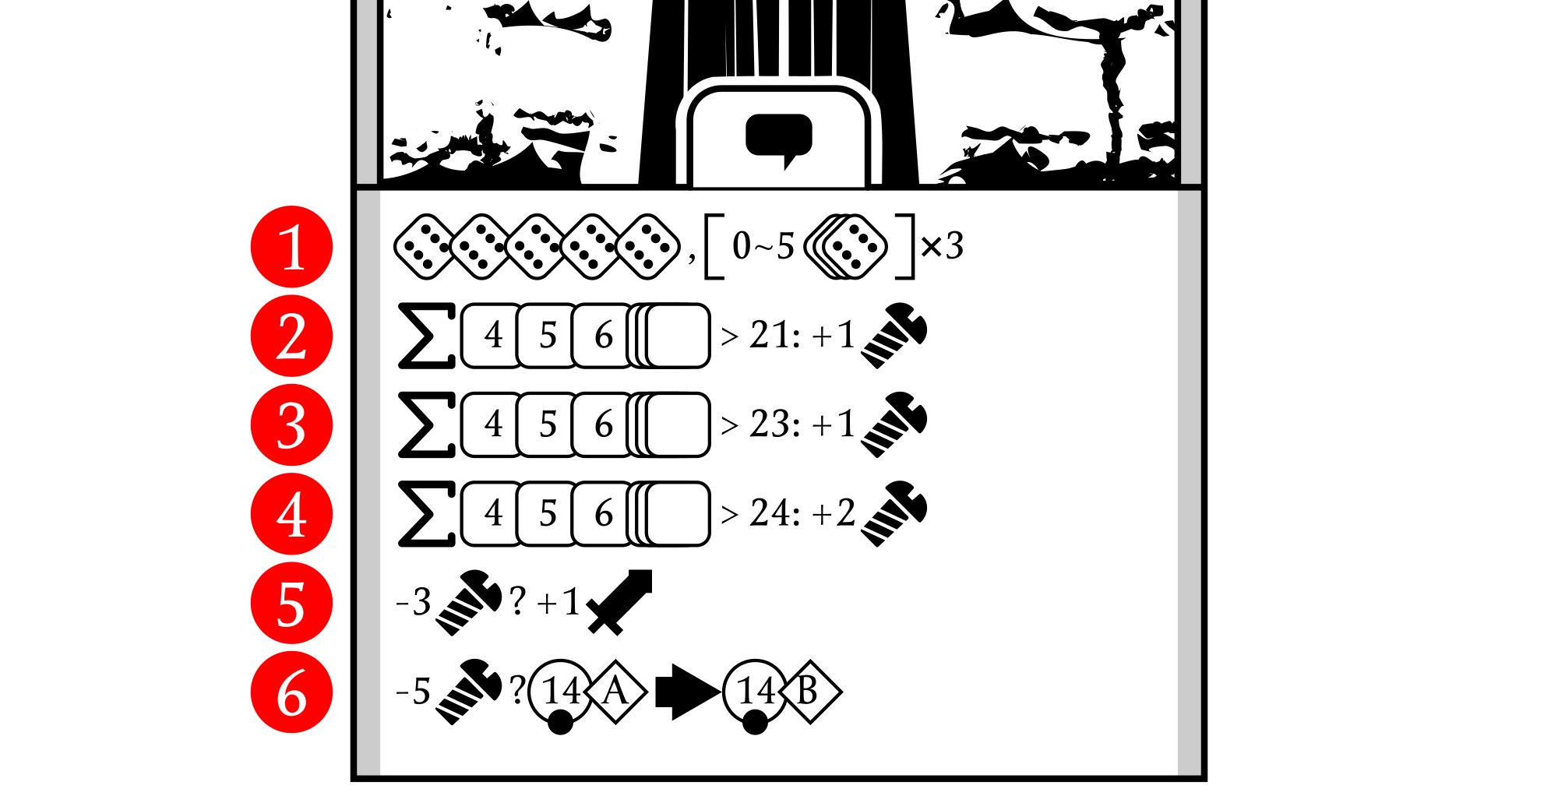
As this card has a round-shaped tab with a balloon icon on it, you can activate the card by performing a Talk action.

Roll 5 dice. Then, for 3 times, you can select from 0 to 5 of them and reroll.
If the sum of a dice set composed of a 4, a 5, a 6, and all other dice is greater than 21, gain 1 Screw resource.
If the sum of a dice set composed of a 4, a 5, a 6, and all other dice is greater than 23, gain 1 Screw resource. That means that, with a 24, you get 2 Screws: this one and the one from the previous line.
If the sum of a dice set composed of a 4, a 5, a 6, and all other dice is greater than 24, gain 2 Screws resource. With a 25, you get 4 Screws in total!
If you can lose 3 Screws and you want to do that (due to the question mark after the condition), you get 1 Strength resource.
If you can lose 5 Screws and you want to do that, swap the 14A card in any area with the 14B card in the Forgotten Deck.

This card appears to illustrate the rules of a dice game very similar to one known in our world as "Ship, Captain, and Crew." During our tests, several such games appeared, activated by "talking" to hooded figures, who exchanged their prizes for useful items or even opening locked passages. From this, we imagined that the Stampadians were particularly fond of dice games.

Card 3

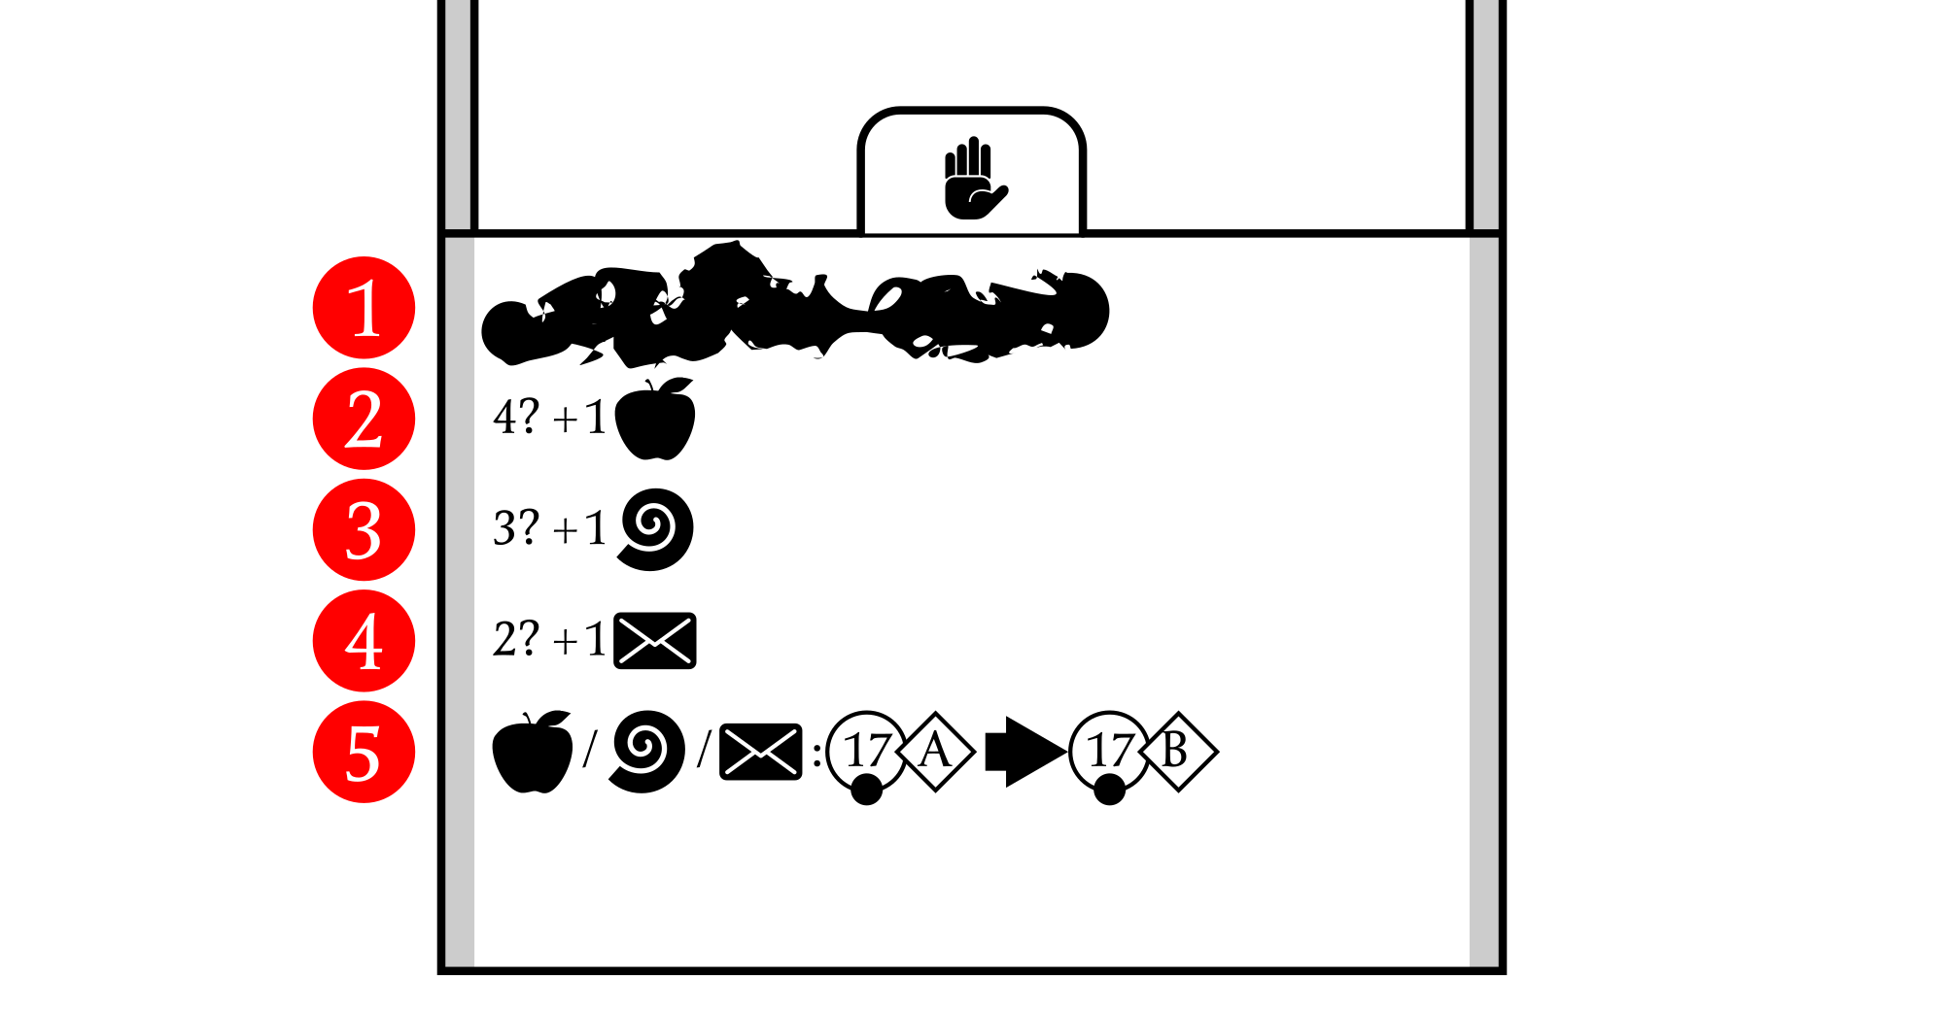
As this card has a round-shaped tab with a hand icon on it, you can activate the card by performing a Use action.

There may be garbage text, symbols, math formulas with variables, etc. We've blanked it as we didn't understand any of them.
If "4" and you want to do it, then gain 1 Apple resource. We don't know what "4" means.
If "3" and you want to do it, then gain 1 Snail resource. We don't know what "3" means.
If "2" and you want to do it, then gain 1 Envelope resource. We don't know what "2" means.
If you have at least 1 Apple, 1 Snail, or 1 Envelope, swap the 17A card in any area with the 17B card in the Forgotten Deck.

We have no idea what this card means. We know that you need to get at least one resource to swap one of the cards.

