
Game version: 0.9 – Manual version: 0.91

You can find an up-to-date digital copy of this manual, FAQs, videos, and more stuff on how to play Stampadia at https://kesiev.com/stampadia/learn.html

Discover Stampadia!

The reign of Stampadia had thousands of years of history of dangerous places and brave mercenaries before disappearing mysteriously from our globe. But Stampadia monks, generation after generation, managed to document relentlessly the story of every single adventurer, the map of every single dungeon, and the clue of every single mystery in a huge tome called Chronicles Of Stampadia.

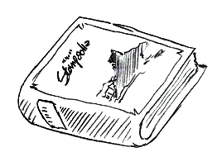
We managed to find a damaged copy in an abandoned basement and it looks like that the book is imbued with some kind of magic: the reader can live every page of its story with just two dices, an eraser, and a small token! We’re trying to recover, translate and digitalize a new page of this book every day at https://kesiev.com/stampadia. Go there, download the daily page, and bring back to life the story of a brave Stampadian!

Setup

Print the adventure sheet, pick 2 dice, a pencil, an eraser, the Hero Token (you can use a small button, thimble, or a cube taken from another board game), and you're ready to go!

How to read the Map

It’s a grid that shows where rooms, enemies, treasures, and traps are. When your adventure starts only the walls of the starting room are visible (the squared black outline with a stairs symbol in the middle) but you’ll soon discover more rooms as your hero will start exploring.

Calculating the distance

Sometimes you’ll need to check the distance between two cells on the map. To calculate it, count the number of cells crossed by the shortest path from these two cells, moving orthogonally and counting the destination cell too. This path can cross any cell and door but can't cross room walls.

How to read the Rooms Table

The Rooms Table shows which rooms your dungeon has, where they are, and how they work. Try avoiding spoilers and read this table just when needed!
The first column indicates the room number and has a checkbox on it: the game will instruct you how to use these during the adventure.
The second column indicates where the room is on the map and you will use this information to draw them as your hero explores the dungeon.
The third column shows the Room Instructions, which describe how that specific room works. When your hero will be in that room you will follow that room’s rules.

How to read the Inventory

The Inventory lists your hero equipment (the Equipment Scroll) and gold (the Gold Bar). The Gold Bar also tracks your time left and your end-game score!

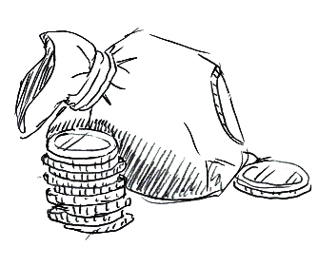
Spending gold (-x G)

Spend gold (-x G) ticking a circle from the Gold Bar. If you don't have enough empty circles in the Gold Bar to act, that action cannot be performed.

Time is Gold!

The game uses gold to track your time left too: 1 gold is spent every time the Hero Token crosses a door. If you can't afford that, your time is up and your hero is lost in the dungeon. You've to leave him to his terrible fate and your game ends.

Gaining gold (+x G)

Gain gold (+x G) erasing ticks from the Gold Bar. If you don't have enough ticked circles on the Gold Bar, use the ones you have and the remaining gained gold is lost. If your quest ends successfully, the gold left is your score so try to manage it as better as you can!
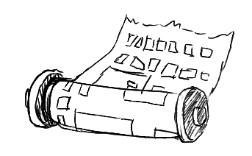
Using items

To use an item from the Equipment Scroll, tick its box and apply its effects explained in brackets. Items can't be used multiple times, so use them wisely!

How to read the Hero Sheet

The Hero Sheet shows your hero stats: there is a row of defense bonuses (+x DEF), a row of groups of HP boxes that tracks the hero health points (HP), a row of pairs of abilities the hero will use in battle, and a row of groups of XP boxes that track the hero experience points (XP).
At the start of your adventure, only the first column of stats is enabled and the other columns are ignored, but you will unlock more columns as your hero gains XPs: every time a group of XP boxes is completed, the relative column will be enabled, giving your hero more defense bonuses, HP, and abilities to use!

Gaining XP (+x XP)

Your hero will gain XP (+x XP) killing enemies. Tick as many XP boxes as the gained XP starting from the leftmost group with at least one unchecked box.
As you tick all of the XP boxes of a group, your hero will enable the abilities and bonuses of the relative column, becoming stronger!

Losing hero's HP (-x HP)

Your hero may lose his health (-x HP) in fights or falling into traps. Starting from the leftmost available unticked HP box, tick as many boxes as the damages your hero got. If you have to tick an HP box and there aren’t any that’s available and unticked, your hero is dead!

Gaining hero's HP (+x HP)

Some items or special events may give your hero some health back (+x HP). Starting from the rightmost ticked HP box of the Hero Sheet, erase as many ticks as the HP your hero gained. If you don't have any ticked HP box, the cure is lost.

When your hero dies...

Check the Equipment Scroll of the Inventory: if you have the Resurrection item and at least 5 gold left, you may tick its box, tick 5 gold from the Gold Bar, remove all the ticks from the HP boxes, move your Hero Token back to the cell with the stairs symbol, and continue your adventure. But beware: you can use an item only once so use it carefully!
If you don't have any resurrection item, you don't have enough gold to use it, or you don’t want to use it your game ends.

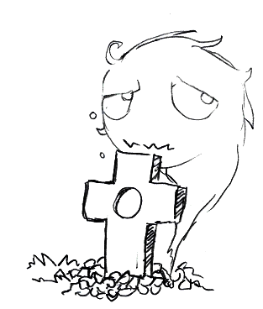
How to read the Enemy Sheet

The Enemy Sheet shows all of your enemies stats: there is a row of defense bonuses (+x DEF), a set of symbols to show which columns are enabled for specific enemies, a row of pairs of abilities the enemy will use in battle, and the XP bonus your hero will gain killing that enemy in battle (+x XP).
When dealing with an enemy, only the first column (ALL) and the columns matching that enemy shape are enabled, the other columns are ignored. Enemies that don't match any column just have the first column enabled.
Enemy’s health is tracked directly by its symbol on the map: when an enemy loses HP tick a white circle on its symbol and when there is no white circle available, cross the entire cell on the map, marking the enemy’s death.

Starting the game

Write down your hero name in the space on the top left of the adventure sheet. Try something evocative!

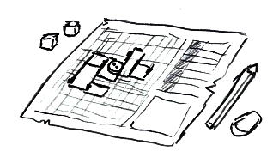
Place the Hero Token on the stairs cell of the map, find the starting room on the Room table (the row with the stairs symbol on the second column), read the stairs room instructions, and you're ready to start your adventure!
The starting room contains no enemy, so keep reading the next paragraph.

When there are no enemies...

When the Hero Token is in a room with no enemies (the gray circles with horns) you can move the Hero Token orthogonally by one space multiple times. Things may happen while you're moving your hero in rooms, so follow the room instructions of the Rooms Table to manage special conditions, like when moving the Hero Token over grayed numbered cells. Any entirely crossed cell is considered a cell with no symbol on it. The Hero Token can't cross room walls but it may leave a room crossing a door, marked by a rectangle along the room walls: stop the Hero Token outside the door and spend 1 gold. Then, if the Hero Token is no longer inside a room, you've discovered a new one: sum the black number under the Hero Token with that cell's column and row numbers, and follow the next paragraph instructions.

Discovering a new room

The second column of the Rooms Table explains where the room is on the map.
First, draw the room walls: the first pair of numbers (i.e. 3,5) tells in which column and row the top-left cell of the room is on the map, and the second pair of numbers (i.e. 4x3) tells how many cells the room is large and tall. Find the top-left cell of the discovered room and draw the room rectangle on the map. Remember that the top-left cell of the first pair of numbers will end inside the room. You can note the room number anywhere inside the room, so you can use it to find the room instructions later easily.
The room walls may cross tiny rectangles already printed on the sheet: these are the room doors your hero may use to leave the room.
Finally, if your Hero Token is inside this new room, read and follow the room instructions on the third column.

How to read room instructions

Find the room number on the first column of the Rooms Table and read the text on that row third column. You're going to read the room instructions and apply it mostly when you discover a new room, but some conditions may keep applying during the game (i.e. how to manage the grayed numbered cells in the room or what happens after a battle).

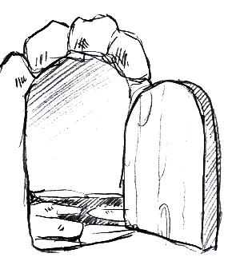
Room instructions contain up to two lines of text per room, that must be read sequentially and may contain trigger and action lines.
A trigger line has the » symbol on it: the left side is the condition, which activates the consequent action on the right side every time is verified. Conditions may be composed of multiple parts divided by a & symbol: all of its parts must be verified to trigger the linked actions. Conditions parts may contain symbols for common actions:

x1: Room 1 on the Rooms table must be ticked
not x1: Room 1 on the Rooms table must not be ticked
pay 5G: You may decide to spend 5 Gold to verify this condition part

Action lines don't contain any » symbol and are executed only once, and when they are read for the first time. Actions may contain symbols too:

x1: Tick the room 1 box on the Rooms Table
x[1]: Cross entirely the grayed cell inside this room that has a 1 on it.

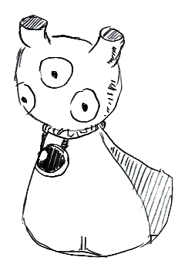
Upside-down text?

A trigger line may have an action with partial or full upside-down text. You’ve to read the upside-down part as a continuation of the action line once you’ve triggered its condition. It’s a way to hide some of the consequences of your choices: while the upright part may give you a hint of what could happen next, you’ve to resist not to read the upside-down part! Will you be brave enough to walk on that suspicious tile?

When there are enemies…

When the Hero Token is in a room with enemies (the gray circles with horns) a battle round starts. All of the enemies in the room are considered active and will play an enemy turn in this round. Your hero goes first.

Battle round — the hero turn

Roll two dices and remove all the dices that rolled a 1: for this turn, you won’t play these. Then place the available dices on the ability spaces of the Hero Sheet to activate them, but following these rules: you can use enabled abilities only (have a look at the "How to read the Hero Sheet" for more), the dices must be placed on different rows and columns, and in descending order from left to right. You may use just one dice instead and place it on any enabled ability, or play no dice at all and jump to the enemies’ turn. Then you have to activate the abilities covered by dices in order from left to right.

Move: Move the Hero Token orthogonally up to the number of spaces displayed on the dice. A modifier may change the dice value (i.e. Move -1 subtracts 1 to the movement). Follow the usual movement rules with two exceptions: you can't move on any space that makes you discover a new room and you can't move over cells containing a living enemy. Note that some rooms may prevent you from leaving the room until all enemies have been eliminated.
ATK/RNG: Attack an enemy that's distant RNG squares from your Hero Token with the strength displayed on the dice. A modifier may change the dice value (i.e. ATK -1 subtracts 1 to the strength). Subtract the enemy defense (the enabled defense bonuses from the Enemy Sheet and the gained defense from that enemy’s previous turn). If the resulting value is greater than 0, the enemy loses 1 HP: tick one circle from his icon on the map to reduce his health or, if there are no circles available, cross its cell entirely to mark his death. Killing enemies this way makes your hero stronger: your hero will gain all of the enabled XP bonuses of that enemy.
DEF: Set the defense by the value displayed on the dice. A modifier may change the dice value (i.e. DEF -1 subtracts 1 to the defense). Defense value is set and not increased, so multiple defenses can't be stacked.
Gain HP: Gain hero’s HP by the value displayed on the dice. A modifier may change the dice value (i.e. Gain HP -5 subtracts 5 to the gained HP). Your hero can’t lose HP this way: if you gain negative HP by using this action it doesn’t have any effect.

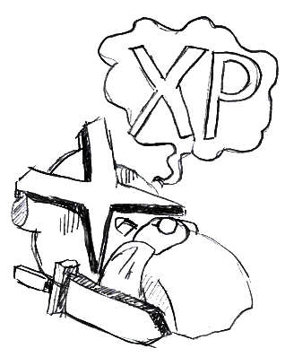
At the end of the hero turn, sum the defense set by abilities if any to the enabled defense bonuses on the Hero Sheet and limit the result to a maximum of 6 to get your hero final defense. You will use it to parry enemies’ attacks. Now all active enemies will play an enemy turn, starting from the nearest to the farthest — the player decides the ties.

Battle round — the enemy turn

Roll two dices, remove all the dices that rolled a 1, and place them on the ability spaces of the Enemy Sheet to activate them, following the same rules of the hero turn. The enabled columns of the Enemy Sheet are the ALL column and the one matching the enemy symbol — so only up to two columns per enemy are enabled each turn. The enemy may play his dices up to 4 ways: using the highest dice on a single ability, using both dices in one of the two valid combinations (the higher dice on the upper ability of the ALL column and the lower dice on the lower ability of the second available column or the higher dice on the lower ability of the ALL column and the lower dice on the upper ability of the second available column) or skipping their turn. The enemy will use as many dices as he can first to move the Hero Token in range of their available attacks, then to deal as much damage as possible, and finally to raise his defense, so choose the best dice actions for the enemy.

Move: Attract the Hero Token toward the shorter path to the enemy up to the number of spaces indicated by the dice, following the Hero turn MOVE rules. A modifier may change the dice value (i.e. Move -1 subtracts 1 to the movement).
ATK/RNG: Attack the hero if the Hero Token is distant RNG squares from the enemy with the strength indicated by the dice. A modifier may change the dice value (i.e. ATK -1 subtracts 1 to the strength). Subtract the Hero defense and, if the resulting value is greater than 0, your hero loses 1 HP.
DEF: Set the defense by the value of the dice. A modifier may change the dice value (i.e. DEF -1 subtracts 1 to the defense). Defense value is set by abilities and cannot be increased by multiple defenses.

At the end of the enemy turn, sum the defense set by abilities if any to the enabled defense bonuses on the Enemy Sheet and limit the result to a maximum of 6 to get the enemy final defense. It will use it to parry your hero attacks on the next battle round. Now play the next active enemy turn until all active enemies played their turn.

Battle round – round end

After all of the enemies played their turn, the battle round ends. If the Hero Token is still in a room with enemies, start a new battle round. If the Hero Token is in a room with no enemies instead, because all enemies are dead or your hero managed to escape, all of the defense is lost and your hero may act as described in "When there are no enemies...".

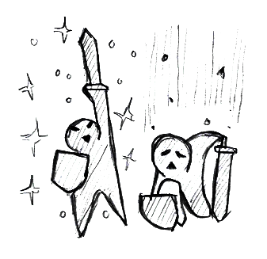
Ending the game

If your hero has all of his HP boxes checked and must lose HPs and can't resuscitate (or you don't want to do that) or if you lose all of your gold, you lost the game and your final score is 0. Victory conditions may vary from adventure to adventure and are often described by the starting room instructions.
If your quest ended successfully, congratulations! Your gold left is your score. Compare scores with friends who played the same adventure and discover who’s the best adventurer!

Variant: Vs. Campaign

You may collect some adventure sheets you’ve collected, print and play them in sequence and then sum the points gained in each adventure. Then compare the overall score with friends that played the same adventures and crown the best adventurer of Stampadia! You may also play against a far friend, playing the same daily adventures for a week and then comparing the sum of the gained points.

Thanks!

Chronicles of Stampadia is an open-source project. More here: https://github.com/kesiev/stampadia. A huge thank you to Bianca and her father Sergio for their contributions, patience, and help!
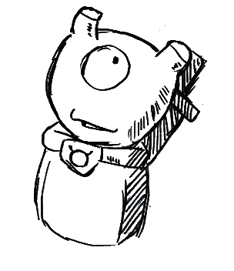
Thanks to the code contributors and the Stampadia Discord travelers for sharing their effort and ideas!

