**Digital Nurture 4.0 Deep Skilling - Java FSE  
WEEK –5 Microservices with Spring Boot 3 and Spring Cloud**

**Microservices with API gateway**

1. **Creating Microservices for account**

**AccountFolder**

**AccountController.java**

package com.cognizant.account.controller;

import org.springframework.web.bind.annotation.*;

import java.util.Map;

@RestController

@RequestMapping("/accounts")

public class AccountController {

@GetMapping("/{number}")

public Map<String, Object> getAccount(@PathVariable String number) {

return Map.of(

"number", number,

"type", "savings",

"balance", 234343

);

}

}

**AccountApplication.java**

package com.cognizant.account;

import org.springframework.boot.SpringApplication;

import org.springframework.boot.autoconfigure.SpringBootApplication;

@SpringBootApplication

public class AccountApplication {

public static void main(String[] args) {

SpringApplication.run(AccountApplication.class, args);

}

}

**application.properties**

spring.application.name=account

**AccountApplicationTests.java**

package com.cognizant.account;

import org.junit.jupiter.api.Test;

import org.springframework.boot.test.context.SpringBootTest;

@SpringBootTest

class AccountApplicationTests {

@Test

void contextLoads() {

}

}

**pom.xml**

<?xml version="1.0" encoding="UTF-8"?>

<project xmlns="http://maven.apache.org/POM/4.0.0" xmlns:xsi="http://www.w3.org/2001/XMLSchema-instance"

xsi:schemaLocation="http://maven.apache.org/POM/4.0.0 https://maven.apache.org/xsd/maven-4.0.0.xsd">

<modelVersion>4.0.0</modelVersion>

<parent>

<groupId>org.springframework.boot</groupId>

<artifactId>spring-boot-starter-parent</artifactId>

<version>3.5.3</version>

<relativePath/> <!-- lookup parent from repository -->

</parent>

<groupId>com.cognizant</groupId>

<artifactId>account</artifactId>

<version>0.0.1-SNAPSHOT</version>

<name>account</name>

<description>Spring Boot Microservice for Account</description>

<url/>

<licenses>

<license/>

</licenses>

<developers>

<developer/>

</developers>

<scm>

<connection/>

<developerConnection/>

<tag/>

<url/>

</scm>

<properties>

<java.version>21</java.version>

</properties>

<dependencies>

<dependency>

<groupId>org.springframework.boot</groupId>

<artifactId>spring-boot-starter-web</artifactId>

</dependency>

<dependency>

<groupId>org.springframework.boot</groupId>

<artifactId>spring-boot-devtools</artifactId>

<scope>runtime</scope>

<optional>true</optional>

</dependency>

<dependency>

<groupId>org.springframework.boot</groupId>

<artifactId>spring-boot-starter-test</artifactId>

<scope>test</scope>

</dependency>

</dependencies>

<build>

<plugins>

<plugin>

<groupId>org.springframework.boot</groupId>

<artifactId>spring-boot-maven-plugin</artifactId>

</plugin>

</plugins>

</build>

</project>

**LoanFolder**

**LoanController.java**

package com.cognizant.loan.controller;

import org.springframework.web.bind.annotation.*;

import java.util.Map;

@RestController

@RequestMapping("/loans")

public class LoanController {

@GetMapping("/{number}")

public Map<String, Object> getLoan(@PathVariable String number) {

return Map.of(

"number", number,

"type", "car",

"loan", 400000,

"emi", 3258,

"tenure", 18

);

}

}

**LoanApplication.java**

package com.cognizant.loan;

import org.springframework.boot.SpringApplication;

import org.springframework.boot.autoconfigure.SpringBootApplication;

@SpringBootApplication

public class LoanApplication {

public static void main(String[] args) {

SpringApplication.run(LoanApplication.class, args);

}

}

**application.properties**

spring.application.name=loan

server.port=8081

**LoanApplicationTests.java**

package com.cognizant.loan;

import org.junit.jupiter.api.Test;

import org.springframework.boot.test.context.SpringBootTest;

@SpringBootTest

class LoanApplicationTests {

@Test

void contextLoads() {

}

}

**pom.xml**

<?xml version="1.0" encoding="UTF-8"?>

<project xmlns="http://maven.apache.org/POM/4.0.0" xmlns:xsi="http://www.w3.org/2001/XMLSchema-instance"

xsi:schemaLocation="http://maven.apache.org/POM/4.0.0 https://maven.apache.org/xsd/maven-4.0.0.xsd">

<modelVersion>4.0.0</modelVersion>

<parent>

<groupId>org.springframework.boot</groupId>

<artifactId>spring-boot-starter-parent</artifactId>

<version>3.5.3</version>

<relativePath/> <!-- lookup parent from repository -->

</parent>

<groupId>com.cognizant</groupId>

<artifactId>loan</artifactId>

<version>0.0.1-SNAPSHOT</version>

<name>loan</name>

<description>Spring Boot Microservice for loan</description>

<url/>

<licenses>

<license/>

</licenses>

<developers>

<developer/>

</developers>

<scm>

<connection/>

<developerConnection/>

<tag/>

<url/>

</scm>

<properties>

<java.version>21</java.version>

</properties>

<dependencies>

<dependency>

<groupId>org.springframework.boot</groupId>

<artifactId>spring-boot-starter-web</artifactId>

</dependency>

<dependency>

<groupId>org.springframework.boot</groupId>

<artifactId>spring-boot-devtools</artifactId>

<scope>runtime</scope>

<optional>true</optional>

</dependency>

<dependency>

<groupId>org.springframework.boot</groupId>

<artifactId>spring-boot-starter-test</artifactId>

<scope>test</scope>

</dependency>

</dependencies>

<build>

<plugins>

<plugin>

<groupId>org.springframework.boot</groupId>

<artifactId>spring-boot-maven-plugin</artifactId>

</plugin>

</plugins>

</build>

</project>

**OUTPUT**

**Account.png**

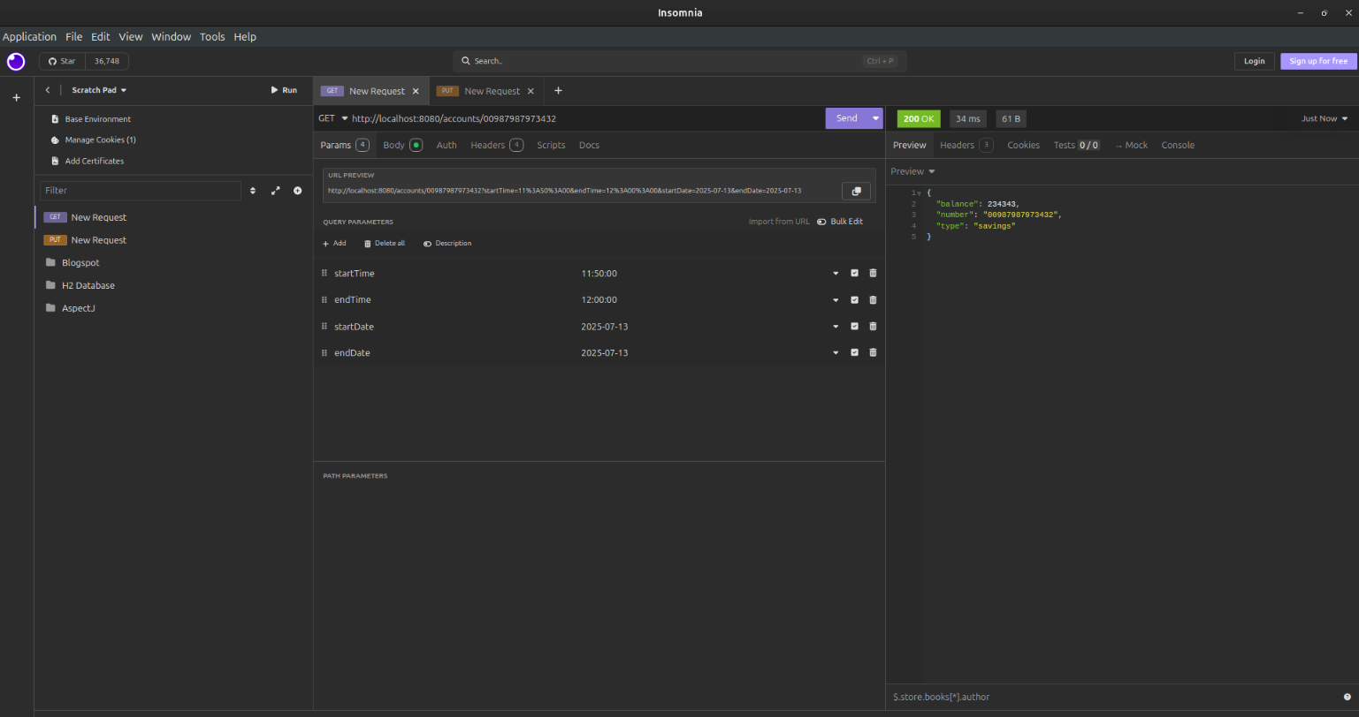

**Loan.png**

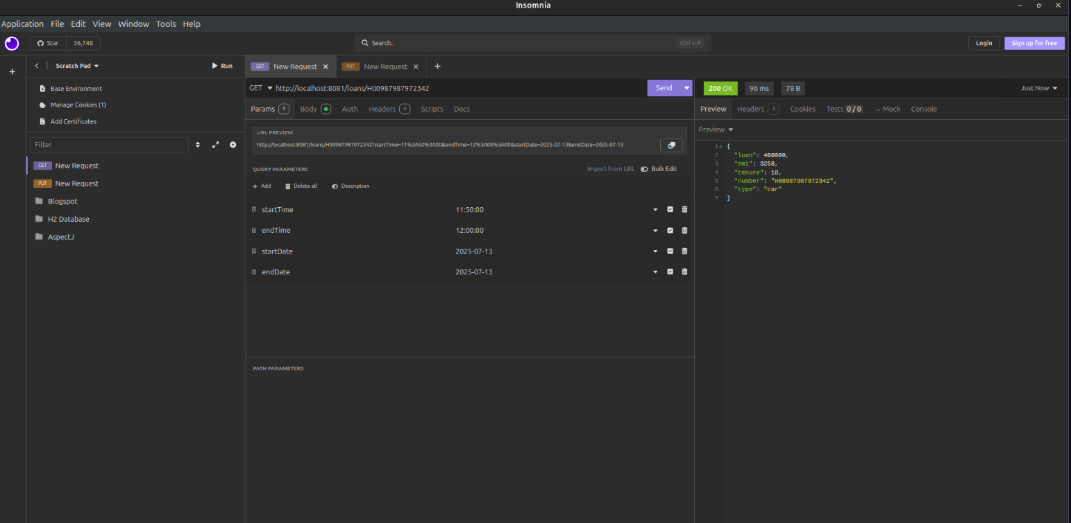

**B.) Create Eureka Discovery Server and register**

**api_gateway.filter**

**LogFilter.java**

package com.cognizant.api_gateway.filter;

import org.slf4j.Logger;

import org.slf4j.LoggerFactory;

import org.springframework.cloud.gateway.filter.GlobalFilter;

import org.springframework.core.Ordered;

import org.springframework.stereotype.Component;

import org.springframework.web.server.ServerWebExchange;

import reactor.core.publisher.Mono;

import org.springframework.cloud.gateway.filter.GatewayFilterChain;

@Component

public class LogFilter implements GlobalFilter, Ordered {

private static final Logger logger = LoggerFactory.getLogger(LogFilter.class);

@Override

public Mono<Void> filter(ServerWebExchange exchange, GatewayFilterChain chain) {

logger.info("Request Path: {}", exchange.getRequest().getPath());

return chain.filter(exchange);

}

@Override

public int getOrder() {

return -1;

}

}

**ApiGatewayApplication.java**

package com.cognizant.api_gateway;

import org.springframework.boot.SpringApplication;

import org.springframework.boot.autoconfigure.SpringBootApplication;

import org.springframework.cloud.client.discovery.EnableDiscoveryClient;

@SpringBootApplication

@EnableDiscoveryClient

public class ApiGatewayApplication {

public static void main(String[] args) {

SpringApplication.run(ApiGatewayApplication.class, args);

}

}

**application.properties**

server.port=9090

spring.application.name=api-gateway

eureka.client.service-url.defaultZone=http://localhost:8761/eureka

spring.cloud.gateway.server.webflux.discovery.locator.enabled=true

spring.cloud.gateway.server.webflux.discovery.locator.lower-case-service-id=true

**ApiGatewayApplicationTests.java**

package com.cognizant.api_gateway;

import org.junit.jupiter.api.Test;

import org.springframework.boot.test.context.SpringBootTest;

@SpringBootTest

class ApiGatewayApplicationTests {

@Test

void contextLoads() {

}

}

**EurekaServerApplicationFolder**

**EurekaServerApplication.java**

package com.cognizant.eureka_server;

import org.springframework.boot.SpringApplication;

import org.springframework.boot.autoconfigure.SpringBootApplication;

import org.springframework.cloud.netflix.eureka.server.EnableEurekaServer;

@SpringBootApplication

@EnableEurekaServer

public class EurekaServerApplication {

public static void main(String[] args) {

SpringApplication.run(EurekaServerApplication.class, args);

}

}

**application.properties**

spring.application.name=eureka-server

server.port=8761

eureka.client.register-with-eureka=false

eureka.client.fetch-registry=false

logging.level.com.netflix.eureka=OFF

logging.level.com.netflix.discovery=OFF

**GreetController.java**

package com.cognizant.greet_service.controller;

import org.springframework.web.bind.annotation.GetMapping;

import org.springframework.web.bind.annotation.RestController;

@RestController

public class GreetController {

@GetMapping("/greet")

public String greet() {

return "Hello World";

}

}

**GreetServiceApplication.java**

package com.cognizant.greet_service;

import org.springframework.boot.SpringApplication;

import org.springframework.boot.autoconfigure.SpringBootApplication;

import org.springframework.cloud.client.discovery.EnableDiscoveryClient;

@SpringBootApplication

@EnableDiscoveryClient

public class GreetServiceApplication {

public static void main(String[] args) {

SpringApplication.run(GreetServiceApplication.class, args);

}

}

**GreetServiceApplicationTests.java**

package com.cognizant.greet_service;

import org.junit.jupiter.api.Test;

import org.springframework.boot.test.context.SpringBootTest;

@SpringBootTest

class GreetServiceApplicationTests {

@Test

void contextLoads() {

}

}

**OUTPUT**

**Eureka.png**

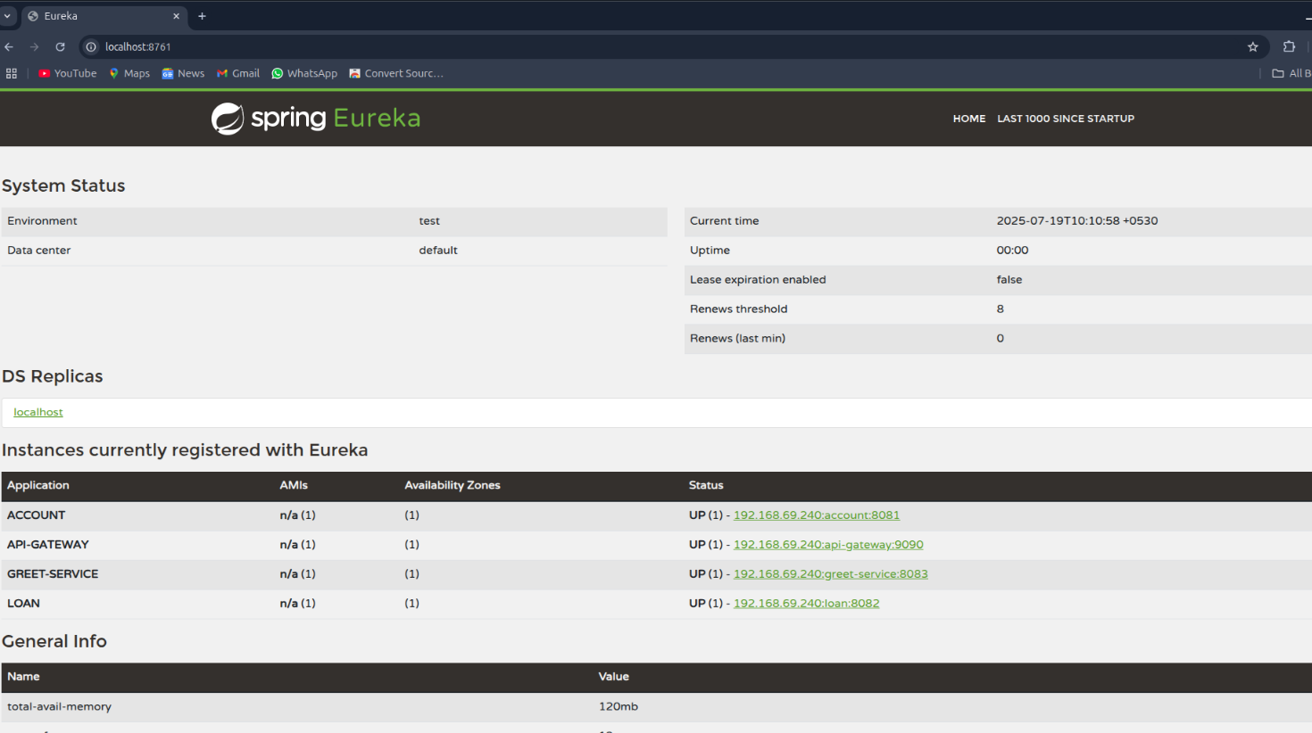

**Account.png**

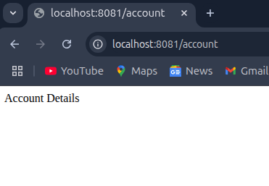

**Loan.png**

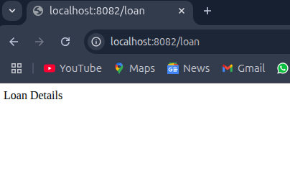

**greet.png**

