**JUnit Test**

**Code Coverage**

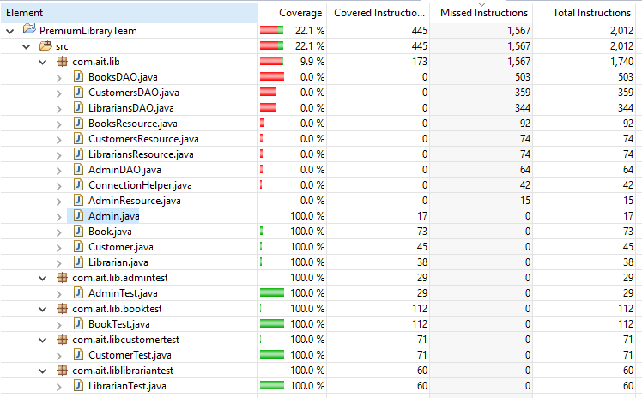

**Book Class Test**

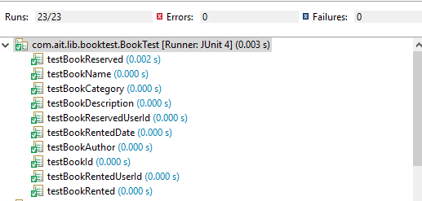

**Customer Class Test**

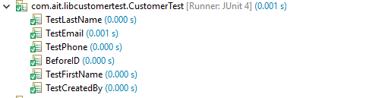

**Librarian Test Class**

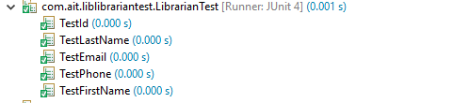

**Admin Test Class**

