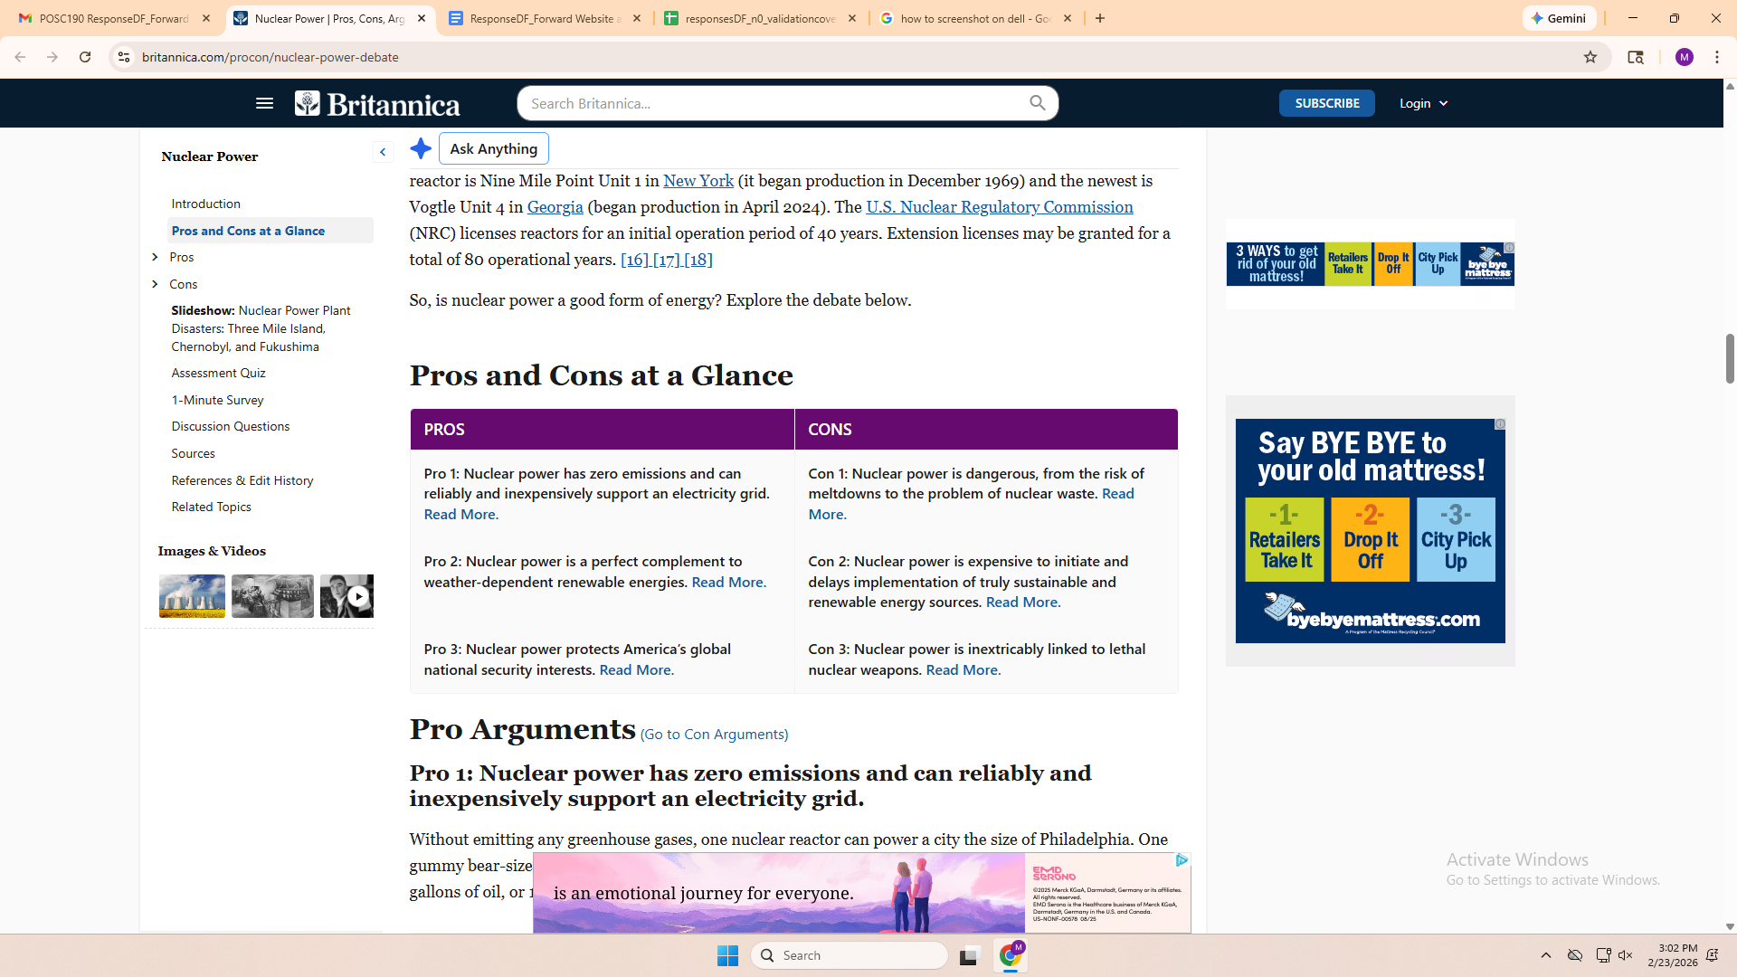
^From britannica

- Nuclear power has zero emissions and can reliably and inexpensively support an electricity grid
- Nuclear power is a perfect complement to weather-dependent renewable energies
- Nuclear power protects americas global national security interests
- Nuclear power is dangerous, from the risk of meltdowns to the problem of nuclear waste.
- Nuclear power is expensive to initiate and delays implementation of truly sustainable and renewable energy sources
- Nuclear power is inextricably linked to lethal nuclear weapons

Societylibrary
- Safety is compared to chernobyl incident, fukushima, three mile island, and other incidents
- economic/cost feasibility/efficiency (ex. Turnaround time for investment, profitability, LCOE, cost overruns)
- Impact on jobs and local communities (new)
- Perceived risks and impact (long and short term): to human health and wellbeing, - psychological effects, -disease (cancer, infant mortality, etc)
- Radioactive impact on humans, including future generations and marginalized groups, -radioactive impact on planet, -radioactive impact on animals, -radioactive impact on water, -prophylactic radiation
- Distraction from other energy solutions/strategies
- Energy production reliability, dispatchability, flexibility, baseload, volume
- Sustainability of source materials, resource efficiency, volume of source materials
- Mitigate climate change, lessen dependence on fossil fuels, GHG emissions/carbon footprint, fossil fuel cliff
- National security, global power market dynamics, global power security dynamics, influence on proliferation.

