MACHINE LEARNING lab2 — LAB MANUAL
Name : Suhana Keswani
CMS:023-24-0080
Section D BS CS
Part 1 — The Business Problem
Every ML project starts with a business question, not a dataset. Before writing any code, think about what the company actually wants to know, and what a single row of this dataset represents.
Tasks
- In 2–3 sentences, state the business problem in your own words, and propose what the target variable likely is.
Answer:
The main business problem is customer churn — the telecom company is losing customers to competitors and wants to identify, in advance, which customers are likely to leave so it can take action (like offering discounts or better plans) to retain them. Based on the dataset, the target variable is likely the Churn column, since it directly indicates whether a customer has left (Yes) or stayed (No)
- List 5 columns you expect to be useful predictors of churn, and 2 columns you expect to be useless as predictors — justify each choice in one line.

Useless predictors:
- customerID — It is just a random unique identifier assigned to each customer, so it has no logical relationship with whether a customer churns or not.
- gender — There's no strong logical reason to believe churn behavior differs based on a customer's gender.
Useful predictors:
- tenure — Newer customers (low tenure) are more likely to leave quickly, while long-time customers tend to be more loyal.
- Contract — Customers on a month-to-month contract can leave anytime, whereas customers on a one- or two-year contract are locked in and less likely to churn soon.
- OnlineSecurity — Customers with "No" online security service may have a less satisfying experience, making them more likely to churn.
- TechSupport — Customers without tech support may face unresolved issues more often, which can increase frustration and the likelihood of churning.
- MonthlyCharges — Customers paying higher monthly bills may feel they're not getting good value for money, which can increase their chance of churning.

- Write down 2 questions you personally want this data to answer about customers who churn.
- Which type of contract (month-to-month, one-year, or two-year) is most associated with customers who churn, and does a shorter contract increase the likelihood of leaving?
- Do customers with higher MonthlyCharges churn more often than customers with lower monthly charges, suggesting that price is a major factor in their decision to leave?
Part 2 — Exploring the Dataset Structure
Before cleaning or analyzing anything, get an accurate picture of the dataset's shape and contents. Running a command is not the same as understanding its output — you must interpret what you see.
Concepts / Functions You May Find Useful
Concept / Function | Purpose
df.shape / df.columns | Row & column counts; column names
df.dtypes / df.info() | Data type of each column
df.head() / df.sample(n) | Inspect actual rows, including a random sample
df[col].unique() / .nunique() | Distinct values in a column
df.describe(include='all') | Summary statistics for numeric & categorical columns
Illustrative Example (generic — not the answer)
# Generic illustration only — apply the equivalent
# investigation to the churn dataset yourself.
df.shape
df.dtypes
df['some_column'].unique()
Tasks
- How many customers and how many features are in this dataset? List the numerical features and the categorical features separately.
"Although SeniorCitizen has a numerical dtype (int64), it is conceptually a categorical/binary variable (0 = No, 1 = Yes), not a true numerical quantity."
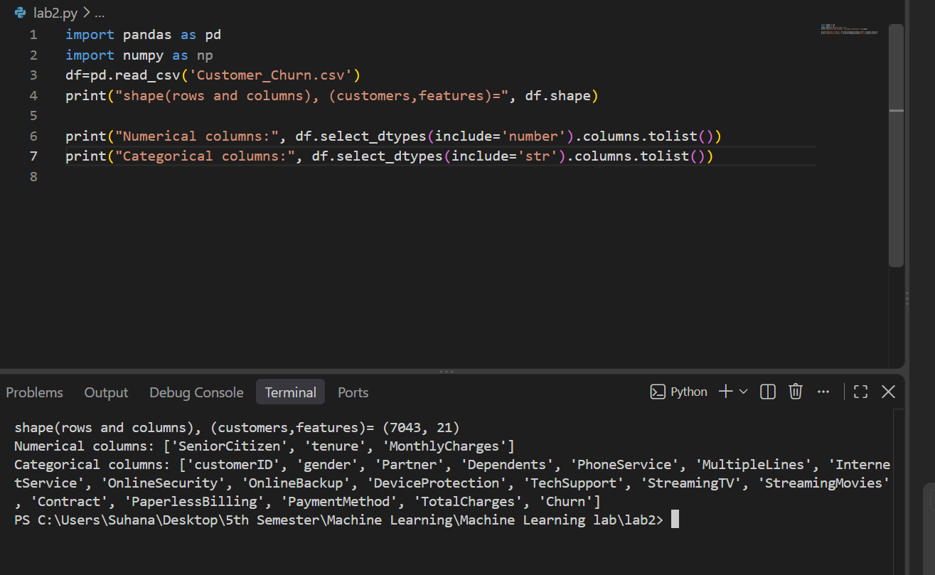
- Identify any column(s) that are simply identifiers rather than predictive features, and any column(s) whose data type looks wrong for what it represents.
Answer:
Identifiers: customerID is purely a primary key identifier with no predictive power for churn.
Incorrect Data Type: TotalCharges is stored as an object (string) dtype instead of float64 due to empty space strings in new customer entries (tenure = 0)

- Pick 3 categorical columns and report their unique values — do any contain unexpected or inconsistent categories?

No inconsistent (i.e., no misspelled, duplicate, or mismatched) categories were found in OnlineSecurity, TechSupport, or PaymentMethod. However, OnlineSecurity and TechSupport each contain an extra category beyond the expected Yes/No — "No internet service" — which isn't an error but reflects customers who don't have internet service at all. PaymentMethod has 4 clean, distinct categories with no issues.

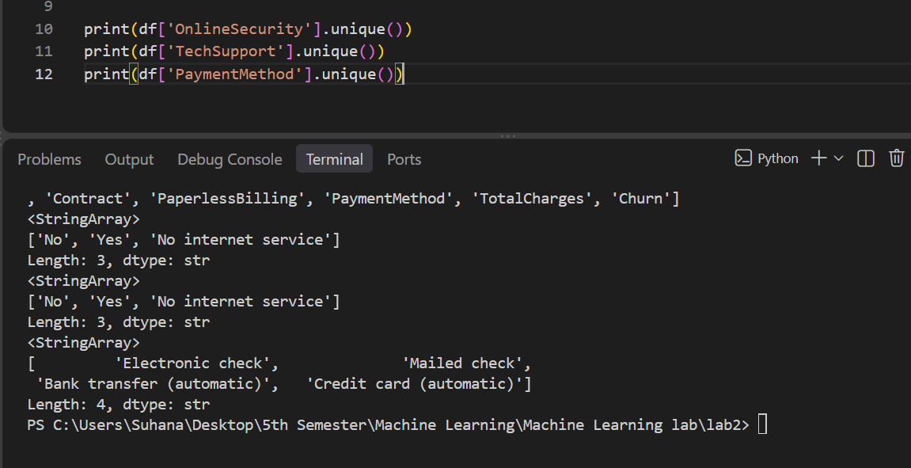

Part 3 — Investigating Data Quality
A dataset can look clean at a glance and still hide serious problems. You must actively search for missing values, duplicates, and suspicious values rather than assume there are none.
Concepts / Functions You May Find Useful
Concept / Function | Purpose
df.isnull().sum() | Count missing values per column
(df.isnull().mean()*100) | Percentage missing per column
df.duplicated().sum() | Count fully duplicated rows
df['id_col'].duplicated().sum() | Count duplicate IDs specifically
df[col].value_counts() | Frequency of each category / possible inconsistencies
Illustrative Example (generic — not the answer)
# Generic illustration only.
df.isnull().sum()
df.duplicated().sum()
Tasks
- Report missing values as both a count and a percentage per column. Which missing-value problems do you think require action, and which don't? Justify your reasoning.
#task 7
# 1. Standard NaN values count and percentage
null_counts = df.isnull().sum()
null_percents = (df.isnull().mean()) * 100

# summary table

missing_summary = pd.DataFrame({'Missing Count': null_counts, 'Percentage (%)':null_percents})
print("=== Standard Missing Values (NaN) ===")
print(missing_summary)

total_charges_numeric = pd.to_numeric(df['TotalCharges'], errors='coerce')
hidden_missing_count = total_charges_numeric.isnull().sum()
hidden_missing_percent = (hidden_missing_count / len(df)) * 100

print("\n=== Hidden Missing Values in TotalCharges ===")
print(f"Count of blank spaces: {hidden_missing_count}")
print(f"Percentage: {hidden_missing_percent:.3f}%")

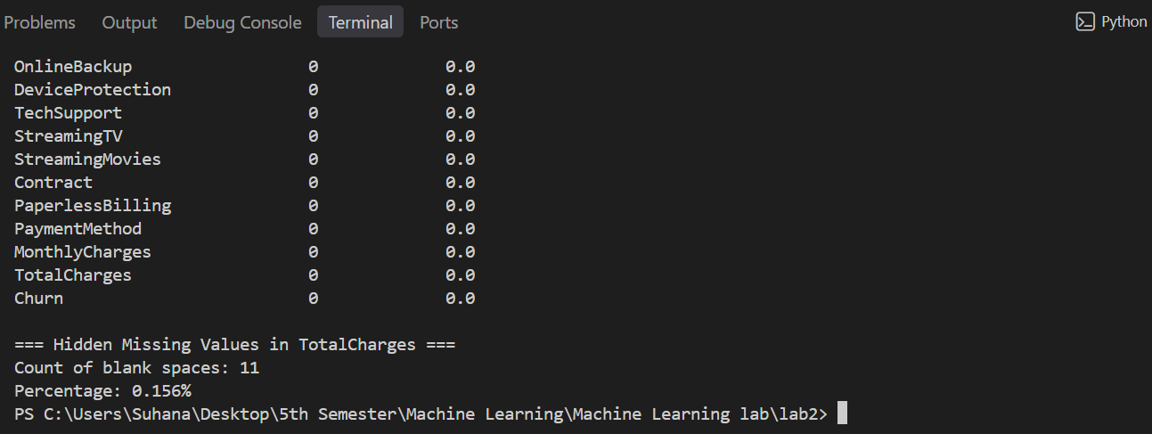
- Check for duplicate rows and duplicate customer IDs separately — are they the same issue or different issues?
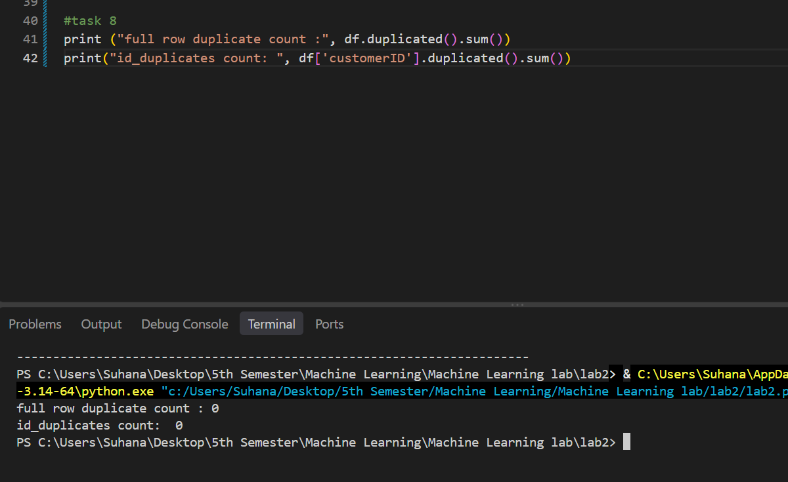
they represent two fundamentally different issues:
- Full-Row Duplicates indicate that an entire data record was cloned during insertion/extraction.
- Duplicate Primary Keys (customerID) indicate structural data integrity failure where multiple conflicting profile logs exist for a single customer identity.
Neither problem is present in this dataset; every row represents a unique customer record

- Find at least one column with a suspicious, invalid, or inconsistently formatted value, and describe how you found it.
Suspicious value found: TotalCharges
How I found it:
I checked the data types of the columns and noticed that TotalCharges was stored as object even though it represents a numerical billing amount. I then inspected its values and found blank/whitespace entries, which are not valid numerical values.
Why it is a problem:
These blank values can cause problems during numerical analysis and machine-learning preprocessing because TotalCharges should contain numeric value
The invalid entries were exposed by coercing the string column into a numeric type using pd.to_numeric(df['TotalCharges'], errors='coerce')

Part 4 — Data Cleaning Decisions
Cleaning is a series of justified decisions, not a fixed recipe. For every issue you fix, you must be able to explain why you chose that method over an alternative.
Concepts / Functions You May Find Useful
Concept / Function | Purpose
pd.to_numeric(s, errors='coerce') | Force a column to numeric, turning bad values into NaN
df.fillna(value) / df.dropna() | Fill or remove missing values
df.drop_duplicates() | Remove duplicate rows
df[col].str.strip() | Remove stray whitespace from text values
df.astype(dtype) | Convert a column to the correct data type
Tasks
- For every data-quality issue you found in Part 3, record: Problem → Decision → Method Used → Reason, in a small table in your notebook. Do not clean anything you cannot justify in writing.
Problem | Decision | Method Used | Reason
TotalCharges is stored as object and contains blank/invalid values | Convert TotalCharges to numeric and treat invalid values as missing | pd.to_numeric(df['TotalCharges'], errors='coerce') | TotalCharges represents a monetary amount, so it should be numeric for analysis and ML.
Duplicate rows | No action required | df.duplicated().sum() | No duplicate rows were found.
Duplicate customerID values | No action required | df['customerID'].duplicated().sum() | All customer IDs are unique, so no duplicate customer records need to be removed.

- Apply your cleaning decisions to produce an intermediate cleaned dataframe, and confirm (with code output) that each issue is actually resolved.
#task 11
clean_df=df.copy()
clean_df['TotalCharges'] = pd.to_numeric(
clean_df['TotalCharges'],
errors='coerce'
)

print(clean_df['TotalCharges'].dtype)

print(clean_df.isnull().sum())

print(clean_df.duplicated().sum())

print(clean_df['customerID'].duplicated().sum())

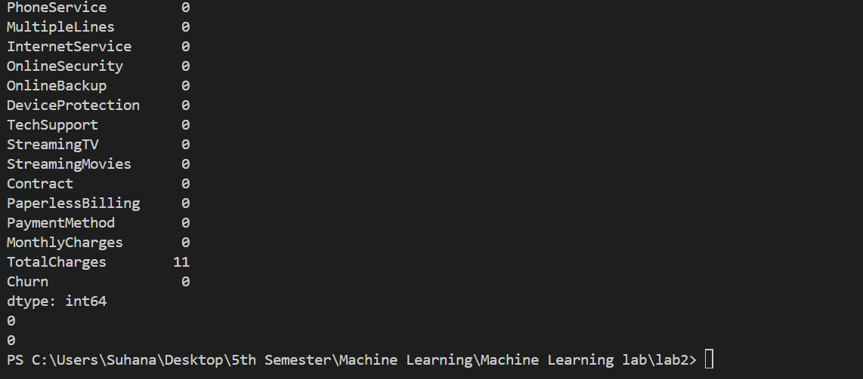
Part 5 — Univariate EDA
Look at individual variables in isolation before looking at relationships. Every chart must be followed by a written interpretation — a graph with no explanation earns no credit.
Concepts / Functions You May Find Useful
Concept / Function | Purpose
df[col].plot(kind='hist') / plt.hist() | Distribution of a numerical column
df.boxplot(column=col) | Spread & outliers of a numerical column
df[col].value_counts().plot(kind='bar') | Frequency of a categorical column
Tasks
- Visualize the distribution of at least 2 numerical features and 2 categorical features. For each chart, write 1–2 sentences on what you learned.
plt.figure(figsize=(8,5))
plt.hist(df['tenure'], bins=20)
plt.xlabel('Tenure')
plt.ylabel('No of customers')
plt.title('Distribution of customer tenure')
plt.show()

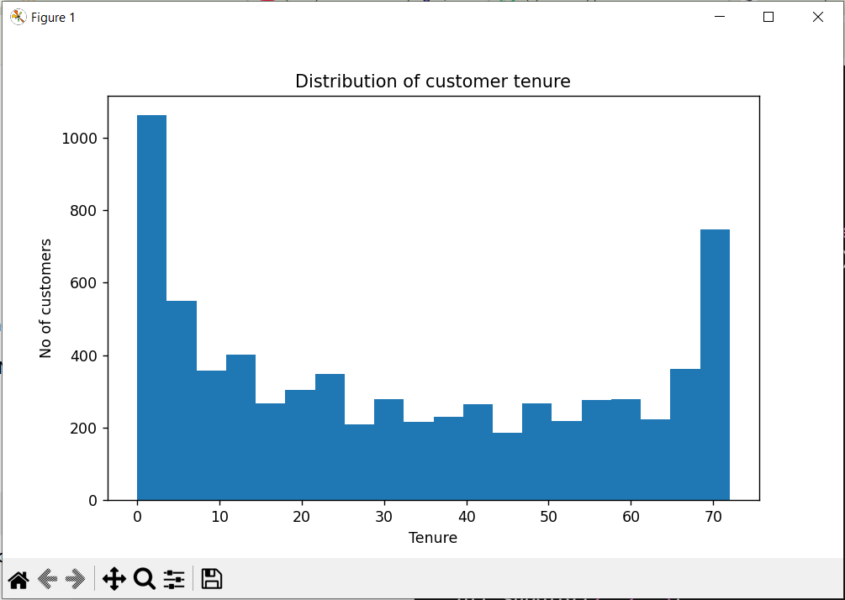
• Shape: The distribution is U-shaped / Bimodal with two distinct peaks at the extremes (0–5 months and 68–72 months).
• Observation:
- A massive cluster of customers has extremely low tenure ($\le 5$ months), indicating a high drop-off/churn rate among new subscribers.
- Another significant spike occurs near 70–72 months, representing a solid core of highly loyal, long-term customers.
- The customer counts for intermediate tenures (10–60 months) remain relatively stable and lower compared to the ends.
• Business Insight: Early customer onboarding and initial retention strategies are critical, as customers are most vulnerable to churning within their first few months of joining.
plt.figure(figsize=(8,5))

plt.hist(df['MonthlyCharges'], bins=20)

plt.xlabel('MonthlyCharges')
plt.ylabel('Number of Customers')
plt.title('Distribution of monthly charges ')

plt.show()
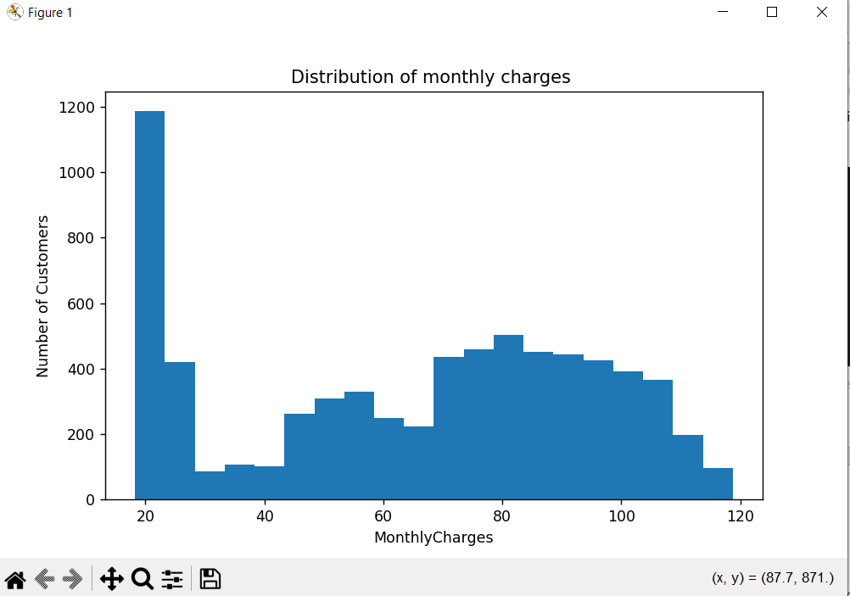
• Shape: The distribution is bimodal with a sharp peak at low charges and a broad distribution at higher charges.
• Observation:
- A massive spike occurs around $18–$25 (nearly 1,200 customers), representing subscribers on basic or single-service plans (e.g., phone-only).
- The count drops significantly between $30 and $40 before rising again into a secondary broad peak spanning from $70 to $110.
- This secondary peak represents premium subscribers using bundled services like Fiber Optic internet, Streaming TV, and Tech Support.
• Business Insight: Customers are clearly split into two main business tiers: basic low-cost users and high-tier bundled users. Price sensitivity may vary significantly between these two groups.

plt.figure(figsize=(8,5))

df['Contract'].value_counts().plot(kind='bar')

plt.xlabel('Contract Type')
plt.ylabel('Number of Customers')
plt.title('Distribution of Contract Types')

plt.xticks(rotation=30, ha='right')

plt.show()

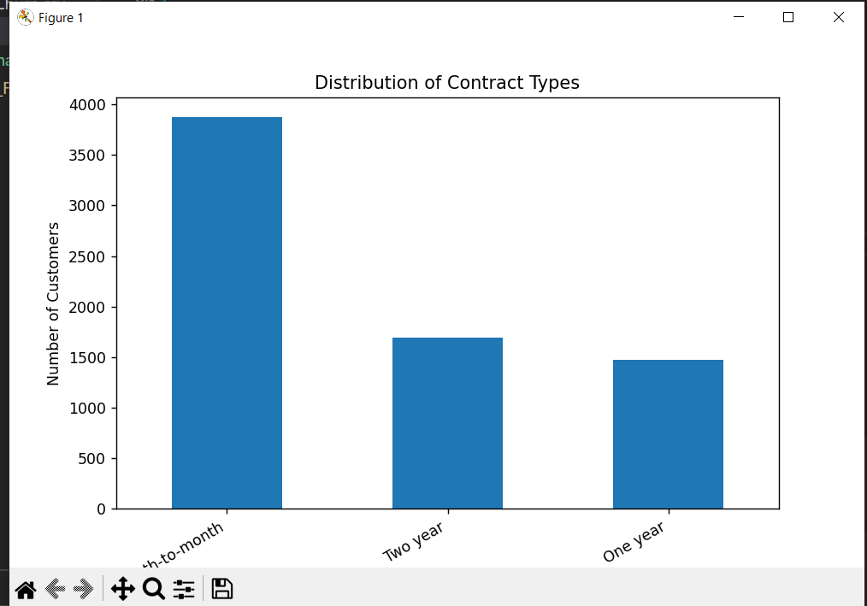
• Type: Categorical Bar Chart.
• Observation:
- The Month-to-month contract category dominates the customer base, accounting for over 3,800 customers (more than half of the total dataset).
- Long-term commitment contracts are significantly less frequent: Two year contracts cover around 1,700 customers, while One year contracts cover roughly 1,500 customers.

plt.figure(figsize=(10,5))

df['PaymentMethod'].value_counts().plot(kind='bar')

plt.xlabel('Payment Method')
plt.ylabel('Number of Customers')
plt.title('Distribution of Payment Methods')

plt.xticks(rotation=45, ha='right')

plt.show()
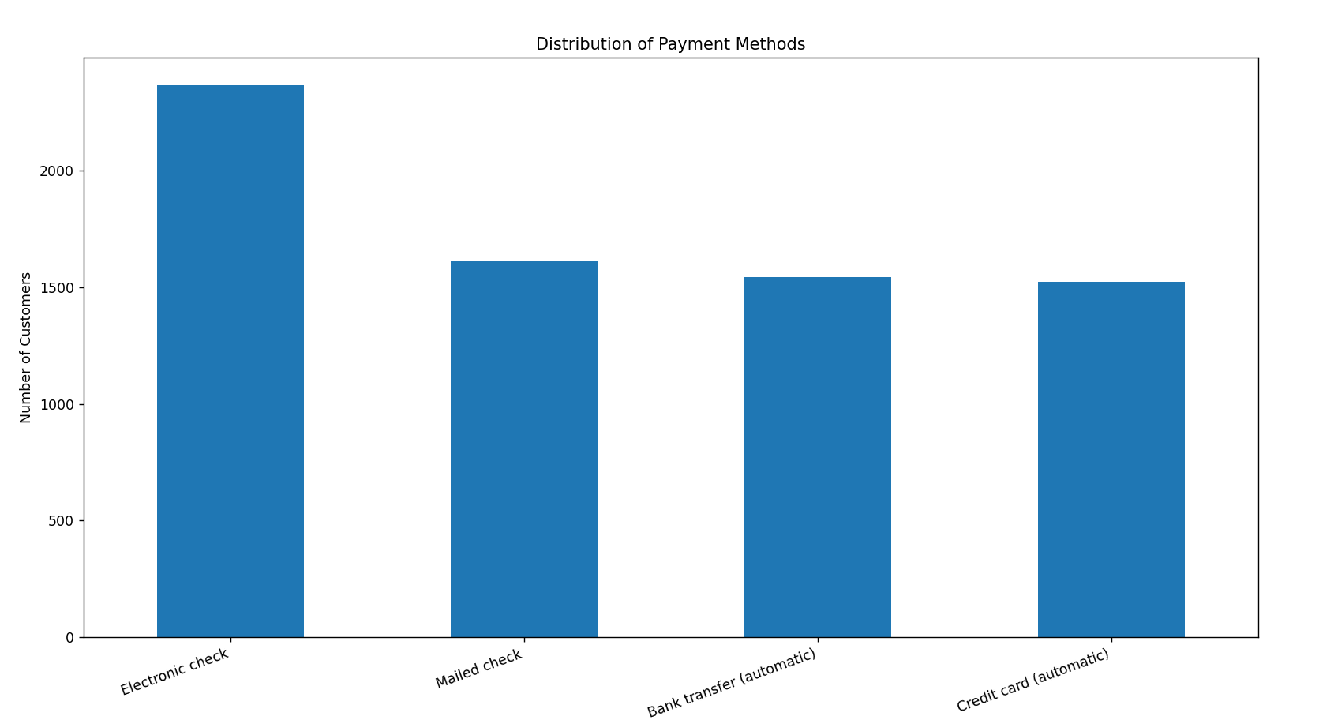
Visual Interpretation (PaymentMethod):
- Type: Categorical Bar Chart.
- Observation:
  - Electronic check is the single most common payment method, accounting for over 2,300 customers.
  - The remaining three categories—Mailed check, Bank transfer (automatic), and Credit card (automatic)—are nearly equal in frequency, each representing around 1,500 to 1,600 customers.
- Business Insight: Non-automatic payment methods (Electronic check + Mailed check) make up the majority of customer payments. Customers using manual monthly billing methods often show higher churn rates compared to those on automatic recurring payments.

- Do any numerical features show outliers or a skewed distribution? What might explain this?
#task 13
plt.figure(figsize=(8,5))
clean_df.boxplot(column='tenure')
plt.title('Box Plot of Tenure')
plt.ylabel('Tenure (Months)')

plt.show()

plt.figure(figsize=(8,5))
clean_df.boxplot(column='MonthlyCharges')
plt.title('Box Plot of Monthly charges')
plt.ylabel('monthly charges')

plt.show()

plt.figure(figsize=(8,5))

clean_df.boxplot(column='TotalCharges')

plt.title('Box Plot of Total Charges')
plt.ylabel('Total Charges')

plt.show()

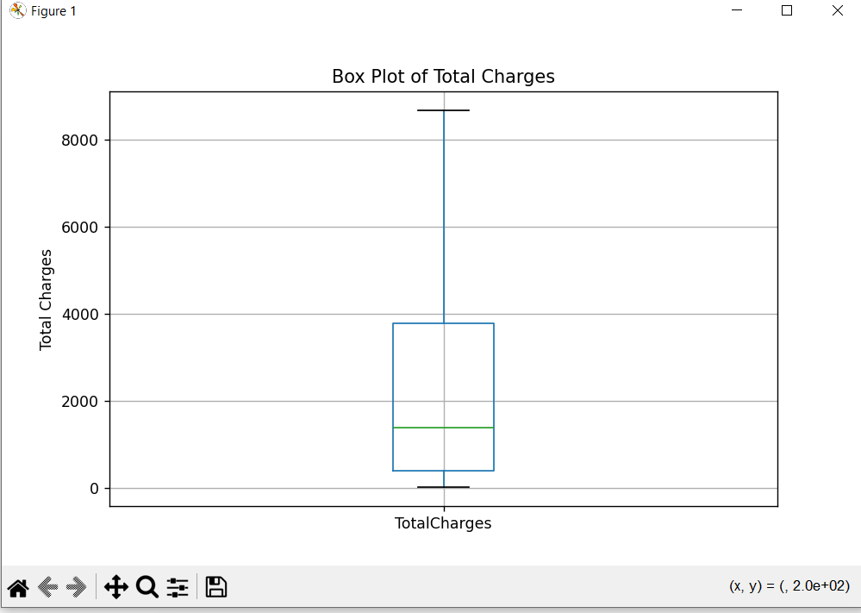
TotalCharges (Right-Skewed / Positively Skewed)
- Shape: Heavily concentrated near lower values (low total billing) with a long tail stretching toward higher amounts up to ~$8,684.
- Explanation: Since a large portion of the customer base has low tenure, their cumulative spend has not had enough time to grow, pushing the median ($1,397) far to the left of the upper limit.

Part 6 — Target Variable Analysis
The Churn column is what you will eventually predict. Before Lab 3, you need to understand its distribution — this has direct consequences for how a model should later be trained and evaluated.
Concepts / Functions You May Find Useful
Concept / Function | Purpose
df['Churn'].value_counts() | Count of each class
df['Churn'].value_counts(normalize=True) | Class proportions
Tasks
- Report the number and percentage of churned vs. non-churned customers. Is the target balanced or imbalanced?
- In 2–3 sentences, explain why class imbalance might matter when a classification model is trained later — do not describe how to fix it, just why it matters.

Part 7 — Bivariate Analysis: Features vs. Churn
Now connect individual features to the target. You choose the appropriate visualization or summary for each feature type — a categorical feature is not explored the same way as a numerical one.
Concepts / Functions You May Find Useful
Concept / Function | Purpose
pd.crosstab(df[col], df['Churn'], normalize='index') | Churn rate across categories
df.groupby(col)['Churn']... | Aggregate churn by group
sns.boxplot(x='Churn', y=col, data=df) | Compare a numerical feature across churn classes
Tasks
- Investigate at least 2 categorical features (e.g. Contract, InternetService, PaymentMethod) against Churn. For each, record: Observation / Evidence / Possible Explanation.
- Investigate at least 2 numerical features (e.g. tenure, MonthlyCharges) against Churn using the same Observation / Evidence / Possible Explanation format.

Part 8 — Correlation & Feature Relationships
Numerical features can be related to each other, not just to the target. Strongly correlated features can cause redundancy problems later, so it's worth knowing about them now.
Concepts / Functions You May Find Useful
Concept / Function | Purpose
df.corr(numeric_only=True) | Correlation matrix of numerical features
sns.heatmap(corr_matrix, annot=True) | Visualize the correlation matrix
Tasks
- Compute and visualize the correlation matrix of the numerical features. Which pairs appear most correlated?
- Does correlation imply causation here? Could any highly correlated features cause problems for a future model? Answer in 2–3 sentences.

Part 9 — Data Leakage Awareness
In Lab 3 you will train a classifier. Before that, you must check whether any column contains information that would not realistically be available at the moment of prediction — using such a column would make a model look artificially accurate.
Tasks
- Inspect the columns for anything that looks like it could only be known after a customer has already churned, or that is purely an identifier. List any suspects and explain your reasoning.
- In 2–3 sentences, explain what would go wrong if such a column were left in the model's input features.

Part 10 — ML-Readiness Checklist
Summarize every column's fate in a single table. This is the bridge between EDA and modeling — Lab 3 will use this table directly.
Template (fill in for every column in the dataset)
Column | Type | Role | Action | Reason
customerID | Identifier | — | Remove | …
tenure | Numerical | Feature | … | …
Contract | Categorical | Feature | … | …
Churn | Categorical | Target | Keep | …
… | … | … | … | …

Tasks
- Complete the ML-readiness table for all columns in the dataset — not just the examples shown above.

Part 11 — Building the Clean Dataset
Bring together every cleaning decision into one final dataframe, clean_df, that Lab 3 can load directly. Do not split into train/test, encode categorical variables, or train any model — that happens next lab.
Tasks
- Produce clean_df with correct data types, missing values handled, duplicates handled, and irrelevant identifier columns removed where justified. Save it (e.g. clean_churn.csv) alongside your notebook.
- Print df.info() (or equivalent) for clean_df as final proof that every issue identified earlier has been resolved.

Part 12 — Key Findings & Final Reflection
Step back from the code and summarize what you actually learned about this dataset and this problem.
Five Important Findings — Template (repeat for each finding)
Finding 1:
Observation: …
Evidence: …
Interpretation: …
Final Reflection Questions
• What was the most important data-quality issue you found?
• What was the most interesting pattern you discovered?
• Which feature seems most useful for predicting churn?
• Which feature should probably not be used, and why?
• What preprocessing will be required before ML modeling (conceptually — do not implement it)?
• What would you do next if you had another 3 hours?

Tasks
- Write your Five Key Findings using the Observation / Evidence / Interpretation format.
- Answer all six Final Reflection questions in your notebook's concluding Markdown cell.
Bonus Tasks (Optional)
• Create one additional meaningful visualization not required above.
• Investigate a surprising customer subgroup you didn't expect to find.
• Calculate churn rate across a combination of 2+ customer segments at once.
• Identify one possible feature-engineering opportunity for Lab 3.
• Identify one possible source of bias in this dataset.
Submission Requirements
Submit the Following
• Jupyter/Colab notebook (.ipynb), organized with Markdown headings matching Parts 1–12.
• GitHub repository link with your notebook committed and pushed.
• Cleaned dataset (clean_churn.csv).
• Your Five Key Findings, clearly written.
• Your completed ML-readiness table.
Every major visualization must include a written interpretation. Notebooks containing only code, with no Markdown discussion, will not be accepted.
Grading Rubric
Criteria | Description
Data Understanding | Correctly identifies target, feature types, and dataset scope
Data Quality Investigation | Thorough, evidenced investigation of missing values, duplicates & invalid data
Data Cleaning Decisions | Every decision justified with a clear, sound reason
EDA Quality | Appropriate visualizations, correctly chosen for each feature type
Interpretation & Insights | Written interpretation accompanies every chart and finding
ML-Readiness & Documentation | Complete readiness table; clean, well-organized notebook

Penalties
• Copied Kaggle notebook or solution: significant mark deduction.
• Plots without written interpretation: no credit for that visualization.
• Unexplained or unjustified cleaning decisions: marks deducted in Part 4.
• Hard-coded / templated answers with no genuine analysis: marks deducted across affected sections.
• Training an ML model in this lab (not requested): marks deducted — save it for Lab 3.

