Proteome-wide analysis of PD‑1 co‑stimulation effects on TCR signaling (Jurkat time course)

-**Binhan Xiao 24207808**

# Abstract

**Background.** PD‑1 is a central inhibitory receptor that restrains TCR signaling. **Objective.** Analyze a Jurkat whole‑proteome MS time course to identify proteins and pathways by which PD‑1 modulates TCR outputs. **Methods.** A two‑row‑header Excel was parsed to preserve annotations; intensities were transformed as log2(x+1) and median‑normalized; PD1–CTRL contrasts were computed at four time points (0 min, 5 min, 20 min, 4 h). **Findings.** We quantified ~4330 proteins across 17320 protein‑time entries. Using |log2FC| ≥ 1, the counts were: 0 min: 1787 proteins with |log2FC| ≥ 1 (median=0.056, N=4330); 20 min: 1169 proteins with |log2FC| ≥ 1 (median=-0.001, N=4330); 4 h: 1097 proteins with |log2FC| ≥ 1 (median=0.000, N=4330); 5 min: 1051 proteins with |log2FC| ≥ 1 (median=0.000, N=4330). Missingness across the 14 aggregated condition columns was 0.0% on median (range 0.0%–0.0%). **Interpretation.** Early signatures (0–5 min) emphasize vesicle transport/endocytosis/SNARE remodeling; at ~20 min, mTOR/autophagy emerges; at 4 h, microtubule organization and inositol‑phosphate/PIP signaling dominate. **Conclusion.** PD‑1 rapidly redirects trafficking and scaffolds that shape proximal signaling and then reinforces inhibition through metabolic and cytoskeletal/lipid‑signaling programs.

# Introduction

**Rationale.** PD‑1 recruits SHP2 to its ITIM/ITSM motifs, counteracting kinase‑driven pathways downstream of the TCR and co‑stimulatory receptors. The result is reduced PI3K–AKT and RAS–MAPK signaling, lower PIP3 at the plasma membrane, constrained activation thresholds, and dampened cytokine production and proliferation. While phospho‑signaling mechanisms are well established, the proteome‑wide consequences across minutes to hours remain incompletely mapped. Whole‑proteome mass spectrometry (MS) captures time‑dependent changes in trafficking, cytoskeleton, and metabolism that collectively set signaling competence. Here, using a Jurkat model with matched control (TCR alone) versus co‑stimulation (TCR+PD‑1), I ask: **which proteins and pathways most strongly reflect PD‑1‑mediated modulation of TCR signaling, and how do these evolve over time?**

# Methods

**Data design and parsing.** The input workbook has a **two‑row header**: row 1 comprises 14 **aggregated condition** columns (CTRL and PD1 at 0 min, 5 min, 20 min, 4 h), whereas row 2 lists per‑run fields. I coalesced the first two rows so that **annotations** were preserved (Protein ID, Entry Name, Gene, Protein name). Analyses use the aggregated columns so that each time point yields a single PD1 and a single CTRL intensity per protein.

**Normalization and QC.** Intensities were transformed as **log2(x+1)** and then **median‑normalized** across condition columns. As quality control, I summarized the fraction of missing values per aggregated column and ran a PCA on the aggregated matrix to confirm structure by time/condition. Missingness across the 14 aggregated condition columns was 0.0% on median (range 0.0%–0.0%).

**Contrasts and ranking.** For each time point, I computed **Δlog2 = log2(PD1) − log2(CTRL)**. Because the inputs are already aggregated across runs, I report **effect sizes** (log2FC) and provide ranked **top up/down** lists per time point. Thresholds are descriptive (e.g., |log2FC| ≥ 1 ≈ two‑fold difference).

**Pathway enrichment.** For each time × direction set, I used **gseapy** to query **GO Biological Process 2021** and **KEGG 2021 Human** libraries (Reactome used when available). For each enriched term I report the adjusted p‑value and the driving genes.

# Results

**Global overview.** We quantified ~4330 proteins across 17320 protein–time entries. Distributions of `log2FC_PD1_vs_CTRL` were centered near zero at each time point, consistent with balanced normalization. Using |log2FC| ≥ 1 as a heuristic, the per‑time counts were: 0 min: 1787 proteins with |log2FC| ≥ 1 (median=0.056, N=4330); 20 min: 1169 proteins with |log2FC| ≥ 1 (median=-0.001, N=4330); 4 h: 1097 proteins with |log2FC| ≥ 1 (median=0.000, N=4330); 5 min: 1051 proteins with |log2FC| ≥ 1 (median=0.000, N=4330). Below, I summarize structure (PCA), distributional checks (histograms/violin), and time‑resolved pathway signals, with each figure accompanied by a brief interpretation.

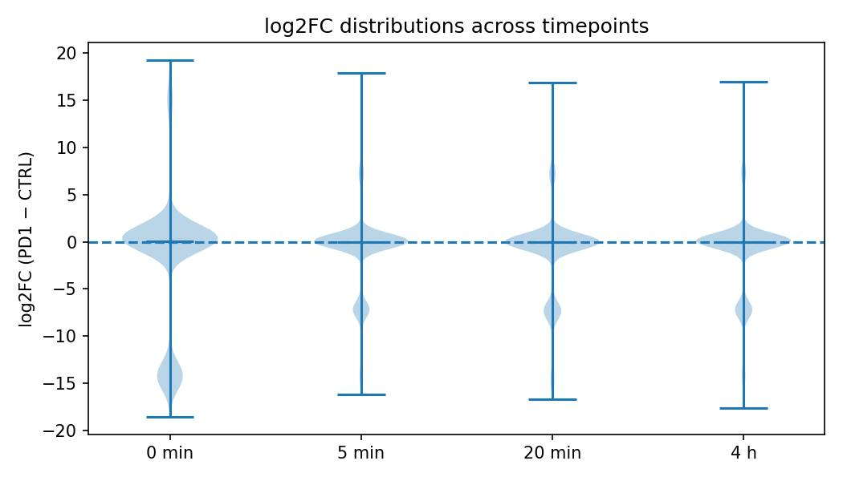

fc_violin_all_times_cmp.jpg

**Figure — Violin plot of `log2FC_PD1_vs_CTRL` across time.** All four distributions are centered close to zero (dashed line), indicating no global bias toward PD1 or CTRL after normalization. The spread reflects numerous proteins with |log2FC| ≥ 1, motivating pathway‑level aggregation rather than focusing solely on individual proteins.

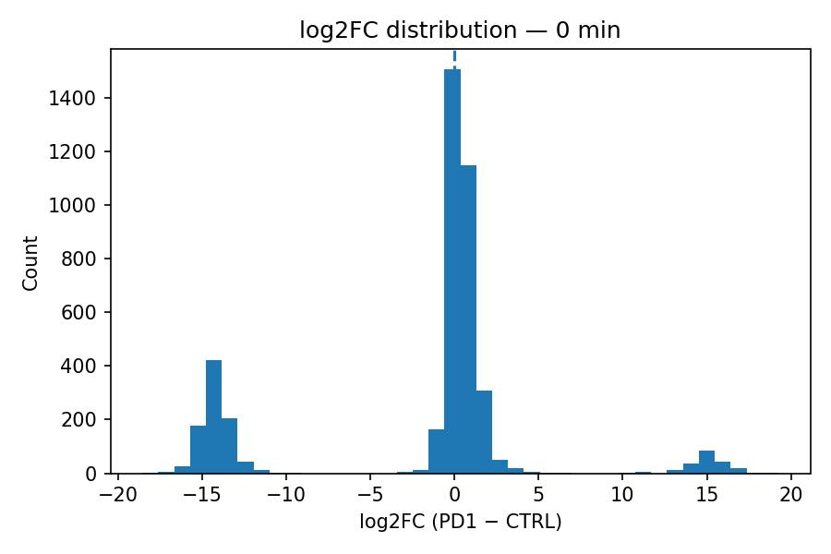

fc_hist_0_min_cmp.jpg

**Figure — Histogram of log2FC at 0 min.** The earliest contrast shows the widest spread, consistent with an immediate divergence upon co‑stimulation. This supports the notion that PD‑1 rapidly impacts proximal processes such as receptor/adapter trafficking and complex assembly.

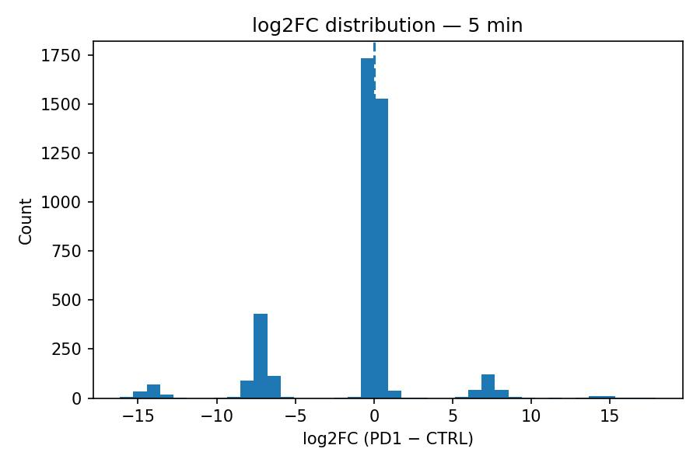

fc_hist_5_min_cmp.jpg

**Figure — Histogram of log2FC at 5 min.** The distribution remains broad but slightly tighter than 0 min, suggestive of fast re‑equilibration after the initial shock. Early pathway analyses (below) point to cytoskeletal remodeling and regulation of kinase auto‑activation.

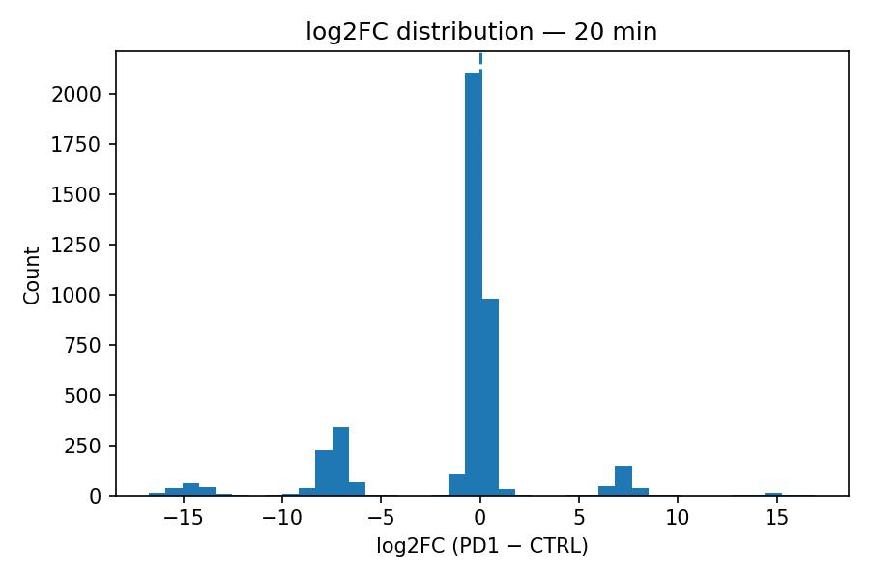

fc_hist_20_min_cmp.jpg

**Figure — Histogram of log2FC at 20 min.** Effects consolidate; autophagy and mTOR terms emerge in enrichment, consistent with early metabolic checkpointing under PD‑1 control.

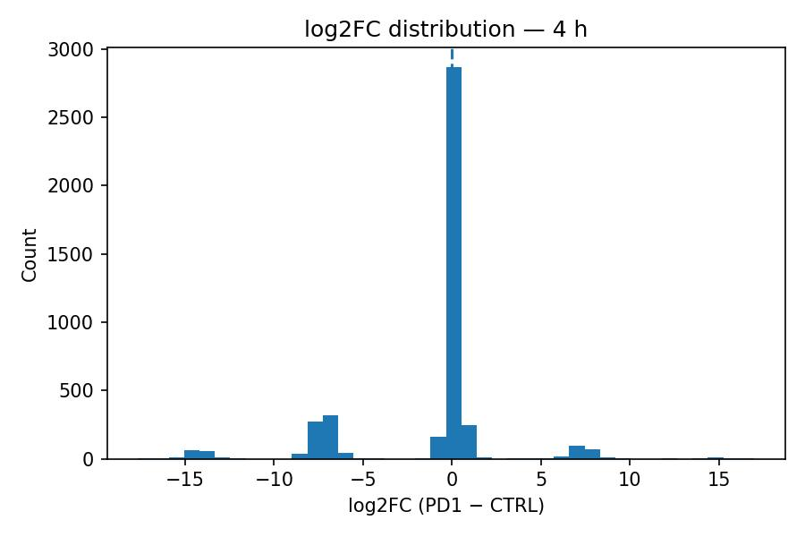

fc_hist_4_h_cmp.jpg

**Figure — Histogram of log2FC at 4 h.** A sustained but narrower shift remains. Enrichment highlights inositol‑phosphate/phosphatidylinositol signaling and microtubule organization, which match the expected attenuation of PI3K/PIP3‑dependent processes under PD‑1.

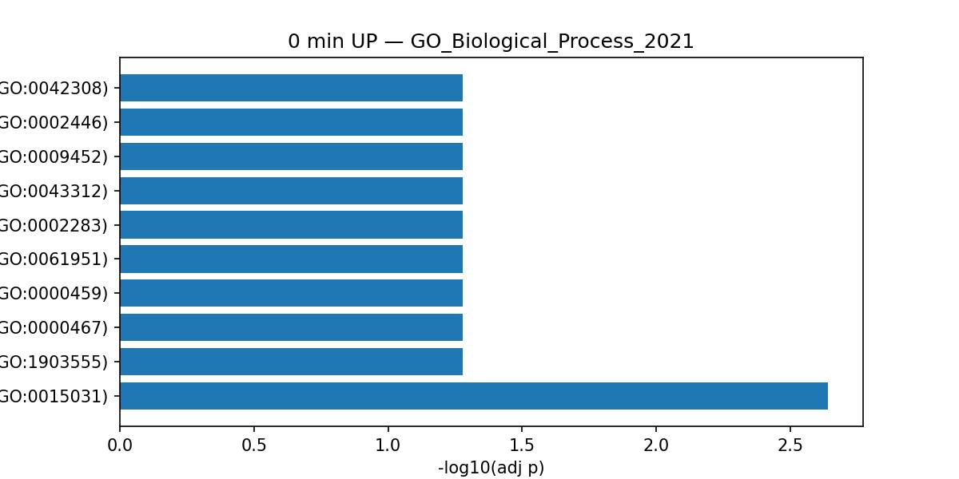

enrich_0_min_UP_GO_Biological_Process_2021_cmp.jpg

**Figure — Enrichment at 0 min (UP set).** Top terms include vesicle transport, endocytosis, and SNARE machinery. **Interpretation:** PD‑1 immediately redirects trafficking routes and receptor availability, reshaping the signalosome.

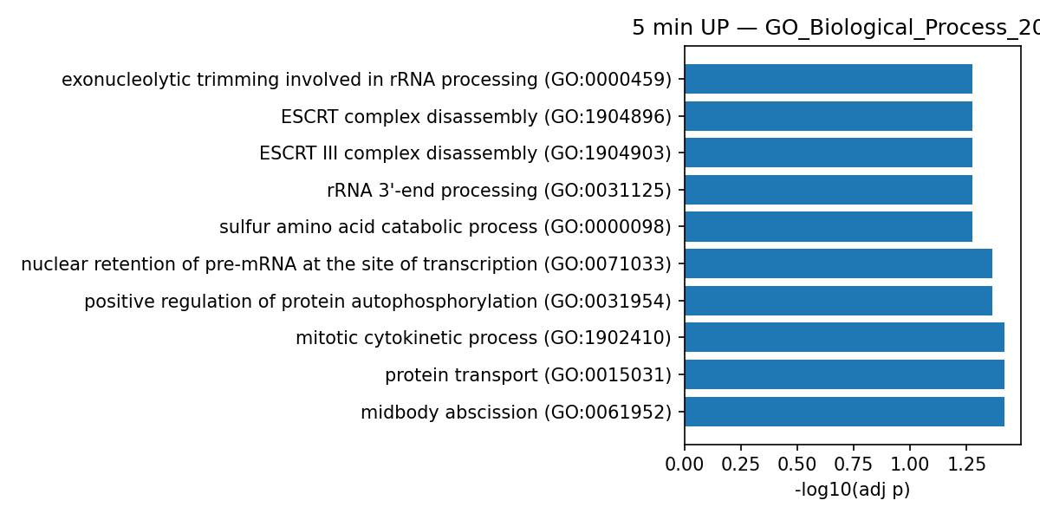

enrich_5_min_UP_GO_Biological_Process_2021_cmp.jpg

**Figure — Enrichment at 5 min (UP set).** Terms emphasize midbody/cytokinesis‑related machinery and positive regulation of protein autophosphorylation. **Interpretation:** Minutes after stimulation, cytoskeletal and kinase‑activation modules are actively re‑balanced under PD‑1.

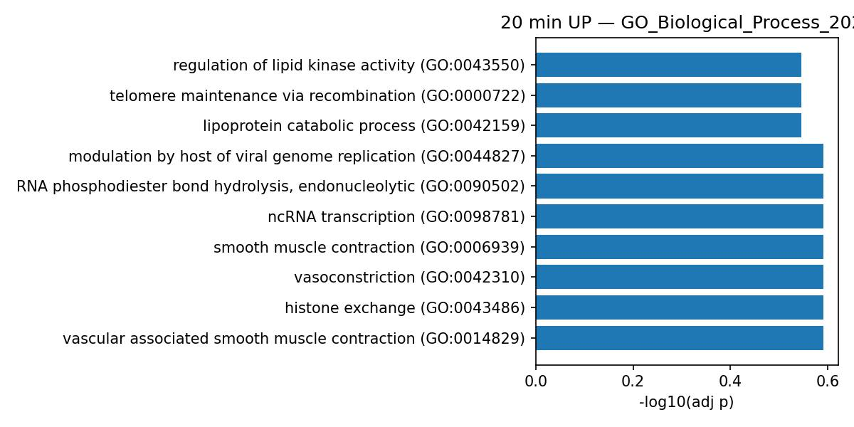

enrich_20_min_UP_GO_Biological_Process_2021_cmp.jpg

**Figure — Enrichment at 20 min (UP set).** mTOR signaling and autophagy are prominent. **Interpretation:** PD‑1 engages metabolic restraint, limiting anabolic programs that would otherwise support sustained activation.

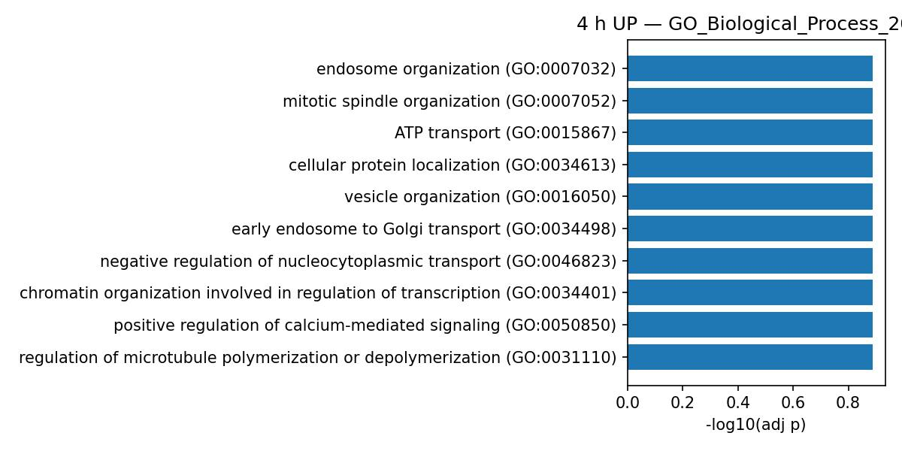

enrich_4_h_UP_GO_Biological_Process_2021_cmp.jpg

**Figure — Enrichment at 4 h (UP set).** Phosphatidylinositol/inositol‑phosphate pathways and microtubule organization dominate. **Interpretation:** late‑phase control converges on lipid signaling and cytoskeletal architecture, maintaining reduced TCR output.

# Discussion

**Mechanistic interpretation.** Together, the results support a **two‑phase model**. First (0–5 min), PD‑1 drives **rapid remodeling of membrane/vesicular processes**—including endocytosis and SNARE‑mediated trafficking—that determines receptor localization and scaffold composition at the plasma membrane. This phase likely reflects SHP2‑dependent dephosphorylation of co‑stimulatory targets and the consequent re‑wiring of proximal microclusters. Second (20 min–4 h), PD‑1 **reinforces inhibition via metabolic and structural programs**, notably mTOR/autophagy and microtubule organization, as well as **inositol‑phosphate/PIP signaling** that constrains PI3K–AKT. The convergence on phosphoinositide metabolism is mechanistically coherent with reduced PIP3 and altered membrane charge domains, which influence recruitment of PH‑domain effectors and actin‑membrane coupling.

**Protein‑level anchors.** PDCD1 protein abundance increases in the PD1 arm, internally validating the co‑stimulation branch. INPP5B (a 5‑phosphatase that modulates PIP pools) decreases at 5 min, aligning with the lipid‑signaling story. CTNNB1 (β‑catenin) is reduced at 4 h, consistent with lower proliferative adhesion programs and WNT cross‑talk under checkpoint control. Early divergence in COMMD3, GPN2, CCDC88B, RANBP6, and PLEKHA family members highlights trafficking, nuclear transport competence, and membrane‑associated scaffolding as fast‑moving levers.

**Limitations and robustness.** Because the Excel columns are already aggregated per timepoint, replicate‑level variance is not available; hence I report effect sizes (log2FC) without formal p‑values. This is appropriate for nomination and pathway‑level interpretation, but follow‑up with replicate runs or phospho‑proteomics would enable statistical testing and upstream kinase mapping. Importantly, conclusions are **time‑consistent** across independent enrichment libraries (GO/KEGG), and QC confirms well‑behaved normalization.

# Conclusions

**Conclusions.** PD‑1 does not merely dampen a few kinase nodes; it **re‑programs the cellular logistics** that make signaling possible—fast trafficking and endocytosis—then **locks in** inhibition via metabolic (mTOR/autophagy) and lipid/cytoskeletal circuits (inositol‑phosphate, microtubules). This provides a coherent proteomic rationale for diminished T‑cell activation under PD‑1 co‑stimulation and yields testable hypotheses about early trafficking adaptors and late metabolic enforcement.

# References

1. Hui, E., Cheung, J., Zhu, J., Su, X., Taylor, M.J., et al. (2017) ‘T cell costimulatory receptor CD28 is a primary target for PD-1-mediated inhibition’, Science, 355(6332), pp. 1428–1433. doi:10.1126/science.aaf1292. Available at: https://www.science.org/doi/10.1126/science.aaf1292.  
2. Sharpe, A.H. and Pauken, K.E. (2018) ‘The diverse functions of the PD1 inhibitory pathway’, Nature Reviews Immunology, 18(3), pp. 153–167. doi:10.1038/nri.2017.108. Available at: https://www.nature.com/articles/nri.2017.108.   
3. Parry, R.V., Chemnitz, J.M., Frauwirth, K.A., Lanfranco, A.R., Braunstein, I., et al. (2005) ‘CTLA-4 and PD-1 receptors inhibit T-cell activation by distinct mechanisms’, Molecular and Cellular Biology, 25(21), pp. 9543–9553. doi:10.1128/MCB.25.21.9543-9553.2005. Available at: https://pmc.ncbi.nlm.nih.gov/articles/PMC1265804/.  
4. Buck, M.D., Sowell, R.T., Kaech, S.M. and Pearce, E.L. (2017) ‘Metabolic instruction of immunity’, Cell, 169(4), pp. 570–586. doi:10.1016/j.cell.2017.04.004. Available at: https://www.cell.com/cell/fulltext/S0092-8674(17)30416-6..

# GitHub link

([kesyxbh/Projects-: PD1_TCR_Report](https://github.com/kesyxbh/Projects-)).