Toby-codehacking-notes

Toby's notes on “codehacking” tutorial

- Set up project “codehacking” on Laravel 5.2.29 using this command:
“composer create-project --prefer-dist laravel/laravel codehacking 5.2.29”

- Updated hosts file: c:\Windows\System32\drivers\etc to include line
127.0.0.1 codehacking.tst

- Updated hosts file: c:\xampp2\apache\conf\extra\httpd-vhosts.conf to include line
<VirtualHost *:31080>
DocumentRoot "C:/xampp2/htdocs/codehacking/public"
ServerName codehacking.tst
</VirtualHost>

- Set up “codehacking” database and ran “migrate” command to set up initial files (users and PW)
C:\xampp2\htdocs\codehacking>php artisan migrate
Migration table created successfully.
Migrated: 2014_10_12_000000_create_users_table
Migrated: 2014_10_12_100000_create_password_resets_table

- Install authentication module using “php artisan make:auth”

C:\xampp2\htdocs\codehacking>php artisan make:auth
Created View: C:\xampp2\htdocs\codehacking\resources/views/auth/login.blade.php
Created View: C:\xampp2\htdocs\codehacking\resources/views/auth/register.blade.php
Created View: C:\xampp2\htdocs\codehacking\resources/views/auth/passwords/email.blade.php
Created View: C:\xampp2\htdocs\codehacking\resources/views/auth/passwords/reset.blade.php
Created View: C:\xampp2\htdocs\codehacking\resources/views/auth/emails/password.blade.php
Created View: C:\xampp2\htdocs\codehacking\resources/views/layouts/app.blade.php
Created View: C:\xampp2\htdocs\codehacking\resources/views/home.blade.php
Created View: C:\xampp2\htdocs\codehacking\resources/views/welcome.blade.php
Installed HomeController.
Updated Routes File.
Authentication scaffolding generated successfully!

Tested login functionality

- Created “admin” folder with subfolders “Categories”, “posts”, “users” and associated blade files.

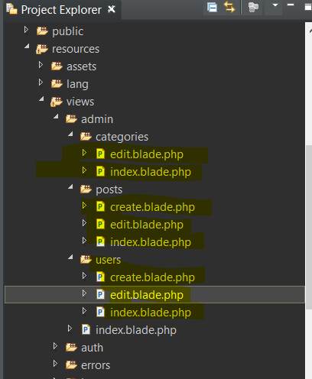

- cvdmvl;

