Ketaki Chhayendra Mahajan

**Batch:** P1-2

**Roll Number:** 16010622050

**Experiment / assignment / tutorial No. 3**

**Grade: AA / AB / BB / BC / CC / CD /DD**

**Signature of the Staff In-charge with date**

|  |
| --- |
| **TITLE:**  Menu driven program. |

**Aim:**

Write a menu driven program for following options -

1. To find whether a number is palindrome or not. (e.g. 1221 is palindrome) using while loop.
2. To calculate the sum of the Fibonacci series up to ‘n’ terms (use do-while loop only).
3. To find the numbers and sum of all integer between 100 and 200 which are divisible by both 3 & 5 (use for loop only).

**______________________________________________________________________**

**Expected OUTCOME of Experiment:**

The objective of this program is to create a menu driven program using switch case which asks the user to select an option such as checking if a number is a palindrome, print Fibonacci series and its sum till the nth term (given by the user), print numbers divisible by 3 and 5 between the range of 100 and 200 and exit the program. Until the user specifically chooses the option to exit the program, the program won’t end and keeps asking the choices.

In case if a number is given by the user which is not within the choices (such as symbols entered when a number had to be entered from 1-4), a message should be displayed to inform the user that an invalid input has been entered.

**_________________________________________________________________**

**Books/ Journals/ Websites referred:**

1. Programming in C, second edition, Pradeep Dey and Manas Ghosh, Oxford University Press.
2. Programming in ANSI C, fifth edition, E Balagurusamy, Tata McGraw Hill.
3. Introduction to programming and problem solving , G. Michael Schneider ,Wiley India edition.
4. [**http://cse.iitkgp.ac.in/~rkumar/pds-vlab/**](http://cse.iitkgp.ac.in/~rkumar/pds-vlab/)

**___________________________________________________________________**

**Problem definition:**

The program accepts a choice from the user using a switch case statement and generates output accordingly.

**Choice 1**: The program checks whether a given numbered by user is palindrome or not.If a number remains same, even if we reverse its digits then the number is known as palindrome number. For example, 12321 is a palindrome number because it remains same if we reverse its digits.

**Choice 2:** Sum of Fibonacci series up to n terms will be generated. Fibonacci series is a series in which each number is the sum of the last two preceding numbers. The first two terms of a Fibonacci series are 0 and 1 (use while loop only).

e.g **-**

Input: n = 5

Output: 7

Explanation: 0 + 1 + 1 + 2 + 3 = 7

**Choice 3:** To find the numbers and sum of all integer between 100 and 200 which are divisible by both 3 & 5 (use for loop only).

**Algorithm:**

START

Initialize all variables

Input choice (number from 1 to 4) for palindrome, Fibonacci series, sum of numbers between 100 and 200 divisible by 3 and 5 and exit

if choice is 1

Start

Input number from user

Declare and initialize the variables reverse and assign input to a temporary variable, original = palin_num

loop until palin_num is greater than 0

Extract the last digit of number, palin_rev = palin_num % 10

Add the digit to a new variable, palin_sum = (palin_sum*10) + palin_rev

Revome the last digit, palin_num = palin_num/10

End loop

Check if original is equal to palin_sum

if true, then print “number is a palindrome”

else, print “number is not a palindrome”

Stop

if choice is 2

Start

Declare and initialize the variables

Input the number of terms till the Fibonacci series to be printed

loop

increment value of i by 1

fib1 = fib2

fib2 = fib3

fib3 = fib1 + fib2

fibsum = fibsum + fib2

end loop

display fibonacci series till nth term

display sum

Stop

if choice is 3

Start

Declare and initialize the variables

loop

Initialize range of the loop from 100 to 200

Compare each value starting from 100 with n % 3==0 and n%5==0

Increase value of number each time by 1 till 200

end loop

print sum of all values divisible by 3 and 5

Stop

if choice is 4

STOP

**Implementation details:**

#include<stdio.h>

#include<process.h> //used for the exit function

int main()

{

printf(" This program can check if a number is a palindrome, print sum of fibonacci series and print the sum of numbers divisible by 3 and 5. ");

int choice, palin_num, palin_sum, palin_rev, original, fib_num, fib1, fib2, fib3, fibsum, i, j, div_sum;

do

{

printf("\n\n 1. Check if number is a palindrome \n 2. Calculate the sum of fibonacci series up to 'n' terms \n 3. Sum of integers between 100 & 200 divisible by 3 an 5 \n 4. Exit");

printf("\n\n Enter a choice: ");

scanf("%d", &choice);

switch(choice)

{

case 1:

printf(" You have chosen option 1.");

palin_sum=0; //initializing the variables

printf("\n\n Enter a number: ");

scanf("%d", &palin_num);

original = palin_num; //holding number in a temporary variable

while(palin_num > 0)

{ //reversing number

palin_rev = palin_num % 10; //divides number by 10 and stores the remainder

palin_sum = (palin_sum*10) + palin_rev; //multiplying by 10 to add the remainder in the units place

palin_num = palin_num/10; //to eliminate the last digit

}

if(original==palin_sum) //comparing temporary number with reversed number and if both are equal, it is a palindrome

printf(" %d is a palindrome.",original);

else

printf(" %d is NOT a palindrome.",original); //if both are not equal, then it is not a palindrome

printf("\n\n ***************************************");

break;

case 2:

printf(" You have chosen option 2.");

fib1=0, fib2=1, fib3=0, fibsum=0, i=0; //initializing the variables

printf("\n\n Enter the number of terms of fibonacci series: ");

scanf("%d", &fib_num);

printf("\n Fibonacci series till %d terms is: ", fib_num);

do

{

i++;

printf(" \n %d \n", fib3);

fib1 = fib2;

fib2 = fib3;

fib3 = fib1 + fib2;

fibsum = fibsum + fib2;

}while(i<fib_num); //prints all the Fibonacci numbers up to the given nth value

printf("\n Sum of fibonacci series till %d terms is: %d", fib_num, fibsum);

printf("\n\n ***************************************");

break;

case 3:

printf(" You have chosen option 3.");

div_sum=0; //initializing the variables

printf("\n\n Numbers divisible by 3 and 5 in the range of 100 to 200 are: ");

for(j=100; j<=200; j++)

{

if(j%3==0 && j%5==0) //checking if a number is divisible by 3 and 5 if the remainder is 0

{

printf("\n %d \n ", j);

div_sum = div_sum + j;

}

}

printf("\n Sum of numbers divisible: %d", div_sum);

printf("\n\n ***************************************");

break;

case 4:

printf(" You have exited the program.");

printf("\n\n ********************************************************");

exit(0);

default:

printf(" Invalid input. ");

printf("\n Enter number from 1 to 4 ");

printf("\n\n ***************************************");

}

}

while(choice!=4); //loop is used so that the program keeps running and asking the user for input until exit command is given

printf("\n\n End of program.");

return 0;

}

**Output(s):**

Choice 1 -

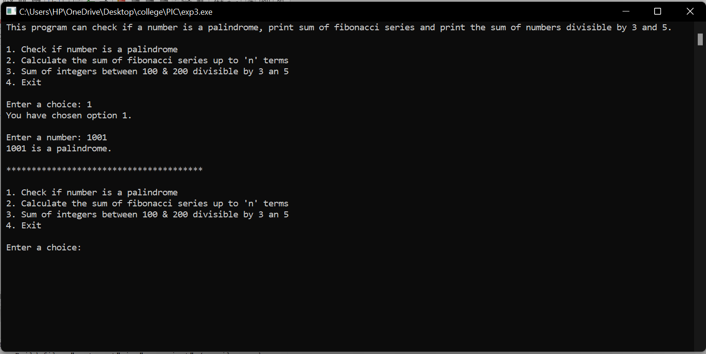

Choice 2 -

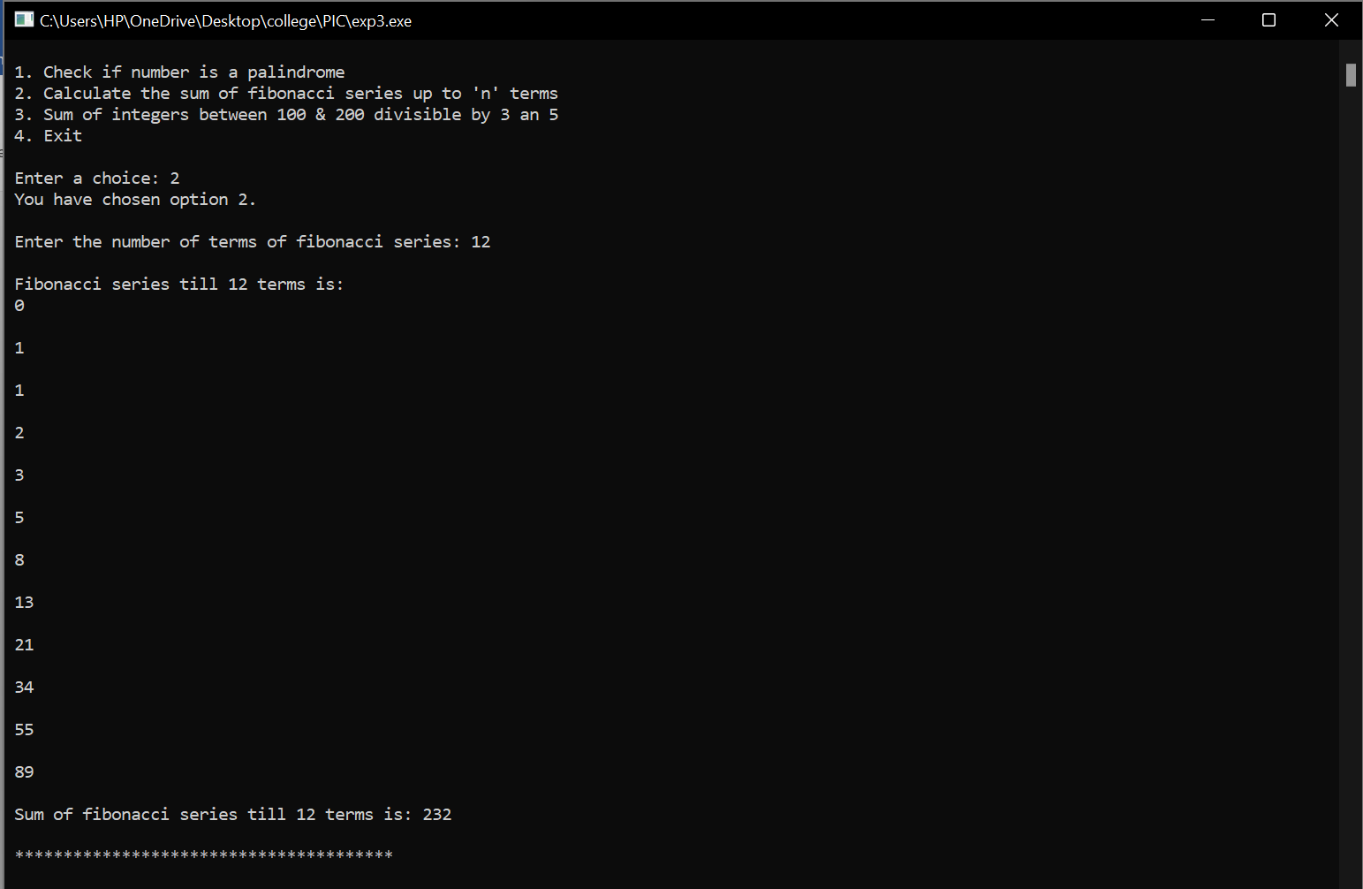

Choice 3 –

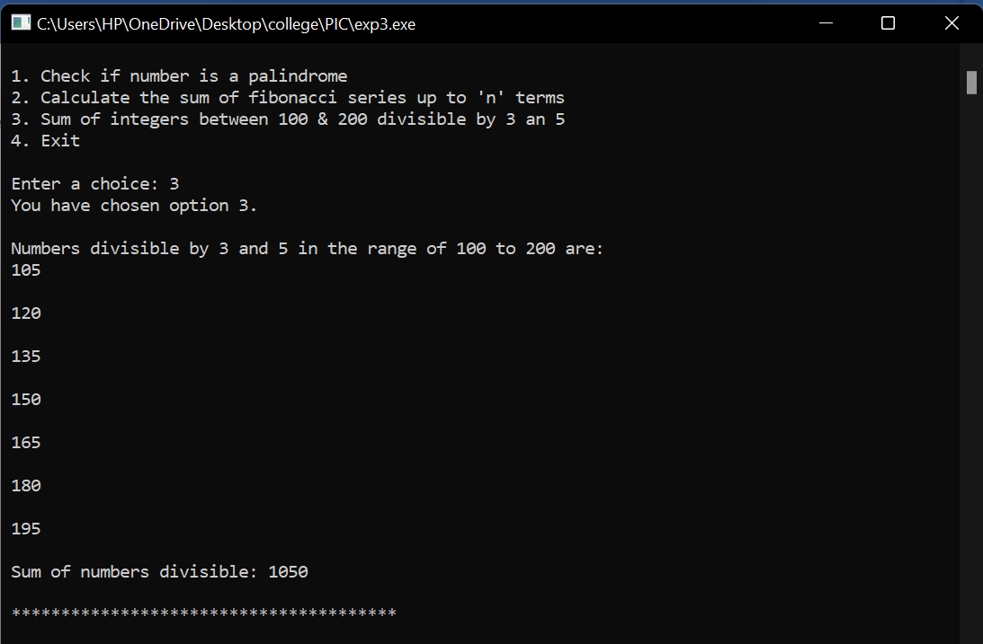

Choice 4 -

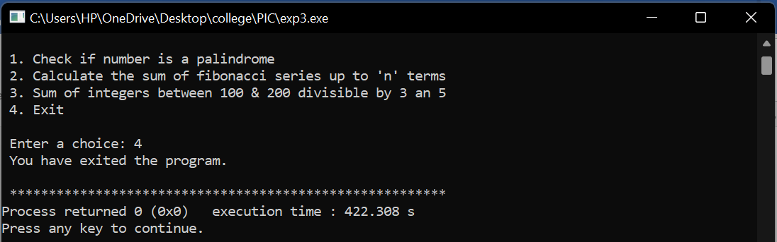

Default case -

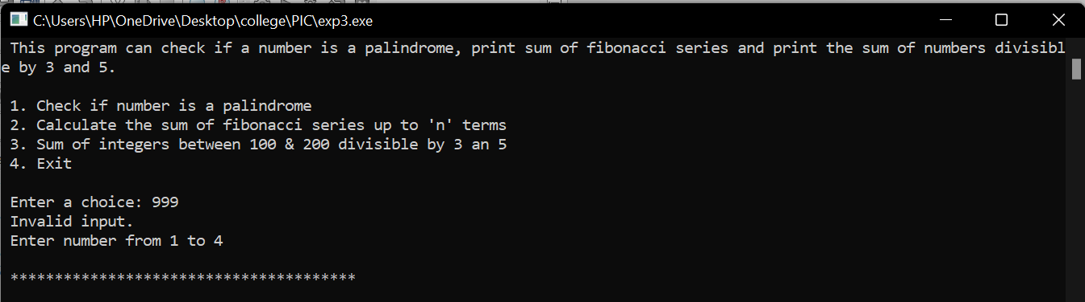

**Conclusion:**

To conclude, carrying out experiment 3 has resulted in learning various new concepts such as –

* using #include<process.h> to carry out the exit function.
* using switch case inside a for loop to create a menu driven program.
* using for loop, while loop and do while loop.
* using relational (= =) and logical operators (&&) in the divisibility program to check if the remainder is 0 upon dividing each number by 3 and 5.

e.g. if (j%3==0 && j%5==0)

* using the break function in switch case to prevent next lines of code from running.

Hence, I was able to successfully carry out experiment 3 and fulfil the objectives that the problem defined as seen in the output.

**Post lab descriptive questions:**

Write menu driven code for the following:

The program allows a user to enter five numbers and then asks the user to select a choice from a menu.

The menu should offer the following options –

1. Display the smallest number entered
2. Display the largest number entered
3. Display the sum of the five numbers entered
4. Display the average of the five numbers entered.
5. Exit

Implementation details -

#include<stdio.h>

#include<process.h> //used for the exit function

int main()

{

printf(" This program inputs 5 numbers from the user and displays the \n - smallest number \n - largest number \n - average \n - sum of 5 numbers \n");

printf("\n ****************************************");

int choice, i, num, sum=0, largest, smallest;

float avg;

printf(" \n\n Inputting 5 numbers! \n");

for(i=0; i<5; i++) //for loop used to input 5 numbers instead of using 5 variables for each number

{

printf("\n Enter a number: ");

scanf("%d", &num);

sum = sum + num; //sum of the numbers entered

if(num >= largest) //compares each with each other and assigns the largest number to variable largest

largest = num;

if(num <= smallest) //compares each with each other and assigns the smallest number to variable smallest

smallest = num;

}

printf("\n ****************************************");

do

{

printf("\n\n Select an option \n 1. Display the smallest number \n 2. Display the largest number \n 3. Sum of 5 numbers \n 4. Average of 5 numbers \n 5. Exit");

printf("\n\n Enter a choice: ");

scanf("%d", &choice);

switch(choice)

{

case 1:

printf("\n The smallest number is: %d", smallest); //displays smallest number

printf("\n\n ****************************************");

break;

case 2:

printf("\n The largest number is: %d", largest); //displays largest number

printf("\n\n ****************************************");

break;

case 3:

printf("\n The sum of 5 numbers is: %d", sum); //displays sum of 5 numbers

printf("\n\n ****************************************");

break;

case 4:

avg = sum / 5;

printf("Average of 5 numbers is: %f", avg); //displays average of 5 numbers

printf("\n\n ****************************************");

break;

case 5:

printf(" You have exited the program.");

printf("\n\n ******************************************************");

exit(0);

default:

printf(" Invalid input. "); //default case printed when user doesn't input choice from 1 to 5

printf("\n Enter number from 1 to 5 ");

printf("\n\n ****************************************");

}

}

while(choice!=5); //loop is used so that the program keeps running and asking the user for input until exit command is given

printf("\n\n End of program.");

return 0;

}

Output(s):

Inputting 5 numbers -

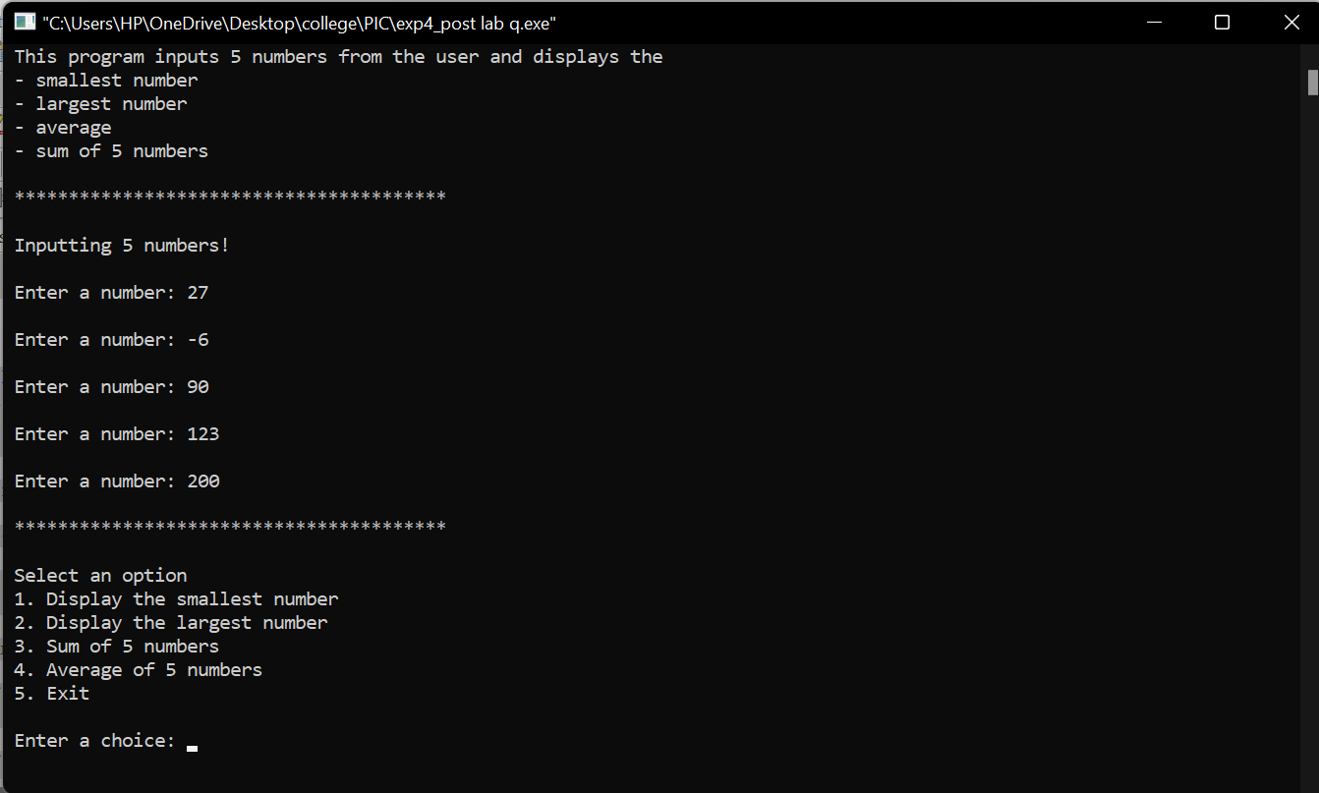

Choice 1 -

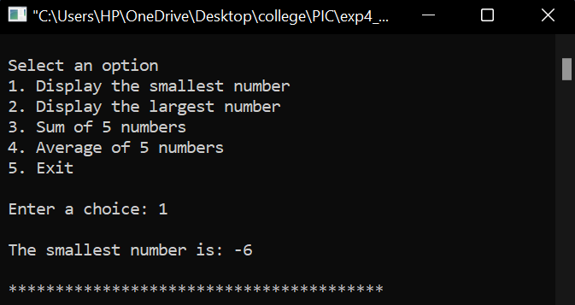

Choice 2-

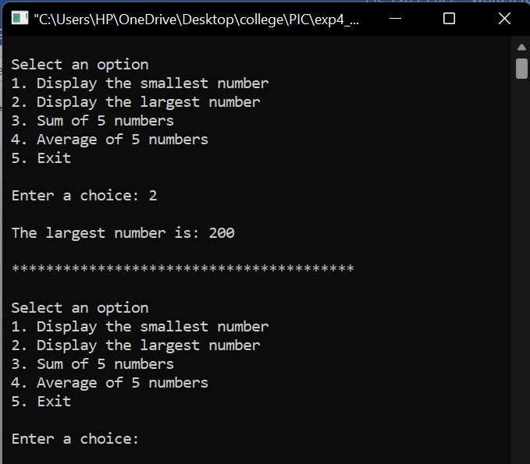

Choice 3 -

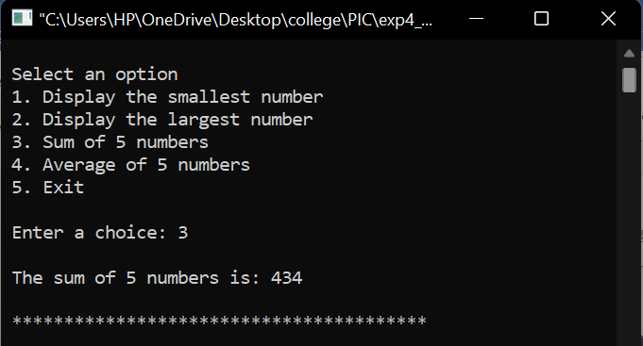

Choice 4 -

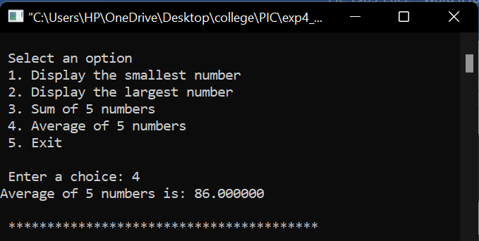

Default case -

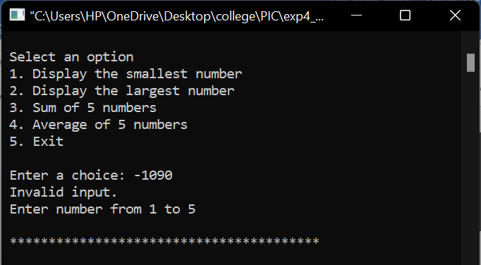

Choice 5 -

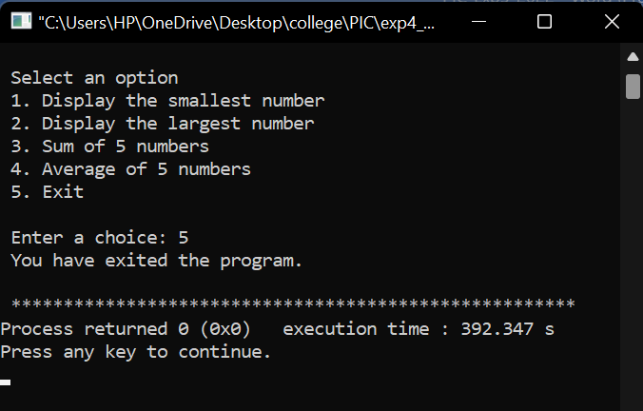

**Date: _____________ Signature of faculty in-charge**