Ketaki Chhayendra Mahajan

**Batch:** P1-2

**Roll Number:** 16014022050

**Experiment / assignment / tutorial No. 3**

**Grade: AA / AB / BB / BC / CC / CD /DD**

**Signature of the Staff In-charge with date**

|  |
| --- |
| **TITLE:**  Program to sort array. |

**Aim:**

Program to sort the 1D array in the ascending or descending order and then accept the element from user and insert in the same array at its correct place by keeping array sorted. **______________________________________________________________________**

**Expected OUTCOME of Experiment:**

The objective of this program is to create a program that inputs numbers from the user and sorts it into ascending and descending order and also inserts a number (given by user) into the sorted list.

**_________________________________________________________________**

**Books/ Journals/ Websites referred:**

1. Programming in C, second edition, Pradeep Dey and Manas Ghosh, Oxford University Press.
2. Programming in ANSI C, fifth edition, E Balagurusamy, Tata McGraw Hill.
3. Introduction to programming and problem solving , G. Michael Schneider ,Wiley India edition.
4. [**http://cse.iitkgp.ac.in/~rkumar/pds-vlab/**](http://cse.iitkgp.ac.in/~rkumar/pds-vlab/)

**___________________________________________________________________**

**Problem definition:**

The program takes a 1D array and sorts it in the specified manner. The user enters an element and the same has to be inserted at the correct place in the sorted array.

**Flowchart:**

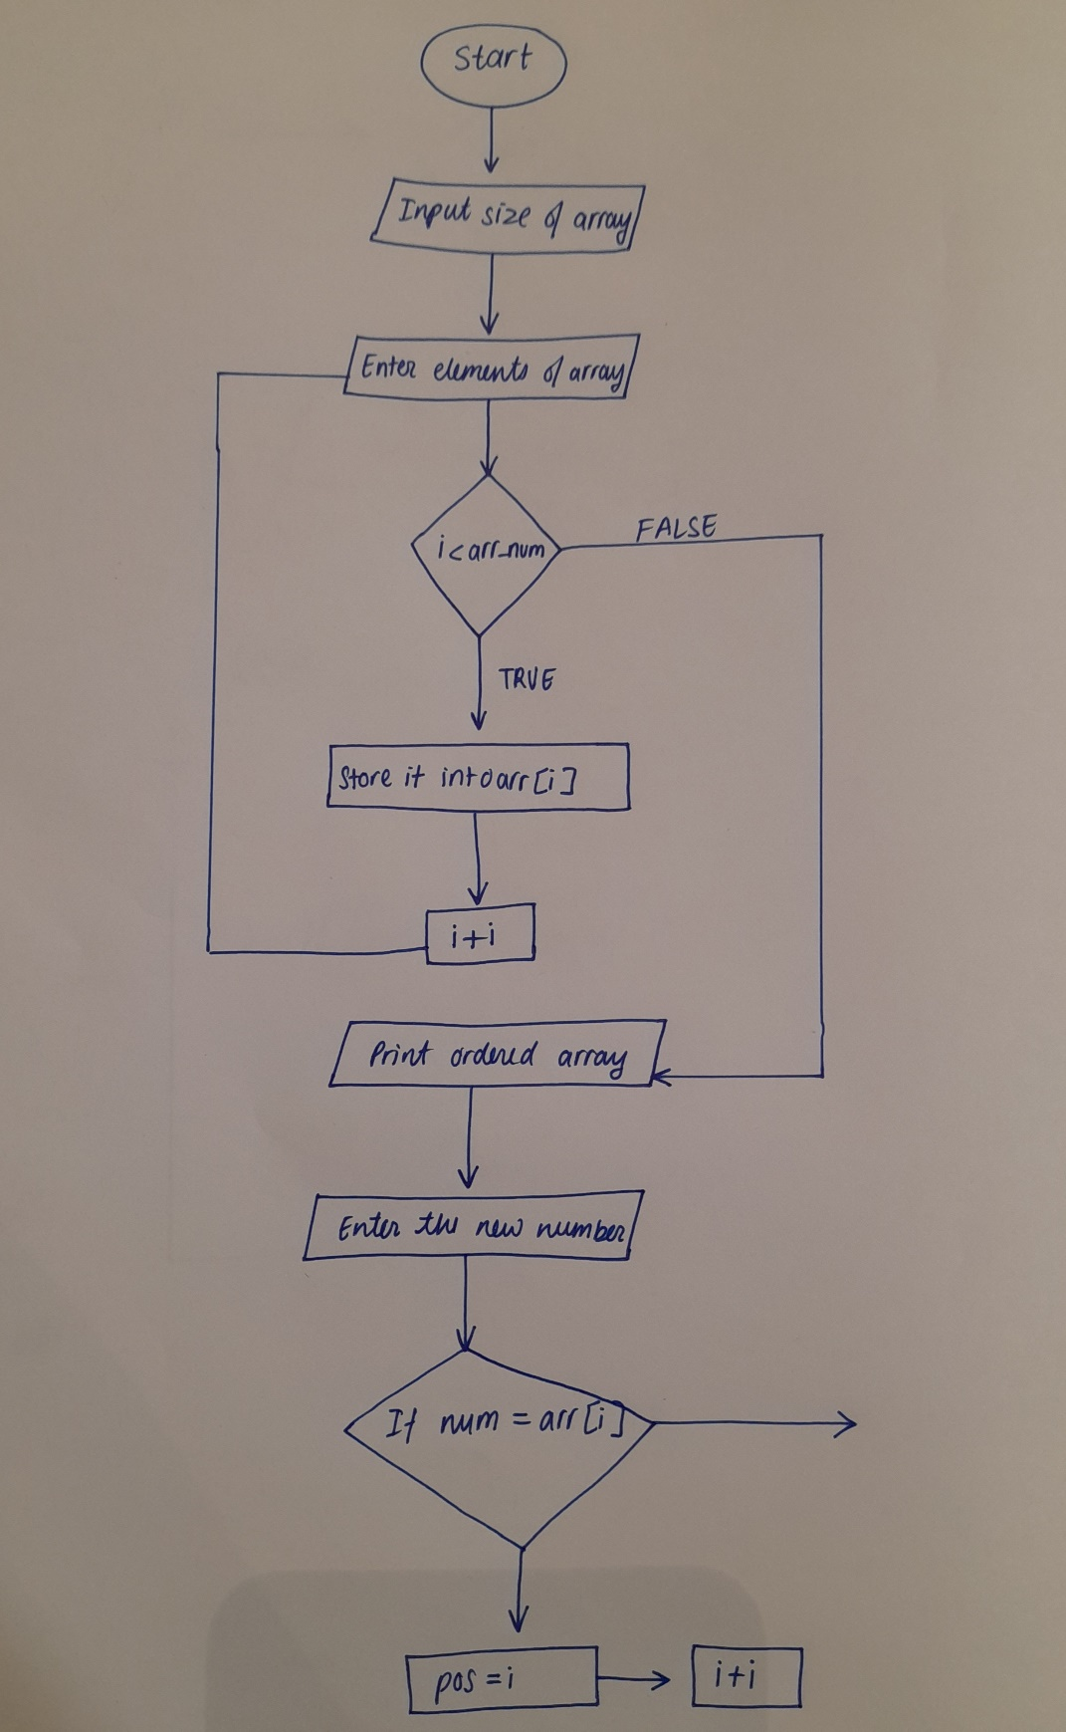

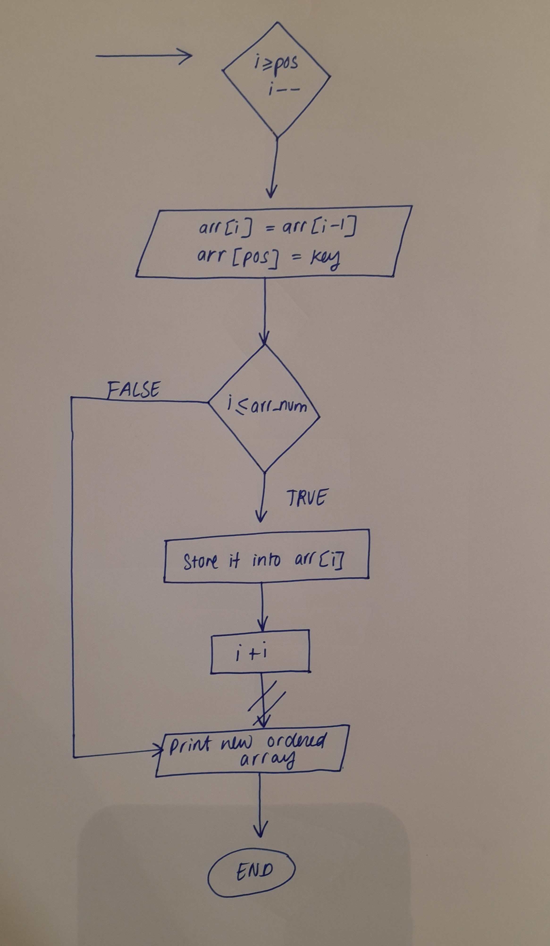

**Implementation details:**

#include<stdio.h>

void main()

{

int i, j, key, pos, temp, arr_num, arr[50];

printf(" Enter the number of elements in array: ");

scanf("%d", &arr_num);

printf("\n Enter the numbers of array: \n");

for (i=0; i<arr_num; i++)

{

scanf (" %d", &arr[i]);

}

printf("\n The entered unsorted array is: ");

for (i=0; i<arr_num; i++)

{

printf ("%d ", arr[i]);

}

printf("\n\n The array arranged in descending order is: ");

for(i=0; i<arr_num; i++)

{

for(j=i+1; j<arr_num; j++)

{

if(arr[i] < arr[j])

{

temp = arr[i];

arr[i] = arr[j];

arr[j] = temp;

}

}

printf("%3d ", arr[i]);

}

printf("\n\n The array arranged in ascending order is: ");

for(i=0; i<arr_num; i++)

{

for(j=i+1; j<arr_num; j++)

{

if(arr[i] > arr[j])

{

temp = arr[i];

arr[i] = arr[j];

arr[j] = temp;

}

}

printf("%3d ", arr[i]);

}

printf("\n\n Enter the element to be inserted: ");

scanf("%d", &key);

for(i=0;i<arr_num;i++)

{

if(key < arr[i])

{

pos = i;

break;

}

else

{

pos = i+1;

}

}

for(i=arr_num+1; i>=pos; i--)

{

arr[i] = arr[i-1];

}

arr[pos] = key;

printf("\n Array after inserting number is: ");

for(i=0;i<=arr_num;i++)

{

printf("%5d ", arr[i]);

}

}

**Output(s):**

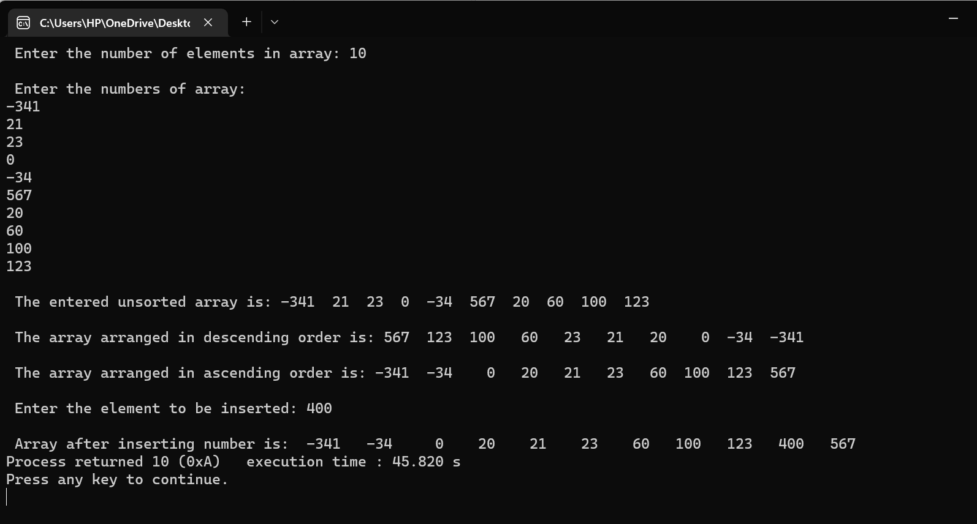

**Conclusion:**

To conclude, carrying out experiment 5 has resulted in learning various new concepts such as–

* sorting the elements of array into specific order such as ascending and descending.
* learning different sorting methods to carry out the task of sorting.
* inserting an element into a sorted array.

Hence, I was able to successfully carry out experiment 5 and fulfil the objectives that the problem defined as seen in the output.

**Post Lab Descriptive Questions:**

Write a program to enter n numbers, store them in an array and rearrange the array in the reverse order.

Implementation details -

#include<stdio.h>

void main()

{

int num, i, temp, arr[50];

printf(" Enter number of elements in array: ");

scanf("%d", &num);

printf("\n Enter %d number: \n", num);

for(i=0; i<num; i++)

{

scanf("%d", &arr[i]);

}

printf("\n\n Entered array is: ");

for(i=0; i<num; i++)

{

printf("%3d ", arr[i]);

}

for(i=0; i<num/2; i++)

{

temp = arr[i];

arr[i] = arr[num-i-1];

arr[num-i-1] = temp;

}

printf("\n\n Reversed array is: ");

for(i=0; i<num; i++)

{

printf("%5d ", arr[i]);

}

}

Output(s) -

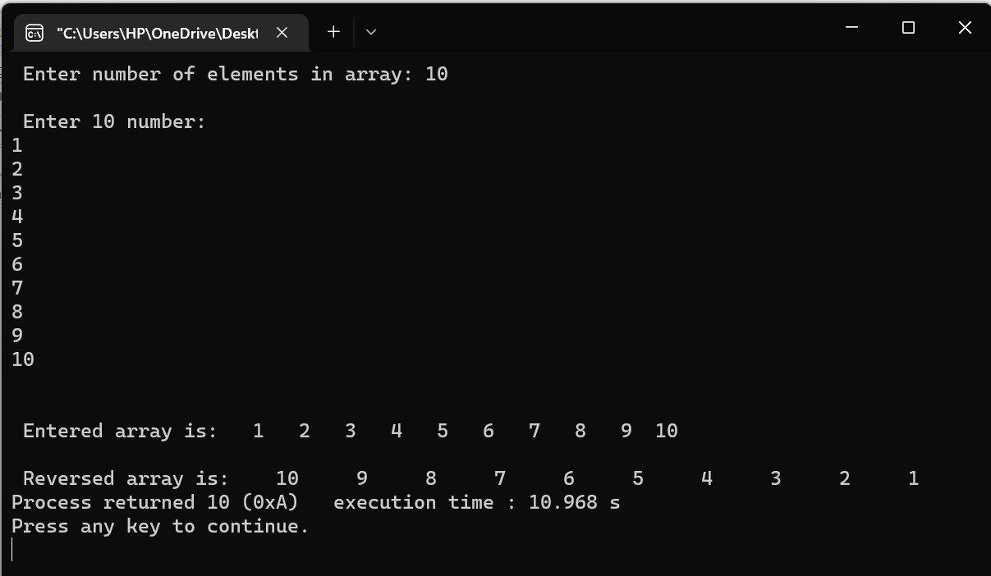

**Date: _____________ Signature of faculty in-charge**