Batch: P1-2

Roll No.: 16010622050

Experiment / assignment / tutorial No. 4

Grade: AA / AB / BB / BC / CC / CD /DD

Signature of the Staff In-charge with date

Ketaki Mahajan

TITLE:
Program to print patterns

Expected OUTCOME of Experiment:
AIM:
Program to print patterns for ‘n’ rows using nested loop ______________________________________________________________________
The objective of this program is display pattern as shown below, using ‘n’ number of rows inputted by user, using nested loops.
Pattern: 9 8 7 6 5
9 8 7 6
9 8 7
9 8
9
_____________________________________________________________________
Books/ Journals/ Websites referred:
- Programming in C, second edition, Pradeep Dey and Manas Ghosh, Oxford University Press.
- Programming in ANSI C, fifth edition, E Balagurusamy, Tata McGraw Hill.
- Introduction to programming and problem solving , G. Michael Schneider ,Wiley India edition.
- http://cse.iitkgp.ac.in/~rkumar/pds-vlab/
____________________________________________________________
Problem Definition:
The program is to print a pattern as given by the user. The program makes use of a nested loop to print a pattern of characters, numbers or alphabets.
e.g. -
Input: number of rows = 5, number of columns = 5
Output:
5
4 5
3 4 5
2 3 4 5
1 2 3 4 5
Algorithm:
START
Declare variables i, j, n, row
Read i, j, n
Print “Enter the number of rows”
Read row
for loop
i<row
for loop
print “%d”
decrease n by 1 in each iteration
end for loop
print new line
end for loop
END

Implementation details:
/*
this program prints the pattern -
9 8 7 6 5
9 8 7 6
9 8 7
9 8
9
*/

#include<stdio.h>
int main()
{
int i, j, n, row;
printf("Enter the number of rows: ");
scanf("%d", &row);

for(i=row; i>=1; i--)
{
n = 9;
for(j=1; j<=i; j++)
{
printf("%d", n);
n--;
}

printf("\n");
}

return 0;
}

Output(s):
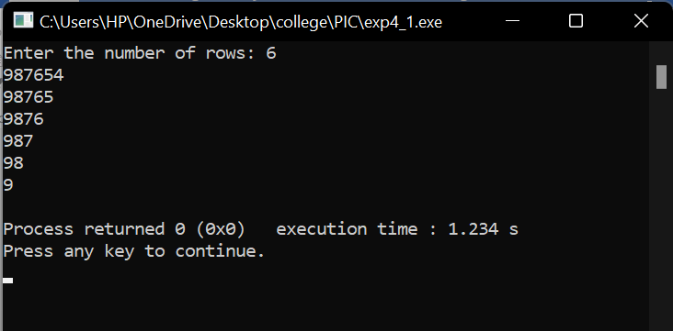

Conclusion:
To conclude, carrying out experiment 4 has resulted in learning various new concepts such as –
- using nested for loops
- manipulating for loops and printf statements to print the required patterns

Hence, I was able to successfully carry out experiment 4 and fulfil the objectives that the problem defined as seen in the output.

Post Lab Descriptive Questions:
Write a program to print the following:
1
2 4
3 6 9
4 8 12 16
5 10 15 20 25
6 12 18 24 30 36
7 14 21 28 35 42 49
8 16 24 32 40 48 56 64
9 18 27 36 45 54 63 72 81
10 20 30 40 50 60 70 80 90 100

Implementation detail –
/* this program prints the pattern
1
2 4
3 6 9
4 8 12 16
etc…
*/

#include <stdio.h>
int main()
{
int i, j, row, product;
for(i=1; i<=10; i++)
{
for(j=1; j<=i; j++)
{
product = i * j;
printf(" %d ",product);
}
printf(" \n");
}
printf("\n End of program");
return 0;
}

Output(s) -
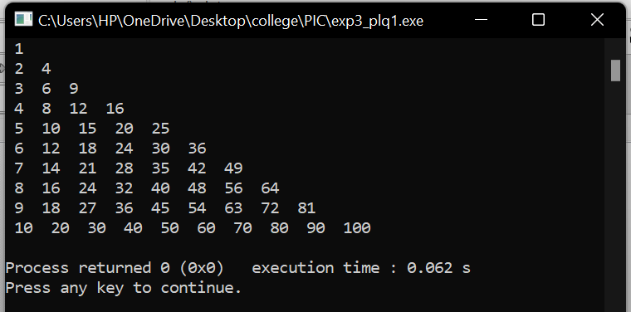

Write a program to print the following pattern:
A
ABA
ABCBA
ABCDCBA

Implementation details -
/*
this program prints the pattern -
A
ABA
ABCBA
etc...
*/

#include <stdio.h>
int main()
{

int A_asci = 65, i, j, k, m;
for(i=1; i<=5; i++)
{
for(j=5; j>=i; j--)
{
printf(" ");
}

for(k=1; k<=i; k++)
{
printf("%c",A_asci++);
}

A_asci--;

for(m=1; m<i; m++)
{
printf("%c",--A_asci);
}

printf("\n");
}
return 0;
}

Output(s) -
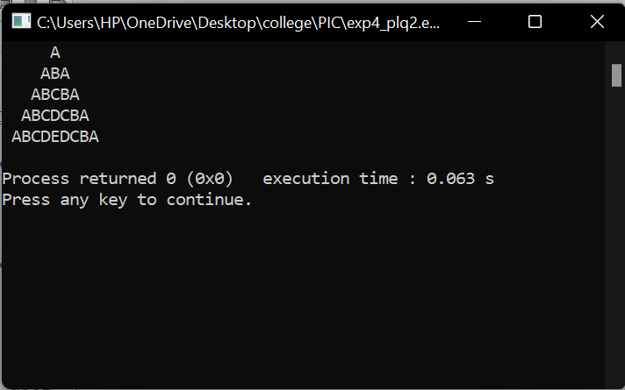

Date: _____________ Signature of faculty in-charge

